Online Fee Chalan Generator

(CU-OFPS)

Gunit Kumar Bedi  
*Apex Intitute of Technology*

*Chandigarh University*  
Mohali, Indiagunitkbedi@gmail.com

Dr. Banita Mandal  
*Apex Institute of Technology*  
*Chandigarh University*Mohali, India

Banita.e13349@cumail.in

***Abstract*—** **Chandigarh University has a large number of students who pay all the university fees through cash deposits, electronic funds transfer or bank drafts to the university’s accounts in specific bank branches. These methods of paying fees have not been efficient enough especially during periods of tests and examinations when most of the students are paying fees to meet the requirements for entering examination rooms. The process of paying fees is characterized by long queues, too much waiting by students and congestion at banks where payments are made. This has always resulted in students missing to sit for their tests and/or examinations while they are queuing to make payments. It was upon such background that the researchers embarked on the project to develop of an alternative system that enables online fees payment by students and their sponsors. With the use of questionnaires, interviews, observation and document reviews, data was collected from project stakeholders and analysed. Data flow diagrams and Entity relationship diagrams were used to accomplish system analysis and design. The system was implemented using Apache web server, MySQL database server, Hypertext Pre-processor, Hypertext markup language, System testing and validation was also done by allowing users of the system interact with it using test data.**

# **Introduction**

Chandigarh University has a large number of students who are supposed to pay all the university fees through cash deposits or bank drafts to the university’s accounts in specific bank branches. This method of paying fees has not been efficient enough especially during periods of tests and examinations when most of the students are paying fees to meet the requirements for entering examination rooms. The process of fees payment in such periods is characterized by long queues, too much waiting by students and congestion at banks where payments are made. Students queue to pay fees and those who do not reach counters within the bank working hours are advised to return the next day.

This process has always resulted in students missing to sit for their tests and/or examinations while they are queuing to make payments. It has also resulted to too much costs and a lot of time used in transferring and withdrawing money whenever sponsors of students make money transfers to students who can pay university fees at specific bank branches. The process requires sponsors of students from wherever they are to send money to students through either bank, mobile money or any other possible way(s) so that students pay university fees or use EFT that require swift codes to pay fees to the university. This consumes time and sponsors incur extra costs in this process of sending money to students.

So, in the proposed system we will have Admin and User where admin will have to generate the fee challan and the user have to pay the generated challan or the fee the user will register in the web using his/her UIDs and they can set a preferable password for their account and they can see the due fees, fees that have been paid by the user and also if they have to pay any fine due to misbehavior or misconduct in the premises.

# Literature REVIEW

Chandigarh University has many students who are supposed to pay all the university fees through cash deposits or bank drafts to the university’s accounts in specific bank branches. This method of paying fees has not been efficient enough especially during periods of tests and examinations when most of the students are paying fees to meet the requirements for entering examination rooms. The process of fees payment in such periods is characterized by long queues, too much waiting by students and congestion at banks where payments are made. Students queue to pay fees and those who do not reach counters within the bank working hours are advised to return the next day.

This process has always resulted in students missing to sit for their tests and/or examinations while they are queuing to make payments. It has also resulted to too much costs and a lot of time used in transferring and withdrawing money whenever sponsors of students make money transfers to students who can pay university fees at specific bank branches. The process requires sponsors of students from wherever they are to send money to students through either bank, mobile money or any other possible way(s) so that students pay university fees or use EFT that require swift codes to pay fees to the university. This consumes time and sponsors incur extra costs in this process of sending money to students.

“Reference [1]” Dr. Sudha L K, Yuktha Raju, Vidya G, Puneeth N, Yashawini: The complexities in fare collection have been eliminated and the project is completed successfully using smart card. This project is made with pre-planning, that it provides flexibility in operation. This innovation has made more desirable and economical. The COLLEGE FEE PAYMENT SYSTEM is designed with the hope that it is very much economical and helpful for teachers, parents and students during journey.

“Reference [2]” Lwanga Newton and Justus Ashaba: The project sought to develop an online fees payment system that provides relief of the long-endured problems of the current modes of paying fees in Makerere University. Problems that students and their sponsors faced regarding paying fees to the university were identified and a solution was designed. Researchers developed a web-based system that enables students and their sponsors to pay university fees from wherever they are using credit and debit cards. This system was welcomed by all its users who believed it would solve most of the problems and improve conditions regarding paying fees in Makerere University.

The project achieved all its objectives and as a result, MUK-OFPS was designed, developed, tested and validated with real users. Hence, it was proved that this online system was fit to be implemented

# Proposed Model



Fig 3.1

CU-OFPS is a web-based application to be hosted on a web server that communicates to a database server. The user on a web interface makes a web request which is received by the web server. The web server processes the request and interacts with the database server using SQL embedded in PHP scripts. The response is a web page data sent on the web interface for the users.

Roles:

There are roles like the Admin, User. Admin, the name itself defines what it is capable of. The user is the lowest in the role chain and has the least privilege. And the Admin have the most privileges

Admin:

The role of admin is to generate the fee challan and do generate the fee payment alert and to manage active and in-active student’s database

User/student:

The role of student/User is to pay their fee challans and, they can keep track of their payments.

Liberty:

The different roles have their different rights and liberties as they need different privilege.

Admin:

Admin has the liberty to generate college fee and other expenses, and also to keep track of registered members.

User/Student:

Student have liberty to pay the fee challan generated.

Fees payments by students in Chandigarh University are made through cash deposits, Electronic Funds Transfer (EFT) and Bank drafts to the university’s accounts in specific bank branches. Plymouth and Martin stress that, “For nearly every business, the simple act of collecting payments from consumers is quite complex. Organizations want to make it easy and convenient for customers to pay, so they offer multiple choices of payment types and channels”. Therefore, the project provides an alternative method that enables secure online fees payment by students and their sponsors. In this project we are proposing a system that will have a user login and an Admin login with their own features and responsibilities.

The proposed system will have Admin and User where admin will have to generate the fee challan and the user must pay the generated challan or the fee the user will register in the web using his/her UIDs and they can set a preferable password for their account and they can see the due fees, fees that have been paid by the user and also if they have to pay any fine due to misbehavior or misconduct in the premises. Admin can manage the generation of challan and the alert the message to the students/users for the payment and will have control over database and they can update the active current/Active users and will store data of passed out students in passed/In-Active students.

Students will have an interface where they will see their due fees and the fee they paid and can also keep a track on how much fee have been paid and how much is left they will be acle to manage their expenses

Advantages with the proposed system:

• Allow students to make secure payments.

• Reduce the hassle and inconvenience of paying fees.

• Easy to use interface and great manageability.

• Saves time on payments and keep track of every payment.

# methodology

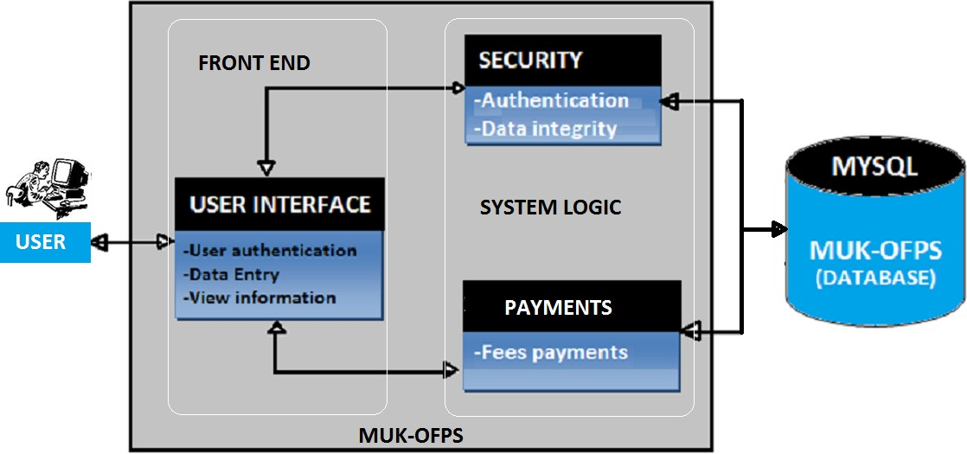

Fig 4.1

The Methodology behind the project is to make a robust system that will ease the way of paying all the college expenses and will create a hassle-free way of keeping the records of payments before this proposed idea students used to pay by check deposit or cash deposit because of hat students must be in long queues and sometime even they get to pay late due to this and also, they miss their examinations because of the delay. So, the following steps for this will be Registering in the application, generation of fee challan, payment of the fee challan, uploading the data.

4.1. Registering on CU-OFPS:

The student will have to use CUIMS ID and Password to register on CU-OFPS and then they can access the web app and see their dues or any fee challan generated.

4.2. Generation of Fee challan:

So, here is the role of the admin. The admin has the privilege to generate the amount of fee and it will be according to the department, every department will have their admin and all the admins have their unique login credentials and they will be in charge to generate the fee challan of the students in their department.

4.3. Payment of Fee challan:

Once the challan have been generated you will get the alert on your user interface from there you can pay your fee challan using UPI, credit card or debit card. It will fasten the process of transaction and you can keep the transition’s evidence also this is a secure method of payment.

4.4. Uploading the data:

After the payment the data and the transaction evidence will be uploaded in the database and hence it will show the user the fee challan have been paid and will show 0 dues. and it involves iteration and alteration of the development cycle.

### Information Gathering: Gathering the information of students and upload data on database.

### Analysis: In the part requirenments are discussed in the detailed manner, basically planning the whole project.

### Design: Designing of the software is implemented in this.

### Coding: Here, development of the code is started.

### Testing: Developed Software is tested to find the bugs and removal of it.

### Deploy: It is the first time that software/application is deployed in the real-environment.

### Feedback: Getting the feedback from the client and if there are changes the whole process starts again.

productive method of Agile which includes iteration throughout the process of software development which includes features like backlogs which is basically a roadmap and requirements of the project. Now,

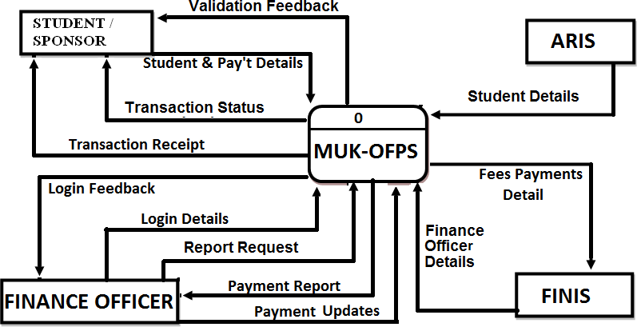

Fig 4.2

Now, let us breakdown the admins interaction with application

1. *Step 1:* Register your user.
2. *Step 2:* Get access to your fee details.
3. *Step 3:* Start adding the details of payable amount (we our using tabular data format that is easy to understand).

Now, let us breakdown the user’s interaction with application

1. *Step 1:* user will fetch fee details.
2. *Step 2:* user will get access to his fee details.
3. *Step 3:* User will pay the outstanding amount.

In “Fig. 4.3” there are only 4 pillars behind the flow chart:

* Front-End: This is where user interacts with user interface.
* Back-End: - It will provide the functionality to the application shown in the
* Database: This is where all the data will be stored and we can interact with the data using APIs.
* APIs: It will help the users to authenticate, fetch, add, and remove the data from the Front-end and make changes in the backend as well.

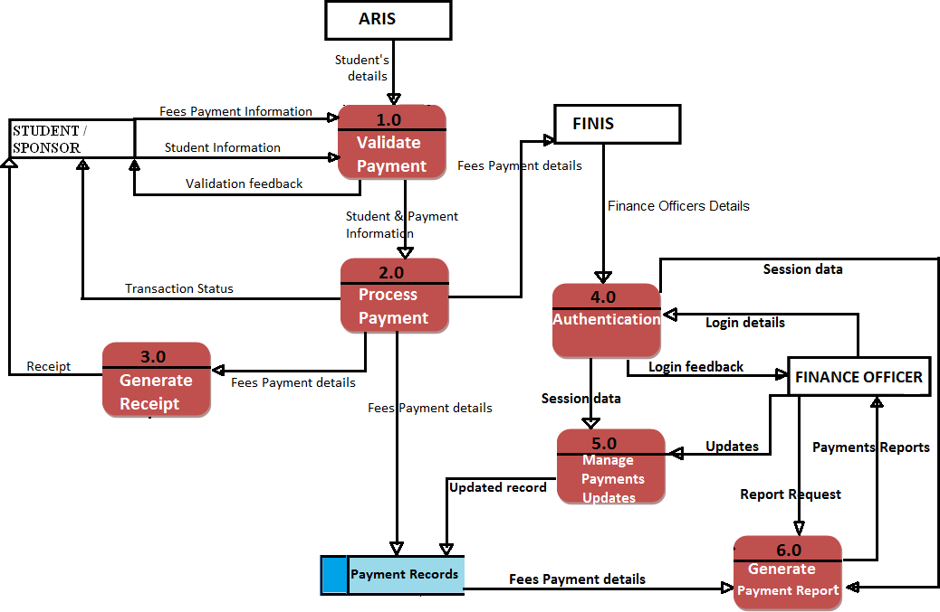

Fig. 4.3 Flow Chart

# Result

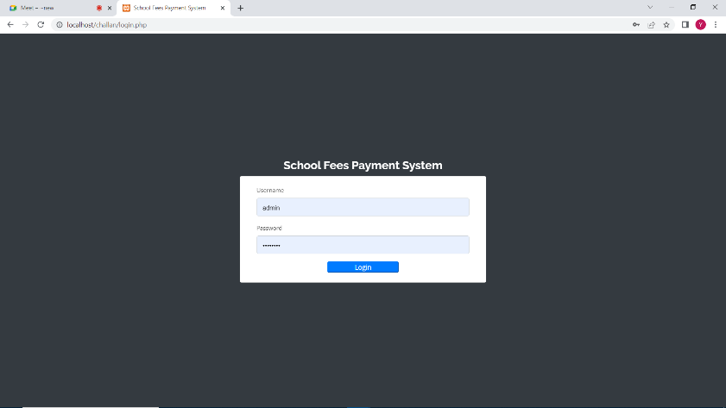

Fig. 5.1 Homepage of CU-OFPS

“Fig. 5.1” is going to be the first page of the application which have sign-up and sign-in option. If user already have an account they don’t need to sign up, they just sign-in with credentials.

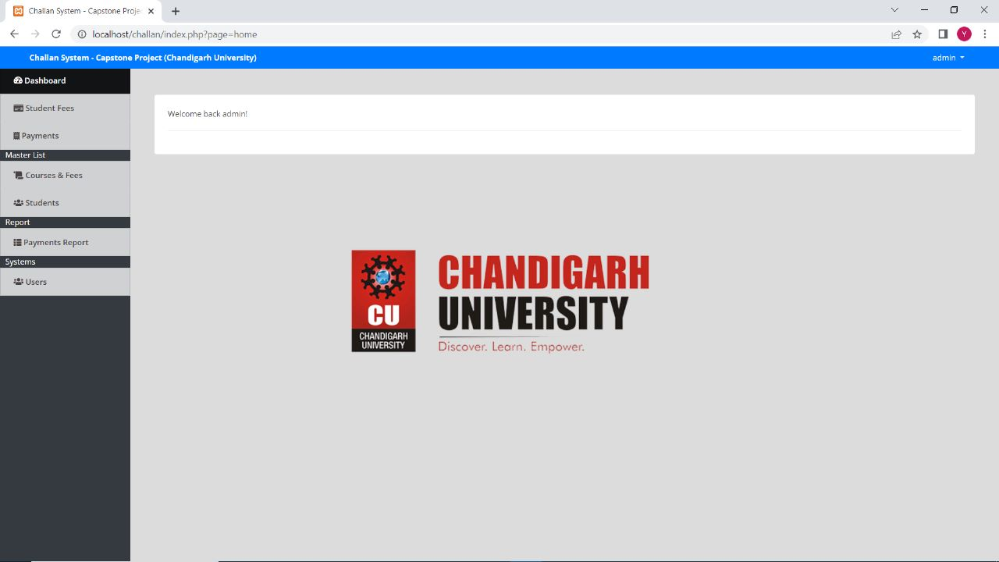

Fig. 5.2 Access of the dashboard after sing-in or sign-up

In “Fig. 5.2” the user can sign in or sign up in the application and now they have the option to go to the Dashboard button.

By clicking on the dashboard, they are routed to all the fee payment options.

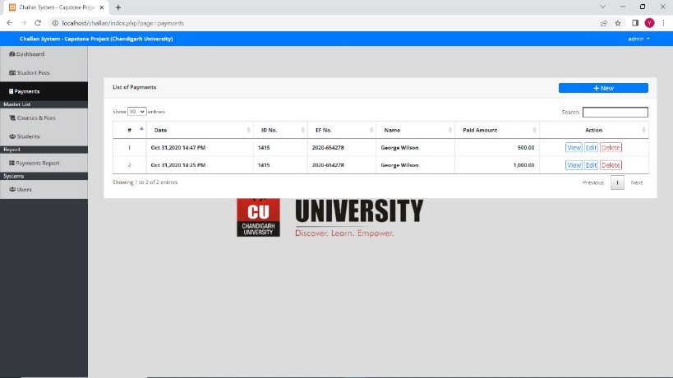

Fig. 5.3 Dashboard

“Fig 5.3” The Dashboard has the following feature like student fees, payments, courses & fees, payment reports, users.

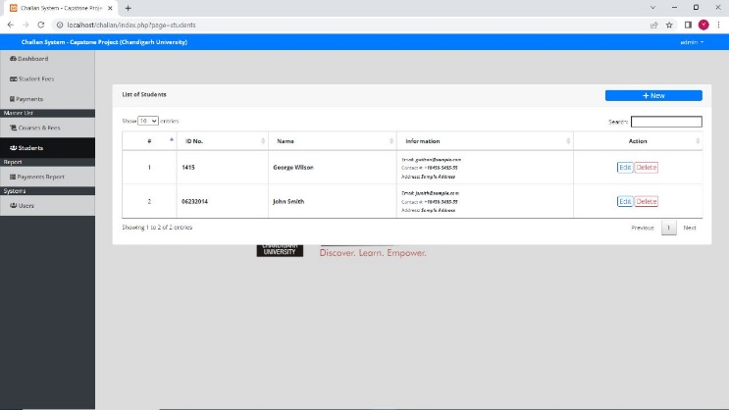Fig. 5.4 Adding student’s data

By clicking on add button this card shown and we got the option to add student’s data “Fig. 5.4”

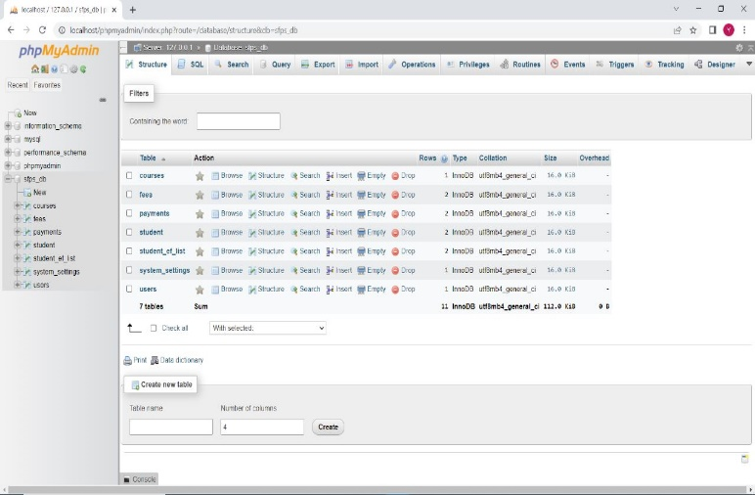

Fig. 5.5 Data shown database

Also, the data that user is adding also stored in the database which are stored in the form of Objects. MySQL provides us the dashboard where we can see the schemas and data models we created and data according to the data models Fig. 5.5

# Conclusion

One of the main benefits of online fee challan generators is that they provide a convenient and user-friendly way for users to make payments. Users can generate their fee challans online and pay through various payment methods such as credit/debit cards, net banking, and mobile wallets. This eliminates the need for users to physically visit the institution or organization to make their payments, saving them time and effort.

Another benefit of online fee challan generators is that they can be customized to suit the needs of different institutions and organizations. They can be designed to include various fields and sections, such as student details, fee structure, due dates, and payment modes. This allows institutions and organizations to streamline their fee collection process and avoid errors or delays in payment processing.

Drawbacks of Online Fee Challan Generators

Despite their benefits, online fee challan generators also have some drawbacks. One of the main concerns is that they can be vulnerable to cyber-attacks, which can compromise the security of user data and financial transactions. Institutions and organizations must ensure that their online fee challan generators are equipped with adequate security measures, such as encryption and firewalls, to protect user data and prevent fraud.

Another potential drawback of online fee challan generators is that they may not be accessible to all users. Some users may not have access to the internet or may not be comfortable using online payment methods. Institutions and organizations must ensure that they provide alternative payment methods, such as cash or check, to accommodate such users.

User Satisfaction with Online Fee Challan Generators

Several studies have examined user satisfaction with online fee challan generators. Overall, users have reported high levels of satisfaction with these tools, citing their convenience, ease of use, and time-saving benefits. However, some users have reported issues with payment processing, such as delays or errors in payment confirmation.

Security Concerns with Online Fee Challan Generators

Several studies have also highlighted security concerns with online fee challan generators. Cyber-attacks, such as phishing and identity theft, can compromise user data and financial transactions. Institutions and organizations must ensure that their online fee challan generators are equipped with robust security measures, such as multi-factor authentication and real-time fraud detection, to protect user data and prevent fraud.

Conclusion

Overall, online fee challan generators have become a popular tool for institutions and organizations to collect fees and payments from their clients. While they offer many benefits, such as convenience and customization, they also have some drawbacks and security concerns. Institutions and organizations must ensure that their online fee challan generators are equipped with robust security measures and provide alternative payment methods to accommodate all users.

# ACKNOWLEDGEMENT

The authors would like to thank Dr. Banita Mandal for his assistant and guidance to this work. Without his guidance this work cannot be done.

# VIII.References

[1] Agarwal, R., & Goyal, M. (2017). Online Fee Collection System: A Case Study. International Journal of Innovative Research in Science, Engineering and Technology, 6(1), 1-7.

[2] Bhatia, A., & Vashist, R. (2018). Automated Fee Collection System in Educational Institutions using PHP and MySQL. International Journal of Computer Sciences and Engineering, 6(6), 66-72.

[3] Gupta, S., Kumar, S., & Singh, M. (2016). An Efficient Online Fee Collection System. International Journal of Innovative Research in Computer and Communication Engineering, 4(5), 422-426.

[4] Kaushik, S., & Suman, A. (2018). Design and Implementation of an Online Fee Collection System for Educational Institutions. International Journal of Computer Science and Mobile Computing, 7(5), 57-61.

[5] Patil, S., & Patil, A. (2019). Online Fee Payment and Management System for Educational Institutions. International Journal of Emerging Trends in Engineering Research, 7(3), 66-70 Motivators and inhibitors, MIS Quarterly, Vol. 12, No. 1, 1993, pp. 47-60.

6] Pradip V Mistary, R H Chile “Real Time Vehicle Tracking

System Based on ARM7 GPS and GSM Technology”, IEEE

INDICON 2015 1570187057

[7] Rana Biswas, Romit S. Beed, Dibyabiva Seth, Proyag Pal,

Kaustav Basu, Triparna Mukherjee ,“Traffic Rule Violation

Information System TRuVIS”, Biswas et al., International Journal

of Advanced Research in Computer Science and Software

Engineering 5(7), July- 2015, pp. 1134-1139

[8] S. Shepard, (2005), “RFID Radio Frequency Identification”,

(2005), USA, ISBN:0-07-144299-5.

[9] Whai-De Chen, Hsuan-Pu Chang,“Using RFID Technology to

Develop an Attendance System and Avoid Traffic, Congestion

around Kindergartens”, 978 -1-4244-1866-4/08/$25.00 ©

2008IEEE.

[10] Ministry of Home Affairs,Govt. of India “Automated Traffic

Monitoring System”, 2010-2012.