**Project Name: Smart Sheild for women safety**

**Short Description:**

Women Safety Application can be used to find and Help Women in emergency. In recent time it’s been identified lots of misbehaving activity in urban and rural part of our country. Since mobility growth is been identified in recent 10 years and Smartphone penetration started 5 years ago. With the rapid growth of Android user and cheaper internet cost we can provide a simple medium to create safety awareness among the working and professional women of young and teen age. Women Safety Application can show you exact location of the women in help to her relatives, guardian and friends along with the specific location, where you can go and help it.

**What’s the problem:**

In today’s world, it is not safe for women to travel alone at night ,it will be high time to travel alone because women is not strong as men to protect herself from them. There is phobia in women’s mind while going alone. She can’t do anything if someone follow her or else.

At the time of traveling if she feels uncomfortable or she have some doubts on driver then she needs to capture the image of no. Plate & upload it on our app, so if she kidnapped then his guardian can easily retrieve her location & send to the police then police will take further actions. This will also helpful for police or his guardian to reach at her location.

**How can technology help?**

For Womens when she is in trouble then she can use the Mobile App by which she can send her location to closest persons and to the police station of respected city within in a couple of minute and when womens will be this app then she fill safe and comfort while going anywhere.

**Long Description:**

In today's date, women face physical harassment in public places, schools and at workplaces or while traveling. Most cases of physical harassment take place when women are alone or while traveling. Women feel insecure to step outside their house.To make womens safe or capable to face the situation is very neccessary for this womens should have some gadjet or we can say that mobile app by which she can easily spread information about her trouble within a couple of minutes.

Hence, solution to face this problem we decided to create one mobile application by which using this features , The users need to register themselves on the app by creating their own account. This app service shall be a one-time registration, the users are required to fill in their basic details at the time of registration. After making an account user would be qualified to use all the services intended to protect and empower them. Services include an automated distress SOS to the nearest police station and to her emergency contacts, not only this the app will also automatically send in distress signals to the nearby people within a specified radius with a live location.

In this feature, the app will be directly connected to police control rooms and the user’s SOS contact list. If the user is not feeling safe in the taxi, she can immediately send the taxi number with help of image (She can capture image that can share to closest one and it is saved to our Database) (At the time of traveling if she feels uncomfortable or she have some doubts on driver then she needs to capture the image of no. Plate & upload it on our app, so if she kidnapped then his guardian can easily retrieve her location & send to the police then police will take further actions. This will also helpful for police or his guardian to reach at her location)to the SOS, and her location will be tracked down.

There is one button, On clicking this button the app sends in a distress message and a live location of the user to the nearest police station and to the ones selected as “close contacts”. The app will also send in a distress message and a live location link to all mobile phones then residing within a given radius from the location of the user. In case the user clicks the button while in a public transport, the system recognises the vehicle and marks it red on the map which is being monitored by the police.

**Kit required to develop Women safety Android application:**

* Android studio
* Firebase Database
* Java

**Architecture:**

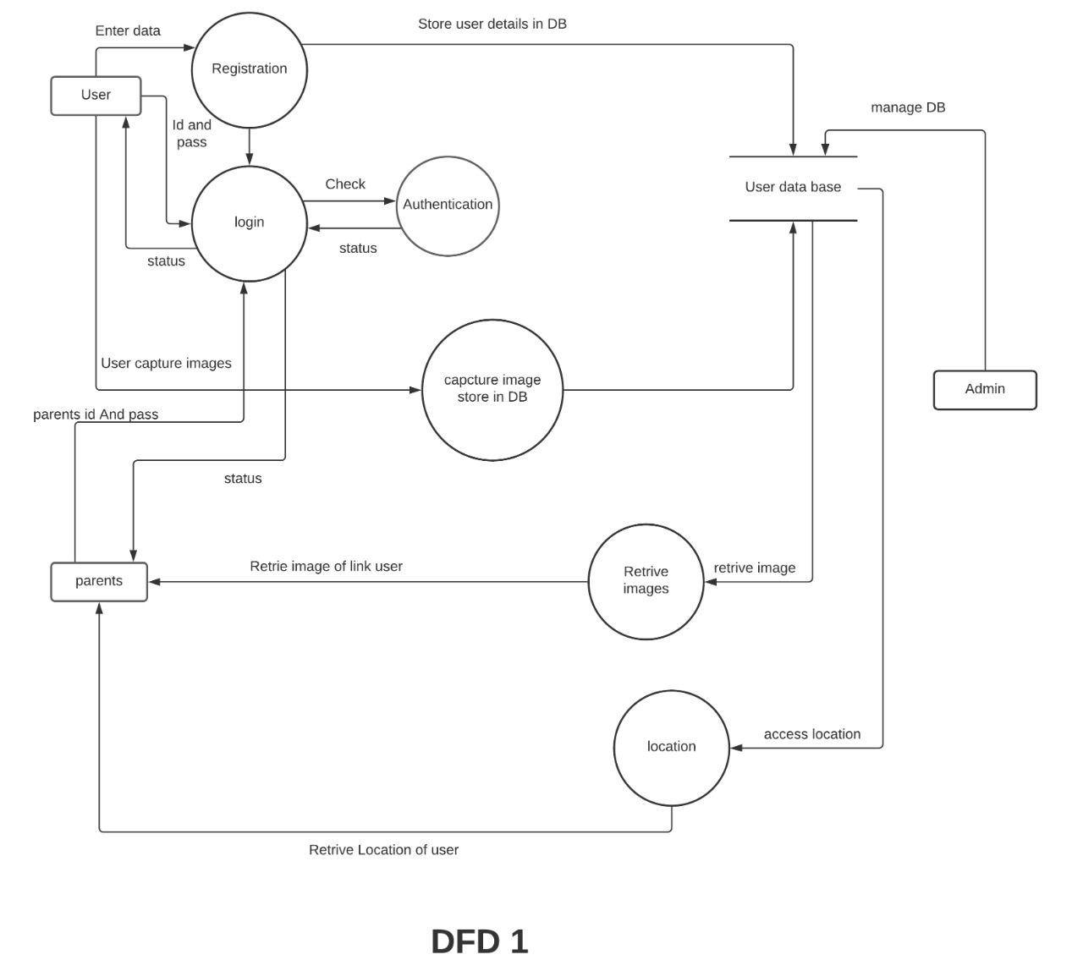

Fig no.1

**Flowchart:**

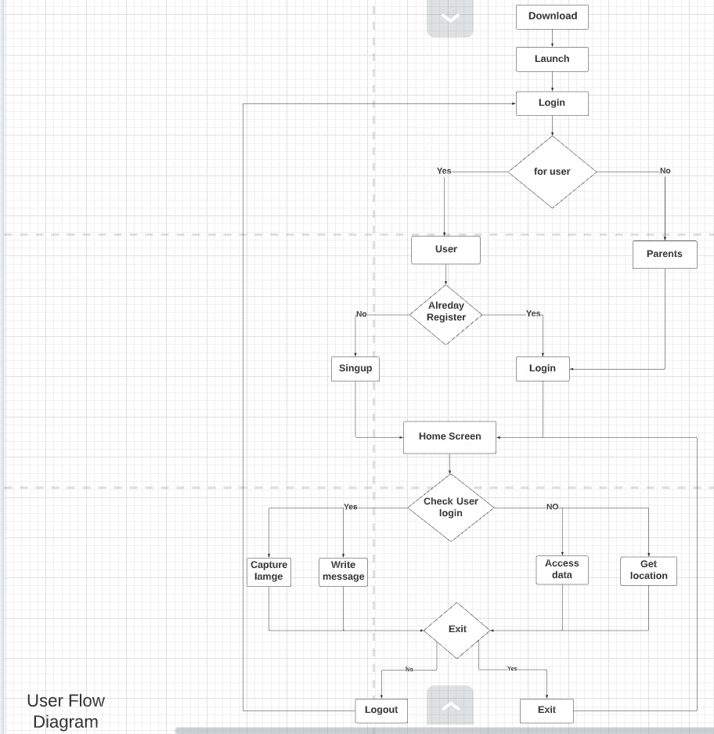

Fig no.2