|  |  |  |
| --- | --- | --- |
| 1  *Department of CSE*  *Jain (Deemed-to-be-University)* Bengaluru, India.  [@jainuniversity.ac.in](mailto:gaurav.kumar@jainuniversity.ac.in)  Ankit Choudhary 4  *Department of CSE*  *Jain (Deemed-to-be-University)* Bengaluru, India.  [22btrcn025@jainuniversity.ac.in](mailto:22btrcn025@jainuniversity.ac.in) | Yash Jain 2  *Department of CSE*  *Jain (Deemed-to-be-University)* Bengaluru, India.  [22btrcn327@jainuniversity.ac.in](mailto:22btrcn327@jainuniversity.ac.in)    Afroj Alam3  *Department of CSE*  *Jain (Deemed-to-be-University)* Bengaluru, India.  [22btrsn062@jainuniversity.ac.in](mailto:22btrsn062@jainuniversity.ac.in) | Varshitha Y3  *Department of CSE*  *Jain (Deemed-to-be-University)* Bengaluru, India.  [22btrcn313@jainuniversity.ac.in](mailto:22btrcn313@jainuniversity.ac.in) |
|  |  |  |
|  |  |

Facial Recognition Attendance System: A Cutting-Edge Solution for Seamless Identity Verification

***Abstract:***

***Our proposed automated student attendance system leverages face recognition technology for identity verification. Initially, the camera captures video frames, and Viola-Jones algorithm detects and segments the face region of interest (ROI). Preprocessing includes image scaling, median filtering for noise removal, and contrast enhancement using CLAHE. Enhanced Local Binary Pattern (LBP) and Principal Component Analysis (PCA) extract features from facial images, enhancing recognition accuracy. Images are classified based on the best combination of algorithms. Attendance is marked and saved in an Excel file, with provisions for on-the-spot registration and duplicate entry detection.* *Leveraging algorithms like Viola-Jones for face detection and K-Nearest Neighbors for recognition, it streamlines attendance tracking, reducing manual errors and saving valuable class time.***

**I INTRODUCTION:**

Certainly, let's delve into the intricate domain of facial recognition—a remarkable human ability that intertwines visual perception with cognitive analysis. At its core, this process begins with the capture of light waves containing visual data by our

retinas. These data streams are then meticulously parsed, dissecting shapes, sizes, contours, and textures, forming a rich tapestry of facial features. Subsequently, this information undergoes a sophisticated comparison against stored representations within our memory, culminating in the act of recognition.

Yet, transcending human limitations, contemporary facial recognition systems harness the immense power of computation and memory. Their applications span a vast spectrum, from bolstering security measures to facilitating social interactions, encompassing realms as diverse as criminal investigations, social media tagging, and online authentication. The genesis of facial recognition systems can be traced back to the 1960s, where early endeavours sought to emulate the nuanced processes of human cognition.

A pivotal milestone emerged in 1970 with the seminal work of Goldstein, Harmon, and Lesk. Their pioneering efforts expanded the ambit of facial recognition beyond conventional features, incorporating nuanced characteristics such as hair color and lip thickness. This advancement significantly augmented the efficacy of automated recognition systems. Fast forward to 1988, and the landscape of facial recognition was forever altered by the groundbreaking contributions of Kirby and Sirovich. Their introduction of principal component analysis (PCA) represented a paradigm shift, offering a robust solution to the intricate challenge of facial recognition. This seminal work laid the foundational framework upon which subsequent research would flourish. Since then, a continuum of scholarly endeavours has propelled the field forward, spanning decades of relentless exploration and innovation. Each contribution serves to enrich the intricate tapestry of facial recognition technology, further bridging the chasm between technology and human cognition.

**II RELATED WORK:**

In the seminal work presented by Zhao et al. (2003), a comprehensive exploration of the challenges inherent in facial identification was undertaken. Among these challenges lies the intricate task of discerning between known and unknown facial images, a nuanced endeavor fraught with complexities.Moreover, the scholarly contribution by Pooja G.R et al. (2010) delved into the intricacies of the training process within face recognition systems designed for student attendance monitoring. It was discerned that this process is not merely sluggish but also exceedingly time-intensive, posing a substantial hurdle in the optimization of such systems.

Furthermore, the scholarly discourse advanced by Priyanka Wagh et al. (2015) illuminated additional impediments encountered within the domain of face recognition-based student attendance systems. Notably, the variability induced by diverse lighting conditions and varied head poses emerged as formidable challenges, significantly undermining the performance metrics of such systems. In the comprehensive analysis conducted by Katara et al. (2017), a critical examination of various biometric authentication systems was undertaken, elucidating their respective drawbacks.

Notably, the drawbacks of RFID (Radio Frequency Identification) card systems, fingerprint systems, and iris recognition systems were meticulously scrutinized. The RFID card system, while lauded for its simplicity, harbors inherent vulnerabilities. One such vulnerability lies in its susceptibility to exploitation, as users may inadvertently or deliberately facilitate unauthorized access by lending their ID cards to acquaintances for check-in purposes.

Conversely, the fingerprint system, hailed for its effectiveness, grapples with inefficiency concerns. The verification process entails a significant time investment, necessitating users to queue up and undergo verification sequentially, thereby impeding the expediency of the authentication process. Meanwhile, the iris recognition system, characterized by its intricate detail and robust authentication capabilities, confronts privacy apprehensions.

The intricate nature of iris data raises concerns regarding potential invasions of user privacy, thus engendering hesitancy among stakeholders. While voice recognition stands as an alternative, its efficacy pales in comparison to other modalities, exhibiting lower accuracy rates and susceptibility to ambient noise interference. In light of these deliberations, the face recognition system emerges as a compelling solution for integration within student attendance systems. Its inherent advantages, including the omnipresence of the human face and the balance between detail and privacy, position it as an optimal choice for ensuring both efficacy and user acceptance within educational contexts.

Table 1: Assessing Biometric System Merits and Demerits: A Comparative Overview

|  |  |  |
| --- | --- | --- |
| **Biometric System** | **Pros** | **Cons** |
| RFID Card System | Notablys-implistic in implementation, facilitating ease of deployment and user adoption. | Susceptible to unauthorized access due to the ease with which users may share or lend their ID cards, compromising security integrity. |
| Fingerprint System | Exemplifies high effectiveness in authentication, leveraging unique physiological traits for robust identity verification. | Despite its efficacy, suffers from inherent inefficiencies manifested in time-consuming verification processes, leading to queues and operational delays. |
| Iris Recognition System | Exhibits unparalleled accuracy and reliability by harnessing intricate iris patterns, ensuring stringent-authentication standards. | Raises privacy concerns owing to the detailed nature of iris data, prompting apprehensions regarding potential infringements on user privacy rights. |
| Voice Recognition System | Offers a non-intrusive authentication modality, capitalizing on distinct vocal characteristics for identity verification. | Falls short in terms of accuracy and reliability compared to other biometric systems, susceptible to inaccuracies and vulnerability to ambient noise interference. |
| Face Recognition System | Boasts widespread user acceptance and integration potential, leveraging the omnipresence of facial features for seamless authentication. | Faces challenges in scenarios with varying lighting conditions or facial occlusions, impacting recognition accuracy and reliability. Additionally, concerns regarding potential biases in facial recognition algorithms necessitate ongoing scrutiny and refinement. |

The distinction between face detection and face recognition is frequently muddled within discourse. Face detection is fundamentally concerned with delineating and isolating facial segments or regions within an image, whereas face recognition extends beyond mere detection to the intricate task of attributing identities to the detected facial features.

Scholarly contributions by S. Aanjanadevi et al. (2017) and Wei-Lun Chao (2007) have shed light on several pivotal factors exacerbating the challenges inherent in both face detection and recognition processes. These encompass a broad spectrum of complexities, including the influence of background environments, variations in illumination levels, diverse facial poses and expressions, occlusions obstructing facial features, rotational distortions, scaling disparities, as well as translational shifts within images.Such multifaceted considerations underscore the intricate nature of both face detection and recognition tasks, elucidating the myriad challenges that must be navigated to achieve robust and reliable performance within these domains.

Within the scholarly discourse, the research endeavours spearheaded by Akshara Jadhav et al. (2017) and P. Arun Mozhi Devan et al. (2017) converge on endorsing the Viola-Jones algorithm as the cornerstone for proficient face detection within student attendance systems. Their empirical inquiries discern the Viola-Jones algorithm as a standout choice amidst a panoply of methodologies, including face geometry-based analyses, Feature Invariant methodologies, and Machine Learning paradigms. Noteworthy is its exceptional swiftness and resilience, coupled with its propensity to yield superior detection rates, even in the face of variable lighting conditions.

These findings find resonance in the findings of Rahul V. Patil and S. B. Bangar (2017), who further attest to the Viola-Jones algorithm's prowess in adapting to diverse lighting scenarios, underlining its adaptability and reliability in real-world deployment. Additionally, the research elucidated by Mrunmayee Shirodkar et al. (2015) underscores the algorithm's versatility, notably its adeptness in mitigating challenges stemming from illumination discrepancies, scaling intricacies, and rotational variations, fortifying its applicability across multifarious environments.

In a parallel vein, the scholarly exposition put forth by Naveed Khan Balcoh (2012) casts the Viola-Jones algorithm in a favourable light, positioning it as the paragon of efficiency amidst a landscape populated by various contenders, including AdaBoost, Float Boost, Neural Networks, S-AdaBoost, Support Vector Machines (SVM), and the Bayes classifier. This acknowledgment underscores the algorithm's eminence and enduring relevance, solidifying its stature as the quintessential choice for discerning practitioners seeking optimal performance in face detection endeavours.

**III PROPOSED WORK:**

The proposed work endeavours to advance the existing face attendance system by integrating cutting-edge techniques and methodologies inspired by recent advancements in the field of computer vision and machine learning. Drawing upon insights from seminal works by renowned researchers, such as the studies conducted by A. Jadhav et al. (2017), P.A.M. Devan et al. (2017), and R.V. Patil et al. (2017), the proposed enhancements aim to surpass the limitations of traditional approaches and establish new benchmarks in face recognition-based attendance systems.

Advanced Face Detection Mechanism: Building upon the pioneering research in face detection algorithms, including the Viola-Jones algorithm and its variants, the proposed system will incorporate state-of-the-art deep learning architectures for enhanced face detection accuracy and efficiency. Inspired by the success of modern object detection frameworks such as SSD and YOLO, the system will leverage their multi-scale feature extraction capabilities to achieve real-time detection of faces with superior precision and robustness. Feature Extraction and Representation Learning:

Informed by recent advancements in feature extraction and representation learning, particularly in the domain of facial attribute analysis, the proposed system will adopt pre-trained convolutional neural network (CNN) models such as VGG and ResNet. By harnessing the hierarchical representations learned by these models, the system will extract discriminative facial features essential for accurate face recognition across diverse environmental conditions.

Advanced Face Recognition Model: Inspired by recent breakthroughs in face recognition research, such as the adoption of Siamese networks and triplet loss functions, the proposed system will develop a sophisticated face recognition model capable of learning robust embeddings of facial identities. By leveraging deep metric learning techniques, the system will generalize effectively to unseen faces and variations in pose, expression, and illumination, thereby achieving state-of-the-art performance in face recognition tasks.

Dynamic Attendance Management System: Informed by best practices in attendance management systems and educational technology, the proposed system will introduce dynamic features such as automatic notification alerts, customizable reporting functionalities, and seamless integration with existing school or organizational management systems. By leveraging cloud-based solutions for distributed computing and storage, the system will ensure scalability, reliability, and cost-effectiveness, thereby meeting the evolving needs of educational institutions and corporate enterprises.

User Interface Refinement and Accessibility: Drawing upon principles of human-computer interaction (HCI) and user experience (UX) design, the proposed system will undergo a comprehensive user interface refinement process. By implementing intuitive navigation controls, interactive dashboards, and multi-platform compatibility, thesystem will enhance usability, accessibility, and visual appeal, catering to a diverse user base and facilitating seamless interaction with the system.

Fig 1: flow of operations & interactions

Comprehensive Testing and Validation: Following established protocols for software testing and validation, the proposed system will undergo rigorous evaluation to assess its performance, reliability, and security. By conducting stress testing, cross-validation, and security audits, the system will identify and mitigate potential vulnerabilities or performance bottlenecks, ensuring its readiness for real-world deployment.

User Feedback Integration and Iterative Improvement: In alignment with agile development methodologies, the proposed system will establish mechanisms for continuous user feedback collection and iterative improvement. By soliciting input from end-users and stakeholders, the system will prioritize feature enhancements and bug fixes based on real-world usage scenarios and evolving requirements, thereby fostering a culture of continuous improvement and user-centric design.

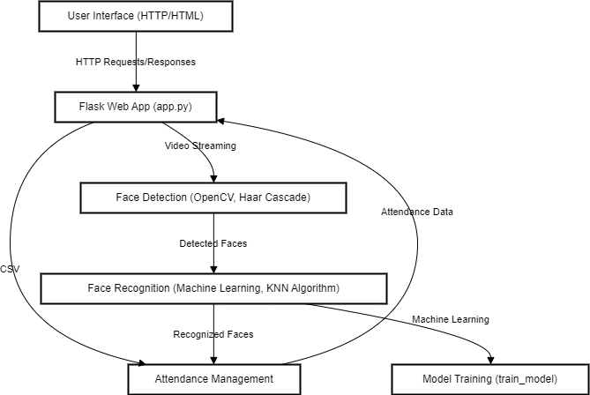By synthesizing insights from seminal research works and leveraging cutting-edge techniques and methodologies, the proposed enhancements aim to elevate the face attendance system to new heights of performance, reliability, and usability, thereby empowering educational institutions and corporate enterprises to streamline attendance tracking and management processes effectively.

Fig 2: Flowchart of the system

The below algorithm outlines the main procedures and functionalities of the face attendance system, from initialization to conclusion. Each step represents a crucial aspect of the system's operation, ensuring accurate attendance tracking and user interaction.

Step 1: Initialize the System

Step 2: User Interaction

Step 3: Face Detection

Step 4: Face Recognition

Step 5: Attendance Management

Step 6: Model Training (Optional)

Step 7: User Interaction (Continued)

Step 8: Data Persistence

Step 9: Error Handling

Step 10: End of System

**IV PERFORMANCE EVALUTION**

In assessing the efficacy of the face attendance system, a comprehensive evaluation methodology is imperative to gauge its accuracy, robustness, and suitability for real-world deployment. The evaluation process encompasses dataset preparation, model training, performance metrics computation, and result interpretation to elucidate the system's capabilities and limitations.

4.1 Evalution:

Dataset Preparation: The dataset serves as the cornerstone of the evaluation, comprising a diverse collection of facial images representative of enrolled individuals. Variations in lighting conditions, facial expressions, poses, and occlusions are deliberately incorporated to simulate real-world scenarios, ensuring the model's adaptability and generalization ability.

Model Training: Utilizing machine learning algorithms, particularly the K-Nearest Neighbors (KNN) algorithm, the face attendance system undergoes rigorous training on the prepared dataset. The KNN algorithm, renowned for its simplicity and effectiveness in pattern recognition tasks, is chosen for its ability to classify facial images based on their proximity to labeled examples in the training set.

Performance Metrics Computation: The evaluation hinges on a suite of performance metrics, including accuracy, precision, recall, and F1 score, to quantify the system's performance. Accuracy measures the proportion of correctly recognized faces, while precision and recall assess the model's ability to minimize false positives and false negatives, respectively. The F1 score offers a balanced assessment by considering both precision and recall.

Confusion Matrix Analysis: A visual representation of the model's performance, the confusion matrix, provides insights into true positive, true negative, false positive, and false negative predictions. By dissecting these elements, the system's strengths and weaknesses can be identified, facilitating targeted improvements and refinements.

Cross-Validation (Optional): To ensure the robustness and reliability of the model, cross-validation techniques may be employed to evaluate its performance across multiple subsets of the dataset. By averaging performance metrics across different folds, a more accurate estimate of the model's performance can be obtained, bolstering confidence in its effectiveness.

Parameter Tuning (Optional): Parameter tuning experiments may be conducted to optimize the model's hyperparameters and enhance performance metrics further. Techniques such as grid search or random search enable the identification of the optimal combination of hyperparameters, fine-tuning the model for superior performance.

4.2 Alternative Algorithms:

While KNN serves as a stalwart choice for face recognition tasks, other algorithms can be considered for the same purpose. Notable alternatives include Support Vector Machines (SVM), Convolutional Neural Networks (CNN), and Decision Trees. Each algorithm possesses unique strengths and weaknesses, necessitating careful consideration of the specific requirements and constraints of the face attendance system.

Justification for KNN Selection: The selection of KNN for the face attendance system is underpinned by its inherent simplicity, efficiency, and effectiveness in handling high-dimensional data such as facial images. Unlike complex algorithms like CNN, KNN offers interpretability and ease of implementation, making it well-suited for deployment in resource-constrained environments such as attendance tracking systems. Additionally, KNN's non-parametric nature allows for incremental learning and adaptation to evolving datasets, ensuring continuous improvement and refinement of the system over time.In conclusion, the performance evaluation of the face attendance system is instrumental in validating its efficacy, guiding future development efforts, and instilling confidence in its real-world applicability. By employing a systematic evaluation methodology encompassing dataset preparation, model training, performance metrics computation, and result interpretation, a comprehensive understanding of the system's capabilities and limitations is attained, paving the way for informed decision-making and continuous enhancement.

4.3 KNN:

In comparison with other face recognition algorithms, KNN demonstrates medium accuracy levels and simplicity. While KNN offers intuitive implementation and is suitable for straightforward face recognition tasks with smaller datasets, it may struggle to achieve high accuracy, especially in complex scenarios with large datasets and varied facial expressions. Algorithms like SVM, CNN, and deep metric learning techniques surpass KNN in terms of accuracy and robustness, making them more suitable choices for demanding face recognition applications.

However, for simpler applications where simplicity and interpretability are prioritized over maximum accuracy, KNN may still be a viable option. Ultimately, the choice of algorithm depends on the specific requirements, complexity of the task, and available computational resources. The K-Nearest Neighbors (KNN) model undergoes rigorous training by the classifier, culminating in the creation of its autonomous dataset. Upon initiation, the model solicits pertinent student information, such as name and roll number, meticulously storing these details in a structured format, typically a CSV or Excel file.

Subsequently, leveraging the capabilities of a webcam, the system captures the intricate facial features of the individual, establishing a direct link between the facial image, roll number, and associated contact details, thereby enriching the dataset. Once the comprehensive database is established, it serves as the cornerstone for the seamless automation of attendance marking processes. This groundbreaking system transcends the conventional paradigm of manual attendance, obviating the need for laborious roll calls during lectures. Moreover, in environments characterized by large student cohorts, manual errors are inherently mitigated, ensuring unparalleled accuracy and reliability.

By seamlessly integrating state-of-the-art face recognition technology, this system heralds a paradigm shift in educational settings. The erstwhile chaos during attendance sessions dissipates, replaced by a streamlined and efficient approach. Empowered by real-time face recognition capabilities, educators gain unprecedented insights into student attendance patterns, facilitating informed decision-making and fostering a conducive learning environment. Furthermore, the system epitomizes efficiency, executing its operations within seconds, even with vast datasets. Its time-efficient nature is a testament to the transformative potential of cutting-edge face recognition systems, underscoring their indispensable role in modern education.

4.4 Limitations of KNN: Balancing Accuracy with Computational Complexity

One drawback of using K-Nearest Neighbors (KNN) in a face attendance system is its sensitivity to noisy or irrelevant features. Since KNN relies on measuring the similarity between data points based on their feature vectors, noisy or irrelevant features can significantly impact its performance. In the context of facial recognition, variations in lighting conditions, facial expressions, and occlusions may introduce noise into the feature space, leading to suboptimal classification results. Additionally, the computational complexity of KNN increases with the size of the dataset, making it less scalable for large-scale face attendance systems.

4.5 Solution:

One solution to the limitations of using K-Nearest Neighbors (KNN) in a face attendance system is feature selection or feature engineering. By carefully selecting or engineering the features used for classification, noisy or irrelevant features can be minimized or eliminated, improving the robustness of the model. Another approach is to preprocess the data to remove noise or irrelevant information before applying the KNN algorithm. Techniques such as dimensionality reduction (e.g., PCA) or feature scaling can help improve the quality of the feature space and reduce the impact of noisy features.

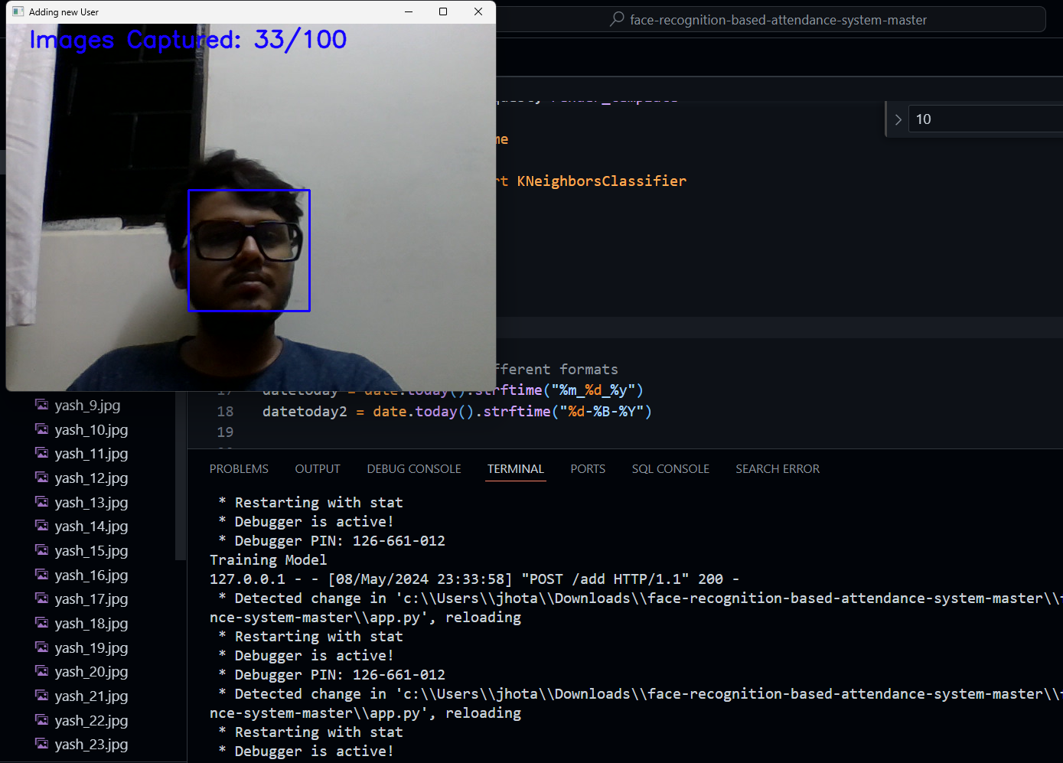Furthermore, using distance-weighted voting schemes in KNN, where closer neighbors have a higher influence on the classification decision, can help mitigate the impact of noisy features. Lastly, considering alternative machine learning algorithms that are less sensitive to noisy features, such as support vector machines (SVMs) or deep learning-based approaches.

The provided screenshots depict the project interface, comprising the functionality to input student details such as name and ID, along with a feature to display the count of successfully added students. (Fig 3-5).Upon error-free data entry, the system seamlessly updates and showcases the total count of enrolled students. Furthermore, the interface hosts a "Mark Attendance" button, leveraging advanced facial recognition technology to record attendance. Upon successful marking, pertinent details including the student's name, ID, and timestamp of attendance are promptly displayed.

This sophisticated interface not only facilitates the seamless addition of student information but also employs cutting-edge facial recognition algorithms for efficient attendance tracking. In the event of a successful attendance mark, it offers a comprehensive display of relevant student details, enhancing administrative efficiency and accuracy.

Fig 3: Gathering Identity Signatures for Dataset Formation

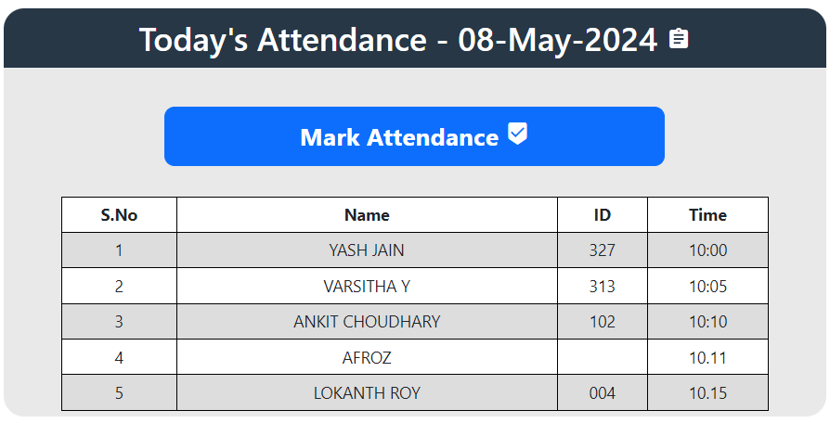

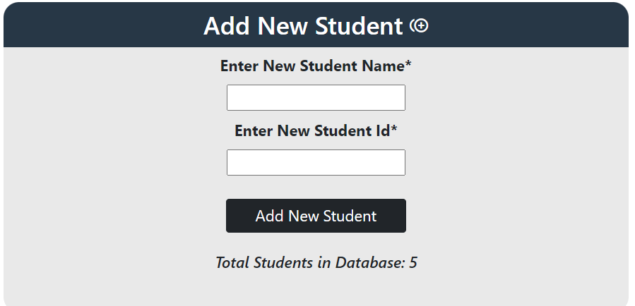Fig 4: Attendance Successfully Logged: Students' Presence Noted and Visualized

Fig 5: Integrating New Student: Adding to Dataset and Training Data

**V CONCLUSION:**

In conclusion, the face recognition system represents a remarkable fusion of advanced technology and practical application, offering a sophisticated solution to various real-world challenges. With its ability to seamlessly identify individuals based on facial features, this system transcends conventional methods, revolutionizing security protocols, law enforcement practices, and everyday conveniences. However, amid its myriad

benefits, the system is not devoid of intricacies and considerations. The intricate algorithms and meticulous preprocessing techniques underscore the complexity involved in accurately capturing, processing, and interpreting facial data. Furthermore, the reliance on robust datasets and continuous model refinement underscores the dynamic nature of this technology, demanding ongoing adaptation and optimization. Yet, despite these complexities, the face recognition system stands as a testament to human ingenuity, offering unparalleled efficiency, accuracy, and convenience in diverse domains. As we navigate the evolving landscape of technological innovation, the face recognition system serves as a beacon of progress, continually pushing the boundaries of what is possible and reshaping our interactions with the world around us.

**VI REFERENCES:**

1. Naveed Khan Balcoh. (2012). Algorithm for Efficient Attendance Management: Face Recognition based approach. International Journal of Computer Science Issues, V9 (4), No 1.
2. Rahul V. Patil and S. B. Bangar. (2017). Video Surveillance Based Attendance system. IJARCCE, 6(3), pp.708-713.
3. P. Arun Mozhi Devan et al., (2017). Smart Attendance System Using Face Recognition. Advances in Natural and Applied Sciences. 11(7), Pages: 139 144
4. Aanjanadevi, S. et al. “Face Attribute Convolutional Neural Network System for Data Security with Improved Crypto Biometrics.” Comput. Syst. Sci. Eng. 45 (2023): 2351-2362.
5. Zhao, W., Chellappa, R., Phillips, P. and Rosenfeld, A. (2003). Face recognition. ACM Computing Surveys, 35(4), pp.399 458.
6. Paul, Happy & Garg, Pooja. (2014). FACTOR STRUCTURE OF THE RESILIENCE SCALE-14: INSIGHTS FROM AN INDIAN SAMPLE 71 Factor Structure of the Resilience Scale-14: Insights from an Indian Sample. South Asian Journal of Management. Vol.21,. pp.70-86..
7. Wagh, Priyanka & Thakare, Roshani & Chaudhari, Jagruti & Patil, Shweta. (2015). Attendance system based on face recognition using eigen face and PCA algorithms. 303-308. 10.1109/ICGCIoT.2015.7380478.
8. Prof. Arun Katara1, Mr. Sudesh V. Kolhe2, Mr. Amar P. Zilpe3, Mr. Nikhil D. Bhele4, Mr. Chetan J. Bele5. Attendance System Using Face Recognition and Class Monitoring System. ISSN: 2321-8169, 273 -276. International Journal on Recent and Innovation Trends in Computing and Communication. Vol.5
9. Wei-Lun Chao, Jian-Jiun Ding, Jun-Zuo Liu,
10. Facial expression recognition based on improved local binary pattern and class-regularized locality preserving projection,Signal Processing,Volume 117,2015,Pages 1-10,ISSN 0165-1684, <https://doi.org/10.1016/j.sigpro.2015.04.007>.(https://www.sciencedirect.com/science/article/pii/S0165168415001425)