

School Of Engineering And Technology

Computer Science And Engineering Department

Navrachana University, Vadodara

Fourth Year B.Tech CSE (Semester 7)

Academic Year 2024-2025

Augmented & Virtual Reality (ARVR)

Course In-Charge: Professor Darshan Parmar

**Topic: AR Fitness Trainer**

Team Member Name:

Manshi Singhi (21124029)

Yash Joshi (21124046)

Date: 12/11/24

**GitHub :**

**Task 1: Set Up Your Unity Project & Configure the AR Environment**

* Installed Unity and click on New Project
* In templates, select 3D Core template and give your project a name and create project

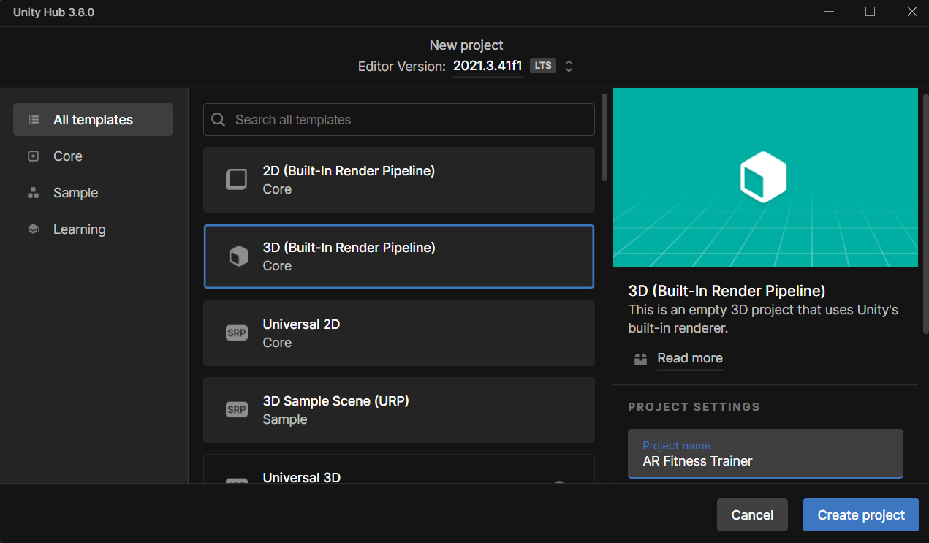

* Install AR Foundation and ARCore XR Plugin

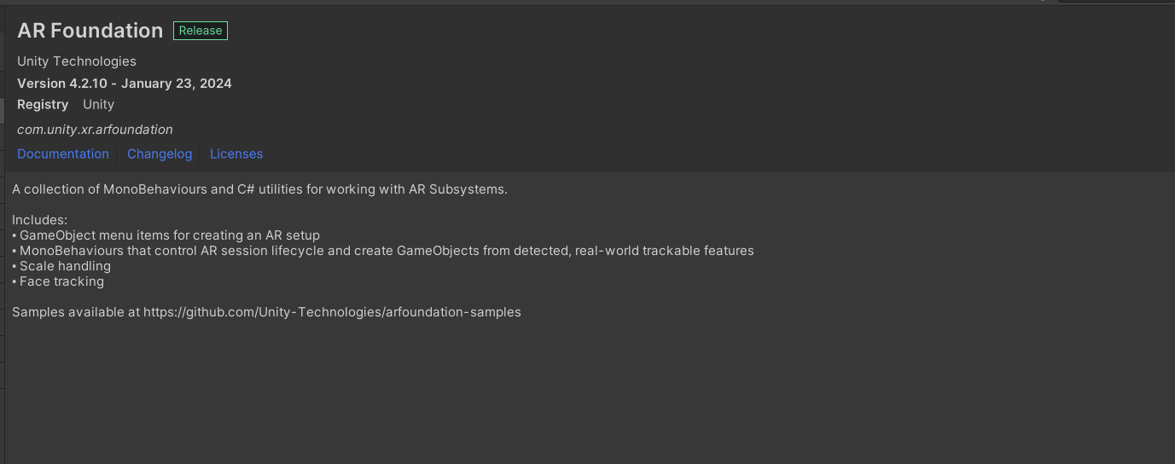

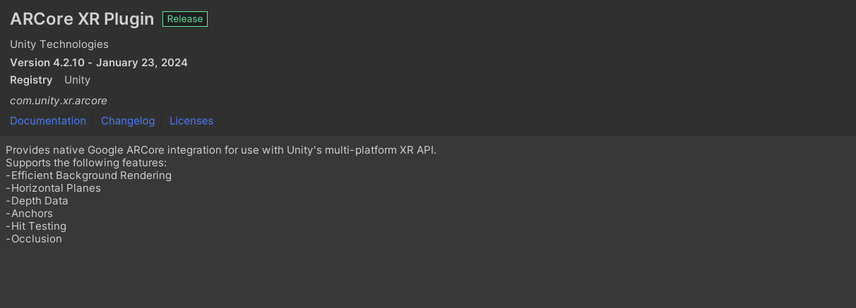\

* Configure player settings

1. Change colour space from Gamma to Linear
2. Uncheck Auto Graphics API
3. Delete Vulkan from graphics API and add OpenGLES3
4. Uncheck multithreading rendering

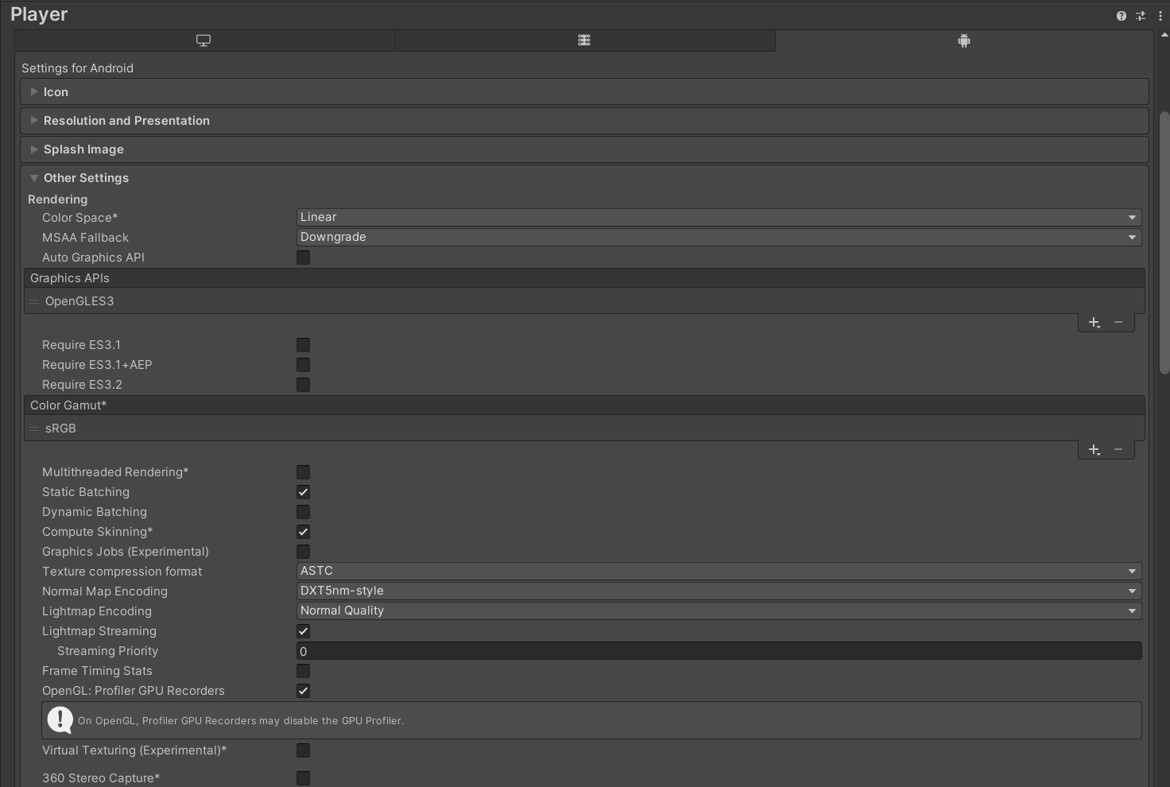

1. Select Android 8.1 ‘Oreo’ as minimum API level
2. Set automatic for target API Level
3. Select IL2CPP for Scripting Backend
4. Check ARM64

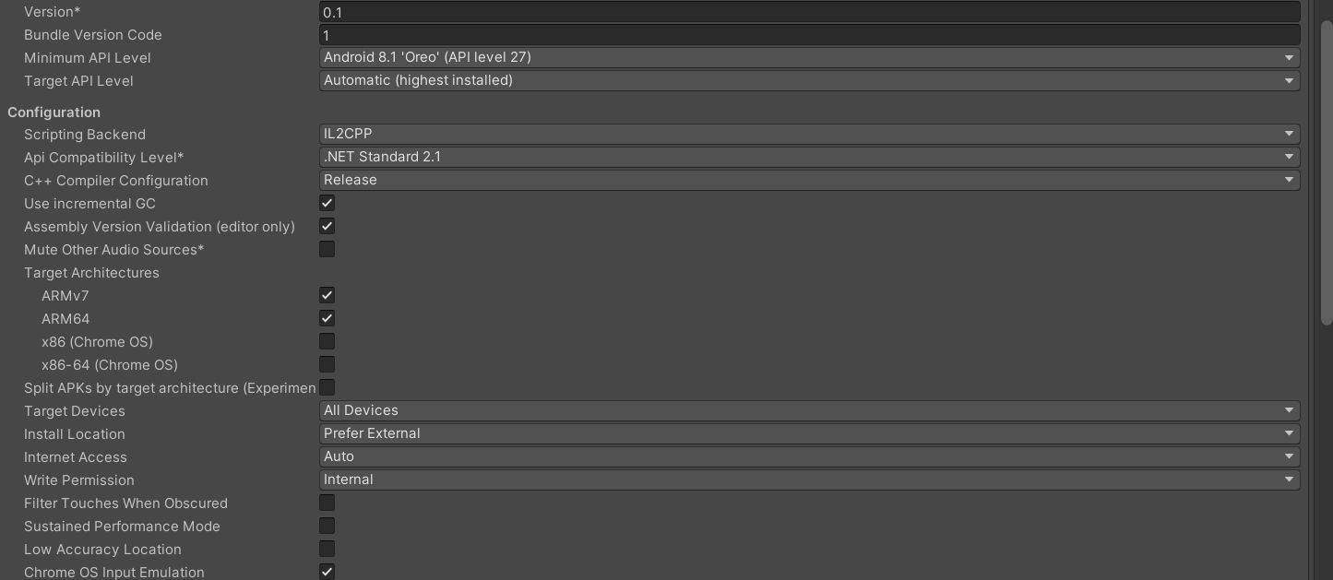

**Task 2: Create Intro Page, Home page and Splash screen**

* For our app, we first added an intro page which gives introduction of our app and when user clicks on get started the app loads our main page
* For intro page, we first added AR Session and AR Session Origin. Then we added a canvas to add text and graphics to our intro page.
* Inside canvas, in panel we added our background image and inside the panel we added a text and our get started button

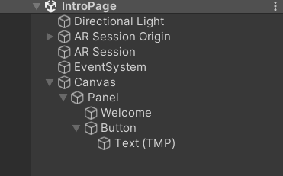

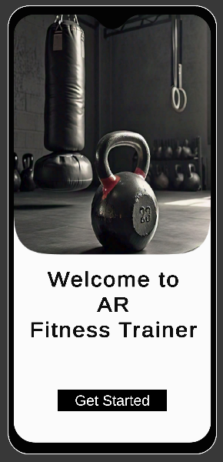

* In our home page, we have 3 buttons –

1. Fitness
2. MMA
3. About Us

* For all the scenes, we first added AR Origin and AR Session Origin.
* We then added canvas, which consists 3 buttons for different pages, one back button to redirect the user to intro page and one profile button.

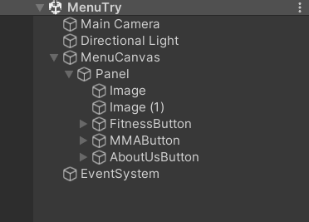

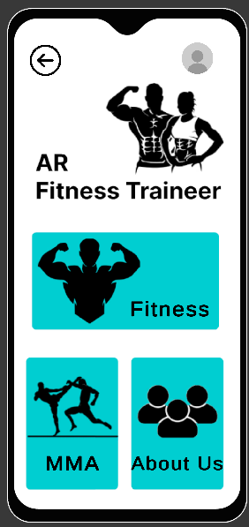

* For splash screen, we opened players settings.

1. In that we added our photo which has to displayed under Logos
2. Adjusted the logo duration to 2.5
3. Changed the splash style to dark on light
4. Changed Draw Mode from Sequential to unity Logo below as we wanted our picture and unity logo in same screen not 2 different screens.
5. Also changed the background colour to white as it matched our image

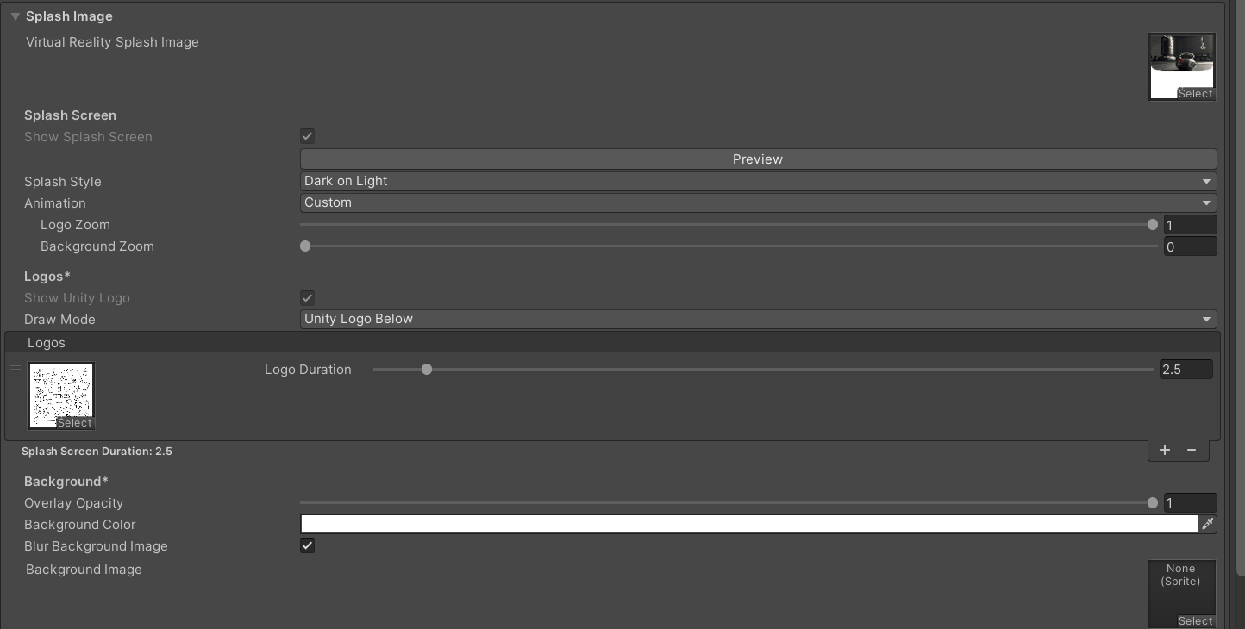



**Task 3: Fitness Scene**

* In this fitness scene there are total of 4 Training Style
* Freestyle
* Strength Training
* Weight Lifting
* Core Strength
* We first make 4 different buttons for these 4 Styles
* All the other settings are the same as we made in the menu page

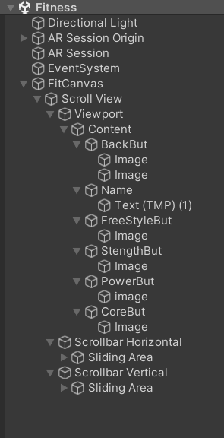

* After the creation of Fitness Scene we then create separate scenes for all individuals
* And all the necessary settings are same as fitness scene
* After that in Free Style Scene we added total of 5 exercises that are listed below

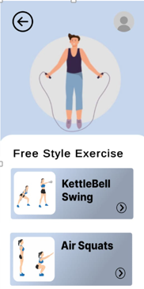

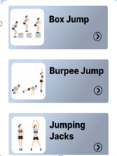

* In Strength Training we added total of 6 exercise

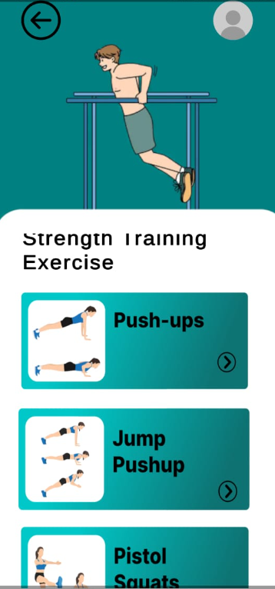

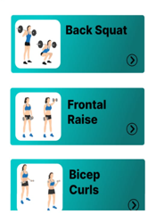

* In Weight lifting 2 exercises are there

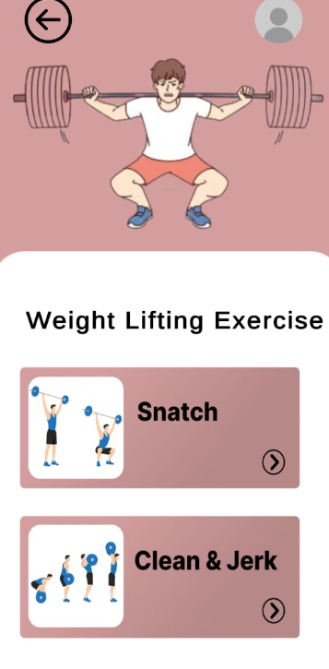

* After Weight lifting we made Core Strength page and in that we add 3 exercise

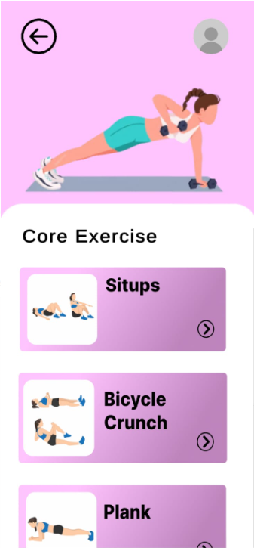

* We completed the UI part and all the connections between scene via buttons
* After the UI part we created camera scenes to show exercise animations via 3d model
* When we click on any of this exercise it will show a 3D model doing that exercise
* We imported that 3D model from Mixamo
* Also we imported all the exercise animations form the mixamo

* This is the model we imported from the mixamo
* For all the exercise me create different scenes and in that scene all the common settings and components are same, but the animation of exercises is different
* Following is the settings of all the camera scenes

* Lean touch: this is the important for our app, because it helps the model to rotate, scale on different size and move
* By doing this user can clearly analyse the exercise and do it in a proper way
* We have to add components like Lean Pinch Scale, Lean Drag Translate and Lean Twist Rotate Axis

* In the character prefab we just change the animations in the controller field

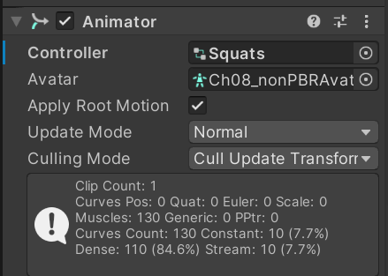

* All the other things remain same in every camera scene
* These are the total animations we created

* Fitness and MMA animations are mix
* Total fitness animations are 16
* Some exercise demo

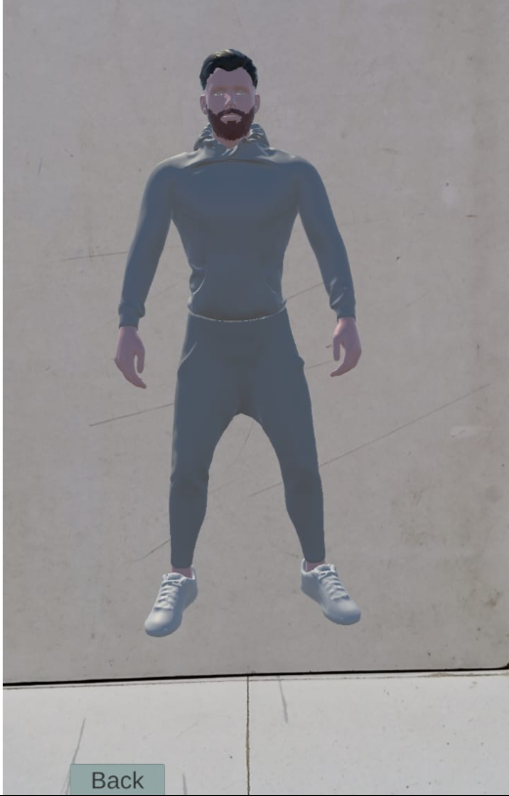

* Push-Ups

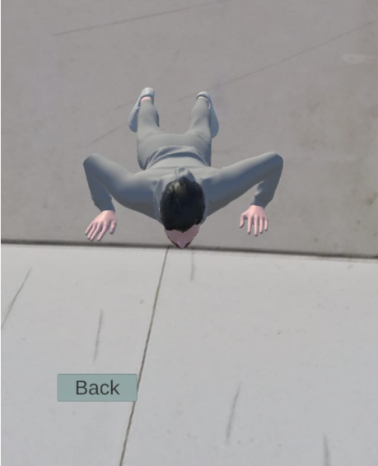

* Squats

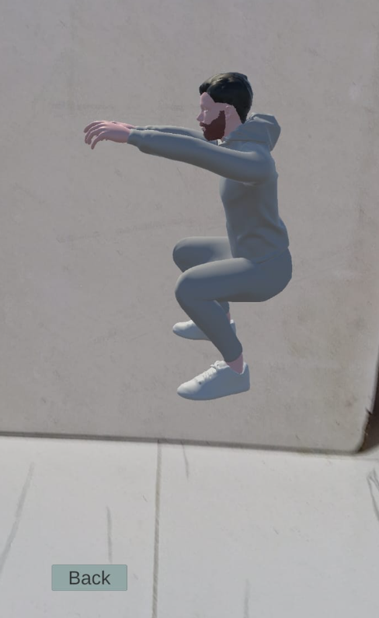

**Task 4: MMA Scene**

* We created one MMA page to demonstrate different punches and kicks
* All the process of creating this scene is same as Fitness scene

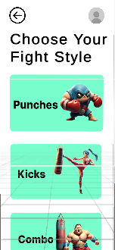

* After creating the MMA scene we then create 3 different buttons for Punches, Kicks and one for Combo
* We then created these 3 scenes and connect them with their respective buttons
* We created this scene same as we created Free Style scene and other exercise scenes
* Punch Scene

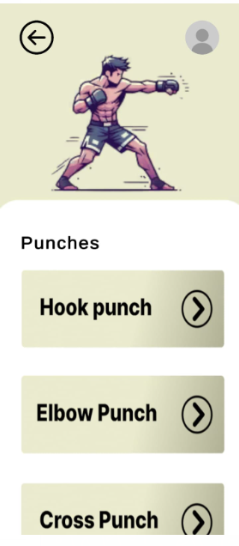

* Kicks Scene

* Combo Scene

* After all the UI work and connectivity complete, we added the camera scenes to display the 3D model
* This process is exact same as we did in fitness camera scene
* Same character but the animation is different and all animations are imported from mixamo

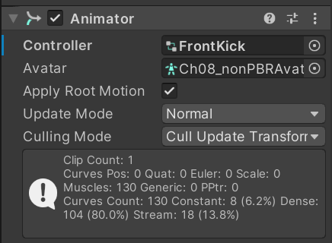

* Demo images of punches and Kicks

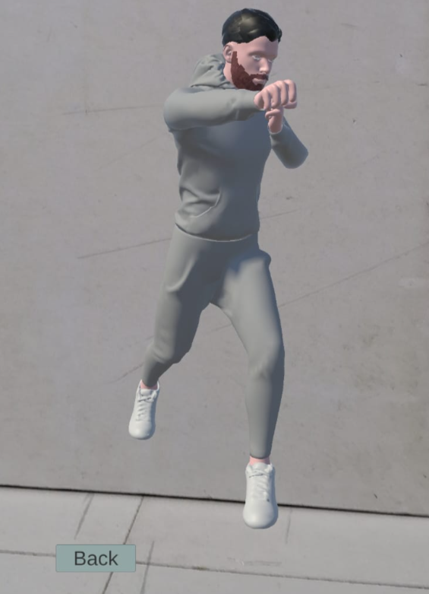

**Task 5: About Us Page**

* Our app’s final page About Us Page
* Just add normal information about our team members

* This is the last page of our app.