Name : Yash Kadam Batch:T13 Rollno : 52
EXPERIMENT 10

Aim
To create a Dockerfile for a Python Flask web application, build a Docker image, run a container, and implement multiple routes including dynamic routing, forms, calculator functionality, and a JSON API.

Theory
What is Docker?
Docker is a containerization platform that allows developers to package applications along with their dependencies into containers. Containers ensure that the application runs consistently across different environments.

What is a Dockerfile?
A Dockerfile is a text file containing instructions that Docker uses to build an image. Each instruction creates a new layer in the image.
Basic syntax: DIRECTIVE argument
Common directives:
- FROM

- WORKDIR

- RUN

- COPY

- ENV

- CMD

What is Flask?
Flask is a lightweight Python web framework used to build web applications and APIs.

Implementation

Step 1: Create Project Directory
Open Command Prompt and create a new folder:
mkdir flask-docker-app cd flask-docker-app

Step 2: Create Flask Application (app.py)
Create a file named:
app.py
Add the following code:
from flask import Flask, request, jsonify

app = Flask(__name__)

@app.route('/') def home(): return """
<h1>🚀 Welcome to My Advanced Docker Flask App</h1>
<ul>
<li><a href="/hello/Student">Dynamic Hello</a></li>
<li><a href="/calculator">Calculator</a></li>
<li><a href="/form">Form</a></li>
<li><a href="/api/data">JSON API</a></li>
</ul>
"""

@app.route('/hello/<name>') def hello(name):
return f"<h2>Hello, {name}!</h2>"

@app.route('/calculator', methods=['GET', 'POST']) def calculator(): if request.method == 'POST':
num1 = float(request.form['num1']) num2 = float(request.form['num2']) result = num1 + num2 return f"<h2>Result: {result}</h2>"

return """
<form method="POST">
Number 1: <input type="number" name="num1"><br><br>
Number 2: <input type="number" name="num2"><br><br>
<input type="submit" value="Add">
</form>
"""

@app.route('/form', methods=['GET', 'POST']) def form():
if request.method == 'POST':
username = request.form['username'] return f"<h2>Welcome, {username}!</h2>"

return """
<form method="POST">
Enter Name: <input type="text" name="username">
<input type="submit" value="Submit">
</form>
"""

@app.route('/api/data') def api_data(): return jsonify({
"message": "Dockerized Flask App",
"status": "success"
})

if __name__ == '__main__':
app.run(host='0.0.0.0', port=5000)
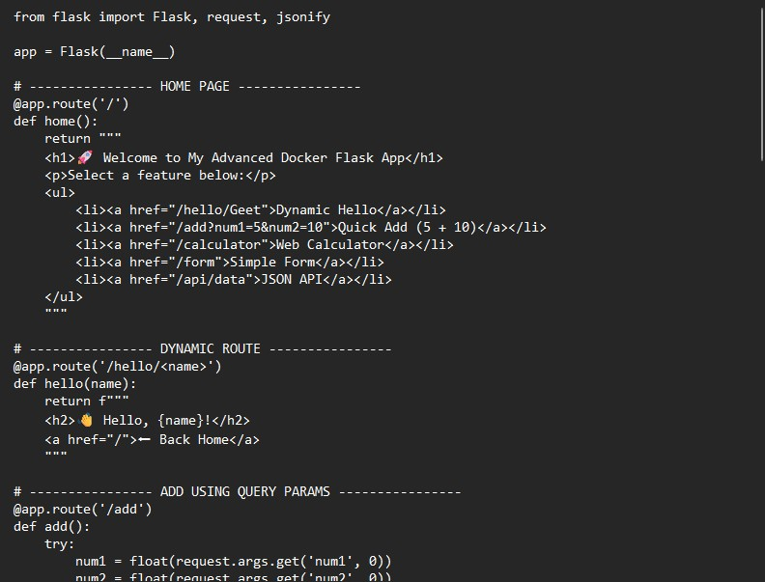

Step 3: Create Dockerfile
Create a file named:
Dockerfile
Add:
FROM python:3.11-slim

WORKDIR /app

RUN pip install flask==2.3

COPY . /app

ENV FLASK_APP=app.py

CMD ["flask", "run", "--host=0.0.0.0", "--port=5000"]

Step 4: Create .dockerignore File
Create file: .dockerignore Add:
Dockerfile
__pycache__

Step 5: Build Docker Image
Run: docker build -t sample-flask-app:v1 .
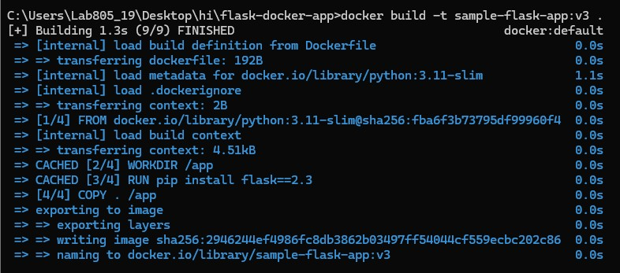

Step 6: Verify Image Creation
docker images

Step 7: Run Docker Container
docker run -d -p 5000:5000 sample-flask-app:v1
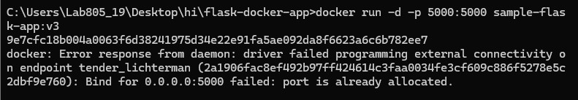

Step 8: Verify Running Container
docker ps
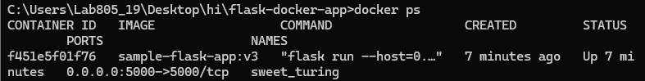

Step 9: Test Application in Browser
Open:
http://localhost:5000
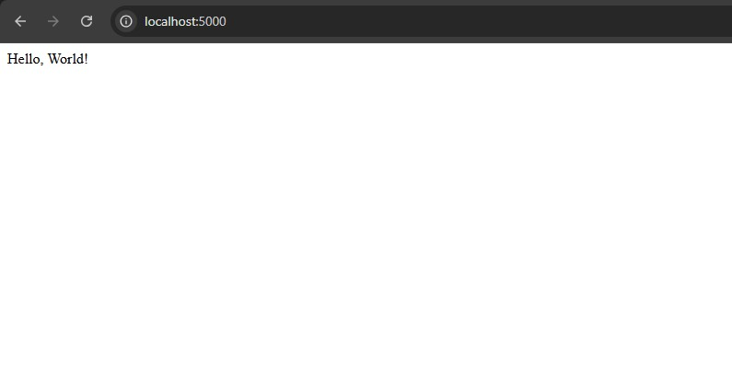
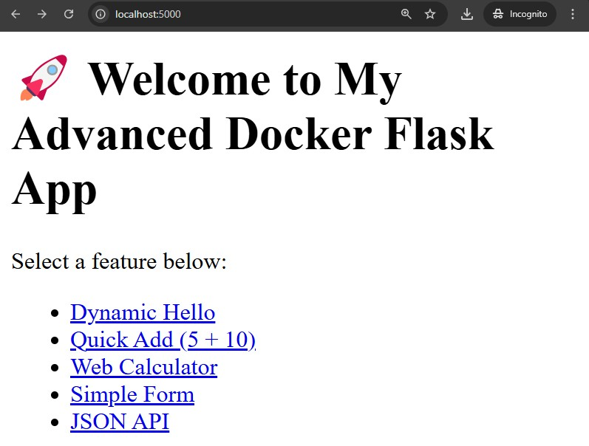
Test additional routes:
http://localhost:5000/hello/YourName
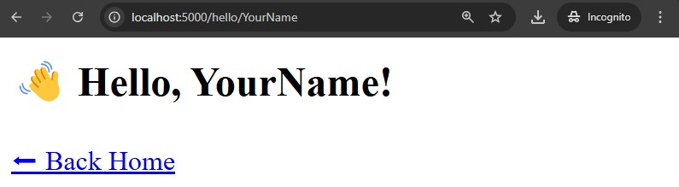
http://localhost:5000/calculator
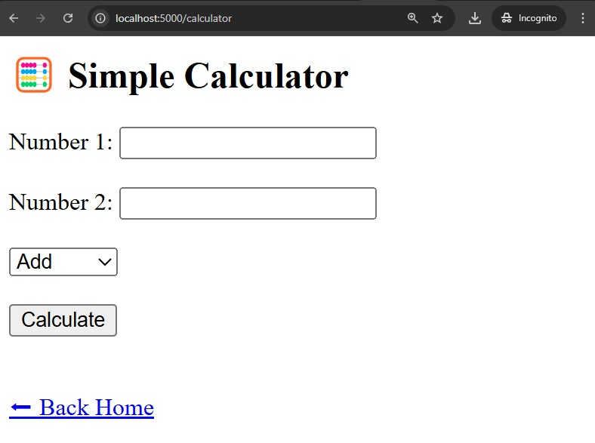
http://localhost:5000/api/data
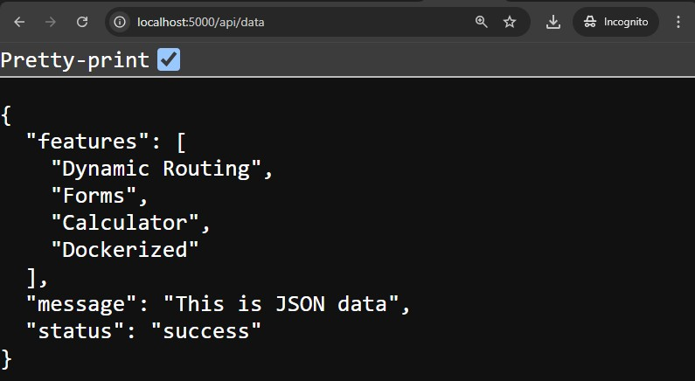

Output
The Flask application was successfully containerized using Docker.
The Docker image was built and the container was executed.
All routes including dynamic routing, form submission, calculator functionality, and JSON API were tested successfully.

Conclusion
In this experiment, we:
- Learned Dockerfile instructions

- Built a Docker image

- Created and ran a Docker container

- Implemented multiple Flask routes

- Tested the web application in a browser

The experiment demonstrates practical implementation of Docker with a Python Flask web application.

