**Sonar Cloud**

Login Into Sonar Cloud using GITHUB

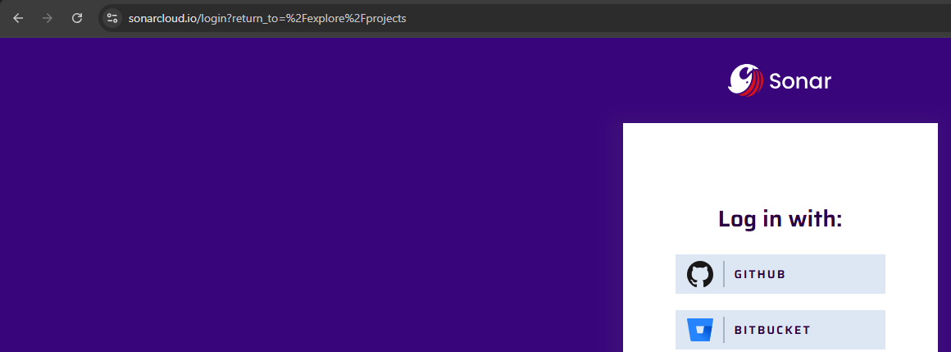

Analyse New Project

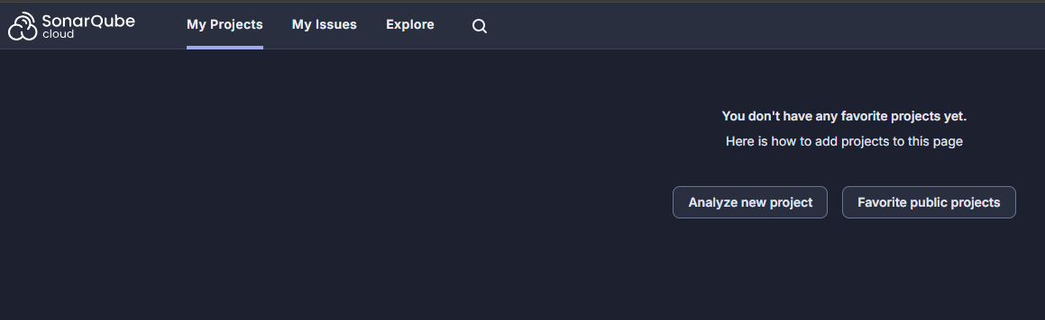

Import from your GIT HUB

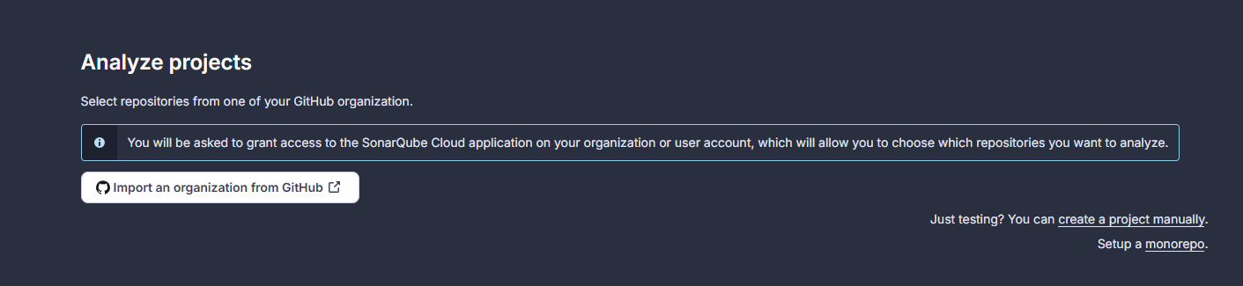

Give Organization Name and Select Free Version

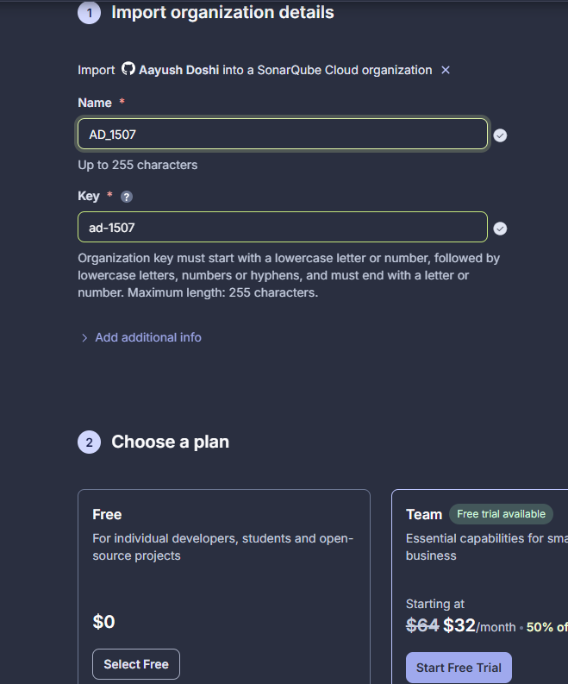

Analyze New Project

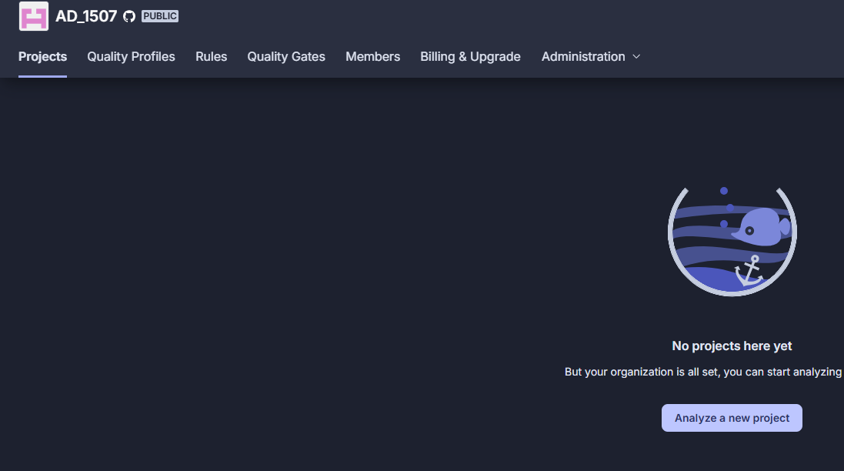

Go to Git Hub and Click on New to Create a New repository

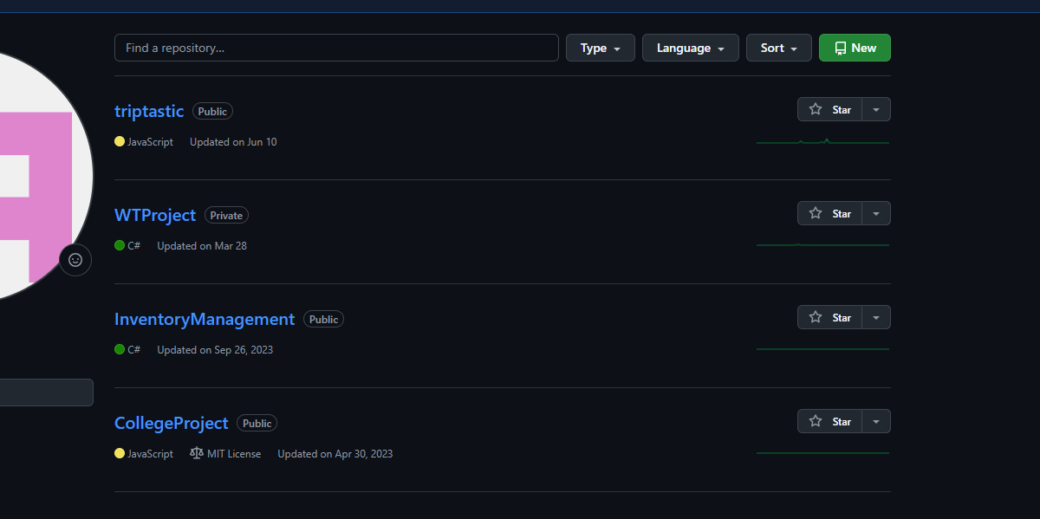

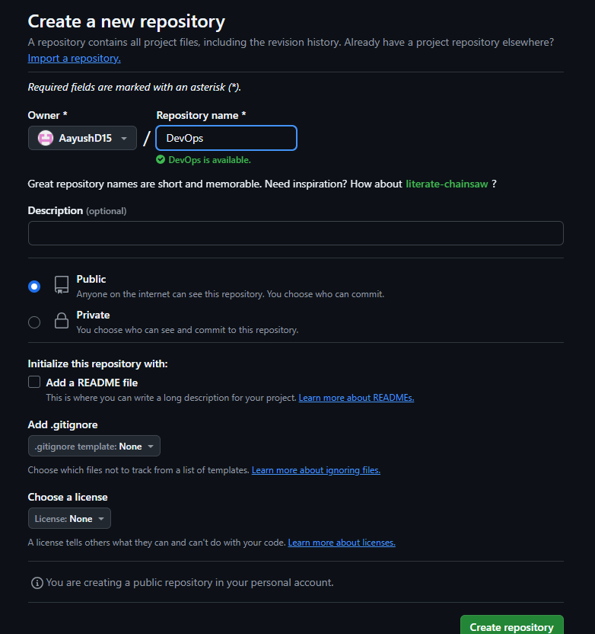

Add a new File from Add File Option on Top Right Cor

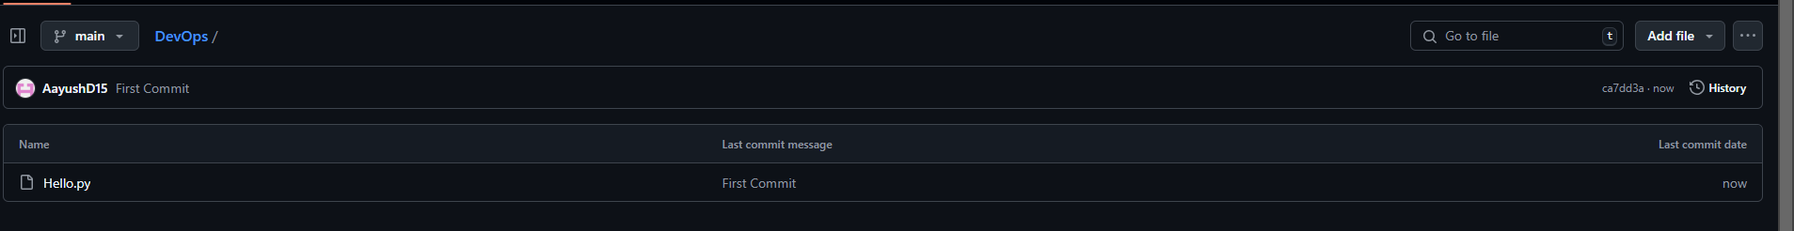

In the Root Directory create a normal python file

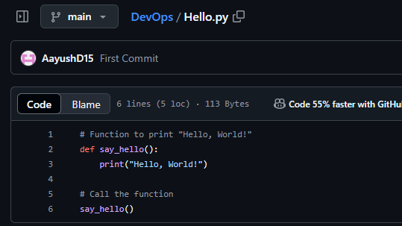

Click on the Repository in Sonar Cloud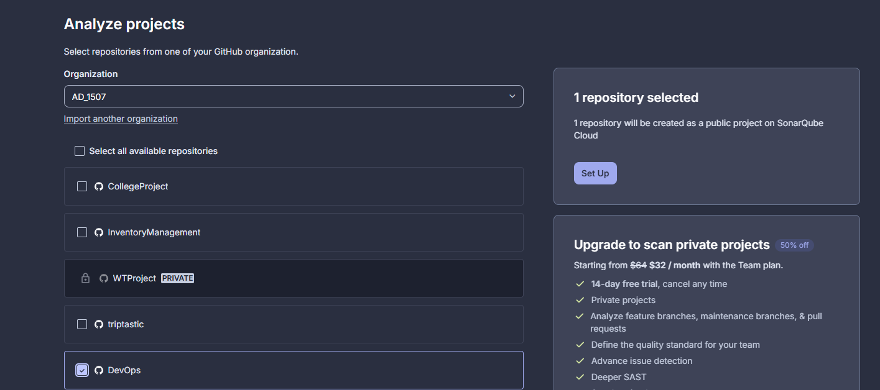

In the Left Hand Panel click on Administration and click on Analysis Method and Click on

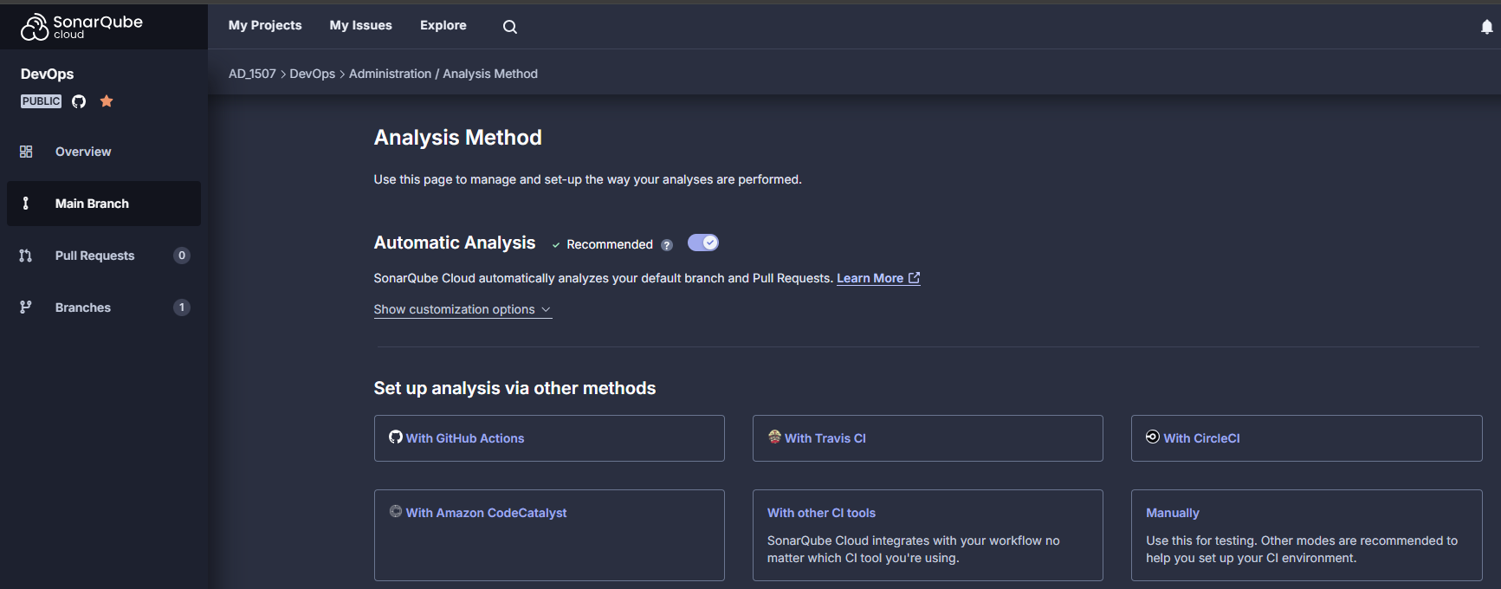

Copy the Name: **SONAR_TOKEN** and Token and click on Python on 3rd Step

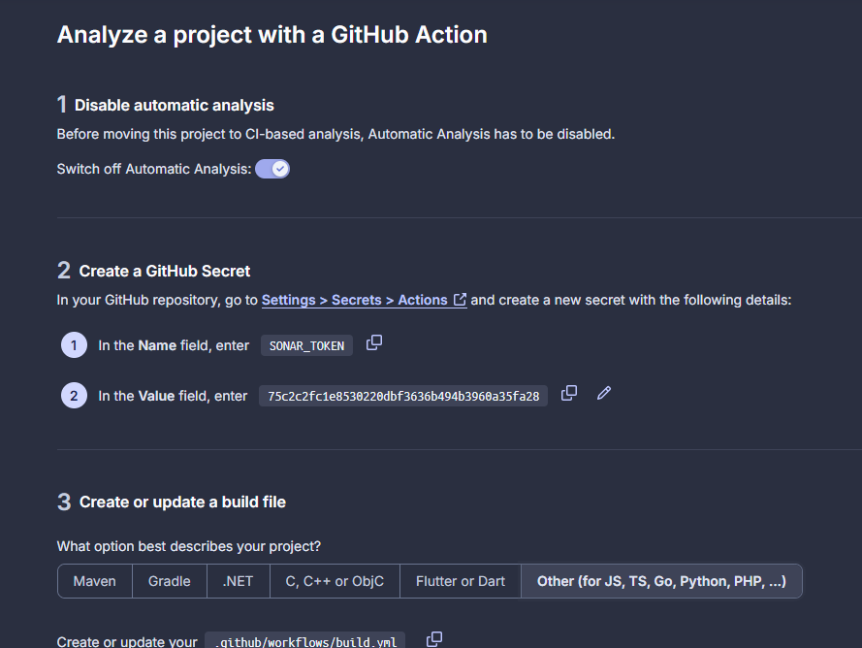

Create a file in Github Repository and name should be 🡪 **.github/workflows/build.yml**

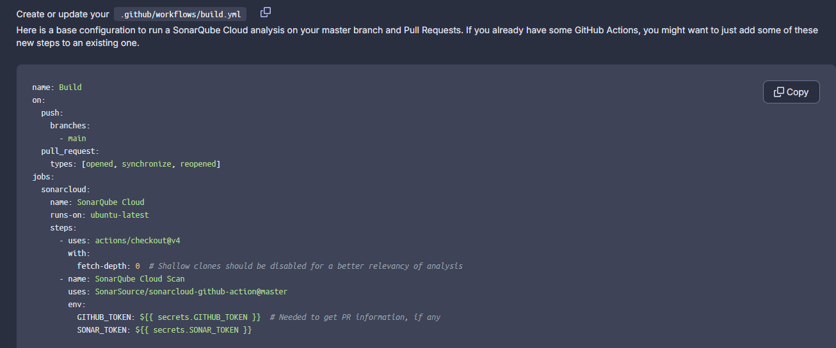

Create Another File with name 🡪 **sonar-project.properties**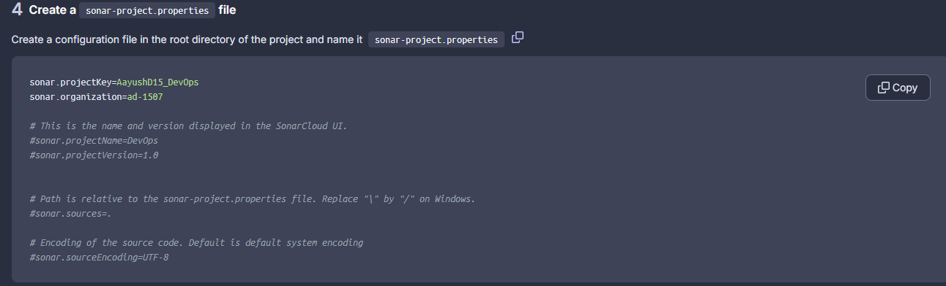

In Git Hub Repository

Go to Settings🡪 Secrets and Variables 🡪 Actions

Copy the Name and Value here

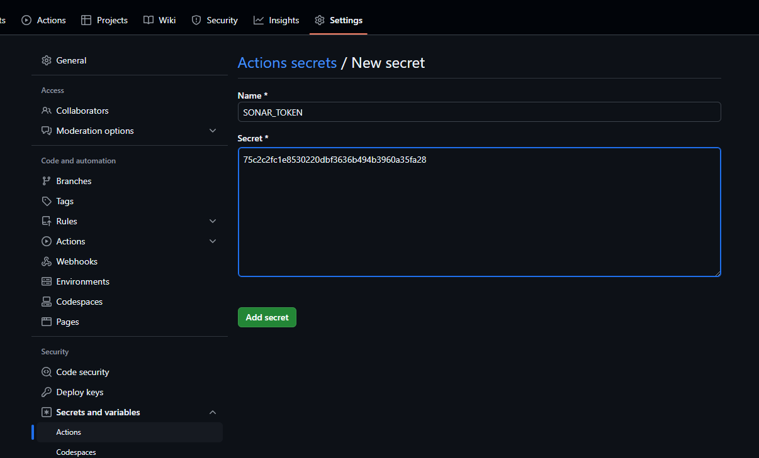

**Terraform**

* **Command**

docker-compose run terraform init

docker-compose run terraform plan

docker-compose run terraform apply -auto-approve

* **Create Main.TF file in a Directory**

# Configure the Docker provider

terraform {

required_providers {

docker = {

source = "kreuzwerker/docker"

version = "~> 2.0"

}

}

}

provider "docker" {

host = "unix:///var/run/docker.sock"

}

# Pull Nginx image from DockerHub

resource "docker_image" "nginx" {

name = "nginx:latest"

keep_locally = false

}

# Create an Nginx container

resource "docker_container" "nginx" {

image = docker_image.nginx.image_id

name = "Devops_Final_Exam"

ports {

internal = 80

external = 8088

}

}

* **docker-compose.yml**

version: '3.8'

services:

  terraform:

    image: hashicorp/terraform:latest

    container_name: terraform

    volumes:

      - E:/Aayush/DevOps/Terraform:/workspace  *# Adjust this path based on your local directory*

      - /var/run/docker.sock:/var/run/docker.sock  *# This allows Terraform to interact with Docker*

    working_dir: /workspace

    entrypoint: ["terraform"]

    command: ["init"]  *# Default command (can be overridden)*

* **Output**

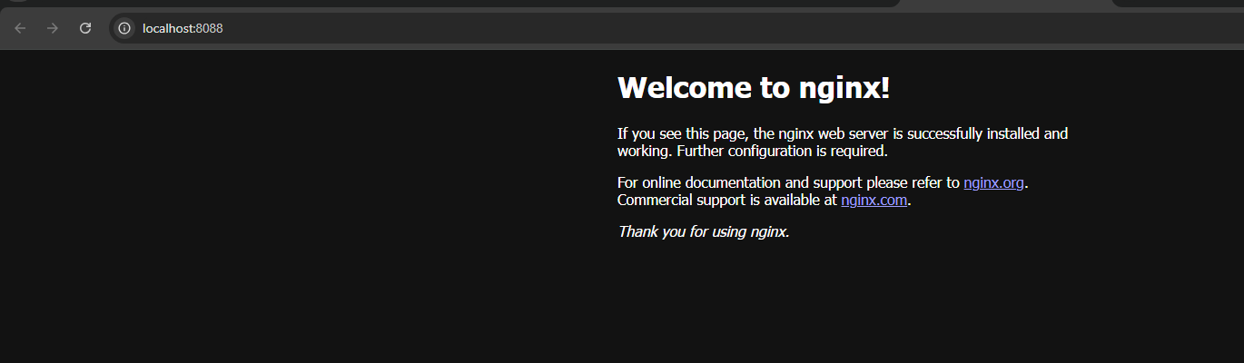

**Docker**

Index.html

<!DOCTYPE html>

<html>

<head>

    <title>Final Examination</title>

</head>

<body>

    <h1>Docker Question</h1>

    <p>MCA Final Examnination </p>

</body>

</html>

dockerfile

*# Use the official Nginx image*

FROM nginx:alpine

*# Copy the index.html to the appropriate directory in the container*

COPY index.html /usr/share/nginx/html/index.html

*# Expose port 80 to access the web page*

EXPOSE 8080

**Commands**

**Create Image**

* docker build -t firstimage .

**Create Container and Run Image**

* docker run -d -p 8080:80 firstimage

**Output**

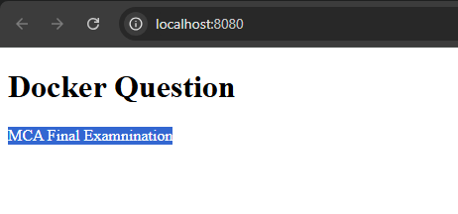

**Kubernetes**

For Nginx Image

Deployment.yaml

apiVersion: apps/v1

kind: Deployment

metadata:

  name: public-deployment

spec:

  replicas: 2  *# Start with 2 replicas*

  selector:

    matchLabels:

      app: nginx

  template:

    metadata:

      labels:

        app: nginx

    spec:

      containers:

        - name: nginx

          image: nginx:latest  *# Public Nginx image*

          ports:

            - containerPort: 80

Service.yaml

apiVersion: v1

kind: Service

metadata:

  name: public-service

spec:

  selector:

    app: nginx

  ports:

    - protocol: TCP

      port: 80  *# Exposing port 80 externally*

      targetPort: 80  *# Port inside the container*

  type: NodePort  *# Use NodePort for local access*

**Commands**

* kubectl apply -f Deployment.yaml
* kubectl apply -f Service.yaml
* kubectl get deployments
* kubectl get services

Forward the Port in Rancher Desktop

**Output**

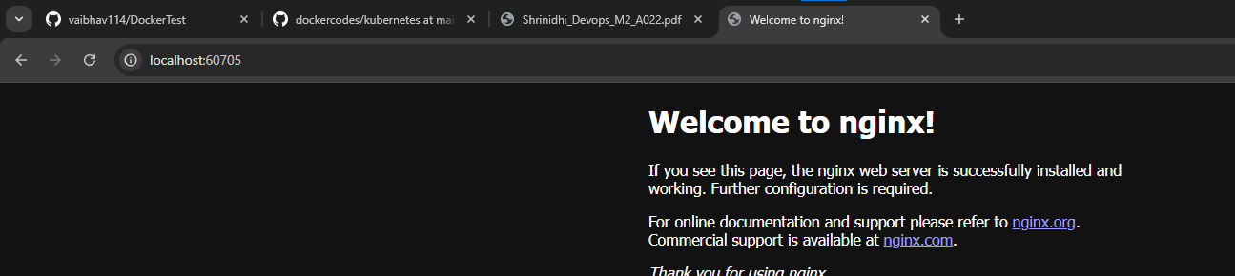

For Custom Image

dockerfile

*# Use the official Nginx image*

FROM nginx:alpine

*# Copy the index.html to the appropriate directory in the container*

COPY index.html /usr/share/nginx/html/index.html

*# Expose port 80 to access the web page*

EXPOSE 8080

Index.html

<!DOCTYPE html>

<html>

<head>

    <title>Final Examination</title>

</head>

<body>

    <h1>Docker Question</h1>

    <p>MCA Final Examnination </p>

</body>

</html>

Deployment.yaml

apiVersion: apps/v1

kind: Deployment

metadata:

  name: custom-deployment

spec:

  replicas: 2  *# Initial number of replicas*

  selector:

    matchLabels:

      app: nginx

  template:

    metadata:

      labels:

        app: nginx

    spec:

      containers:

        - name: nginx

          image: aayush1507/secondimage:latest

          ports:

            - containerPort: 80

Service.yaml

apiVersion: v1

kind: Service

metadata:

  name: custom-service

spec:

  selector:

    app: nginx

  ports:

    - protocol: TCP

      port: 80  *# Exposing port 80*

      targetPort: 80  *# Inside the container*

  type: NodePort    *# Or you can use NodePort if LoadBalancer isn't available*

Commands

* docker login
* docker build -t aayush1507/secondimage:latest .
* docker push aayush1507/secondimage:latest
* kubectl apply -f Deployment.yaml
* kubectl apply -f Service.yaml
* kubectl get services
* kubectl get deployments

Output

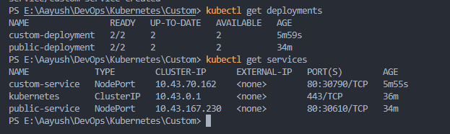

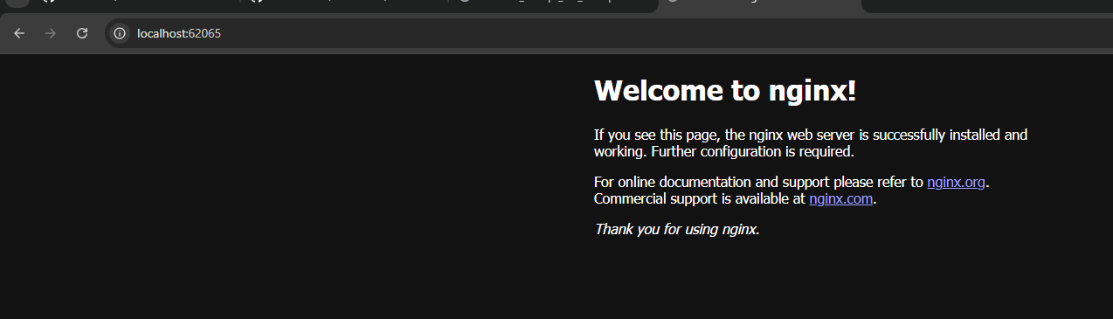

**Jenkins**

Create a Project Directory

**Jenkins**

Inside Project Directory

Create a Folder **jenkins**

Just like below

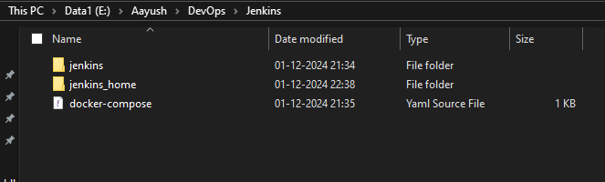

Create docker-compose.yml

version: '3.8'

services:

  jenkins:

    build:

      context: ./jenkins  *# This is where your Jenkins-specific Dockerfile is located*

      dockerfile: Dockerfile  *# This references the Dockerfile inside the jenkins folder*

    privileged: true

    user: root

    ports:

      - "8083:8080"

      - "50000:50000"

    container_name: jenkins

    volumes:

      - E:/Aayush/DevOps/Jenkins/jenkins_home:/var/jenkins_home

      - /var/run/docker.sock:/var/run/docker.sock

    networks:

      - jenkins-net

networks:

  jenkins-net:

    driver: bridge

volumes:

  jenkins_home:

**inside the jenkins folder create a dockerfile**

FROM jenkins/jenkins:lts

USER root

*# Install Docker CLI and dependencies*

RUN apt-get update && \

    apt-get -y install \

    apt-transport-https \

    ca-certificates \

    curl \

    gnupg2 \

    software-properties-common && \

    curl -fsSL https://download.docker.com/linux/debian/gpg | apt-key add - && \

    add-apt-repository \

    "deb [arch=amd64] https://download.docker.com/linux/debian \

    $(lsb_release -cs) \

    stable" && \

    apt-get update && \

    apt-get -y install docker.io

*# Switch back to jenkins user*

USER jenkins

**Folder Structure**

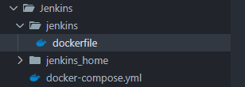

**Command**

Run the below command in both the Root Directory and jenkins directory

**docker-compose up --build -d**

Once Executed the above command

The below URL will be Jenkins URL

[**http://localhost:8083/**](http://localhost:8083/)

To Login it will ask for initialpassword it will be in

**Jenkins_home 🡪 secrets 🡪 initialAdminPassword**

Once logged in click on Manage Jenkins on Left Hand Side

Click on Plugin

Search Docker and select below and install

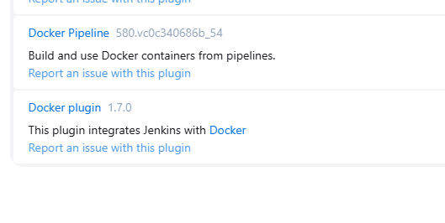

Go to Dashboard 🡪 New Items

Give a Name and Select Pipeline

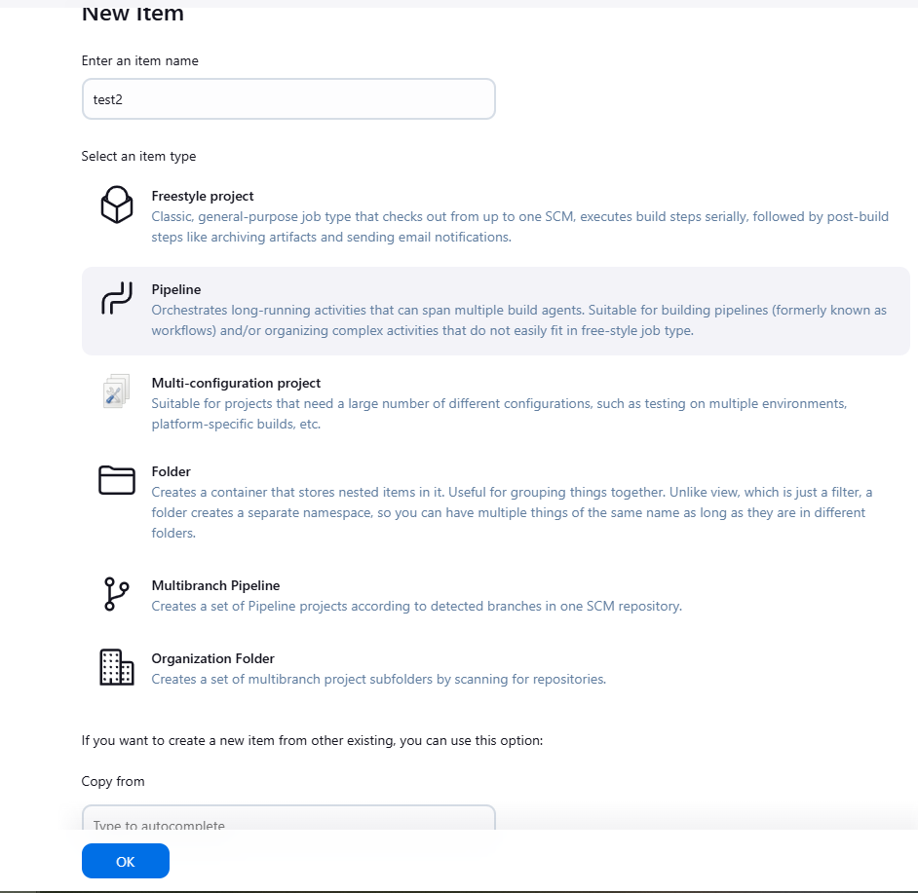

In the Script Section paste the below script and click on Save

**pipeline {**

**agent any**

**environment {**

**DOCKER_IMAGE = 'nginx'**

**CONTAINER_NAME = 'nginx-container'**

**}**

**stages {**

**stage('Pull Nginx Docker Image') {**

**steps {**

**script {**

**// Pull the Nginx image from Docker Hub**

**sh 'docker pull $DOCKER_IMAGE'**

**}**

**}**

**}**

**stage('Run Docker Container') {**

**steps {**

**script {**

**// Run the Nginx container on port 8080**

**sh 'docker run -d --name $CONTAINER_NAME -p 8080:80 $DOCKER_IMAGE'**

**}**

**}**

**}**

**}**

**post {**

**always {**

**echo 'Pipeline finished.'**

**}**

**success {**

**echo 'Deployment succeeded.'**

**}**

**failure {**

**echo 'Deployment failed.'**

**}**

**}**

**}**

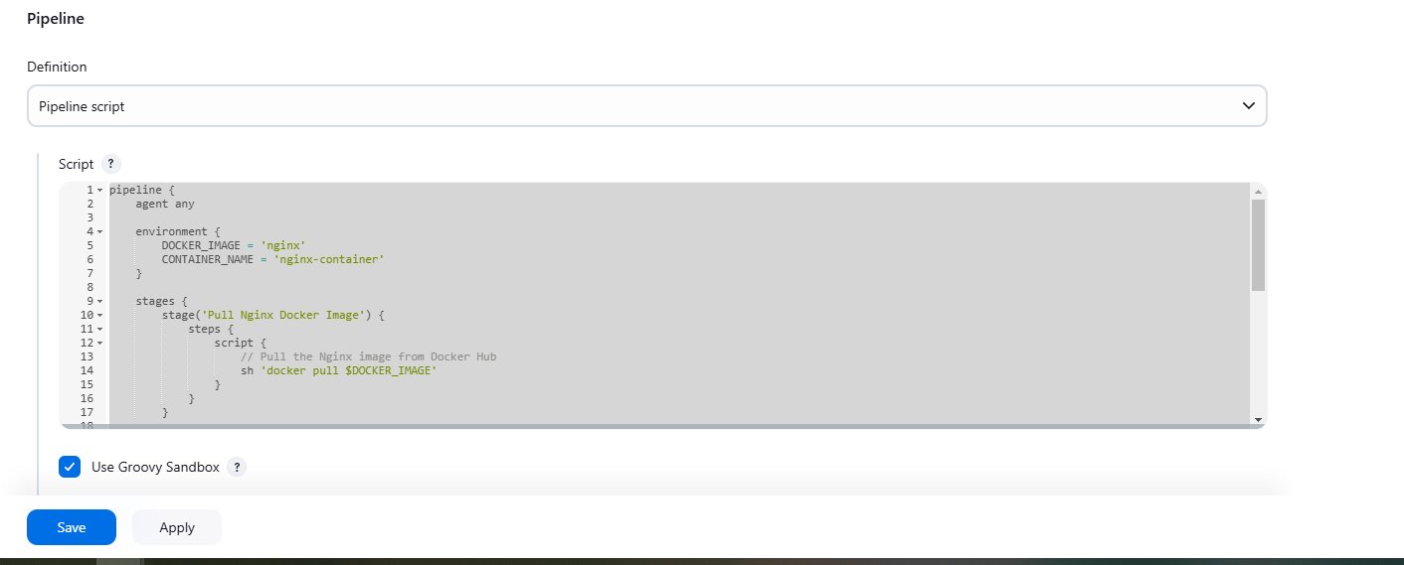

**Click on Build Now**

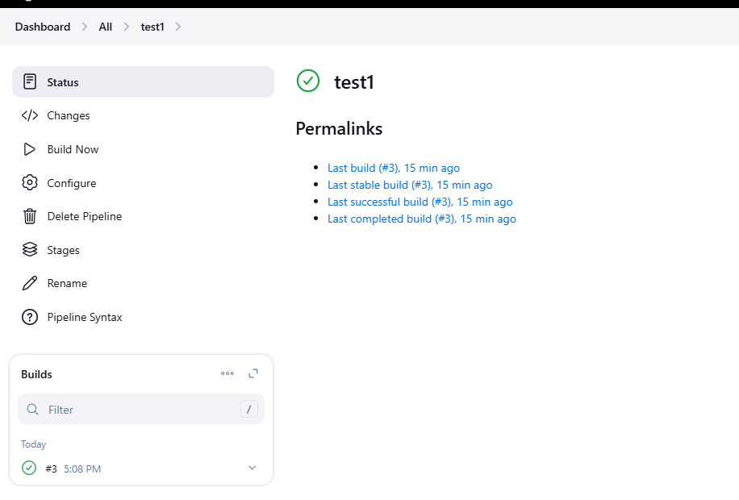

**In the Docker Desktop**

**The below container will be created**



**Output**

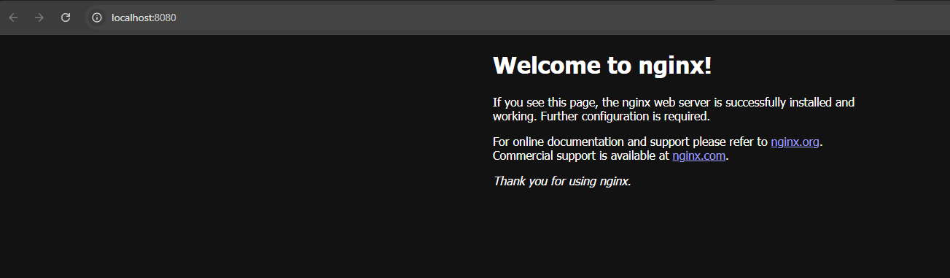

**Ansible**

Commands

**docker-compose up --build -d**

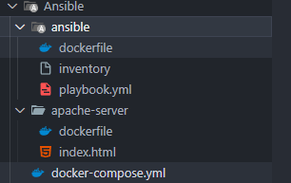

Ansible 🡪 dockerfile

*# ansible/Dockerfile*

FROM ubuntu:20.04

*# Install Ansible and SSH client for remote communication*

RUN apt-get update && \

    apt-get install -y ansible sshpass python3-pip && \

    apt-get clean

*# Install necessary Ansible dependencies*

RUN pip3 install ansible

*# Set working directory*

WORKDIR /ansible

*# Copy the playbook and inventory into the container*

COPY playbook.yml /ansible/playbook.yml

*# Entry point for Ansible to run the playbook*

CMD ["ansible-playbook", "/ansible/playbook.yml", "-i", "inventory"]

Playbook.yml

*# ansible/playbook.yml*

---

- name: Install Apache and ensure it is running

  hosts: apache-server

  become: true

  tasks:

    - name: Install Apache

      apt:

        name: apache2

        state: present

        update_cache: yes

    - name: Start Apache service

      service:

        name: apache2

        state: started

        enabled: yes

**inventory**

[apache-server]

apache-server ansible_host=apache-server ansible_port=22

[apache-server:vars]

ansible_ssh_user=root

ansible_ssh_pass=password

**apache-server 🡪 dockerfile**

FROM ubuntu:20.04

*# Minimize layer creation and reduce build time*

RUN set -xe \

    && apt-get update \

    && DEBIAN_FRONTEND=noninteractive apt-get install -y --no-install-recommends \

        apache2 \

        openssh-server \

    && rm -rf /var/lib/apt/lists/* \

    && mkdir /var/run/sshd \

    && echo 'root:password' | chpasswd \

    && sed -i 's/^PermitRootLogin prohibit-password/PermitRootLogin yes/' /etc/ssh/sshd_config

*# Expose Apache and SSH ports*

EXPOSE 80 22

*# Create a basic index.html for Apache*

COPY index.html /var/www/html/index.html

*# Start SSH and Apache in the background and keep the container running*

CMD service ssh start && apache2ctl -D FOREGROUND

**Index.html**

*<!-- apache-server/index.html -->*

<html>

  <head>

    <title>Apache Server</title>

  </head>

  <body>

    <h1>Welcome to Apache!</h1>

  </body>

</html>

**docker-compose.yml**

*# docker-compose.yml*

version: '3.8'

services:

  apache-server:

    build: ./apache-server

    container_name: apache-server

    ports:

      - "8085:80"

    networks:

      - app-network

  ansible:

    build: ./ansible

    container_name: ansible-container

    depends_on:

      - apache-server

    networks:

      - app-network

networks:

  app-network:

    driver: bridge

**Once ran the command**

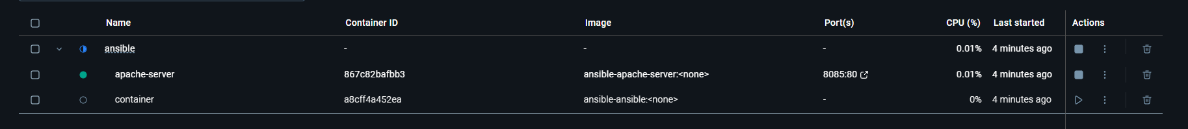

**Output**

