**Lab 2**

**Name:** Satya Yaswanth Kalla **Summer 2023. CIS 5765**

**Name your submission file as LastNameFirstName-Lab2.docx.**

(1) Create a Cosmo DB instance and the resource summary screenshot.

**Ans:**

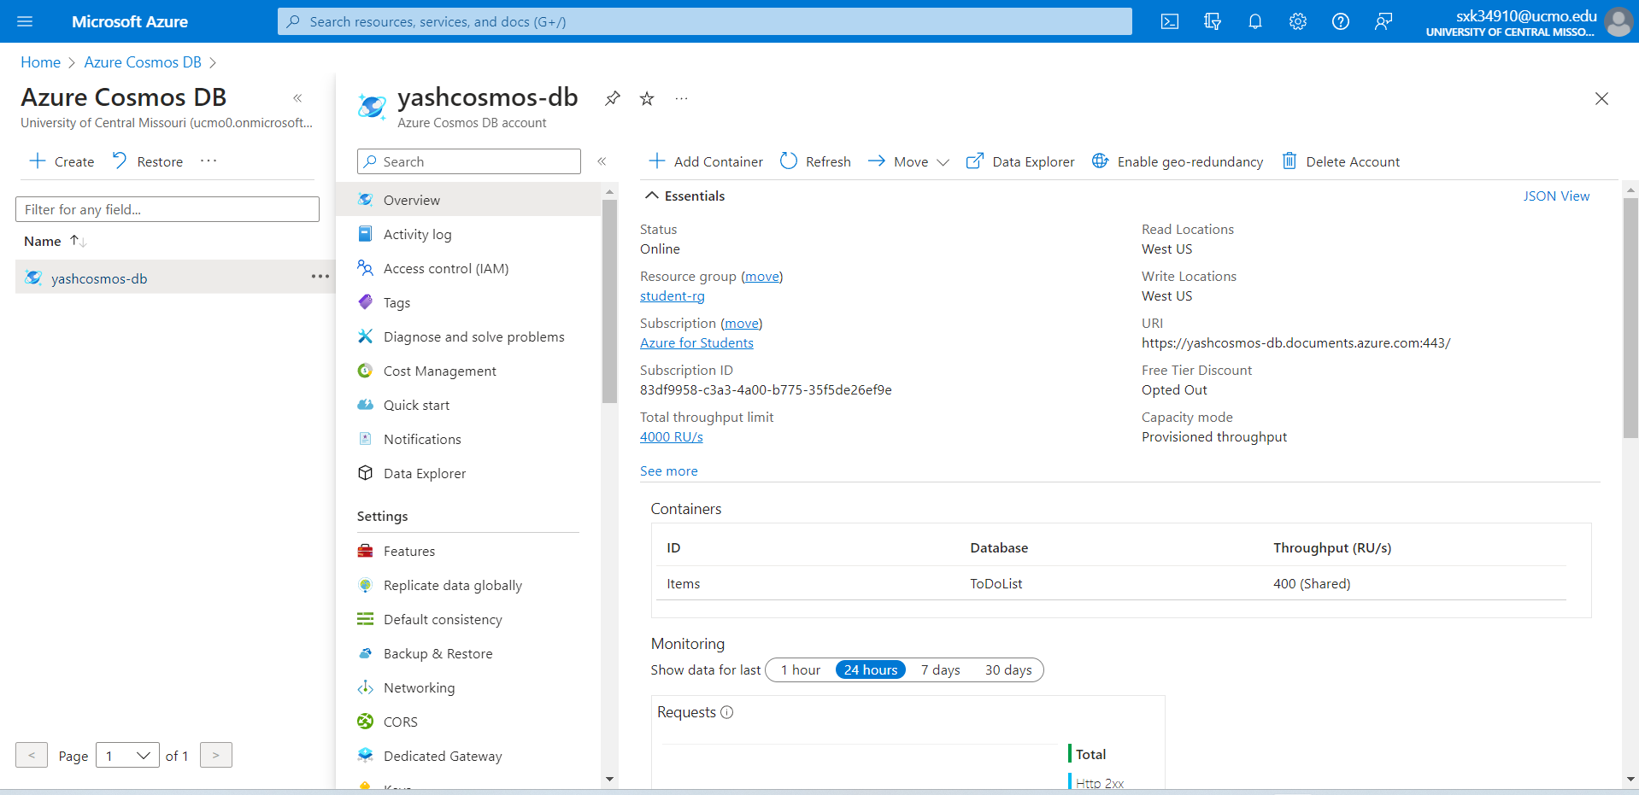

(2) Identify the resource group in which the DB instance is placed.

**Ans: DB is placed in student-rg**

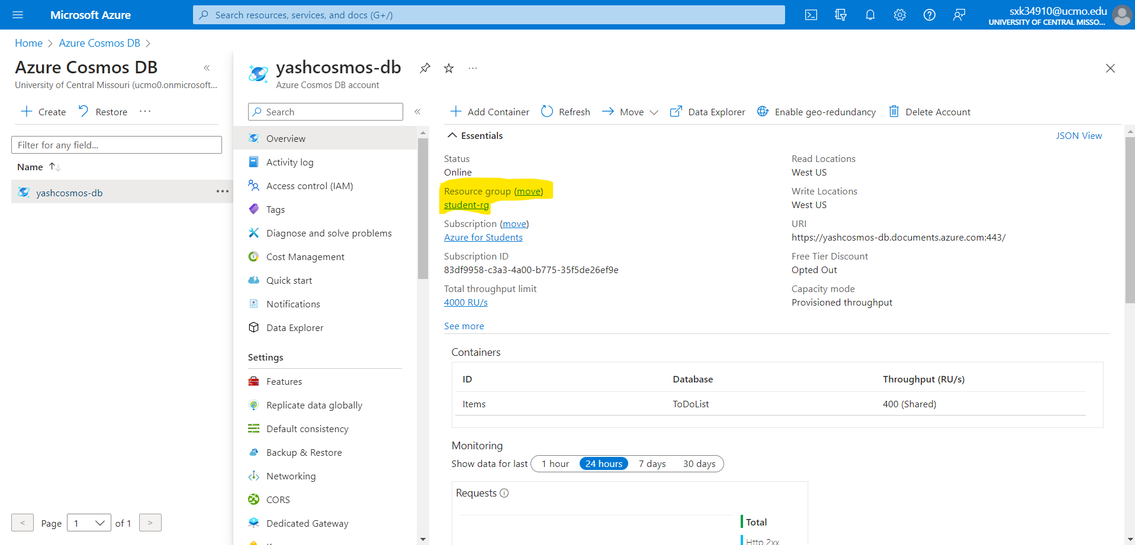

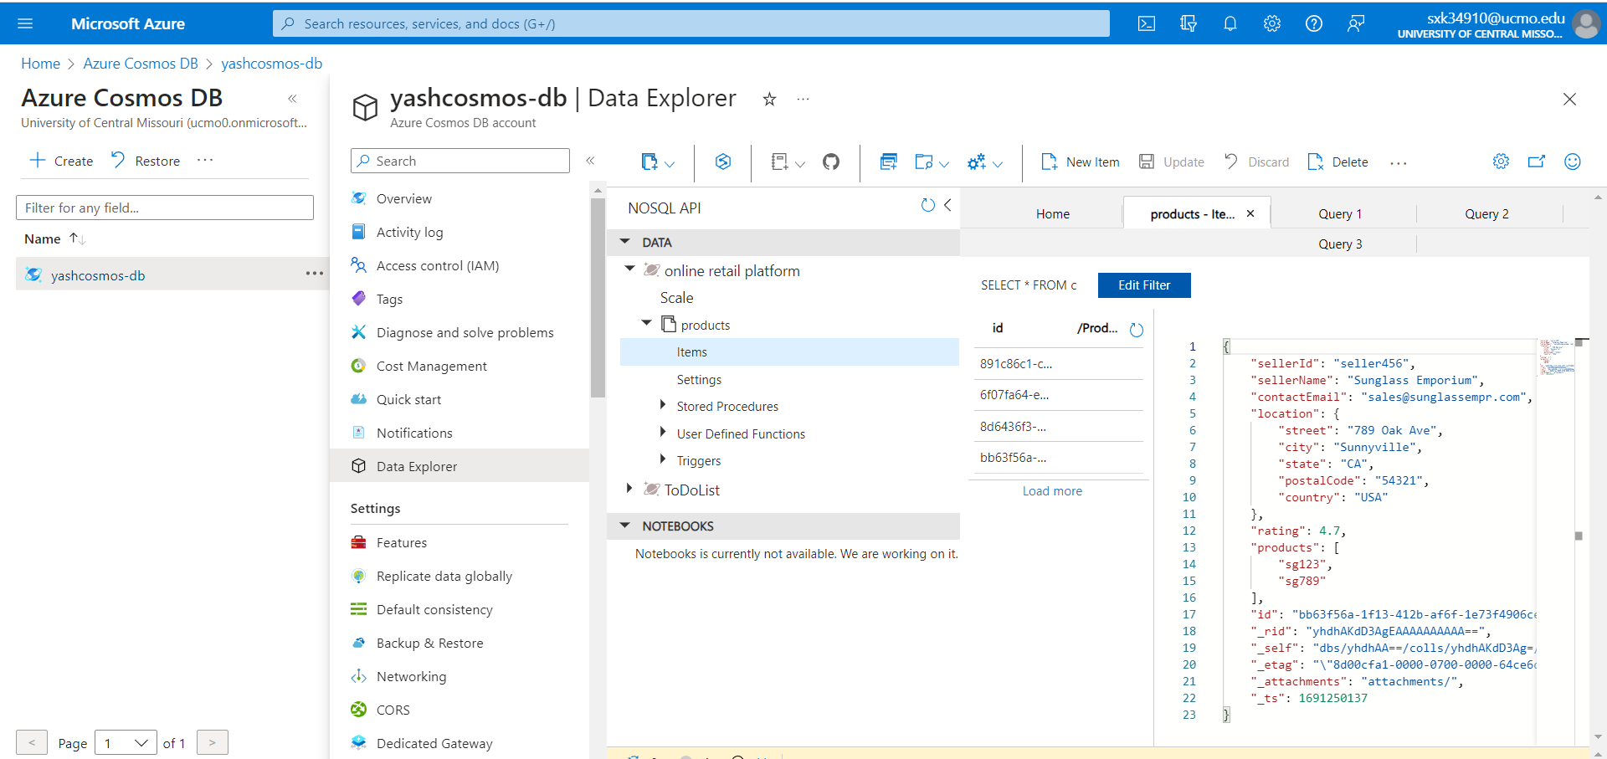

(3) Create a NoSQL database for online retail platform where different sellers can list their products and customers can buy the listed products. List a fragment of features needed for this application that you think you can implement using document data type NoSQL.

**Ans:**

**Product listing:**

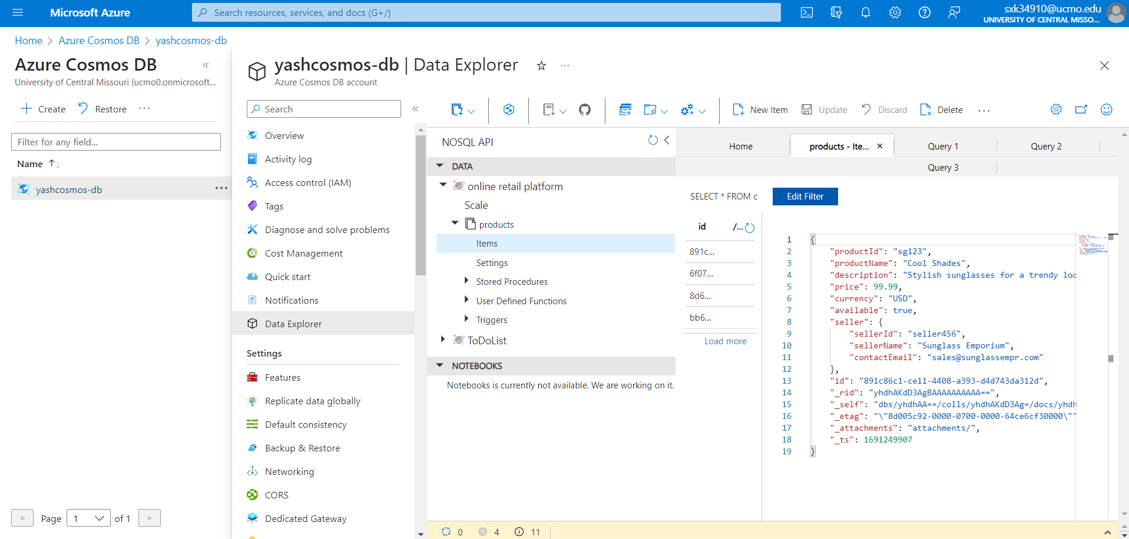

Customer Details:

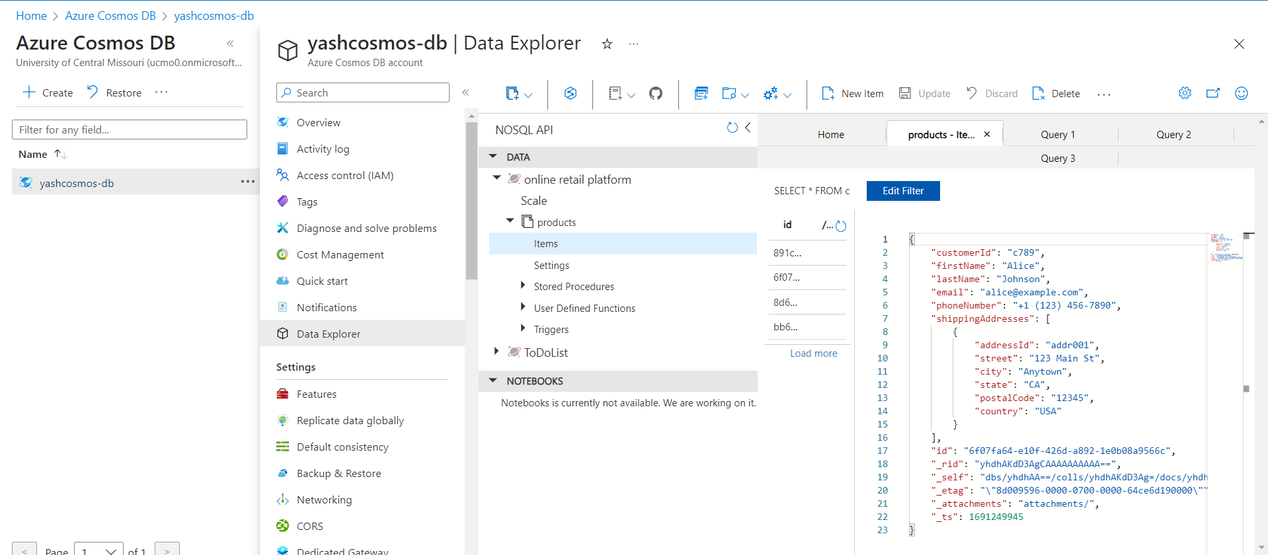

Order Details:

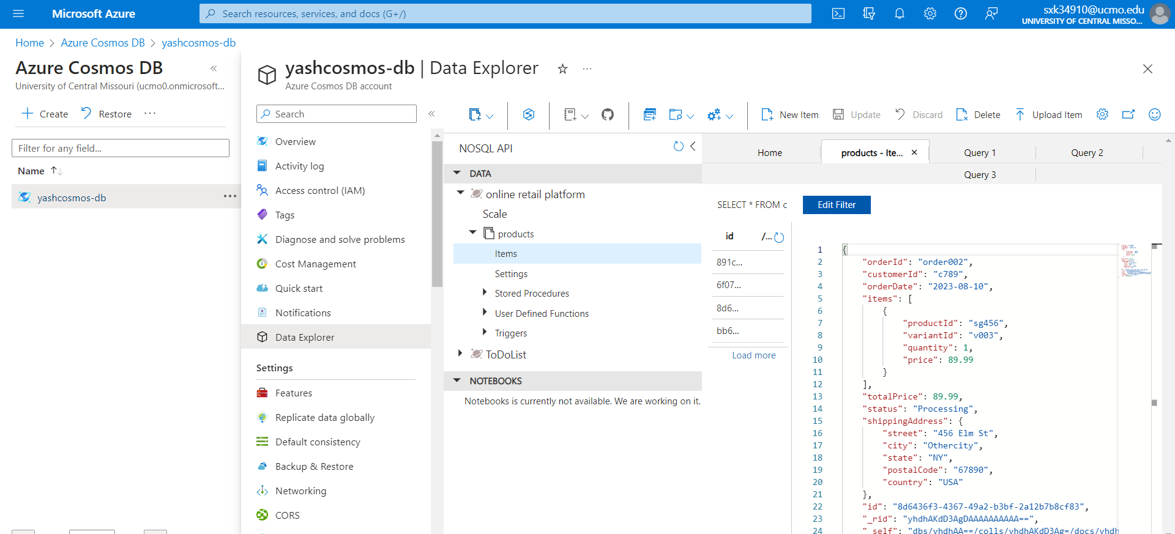

Seller Details:

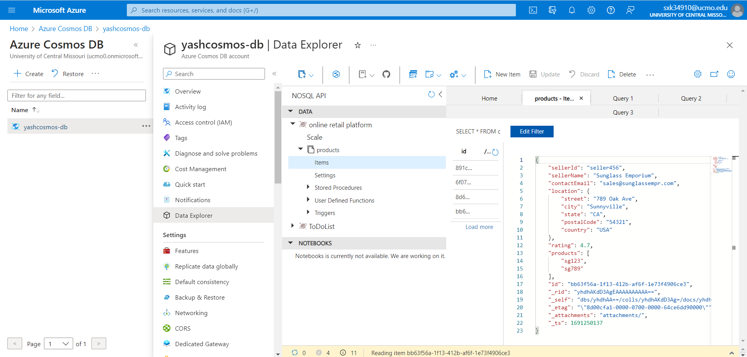

(4) For each identified feature in step 3, provide a demo with four business questions and their corresponding query.

**Ans:**

Question1: How to find the seller?

Query: SELECT * FROM products p WHERE p.seller.sellerId = 'seller456'

Output Screen:

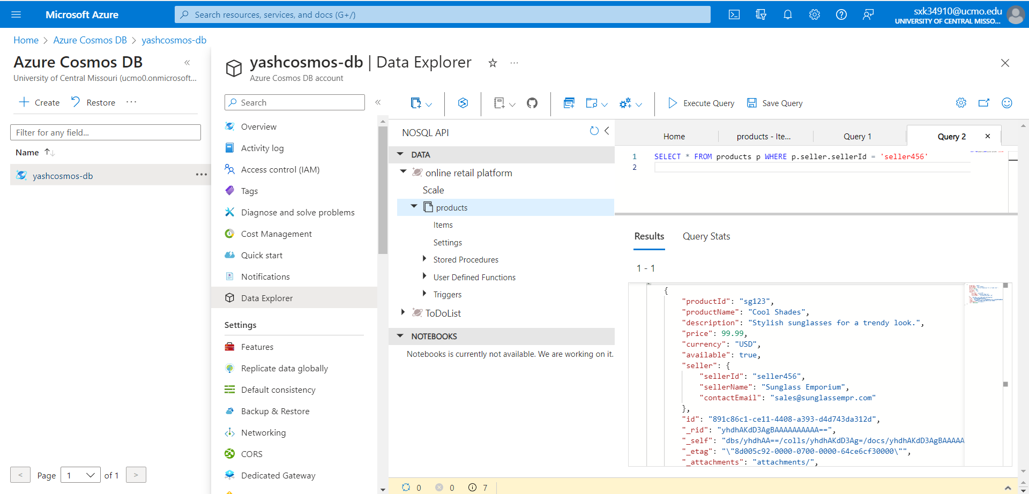

Question 2: How to Retrieve Available Sunglasses Under a Price Limit?

Query: SELECT * FROM products p

WHERE p.available = true AND p.price < 100.00

Output:

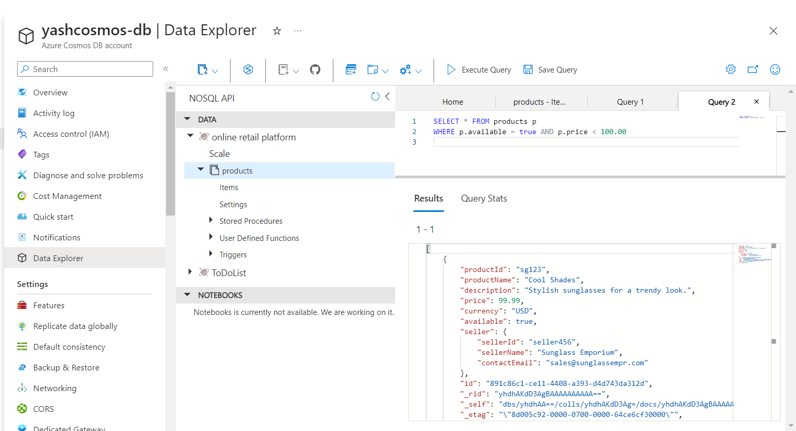

Question 3:

How to find customer name ?

Query : SELECT c.firstName, c.lastName

FROM customers c

WHERE c.customerId = 'c789'

Output:

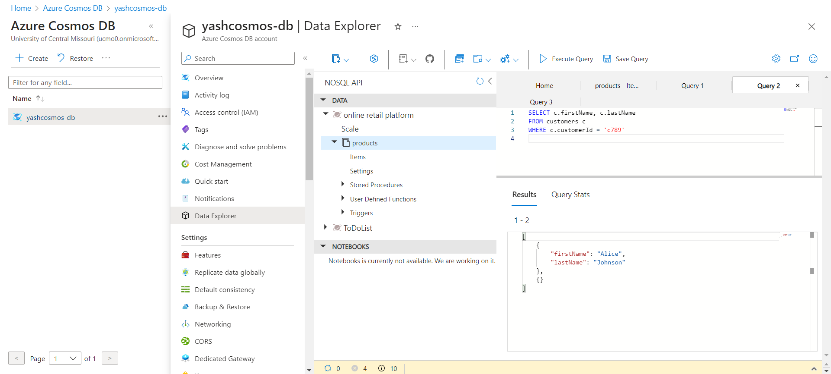

Question 4:

How to find customer address ?

Query:

SELECT VALUE addr

FROM customers c

JOIN addr IN c.shippingAddresses

WHERE c.customerId = 'c789' AND addr.addressId = 'addr001'

Output:

