**Lab 1** Points =50

**Name:** Satya Yaswanth Kalla **Summer 2023. CIS 5765**

**Name your submission file as CRN#- # Lab1.docx.**

**Replace the first # with your course CRN number and second # with your name and keep the rest of them unchanged.**

1. Create a virtual machine and setup a web server for a made-up business company.

Make the following choices on your own and write them below.

1. Operating system: ______Windows 10_______
2. Webserver: ____Windows Server_________
3. Create a simple HTML webpage with the company name, a welcome message and your name. Host the webpage in the webserver.

Make the following choices on your own and write them below.

1. Name and address of the company: ____Planet Earth__________
2. Welcome message (a sentence or two): __Welcome to Yash Sec Solutions_________
3. Show a screenshot where the web page is accessible for anonymous users from a web browser. The screenshot should show (1) address bar with web page URL or IP address.

Answer: Accessing Web page from local machine

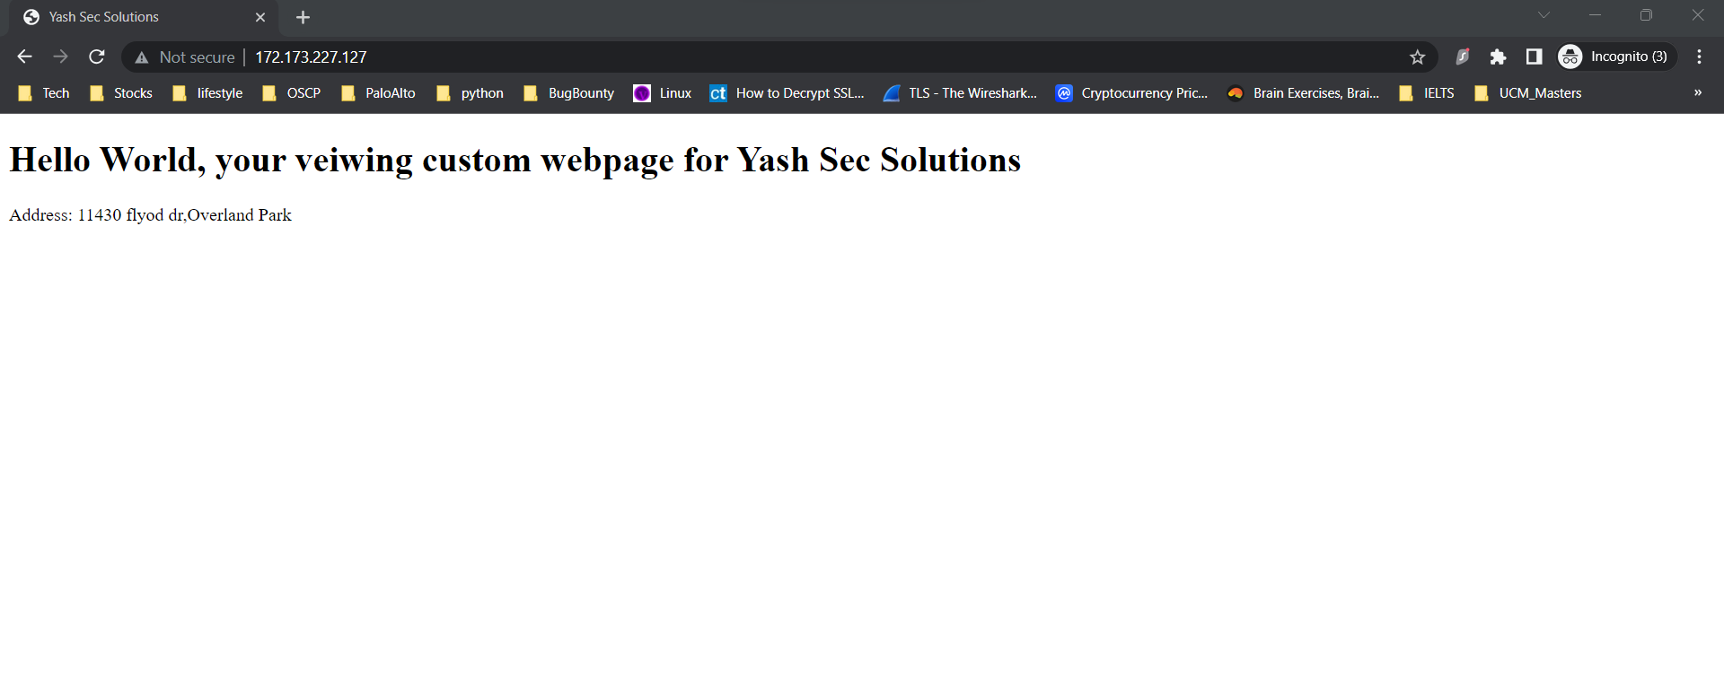

**Screenshots for the below questions should show your Azure account name and portal address bar along with the other components asked in the specific question. Otherwise, your answers will not receive any points.**

1. Show a screenshot of VM summary page of the Azure portal where (1) the IP address and (2) the Azure account name are clearly visible.

Answer:

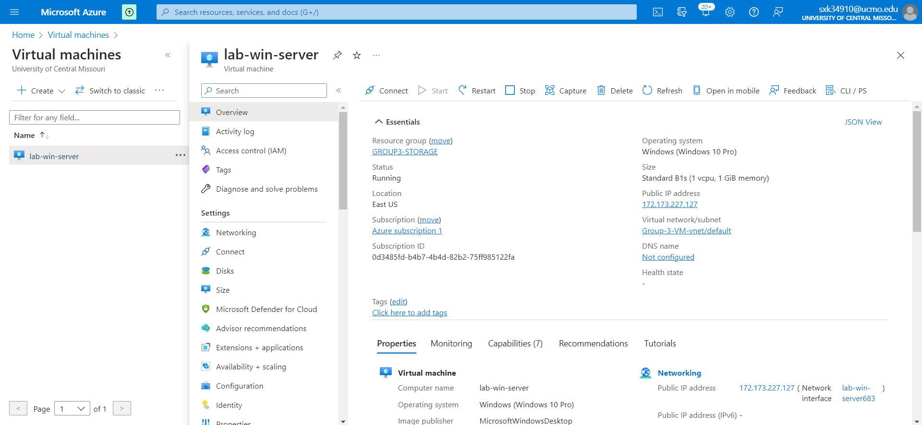

1. Show the summary page of VM which hosts the website with its private IP address, if any.

Answer: Private of the VM which has webserver enabled

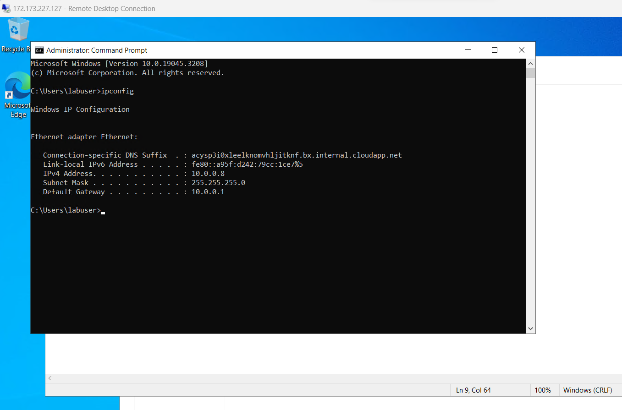

1. Show the summary page of Vnet where your VM is placed.

Answer:

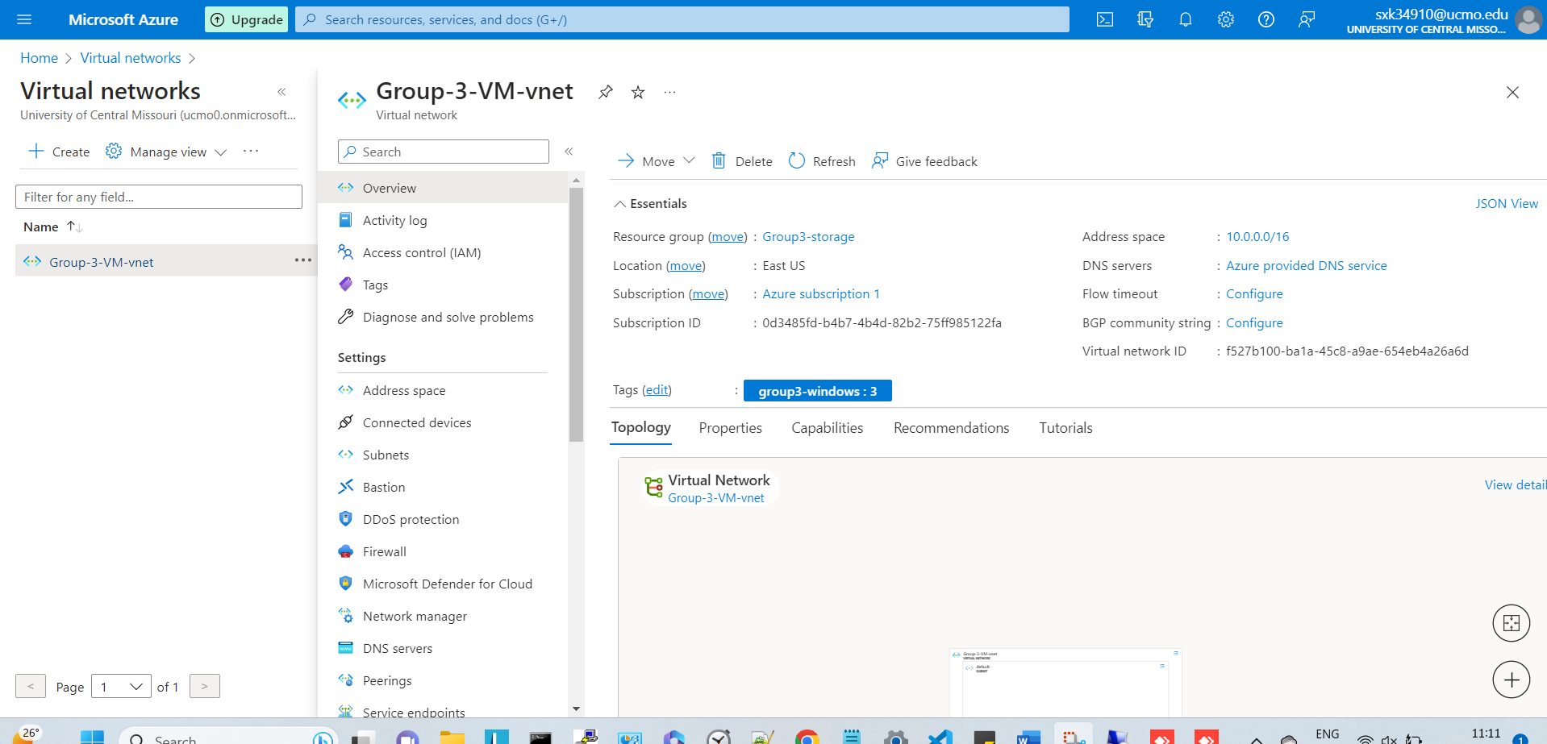

1. Show the summary page of resource group which contains the Vnet.

Answer:

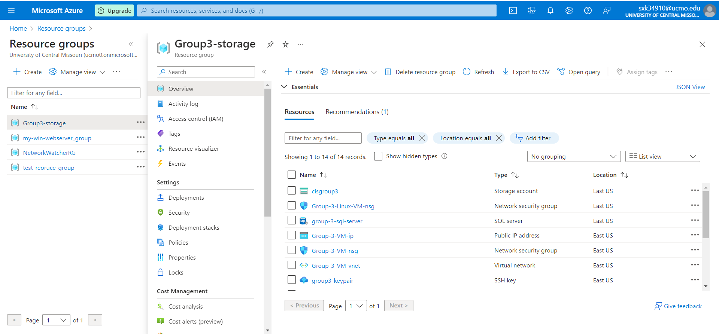

1. Show the inbound and the outbound security rules of the VM.

Answer: Inbound rules.

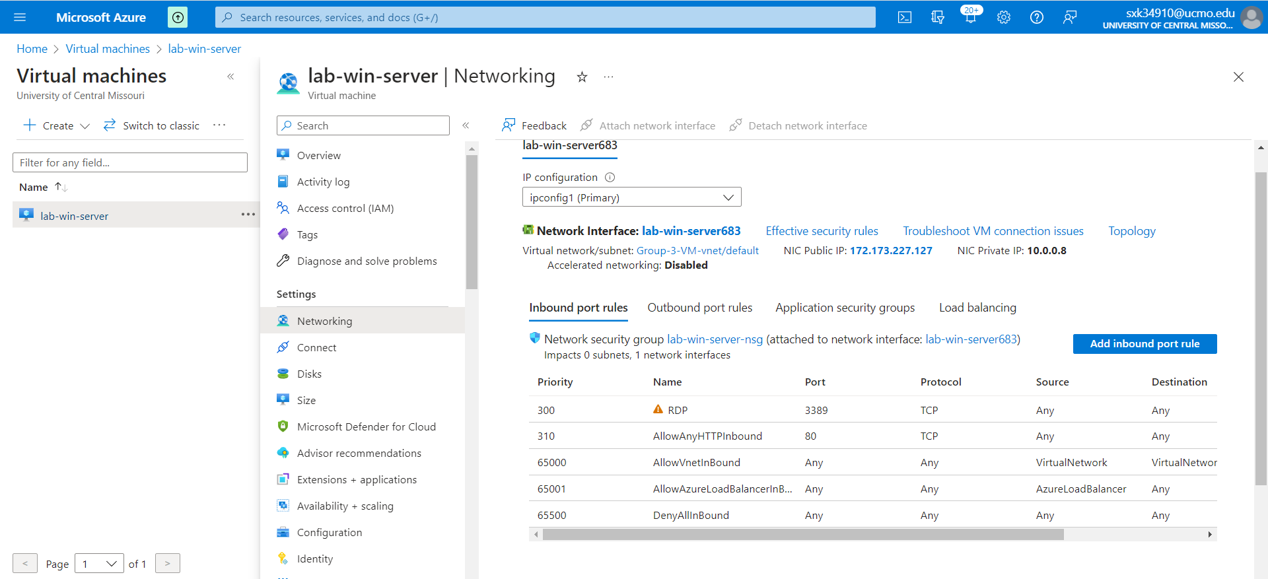

Answer: outbound rules.

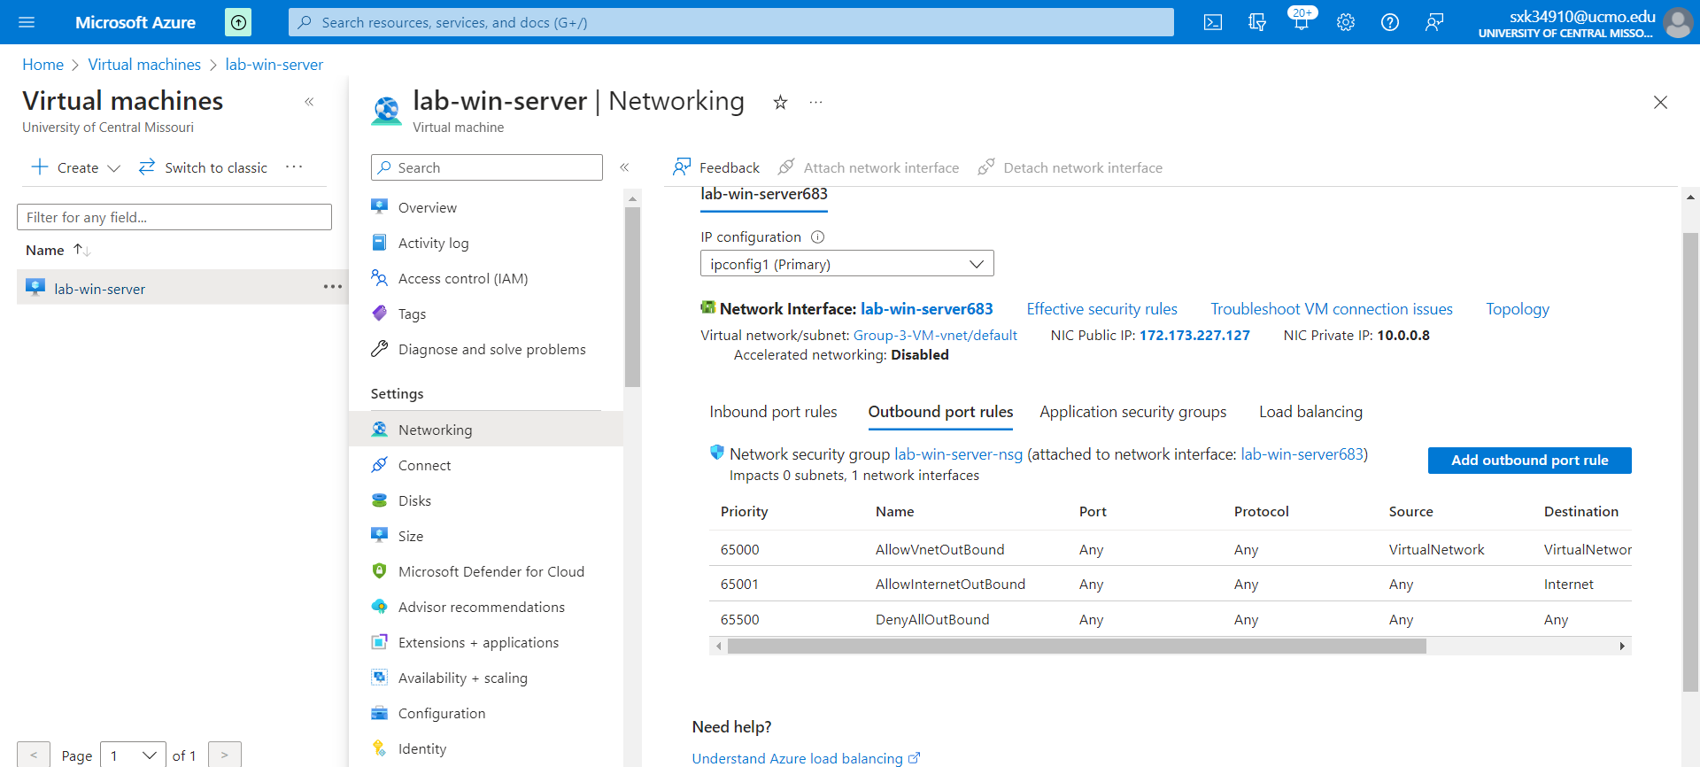

1. If you block all the outgoing traffic from your VM created in step 1, can the anonymous users still get reply from the webserver?

Yes/No? Yes

Explain the reason in a sentence or two:

Because we have allowed incoming traffic from inbound rules