

# Name: YASH KANJARIYA Sap ID: 60009220030

**Branch: CSE(DS) Div:H**

# Course: Object Oriented Programming using Java Roll No.: D126

## Experiment no: 7

**AIM:** To implement Inheritance

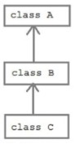**Problem Statement 1:** WAP to demonstrate the role of Constructors in inheritance in the following class diagram.

## CODE:

import java.lang.*; class A {

A() {

super();

}

}

class B extends A { B() {

super();

System.out.println("In the Constructor of Class B");

}

B(int a, int b) {

this();

System.out.println("Addition of " + a + " + " + b + " = " + (a + b));

}

}

class C extends B { C() {

super(10, 20);

C(int a) {

this(); // this() method is used to call the overloaded constructor of the same class System.out.println("Value of a = " + a);

}

}

public class ConstructorInInheritance { public static void main(String args[]) {

C obj = new C(20);

}

}



## OUTPUT:

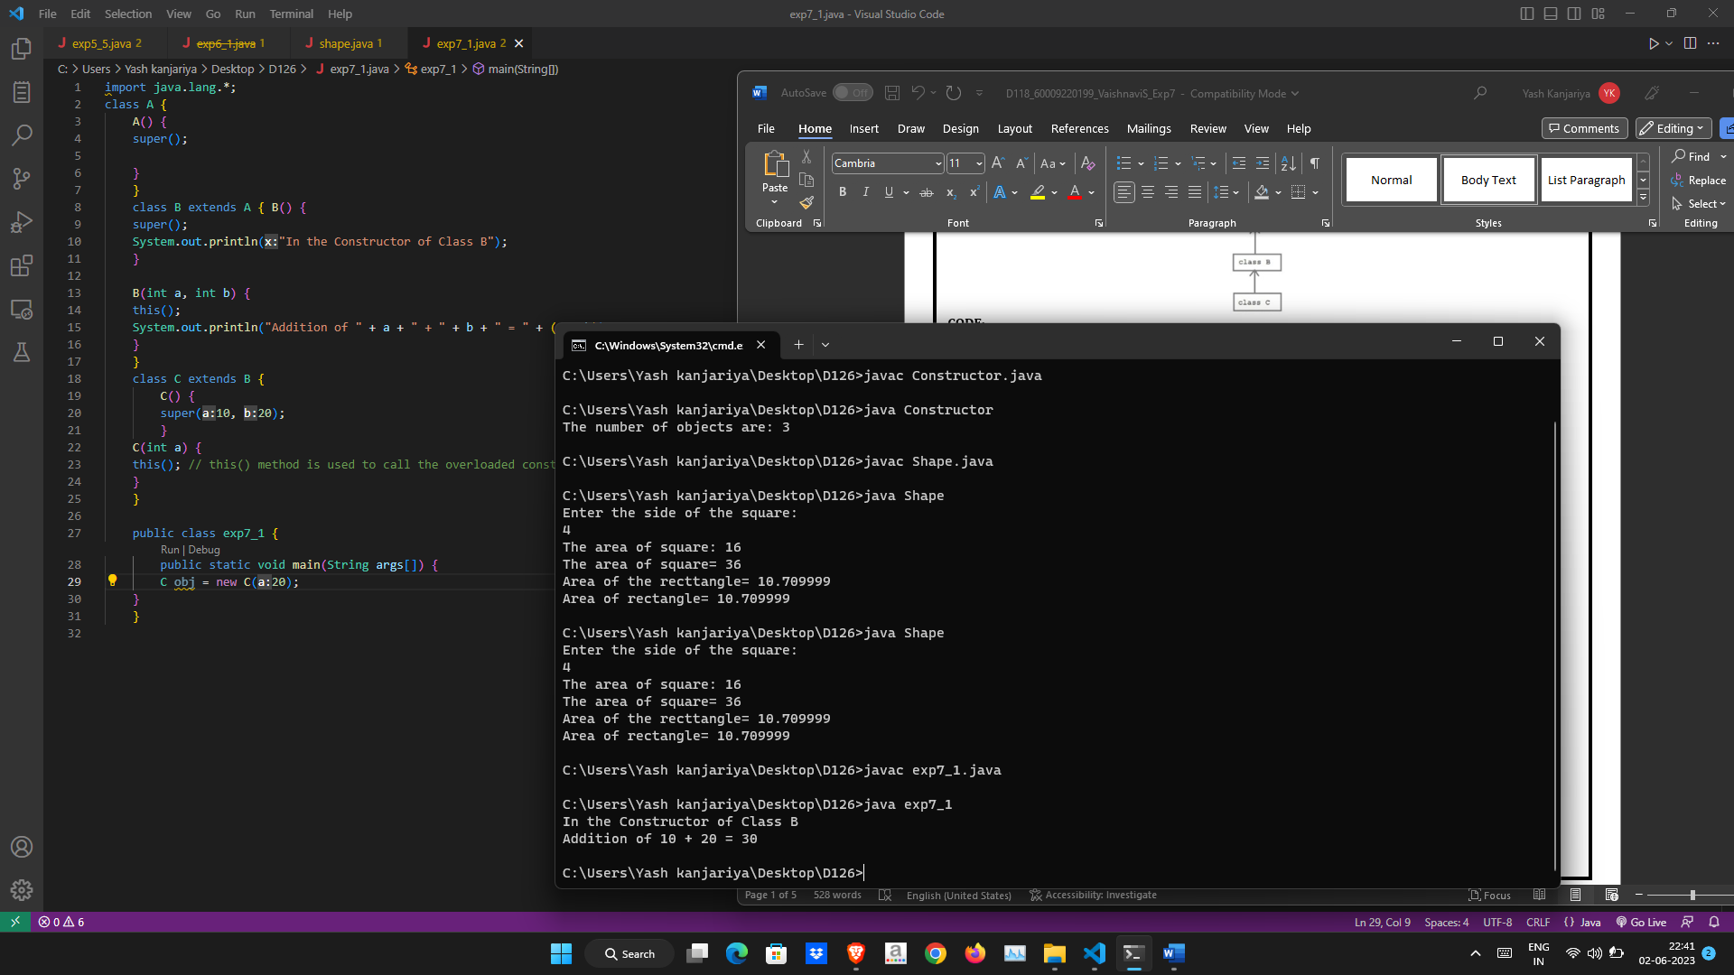

**PROBLEM STATEMENT 2:** Display data of the specialized classes given in the following class diagram

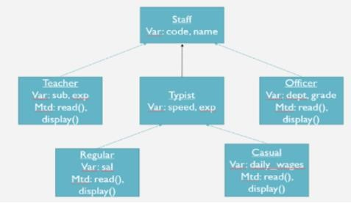

## CODE:

import java.util.Scanner; class Staff {

String code; String name;

Staff(String c, String n) { code = c;

name = n;

}

}

class Teacher extends Staff { String sub;

int exp;

Teacher() {

super("DJ:707", "Prof. Sudhir");

}

public void read() {

Scanner sc = new Scanner(System.in);



System.out.println("Enter Teacher Subject and Experience:"); sub = sc.next();

exp = sc.nextInt();

}

public void display() { System.out.println("**Teacher Information**"); System.out.println("Code: " + code); System.out.println("Name: " + name); System.out.println("Teacher Subject: " + sub); System.out.println("Teacher Experience: " + exp);

}

}

class Typist extends Staff { int speed;

int exp;

Typist(int speed, int exp, String code, String name) { super(code, name);

this.speed = speed; this.exp = exp;

}

}

class Regular extends Typist { int sal;

Scanner sc = new Scanner(System.in);

Regular(int speed, int exp, String code, String name) { super(speed, exp, code, name);

}

public void read() {

System.out.println("Enter salary of Regular Typist:"); sal = sc.nextInt();

}

public void display() {

System.out.println("**Regular Typist Information**"); System.out.println("Code: " + code); System.out.println("Name: " + name); System.out.println("Typing Speed: " + speed); System.out.println("Experience: " + exp); System.out.println("Salary: " + sal);

}

}

class Casual extends Typist {



int sal;

Scanner sc = new Scanner(System.in);

Casual(int speed, int exp, String code, String name) { super(speed, exp, code, name);

}

public void read() {

System.out.println("Enter salary of Casual Typist:"); sal = sc.nextInt();

}

public void display() {

System.out.println("**Casual Typist Information**"); System.out.println("Code: " + code); System.out.println("Name: " + name); System.out.println("Typing Speed: " + speed); System.out.println("Experience: " + exp); System.out.println("Salary: " + sal);

}

}

class Officer extends Staff { String dept;

String grade;

Scanner sc = new Scanner(System.in);

Officer() {

super("DJ:808", "Dr. Nilesh");

}

public void read() { System.out.println("Enter Officer Dept: "); dept = sc.next();

System.out.println("Enter Officer Grade: "); grade = sc.next();

}

public void display() { System.out.println("**Officer Information**"); System.out.println("Code: " + code); System.out.println("Name: " + name);

System.out.println("Officer Department: " + dept); System.out.println("Officer Grade: " + grade);

}

}

class Administration {

public static void main(String args[]) {



Teacher t = new Teacher(); t.read();

t.display();

Officer o = new Officer(); o.read();

o.display();

Regular r = new Regular(30, 10, "DJ:505", "Mr. Subhash"); r.read();

r.display();

Casual c = new Casual(25, 5, "DJ:404", "Mr. Rahul"); c.read();

c.display();

}

}

## OUTPUT:

