**Name: Yash Kanjariya Sap id: 60009220030**

**Branch: Btech CSE DS Div: D126**

**Course**: **Object Oriented Programming using Java**

# Experiment no. __2__

Aim: Implementing arrays in java

Problem Statement 1: You have been given an array of positive integers A1, A2, …, An with length N and you have to print an array of same length (N) where the values in the array are the sum of every number in array, except the number at that index.

i/p 1 2 3 4

For the 0th index, the result will be 2+3+4=0, similarly for the second, third and fourth index the corresponding results will be 8, 7 and 6 respectively.

i/p 4 5 6

o/p 11 10 9

Code:

import java.util.*;

public class arraysum {

public static void main(String[] args){

Scanner sc = new Scanner(System.in);

int n = sc.nextInt();

int[] myArray = new int[n];

int[] arraySum = new int[n];

int i,j;

for(i=0;i<n;i++){

arraySum[i] = 0;

}

for(i=0;i<n;i++){

myArray[i] = sc.nextInt();

}

for(i=0;i<n;i++){

for(j=0;j<n;j++){

if(i==j){

continue;

}else{

arraySum[i] = arraySum[i] + myArray[j];

}

}

}

for(i=0;i<n;i++){

System.out.println(arraySum[i]);

}

}

}

O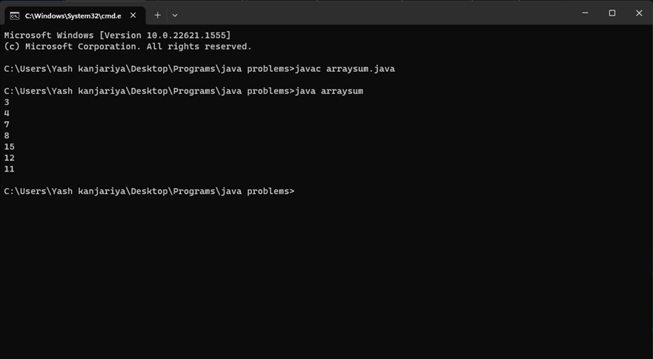utput:

Problem Statement 2: The annual examination results of 5 students are tabulated as follows:

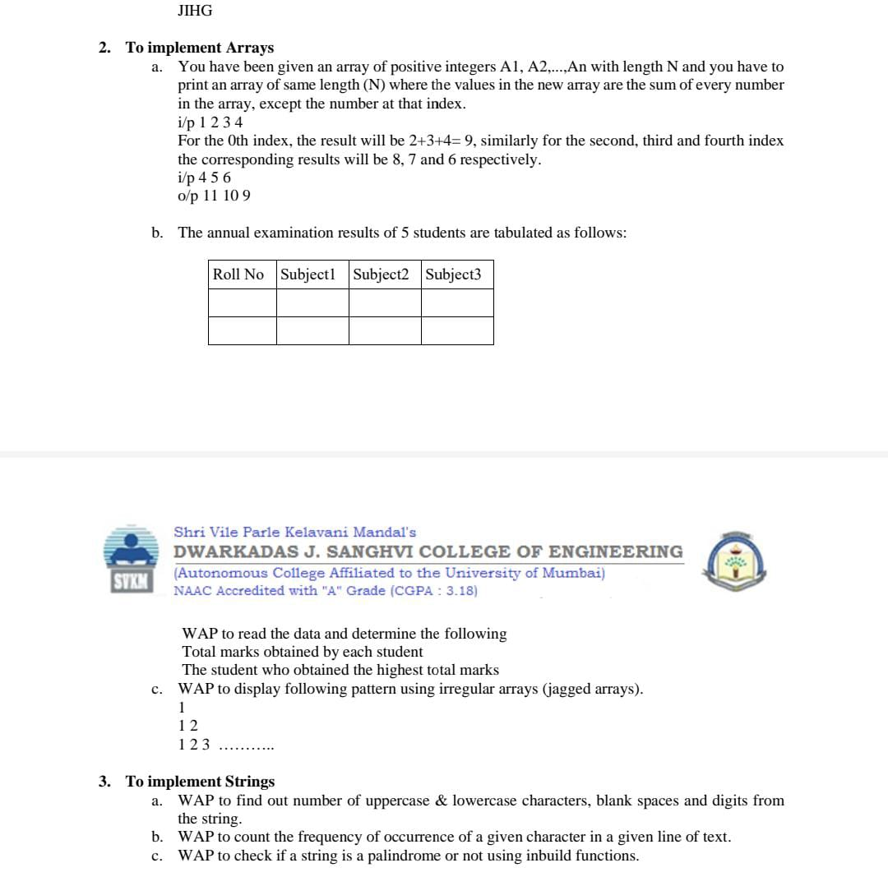

WAP to read the data and determine the following

Total marks obtained by each student

The student who obtained the highest marks

Code:

import java.util.*;

public class array3{

public static void main(String args[]){

Scanner sc = new Scanner(System.in);

int no_students = 3;

int no_subjects = 3;

int student[][] = new int[no_students][no_subjects];

int sum[] = new int[no_students];

int i,j,g1,g2,g;

for(i=0;i<no_students;i++){

System.out.println("Enter student "+(i+1)+" details");

for(j=0;j<no_subjects;j++){

System.out.println("Enter roll no. "+(i+1)+" student's "+(j+1)+" subject's marks");

student[i][j] = sc.nextInt();

sum[i] += student[i][j];

}

}

g1 = (sum[0]>sum[1])?sum[0]:sum[1];

g2 = (sum[2]>sum[1])?sum[2]:sum[1];

g = (g1>g2)?g1:g2;

System.out.println(g + " is greatest score");

}

}

Output:

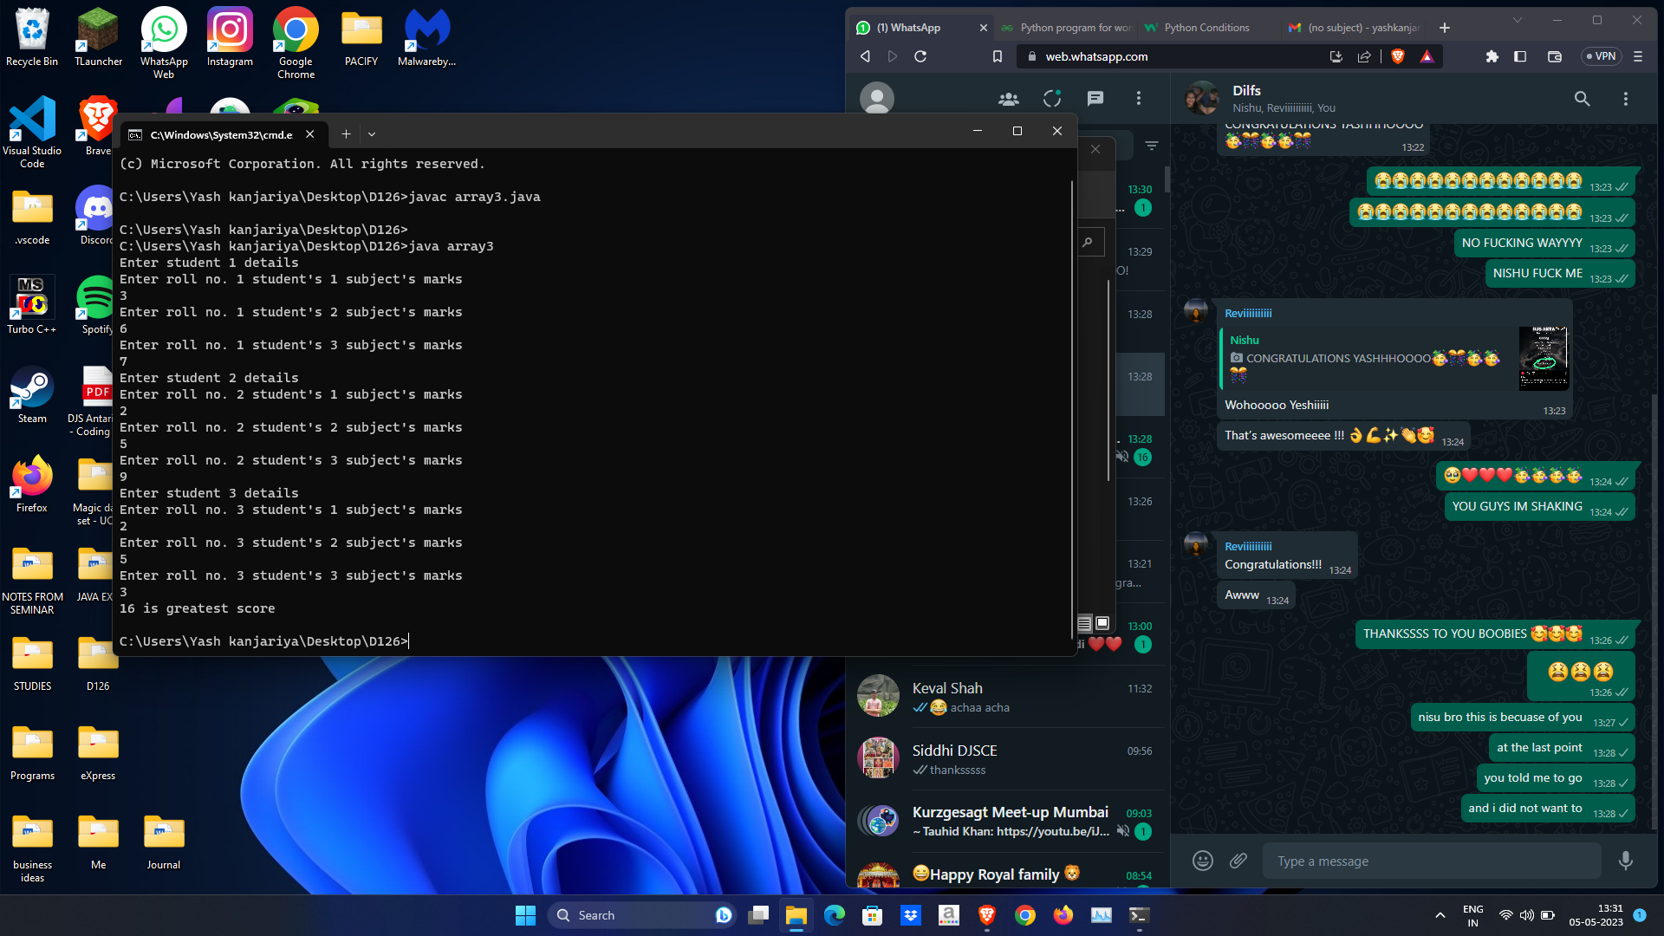

Problem Statement 3: WAP to display following pattern using irregular arrays (jagged array).

Code:

import java.util.*;

public class pattern{

public static void main(String[] args){

Scanner sc = new Scanner(System.in);

int i,j;

int r = sc.nextInt();

int myArray[][] = new int[r][];

for(i=0;i<r;i++){

myArray[i] = new int[i+1];

}

for(i=0;i<r;i++){

for(j=0;j<=i;j++){

myArray[i][j] = j+1;

}

}

for(i=0;i<r;i++){

for(j=0;j<=i;j++){

System.out.print(myArray[i][j]);

}

System.out.println(" ");

}

}

}

Output:

