a)

import java.util.*;

public class arraysum {

public static void main(String[] args){

Scanner sc = new Scanner(System.in);

int n = sc.nextInt();

int[] myArray = new int[n];

int[] arraySum = new int[n];

int i,j;

for(i=0;i<n;i++){

arraySum[i] = 0;

}

for(i=0;i<n;i++){

myArray[i] = sc.nextInt();

}

for(i=0;i<n;i++){

for(j=0;j<n;j++){

if(i==j){

continue;

}else{

arraySum[i] = arraySum[i] + myArray[j];

}

}

}

for(i=0;i<n;i++){

System.out.println(arraySum[i]);

}

}

}

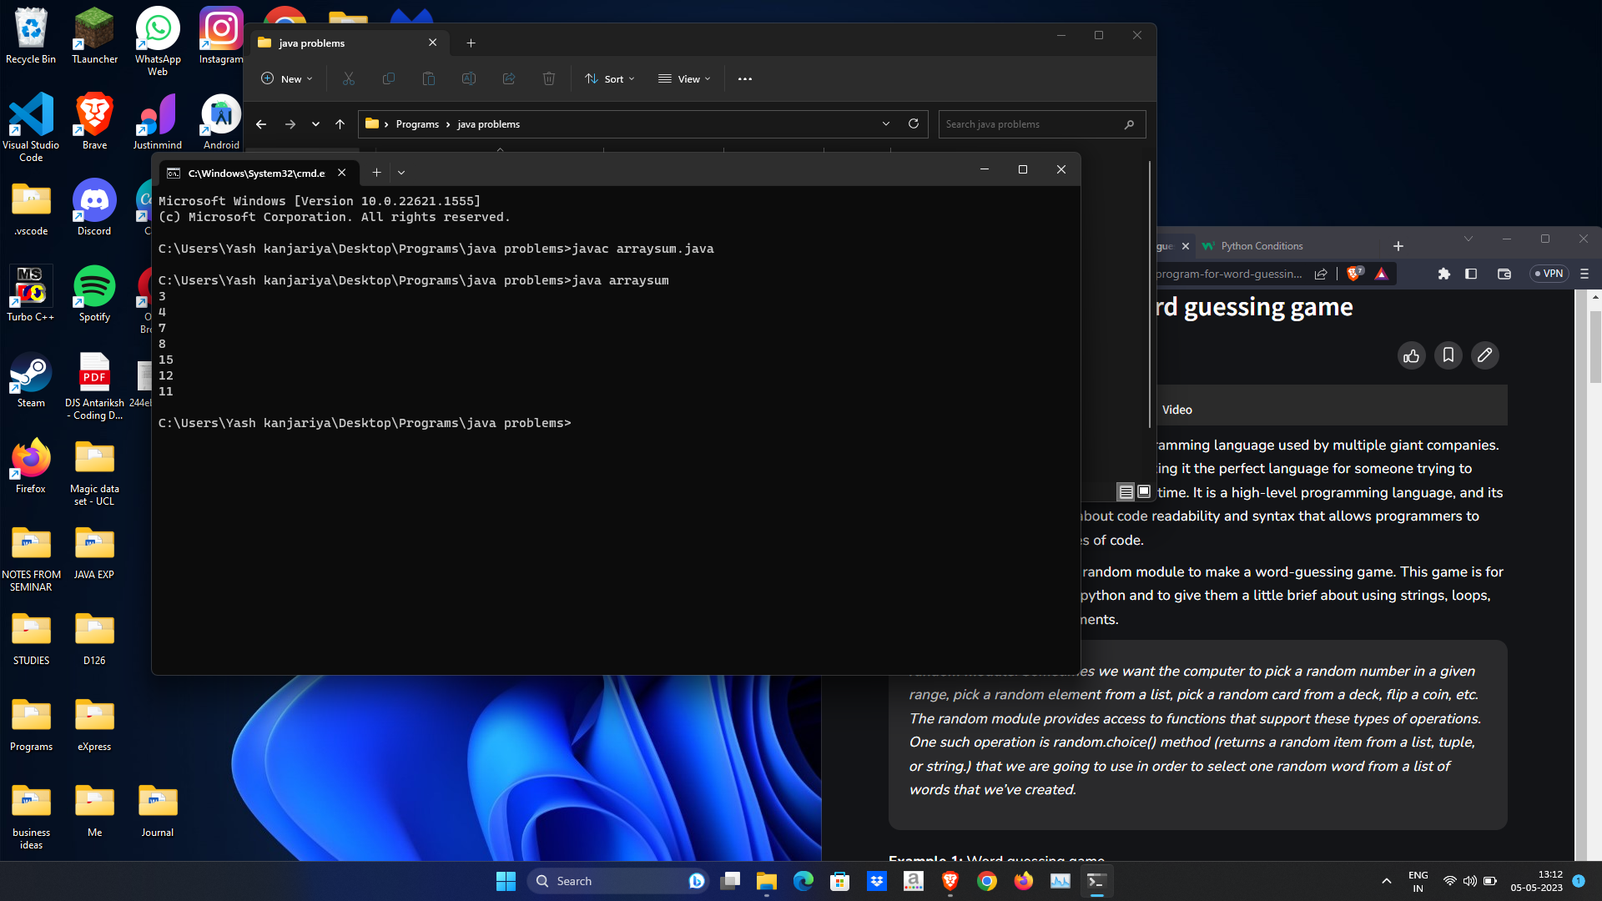

b)

import java.util.*;

public class array3{

public static void main(String args[]){

Scanner sc = new Scanner(System.in);

int no_students = 3;

int no_subjects = 3;

int student[][] = new int[no_students][no_subjects];

int sum[] = new int[no_students];

int i,j,g1,g2,g;

for(i=0;i<no_students;i++){

System.out.println("Enter student "+(i+1)+" details");

for(j=0;j<no_subjects;j++){

System.out.println("Enter roll no. "+(i+1)+" student's "+(j+1)+" subject's marks");

student[i][j] = sc.nextInt();

sum[i] += student[i][j];

}

}

g1 = (sum[0]>sum[1])?sum[0]:sum[1];

g2 = (sum[2]>sum[1])?sum[2]:sum[1];

g = (g1>g2)?g1:g2;

System.out.println(g + " is greatest score");

}

}

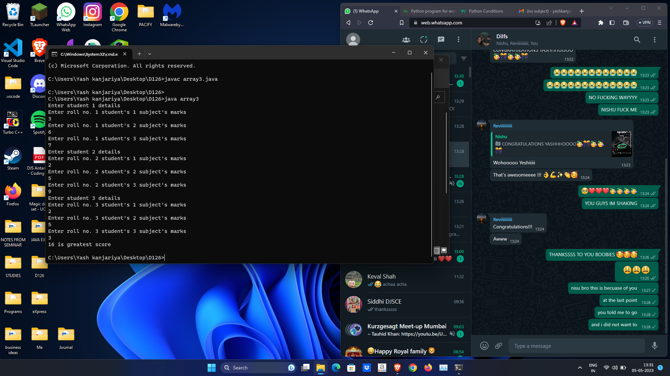

c)

import java.util.*;

public class pattern{

public static void main(String[] args){

Scanner sc = new Scanner(System.in);

int i,j;

int r = sc.nextInt();

int myArray[][] = new int[r][];

for(i=0;i<r;i++){

myArray[i] = new int[i+1];

}

for(i=0;i<r;i++){

for(j=0;j<=i;j++){

myArray[i][j] = j+1;

}

}

for(i=0;i<r;i++){

for(j=0;j<=i;j++){

System.out.print(myArray[i][j]);

}

System.out.println(" ");

}

}

}

