**Name: YASH KANJARIYA Sap id: 60009220030**

**Branch: Computer Science and Engg(Data Science) Div: D2-3 Course**: **Object Oriented Programming using Java**

**Experiment no. 4**

**Aim:** To implement collections (Array List/ Vectors)

**Problem Statement 1:** WAP to accept students name from command line and store them in vector.

**Code:** s

import java.util.*; import java.util.Vector; public class exp4_1{

public static void main(String[] args) { Vector<String>v=new Vector<String>(); for(int i=0;i<=args.length-1;i++)

{

v.addElement(args[i]);

}

for(int i=0;i<=v.size()-1;i++)

{

System.out.println(v.elementAt(i));

}

}

}

**Output:**

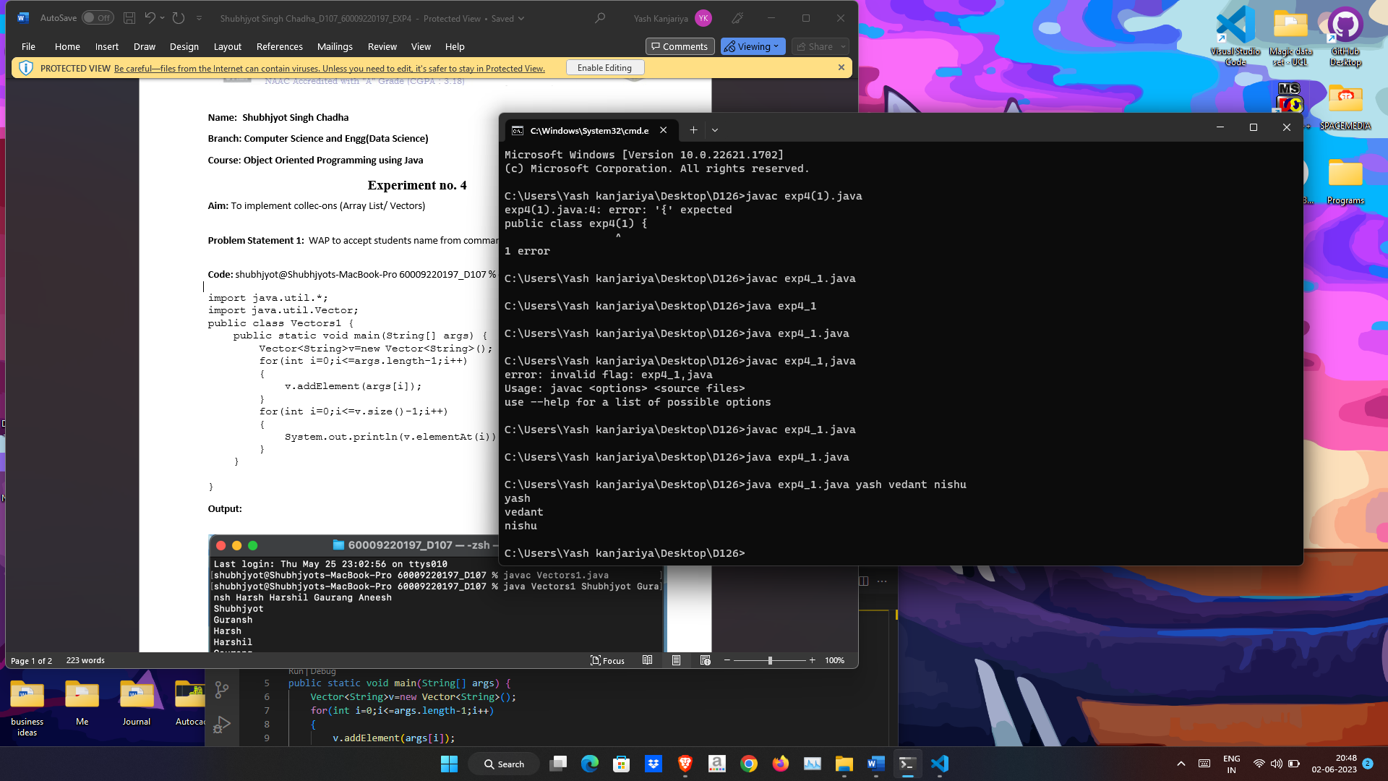



**Problem Statement 2:** WAP to add n strings in a vector array. Input new string and check if it is present in the vector.

If present delete it, else add to the vector

**Code:**

import java.util.*;

public class exp4_2 {

public static void main(String[] args) { Scanner scanner = new Scanner(System.in);

Vector<String> vector = new Vector<>();

System.out.print("Enter the number of strings to add: "); int n = scanner.nextInt();

// Add n strings to the vector for (int i = 0; i < n; i++) {

System.out.print("Enter a string to add: "); String str = scanner.next(); vector.add(str);

}

System.out.print("Enter a string to check and add/delete: "); String newString = scanner.next();

if (vector.contains(newString)) { vector.remove(newString);

System.out.println("String removed from the vector.");

}

else {

vector.add(newString);

System.out.println("String added to the vector.");

}

System.out.println("Updated vector: " + vector);

}

}

**Output:**

