*1.*

import javax.swing.*;

import java.awt.*;

import java.awt.event.*;

class Loginevent extends JFrame implements ActionListener

{

JFrame jf;

JLabel l1,l2;

JTextField tf1, ot;

JPasswordField tf2;

JButton b1,b2;

Loginevent()

{

//create componant

jf= new JFrame("Login Test");

tf1=new JTextField(10);

l1=new JLabel("Username");

ot=new JTextField(20);

l2=new JLabel("Passward");

tf2 = new JPasswordField(10);

b1=new JButton("OK");

b2=new JButton("Reset");

//set Layout

jf.setLayout(new FlowLayout());

//add component on frame/window

jf.add(l1);

jf.add(tf1);

jf.add(l2);

jf.add(tf2);

jf.add(b1);

jf.add(b2);

jf.add(ot);

//register component which are causing events

b1.addActionListener(this);

b2.addActionListener(this);

jf.setSize(500,100);

jf.setVisible(true);

}

public void actionPerformed(ActionEvent e)

{

if(e.getSource()==b1)

{

String s1=tf1.getText();

String s2 = String.valueOf(tf2.getPassword());

ot.setText("UserName="+s1+" Passward="+s2);

}

else if(e.getSource()==b2)

{

tf1.setText("");

tf2.setText("");

ot.setText("");

}

}

public static void main(String args[])

{

Loginevent x=new Loginevent();

}

}

Output :

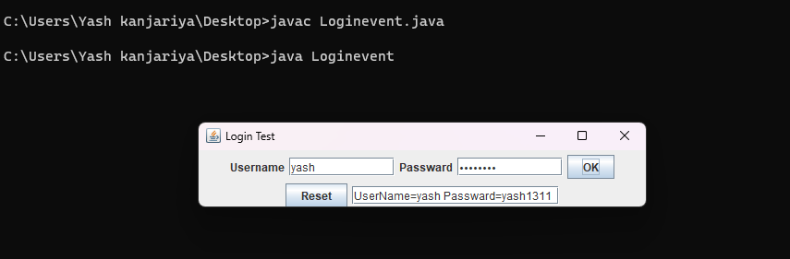

2.

Code :

import java.awt.event.*;

import javax.swing.*;

import java.awt.*;

class calculatorNew extends JFrame implements ActionListener

{

double a=0,b=0,result=0;

JTextField t;

JButton b0, b1, b2, b3, b4, b5, b6, b7, b8, b9, ba, bs, bd, bm, be, beq, beq1;

int operator=0;

calculatorNew()

{

b0 = new JButton("0");

b1 = new JButton("1");

b2 = new JButton("2");

b3 = new JButton("3");

b4 = new JButton("4");

b5 = new JButton("5");

b6 = new JButton("6");

b7 = new JButton("7");

b8 = new JButton("8");

b9 = new JButton("9");

// create operator buttons

beq1 = new JButton("=");

ba = new JButton("+");

bs = new JButton("-");

bd = new JButton("/");

bm = new JButton("*");

beq = new JButton("C");

be = new JButton(".");

t=new JTextField(20);

t.setSize(10,10);

JPanel p = new JPanel();

bm.addActionListener(this);

bd.addActionListener(this);

bs.addActionListener(this);

ba.addActionListener(this);

b9.addActionListener(this);

b8.addActionListener(this);

b7.addActionListener(this);

b6.addActionListener(this);

b5.addActionListener(this);

b4.addActionListener(this);

b3.addActionListener(this);

b2.addActionListener(this);

b1.addActionListener(this);

b0.addActionListener(this);

be.addActionListener(this);

beq.addActionListener(this);

beq1.addActionListener(this);

p.add(t);

p.add(ba);

p.add(b1);

p.add(b2);

p.add(b3);

p.add(bs);

p.add(b4);

p.add(b5);

p.add(b6);

p.add(bm);

p.add(b7);

p.add(b8);

p.add(b9);

p.add(bd);

p.add(be);

p.add(b0);

p.add(beq);

p.add(beq1);

setDefaultCloseOperation(JFrame.EXIT_ON_CLOSE);

p.setBackground(Color.pink);

// add panel to frame

add(p);

setSize(235, 235);

setVisible(true);

}

public void actionPerformed(ActionEvent e)

{

if(e.getSource()==b1)

t.setText(t.getText().concat("1"));

if(e.getSource()==b2)

t.setText(t.getText().concat("2"));

if(e.getSource()==b3)

t.setText(t.getText().concat("3"));

if(e.getSource()==b4)

t.setText(t.getText().concat("4"));

if(e.getSource()==b5)

t.setText(t.getText().concat("5"));

if(e.getSource()==b6)

t.setText(t.getText().concat("6"));

if(e.getSource()==b7)

t.setText(t.getText().concat("7"));

if(e.getSource()==b8)

t.setText(t.getText().concat("8"));

if(e.getSource()==b9)

t.setText(t.getText().concat("9"));

if(e.getSource()==b0)

t.setText(t.getText().concat("0"));

if(e.getSource()==be)

t.setText(t.getText().concat("."));

if(e.getSource()==ba)

{

a=Double.parseDouble(t.getText());

operator=1;

t.setText("");

}

if(e.getSource()==bs)

{

a=Double.parseDouble(t.getText());

operator=2;

t.setText("");

}

if(e.getSource()==bm)

{

a=Double.parseDouble(t.getText());

operator=3;

t.setText("");

}

if(e.getSource()==bd)

{

a=Double.parseDouble(t.getText());

operator=4;

t.setText("");

}

if(e.getSource()==beq1)

{

b=Double.parseDouble(t.getText());

switch(operator)

{

case 1: result=a+b;

break;

case 2: result=a-b;

break;

case 3: result=a*b;

break;

case 4: result=a/b;

break;

default: result=0;

}

t.setText(""+result);

}

if(e.getSource()==beq)

t.setText("");

}

public static void main(String args[])

{

calculatorNew cal=new calculatorNew();

}

}

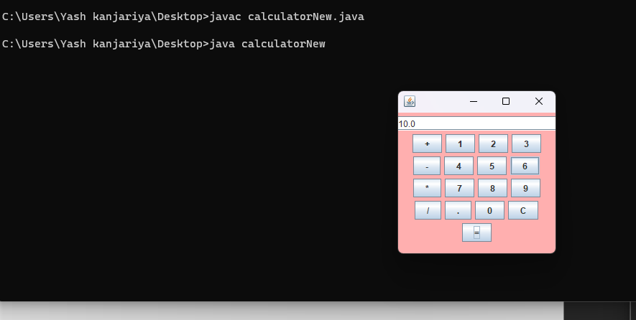

3.

Code :

import javax.swing.*;

import java.awt.*;

import java.awt.event.*;

class Form extends JFrame implements ActionListener

{

JLabel name,gen,interest,place,details;

JTextField tname;

JRadioButton male, female;

JComboBox cplace;

JButton submit,exit;

JTextArea tadd;

JCheckBox music,swim;

ButtonGroup gengp;

public Form()

{

setTitle("Form");

setBounds(200, 80, 800, 800);

setDefaultCloseOperation(EXIT_ON_CLOSE);

setResizable(false);

setLayout(null);

name = new JLabel("Name");

name.setFont(new Font("Arial", Font.PLAIN, 15));

name.setSize(100, 20);

name.setLocation(100, 100);

add(name);

tname = new JTextField();

tname.setFont(new Font("Arial", Font.PLAIN, 15));

tname.setSize(190, 20);

tname.setLocation(200, 100);

add(tname);

gen = new JLabel("Gender");

gen.setFont(new Font("Arial", Font.PLAIN, 15));

gen.setSize(100, 20);

gen.setLocation(100, 150);

add(gen);

male = new JRadioButton("Male");

male.setFont(new Font("Arial", Font.PLAIN, 15));

male.setSelected(true);

male.setSize(80, 20);

male.setLocation(200, 150);

add(male);

female = new JRadioButton("Female");

female.setFont(new Font("Arial", Font.PLAIN, 15));

female.setSize(80, 20);

female.setLocation(350, 150);

add(female);

gengp = new ButtonGroup();

gengp.add(male);

gengp.add(female);

interest = new JLabel("Interest");

interest.setFont(new Font("Arial", Font.PLAIN, 15));

interest.setSize(100, 20);

interest.setLocation(100, 200);

add(interest);

music = new JCheckBox("Music");

music.setFont(new Font("Arial", Font.PLAIN, 15));

music.setSize(100, 20);

music.setLocation(200, 200);

add(music);

swim = new JCheckBox("Swim");

swim.setFont(new Font("Arial", Font.PLAIN, 15));

swim.setSize(100, 20);

swim.setLocation(350, 200);

add(swim);

place = new JLabel("Fav Place");

place.setFont(new Font("Arial", Font.PLAIN, 15));

place.setSize(100, 20);

place.setLocation(100, 250);

add(place);

cplace = new JComboBox();

cplace.setFont(new Font("Arial", Font.PLAIN, 15));

cplace.setSize(150, 20);

cplace.setLocation(200, 250);

add( cplace);

cplace.addItem("India");

cplace.addItem("USA");

cplace.addItem("Bhutan");

cplace.addItem("Srilanka");

cplace.addItem("Maldives");

details = new JLabel("Details");

details.setFont(new Font("Arial", Font.PLAIN, 15));

details.setSize(100, 20);

details.setLocation(100, 300);

add(details);

tadd = new JTextArea();

tadd.setFont(new Font("Arial", Font.PLAIN, 15));

tadd.setSize(200, 200);

tadd.setLocation(200, 300);

tadd.setLineWrap(true);

tadd.setEditable(false);

add(tadd);

submit = new JButton("Submit");

submit.setFont(new Font("Arial", Font.PLAIN, 15));

submit.setSize(100, 20);

submit.setLocation(150, 550);

submit.addActionListener(this);

add(submit);

exit = new JButton("Reset");

exit.setFont(new Font("Arial", Font.PLAIN, 15));

exit.setSize(100, 20);

exit.setLocation(270, 550);

exit.addActionListener(this);

add(exit);

setVisible(true);

}

public void actionPerformed(ActionEvent e)

{

if(e.getSource() == submit)

{

String data = "Name : " + tname.getText() + "\n" +

" Gender : " +(male.isSelected()==true?"Male":"Female") + "\n" +

" Interests : "+ (music.isSelected()==true?"Music ":"")+

(swim.isSelected()==true?"Swimming":"") +"\n" +

" Favorite Place : " + cplace.getItemAt(cplace.getSelectedIndex());

tadd.setVisible(true);

tadd.setText(data);

tadd.setEditable(false);

}

else if(e.getSource() == exit)

{

tadd.setText("");

}

}

}

class Forms {

public static void main(String[] args) throws Exception

{

Form f = new Form();

}

}

Output :

