**Name: Yash Kanjariya Sap id: 6009220030**

**Branch: CSE(DS) Div: D2**

**Course**: **Object Oriented Programming using Java**

# Experiment no. 3

Aim: To implement strings

Problem Statement 3a: WAP to find out number of uppercase & lowercase characters, blank spaces and digits from the string

Code: import java.io.*;

import java.util.*;

class exp3_1

{

public static void main(String args[])

{

Scanner sc= new Scanner(System.in);

System.out.println("Enter the string");

String str=sc.nextLine();

int upper = 0, lower = 0, number = 0, special = 0;

for(int i = 0; i < str.length(); i++)

{

char ch = str.charAt(i);

if (ch >= 'A' && ch <= 'Z')

upper++;

else if (ch >= 'a' && ch <= 'z')

lower++;

else if (ch >= '0' && ch <= '9')

number++;

else

special++;

}

System.out.println("Lower case letters : " + lower);

System.out.println("Upper case letters : " + upper);

System.out.println("Number : " + number);

System.out.println("Special characters : " + special);

}

}

Output:

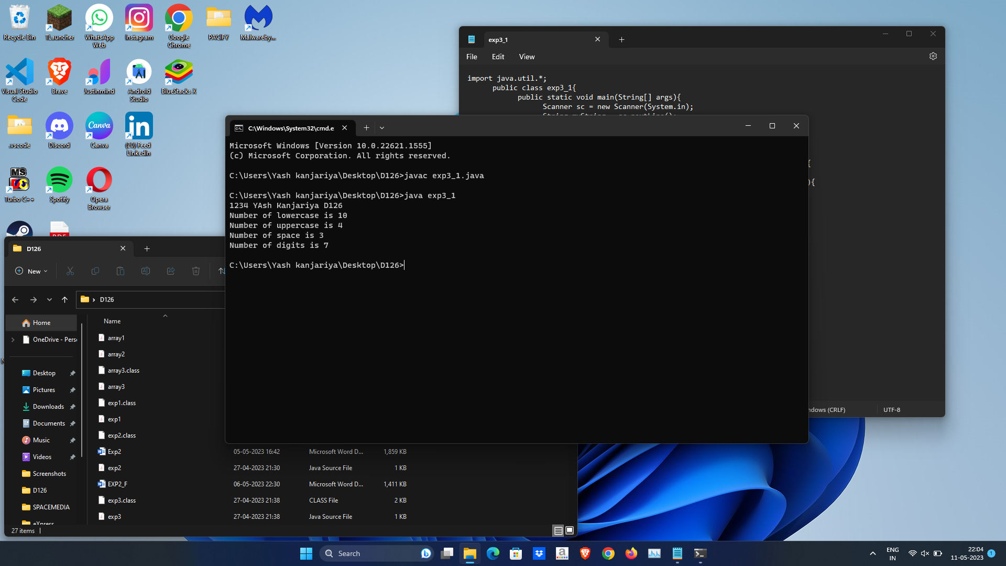

Problem Statement 3b:

WAP to count the frequency of occurrence of a given character in a given line of text.

Code:

import java.io.*;

import java.util.*;

class exp3_2

{

public static void main(String args[])

{

Scanner sc= new Scanner(System.in);

System.out.println("Enter the string");

String s=sc.nextLine();

System.out.println("Enter the Character");

char c=sc.next().charAt(0);

int res = 0;

for (int i=0; i<s.length(); i++)

{

if (s.charAt(i) == c)

res++;

}

System.out.println(s+","+res);

}

}

Output: 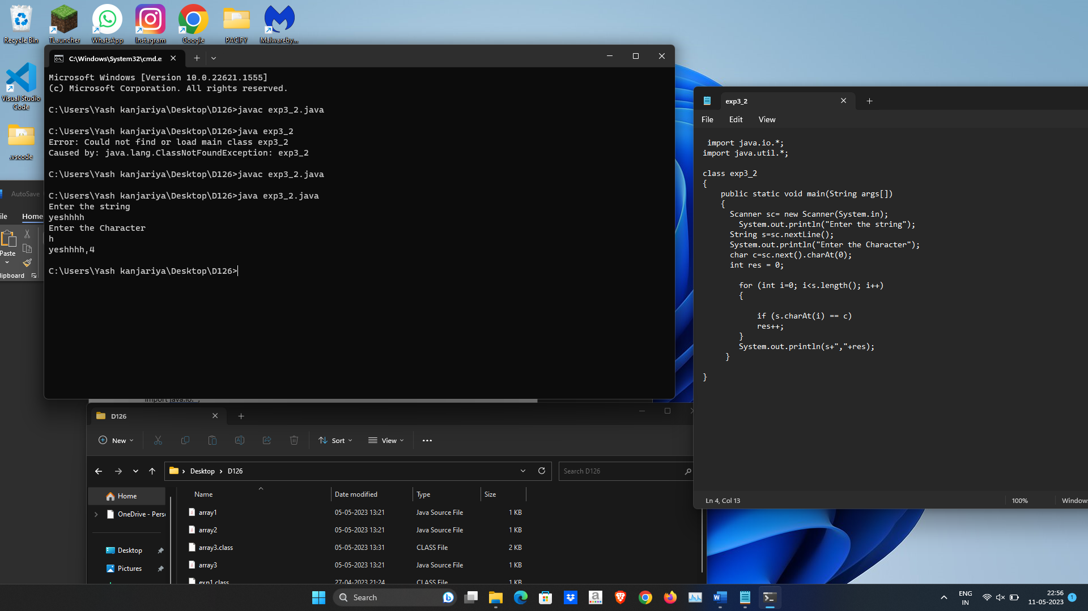

Problem Statement 3c:

import java.util.Scanner;

class exp3_3

{

public static void main(String arg[])

{

String str,strrev="";

Scanner sc=new Scanner(System.in);

System.out.print("Enter a string :");

str=sc.next();

for(int i=str.length()-1;i>=0;i--)

{

strrev=strrev+str.charAt(i);

}

System.out.println("Reverse of a string is : "+strrev);

if(strrev.equalsIgnoreCase(str))

System.out.println("Entered string is palindrome");

else

System.out.println("Entered string is not a palindrome number ");

}

}

Output:

