Java Database Connectivity with 5 Steps
There are 5 steps to connect any java application with the database using JDBC.
- Register the Driver class
- Create connection
- Create statement
- Execute queries
- Close connection
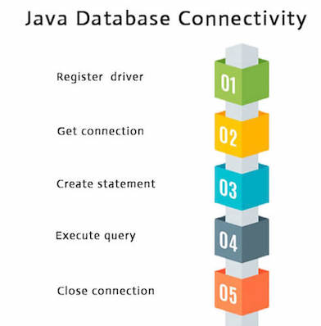

1) Register the driver class
The forName() method of Class class is used to register the driver class.
This method is used to dynamically load the driver class.

Syntax of forName() method
public static void forName(String className)throws ClassNotFoundException
e.g.
Class.forName("oracle.jdbc.driver.OracleDriver");

2) Create the connection object
The getConnection() method of DriverManager class is used to establish connection
with the database.

Syntax of getConnection() method
1) public static Connection getConnection(String url)throws SQLException
2) public static Connection getConnection(String url,String name,String password)
throws SQLException

e.g.

Connection con=DriverManager.getConnection(
"jdbc:oracle:thin:@localhost:1521:xe","system","password");

3) Create the Statement object
The createStatement() method of Connection interface is used to create
statement. The object of statement is responsible to execute queries
with the database.

Syntax of createStatement() method
public Statement createStatement()throws SQLException

e.g.
Statement stmt=con.createStatement();

4) Execute the query
The executeQuery() method of Statement interface is used to
execute queries to the database. This method returns the
object of ResultSet that can be used to get all the records of
a table.

Syntax of executeQuery() method
public ResultSet executeQuery(String sql)throws SQLException

e.g.

ResultSet rs=stmt.executeQuery("select * from emp");

5) Close the connection object
By closing connection object statement and ResultSet will be
closed automatically. The close() method of Connection
interface is used to close the connection.

Syntax of close() method
public void close()throws SQLException
E.g.

con.close();

Java connectivity to SQL Server

import java.sql.DriverManager;
import java.sql.Connection;
import java.sql.ResultSet;
import java.sql.SQLException;
import java.sql.Statement;

public class Main
{

public static void main(String[] args) throws SQLException, ClassNotFoundException
{
Connection conn = DriverManager.getConnection("jdbc:sqlserver://localhost:1433/dsn”,”sa”,”student”);
System.out.println("test");
Statement sta = conn.createStatement();
String Sql = "select * from testing_table";
ResultSet rs = sta.executeQuery(Sql);
Int row=0;
while (rs.next())
{
row++;
System.out.println(row);
}
}
}

How to create dsn?
Dsn: Data source name.
Control panel-> Administrative tools-> Data Sources(ODBC)-> add new ->choose driver for sql server->give DSN name->choose database.

import java.sql.*;
class Test
{
public static void main(String ar[])
{
Try
{
String url ="jdbc:odbc:sample";
Class.forName("sun.jdbc.odbc.JdbcOdbcDriver");
Connection c = DriverManager.getConnection(url);
Statement st = c.createStatement();
ResultSet rs = st.executeQuery("select * from d6b");

while(rs.next()){
System.out.println(rs.getString(1));
}

}catch(Exception ee){System.out.println(ee);}

}}

