

Data Base Management System

Project No. 9 :

Dining Philosopher Visualizer

Submitted By:
Tanishi Shukla [70022400270]
Yash Kavar [70022400796]
Abhiram [70022400]

Submitted To: Prof. Wasiha Tasneem

Submission Date : 28-09-2026

Operating Systems
Mini Project Report
Dining Philosophers Problem Visualizer
Real threads, real locks, and a live deadlock demonstration
Project No. (Appendix A) | 9
Unit / Topic | Unit 3 – Process Concurrency
Course Code | [Course Code]
Group No. | 3
Faculty Name | Prof. Wasiha Tasneem
Source Code | https://github.com/yashkavar01/dining-philosophers-simulation
Submission Date | 28-09-2026

Group Members
S. No. | Name | Roll No.
1 | Tanishi Shukla | C002
2 | Yash Kavar | C066
3 | Abhiram | C0

Certificate
This is to certify that the mini project titled “Dining Philosophers Problem Visualizer”, submitted as part of the Operating Systems course , is a bonafide work carried out by the students named on the cover page under the guidance of Prof. Wasiha Tasneem. The work is submitted in partial fulfilment of the internal assessment requirements of the course.

Declaration
We declare that this project, including its source code and this report, is the original work of our group. Where external libraries or reference material were used, they are cited in the source code comments and in the References section of this report. The Flask web framework and the pytest testing framework are the only third-party libraries used. We understand that copied or plagiarised work will be penalised as per the course’s academic-integrity policy.

Abstract
Deadlock is a classic failure mode of concurrent systems, and the Dining Philosophers problem is the standard way to study it. This project implements the problem with real operating-system primitives instead of a scripted animation: each philosopher is a Python thread, each fork is a mutual-exclusion lock, and a Flask server exposes the live state to a browser-based visualiser. Three fork-acquisition strategies are provided: a naive left-then-right policy that can deadlock, Dijkstra’s resource-ordering policy that eliminates circular wait, and a semaphore-based waiter that admits at most N−1 philosophers to fork contention. A barrier-based trigger reproduces the deadlock on demand, and a background detector finds the circular wait by building a wait-for graph. In 40-second test runs with five philosophers, the forced naive run froze after 5 meals with a detected five-node cycle, while the ordering and waiter strategies completed 185 and 187 meals with no deadlock detections. A suite of 28 automated tests, all passing, checks mutual exclusion, deadlock reproduction, deadlock freedom and simulator lifecycle behaviour.
Keywords: Dining Philosophers, deadlock, mutual exclusion, semaphore, resource ordering, wait-for graph, Python threading.

1. Introduction
1.1 Background
An operating system continually schedules threads and processes that compete for a limited set of shared resources such as locks, files, memory regions and devices. If that competition is not synchronised correctly, the result is either a race condition (two threads corrupt shared state) or a deadlock (a set of threads wait on each other forever while everything else looks healthy). The Dining Philosophers problem, introduced by Edsger Dijkstra in the 1960s and later retold with philosophers and forks, distils this into a small, symmetric case: N philosophers sit around a table with one fork between each neighbouring pair, and each needs both adjacent forks to eat.
1.2 Motivation
Most classroom demonstrations of this problem are animations: the deadlock appears because the author scripted it. This project takes the opposite approach. The philosophers are genuine threads scheduled by the operating system, the forks are genuine locks, and the browser only displays what a running Python server reports. A deadlock therefore occurs, and is detected, because the synchronisation policy allows it, and it disappears when the policy is changed.
1.3 Problem Statement
The project corresponds to item 9 (Unit 3 – Process Concurrency) of the approved list: “Simulate the classic dining philosophers problem with a deadlock-free solution.” Concretely, the system must:
- model N philosophers and N forks as genuinely concurrent entities and genuinely exclusive shared resources;
- show that a naive synchronisation policy can deadlock;
- implement at least one policy that is deadlock-free by construction, not merely by observation;
- make both the failure and the fix visible in real time, with measured supporting data.

1.4 Objectives
- Implement each philosopher as an independent operating-system thread and each fork as a threading.Lock.
- Reproduce the textbook deadlock reliably, on demand, for a live demonstration.
- Implement two deadlock-free strategies, each attacking a different Coffman condition.
- Detect deadlock algorithmically by finding a cycle in a live wait-for graph.
- Visualise philosopher states, fork ownership and the circular wait in a browser.
- Record real, measured metrics (meals, waiting times, blocked attempts, fork utilisation) to compare strategies.
- Validate the behaviour with an automated test suite.

2. Related Concepts / Theory
2.1 Threads and shared resources
A process owns a private address space, whereas the threads of a process share it. The philosophers must contend for the same fork objects, so this project uses threads (Philosopher extends threading.Thread); using processes would require explicit inter-process communication to share the forks. Which thread runs at any instant is decided by the operating-system scheduler, not by the program.
2.2 Mutual exclusion, locks and semaphores
A critical section is code that must not be executed by two threads at once. Here it is the pair of steps “check whether a fork is free” and “take it”. A threading.Lock makes that pair a single atomic operation, so two philosophers can never both hold the same fork; a plain boolean flag would not, because reading and then writing it is not atomic. A counting semaphore generalises the lock: it admits up to a fixed number of threads. The waiter strategy uses a semaphore initialised to N−1.
2.3 Deadlock and the Coffman conditions
A deadlock is a state in which every thread in a set waits for a resource held by another thread in the same set, so none can proceed. Coffman et al. showed that deadlock requires four conditions to hold simultaneously. The naive dining-philosophers strategy satisfies all four.
Condition | Meaning | How it appears here
Mutual exclusion | A resource is held by at most one thread. | Each fork is a threading.Lock.
Hold and wait | A thread keeps what it holds while waiting for more. | A philosopher keeps the first fork while polling for the second.
No preemption | Resources are only released voluntarily. | No code ever takes a fork away from its holder.
Circular wait | A cycle of threads each waits on the next. | P0 → P1 → P2 → P3 → P4 → P0 when everyone holds their left fork.

2.4 Prevention, avoidance and detection
Prevention removes one Coffman condition by a fixed policy, so deadlock becomes structurally impossible; avoidance (for example the Banker’s Algorithm) grants a request only if the resulting state is provably safe and needs advance knowledge of maximum demands; detection lets deadlock happen and finds it afterwards, typically as a cycle in a resource-allocation or wait-for graph. This project implements two prevention strategies (resource ordering and the waiter) and uses detection to observe the naive failure and to confirm that the safe strategies never trigger it. Avoidance is out of scope.
2.5 Starvation, fairness and progress
A system can be free of deadlock and still starve one thread that is never served. Progress means that some thread’s request is eventually granted. The project does not claim a fairness guarantee; it measures a starvation proxy (maximum wait per philosopher) and asserts system-wide progress in its tests.

3. System Design
3.1 Architecture
The system has three tiers (Figure 1). The browser polls a thin Flask layer every 300 ms and renders what it receives. Flask delegates every request to a single Simulator object, which owns the philosopher threads, the fork locks, the active strategy, a background deadlock-detector thread, a thread-safe event logger and a thread-safe metrics collector. JavaScript never invents philosopher behaviour; it only draws the state reported by the backend.
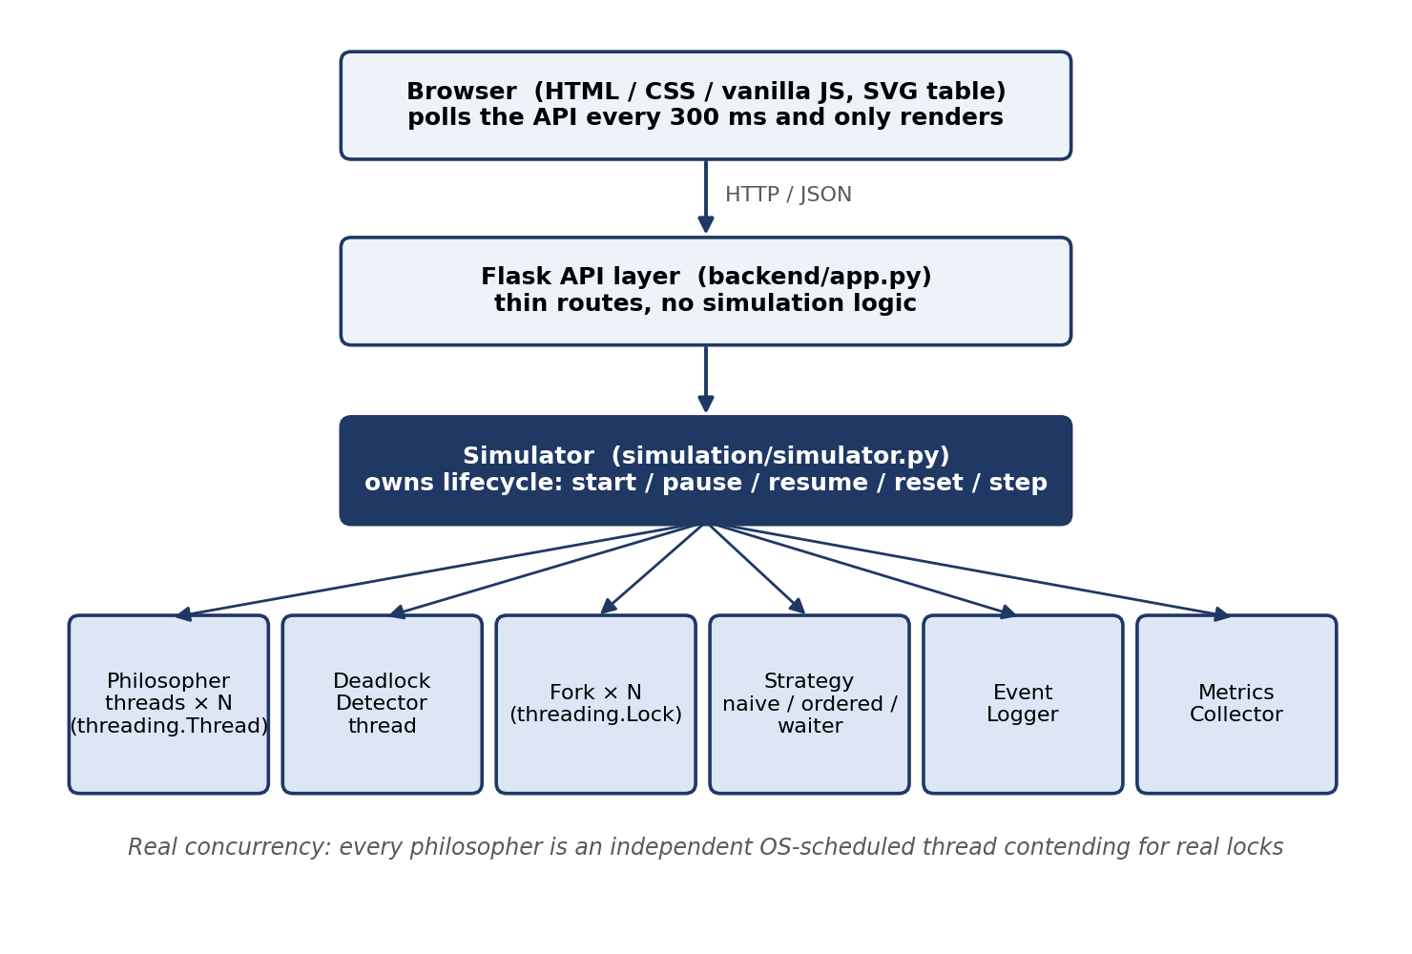
Figure 1: System architecture
3.2 Modules
Module | Responsibility
models.py | Enumerations (PhilosopherState, EventType) and the Event dataclass.
fork.py | Fork: a threading.Lock plus ownership metadata (held_by, acquired_at).
philosopher.py | Philosopher(threading.Thread): state machine and fork-acquisition loop.
strategies.py | NaiveStrategy, OrderedStrategy, WaiterStrategy behind one BaseStrategy interface.
step_controller.py | Semaphore-based gate that lets the user advance the simulation one event at a time.
deadlock_detector.py | Background thread: builds the wait-for graph and detects cycles.
simulator.py | Lifecycle owner (start, pause, resume, reset, step); produces thread-safe snapshots.
metrics.py, event_logger.py | Thread-safe counters/derived statistics and an incrementally readable event log.
app.py | Flask routes; the only module that talks HTTP, and it calls only Simulator.
frontend/ | index.html, style.css, script.js: polling and SVG rendering only.

3.3 Philosopher life cycle
Every philosopher repeats the cycle in Figure 2: think for a random time, become hungry, request the two forks chosen by the active strategy (entering WAITING whenever a fork is busy), eat for a random time, then release both forks. Think and eat times are drawn from 1–3 s and 1–2 s and divided by the speed factor (0.25×–4×).
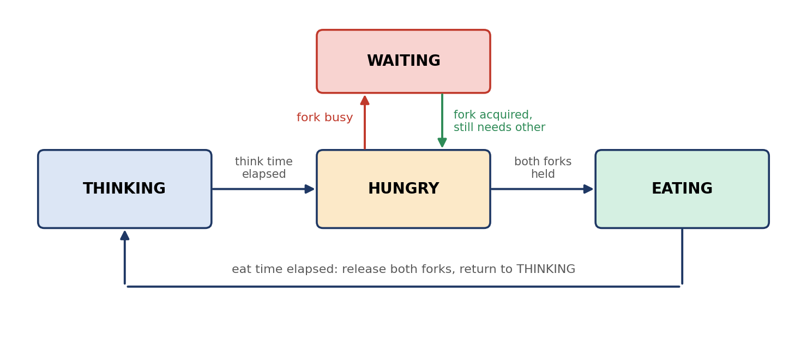
Figure 2: Philosopher state transitions
3.4 Flow of control for one dining cycle
- Ask the strategy for (first, second) = fork_order(id, N).
- Run the strategy’s pre-acquire hook (the waiter strategy takes a semaphore permit here).
- For each fork in order: poll Lock.acquire(timeout=0.05 s); on the first failure record a blocked attempt and enter WAITING; on success record the wait duration and continue.
- After the first fork, if the deadlock barrier is armed, rendezvous with the other philosophers.
- Eat, then release both forks and run the post-release hook (the semaphore permit is returned).

3.5 Strategies
All strategies share exactly the same low-level acquisition code; only the ordering policy and an optional admission gate differ. This isolates the synchronisation policy as the variable under test.
Strategy | Fork order for Pi | Extra gate | Coffman condition attacked | Deadlock possible?
Naive | Left (i), then right ((i+1) mod N) | None | None | Yes
Resource ordering | Lower-numbered fork first | None | Circular wait | No
Waiter / semaphore | Left, then right | Semaphore(N−1) around the whole acquisition | Hold-and-wait at full scale | No

Why ordering is safe. A wait-for chain under the ordering rule requires each philosopher to wait for a fork with a number no lower than the one it already holds, so along any chain the numbers of the forks being waited on can only rise. A cycle would need them to return to the start, which is impossible, so the chain always ends at a philosopher who can eat (Figure 3, right).
Why the waiter is safe. A circular wait among N philosophers requires all N to hold one fork each. The semaphore admits at most N−1, so at least one fork is always free and at least one admitted philosopher can obtain both forks.
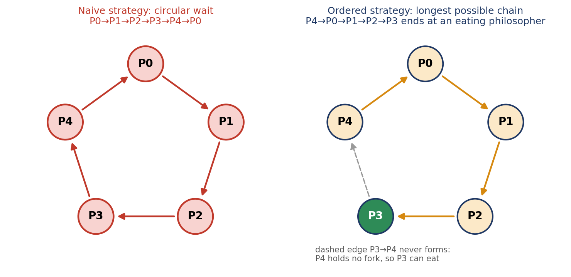
Figure 3: Circular wait under the naive strategy (left) versus the longest chain under resource ordering (right)
3.6 Deadlock detection
A philosopher waits for at most one fork at a time, so the wait-for graph (edge Pi → Pj when Pi is WAITING for a fork held by Pj) has out-degree at most one and a cycle can be found by following pointers until a node repeats. The detector thread does this every 150 ms and reports a deadlock only when the same cycle has persisted for 1.5 s, so a wait that is about to resolve is not mistaken for a deadlock. The detector runs identically under every strategy, which is how the safe strategies can be checked by observing zero detections.
3.7 Deterministic deadlock trigger
Because a naive run may not deadlock within a short demonstration (see Section 5.5), the “Force Deadlock Demo” button arms a threading.Barrier(N). Every philosopher waits at the barrier right after taking its first fork, which guarantees that all N hold their left fork at the same moment. This is still a real execution of the naive policy: the outcome is not scripted.
3.8 Web API
Route | Method | Purpose
/api/simulation/start | POST | Start a run with the chosen strategy, N and speed.
/api/simulation/pause, /resume, /reset | POST | Pause, resume or stop and archive the run.
/api/simulation/step, /manual_mode | POST | Advance one synchronisation event; toggle step mode.
/api/simulation/speed, /strategy | POST | Change speed live; switch strategy.
/api/deadlock/trigger | POST | Arm the deadlock barrier (naive strategy only).
/api/state, /events, /metrics, /comparison | GET | Live state, incremental event log, metrics, per-run comparison rows.

3.9 Assumptions
- One operator uses the tool locally; there is no authentication, persistence or multi-user separation.
- Between 3 and 10 philosophers are supported; the count and the speed are clamped to valid ranges.
- Thinking and eating are modelled as random sleeps; only fork acquisition is synchronised.
- The Flask development server is sufficient for a local demonstration.

4. Implementation
4.1 Tools and technologies
Area | Choice
Language / runtime | Python 3.10+ (developed and tested on 3.12)
Concurrency | Standard-library threading: Thread, Lock, RLock, Semaphore, Event, Barrier
Backend | Flask (tested with 3.1.3), about 1,100 lines of Python in total
Frontend | HTML5, CSS3, vanilla JavaScript and hand-built SVG; no build step or external libraries (about 550 lines)
Testing | pytest (9.1.1), 28 tests in 6 files (about 420 lines)
Storage | None: state is in memory by design

4.2 Key code
The excerpts below are abridged from the repository (github.com/yashkavar01/dining-philosophers-simulation); full listings are in the source.
Fork = lock + metadata. The lock provides mutual exclusion; held_by exists only so the API can report ownership.
def try_acquire(self, philosopher_id, timeout):
acquired = self.lock.acquire(timeout=timeout)
if acquired:
self.held_by = philosopher_id
self.acquired_at = time.monotonic()
return acquired
Strategies differ only in ordering and admission.
class NaiveStrategy(BaseStrategy):
def fork_order(self, philosopher_id, num_philosophers):
left = philosopher_id
right = (philosopher_id + 1) % num_philosophers
return left, right # no global order

class OrderedStrategy(BaseStrategy):
def fork_order(self, philosopher_id, num_philosophers):
left = philosopher_id
right = (philosopher_id + 1) % num_philosophers
return (left, right) if left < right else (right, left)

class WaiterStrategy(BaseStrategy):
def pre_acquire_hook(self, philosopher):
philosopher.simulator.dining_semaphore.acquire() # Semaphore(N-1)
def post_release_hook(self, philosopher):
philosopher.simulator.dining_semaphore.release()
Acquisition loop. The loop polls with a 50 ms timeout instead of blocking indefinitely, so Pause, Reset and Step stay responsive even while a philosopher is genuinely deadlocked. A philosopher never releases a fork it already holds while polling, so hold-and-wait is fully preserved.
first_id, second_id = strategy.fork_order(self.id, sim.num_philosophers)
strategy.pre_acquire_hook(self)
for fork_id in (first_id, second_id):
fork = sim.forks[fork_id]
while not sim.stop_event.is_set():
if fork.try_acquire(self.id, timeout=POLL_INTERVAL): # 0.05 s
break # got the fork
if not reported_blocked: # first failed attempt
sim.metrics.record_blocked()
self._enter_waiting(fork_id, fork.held_by)
reported_blocked = True
...
if sim.deadlock_barrier is not None and fork_id == first_id:
sim.deadlock_barrier.wait(timeout=5) # forced-deadlock rendezvous
Wait-for graph and cycle detection.
def _build_wait_for_graph(self):
graph = {}
with sim.state_lock:
for p in sim.philosophers:
if p.state == PhilosopherState.WAITING and p.waiting_for_fork is not None:
holder = sim.forks[p.waiting_for_fork].held_by
if holder is not None:
graph[p.id] = holder # edge: Pi waits for P_holder
return graph

def _find_cycle(graph):
for start in graph:
visited, seen, node = [], set(), start
while node in graph:
if node in seen:
return visited[visited.index(node):]
seen.add(node); visited.append(node)
node = graph[node]
return None
4.3 Concurrency problems found and how they were handled
- Display race. state and waiting_for_fork were first written in two separate lock acquisitions, so a snapshot could see WAITING with no fork named. _enter_waiting() now sets both under one state_lock acquisition.
- No leaked forks. Release runs in a finally block, so a philosopher stopped mid-deadlock still returns its forks and semaphore permit.
- Reset while deadlocked. Reset sets the stop event, aborts the barrier and joins every thread, so no stale threads survive into the next run.
- Re-entrant state lock. Simulator.state_lock is an RLock because simulator methods that already hold it call others that also acquire it.

5. Results & Discussion
5.1 Experimental setup
Each strategy was run once for 40 s with five philosophers at 4× speed (think and eat times divided by four), driving the Simulator directly and reading metrics.snapshot() at the end. The forced-deadlock run was armed 1 s after start and therefore observed for 41 s. Environment: Linux, Python 3.12.3, Flask 3.1.3. All wait times are wall-clock seconds at 4× speed. Each figure is from a single run; repeated trials were not performed.
5.2 Screenshots of the running system
Figure 4 shows the naive strategy after the deadlock trigger: all five philosophers are WAITING, every fork is held, the red banner reports the cycle, and the arrows on the table draw the wait-for edges. Figure 5 shows the same table under resource ordering, where philosophers keep cycling and only a short, non-circular wait (P4 on F0) is visible.
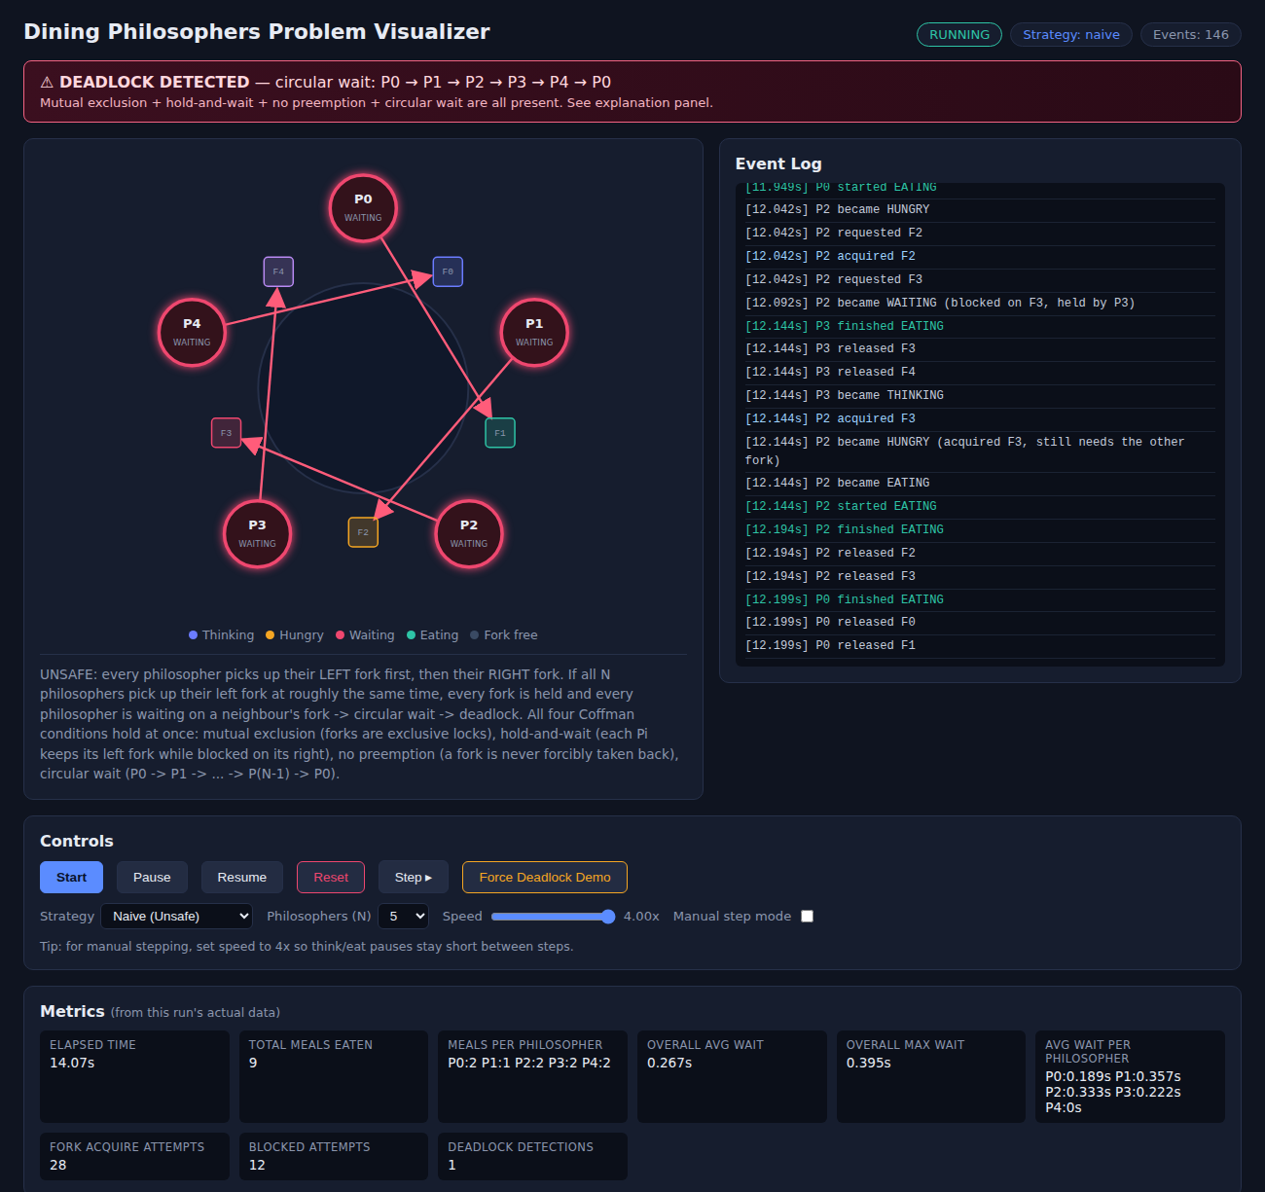
Figure 4: Naive strategy after “Force Deadlock Demo” – DEADLOCK DETECTED with cycle P0 → P1 → P2 → P3 → P4 → P0
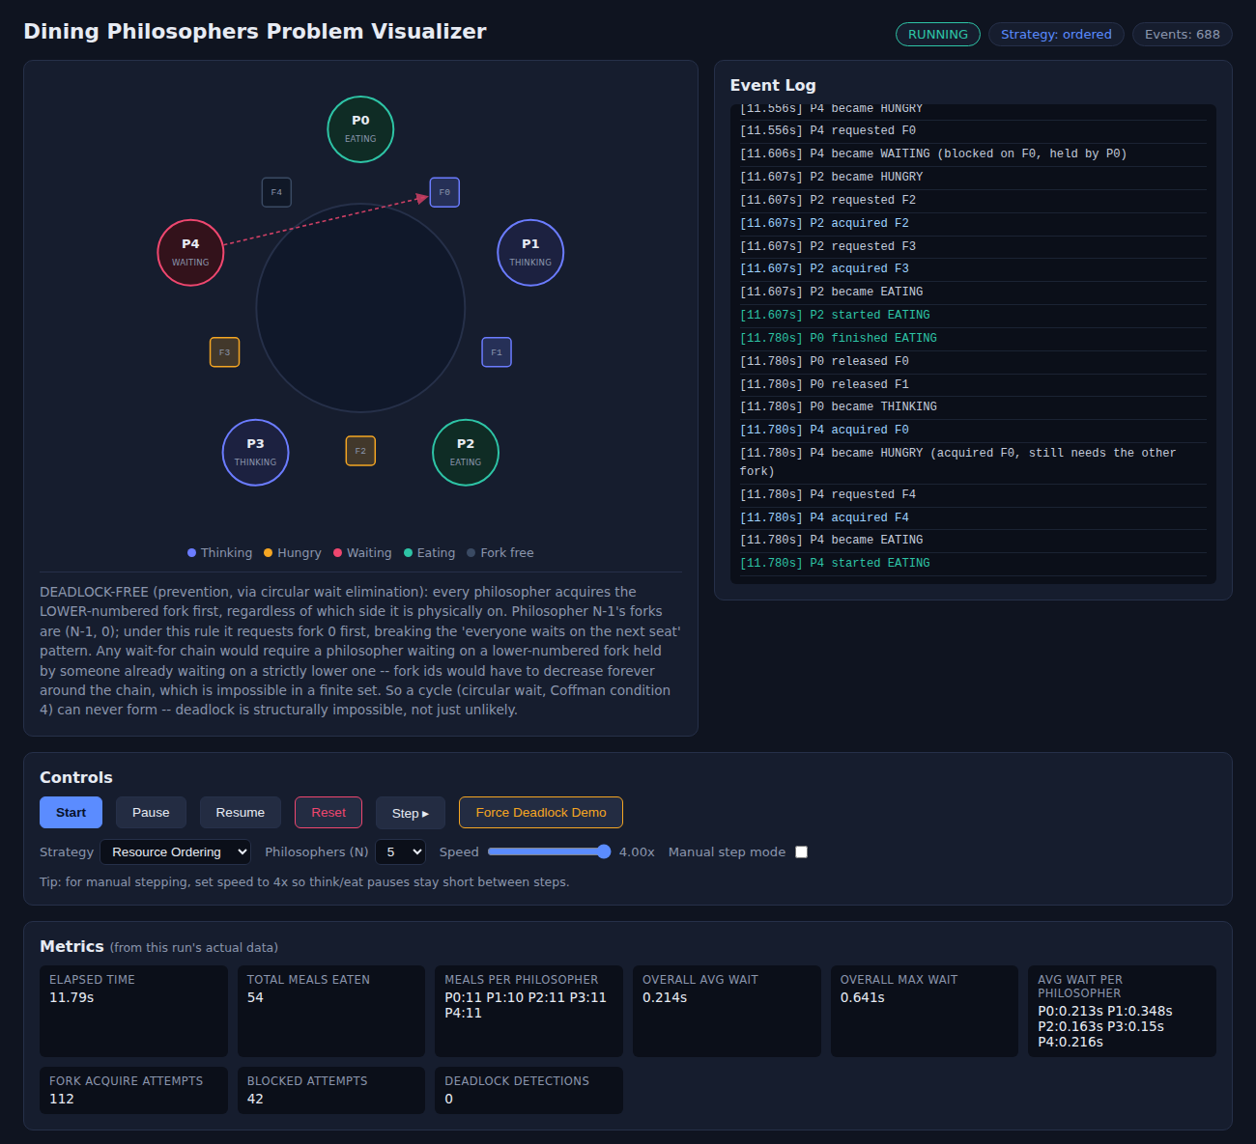
Figure 5: Resource-ordering strategy, 54 meals in 11.8 s, zero deadlock detections
5.3 Reproducing the deadlock
The event log below is real output from a forced-deadlock run. Once every philosopher has taken its first fork, all five request the next one, all five block, and about 1.5 s later the detector confirms the cycle. The five edges of the wait-for graph are {0:1, 1:2, 2:3, 3:4, 4:0}.
[ 1.713s] P1 acquired F1
[ 1.713s] P1 requested F2
[ 1.713s] P0 requested F1
[ 1.713s] P2 requested F3
[ 1.713s] P4 requested F0
[ 1.713s] P3 requested F4
[ 1.763s] P3 became WAITING (blocked on F4, held by P4)
[ 1.763s] P1 became WAITING (blocked on F2, held by P2)
[ 1.763s] P0 became WAITING (blocked on F1, held by P1)
[ 1.763s] P2 became WAITING (blocked on F3, held by P3)
[ 1.763s] P4 became WAITING (blocked on F0, held by P0)
[ 3.306s] DEADLOCK DETECTED: circular wait P0 -> P1 -> P2 -> P3 -> P4 -> P0
5.4 Strategy comparison
Metric (40 s, N = 5, 4×) | Naive  (no trigger) | Naive  (forced) | Resource  ordering | Waiter /  semaphore
Total meals | 191 | 5 | 185 | 187
Meals per philosopher (P0–P4) | 38, 38, 39, 38, 38 | 1, 1, 1, 1, 1 | 37, 37, 37, 38, 36 | 38, 37, 37, 36, 39
Deadlock detections | 0 | 1 | 0 | 0
Fork acquire attempts | 384 | 20 | 375 | 378
Blocked attempts | 154 | 11 | 154 | 141
Average wait (s) | 0.198 | 0.215 | 0.220 | 0.205
Maximum wait (s) | 0.532 | 0.409 | 0.699 | 0.651
Mean fork utilisation | 0.720 | 0.019 | 0.711 | 0.705

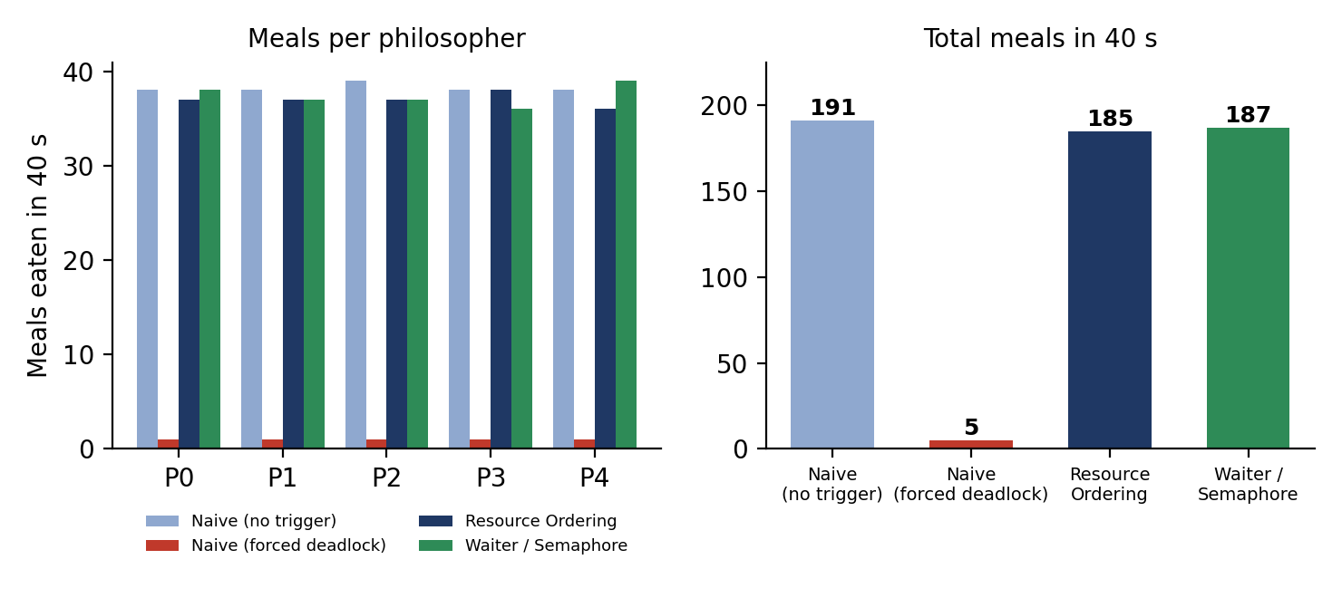
Figure 6: Meals per philosopher (left) and total meals (right) over 40 s
The application also builds its own comparison table from completed runs. Figure 7 shows it after three short (12–14 s) interactive runs of ordering, waiter and forced-naive.
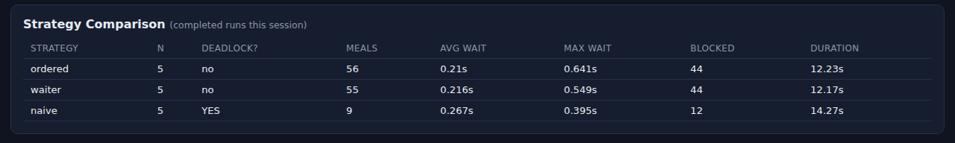
Figure 7: The in-app “Strategy Comparison” table
5.5 Discussion
- The deadlock is genuine. In the forced run each philosopher completed one meal, then all five ended WAITING, forks F0–F4 were each held by a different philosopher, the five-node cycle was detected, and no further meals occurred for the rest of the 41 s.
- A naive run does not always deadlock. The untriggered naive run completed 191 meals with no detection. Deadlock needs all five philosophers to take their left fork inside the same very short window, and random think times spread their requests out. Passing a test run therefore proves nothing about the naive policy; this is why the trigger exists, and it is also why the safety of the other two strategies rests on the structural arguments in Section 3.5, with the zero-detection runs serving as confirmation.
- Both prevention strategies keep the system live. Ordering and waiter completed 185 and 187 meals with zero detections. Their totals are within about 3% of the untriggered naive run, which is within what a single 40 s run can distinguish, so no ranking between them is claimed. In this workload eating and thinking dominate, so the cost of prevention is small.
- No starvation was observed, but none is guaranteed. Per-philosopher meals ranged from 36 to 39 and the longest single wait was 0.70 s. Lock.acquire() gives no first-in-first-out guarantee, so this is a measurement, not a proof.
- Utilisation exposes the cost of deadlock. Mean fork utilisation was about 0.71 in the live runs and 0.019 in the deadlocked run: the forks were held but not used.
- Metric caveat. A wait is recorded only when it ends in a successful acquisition, so the permanent waits in a deadlock do not appear in the average or maximum wait of the forced run. In that run the deadlock shows up in the detection count, the philosopher states and the stalled meal count instead.

5.6 Automated testing
All 28 tests pass (pytest tests -v: 28 passed in 30.84 s). Most tests run the real concurrency engine for a second or two instead of mocking it.
Test file | Tests | What it checks
test_fork.py | 4 | Mutual exclusion under an 8-thread stress test; metadata set and cleared; second acquire blocks until release; release by a non-owner is a no-op.
test_strategies.py | 5 | Naive has no global order; ordered picks the lower fork first and breaks the naive asymmetry; waiter exposes its hooks; every strategy explains itself.
test_philosopher.py | 3 | States are always valid; fork ownership is consistent and never double-booked; philosophers eat under a safe strategy.
test_deadlock.py | 4 | Naive deadlocks when triggered; ordered and waiter never deadlock over a timed run and make progress; the trigger is rejected outside naive mode.
test_simulation.py | 9 | Reset leaves no stale threads; pause and resume; event ids monotonic; incremental event fetch; fresh metrics per run; count clamped to 3–10; history archived; manual step gating.
test_metrics.py | 3 | Average and maximum wait against hand-computed values; counters; zero activity gives zeros, not placeholders.

5.7 “What if” cases
Situation | Behaviour
Reset while all philosophers are deadlocked | Stop event set, barrier aborted, forks released in finally, all threads joined (test: no stale threads).
Philosopher count outside 3–10, speed outside 0.25×–4× | Values are clamped to the valid range (tested for the count).
Deadlock trigger requested under a safe strategy | Rejected; only the naive strategy can be forced (tested).
Fork released by a thread that does not own it | Ignored as a safe no-op (tested).
Pause during a deadlock or a normal run | Progress freezes and resumes on demand; the polling loop keeps checking the pause flag (tested).

6. Conclusion & Future Scope
6.1 Conclusion
The project shows that deadlock and deadlock prevention can be observed rather than only described. The same threads and locks that freeze permanently under the naive policy make continuous progress under resource ordering or the waiter, with no change to the resource model, only to the ordering and admission policy. Deadlock was reproduced on demand, detected algorithmically through a wait-for graph, and avoided by two strategies that attack different Coffman conditions. The results are backed by 28 automated tests and by measured, not scripted, data.
6.2 Limitations
- No fairness or starvation-freedom guarantee is implemented; only a maximum-wait proxy is measured.
- Only prevention is implemented; deadlock avoidance (Banker’s Algorithm) is out of scope.
- Results come from single 40 s runs at 4× speed; a statistical comparison would need repeated trials.
- Fork utilisation counts only time spent eating, not time spent holding one fork while blocked.
- The Flask development server and in-memory state make it a local teaching tool, not a production service.

6.3 Future scope
- A monitor or condition-variable strategy that acquires both forks atomically, attacking hold-and-wait directly.
- Banker’s-Algorithm-style deadlock avoidance as a contrasting fourth approach.
- A fair, ticket-based fork queue with a bounded-wait test, moving fairness from “measured” to “guaranteed”.
- A batch benchmark that repeats each strategy many times and reports means and confidence intervals.
- Optional persistence of run history across server restarts.

7. References
- Dijkstra, E. W. (1971). Hierarchical ordering of sequential processes. Acta Informatica, 1(2), 115–138.
- Coffman, E. G., Elphick, M. J., & Shoshani, A. (1971). System deadlocks. ACM Computing Surveys, 3(2), 67–78.
- Silberschatz, A., Galvin, P. B., & Gagne, G. (2018). Operating System Concepts (10th ed.). Wiley. Chapters on process synchronisation and deadlocks.
- Tanenbaum, A. S., & Bos, H. (2015). Modern Operating Systems (4th ed.). Pearson. Section on the dining philosophers problem.
- Python Software Foundation. threading - Thread-based parallelism. Python 3 documentation. https://docs.python.org/3/library/threading.html
- Pallets Projects. Flask documentation. https://flask.palletsprojects.com/
- pytest documentation. https://docs.pytest.org/
- Project source code, tests and documentation: https://github.com/yashkavar01/dining-philosophers-simulation

