Contents

Sign In 2

Register 3

Home Screen 4

Navigation Drawer 5

Maps 6

Report 7

Pie Diagram 7

Line graph 8

Bar Graph 9

# Sign In

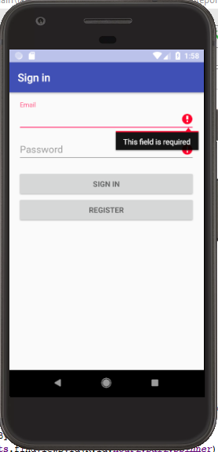

# Register

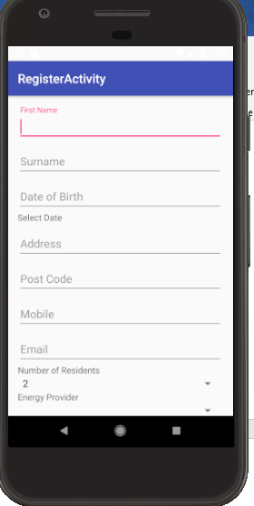

# Home Screen

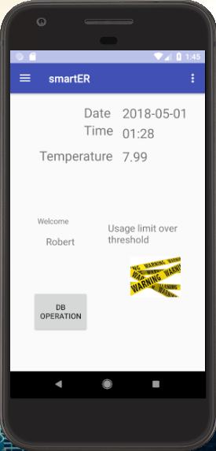

# Navigation Drawer

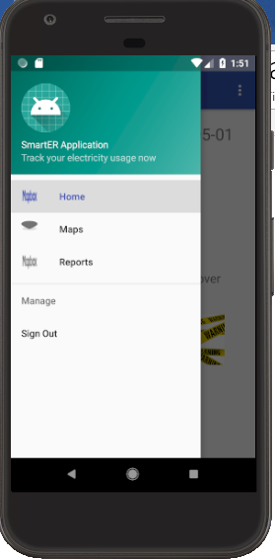

# Maps

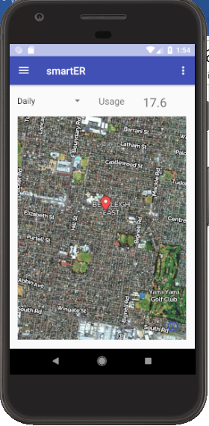

# Report

## Pie Diagram

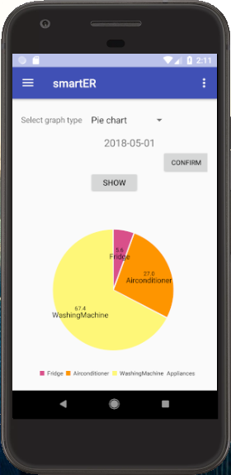

## Line graph

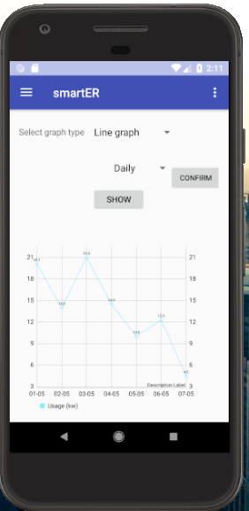

## Bar Graph

