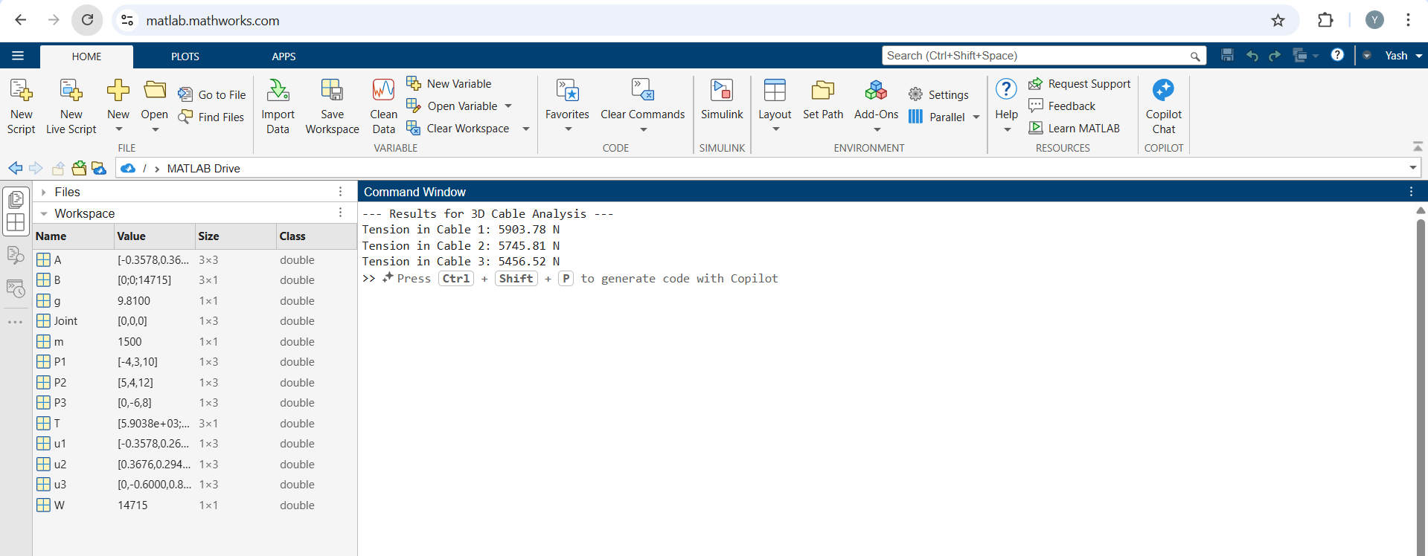
Figure 1: MATLAB Code Result

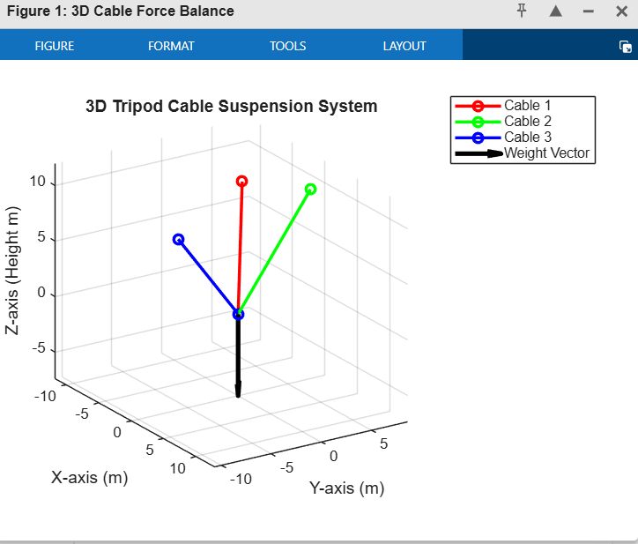
Figure 2: 3D Cable Force Balance

