Fullstackopen
Visit https://fullstackopen.com

Fundamentals

- Always keep the developer console open while doing web development
As well as check the disable the cache from the console, hide extension URLs and enable the preserve log option
- Each image, each file, each individual file is fetched using a separate HTTP request by the browser

Concat function
const arr1 = [1, 2, 3, 4, 5];
const arr2 = [6, 7, 8, 9, 10];

const arr3 = arr1.concat(arr2);

console.log(arr3);

In react, we are advised to use contants only! So concat is the function to merge to arrays or add new items into an array and save them in a new array. So no item is mutated.

Map
// MAP
const words = ["hello", "world", "how", "do you do"];
const newwords = words.map((word) => {
return "New " + word;
})
console.log(newwords);

Map is another useful function in javascript which we can use to modify every item of the array and form a new array out of it. The returned value is saved as a value in the new array;

Destructing Assignment
// Destructing assignment
const array = [1, 2, 3, 4, 5, 6, 7, 8, 9, 10];
const [first, last, ...all] = array;
console.log(first); // 1
console.log(last); // 2
console.log(all); // [3, 4, 5, 6, 7, 8, 9, 10]

Destructing assignment takes an array and assigns it’s values to variables / constants.

Object Destructuring
// Object destructuring
const yash = {
name: "Yash Kolambekar",
age: 18,
dob: "20/02/2005",
country: "Bharat"
}
const {name, country} = yash;
console.log(name); // Yash Kolambekar
console.log(country); // Bharat

We can assign the values from an object to variables or constants directly from the object using object destructuring.

React

To create a react app, we do
npm create vite@latest appname -- --template react

This created a react a new react app with vite, in a newfolder named appname
We can do `npm run dev` to start the server and check our react app in the browser
Everything in a React app that can be seen on the browser is a react component, including the main App.jsx file, so the App.jsx is a component in itself.
This is how a component looks like
const App = () => {
let a = 12;
let b = 12;
return (
<div>
<p>Hello world</p>
<p>{a} plus {b} is {a + b}</p>
</div>
)
}

export default App

The returned value is actually what we will be seeing on the frontend when that component is used somewhere. And we can also evaluate js within the html using curly braces.
The first letter of the react component name should always be capital or else react will think that it is a normal html component. This should be kept in mind everytime.
We can define many different components in a single file but only one can be exported from a single file.
We can pass parameters to a component, known as props, this enables us to serve dynamic data to the components.
const Hello = (props) => {
return(
<div>
<p>Hello {props.client_name}, you are {props.age} years old!</p>
</div>
)
}

This Hello component takes in two props “client_name” and “age” . We have to pass the props when we are calling the component
const App = () => {
return (
<div>
<p>Greetings</p>
<Hello client_name='Yash' age="18" />
<Hello client_name="Sai" age="19" />
<Hello client_name="Siddhi" age="17" />
<Hello client_name="Bhakti" age="16" />
</div>
)
}

As we called the Hello component several times in the above example, it will give an output like
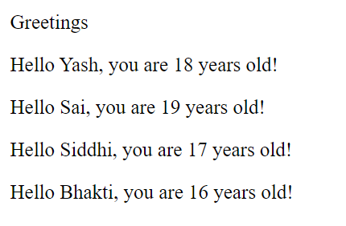
This feature of react will be essential for us to easily embed data into the components without much of a hassle
In react we need to give every component an outer wrapper or the root element and without it, the react compiler will throw errors, to avoid this, we can use on smart trick, we can create an empty element and use it as the root element in our component, it won’t be render in our browser and we can easily bypass the need of the extra root element div too!
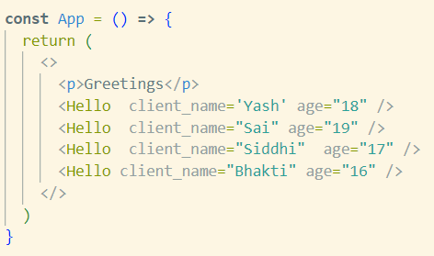

We can also take in props directly through object destructuring
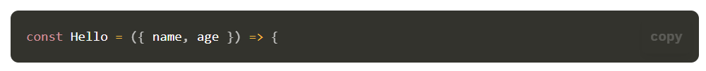

useState
States are like variables that store values that can be used in the app like normal variables but the thing that makes it different from the variables is that the component is re-rendered when the value of the variable is updated.
To use states in our react app, we have to
Once, that is done we can start using states in our react app
Here, we have defined the state (variable) named counter and a function named setCounter which updates the value of counter and sets its equal to the parameter passed in that function.
We can create a function to add or subtract or replace the values of that state, using the setState function inside it.
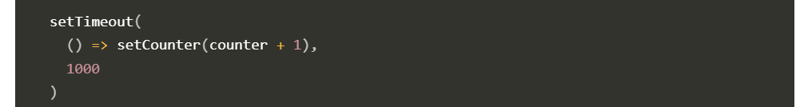
And we can let it run on clicks of a button too
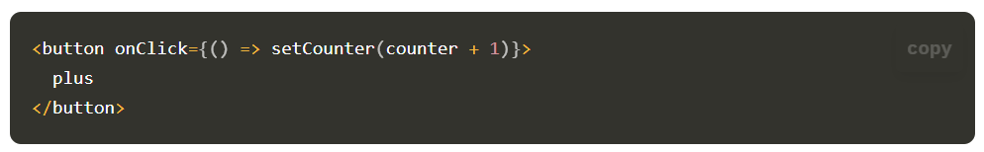
Ideally, we should create the functions outside the jsx and then reference them inside jsx when we need. Like this:
