Weather Data Analysis
Temperature, humidity and seasonal trends in Delhi, 2013–2017
Project report | Prepared by Yash, MCA, Karnatak University, Dharwad | Python, Pandas, Matplotlib, Seaborn

1. Summary
This project analyses 1,575 days of daily weather observations for Delhi (2013-01-01 to 2017-04-24). After cleaning the data, it measures how temperature, humidity, wind and pressure change through the year and compares months, seasons and years.
- Strong seasonality. June is the hottest month (33.7°C on average) and January the coolest (13.8°C), an annual swing of 19.9°C.
- Hot and dry before the monsoon, humid during it. Average humidity falls to 35.7% in May and recovers to about 70.6% in July–August. Temperature and humidity are negatively correlated (r = -0.57).
- Rain-bearing conditions are concentrated in July and August. About 54% of July days and 53% of August days were warm and humid, against 0% from November to April (a proxy, because the dataset has no rainfall column).
- The record warms across the period. 2016 was the warmest full year (27.1°C vs 24.79°C in 2013), but four years is too short to call this a climate trend.

2. Data
Source: Daily Climate time series data (Kaggle, by Sumanth Vrao), daily means for Delhi. The Kaggle train and test files were combined into one continuous series. Variables: mean temperature (°C), relative humidity (%), wind speed (km/h) and mean atmospheric pressure (hPa).
Important limitation: the dataset contains no rainfall measurements. To still address rainfall, the project counts “warm and humid days” (humidity ≥ 70% and temperature ≥ 25°C) as a rain-bearing proxy. The temperature condition removes cold, foggy winter days, which are humid but not rainy. Treat it as an indicator of monsoon-type conditions, not as millimetres of rain.

3. Cleaning and quality checks
All fixes are performed by code (src/cleaning.py) and logged to outputs/tables/cleaning_audit.json, so the process is reproducible.
Check | Result | Action taken
Missing values | None in any column | Interpolation logic kept in the pipeline
Gaps in the daily calendar | 0 missing dates | None needed
Duplicate dates | 1 (2017-01-01) | Kept the later, complete record
Incorrect records | 10 pressure values outside 980–1050 hPa | Set to missing, then time-interpolated
Rows | 1,576 raw to 1,575 clean | Saved to data/processed/

The invalid pressure readings include impossible values such as 7,679 hPa (2016-03-28) and −3 hPa (2016-08-16); nine of the ten fall in 2016. Temperature, humidity and wind were within plausible ranges, so no other values were changed.
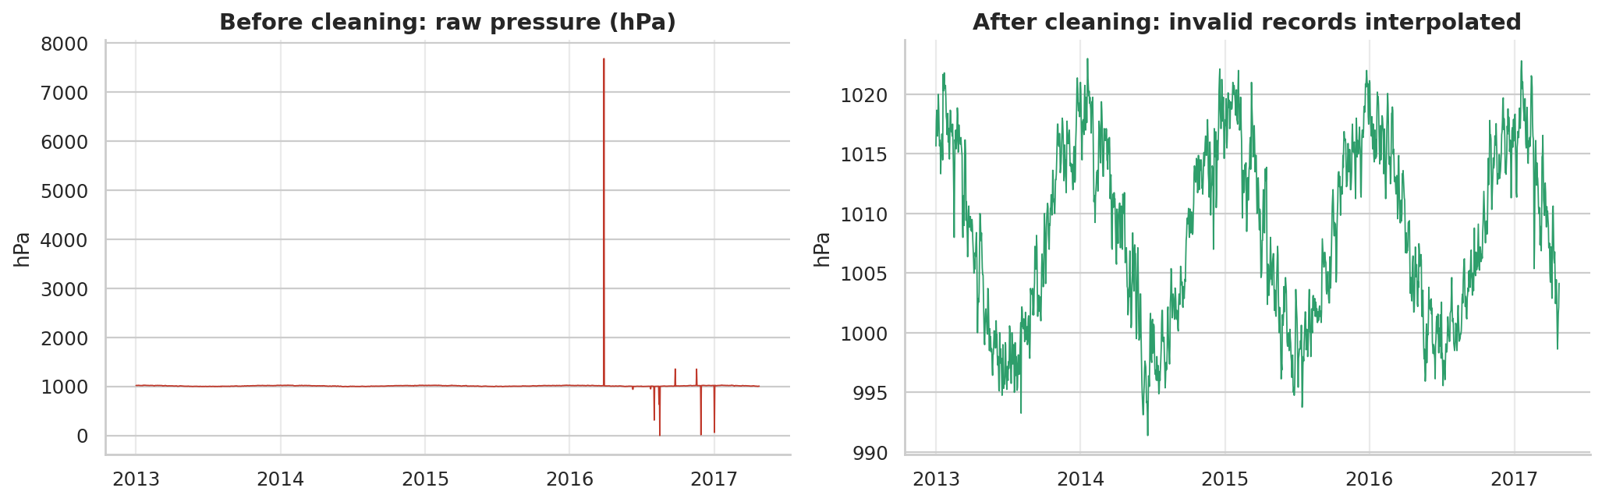
Figure 1. Pressure before and after removing invalid records.

4. Findings

4.1 Temperature
Temperature follows a clear annual cycle. It rises from 13.8°C in January to a May–June peak (33.3°C and 33.7°C), eases through the monsoon months (about 30.6°C in August) and drops again from October. The hottest recorded day was 2013-05-25 (38.71°C) and the coldest was 2013-01-05 (6°C).
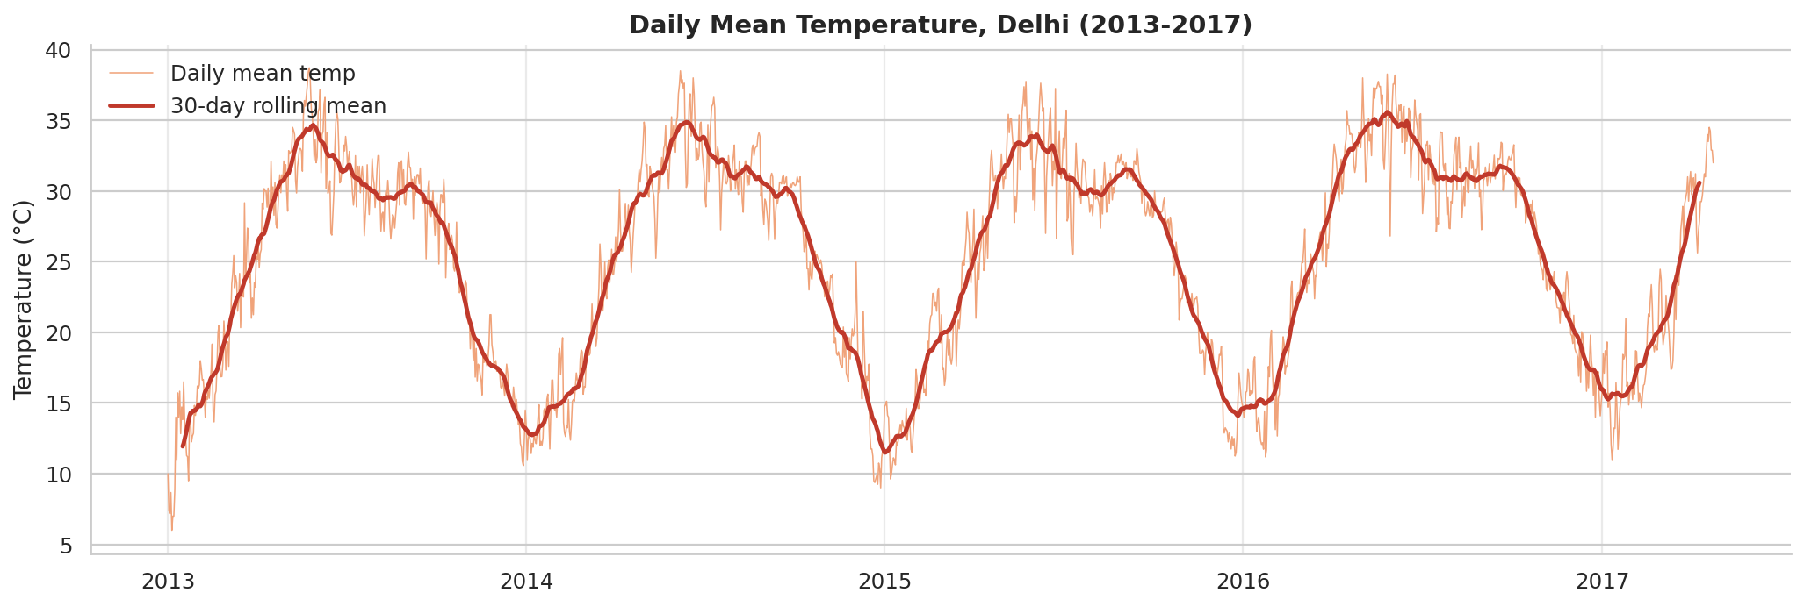
Figure 2. Daily mean temperature with a 30-day rolling mean.
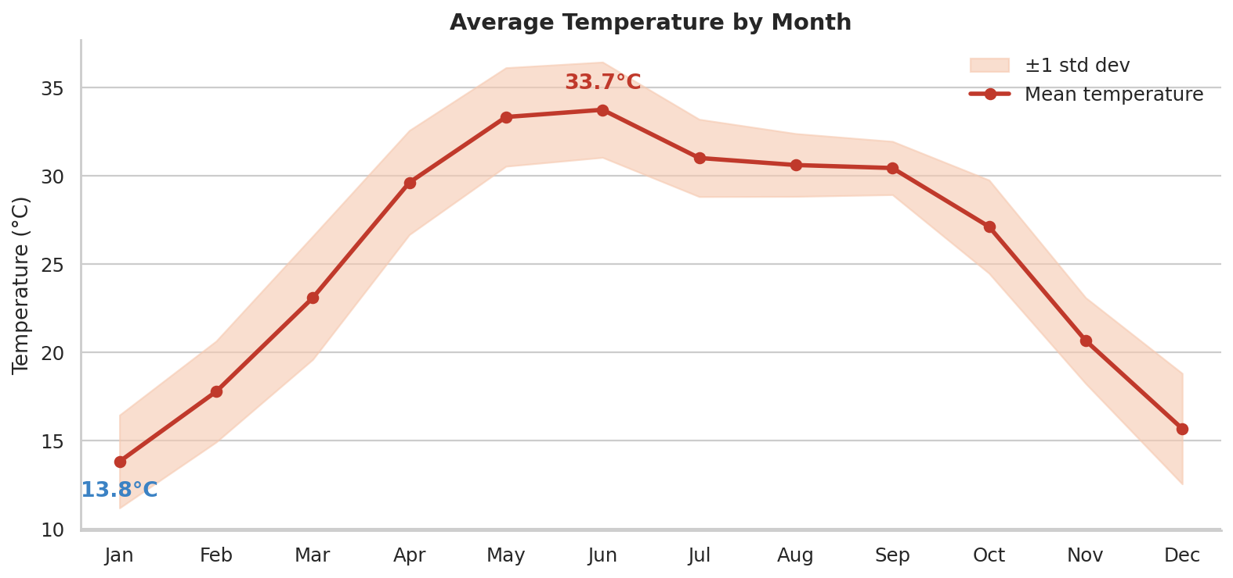
Figure 3. Average temperature by month (shaded band = ±1 standard deviation).

4.2 Humidity
Humidity moves opposite to temperature. The driest months are April and May (37.6% and 35.7%). January has the highest average (78.2%) which is consistent with cool winter air and fog, followed by December (72.4%) and the monsoon months July and August (about 70.6%). The overall temperature–humidity correlation is -0.57.
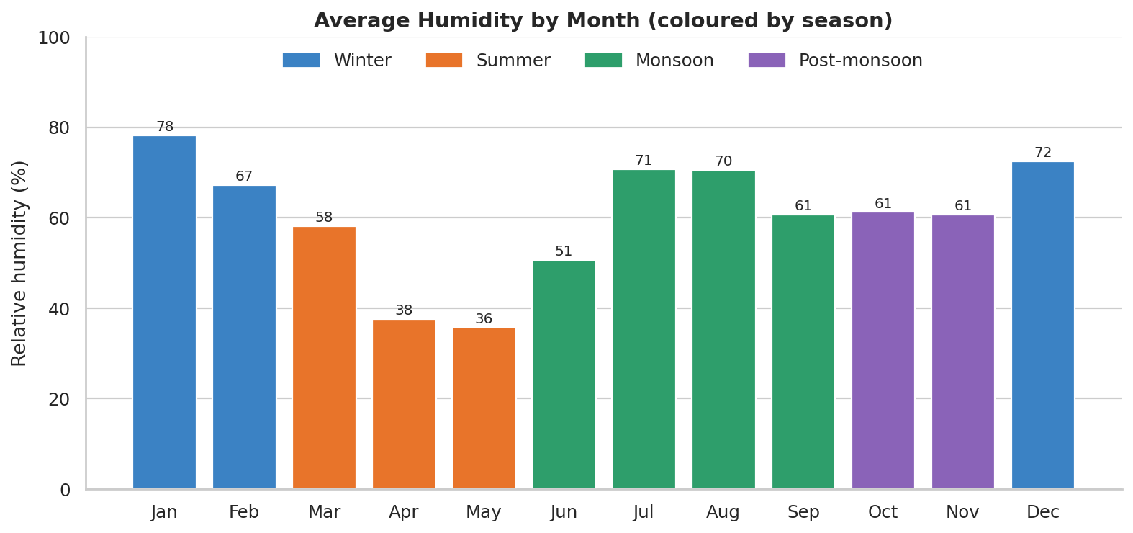
Figure 4. Average humidity by month, coloured by season.
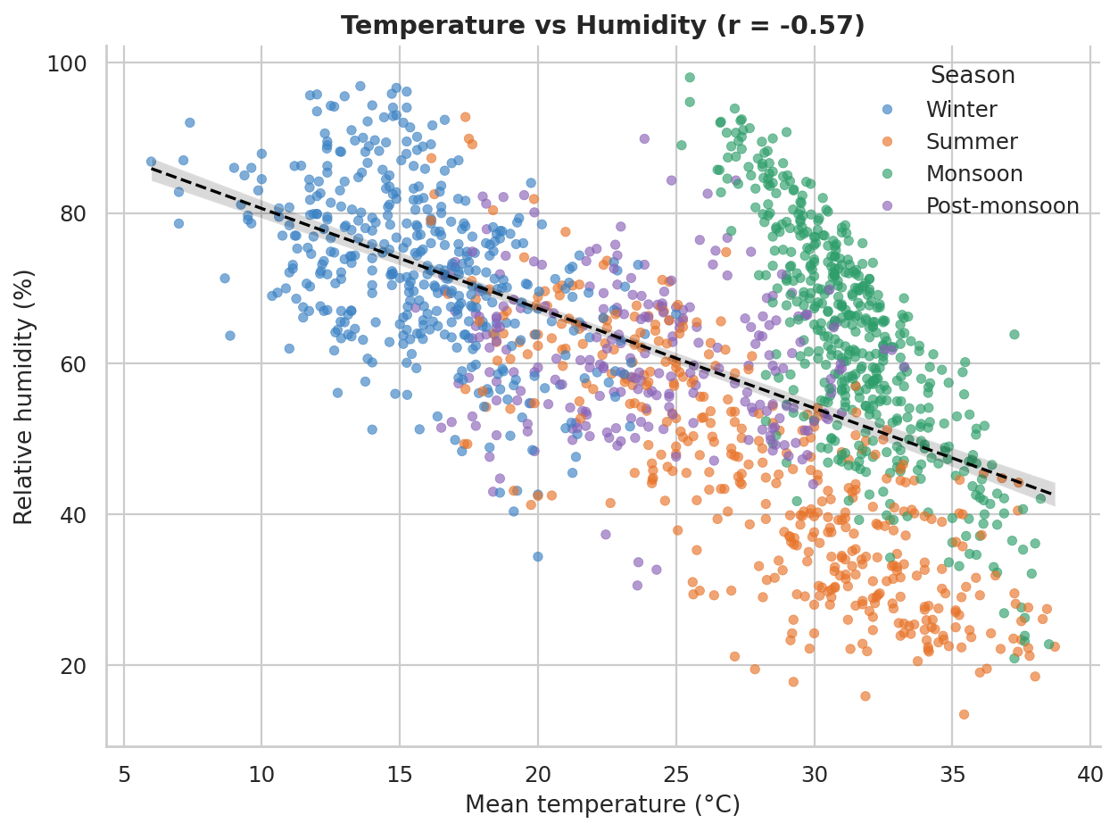
Figure 5. Temperature vs humidity. Monsoon days form a warm and humid cluster.

4.3 Rainfall proxy
Warm and humid days are almost absent from November to May. They jump to 8.3% of days in June, peak in July (54.0%) and August (53.2%), and fade through September (18.3%). Across the monsoon season as defined by the IMD (June–September), 33.8% of days met the condition.
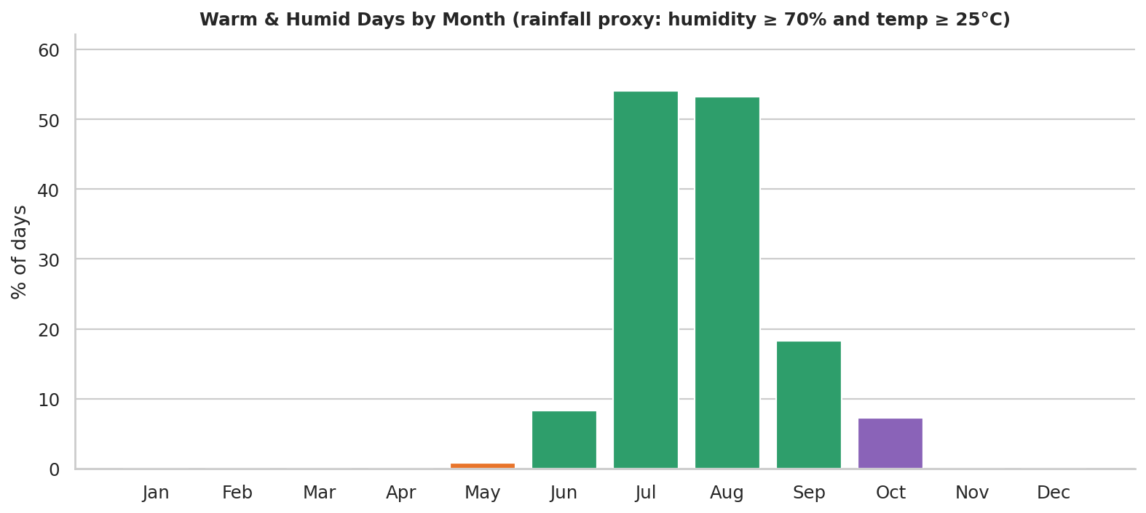
Figure 6. Share of warm and humid days by month (rainfall proxy).

4.4 Month and season comparison
Month | Temp (°C) | Humidity (%) | Wind (km/h) | Pressure (hPa) | Warm & humid days (%)
Jan | 13.8 | 78.2 | 5.4 | 1018.1 | 0.0
Feb | 17.8 | 67.3 | 6.7 | 1015.4 | 0.0
Mar | 23.1 | 58.2 | 7.9 | 1012.3 | 0.0
Apr | 29.6 | 37.6 | 8.8 | 1006.6 | 0.0
May | 33.3 | 35.7 | 9.0 | 1002.0 | 0.8
Jun | 33.7 | 50.6 | 9.4 | 998.4 | 8.3
Jul | 31.0 | 70.6 | 7.4 | 998.5 | 54.0
Aug | 30.6 | 70.5 | 6.9 | 1001.0 | 53.2
Sep | 30.4 | 60.7 | 7.6 | 1004.6 | 18.3
Oct | 27.1 | 61.2 | 4.8 | 1010.5 | 7.3
Nov | 20.7 | 60.6 | 3.9 | 1014.6 | 0.0
Dec | 15.7 | 72.4 | 4.8 | 1016.6 | 0.0

Wind is strongest in June (9.4 km/h) and weakest in November (3.9 km/h). Pressure moves with temperature (r = -0.88): about 1018.1 hPa in January against 998.4 hPa in June. By season, winter averages 15.7°C, the pre-monsoon summer 28.3°C, the monsoon 31.4°C and the post-monsoon 23.9°C. The monsoon block averages hotter than summer because June, the hottest month, belongs to it.
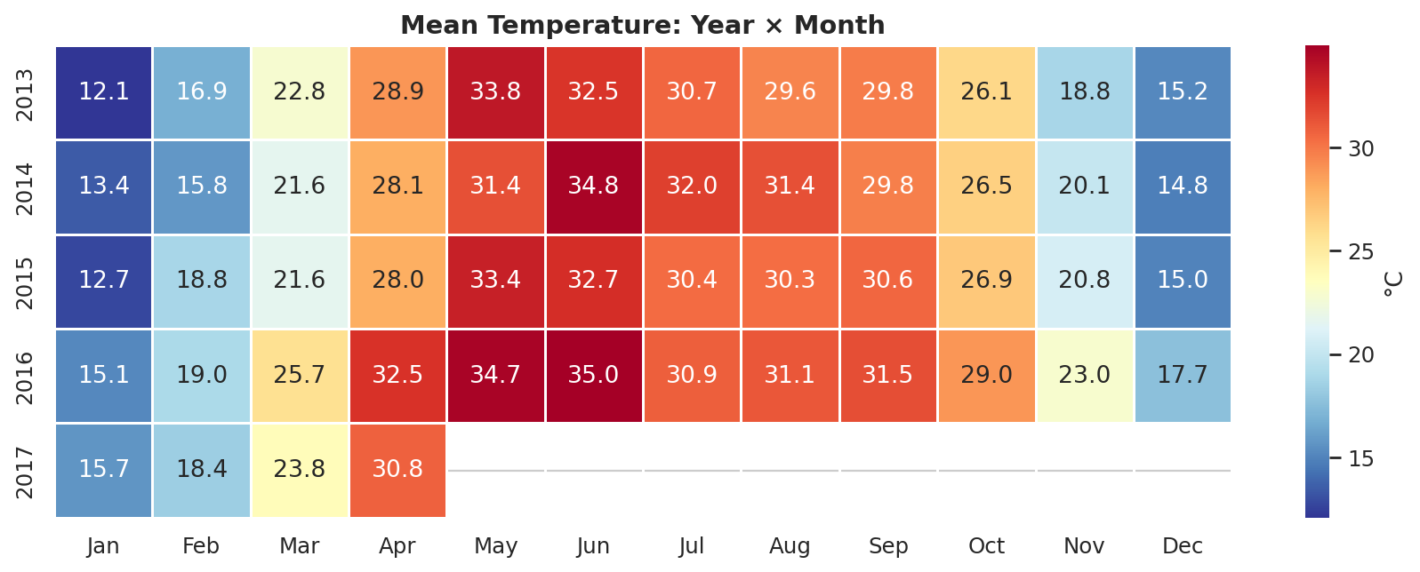
Figure 7. Mean temperature by year and month.
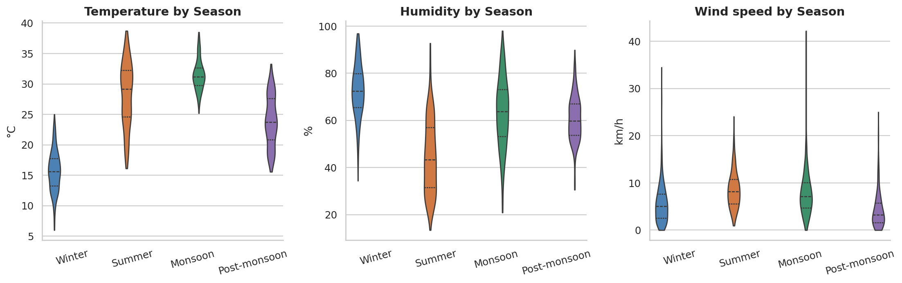
Figure 8. Temperature, humidity and wind speed distributions by season.

4.5 Year-over-year change
Among the four complete years, mean temperature rose from 24.79°C (2013) to 27.1°C (2016) and mean humidity fell from 63.05% to 58.74%. After removing the seasonal cycle, monthly temperature anomalies increase by about 0.658°C per year (r = 0.66, 52 months) and humidity anomalies fall by about 1.496 percentage points per year. These slopes describe this short record only. They should not be read as a long-term climate trend, and part of the shift may reflect changes in how the data were collected.

5. Limitations
- No rainfall column: the warm-and-humid-day measure is a proxy and cannot give rainfall amounts.
- One location and a short record (about 4.3 years); 2017 covers January to April only, so year comparisons use 2013–2016.
- Daily means hide extremes; the dataset has no daily minimum or maximum temperature.
- Pressure values were repaired by interpolation, so pressure statistics are approximate for the ten affected days.

6. Conclusion and next steps
The data shows a pronounced hot, dry pre-monsoon (April to June), a humid monsoon peak in July and August, and a cool, foggy and humid winter. Temperature, humidity and pressure are tightly linked through the seasonal cycle. Natural extensions are adding a dataset with real rainfall, forecasting temperature with a time-series model (for example SARIMA or Prophet), and repeating the pipeline for other Indian cities.

