**LAB-1**

Create Database and Tables(Person, Car, Accident, Owns, Participated)

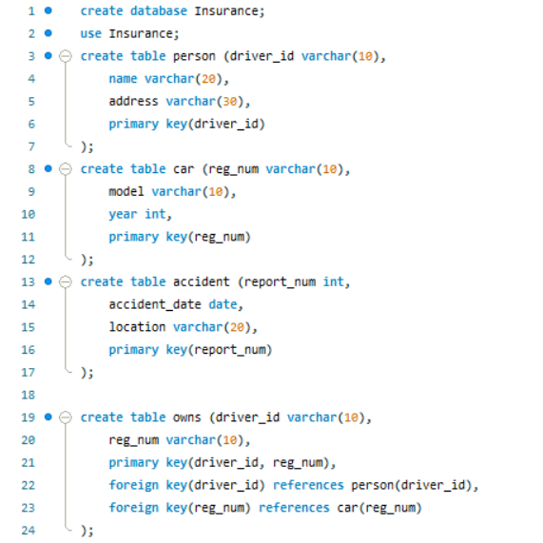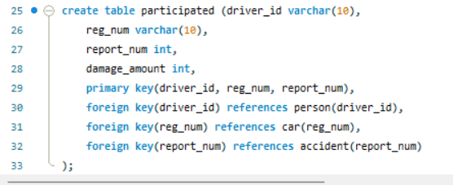

Insert in Tables

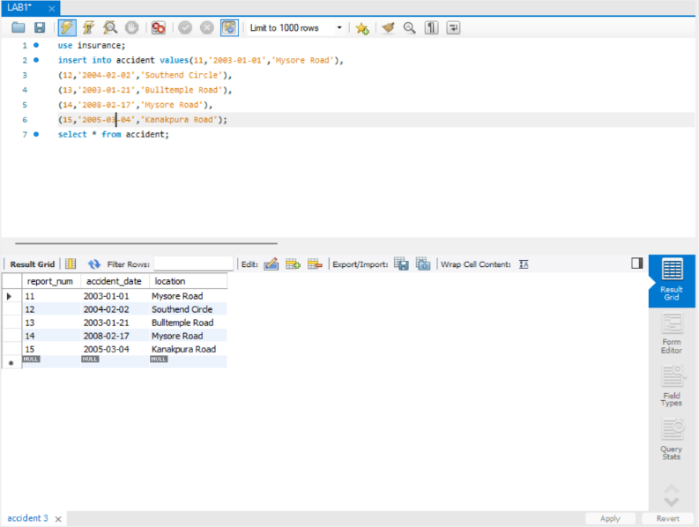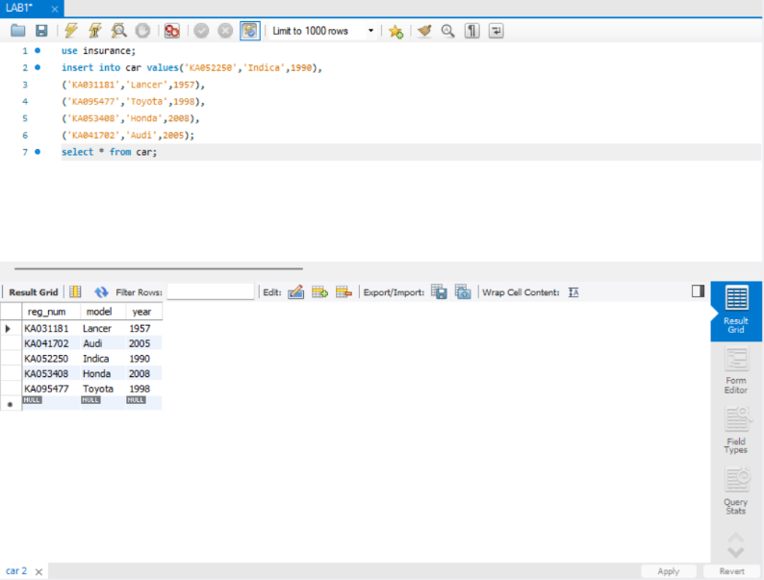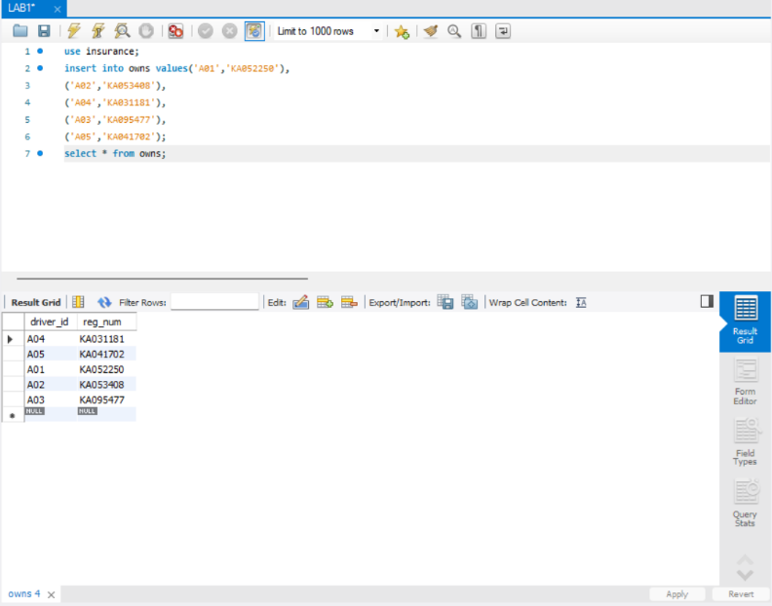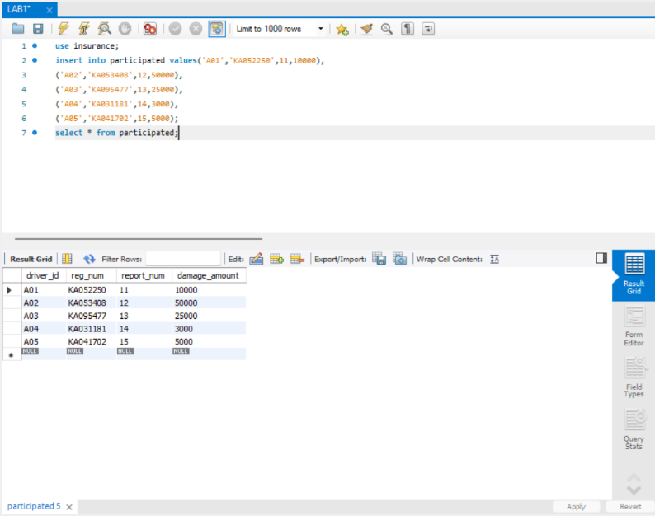

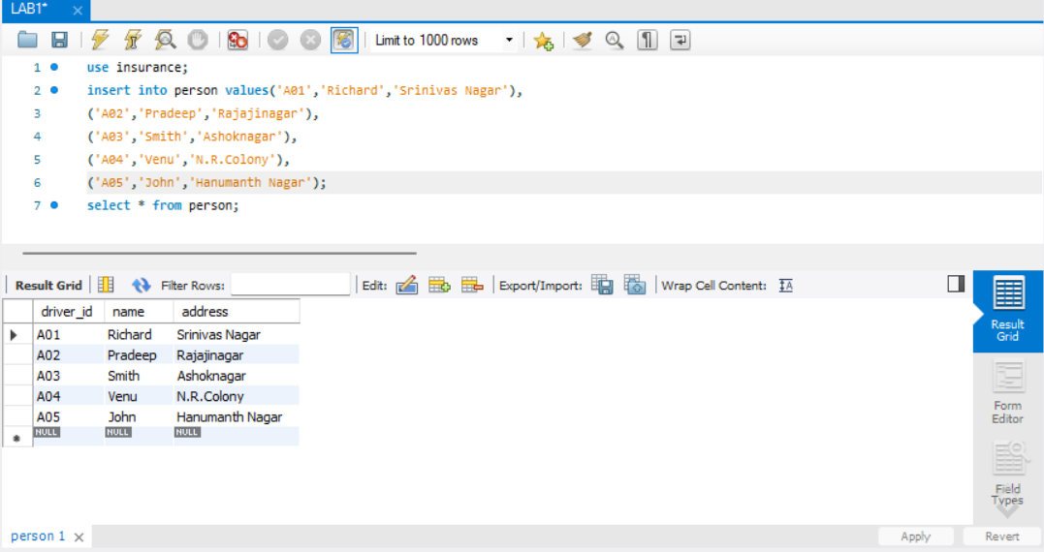

QUERY 1:

o Update the damage amount to 25000 for the car with a specific reg-num (example ‘KA053408’) for which the accident report number was 12.

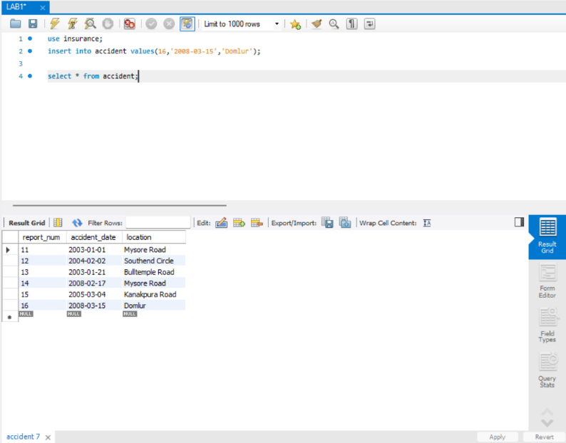

QUERY 2:

o Add a new accident to the database.

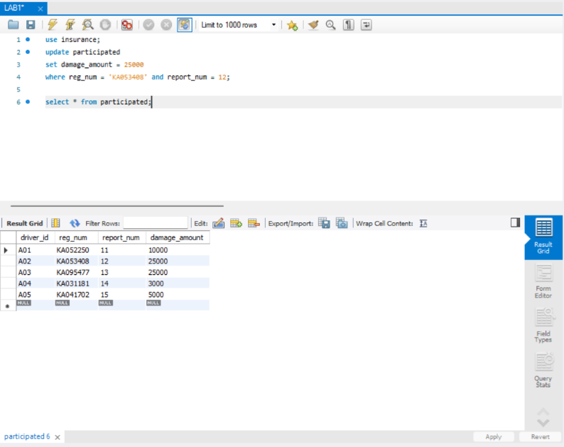

QUERY 3:

Find the number of accidents in which cars belonging to a specific model (example ‘KA053408’) were involved.

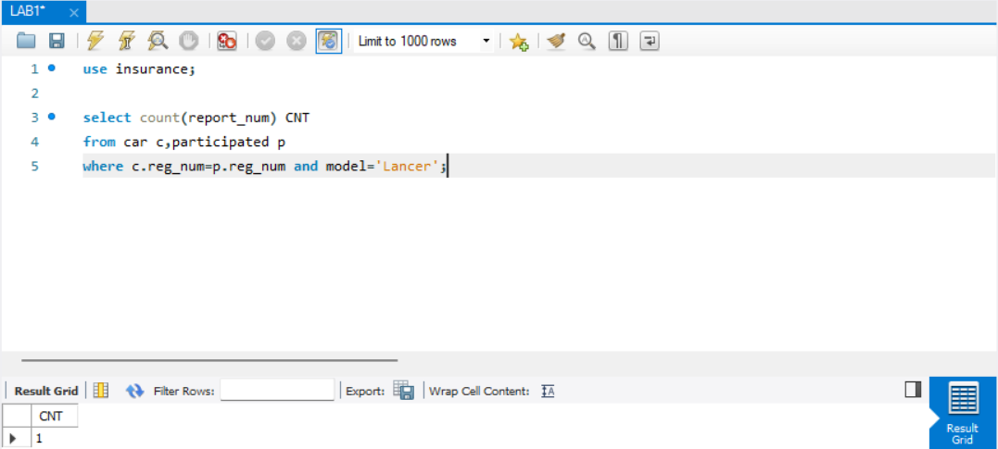

QUERY 4:

Find the total number of people who owned cars that were involved in accidents in 2008.

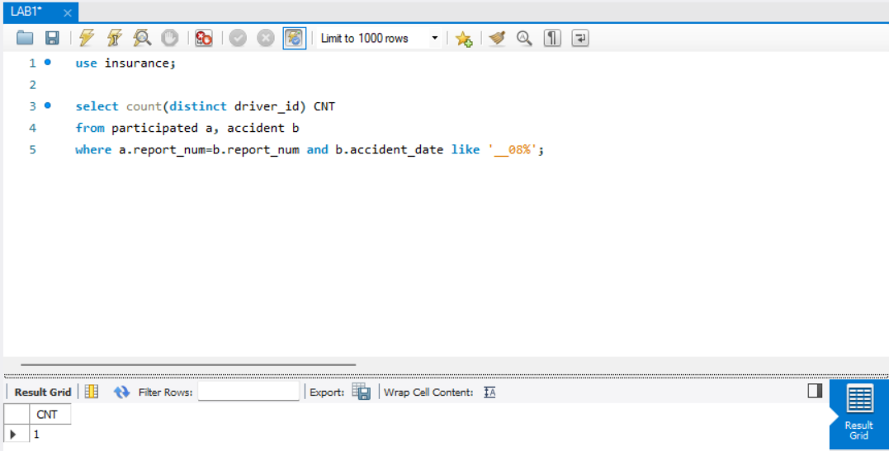

QUERY 5:

Find the number of accidents in which cars belonging to a specific model (ex: ‘Lancer’) were involved accidents in 2008.

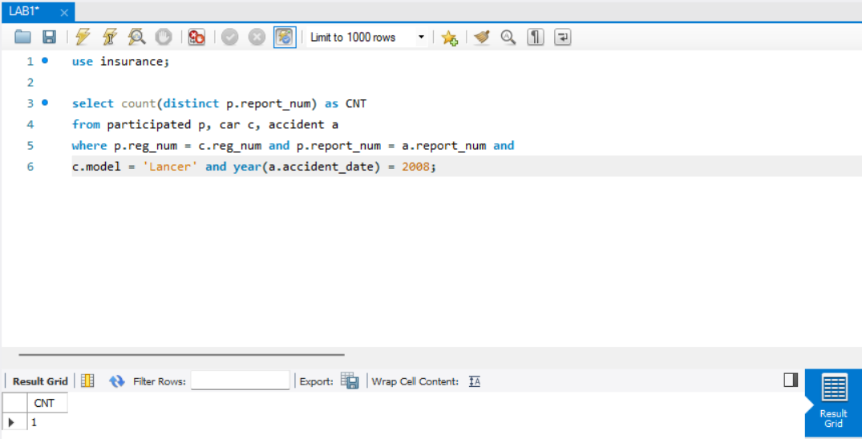

ADDITIONAL QUERIES:

LIST THE ENTIRE PARTICIPATED RELATION IN DESCENDING ORDER OF DAMAGE AMOUNT.

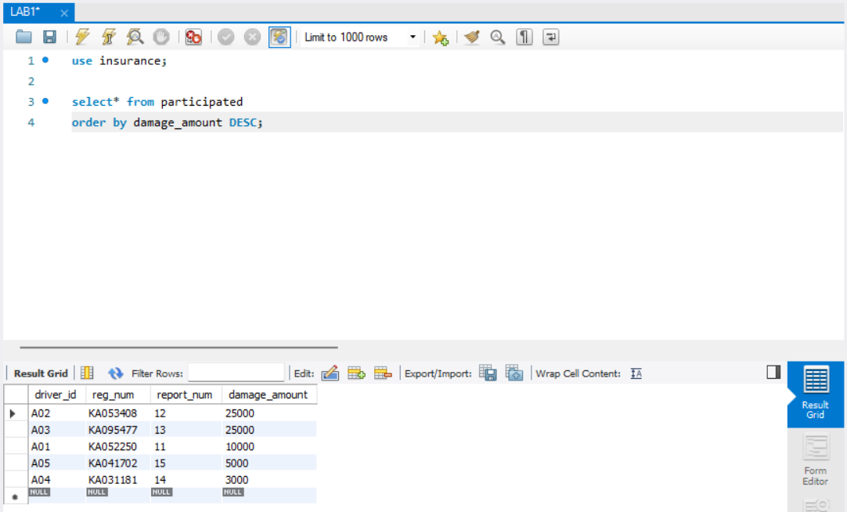

FIND THE AVERAGE DAMAGE AMOUNT

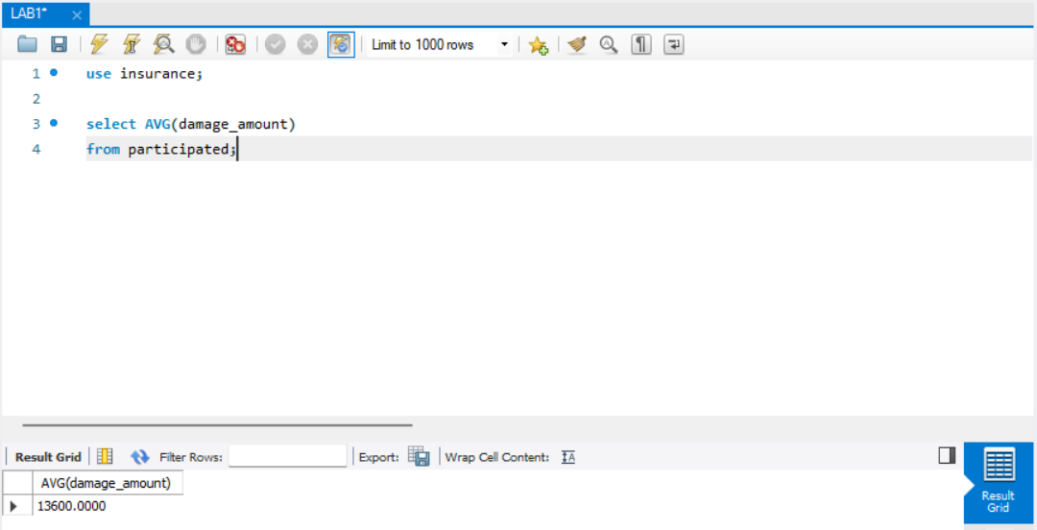

DELETE THE TUPLE FROM PARTICIPATED RELATION WHOSE DAMAGE AMOUNT IS BELOW THE AVERAGE DAMAGE AMOUNT

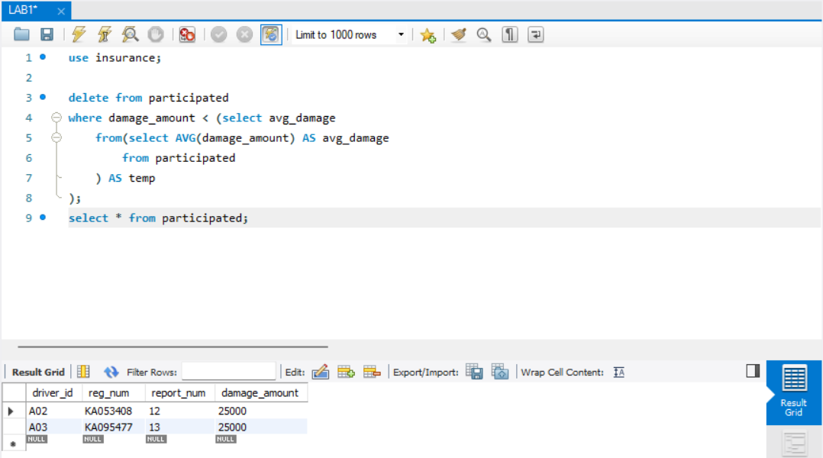

LIST THE NAME OF DRIVERS WHOSE DAMAGE IS GREATER THAN THE AVERAGE DAMAGE AMOUNT.

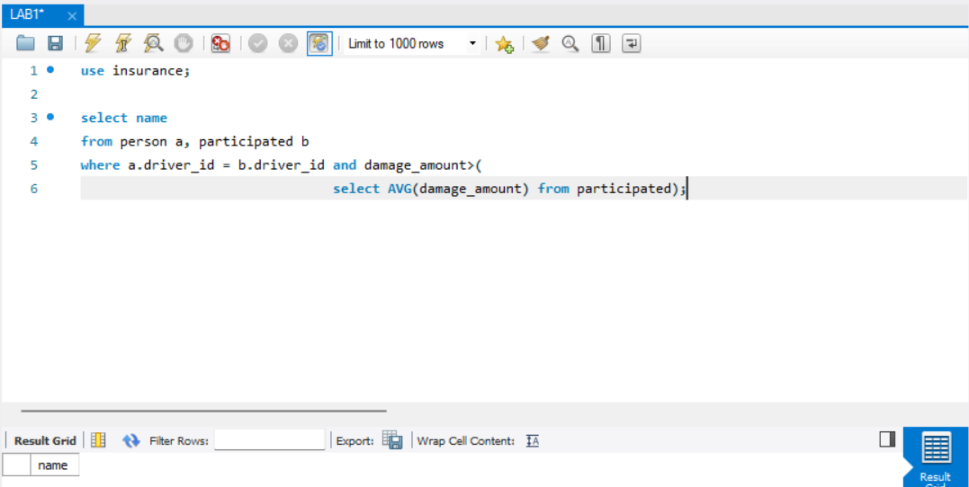

FIND MAXIMUM DAMAGE AMOUNT.

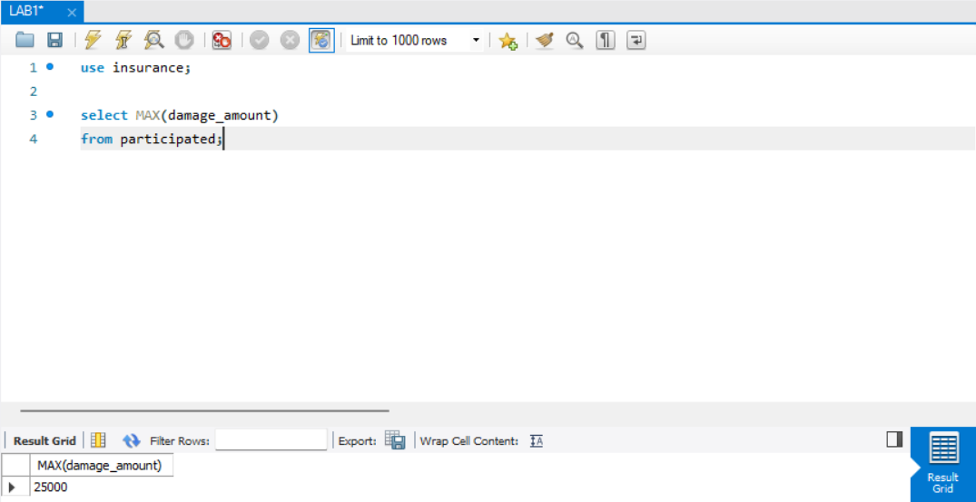

Display the entire CAR relation in the ascending order of manufacturing year.

