**LAB-2**

Create Database and Tables (Branch, Bankaccount, Bankcustomer, Depositor, Loan)

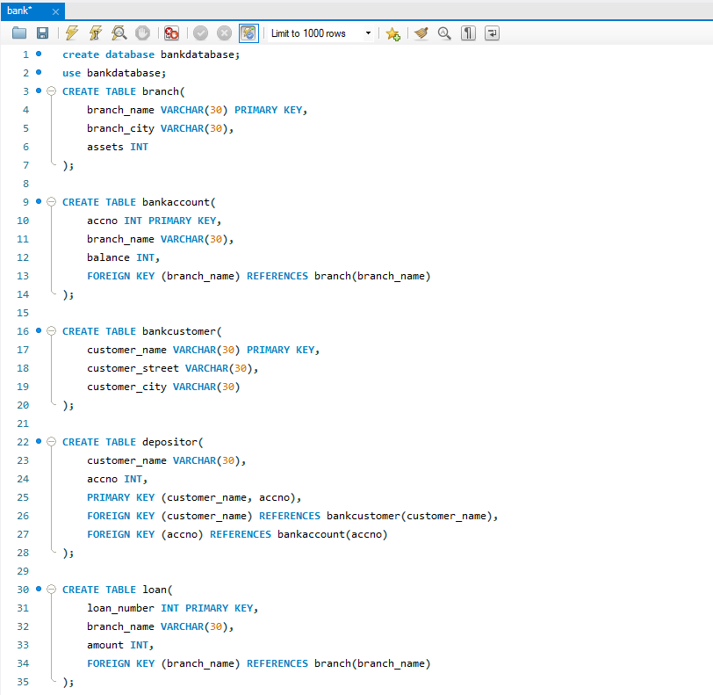

Insert in Tables

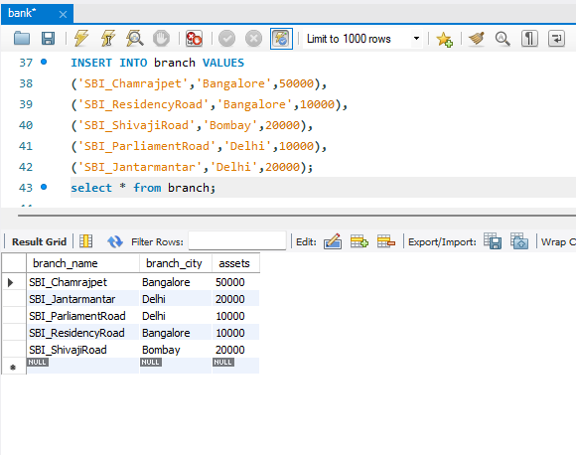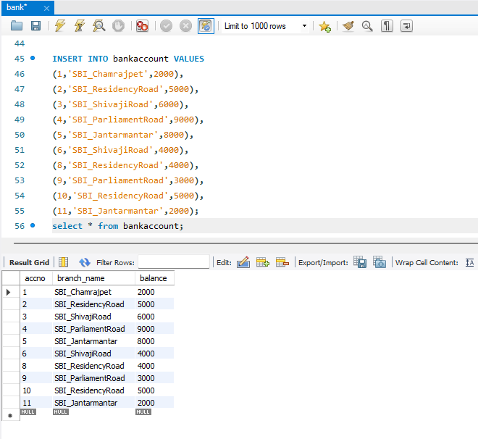 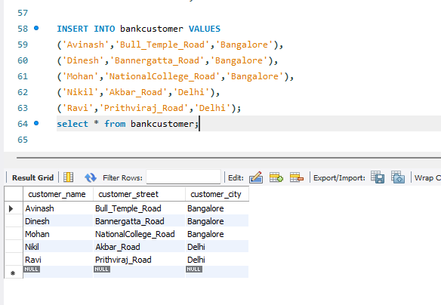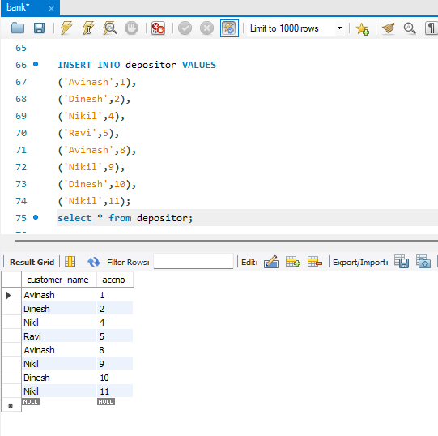

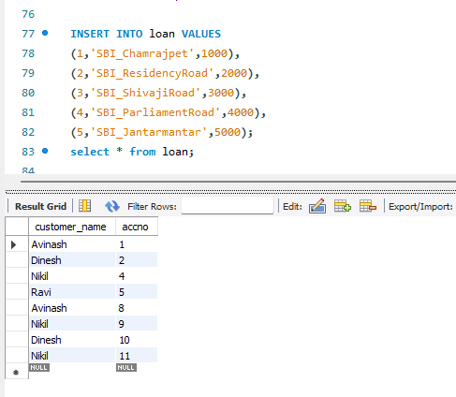

QUERY 3:

Display the branch name and assets from all branches in lakhs of rupees and rename the assets column to 'assets in lakhs'.

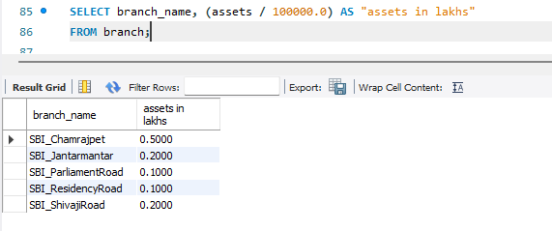

QUERY 4:

Find all the customers who have at least two accounts at the same branch (ex. SBI_ResidencyRoad).

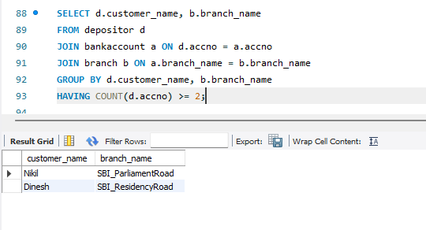

QUERY 5:

CREATE A VIEW WHICH GIVES EACH BRANCH THE SUM OF THE AMOUNT OF ALL THE LOANS AT THE BRANCH.

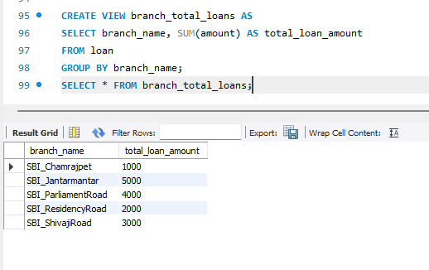

ADDITIONAL QUERIES:

Find all the customers who have an account at all the branches located in a specific city (Ex: Delhi)

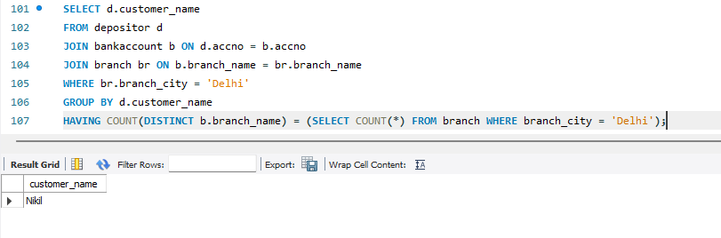

Find all customers who have a loan at the bank but do not have an account.

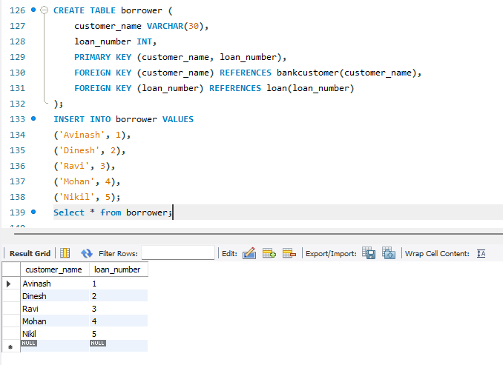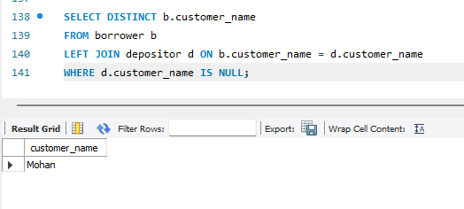

Find all customers who have both an account and a loan at the Bangalore branch.

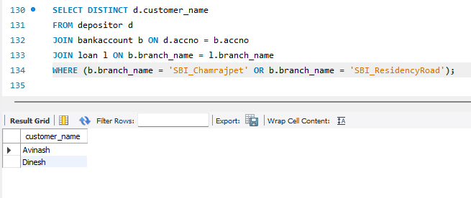

Find the names of all branches that have greater assets than all branches located in Bangalore.

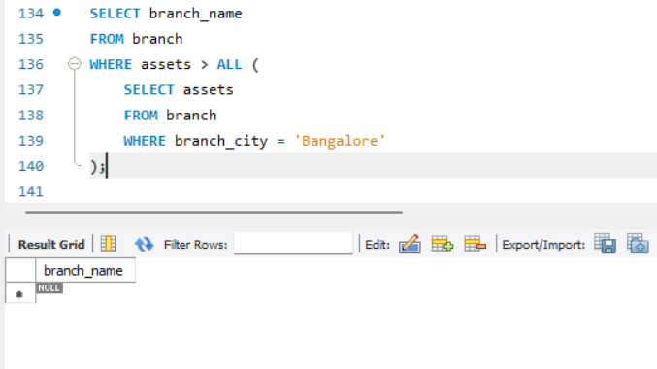

Demonstrate how you delete all account tuples at every branch located in a specific city (Ex: Bombay)

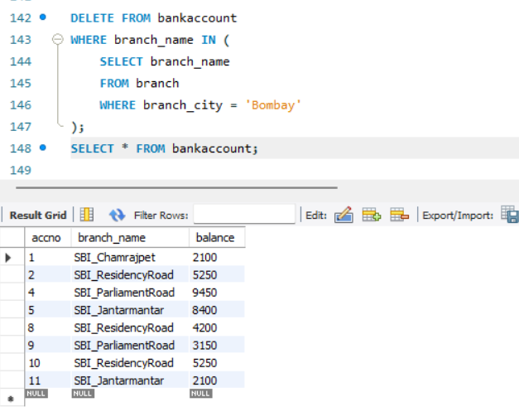

Update the balance of all accounts by 5%.

