**LAB-3**

Create Database and Tables (Dept, Employee, Project, Assigned_to, Incentives)

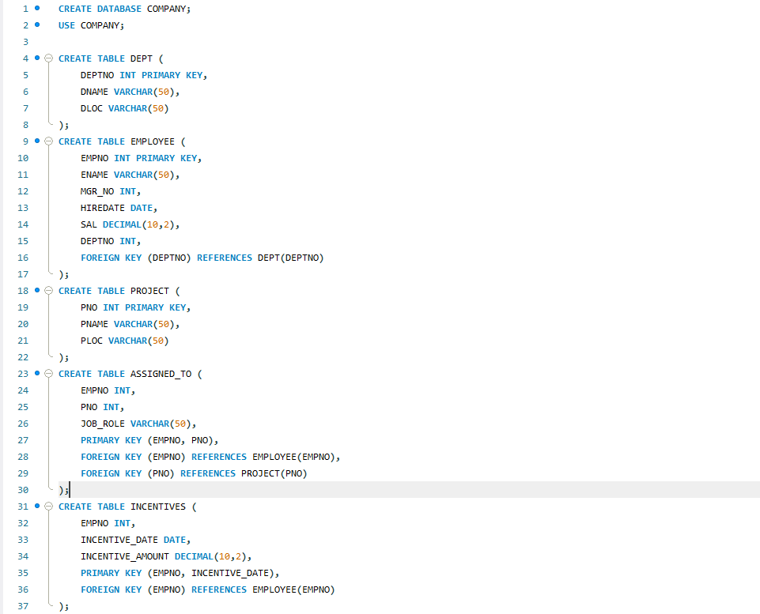

Insert in Tables

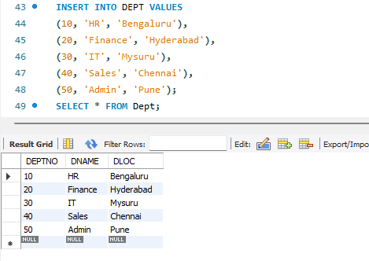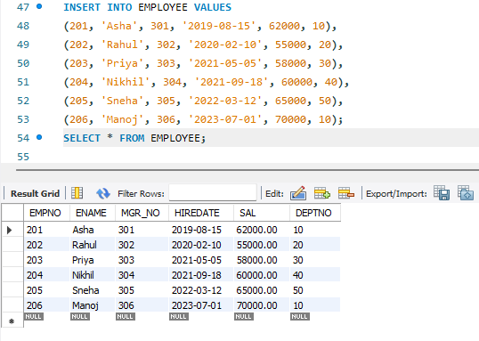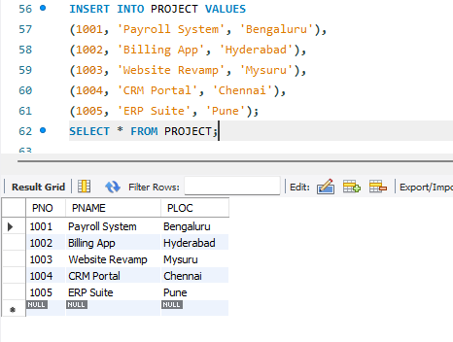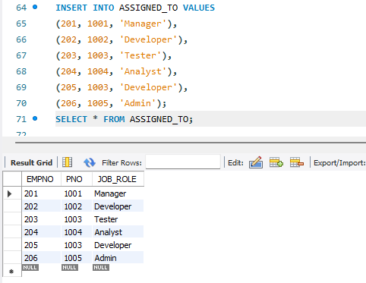

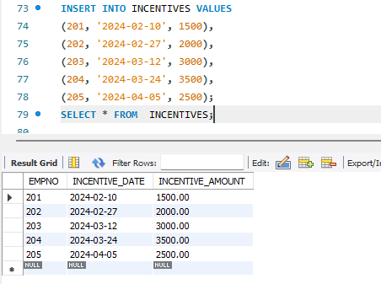

QUERY 3:

Retrieve the employee numbers of all employees who work on projects located in Bengaluru, Hyderabad, or Mysuru

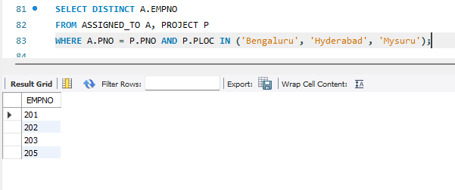

QUERY 4:

Get Employee IDs of those employees who didn’t receive incentives

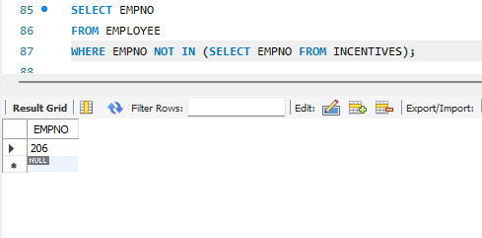

QUERY 5:

Write a SQL query to find the employees name, number, dept, job_role, department location and project location who are working for a project location same as his/her department location.

