LAB-4
Create Database and Tables (Suppliers, Parts, Catalog)
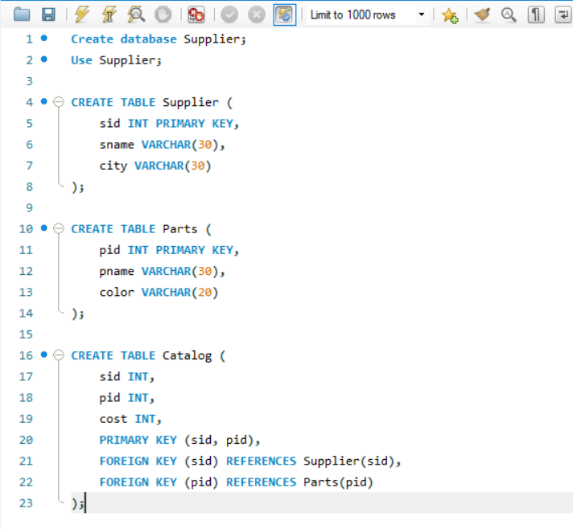
Insert in Tables
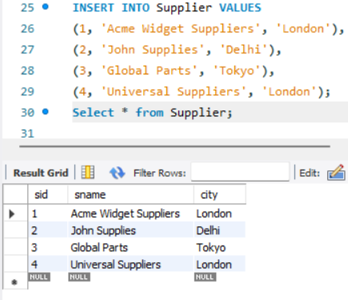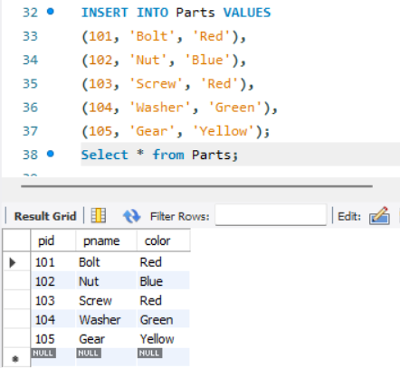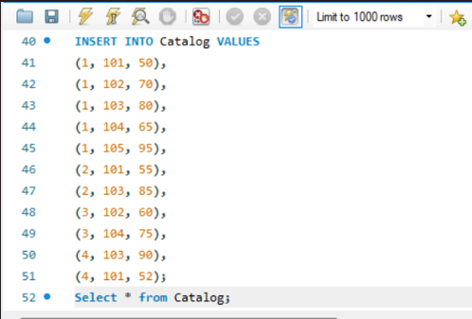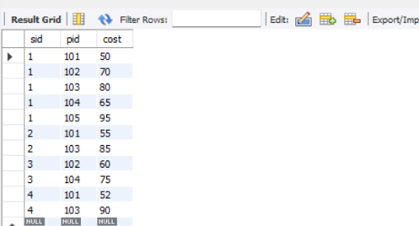
QUERY 3:
Find the pnames of parts for which there is some supplier.
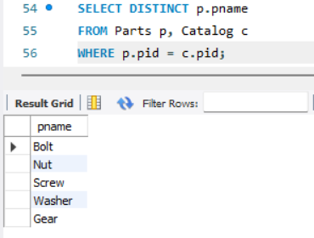
QUERY 4:
Find the snames of suppliers who supply every part.
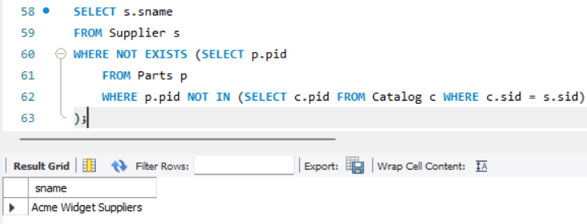
QUERY 5:
Find the snames of suppliers who supply every red part.
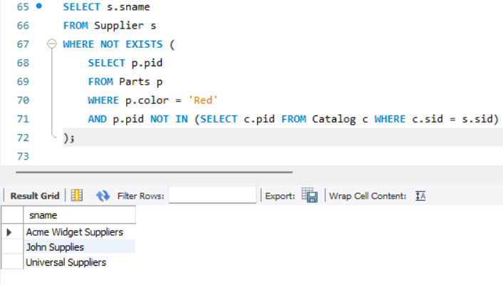

QUERY 6:
Find the pnames of parts supplied by Acme Widget Suppliers and by no one else.
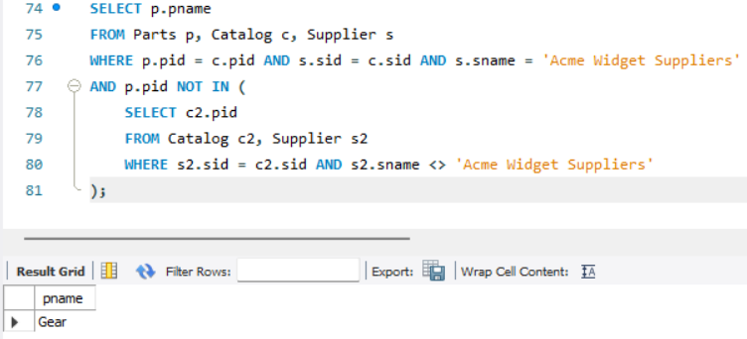
QUERY 7:
Find the SIDs of suppliers who charge more for some part than the average cost of that part.
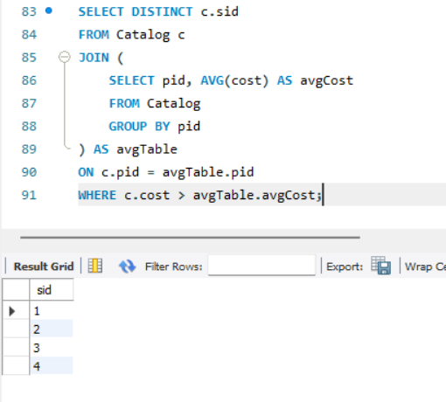
QUERY 8:
For each part, find the sname of the supplier who charges the most for that part.
