LAB-3
Create Database and Tables (Dept, Employee, Project, Assigned_to, Incentives)
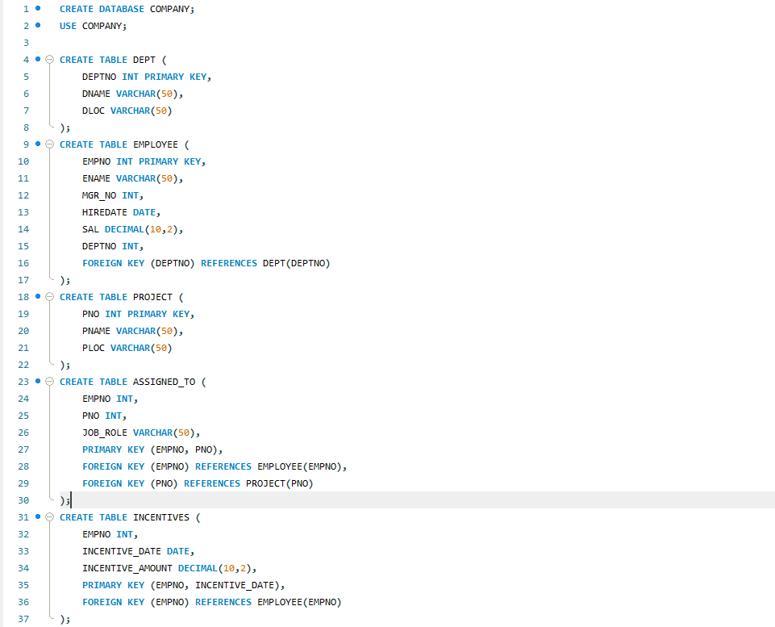
Insert in Tables
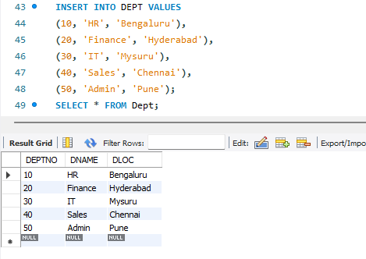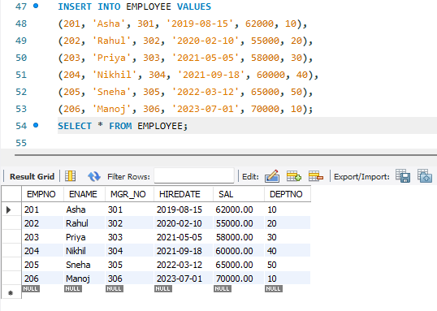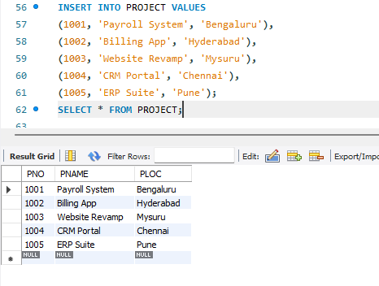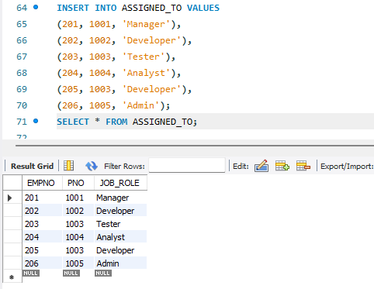
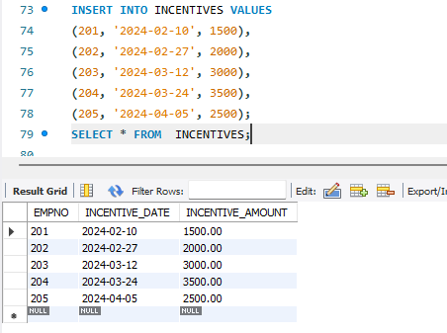

QUERY 3:
Retrieve the employee numbers of all employees who work on projects located in Bengaluru, Hyderabad, or Mysuru
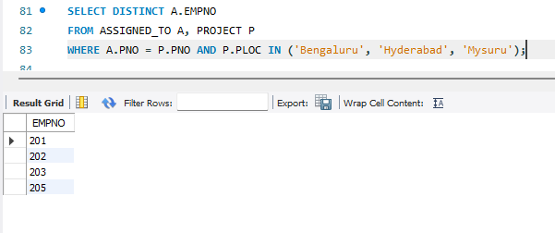

QUERY 4:
Get Employee IDs of those employees who didn’t receive incentives
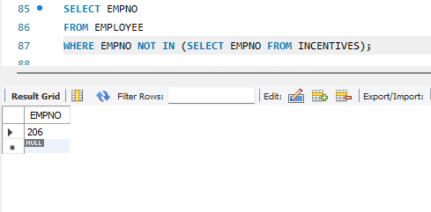

QUERY 5:
Write a SQL query to find the employees name, number, dept, job_role, department location and project location who are working for a project location same as his/her department location.
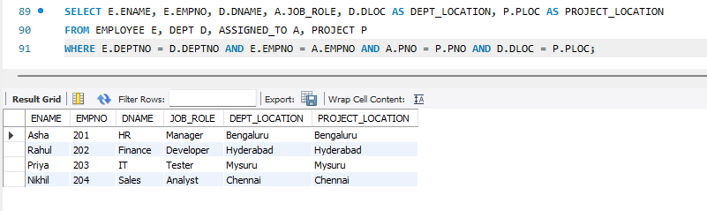

ADDITIONAL QUERIES
QUERY 6:
List employees with their department name & location.
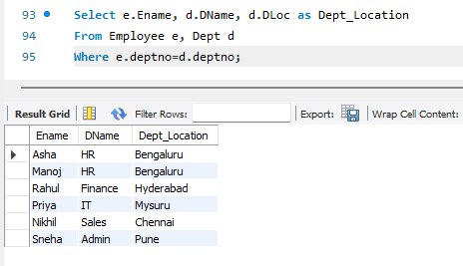
QUERY 7:
Employees who are not assigned to any project ,Project-wise headcount.
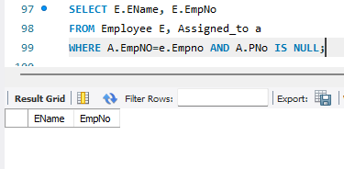

QUERY 8:
Department-wise average & max salary.
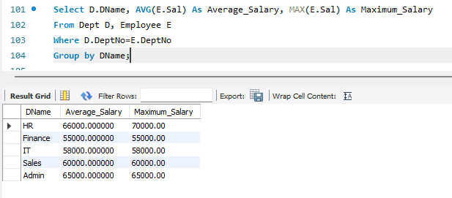
QUERY 9:
Total incentives earned by each employee (lifetime).
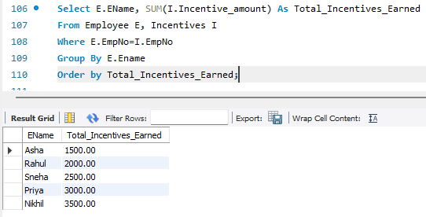
QUERY 10:
Employees working on a given project (project name : Website Revamp).
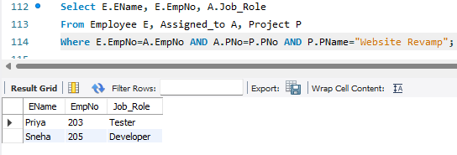

QUERY 11:
Departments with no employees.
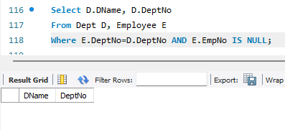
QUERY 12:
Managers and their direct report counts (MGR_NO references EMPNO).
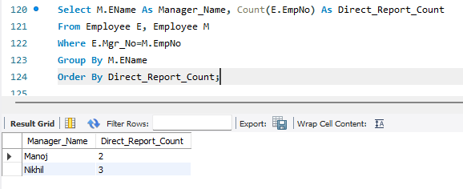
QUERY 13:
Employees assigned to more than one project.
