PROGRAM-8
Create Database Student and Insert Appropriate Values
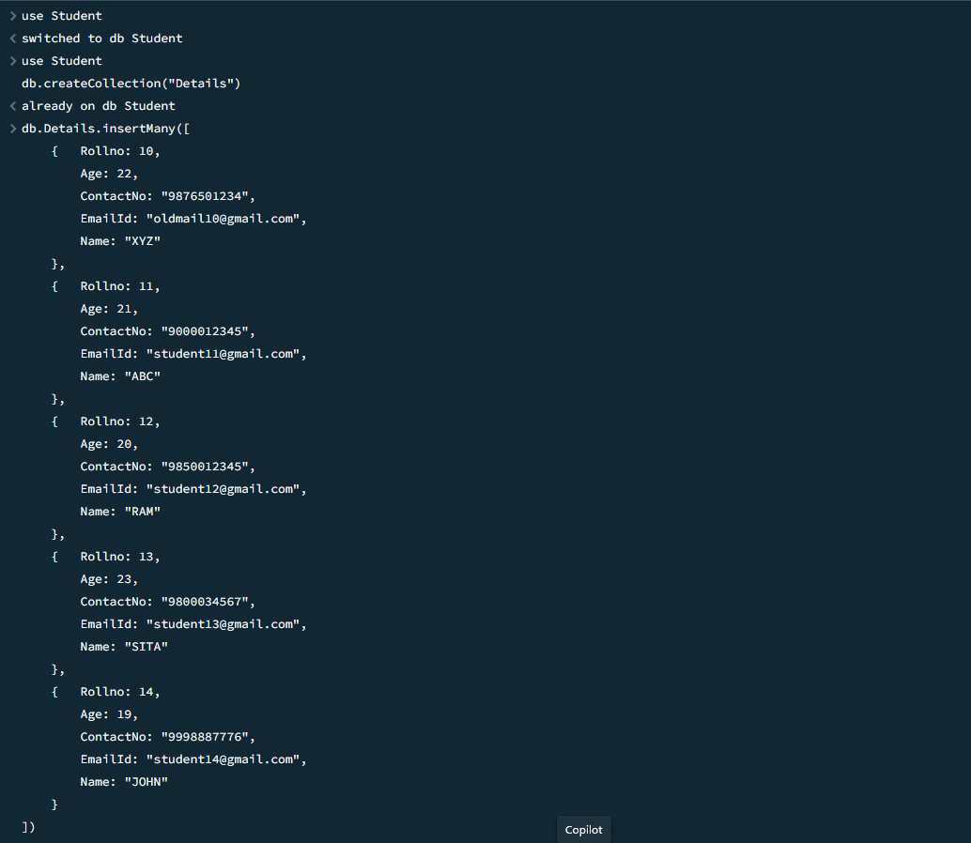
QUERY 3:
Write a query to update the Email-Id of a student with rollno 10
QUERY 4:
Replace the student name from “ABC” to “FEM” of rollno 11.
QUERY 6:
Drop the table.
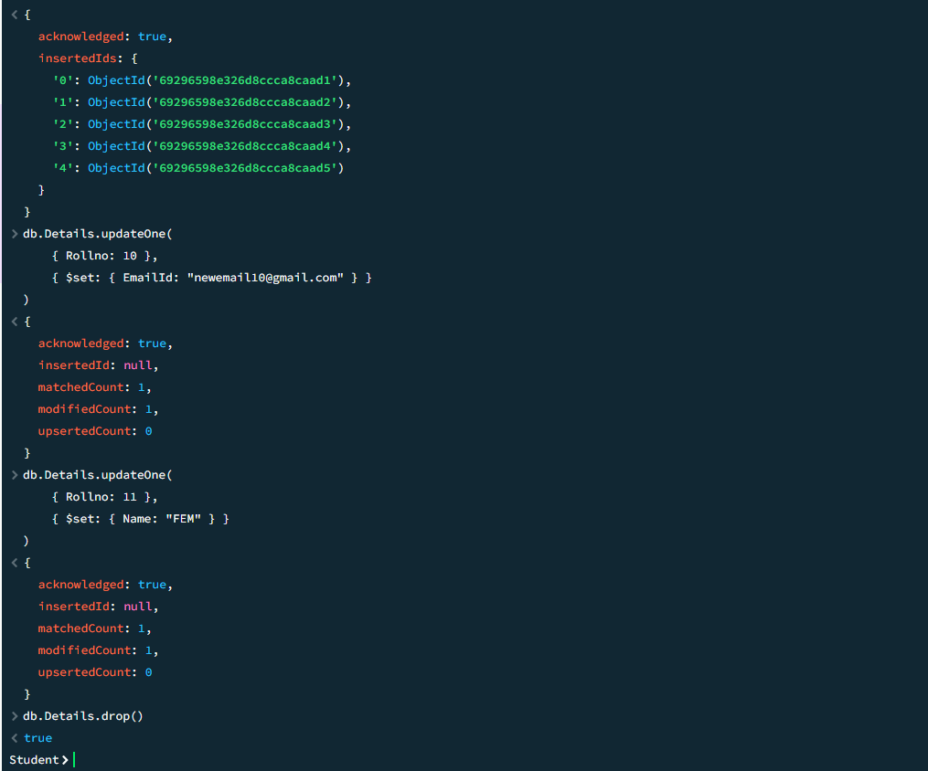
Final Details Collection
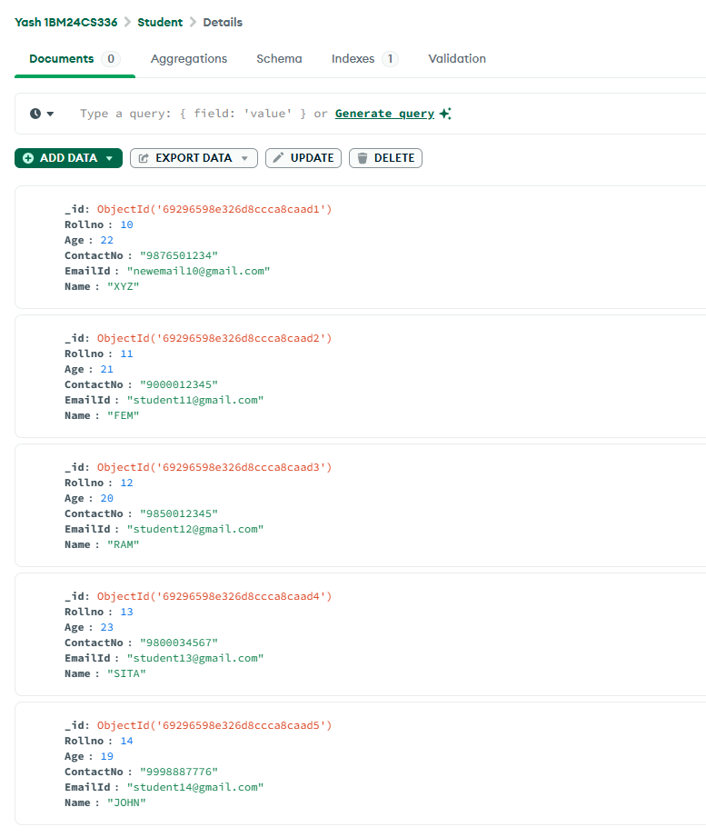
QUERY 7: Final ImportedData Collection
Import a given csv dataset from local file system into mongodb collection.
