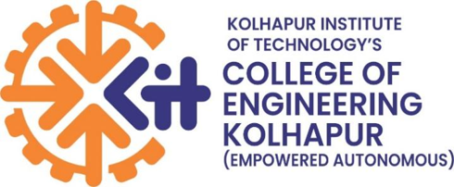
Kolhapur Institute of Technology's
College of Engineering (Autonomous), Kolhapur
Department of Computer Science Engineering
(Artificial Intelligence & Machine Learning)
AI INTERVIEW COACH
Real-Time Mock Interview Analysis & Feedback System
"Practice with Data. Speak with Confidence."
(Initial Project Report)
Mini Project-III (Android) [UAMIL0571]
Submitted By:
Sr No. | Name | PRN | Roll No. | Class
1 | Yash Lad | 2425000030 | B35 | T.Y - B
2 | Rohit Mithari |  | B37 | T.Y - B
3 | Rushi Parit |  | B-36 | T.Y - B
4 | Onkar Karande |  | B26 | T.Y - B
Academic Year: 2025 – 2026

1. Abstract
The AI Interview Coach is an Android mobile application engineered to democratize access to objective, data-driven mock interview practice for engineering students and job aspirants. Traditional interview preparation relies heavily on peer feedback—which is often subjective or inconsistent—or commercial coaching services that are expensive and non-scalable. The proposed solution bridges this gap by offering a privacy-first, on-device multimodal evaluation system.
By leveraging Android Jetpack CameraX for high-fps video capture, native Android SpeechRecognizer for speech-to-text processing, and computer vision models (Google ML Kit / MediaPipe) for non-verbal tracking, the application captures and analyzes practice interview responses in real time. The app evaluates speech pace (words per minute), filler word frequency (e.g., 'um', 'like'), eye contact consistency, head movement stability, and posture. Upon completing an answer, candidates receive an instant, actionable feedback report highlighting strengths, areas of improvement, and historical progress. This project delivers an accessible, repeatable, and scalable platform for building interview confidence.
2. Introduction
Interview readiness is a paramount factor governing graduate employability. Despite technical competence, many candidates fail to convert interview opportunities due to poor delivery, hesitations, lack of structured answers, and weak non-verbal communication such as poor eye contact and fidgeting.
While automated technical evaluation platforms (e.g., competitive coding portals) are widely adopted, non-verbal and verbal speech evaluation remains predominantly manual. Emerging cloud-based AI tools exist, but they suffer from high subscription fees, latency, and privacy concerns associated with uploading personal facial video recordings to third-party cloud servers.
The AI Interview Coach addresses these challenges by delivering an integrated mobile experience. Operating natively on Android devices, it functions as a personal, on-demand interview trainer. The student selects an interview question from a categorized bank (Technical, HR, Behavioral), records their response, and receives instant multimodal feedback without requiring continuous internet streaming or cloud storage of raw media.
3. Problem Statement
Students preparing for campus recruitment face significant hurdles due to the lack of structured, objective, and private mock interview tools. Specifically, the problem encompasses:
- Subjective & Inconsistent Feedback: Peer practice lacks standard evaluation metrics, leading to biased or superficial advice.
- Lack of Quantitative Speech Metrics: Candidates are unaware of their unconscious speech filler words ('um', 'ah', 'like') and speaking pace bottlenecks.
- Unmonitored Non-Verbal Cues: Self-monitoring eye contact, body alignment, and facial stress while simultaneously formulating answers is impossible without automated vision analytics.
- High Cost & Accessibility Barriers: Commercial human-led mock interviews are costly and difficult to schedule frequently.
- Privacy & Latency Concerns: Uploading video recordings of candidates to third-party servers raises serious data privacy and security concerns.
4. Existing System & Limitations
Current interview preparation methods fall into three broad categories: manual peer practice, video recording playback, and cloud-based AI platforms.
- Standard Camera Playback: Students record themselves using standard phone cameras and manually re-watch videos. This is tedious, time-consuming, and lacks automated metrics.
- Online Question Banks: Web-based questionnaires provide static text answers but cannot evaluate verbal confidence or body language.
- Cloud AI Services: Services like Big Interview or Interviewer.AI provide automated evaluation but require high-bandwidth cloud uploads, paid subscriptions, and web infrastructure.
Key Limitations of Existing Systems:
- 1. Lack of Integrated Mobile Analytics: No single offline-first mobile app combines speech rate, filler words, and eye contact tracking.
- 2. High Processing Latency: Cloud video processing introduces noticeable delays before receiving feedback reports.
- 3. Privacy Risks: Streaming video streams to remote servers introduces data leakage risks.
- 4. Absence of Session Progress Tracking: No local tracking of candidate improvement over sequential practice sessions.
5. Proposed System & Key Objectives
The proposed AI Interview Coach is a native Android application designed to capture audio and video concurrently via CameraX. It processes speech transcripts and facial landmarks using on-device/local SDKs to deliver real-time feedback immediately post-recording.
5.1 Key Objectives
- 1. Centralized Practice Portal: Develop an intuitive Android interface featuring curated HR, Technical, and Behavioral question categories.
- 2. Automated Speech Analysis: Utilize Android SpeechRecognizer to transcribe audio into text and calculate Words Per Minute (WPM) and filler word count.
- 3. Computer Vision Evaluation: Deploy Google ML Kit / MediaPipe Face Landmarker to monitor eye contact ratio, head orientation, and facial composure.
- 4. Instant Feedback Report: Aggregate speech and visual parameters into a consolidated 0–100 candidate score with explicit actionable suggestions.
- 5. Local Session History: Persist historic recording summaries locally using Room Database to enable progress visualization over time.
6. Scope of the Project
In-Scope Features | Out-of-Scope Boundaries
- Curated Question Bank (HR, Tech, Behavioral) | - Live human recruiter match / video calling
- CameraX dual video & audio recording | - Guaranteed job placement or hiring dispatch
- On-device Speech-to-Text transcription | - External biometric wearable sensor integration
- Filler word detection ('um', 'like', 'uh') | - Multi-language speech transcription (Initial scope: English)
- Eye contact & pose stability calculation
- Instant score report & feedback synthesis
- Local Room DB progress history
7. Stakeholders, Assumptions & Constraints
7.1 Stakeholders
- Primary Users: Students and job seekers practicing mock interviews to improve confidence and delivery.
- Institutional Users: College Training & Placement Cell (TPC) tracking student interview preparedness.
- Mentors & Evaluators: Faculty and placement mentors reviewing candidate progress reports.
7.2 Assumptions
- The candidate's device runs Android 8.0 (API 26) or higher with an active front camera and microphone.
- Practice sessions take place in moderately illuminated environments for accurate facial landmark detection.
- The user speaks clearly in English during the recording session.
7.3 Constraints
- Speech recognition accuracy depends on ambient background noise levels.
- Real-time frame processing is throttled on low-end smartphones to prevent thermal CPU scaling.
8. Project Methodology & Stages
The project follows an Agile iterative engineering approach divided into six distinct stages:
- Stage 1: Requirement Gathering & SRS: Gathering user stories from students, analyzing evaluation metrics, and defining system requirements.
- Stage 2: Architecture & UI/UX Design: Designing wireframes, activity diagrams, DFDs, and Room DB schema.
- Stage 3: Camera & Recording Pipeline: Setting up Android Studio project, CameraX preview, and audio/video recorder pipeline.
- Stage 4: Multimodal ML Engine Build: Integrating SpeechRecognizer, filler detection logic, and ML Kit Face Landmarker.
- Stage 5: Feedback & History Modules: Developing score aggregation rules, report view, and Room DB history persistence.
- Stage 6: Testing & Optimization: Unit testing modules, measuring STT latency, and conducting usability trials.
9. System Architecture
The AI Interview Coach architecture adopts a modular client-centric design pattern:
- 1. Presentation Layer (UI): Built using Jetpack ViewBinding / Fragments adhering to MVVM design principles for clean separation of concerns.
- 2. Media Stream Layer: CameraX manages video frames; Audio Extractor provides PCM streams to the speech analyzer simultaneously.
- 3. Analytics Engine: Combines Android SpeechRecognizer (transcription & WPM/filler count) with ML Kit Face Landmarker (eye contact & posture stability).
- 4. Scoring & Rules Engine: Normalizes sub-scores (Speech Pace, Filler Score, Visual Score, Content Match) into a unified 100-point index.
- 5. Data Persistence Layer: Room Database stores local session metadata, scores, and timestamped transcripts; Firebase handles optional sync.
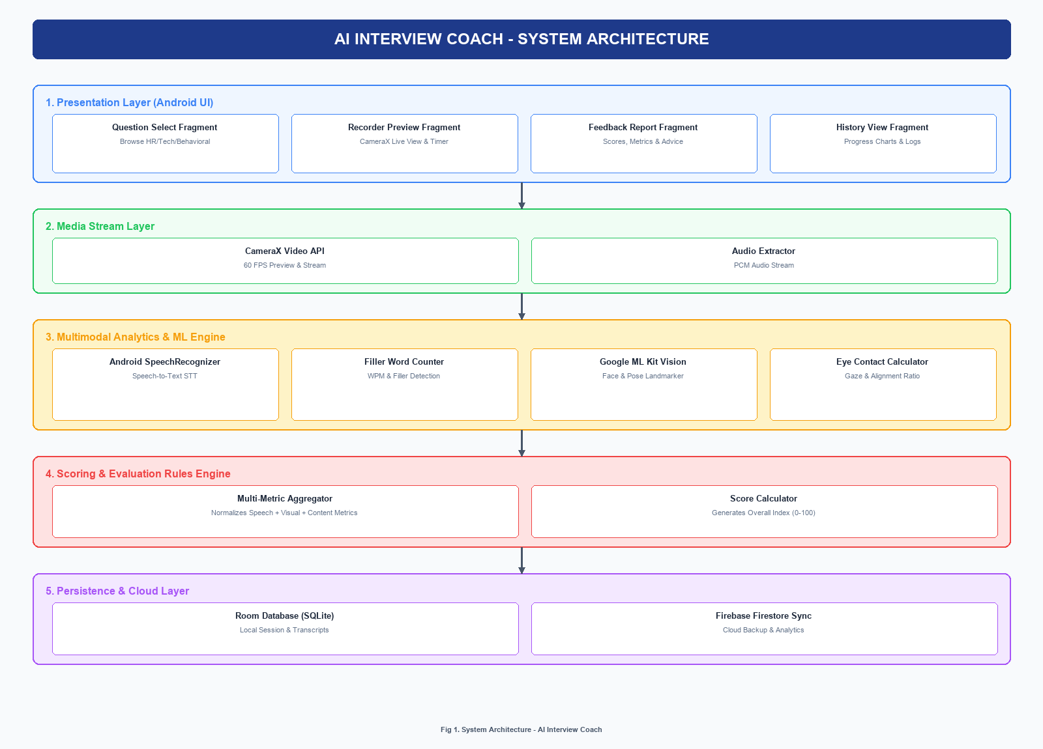
Fig 1. System Architecture Diagram - AI Interview Coach
9.1 Use Case Diagram
The Use Case diagram below illustrates the interaction between the primary actor (Student/Candidate), the secondary actor (Firebase/Local DB), and the system use cases:
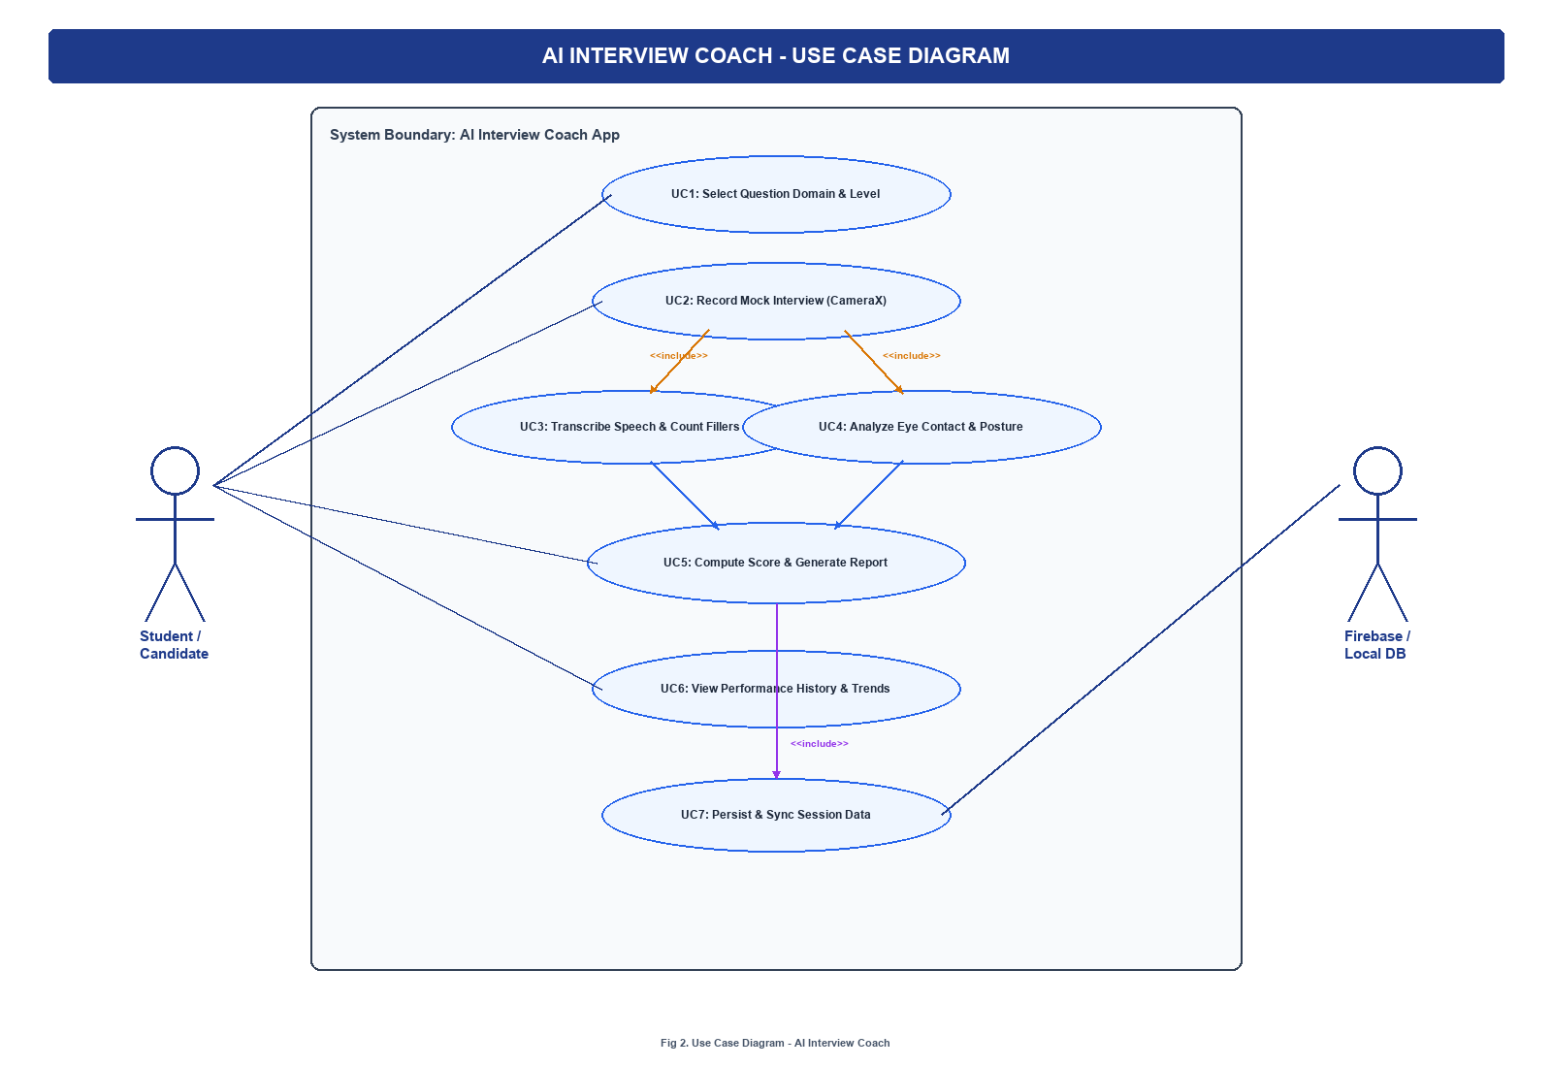
Fig 2. Use Case Diagram - System Actors & Interactions
10. Data Flow Diagrams (DFD)
The Data Flow Diagrams depict the movement of information through the AI Interview Coach system, from initial user input and video/audio streaming to feature extraction, score aggregation, and persistent session storage.
10.1 Level 0 (Context Diagram)
The Level 0 Context Diagram represents the high-level system boundary, showing information exchange between the Student external entity, the central application process, and the underlying data store:
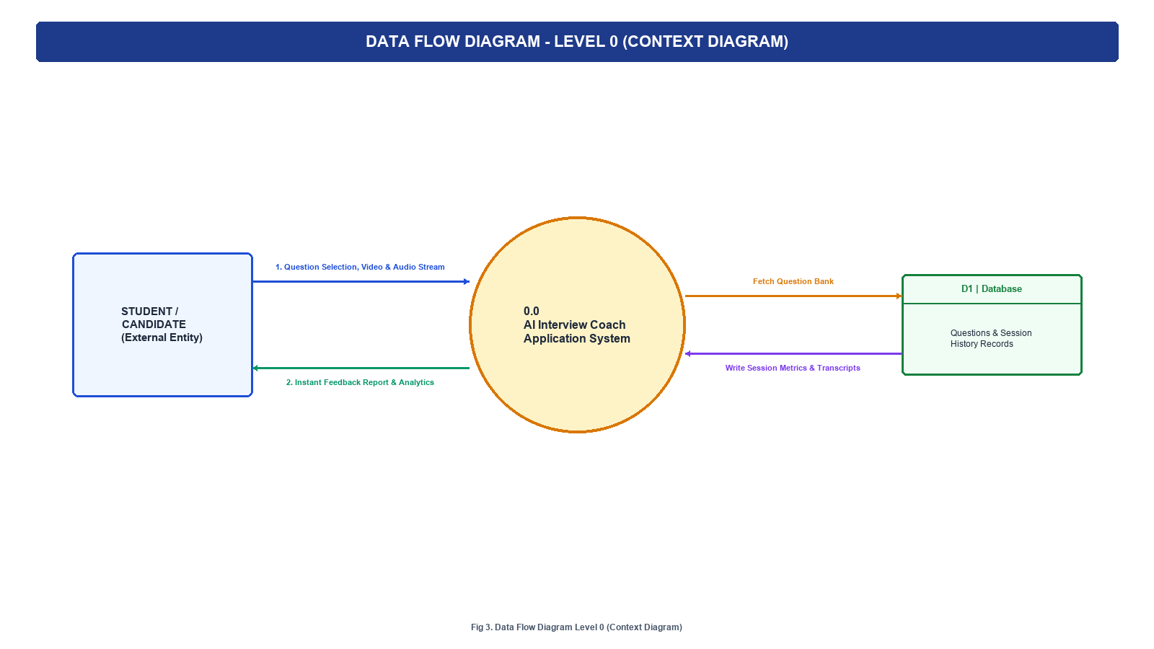
Fig 3. Level 0 Context Data Flow Diagram
10.2 Level 1 (Decomposed Process View)
The Level 1 DFD decomposes the system into six core sub-processes, detailing raw media streaming, parallel speech & vision analytics, score aggregation, and historical data logging:
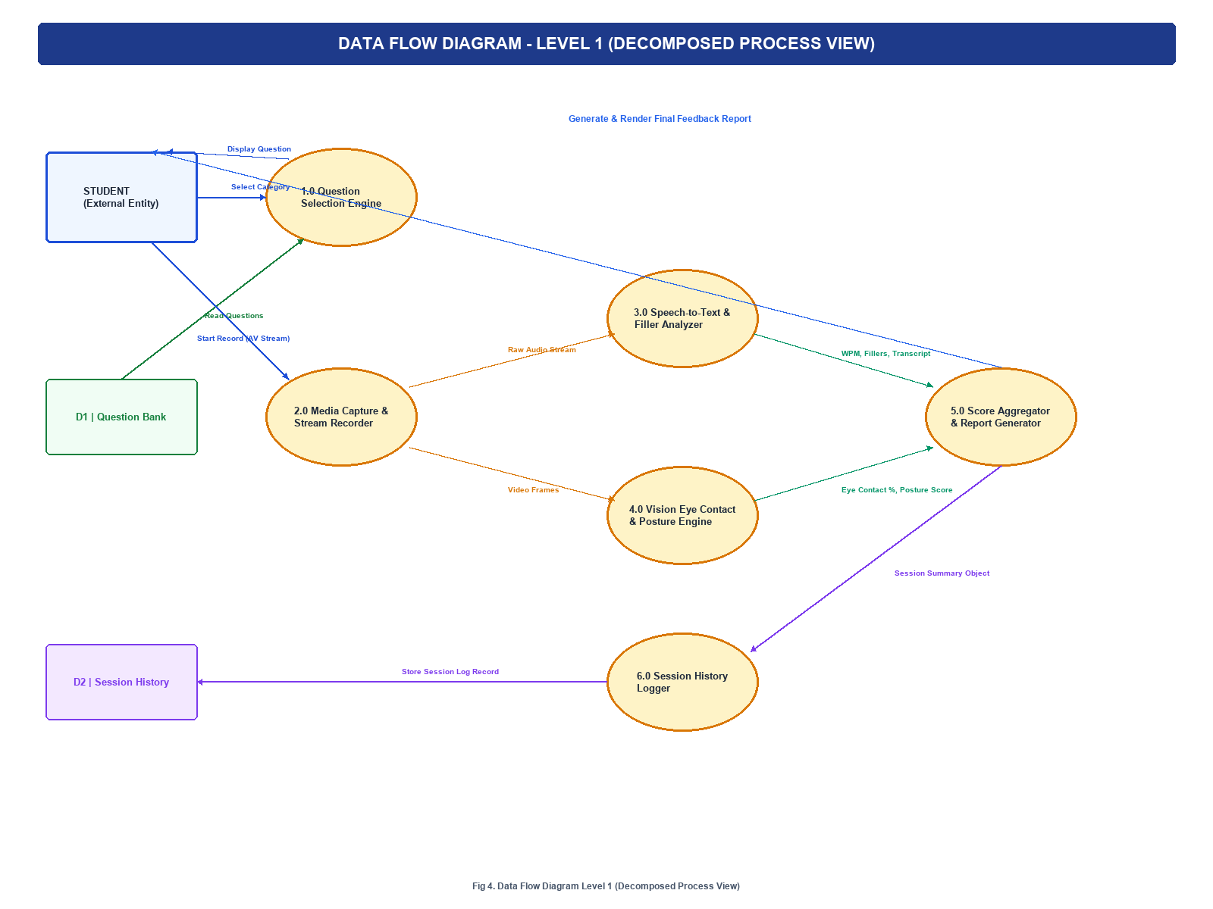
Fig 4. Level 1 Decomposed Process Data Flow Diagram
11. Functional Modules
- Module 1 - Question Selection: Allows users to browse and filter practice questions by domain (HR, Technical, Behavioral) and difficulty level.
- Module 2 - Recording Interface: Handles front-camera video preview, audio input levels, timer countdown, and smooth recording lifecycle.
- Module 3 - Speech & Pace Analyzer: Converts speech to text, detects filler word counts ('um', 'like', 'basically'), and computes speaking pace (WPM).
- Module 4 - Vision Pose Engine: Tracks face bounding box and eye gaze vectors to calculate percentage of time candidate maintained direct eye contact.
- Module 5 - Feedback Report Generator: Displays breakdown graphs, key suggestions, transcribed text, and calculated score metric.
- Module 6 - History & Progress Tracker: Logs past practice attempts into Room DB, rendering historic score trends for self-evaluation.
12. Feasibility Study
- Technical Feasibility: Utilizes mature Android Jetpack, ML Kit, and Speech APIs. No experimental hardware required.
- Operational Feasibility: Intuitive single-button recording workflow requires no user training.
- Economic Feasibility: Built entirely using open-source tools and on-device processing, eliminating recurring server licensing costs.
13. Technology Stack
The technological choices below reflect a robust, well-supported mobile architecture optimized for real-time multimodal processing on Android devices.
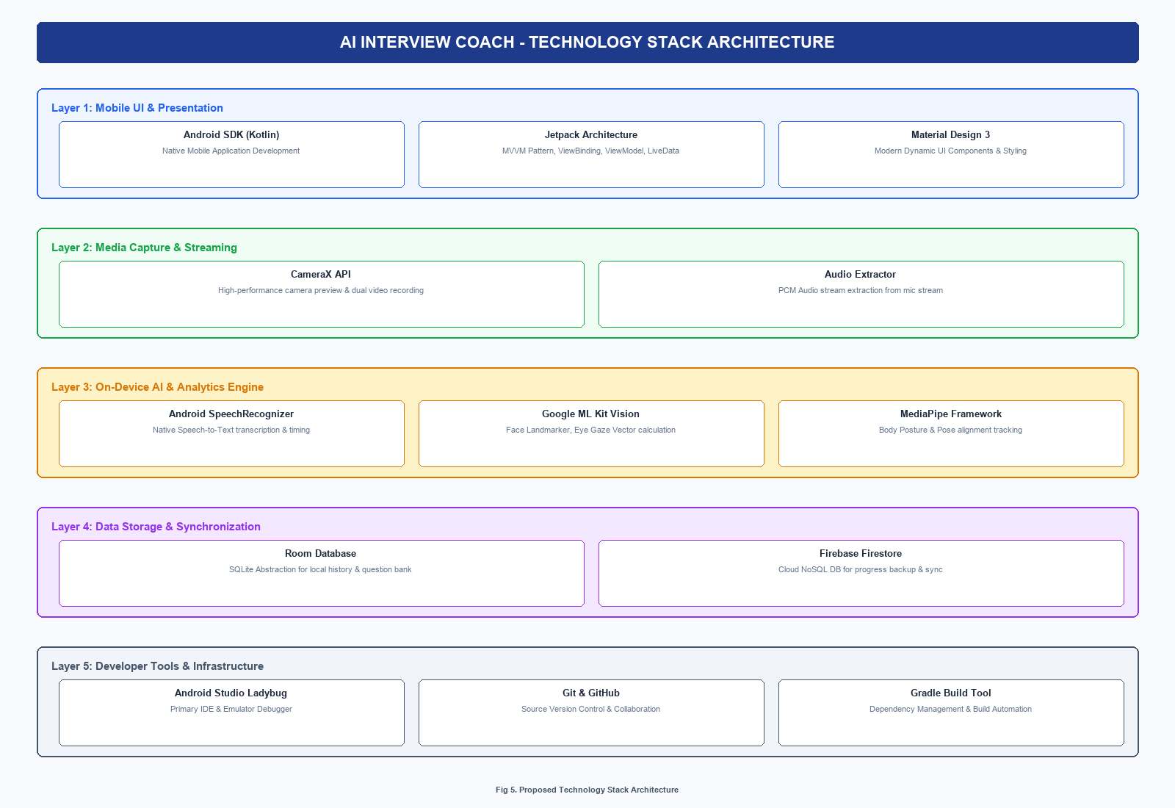
Fig 5. Technology Stack Architecture Diagram
Layer | Technology | Purpose / Rationale
Mobile Platform | Android SDK (Kotlin) | Core application logic, UI lifecycle & MVVM architecture
Media Recording | CameraX API | High-performance camera preview & dual video/audio capture
Speech Processing | Android SpeechRecognizer | Native on-device speech-to-text conversion & timing
Vision Analytics | Google ML Kit / MediaPipe | Face landmarker, eye gaze estimation & pose posture tracking
Local Database | Room Database (SQLite) | Structured persistence of practice history & question bank
Cloud Backup | Firebase Firestore / Storage | Optional cloud synchronization of user metrics & feedback
Version Control | Git & GitHub | Source code management, branch workflows & project tracking
14. Future Scope
- Integration with Large Language Models (LLMs) to generate dynamic follow-up interview questions based on candidate answers.
- Voice tone and emotion analysis using audio pitch processing to detect nervousness or enthusiasm.
- Support for multi-language mock interviews to aid regional language candidates.
- 3D Avatar Recruiter simulation for immersive virtual interview environments.
15. Conclusion
The AI Interview Coach provides a practical, scalable, and privacy-first solution to a critical problem faced by engineering students preparing for recruitment drives. By combining mobile video recording, speech-to-text processing, and computer vision analytics into an intuitive Android application, the system replaces subjective peer evaluation with objective, actionable performance metrics. The system architecture, use case diagram, data flow diagrams, and tech stack diagrams presented in this initial report establish a robust engineering foundation for building an empowering self-preparation tool for candidates.

