1. W.A.P to get n number of strings from the user. Find out total no. of duplicate strings and display duplicate strings along with duplicate occurrence using 1D array.

Code:-

using System;

namespace C1

{

class Program

{

static void Main(string[] args)

{

Console.WriteLine("Enter the total number value");

int n = Convert.ToInt32(Console.ReadLine());

String[] ar = new String[n];

for (int i = 0; i < n; i++)

{

Console.WriteLine("Enter the the " + i + "th string");

ar[i] = Console.ReadLine();

}

int c = 0;

for (int i = 0; i < n; i++)

{

for (int j = i+1; j < n; j++)

{

if (ar[i] == ar[j])

{

Console.WriteLine("Dublicate String is"+ar[i]);

c = c + 1;

}

}

}

Console.WriteLine("Total number of duplicated value is" + c);

}

}

}

O/P:-

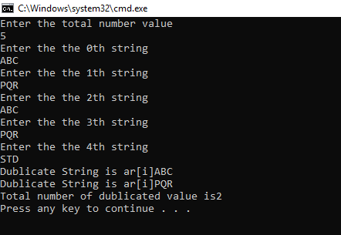

1. W.A.P to calculate area of Circle, Ractangle, Square and Tringle. Which contain two classes in which 1st class contains main method & 2nd class which contains methods to find area for diff. shapes using method overloading?

Code:-

using System;

namespace C2

{

class Calculator

{

static double pi = 3.14;

public double Area(int n)

{

return pi * n * n;

}

public double Area(int h,int w)

{

return h * w;

}

public double Area(int a, int b, int c)

{

return (a + b + c) / 3;

}

}

class Program

{

static void Main(string[] args)

{

Calculator c1 = new Calculator();

Console.WriteLine("Enter the radious of the circle");

int r = Convert.ToInt32(Console.ReadLine());

double ans = c1.Area(r);

Console.WriteLine("Enter the height of the Square");

int h = Convert.ToInt32(Console.ReadLine());

Console.WriteLine("Enter the width of the Square");

int w = Convert.ToInt32(Console.ReadLine());

double ans1 = c1.Area(h, w);

Console.WriteLine("Enter the value of a for the

triangle");

int a = Convert.ToInt32(Console.ReadLine());

Console.WriteLine("Enter the value of b for the triangle");

int b = Convert.ToInt32(Console.ReadLine());

Console.WriteLine("Enter the value of c for the triangle");

int c = Convert.ToInt32(Console.ReadLine());

double ans2 = c1.Area(a, b, c);

Console.WriteLine("if radious is " + r + "then the area of the circle is " + ans);

Console.WriteLine("if height is " + h + " and the width is " + w + " Then the area of square is " + ans1);

Console.WriteLine("if the value of a= "+a+" value of b = "+b+"value of c = "+c+" then the area of triangle is "+ans2);

}

}

}

O/P:-

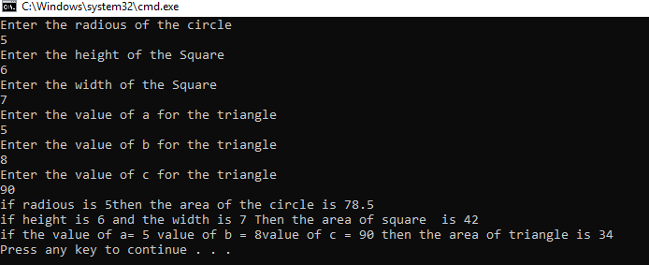3) W.A.P. to find max and min number from an integer array. Create a method getMinMax() by passing out parameter.

using System;

namespace C3

{

class Program

{

public static void getMinMax (int[] a, int b)

{

int min, max;

min = a[0];

max = a[0];

for (int i = 1; i < b; i++)

{

if (min >= a[i])

{

min=a[i];

}

if(max<= a[i])

{

max = a[i];

}

}

Console.WriteLine ("Minimum number into array is "+min);

Console.WriteLine ("Maximum number into array is” + max);

}

static void Main(string[] args)

{

Console.WriteLine ("Enter the number of element of an array");

int n = Convert.ToInt32(Console.ReadLine());

int[] ar = new int[n];

for (int i = 0; i < n; i++)

{

Console.WriteLine ("Entered the ar [" + i + "] th index value");

ar[i] = Convert.ToInt32(Console.ReadLine());

}

Console.WriteLine("You entered array are as follow");

for (int i = 0; i < n; i++)

{

Console.WriteLine ("Value of ar ["+i+"]==>>"+ar[i]);

}

getMinMax(ar, n);

Console.ReadKey();

}

}

}

O/P:-

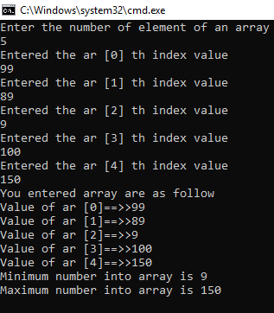

4) Write a Program to create an int Jagged Array which consists at least 5 array in it. Sort every array of Jagged array and display all jagged array after sorting.

Code:-

using System;

namespace C4

{

class Program

{

static void Main(string[] args)

{

int[][] jagged_array = new int[5][];

jagged_array[0] = new int[] { 1, 5, 4, 3, 2 };

jagged_array[1] = new int[] { 67, 34, 11 };

jagged_array[2] = new int[] { 44, 22, 66, 10 };

jagged_array[3] = new int[] { 99, 22, 44, 11, 55 };

jagged_array[4] = new int[] { 55, 22, 77, 44, 11, 55, 66 };

for (int i = 0; i < 5; i++)

{

Array.Sort(jagged_array[i]);

Console.WriteLine("After Sorting [" + i + "] th array");

for (int j = 0; j < jagged_array[i].Length; j++)

{

Console.WriteLine(jagged_array[i][j]);

}

}

}

}

}

O/P:-

