1 Write set of servlet which counts the number of visit on that URL by

particular user and display it to user by using all client side

techniques.

SessionTrack.java

import java.io.*;

import javax.servlet.*;

import javax.servlet.http.*;

import java.util.*;

public class SessionTrack extends HttpServlet {

public void doPost(HttpServletRequest req, HttpServletResponse res)

throws ServletException, IOException {

HttpSession session = req.getSession(true);

Date createTime = new Date(session.getCreationTime());

Date lastAccessTime = new Date(session.getLastAccessedTime());

String title = "Welcome Back to my website";

Integer visitCount = new Integer(0);

String visitCountKey = new String("visitCount");

String userIDKey = new String("userID");

String userID ;

userID= req.getParameter("name");

if (session.isNew()) {

title = "Welcome to my website";

session.setAttribute(userIDKey, userID);

}

else {

visitCount = (Integer)session.getAttribute(visitCountKey);

visitCount = visitCount + 1;

userID = (String)session.getAttribute(userIDKey);

}

session.setAttribute(visitCountKey, visitCount);

res.setContentType("text/html");

PrintWriter out = res.getWriter();

//out.println(userID);

out.println("<html>\n" +"<head><title>" + title + "</title></head>\n" );

out.println( "<body bgcolor = \"#f0f0f0\">\n" +"<h1 align = \"center\">"+ title + "</h1>\n" );

out.println("<h2 align = \"center\">Session Infomation</h2>\n" );

out.println("<table border = \"1\" align = \"center\">\n");

out.println("<tr bgcolor = \"#949494\">\n");

out.println(" <th>Session info</th><th>value</th> </tr>\n" +"<tr>\n");

out.println(" <td>id</td>\n" +" <td>" + session.getId() + "</td></tr>\n");

out.println("<tr>\n" +" <td>Creation Time</td>\n" +" <td>" + createTime + " </td></tr>\n" + "<tr>\n" );

out.println( " <td>Time of Last Access</td>\n" +" <td>" + lastAccessTime + " </td></tr>\n");

out.println("<tr>\n" +" <td>User ID</td>\n" +" <td>" + userID + " </td></tr>\n");

out.println("<tr>\n" +" <td>Number of visits</td>\n" +" <td>" + visitCount + "</td></tr>\n)");

out.println("</table>\n" +"</body></html>");

}

}

Index.html

<HTML>

<HEAD>

<TITLE>Login Page</TITLE>

</HEAD>

<body>

<form method="post" action="St">

Enter the User Name<input type="text" name="name"><br>

<input type="submit" name="submit">

</form>

</body>

</html>

Web.xml

<web-app>

<servlet>

<servlet-name>SessionTrack</servlet-name>

<servlet-class>SessionTrack</servlet-class>

</servlet>

<servlet-mapping>

<servlet-name>SessionTrack</servlet-name>

<url-pattern>/St</url-pattern>

</servlet-mapping>

</web-app>

O/P:-

1) index.html

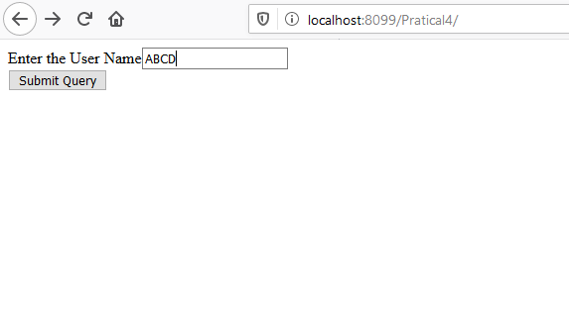

2) SessionTrack.java

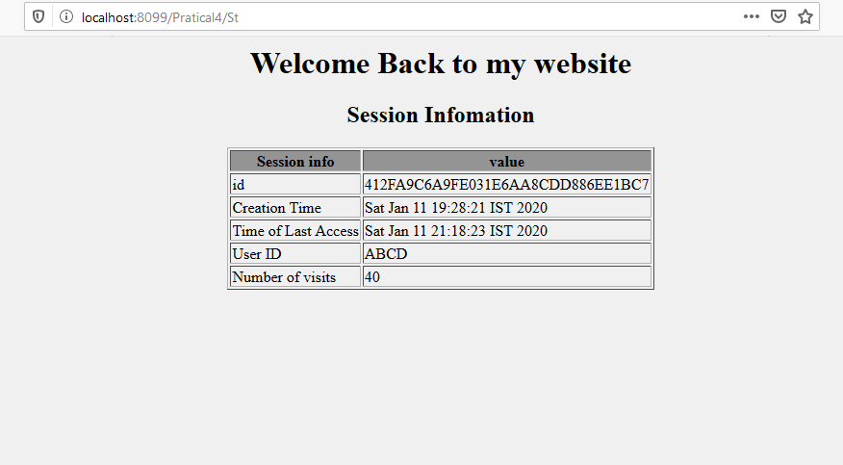

2) Write a simple servlet which counts the number of visit on that URL by particular user and display it to user along with the unique-id

and whether it is from cookie/URL, when user first visited the URL

and when it was last accessed.

Index.html

<HTML>

<HEAD>

<TITLE>Login Page</TITLE>

</HEAD>

<body>

<form method="post" action="St">

Enter the User Name<input type="text" name="name"><br>

<input type="submit" name="submit">

</form>

</body>

</html>

VisitServlet.java

import java.io.*;

import javax.servlet.*;

import javax.servlet.http.*;

import java.util.*;

public class VisitServlet extends HttpServlet

{

static int i=1;

static String s;

static String crT;

UUID uid;

public void init(ServletConfig config)

{

s=new Date().toString();

}

public void doPost(HttpServletRequest request, HttpServletResponse response)

throws IOException, ServletException

{

response.setContentType("text/html");

String name = request.getParameter("name");

PrintWriter out = response.getWriter();

String k=String.valueOf(i);

Cookie c = new Cookie("ABCD",k);

response.addCookie(c);

int j=Integer.parseInt(c.getValue());

if(j==1)

{

crT=new Date().toString();

uid = UUID.randomUUID();

out.println("<html><body><center><table border=1>"+

"<tr><td>User Name</td><td>"+name+"</td></tr><tr><td>"+

" Cookie creation Time</td><td>"+crT+"</td></tr><tr><td>"+

"Cokkie id</td><td>"+uid +"</td></tr></table></body></html>");

}

else

{

out.println("<html><body><center><table border=1><tr><td>User Name</td>"+

"<td>"+name+"</td></tr><tr><td>Cookie creation Time</td><td>"+crT+"</td></tr>"+

"<tr><td>Cokkie id</td><td>"+uid +"</td></tr><tr><td>Total Number of visit</td><td>"+i+

"</td></tr><tr><td>Last Access Time</td><td>"+s+"</td></tr></table></body></html>");

if(c!=null)

{

out.println("Cookie is available");

}

else

{

out.println("Cookie is not available");

}

}

i++;

s=new Date().toString();

}

}

Web.xml

<web-app>

<servlet>

<servlet-name>VisitServlet </servlet-name>

<servlet-class>VisitServlet </servlet-class>

</servlet>

<servlet-mapping>

<servlet-name>VisitServlet </servlet-name>

<url-pattern>/St</url-pattern>

</servlet-mapping>

</web-app>

O/P:-

1) index.html

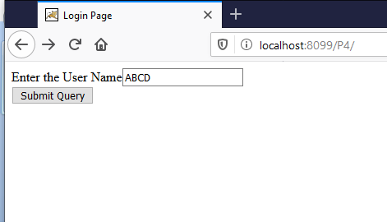

2) When the cookie is created

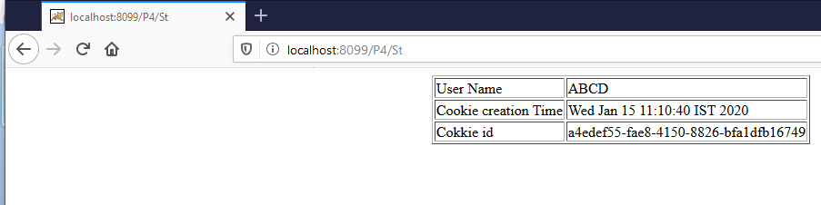

3) Again goto the that page

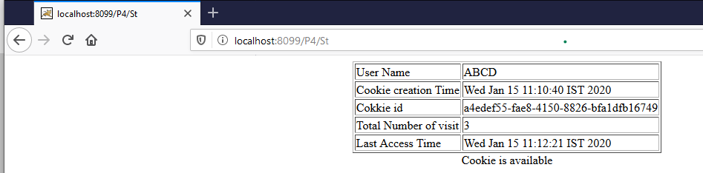

3) Write a servlet application for online store with following

Functionalities.

Accept Username and Password through Login.html

• Check validity of username and password using a servlet and its

config parameters.

• On successful login user has to be redirected to Product List page.

This page displays product list with rate. User are able to select

multiple products and specify its quantity.

• User can either select Buy Now option or Reset option on Product

list page.

• Buy Now option will take user to invoice page. Reset option will

redirect to product list page.

• Invoice page will contain the products selected by user along with

their rate and total bill of each and all products. User can select

Pay Now option to proceed.

• This will display user with invoice details and thank you message.

• All pages after login will have logout functionality which will save

the current state of cart and logout.

• You must use Session management at client side and server side

in this program.

• Program must be able to run successfully by concurrent users.

• Indefinite program close will allow user to maintain their state.

Index.html

<html>

<head>

<title>Online Store</title>

</head>

<body>

<pre>

<hr><h1>ONLINE STORE</h1><hr>

<form method="POST" action="login">

UserName : <input type="text" name="unm"><br>

Password : <input type="password" name="pass"><br>

<input type ="submit" name="submit" value="Log "><br>

</form>

</pre>

</body>

</html>

Login.java

import java.io.*;

import javax.servlet.*;

import javax.servlet.http.*;

public class Login extends HttpServlet{

public void doPost(HttpServletRequest req,HttpServletResponse res)throws IOException,ServletException{

String name = req.getParameter("unm");

String Passw = req.getParameter("pass");

PrintWriter out = res.getWriter();

String username = getServletConfig().getInitParameter("username"); if(name.equals(username)){

res.sendRedirect("product_list.html");

}

else{

res.sendRedirect("login.html");

}

}

}

product_list.html

<html>

<head>

<title>Online Store</title>

</head>

<body>

<pre>

<hr><h1>ONLINE STORE</h1><hr>

<form method="POST" action="pay">

<table border=1>

<tr>

<td>Product List</td>

<td>Choice</td>

<td>Price</td>

<td>Product Quantity</td>

</tr>

<tr>

<td>AC</td>

<td> <input type="checkbox" name="ac"value="Ac" ></td>

<td><input type="text" name="aprice" value="55000" ></td>

<td><input type="text" name="aqan"></td>

</tr>

<tr>

<td>Tv</td>

<td> <input type="checkbox" name="tv" value="tv" ></td>

<td><input type="text" name="tprice" value="36000" ></td>

<td><input type="text" name="tqan"></td>

</tr>

<tr>

<td>WashingMachine</td>

<td> <input type="checkbox" name="washingmachine" value="washingmachine" ></td>

<td><input type="text" name="wprice" value="75000" ></td>

<td><input type="text" name="wqan"></td>

</tr>

</table>

<input type="submit" name="submit" value="Buy Now">

</form>

</pre>

</body>

</html>

ProductShow.java

import java.io.*;

import javax.servlet.*;

import javax.servlet.http.*;

public class ProductShow extends HttpServlet{

public void doPost(HttpServletRequest req,HttpServletResponse res) throws IOException,ServletException{

PrintWriter out = res.getWriter();

double gTotal=0;

double tTax=0;

double gtTax=0;

if(req.getParameter("ac") != null){

out.println("ITEM NAME : Ac");

int mprice = Integer.parseInt(req.getParameter("aprice"));

int mqan = Integer.parseInt(req.getParameter("aqan"));

out.println("ITEM PRICE : "+mprice);

out.println("ITEM QUANTITY : "+mqan);

double tot = mqan * mprice;

out.println("TOTAL AMOUNT : " + tot);

gTotal = gTotal + tot; out.println("=============================================================================================");

}

if(req.getParameter("tv") != null){

out.println("ITEM NAME : Tv");

int mprice = Integer.parseInt(req.getParameter("tprice"));

int mqan = Integer.parseInt(req.getParameter("tqan"));

out.println("ITEM PRICE : "+mprice);

out.println("ITEM QUANTITY : "+mqan);

double tot = mqan * mprice;

out.println("TOTAL AMOUNT : " + tot);

gTotal = gTotal + tot; out.println("=============================================================================================");

}

if(req.getParameter("washingmachine") != null){

out.println("ITEM NAME : washingmachine ");

int mprice = Integer.parseInt(req.getParameter("wprice"));

int mqan = Integer.parseInt(req.getParameter("wqan"));

out.println("ITEM PRICE : "+mprice);

out.println("ITEM QUANTITY : "+mqan);

double tot = mqan * mprice;

out.println("TOTAL AMOUNT : " + tot);

gTotal = gTotal + tot; out.println("=============================================================================================");

}

out.println("Before Tax Total Payable Amount is"+gTotal);

tTax=((gTotal*20)/100);

gtTax= gTotal + tTax;

out.println("After tax Total Payable Amount is"+gtTax);

}

}

Web.xml

<?xml version="1.0" encoding="ISO-8859-1"?>

<web-app>

<servlet>

<servlet-name>login</servlet-name>

<servlet-class>Login</servlet-class>

<init-param>

<param-name>username</param-name>

<param-value>admin</param-value>

</init-param>

</servlet>

<servlet-mapping>

<servlet-name>login</servlet-name>

<url-pattern>/login</url-pattern>

</servlet-mapping>

<servlet>

<servlet-name>productlist</servlet-name>

<servlet-class>ProductShow</servlet-class>

</servlet>

<servlet-mapping>

<servlet-name>productlist</servlet-name>

<url-pattern>/pay</url-pattern>

</servlet-mapping>

</web-app>

O/P:-

1) index.html

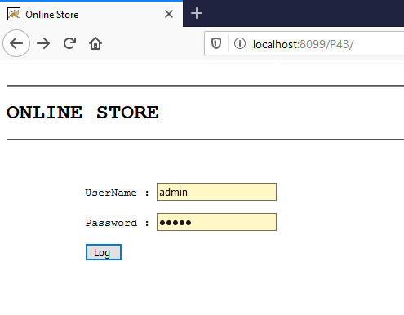

2) product_list.html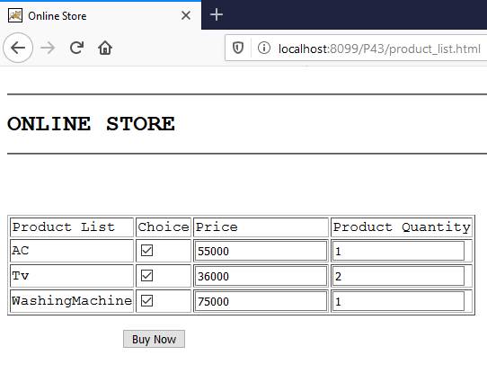

3)Pay

