Q-1 Create a Servlet Which gets color from init parameter and username from user and sets the background color of web browser with welcome message in center with Heading1 in response.

Ans-1

BgColor.java

import java.io.\*;

import javax.servlet.\*;

import javax.servlet.http.\*;

public class BgColor extends HttpServlet

{

private String uname;

public void doGet(HttpServletRequest req, HttpServletResponse res) throws ServletException,IOException

{

res.setContentType("text/html");

PrintWriter out = res.getWriter();

ServletConfig conf=getServletConfig();

uname = conf.getInitParameter("uname");

String s1=conf.getInitParameter("color");

out.println("Username = " + uname + " Color = " + s1 + "Hello");

out.println("<html><body style='background-color:" + s1 + ";color:white'>Hello Welcome</body></html>" );

out.close();

}

}

Web.xml

<?xml version="1.0" encoding="ISO-8859-1"?>

<web-app>

<servlet>

<servlet-name>BgColor</servlet-name>

<servlet-class>BgColor</servlet-class>

<init-param>

<param-name>uname</param-name>

<param-value>yash</param-value>

</init-param>

<init-param>

<param-name>color</param-name>

<param-value>green</param-value>

</init-param>

</servlet>

<servlet-mapping>

<servlet-name>BgColor</servlet-name>

<url-pattern>/Bg</url-pattern>

</servlet-mapping>

</web-app>

O/P:-

Bg.java

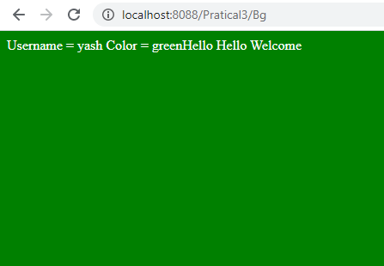

Q-2 Create a login.html file which allows user to input username and password. Create a servlet that takes the username as password and check it with stored context parameters. If the user is valid then redirect to welcome servlet which shows a welcome message to user nselse redirect back to login.html. (Use sendRedirect).

Ans-2

Login.html

<html>

<head>

<title>login form</title>

</head>

<body>

<form method="GET" action="Second">

Email ID:<input type="text" name="user" /><br/>

Password:<input type="text" name="pass" /><br/>

<input type="submit" value="login" />

</form>

</body>

</html>

second.java

import java.io.\*;

import javax.servlet.\*;

import javax.servlet.http.\*;

public class Second extends HttpServlet

{

public void doGet(HttpServletRequest req,HttpServletResponse res)throws IOException,ServletException

{

ServletContext con=getServletContext();

String ouser=con.getInitParameter("username");

String opass=con.getInitParameter("password");

PrintWriter out=res.getWriter();

out.println(ouser);

out.println(opass);

res.setContentType("text/html");

String user=req.getParameter("user");

String pass=req.getParameter("pass");

if(user.compareTo(ouser)==0 && pass.compareTo(opass)==0)

{

res.sendRedirect("Welcome?user="+user);

}

else

{

res.sendRedirect("login.html");

}

}

}

Welcome.java

import java.io.\*;

import javax.servlet.\*;

import javax.servlet.http.\*;

public class Welcome extends HttpServlet

{

public void doGet(HttpServletRequest req,HttpServletResponse res)throws IOException,ServletException

{

PrintWriter out=res.getWriter();

out.println("Welcome : "+req.getParameter("user"));

}

}

Web.xml

<web-app>

<context-param>

<param-name>username</param-name>

<param-value>admin</param-value>

</context-param>

<context-param>

<param-name>password</param-name>

<param-value>admin</param-value>

</context-param>

<servlet>

<servlet-name>Second</servlet-name>

<servlet-class>Second</servlet-class>

</servlet>

<servlet>

<servlet-name>Welcome</servlet-name>

<servlet-class>Welcome </servlet-class>

</servlet>

<servlet-mapping>

<servlet-name>Second</servlet-name>

<url-pattern>/Second</url-pattern>

</servlet-mapping>

<servlet-mapping>

<servlet-name>Welcome</servlet-name>

<url-pattern>/Welcome</url-pattern>

</servlet-mapping>

</web-app>

O/P:-

Login.html

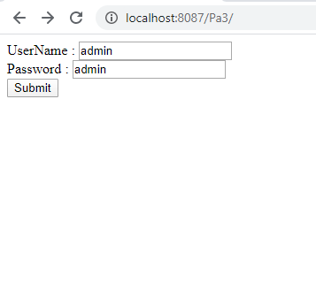

2)welcome.java

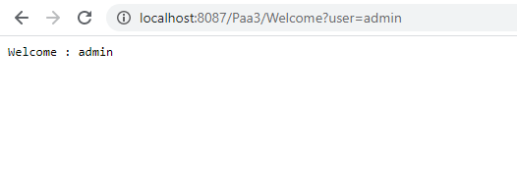

3) if user id and password are not correct

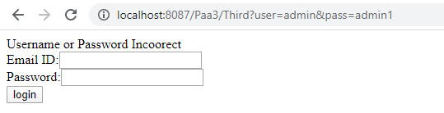

Q-3 Create a login.html file which allows user to input username and password. Create a servlet that takes the username as password and check it with stored config parameters. If the user is valid then redirect to welcome servlet which shows a welcome message to user else redirect back to login.html. (Use Request Dispatcher).

Ans-3

login2.html

<html>

<head>

<title>login form</title>

</head>

<body>

<form method="GET" action="Third">

Email ID:<input type="text" name="user" /><br/>

Password:<input type="text" name="pass" /><br/>

<input type="submit" value="login" />

</form>

</body>

</html>

Third.java

import java.io.\*;

import javax.servlet.\*;

import javax.servlet.http.\*;

public class Third extends HttpServlet

{

public void doGet(HttpServletRequest req,HttpServletResponse res)throws IOException,ServletException

{

String ouser=getInitParameter("username");

String opass=getInitParameter("password");

PrintWriter out=res.getWriter();

res.setContentType("text/html");

String user=req.getParameter("user");

String pass=req.getParameter("pass");

if(user.compareTo(ouser)==0 && pass.compareTo(opass)==0)

{

RequestDispatcher rd=req.getRequestDispatcher("Welcome");

rd.forward(req,res);

}

else

{

out.println("Username or Password Incoorect");

RequestDispatcher rd=req.getRequestDispatcher("login.html");

rd.include(req,res);

}

}

}

Welcome.java

import java.io.\*;

import javax.servlet.\*;

import javax.servlet.http.\*;

public class Welcome extends HttpServlet

{

public void doGet(HttpServletRequest req,HttpServletResponse nres)throws IOException,ServletException

{

PrintWriter out=res.getWriter();

out.println("Welcome : "+req.getParameter("user"));

}

}

Web.xml

<web-app>

<servlet>

<init-param>

<param-name>username</param-name>

<param-value>admin</param-value>

</init-param>

<init-param>

<param-name>password</param-name>

<param-value>admin</param-value>

</init-param>

<servlet-name>Third</servlet-name>

<servlet-class>Third</servlet-class>

</servlet>

<servlet>

<servlet-name>Welcome</servlet-name>

<servlet-class>Welcome </servlet-class>

</servlet>

<servlet-mapping>

<servlet-name>Third</servlet-name>

<url-pattern>/Third</url-pattern>

</servlet-mapping>

<servlet-mapping>

<servlet-name>Welcome</servlet-name>

<url-pattern>/Welcome</url-pattern>

</servlet-mapping>

</web-app>

O/P:-

1) Login2.html



2) Welcome.java



3) User id and pass word is not matched



Q-4 Write a simple servlet which counts the total number of visit on that URL and display it to user along with the request time, request URI, Protocol, PathInfo, IP Address.

Ans-4

Four.java

import java.io.\*;

import java.util.\*;

import javax.servlet.\*;

import javax.servlet.http.\*;

public class Four extends HttpServlet

{

private static int count ;

public void init()

{

count=0;

}

public void doGet(HttpServletRequest req,HttpServletResponse res)throws IOException,ServletException

{

count++;

Date reqtime=new Date();

PrintWriter out=res.getWriter();

out.println("Number of Hits"+count);

out.println("Request time="+reqtime);

out.println("Request Url="+req.getRequestURI());

out.println("Protocol="+req.getProtocol());

out.println("Path info="+req.getPathInfo());

out.println("IP address="+req.getRemoteAddr());

}

}

Web.xml

<web-app>

<servlet>

<servlet-name>Four</servlet-name>

<servlet-class>Four</servlet-class>

</servlet>

<servlet-mapping>

<servlet-name>Four</servlet-name>

<url-pattern>/Four</url-pattern>

</servlet-mapping>

</web-app>

O/P:-

Four.java

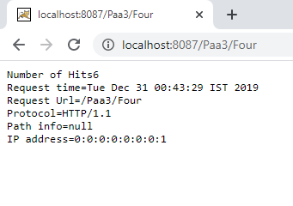

Q-5 Write a simple servlet which auto refresh at every second to show user the correct time on browser.

Ans-5

Time1.java

import java.io.\*;

import javax.servlet.\*;

import javax.servlet.http.\*;

import java.util.\*;

public class Time1 extends HttpServlet{

public void doGet(HttpServletRequest req,HttpServletResponse res)throws IOException,ServletException{

PrintWriter out = res.getWriter();

out.println(new Date().toString());

res.setIntHeader("Refresh",1);

}

}

Web.xml

<?xml version="1.0" encoding="ISO-8859-1"?>

<web-app>

<servlet>

<servlet-name>Time1</servlet-name>

<servlet-class>Time1</servlet-class>

</servlet>

<servlet-mapping>

<servlet-name>Time1</servlet-name>

<url-pattern>/t</url-pattern>

</servlet-mapping>

</web-app>

O/P:-

Time1.java

