UML representation of

LIBRARY SYSTEM

CLASS DIAGRAM

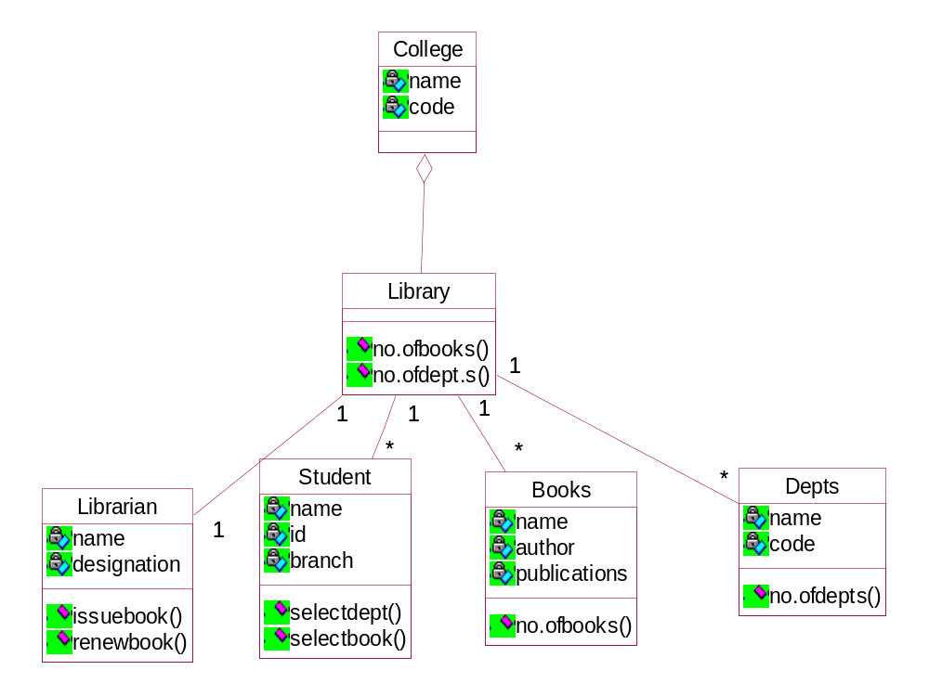

OBJECT DIAGRAM

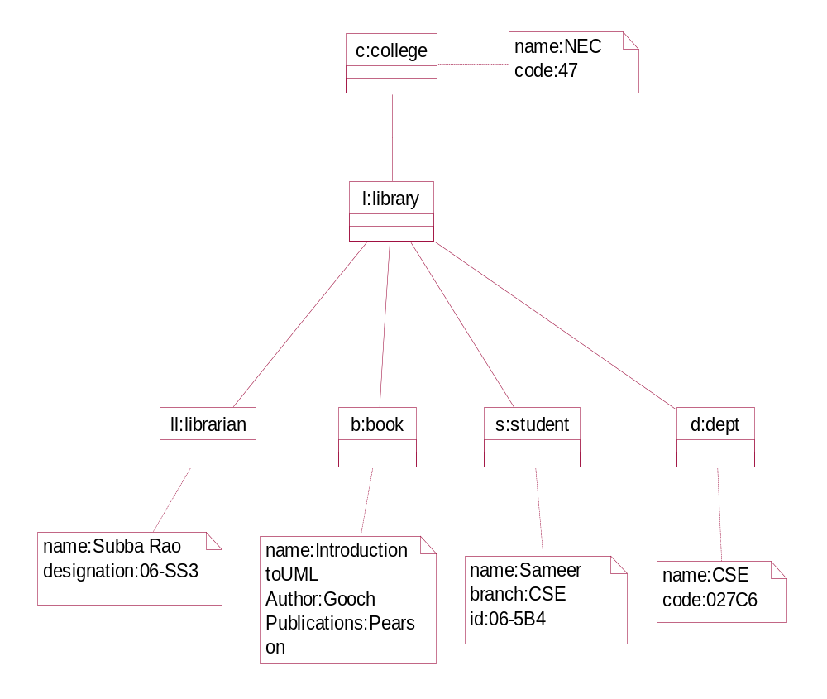

COMPONENT DIAGRAM

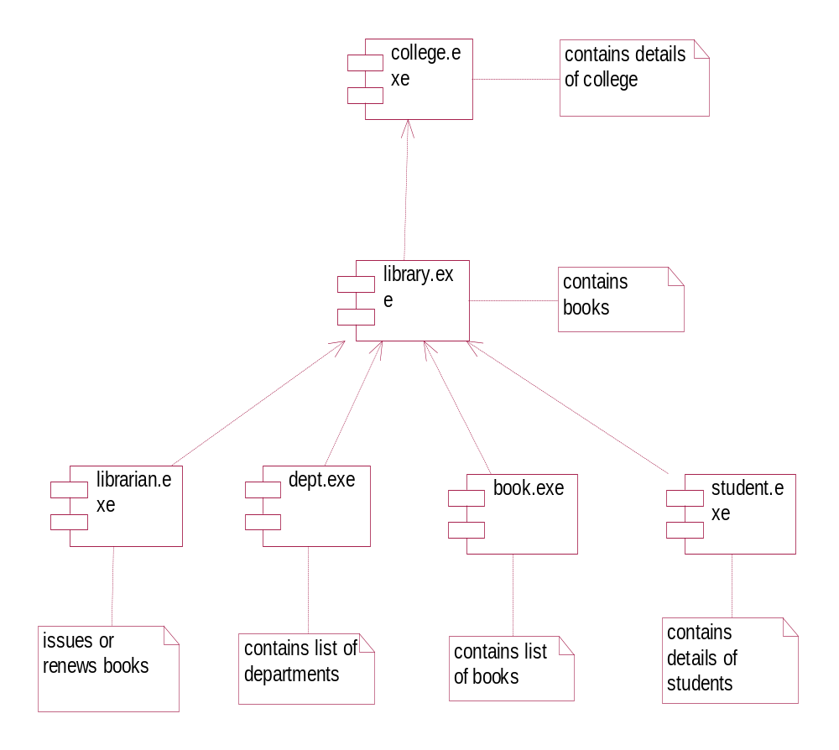

DEPLOYMENT DIAGRAM

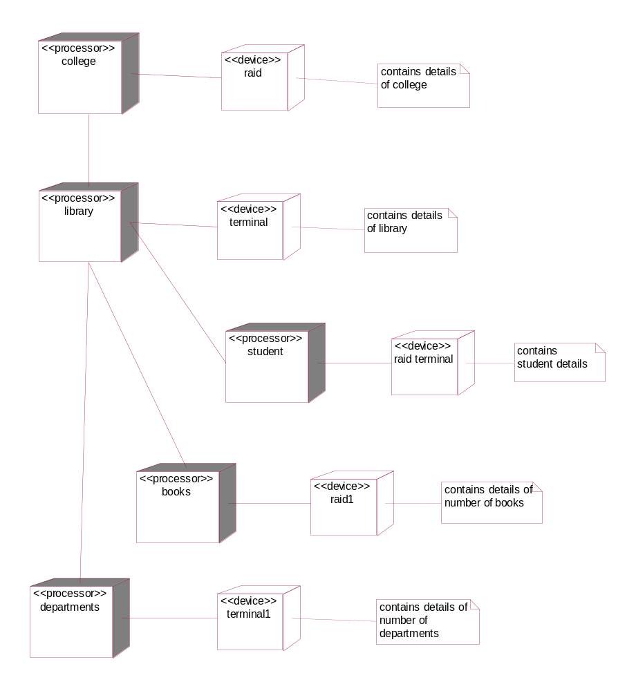

USECASE DIAGRAM

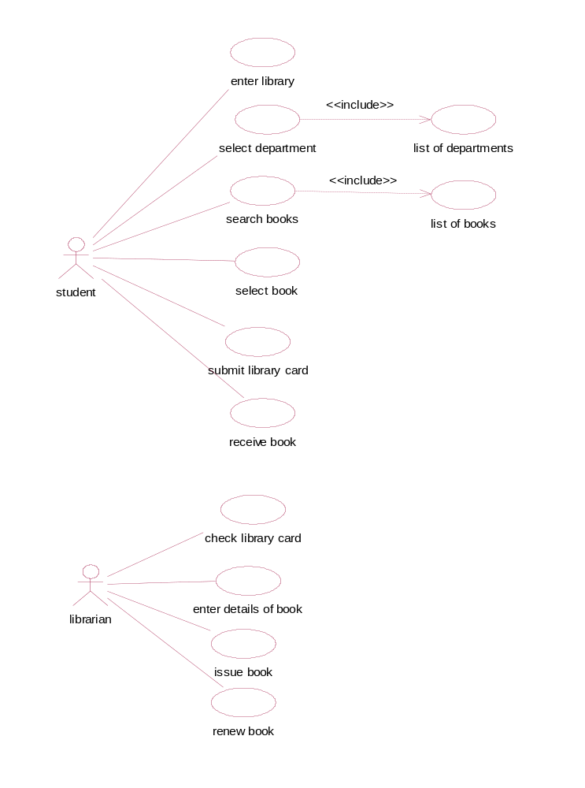

SEQUENCE DIAGRAM

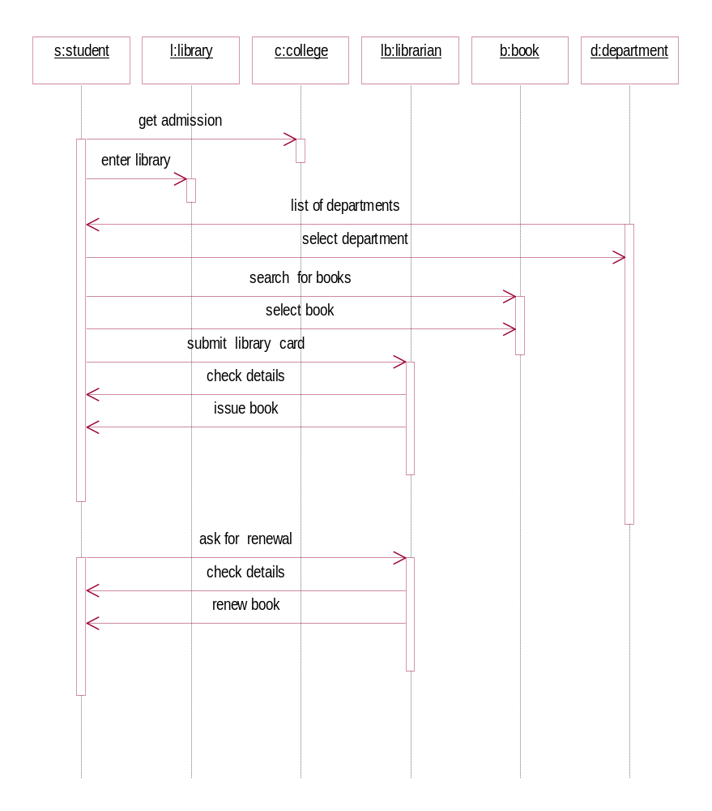

COLLABORATION DIAGRAM

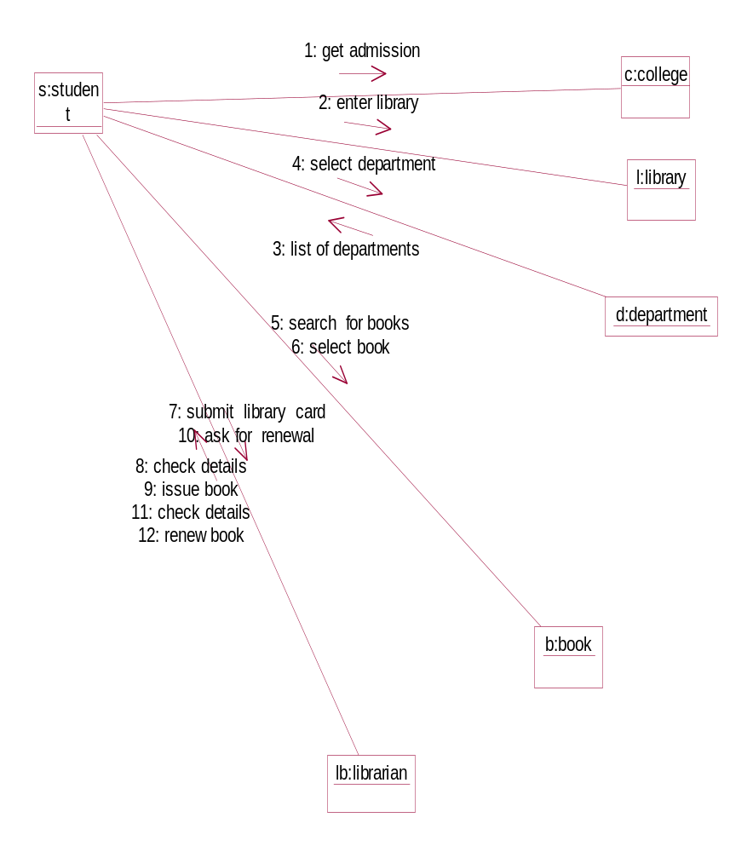

ACTIVITY DIAGRAM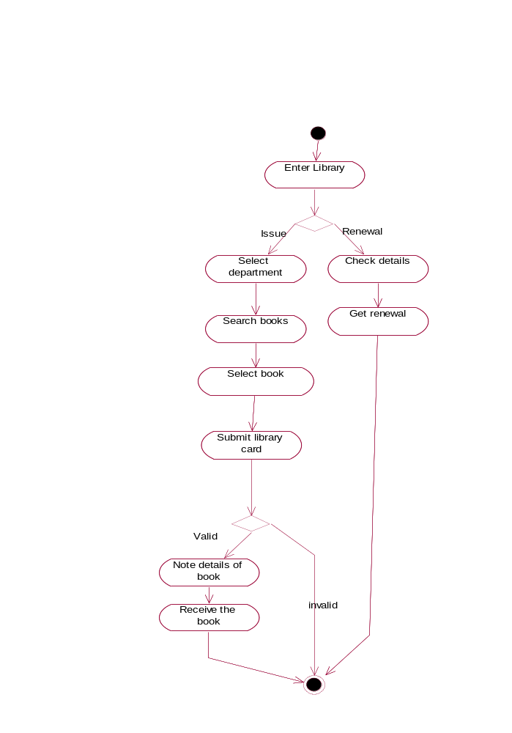

STATECHART DIAGRAM
