UML REPRESENTATION OF

ONLINE BOOKSHOP SYSTEM

CLASS DIAGRAM

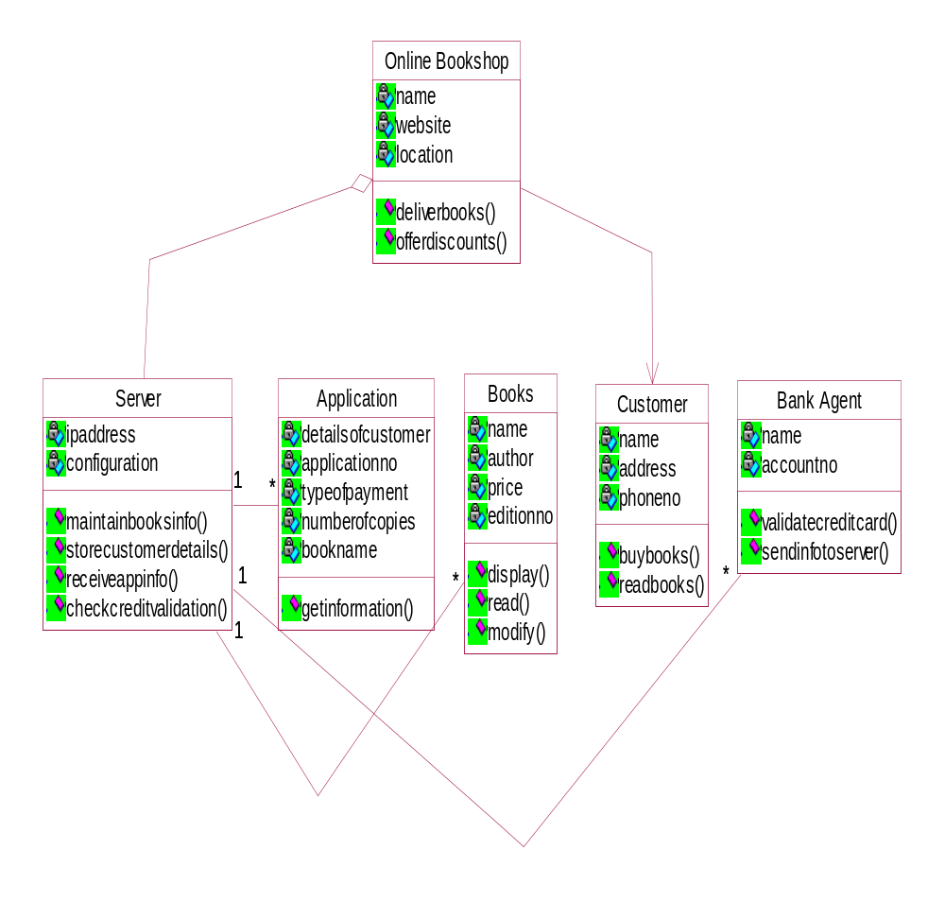

OBJECT DIAGRAM

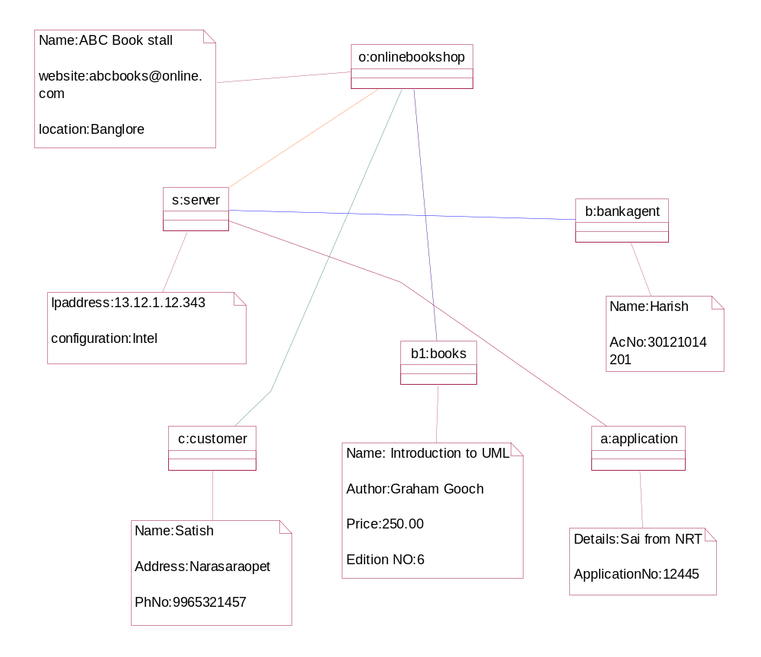

COMPONENT DIAGRAM

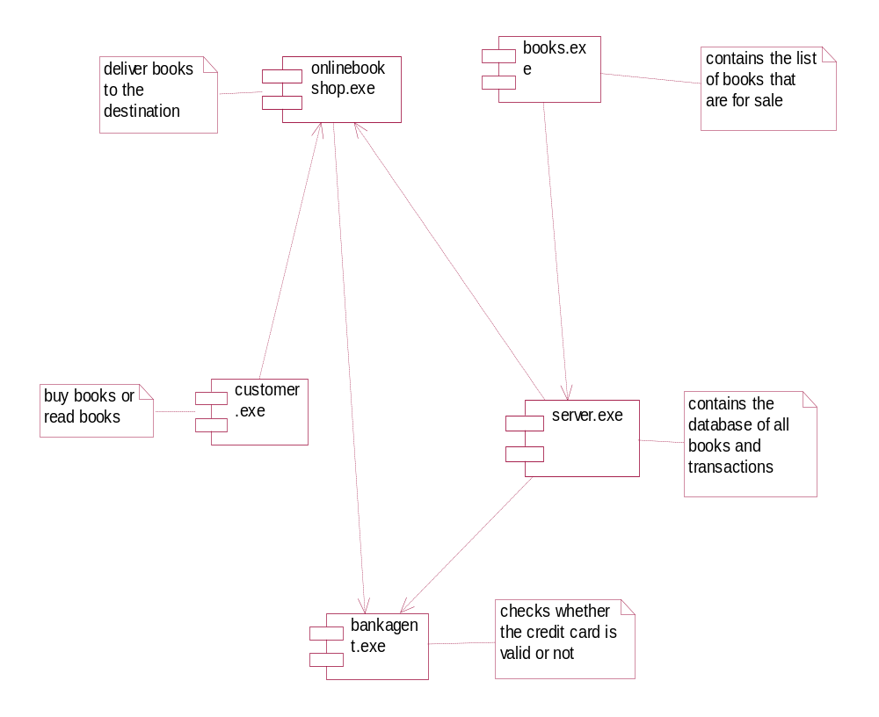

DEPLOYMENT DIAGRAM

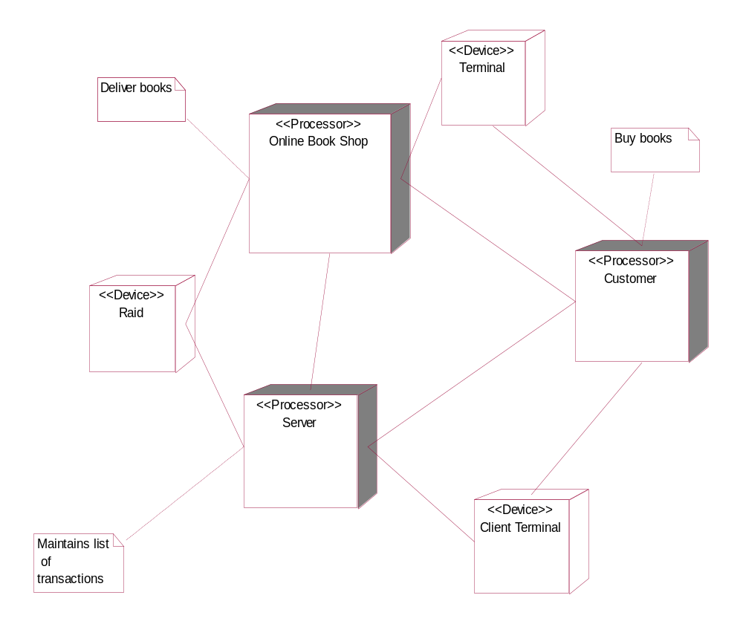

USECASE DIAGRAM
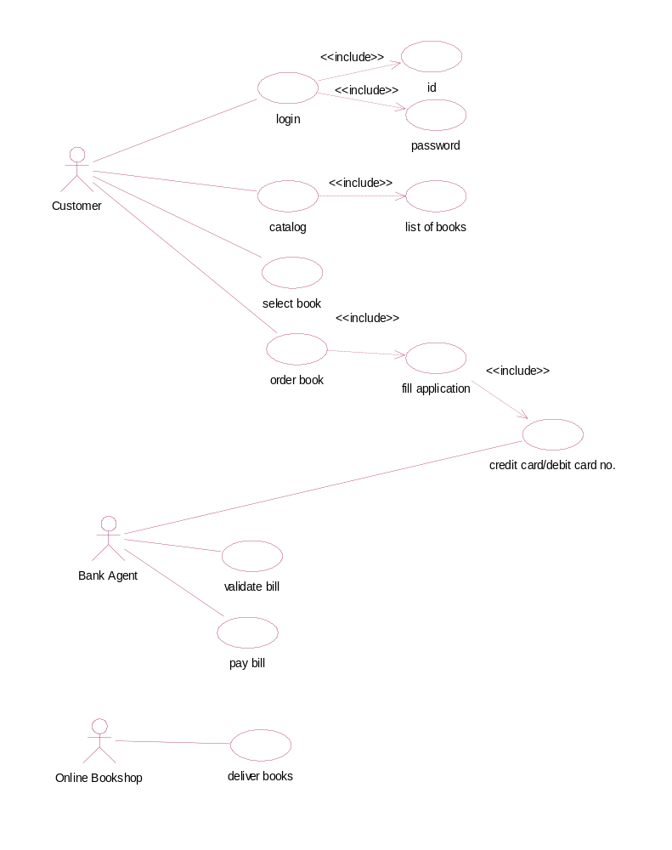

SEQUENCE DIAGRAM

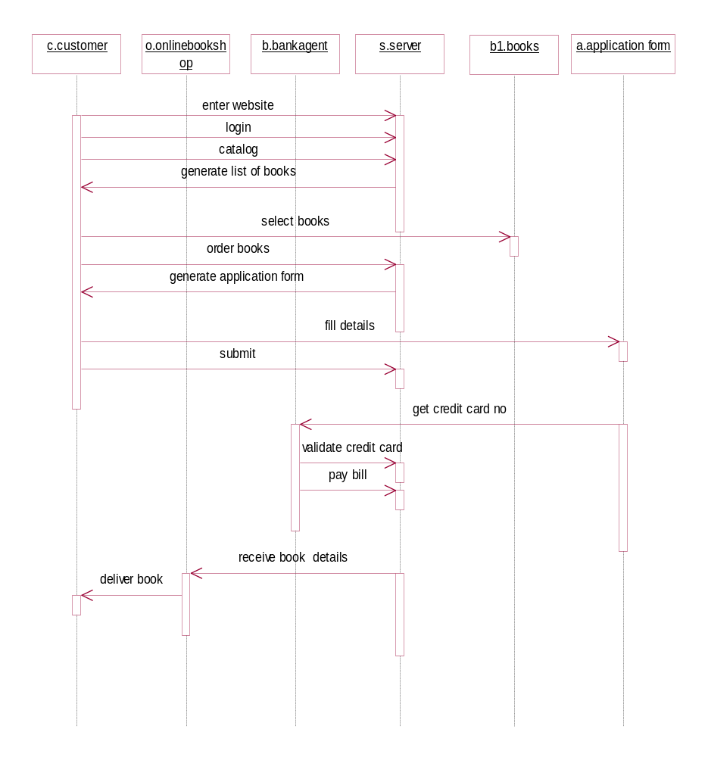

COLLABORATION DIAGRAM

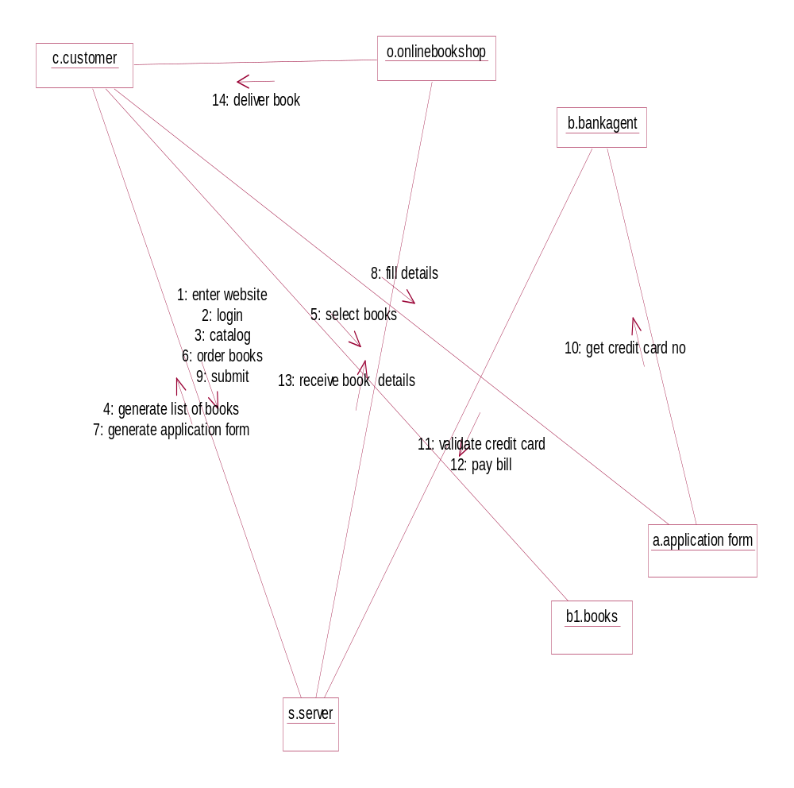

ACTIVITY DIAGRAM

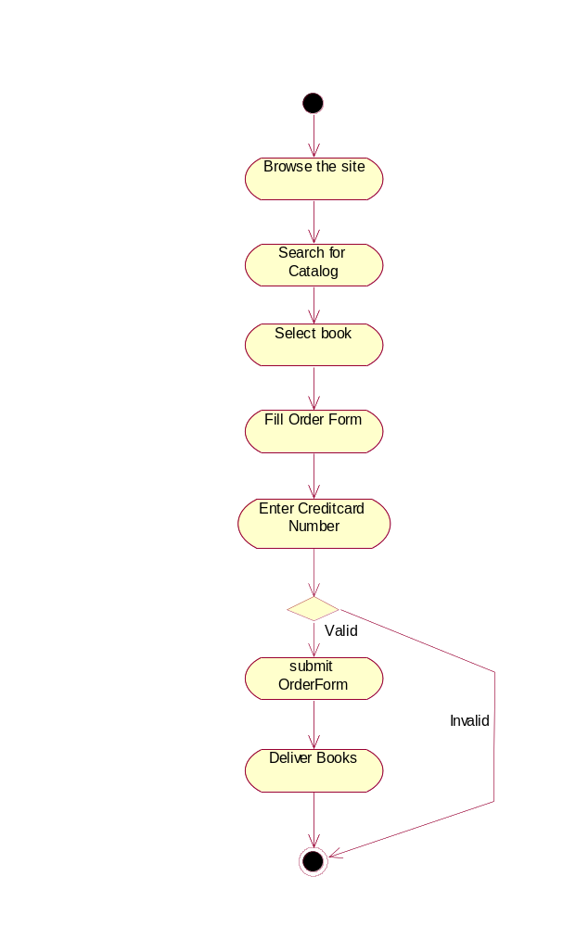

STATECHART DIAGRAM
