UML REPRESENTATION OF

UNIVERSITY SYSTEM

CLASS DIAGRAM

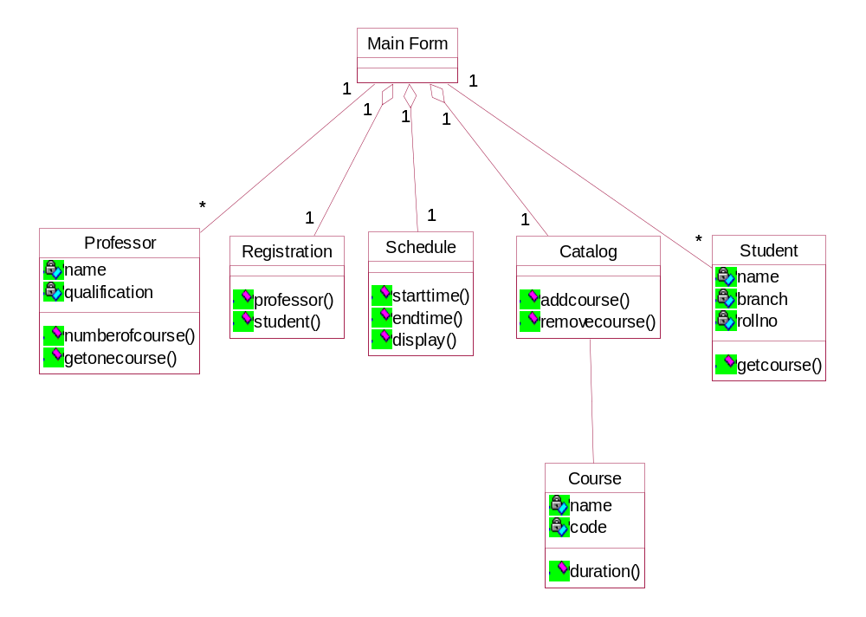

OBJECT DIAGRAM

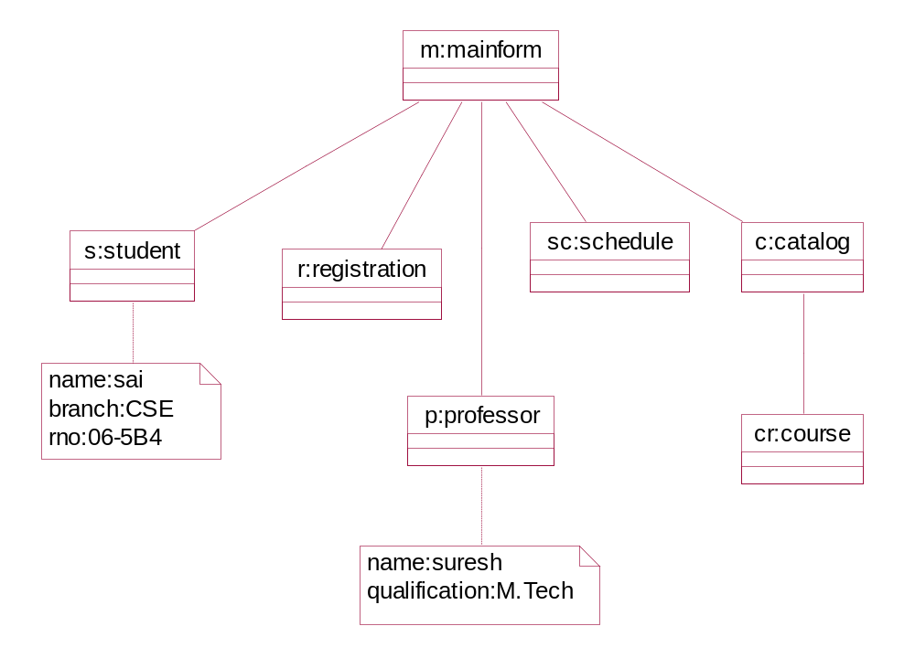

COMPONENT DIAGRAM

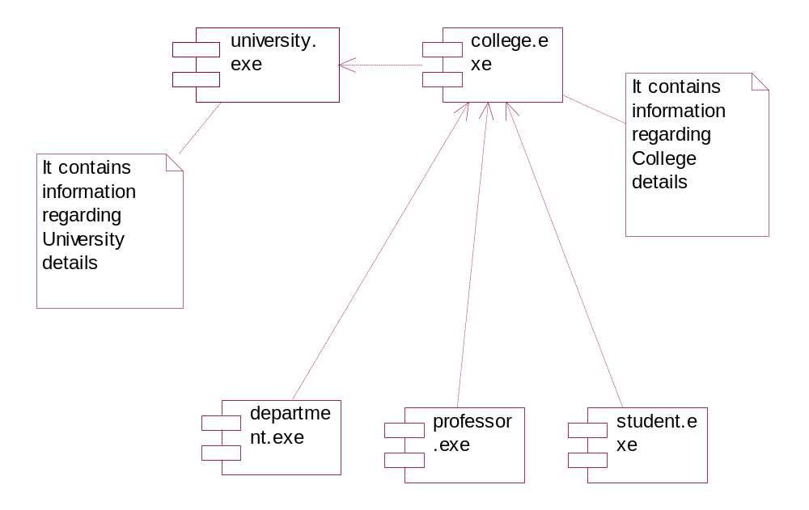

DEPLOYMENT DIAGRAM

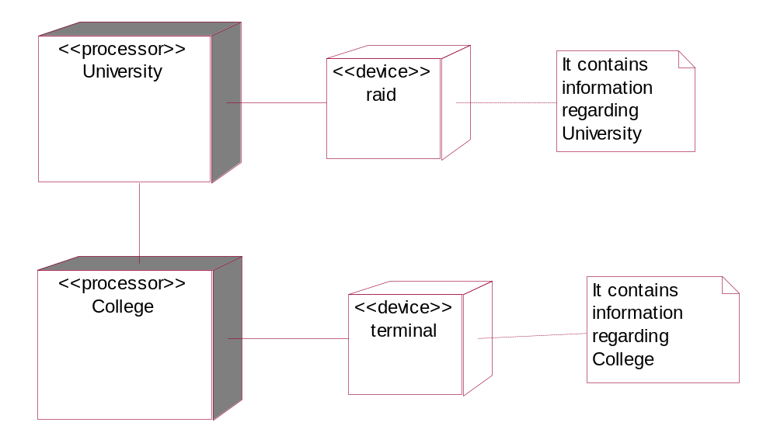

USECASE DIAGRAM

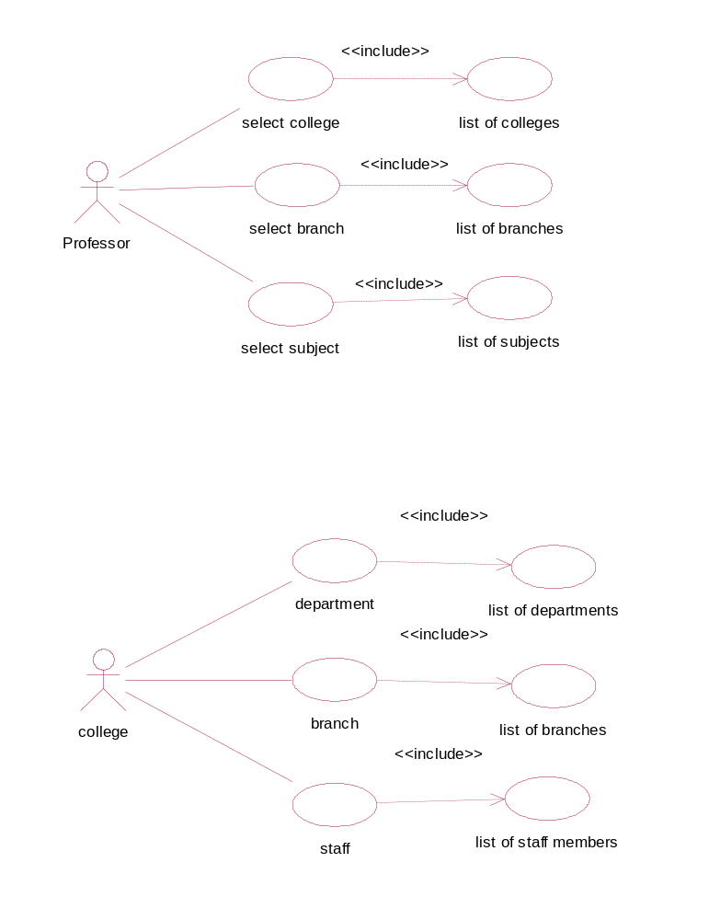

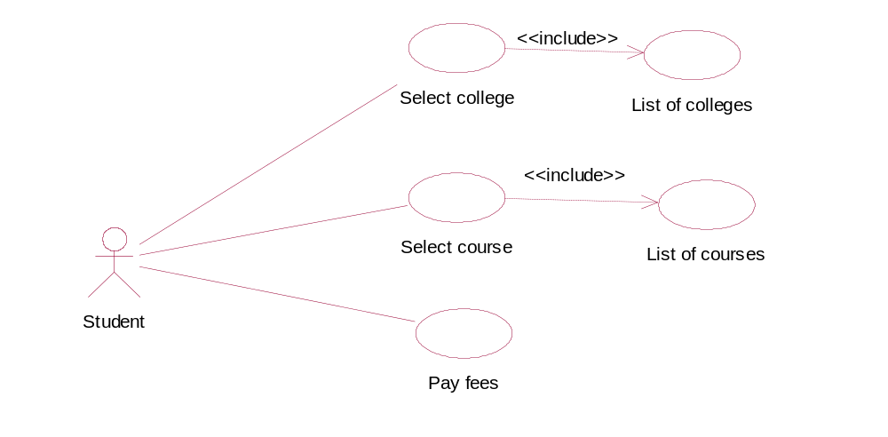

SEQUENCE DIAGRAM
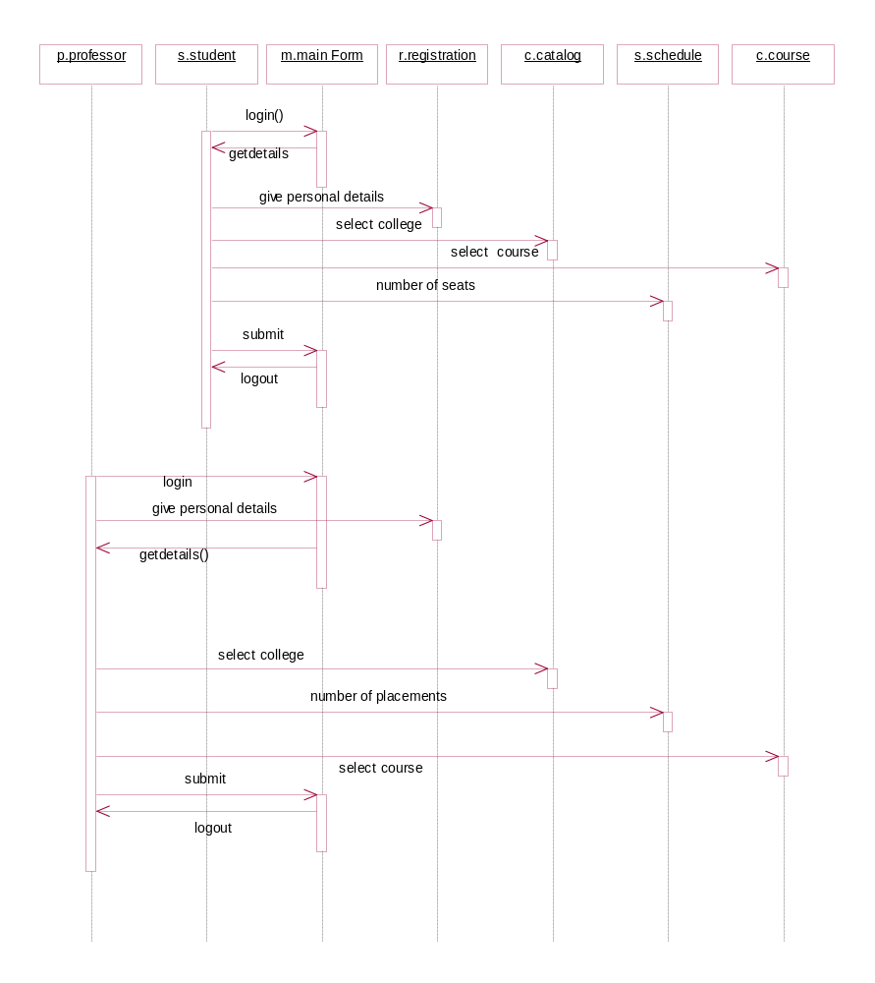

COLLABORATION DIAGRAM

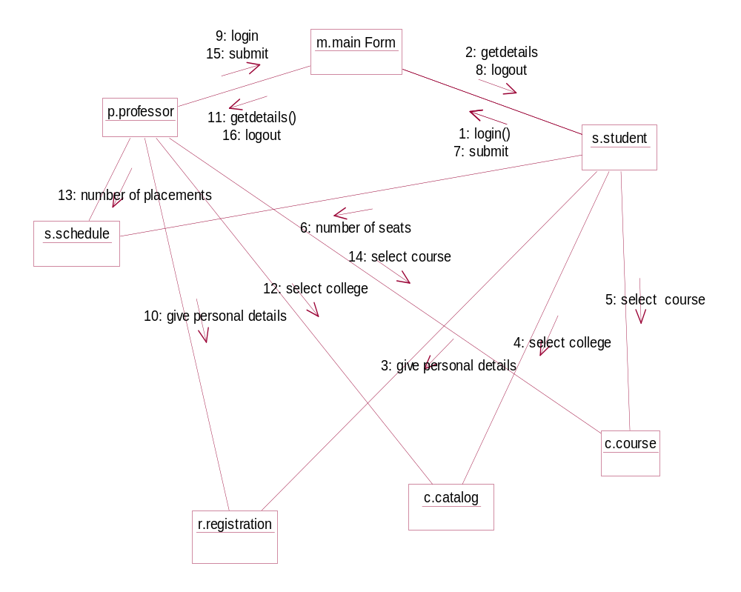

ACTIVITY DIAGRAM

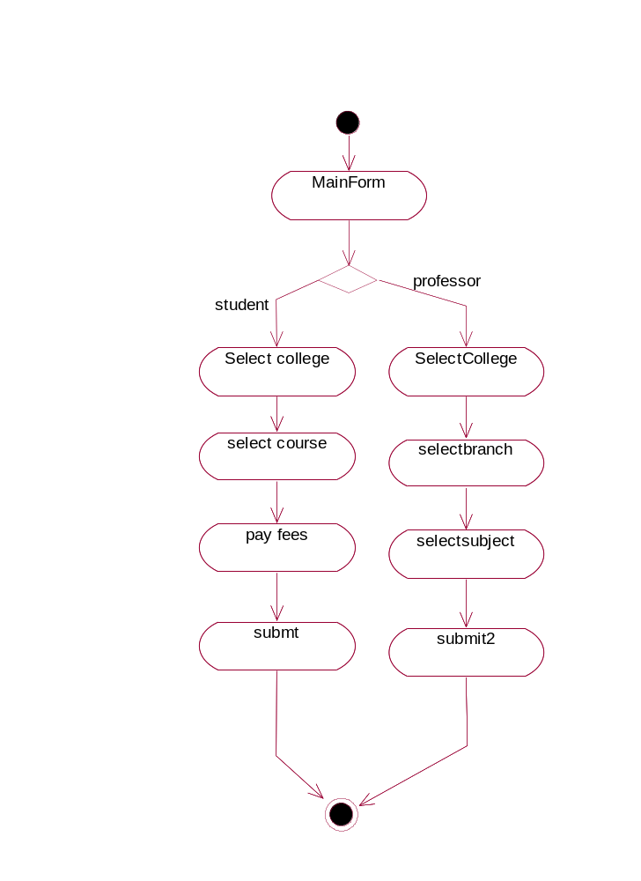

STATECHART DIAGRAM

