JAGETIYA METALS · SINCE 1990 · VADODARA, GUJARAT
JAGETIYA METALS
Premium Alloy & Tool Steel Solutions
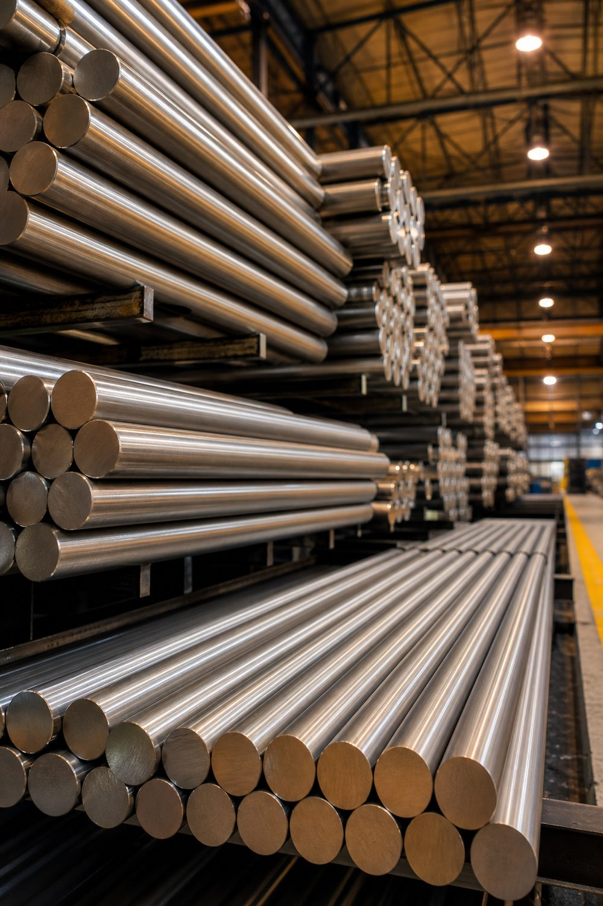
Three decades of trusted supply in ferrous & non-ferrous metals — round bars, bright bars, forged bars and precision cutting for India's leading industries.
30+ Years of Excellence | 500+ Customers | Cutting Capacity 16–550 mm
www.jkmetal.in

COMPANY PROFILE
About Jagetiya Metals
Founded in 1990 in Vadodara, Gujarat, Jagetiya Metals has grown into a cornerstone of Gujarat's steel industry — supplying premium ferrous and non-ferrous metals to industrial powerhouses across Makarpura G.I.D.C., Baroda, Por, Halol, Savali and the Panchmahal District. We combine decades of expertise with a commitment to precision, reliability and tailored procurement.
30+ YEARS | 500+ CUSTOMERS | EST. 1990 | 100% TEST CERTIFIED
Industry leadership | Served across India | Three decades strong | Supplied with T.C.
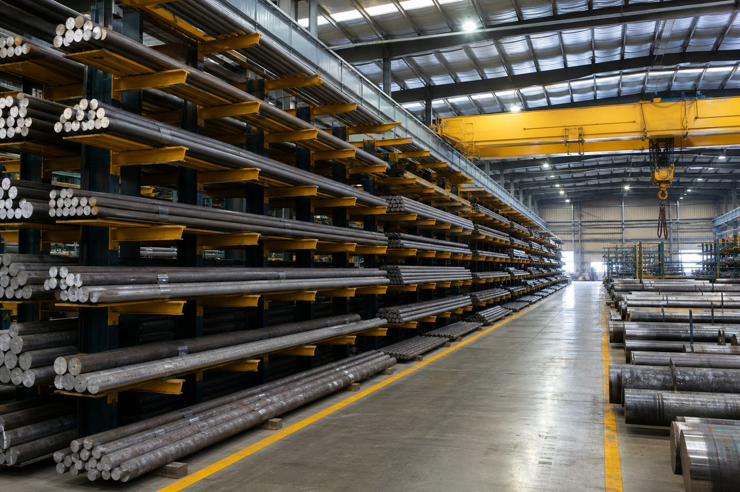
What We Do
We deliver top-tier alloy, tool and structural steels in round, bright, forged, square, flat, RCS and hex forms — backed by in-house hydraulic bandsaw cutting from 16 mm to 550 mm. Every order ships with material test certificates.
Why Choose Us
- Certified Quality — premium metals supplied with testing certificates.
- Custom Dimensions — exact quantities and cut sizes to optimise your stock cost.
- On-Time Delivery — stringent standards and dependable logistics.
- Trusted Partner — enduring relationships built on reliability.

MATERIALS WE STOCK
Grades & Sizes We Keep
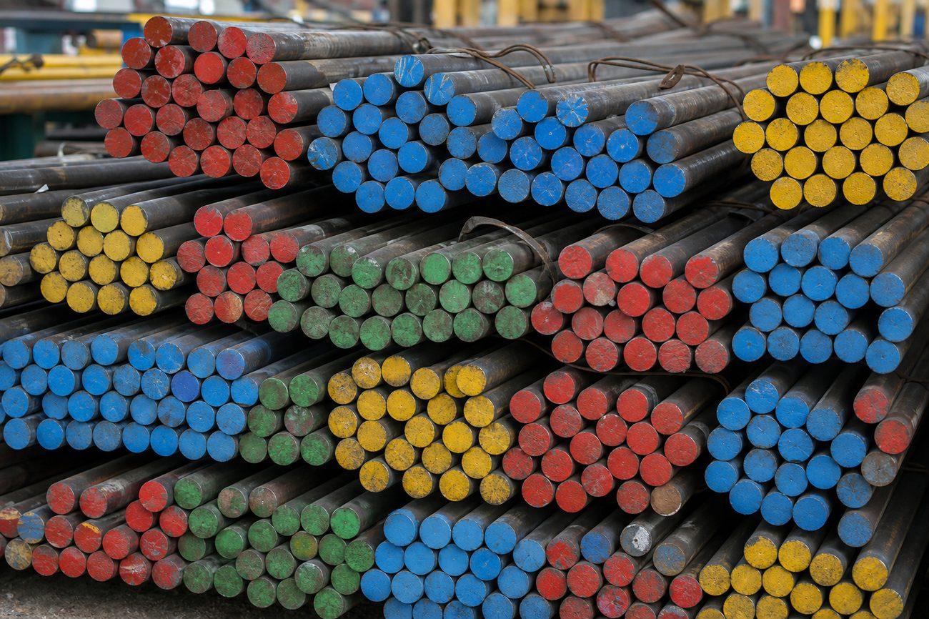
GRADE | STANDARD | DESCRIPTION | APPLICATIONS
42CrMo4 | DIN 1.7225 · EN19 · 4140 | High-tensile chromium-molybdenum alloy steel with excellent hardenability, strength and toughness. | Axles, shafts, gears, crankshafts, spindles, high-tensile bolts.
42CrMo7-6 | Cr-Mo · high hardenability | Enriched Cr-Mo grade for larger cross-sections and heavy-duty parts needing deep, uniform hardness. | Heavy forgings, large shafts, dies, gear blanks.
16MnCr4 | DIN 1.7131 · case-hardening | Chromium-manganese carburising steel — hard, wear-resistant case with a tough, ductile core. | Gears, gudgeon pins, camshafts, bushings, pinions.
ST52-3 | DIN 17100 · S355 | Low-alloy high-tensile structural steel (ST523), ~355 MPa yield, superb weldability & machinability. | Machine bases, hydraulic cylinder tubes, structural.
Sizes & Forms We Keep
- Round Bars: 16 – 550 mm dia (rolled + forged)
- Bright Bars: drawn, precision ground · Forged Bars: large diameters
- Square Bars, Flat Bars, RCS & Hex Bars — multiple sections
- Billets / Ingots — casting stock · Cut lengths made to order
- Precision cutting on hydraulic bandsaw: 16 – 550 mm

READY STOCK · EN SERIES · BRIGHT BAR · FORGING
Stock List
Carbon Steel — EN-8 / EN-8D / C-45
GRADE & MAKE | FORM | SIZE RANGE (MM)
EN-8D (VSP make) | Round (rolled) | 16 – 90 dia
EN-8D (R.L. Steel / LSR) | Round (rolled) | 85 – 210 dia
EN-8D / C-45 (imported China/Korea) | Round (rolled) | 210 – 350 dia
EN-8 / EN-9 (forging rod) | Forged round | 310 – 450 dia
EN-8 | Square | 16 – 155 sq
EN-8D | Bright round | 8 – 63 dia
EN-8 | Centreless-ground round | 12 – 40 dia
EN-8 | Flat | 6 – 50 thk × up to 250 wide
Mild Steel (M.S.)
GRADE & MAKE | FORM | SIZE RANGE (MM)
M.S. (rolling & VSP) | Bright round | 4 – 75 dia
M.S. | Bright hex | 12 – 75 A/F
M.S. | Bright square | 8 – 63 sq
M.S. (rolling / VSP / imported) | Black round | 16 – 300 dia
M.S. | Bright flat | 5 – 32 thk × up to 125 wide
M.S. | Black heavy flat | 32 – 50 thk × up to 200 wide

READY STOCK · ROLLED & FORGED · WITH T.C.
Stock List — Alloy, Tool & Die
Alloy Steel — EN Series
GRADE (EQUIVALENT) | FORM | SIZE RANGE (MM)
EN-19 (42CrMo4 / 4140) | Round · Forged | 16 – 200 rolled · 210 – 450 forged
EN-24 (34CrNiMo6 / 4340) | Round · Forged | 16 – 200 rolled · 210 – 450 forged
20MnCr5 (case-hardening) | Round · Forged | 16 – 200 rolled · 210 – 450 forged
EN-353 (case-hardening) | Round · Forged | 16 – 160 rolled · 150 – 350 forged
EN-31 (100Cr6 bearing) | Round · Forged | 16 – 200 rolled · 160 – 450 forged
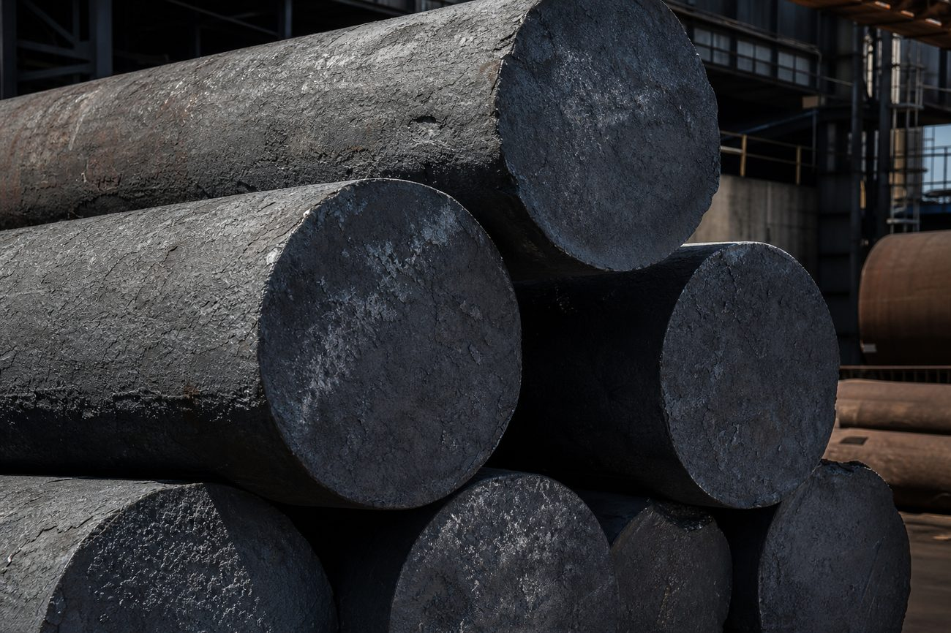
Tool & Die Steel
GRADE (EQUIVALENT) | FORM | SIZE RANGE (MM)
WPS / D3 (1.2080) | Round | 8 – 75 · turn rod 80 – 350 dia
WPS / D3 | Flat | 6 – 105 thk × up to 410 wide
WPS / D3 | Square | 16 – 155 sq
H11 (1.2343) | Round · Square · Flat · Forged | as available
H13 (1.2344) | Round · Square · Flat · Forged | as available

READY STOCK · WHOLESALE & EXPORT
Stock List — Special, Stainless & Non-Ferrous
Also Stockist In — Annealed Prime with T.C.
GRADE | CONDITION | SIZE RANGE (MM)
EN-353 · EN-36 · EN-41B · EN-47 | Annealed, prime, with T.C. | 16 – 150 rolled · 160 – 330 forged
8620 SAE | Forge rod | 16 – 330 dia
EN-8 & M.S. | Centreless-ground rod | on request
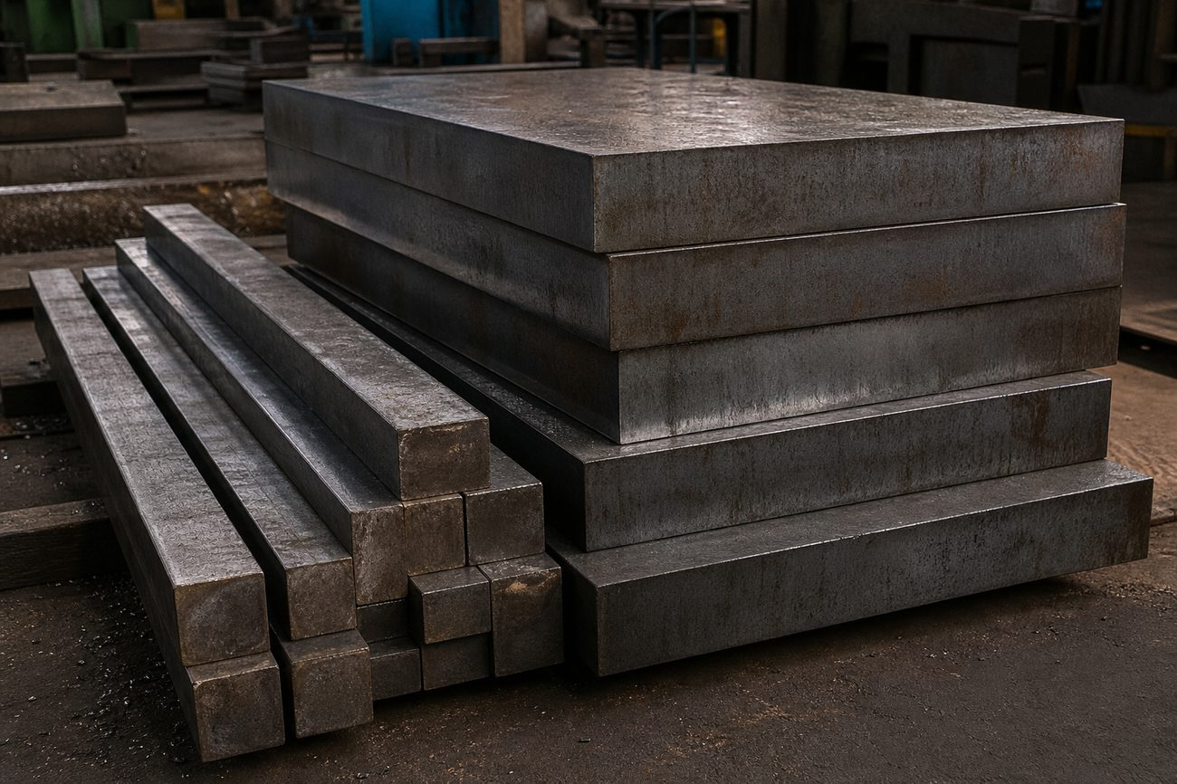  Tool & Die Steel  Blocks, flats and squares in D3, H11 and H13. | 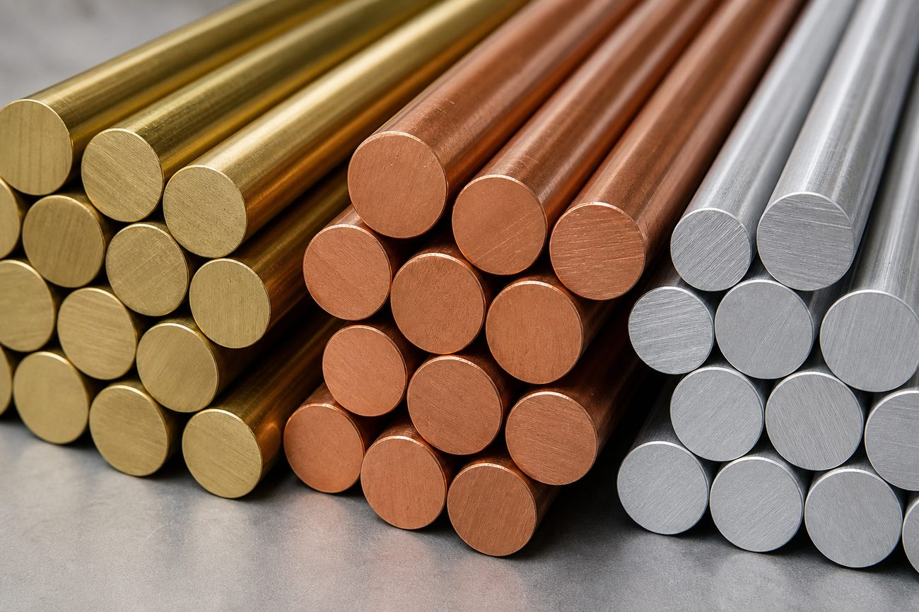  Non-Ferrous Metals  Brass, copper and aluminium in multiple forms.
Stainless & Non-Ferrous — Wholesale Stockist & Dealers
METAL | GRADES | FORMS
Stainless Steel | 304 · 304L · 316 · 316L · 321 · 410 · 420 · 430F · 431 · 440C · 17-4-PH | Rod
Brass | Standard | Rod · Hex · Square · Flat · Sheet
Copper | E.C. grade | Rod · Flat · Sheet
Aluminium | HE30 · 6082 grade | Rod · Flat · Hex · Square · Sheet · Roll
Full size-wise stock list available on request. Large ready stock of grades, sizes & shapes maintained for domestic supply & export.

PRODUCT RANGE
Our Steel Product Range
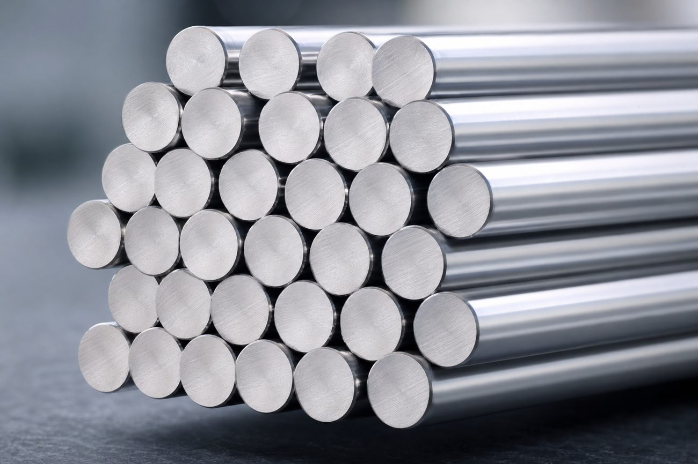  Bright Bars  High-precision drawn bars with excellent surface finish and dimensional accuracy. |   Forged Bars  High reduction-ratio forging with controlled cooling for durability.
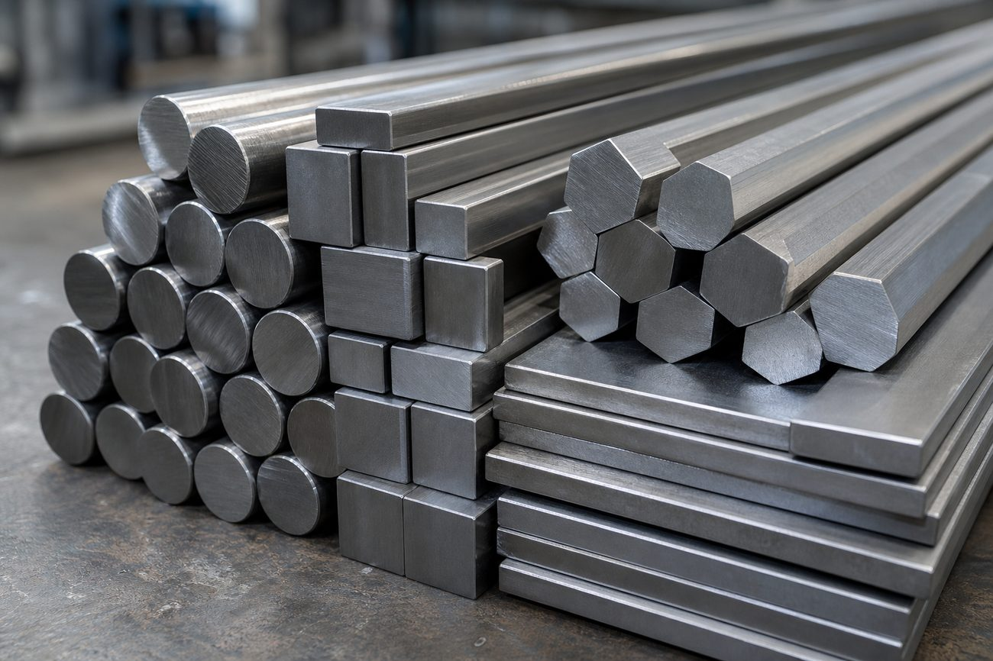  Round · Square · Flat · Hex  Hot-rolled & forged sections in multiple grades. | 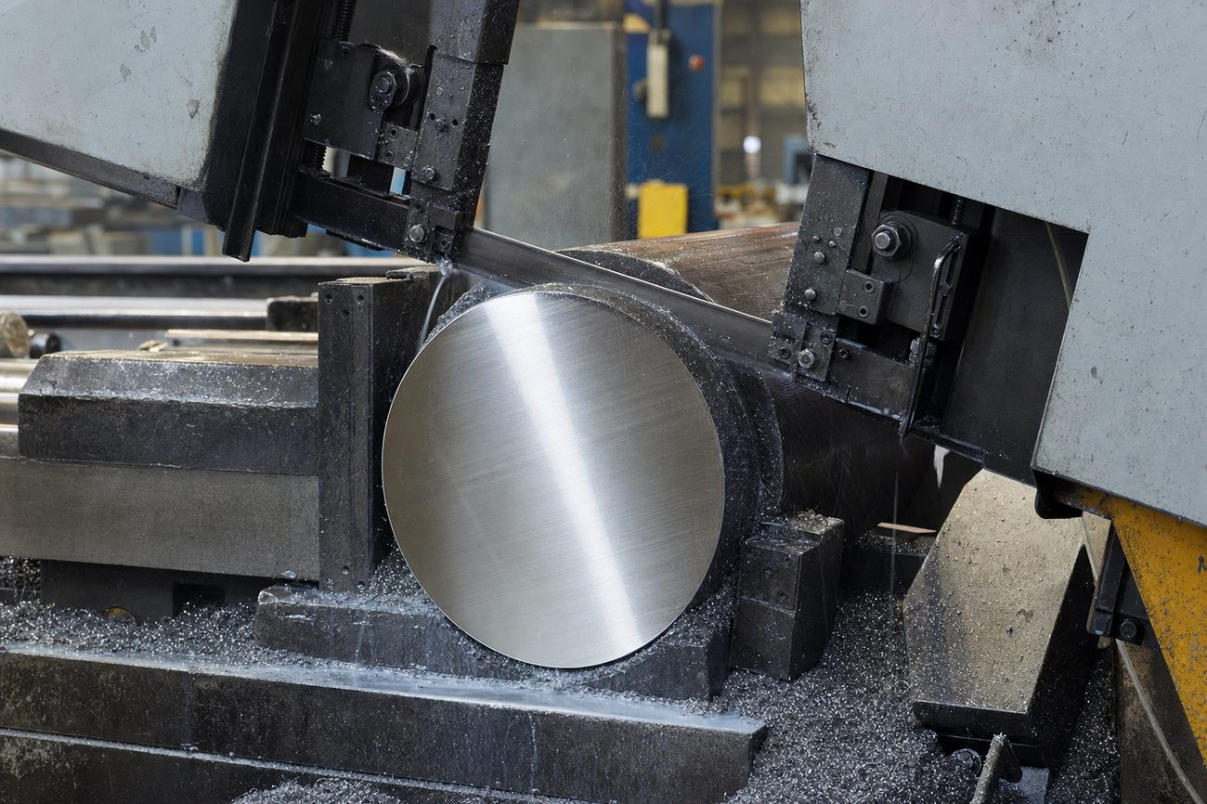  Precision Cutting Job Work  All-type cutting on hydraulic bandsaw — 16 to 550 mm.
Materials We Supply
Mild Steel · Alloy Steel · Tool Steel · Die Steel · High Speed Steel · Spring Steel · Stainless Steel · Bearing Steel · Brass · Copper · Aluminium · Casting Ingots / Billets

TRUSTED PARTNERSHIPS
Customers & Industries
From global engineering leaders to specialised manufacturers, 500+ customers rely on Jagetiya Metals for consistent quality and dependable supply.
ABB · ALSTOM · SIEMENS · COSMOS · CONMAT · 500+ more
Industries We Serve
- Power & Energy
- Railways & Transport
- Heavy Engineering
- Automotive
- Machine Tools & Dies
- Construction Equipment
- Oil, Gas & Process
- General Fabrication
Products We Supply To
- Gears & Pinions
- Shafts & Axles
- Dies & Moulds
- Forgings & Flanges
- Fasteners & Bolts
- Cutting Tools
- Structural Members
- Hydraulic Components
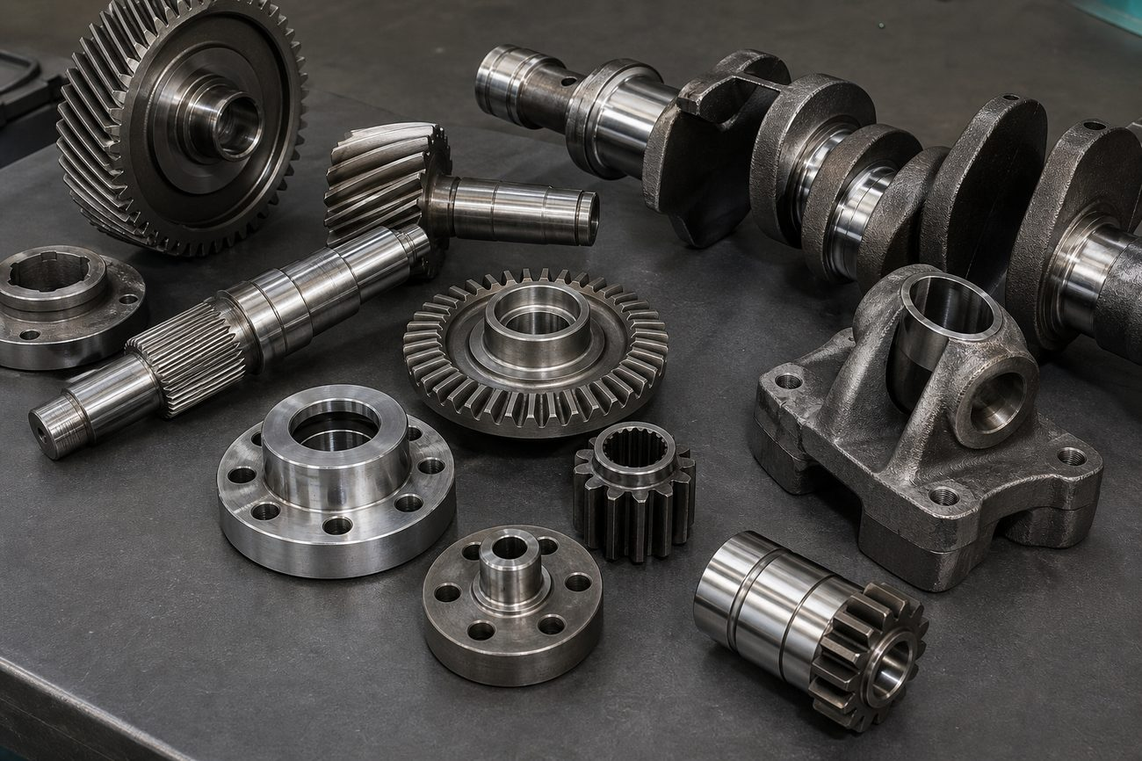

GET IN TOUCH
Contact Jagetiya Metals
Address | 502/A-1, Makarpura G.I.D.C., Vadodara, Gujarat — 390010, India
Phone | +91 98240 12344 · +91 99259 77784 · 0265-2646424
Email | kamlesh@jkmetal.in
Website | www.jkmetal.in
Proprietor | Mr. Kamlesh Shah
GSTIN | 24AGIPS3207M1Z7
JAGETIYA METALS — Premium Alloy & Tool Steel · Since 1990

