Contents

Topic choice 1

Museum Gallery Inventory Data Dictionary 1

Records to be put into website 3

**STILL NEED TO DO (**I wasn’t sure if the website had to be done first for this)

* A brief user guide on how to use your website to Add, Update & Delete a record. The guide only needs to be for 1 of the classes/tables in your project. You can include small images to provide clarity if you wish (not a requirement). Using the *Cooking Recipe* example from Task 1, I could create a user guide on how to Add, Update & Delete records from my Ingredients table.

# Topic choice

**Main Topic:** Artworks

**Secondary classes:** Artists, Gallery.

**Museum Gallery inventory ERD**

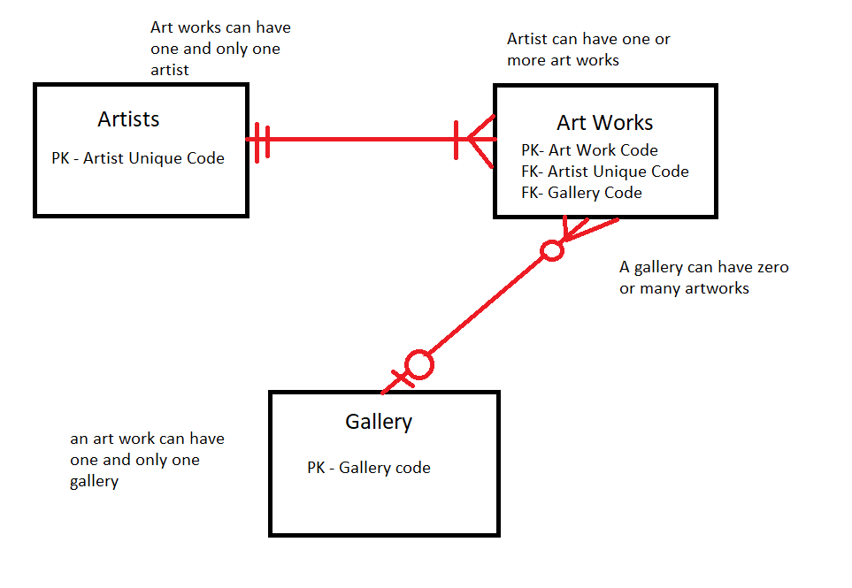

# Museum Gallery Inventory Data Dictionary

Entity: Artists – This table contains information about the artists who have or currently are displaying art work within the Museum Gallery

|  |  |  |  |  |  |  |  |
| --- | --- | --- | --- | --- | --- | --- | --- |
| Field Name | Description | Type | Specifications | Default | Required | Unique | Key |
| Artist Unique Code **(PK** | A code unique to each artist to register them | Integer | 3 alpha - numeric digits |  | Yes | Yes | PK |
| Name | The name of artist | character | Up to 50 characters |  | Yes | No |  |
| Birthplace | Birthplace of artist | Character | Up to 50 characters |  | no | No |  |
| Born | Date they were born | Integer | Up to 8 digits |  | Yes | No |  |
| Death | Date of death if applicable | Integer | Up to 8 digits |  | Yes | No |  |
| Movement | Style of artwork of artist bias to era | character | Up to 50 characters |  | Yes | No |  |

Entity: Art work - This table contains information about the art works being displayed within the gallery

|  |  |  |  |  |  |  |  |
| --- | --- | --- | --- | --- | --- | --- | --- |
| **Field Name** | **Description** | **Type** | **Specifications** | **Default** | **Required** | **Unique** | **Key** |
| Art work code  **(PK)** | Serial number for artwork | Integer | 6 digit Numeric code |  | Yes | Yes | PK |
| Name | Name of artwork | Character | Up to 30 characters |  | Yes | No |  |
| Artist unique code *(FK)* | A code unique to each artist to register them | Integer | 8 alpha - numeric digits |  | Yes | Yes | PK |
| Year | Year the artwork was made | Integer | Up to 4 digits |  | Yes | No |  |
| Type of Art | The medium of the art work | Character | Up to 50 characters |  | Yes | No |  |
| Price | Price of artwork if for sale | Integer | Up to 8 digits |  | Yes | No |  |
| For Sale | Condition of sale | Character | Up to three characters | ‘yes’,  ‘no’ | Yes | No |  |
| Gallery Code | Unique gallery code | Integer | Alpha numeric 6 digits |  | Yes | Yes | FK |

Entity: Gallery - This table contains information about the galleries displaying the artworks

|  |  |  |  |  |  |  |  |
| --- | --- | --- | --- | --- | --- | --- | --- |
| **Field Name** | **Description** | **Type** | **Specifications** | **Default** | **Required** | **Unique** | **Key** |
| Gallery Code | Unique gallery code | Integer | Alpha numeric 2 digits |  | Yes | Yes | FK |
| Name | Name of gallery | Character | Up to 100 characters |  | Yes | No |  |
| Street | Street address | Character | Up to 20 characters |  | Yes | No |  |
| City | City address | Character | Up to 20 characters |  | Yes | No |  |
| State | State address | Character | Up to 3 characters | ‘NSW’ | Yes | No |  |
| Post Code | Post code of area | Integer | Up to 5 alpha numeric digits |  | Yes | No |  |
| Country | Country of gallery | Character | Up to 15 digits |  | Yes | No |  |
| Director | Name of head personal contact | Character | Up to 50 characters |  | Yes | No |  |
| Contact number | Number of galleries contact personnel | Integer | Up to 13 numeric digits |  | Yes | No |  |

# Records to be put into website

Entity: Artwork

|  |  |  |  |  |  |  |  |
| --- | --- | --- | --- | --- | --- | --- | --- |
| Art work code  **(PK)** | Name | Artist Unique Code | Year | Type | Price  $ | For Sale | Gallery Code |
| 012345 | Mona Lisa | 02A | 1505 | Oil on polar panel | 300,00 | No | G7 |
| 123456 | The Starry Night | 01A | 1889 | Oil on canvas | 100,000 | No | G9 |
| 234567 | The Last Supper | 02A | 1498 | Paint on dry plaster | 50,000,00 | Yes | G1 |
| 345678 | Girl with a Peral Earring | 03A | 1665 | Oil on canvas | 250,000 | Yes | G7 |
| 456789 | Guernica | 04A | 1937 | Oil on Canvas | 750,00 | No | G9 |
| 567890 | The creation of Adam | 05A | 1512 | Fresco | 1000,000 | Yes | G1 |

Entity: Artist

|  |  |  |  |  |  |
| --- | --- | --- | --- | --- | --- |
| Artist Unique Code **(PK)** | Name | Birthplace | Born | Death | Movement |
| 01A | Vincent Van Gogh | Italy | 06/03/1475 | 18/02/1564 | High Renaissance |
| 02A | Leonardo Da Vinci | Italy | 15/04/1452 | 03/05/1519 | High Renaissance |
| 03A | Johannes Vermeer | Dutch Republic | ??/10/1632 | 15/12/1675 | Dutch Golden Age Baroque |
| 04A | Pablo Picasso | Spain | 25/10/1881 | 08/04/1973 | Cubism, Surrealism |
| 05A | Michelangelo | Italy | 06/03/1475 | 18/02/1564 | High Renaissance |

Entity: Gallery

|  |  |  |  |  |  |  |  |  |
| --- | --- | --- | --- | --- | --- | --- | --- | --- |
| Gallery Code | Name | Street | City | State | Country | Post code | Director | Contact number |
| G1 | The National Gallery | Trafalgar square | London | London | United Kingdom | Wc2N | Gabriele Finaldi | +442077472885 |
| G7 | Art Gallery of New South Wales | Art Gallery rd | Sydney | NSW | Australia | 2000 | Michael Brand | (02) 92251700 |
| G9 | Louvre Museum | Rue De Rivoli | Paris | Paris | France | 75001 | Marie Laure | +33(0) 140205317 |