Day 09- Kubernetes ingress, URL rewriting, sticky sessions, and autoscaling.

1: Setting Up the Kubernetes Cluster and Static Web App
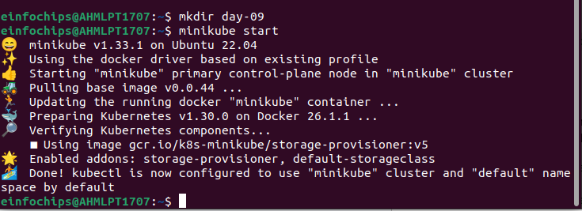
Creating a basic html file
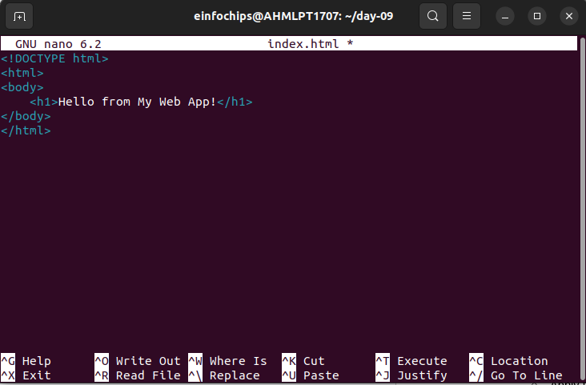

creating docker file

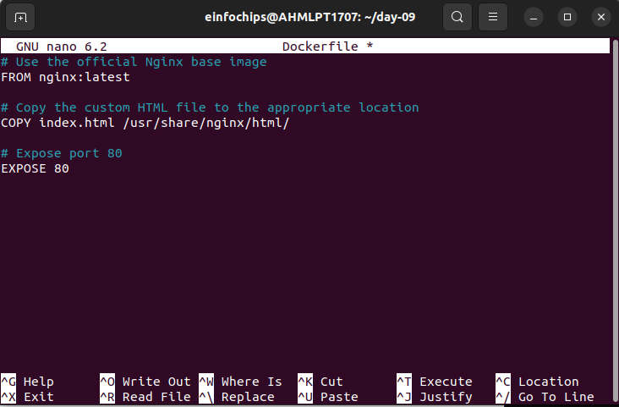
Building the dockerhub image

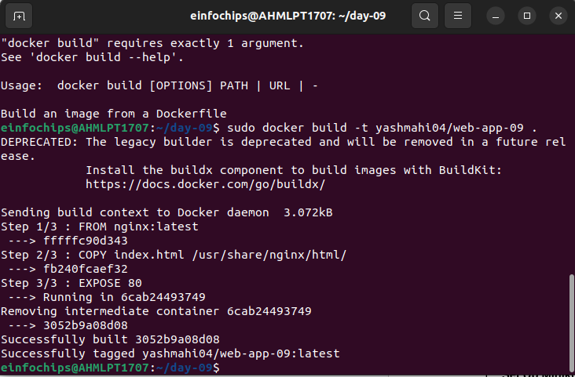

Pushing the image to the docker hub

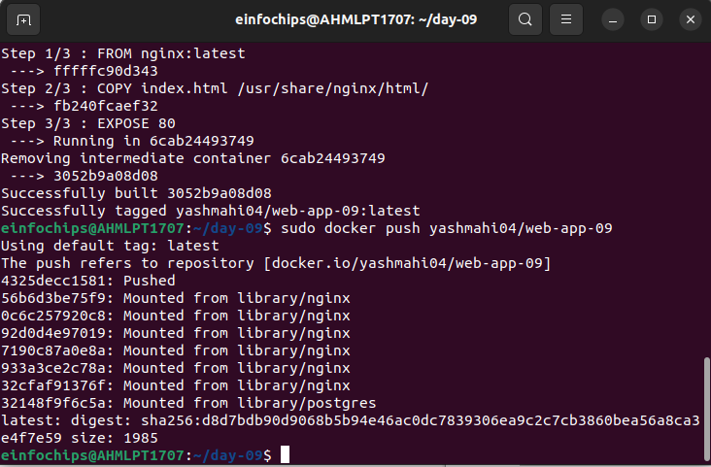
Kubernetes Deployment:
creating deployment.yaml

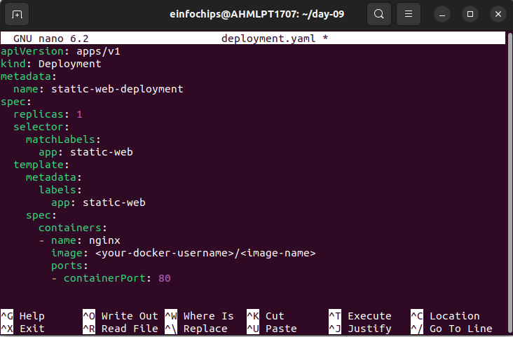

creating service.yaml
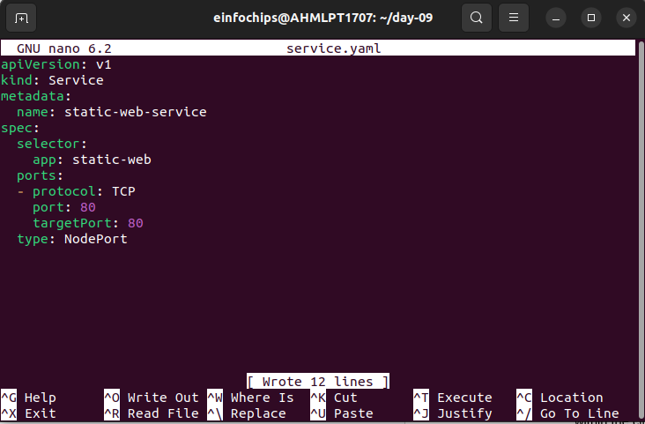
Applying the deployment.yaml and service.yaml
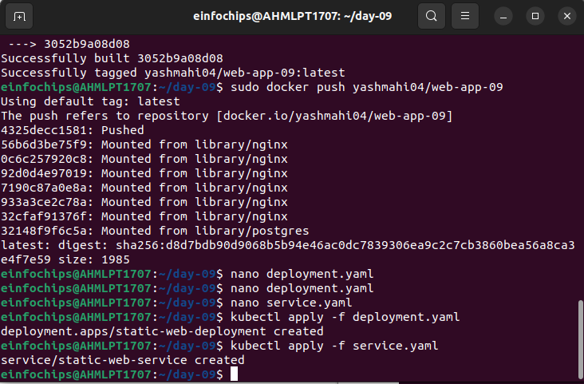

2: Configuring Ingress Networking

Tried to install the ingress using the command
minikube start –addons=ingress
Error occurred
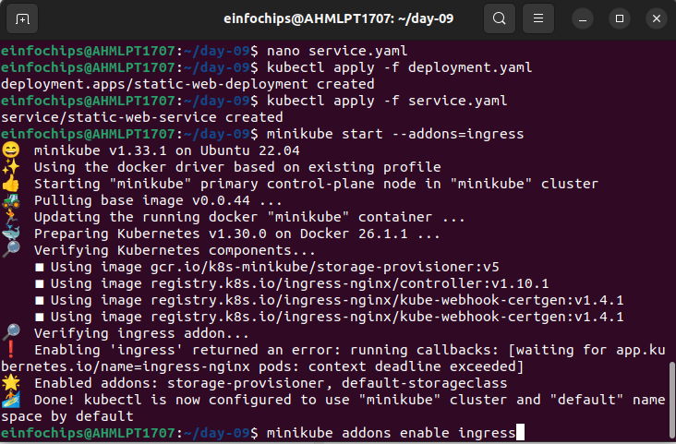
In order to solve this we have to enable the ingress
minikube addons enable ingress
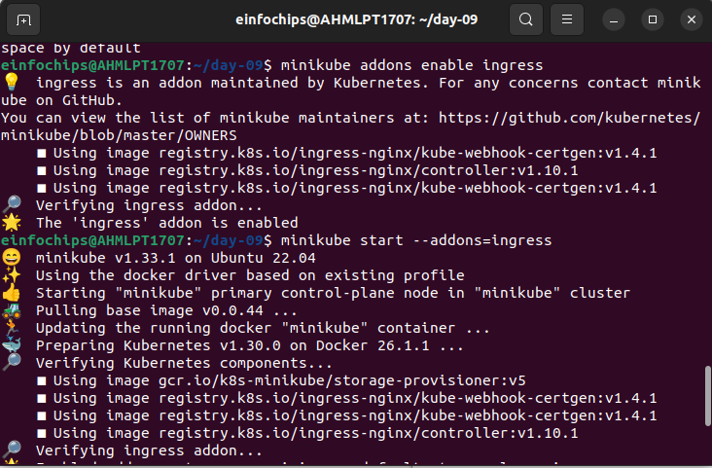

Verify whether the ingress is running and accessible
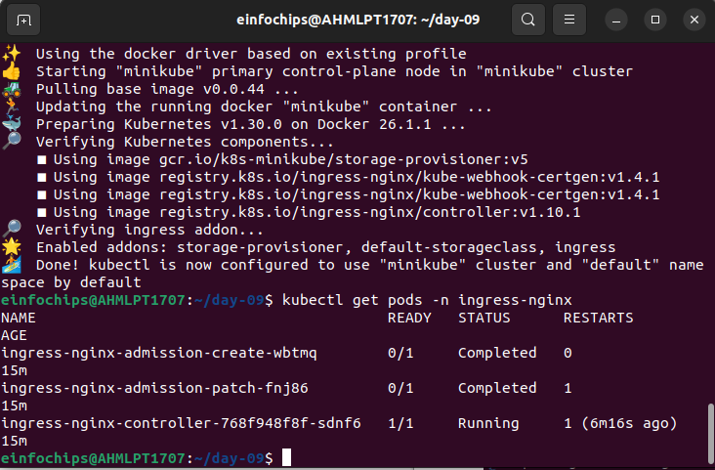
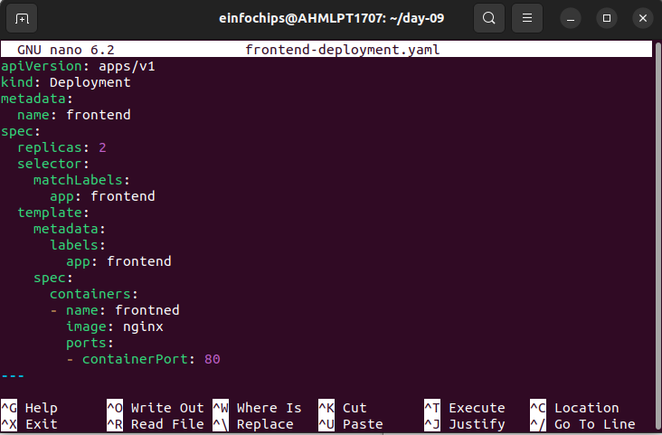
Create Ingress Resource:

Created frontend-deployment.yaml

created backend-deployment.yaml
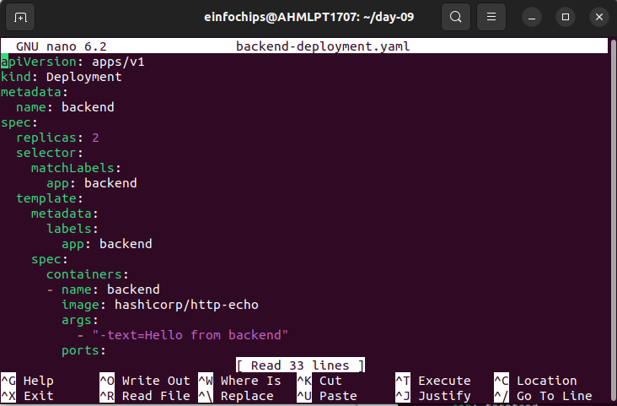
Applying the changes
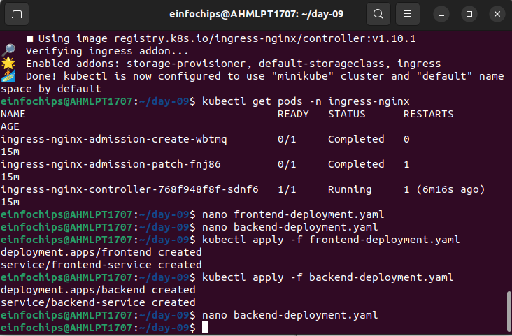

Create an ingress resource
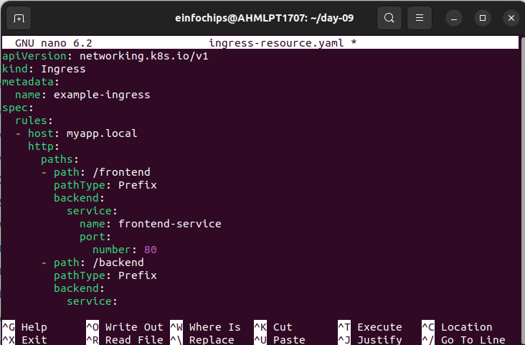
Apply the ingress resource
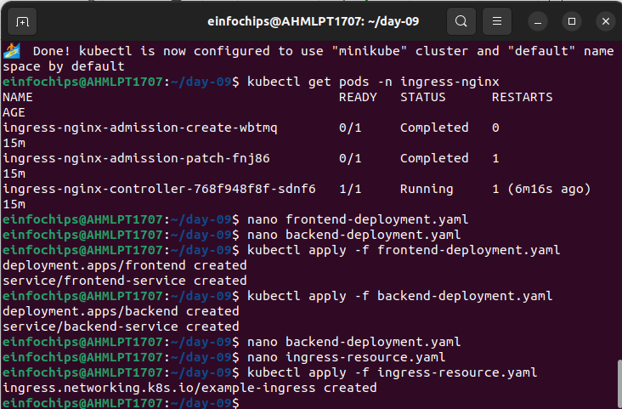

Configure URL rewriting in the ingress resource to modify incoming URLs before they reach the backend services.
Enable sticky sessions to ensure that requests from the same client are directed to the same backend pod.
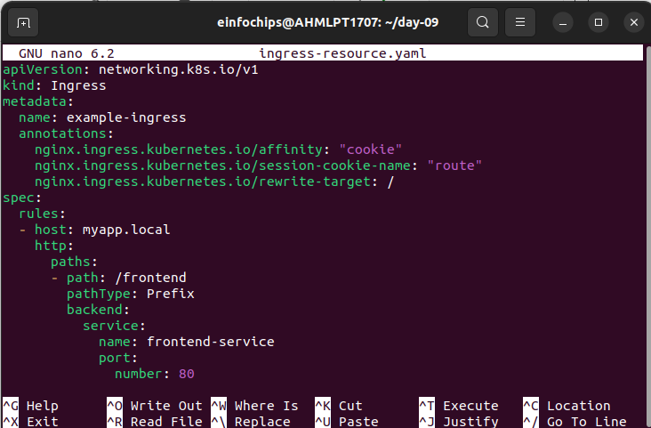
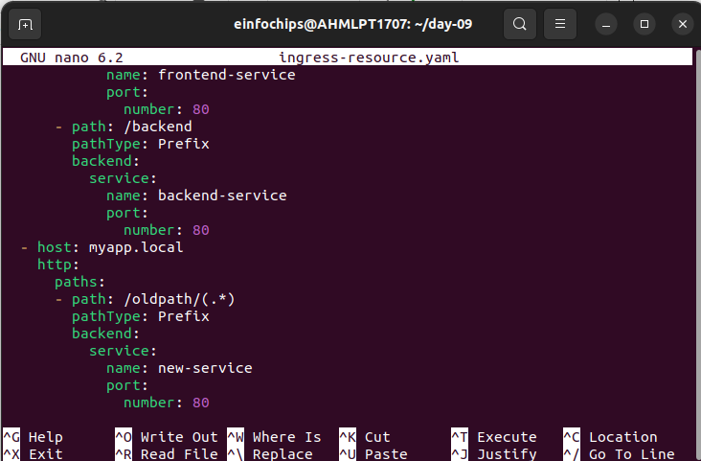

3: Implementing Horizontal Pod Autoscaling
Configure Horizontal Pod Autoscaler:
Write a horizontal pod autoscaler (HPA) manifest to automatically scale the static web application pods based on CPU utilization.
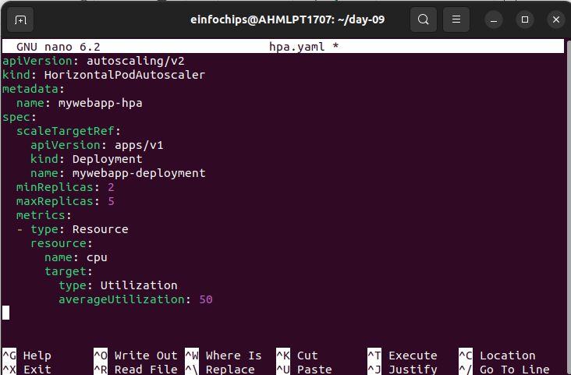
Applying hpa.yaml
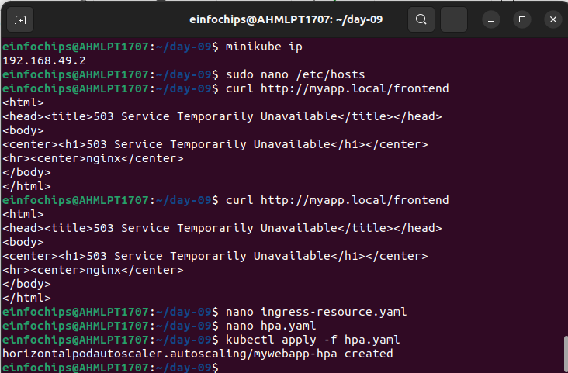

Stres testing
Perform stress testing to simulate traffic and validate the HPA configuration.
Monitor the scaling behavior and ensure the application scales up and down based on the load.

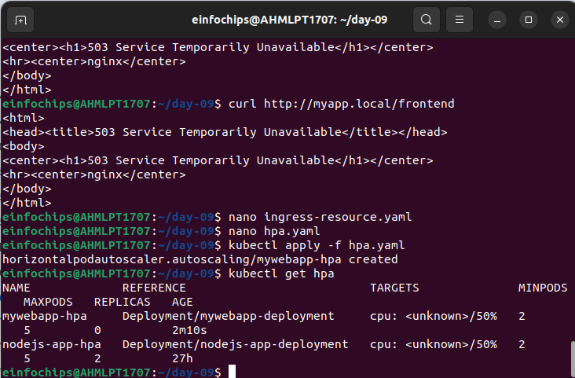
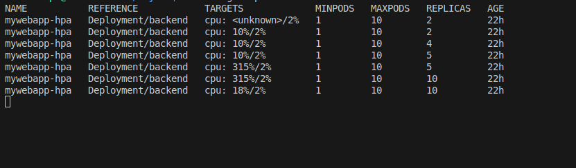

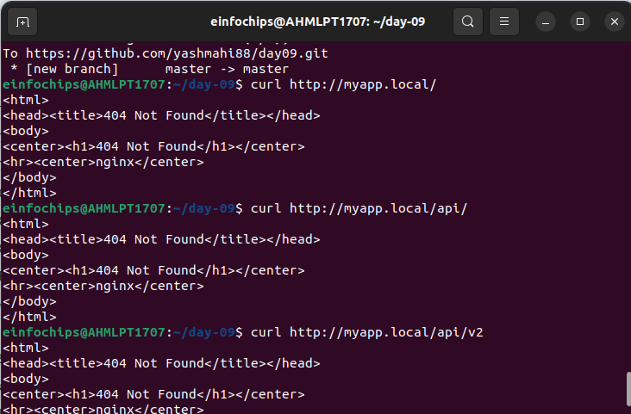
Adding TLS Secret to the ingress-resource.yaml

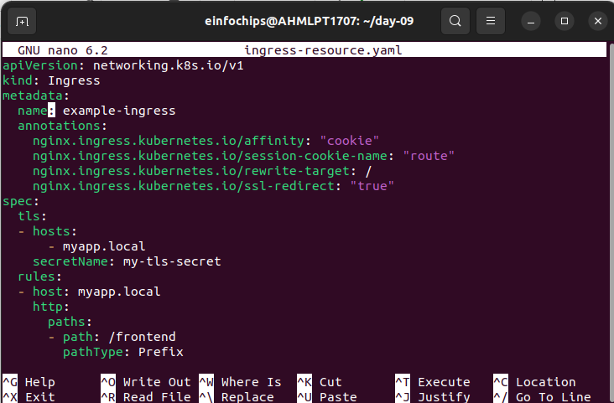

Creating SSL certificate
openssl req -x509 -nodes -days 365 -newkey rsa:2048 -keyout tls.key -out tls.crt -subj "/CN=myapp.ingress/O=ingressapp-tls"

kubectl create secret tls my-tls-secret --cert=tls.crt –key=tls.key

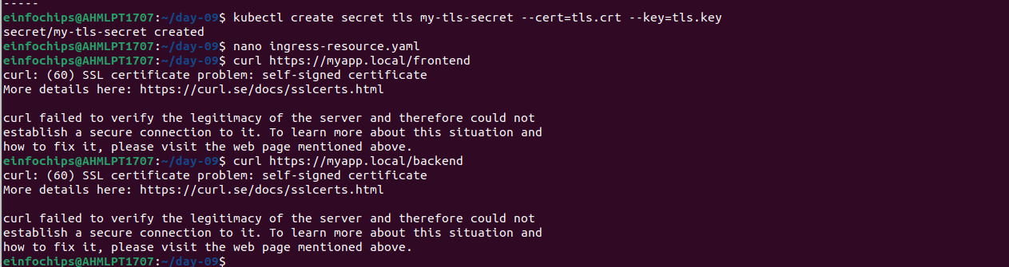
When using https://myapp.local/backend
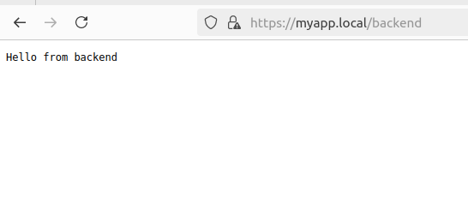
when using https://myapp.local/frontend
