This shell script automates system monitoring tasks on a Linux system and generates detailed reports for system administrators. It collects various system metrics, analyzes logs, performs health checks, implements alerting mechanisms, and generates comprehensive reports.

Prerequisites
- Linux operating system (tested on Ubuntu 20.04 LTS)
- Bash shell (version 4.x or higher)
- Required utilities: top, free, df, netstat, systemctl, ping, mail
Ensure all necessary commands are installed and accessible from the script environment.

Configuration
- Log and Report Files:
  - Logs are stored in /var/log/system_monitor.log.
  - Reports are generated in /tmp/system_report_<timestamp>.txt format.
- Thresholds:
  - Adjust thresholds for CPU (THRESHOLD_CPU) and memory (THRESHOLD_MEM) usage in percentage to trigger alerts.
  - Default thresholds are set to 90%.
- Email Notifications:
  - Specify ADMIN_EMAIL to receive alerts. Example: ADMIN_EMAIL="admin@example.com"

Usage
- Interactive Mode:
  - Run the script interactively to trigger checks manually and view specific metrics.

Outputs
- System Report:
  - The script generates a detailed report in text format (system_report_<timestamp>.txt) with sections on:
    - System Metrics (CPU, memory, disk space, network)
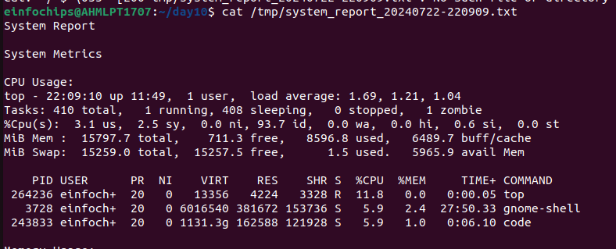
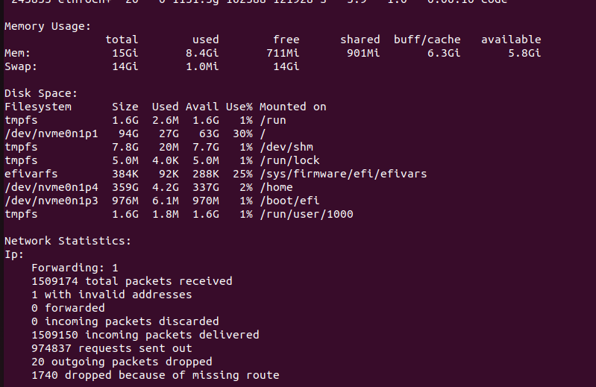
    - Log Analysis (recent syslog entries)
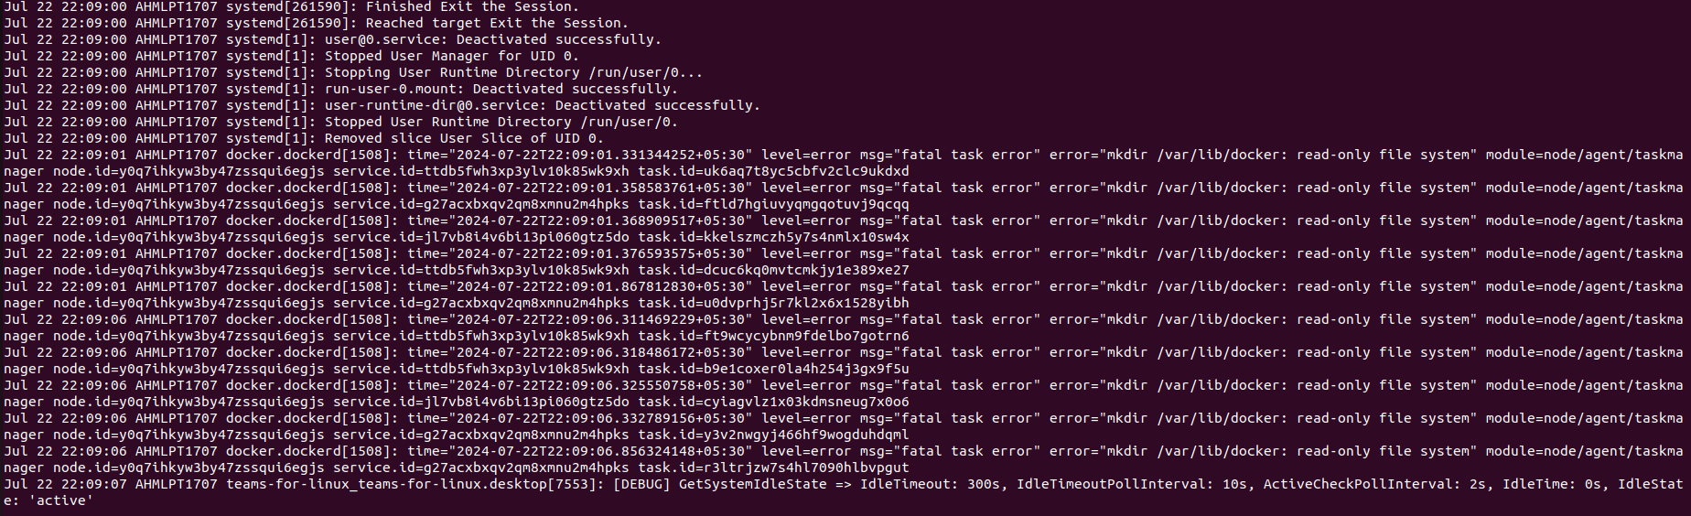
    - Health Checks (service statuses, connectivity tests)
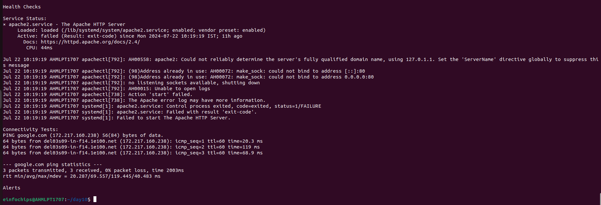
    - Alerts (if thresholds are exceeded)

Customization
- Adding Services:
  - Extend the script to check the status of additional services by adding more systemctl commands under perform_health_checks().
- Enhancing Alerts:
  - Customize email subjects and content in check_alerts() to include more detailed information.

