LedgerLens

Supplier Invoice Reconciliation System Design

STATUS  Proposed |  | OWNER  Project owner |  | LAST UPDATED  September 18, 2026

Authors | Project owner
Reviewers | Technical reviewers
Related docs | Repository README and OpenAPI documentation
Scope | Invoice-first document intake, evidence-backed extraction, deterministic reconciliation, and human decision workflow.

1. Abstract
LedgerLens is a procure-to-pay exception-resolution service. It accepts an invoice, stores the original file once by SHA-256 fingerprint, extracts evidence-backed fields, links the invoice to purchasing records, and runs deterministic checks against the purchase order, delivery receipt, and contract. The design makes the system useful for review without allowing extraction output to silently approve a payment.
The local project supports PDF, PNG, JPEG, and TIFF intake; embedded PDF text; optional Tesseract OCR; a rules baseline; optional Groq comparison; and an opt-in fine-tuned local Qwen adapter. It is a learning and portfolio system, not a production payment service: authentication, migrations, tenant isolation, and production retention policy remain future work.

2. Goals and Non-Goals
Goals | Non-goals
Keep the source document, page text, extracted value, and evidence together for audit. | Automatically release or pay an invoice.
Detect quantity, price, arithmetic, supplier, and currency exceptions deterministically. | Interpret arbitrary legal contract language.
Make duplicate uploads and retried jobs safe to run repeatedly. | Replace an ERP, document management system, or accounts-payable workflow.
Require a human to link records and make the final case decision. | Claim production quality from the current synthetic benchmark.

3. Background and Problem Statement
Accounts-payable review often requires comparing four sources: the supplier invoice, purchase order, delivery receipt, and contract. A simple PDF question-answering application can retrieve text, but it does not preserve a structured evidence trail, distinguish an extraction failure from a business-rule failure, or ensure that a payment decision receives human review. LedgerLens models these records separately so each comparison can name the source of an exception.
The system boundary begins when a reviewer uploads an invoice. The API validates file signatures and persists a document identity; a worker extracts text and schema-validated fields; matching uses saved supplier and PO records; the reconciliation engine compares ordered, accepted, invoiced, and contracted values; and the reviewer decides the case. The guiding invariant is that automated components may propose and explain, but only a reviewer may create purchasing records or approve an exception.

4. Proposed Architecture

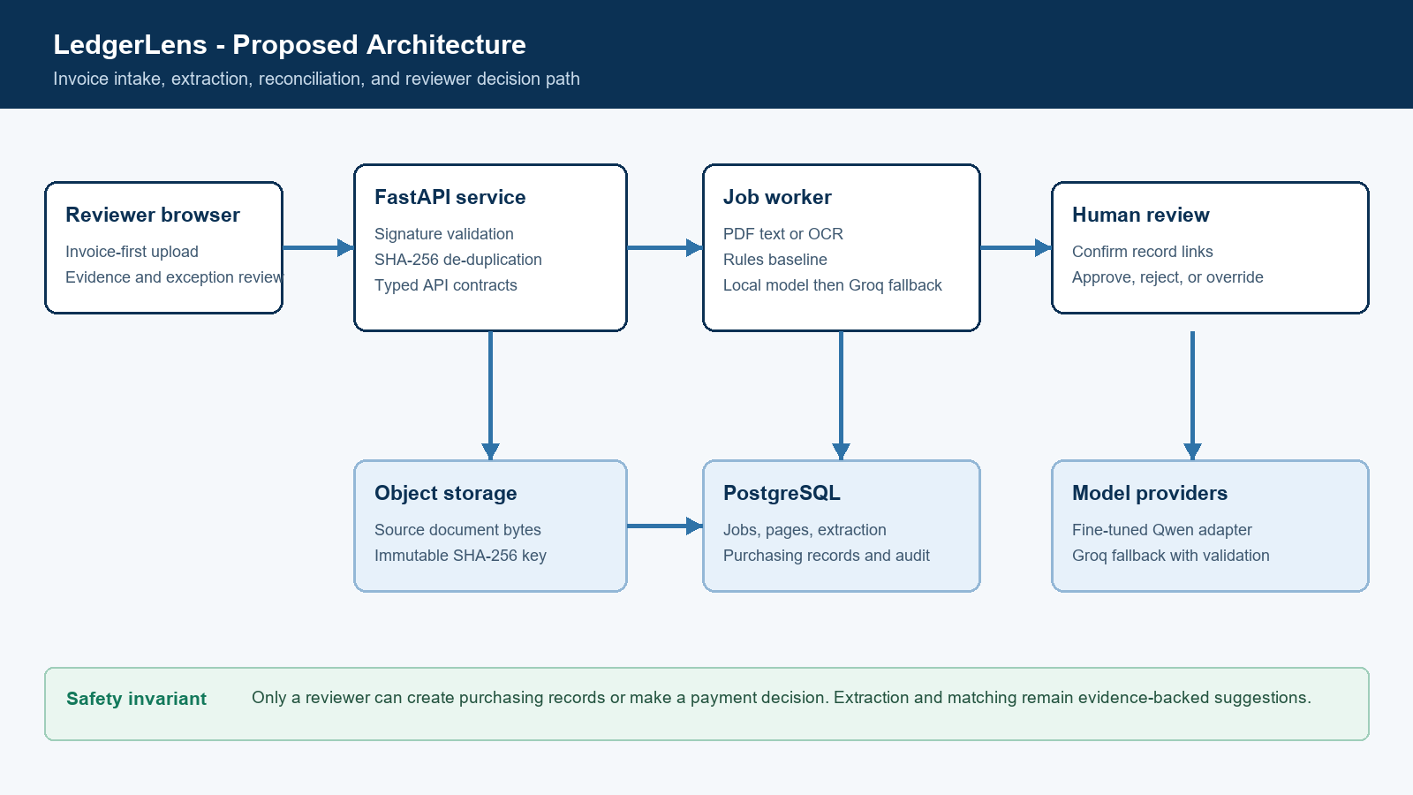
Figure 1. LedgerLens proposed architecture.

Core components

Component | Responsibility | Primary storage | Failure behavior
Review UI | Starts with an invoice and requests supporting documents only when saved records are missing. | Browser session | Shows job status and does not claim reconciliation is complete before the case exists.
FastAPI API | Validates uploads, exposes typed endpoints, proposes matches, and enforces reviewer gates. | PostgreSQL and document storage | Rejects invalid inputs; returns explicit missing-record or validation errors.
Extraction worker | Claims queued jobs, reads PDF text or OCR, and stores pages plus structured output. | DocumentProcessingJob and DocumentPage | Marks job failed with a bounded error; retry is explicit.
Reconciliation engine | Compares invoice lines with PO, receipts, and active contract tolerance. | Invoice, PO, receipt, contract, case tables | Produces needs_review exceptions instead of changing payment state.
Audit and telemetry | Records case events and worker metadata such as extractor version and duration. | Case audit events and job metadata | Loss of a required write fails the operation rather than hiding the event.

5. Request Lifecycle
- 1. A reviewer uploads an invoice. The API checks the file signature, allowed type, declared document type, and content hash before storing the source bytes and upload attempt.
- 2. The API creates or reuses a durable queued processing job. The returned job ID lets the UI poll rather than assuming extraction finishes in the request.
- 3. The worker claims one queued job with row locking. It reads embedded PDF text when available and uses OCR for scanned documents when Tesseract is installed.
- 4. The extractor produces typed invoice fields only when supporting page text is available. The rules result is the stored baseline; Groq and the local adapter are comparison or configured-backend paths validated against the same evidence rule.
- 5. The API proposes exact supplier and PO matches, checks duplicates, and reports which supporting record is missing. The UI asks for the next document only when that record cannot be resolved from saved data.
- 6. A reviewer confirms links or saves a purchasing record. The reconciliation engine then checks supplier, currency, PO line, ordered quantity, accepted quantity, unit price tolerance, and line arithmetic.
- 7. The service stores the report and audit event. A clean report can be approved; a case with blocking exceptions requires a documented override or rejection. The UI shows source evidence and final status.

6. API and Data Contracts

Primary data contract

Field | Type | Required | Description
document_id | UUID | Yes | Stable identity for stored bytes; ties uploads, jobs, pages, and extraction together.
sha256 | string | Yes | Content fingerprint. Identical bytes reuse one stored document while retaining each upload attempt.
document_type | enum | Yes | invoice, purchase_order, delivery_receipt, or contract; determines extraction and follow-up flow.
output_json | object | No | Schema-validated extracted fields, line items, confidence, and page-text evidence.
extractor_version | string | Yes after extraction | Identifies the rules baseline, Groq comparison, or local model path used.
case_id | integer | No | Created after reviewer confirmation; anchors reconciliation checks and decisions.
audit event | object | Yes for decisions | Captures confirmation, reconciliation, approval, rejection, or override activity.

Contract guarantees

- A document job becomes complete only after its page text, extraction record, and job metadata are stored in the database transaction. A job with unavailable OCR or invalid structured output is recorded as failed rather than treated as an empty successful extraction.
- Document identity is content-addressed by SHA-256. Jobs are claimed from the queued state using database locking, and duplicate invoice numbers are checked within the matched supplier before a reviewer can create an invoice record.
- The system retains document ID, upload filename, content fingerprint, page number, extraction method, extractor version, evidence text, job duration, reconciliation report, and reviewer decision event. These identifiers support investigation and replay.
- LedgerLens is the source of truth for its local reconciliation case and audit history. Purchase orders, contracts, and receipts are modeled inside this learning system; a production integration would treat the ERP and receiving system as authoritative upstream sources.
The versioned interface is exposed through the local OpenAPI document at
[Link to interface or schema]`/docs` and should be updated whenever request or response schemas change.

7. Consistency, Idempotency, and Replay

[Explain the consistency, idempotency, replay, ordering, or concurrency guarantees required by this design. Distinguish client-facing guarantees from internal analysis or recovery behavior, and identify where duplicate work or partial failure is acceptable.]
Scenario | Expected behavior | Reasoning
Repeated upload of identical bytes | Reuse the stored document and job; retain a separate upload attempt with its filename. | Prevents duplicate storage and preserves submission history.
Worker crashes or OCR fails | Mark the job failed with a bounded error and allow an explicit retry. | Failure is visible and does not invent extraction values.
Local model inference fails | When configured, call Groq fallback and record the fallback extractor version; otherwise fail the job. | Fallback is observable and retains the same evidence validation rule.
A blocking reconciliation exception exists | Reject ordinary approval; require a reviewer override reason or rejection. | Maintains a human accountability trail for risky decisions.

8. Security and Privacy Considerations

- The local learning app has no authentication and must not be exposed publicly. A production deployment needs authenticated users, role-based authorization for uploads and decisions, and tenant isolation in both storage and queries.
- Source files and extracted page text can contain financial and supplier data. Logs and traces must avoid source text, secrets, and raw document contents; the current code records IDs, versions, duration, page count, notes, and decision events instead.
- Groq credentials belong in an ignored `.env` file or a managed secret store. The API key must never be committed, returned by an endpoint, or copied into job metadata. A local model avoids a provider call but still requires protected model and document storage.
- Replay, record creation, and final decisions remain reviewer-controlled. Debugging endpoints should be restricted in production, and a retry should create an auditable new attempt rather than overwrite prior evidence without trace.
- The project persists source documents locally or in a Compose volume. A production rollout needs explicit retention, deletion, backup, regional-residency, and audit-export policies before real invoice data is accepted.

9. Operational Readiness
Signal | SLO or alert | Owner | Launch gate
Job completion rate | Track complete, failed, and retry outcomes by extractor backend. | Project owner | Required
Processing latency | Capture end-to-end duration and report p95 by document type and extraction method. | Project owner | Required
Extraction quality | Run field-level accuracy and safe-abstention evaluation on a held-out, vendor-separated corpus. | Project owner | Required
Fallback rate | Alert when local-model failures cause Groq fallback beyond the expected baseline. | Project owner | Recommended
Reconciliation integrity | Run synthetic end-to-end case checks for duplicate, quantity, price, and override paths. | Project owner | Required

10. Alternatives Considered

Alternative | Why it was considered | Why it was not selected
PDF question answering | Fast path to retrieve invoice text. | Does not model line items, evidence, reconciliation checks, or reviewer decisions.
LLM-only extraction | Can generalize across layouts and labels. | Needs local schema and source-evidence validation; it cannot be the sole approval mechanism.
Rules-only extraction | Transparent and inexpensive baseline. | Breaks on unfamiliar labels and layouts, so it is compared with model-assisted extractors.
Manual spreadsheet review | Simple and familiar operations workflow. | Does not provide durable source links, repeatable checks, or case-level audit history.

11. Open Questions
- What authentication and reviewer roles are required before any non-synthetic invoice is accepted?
- Which ERP, receiving, and contract systems should become authoritative sources for PO, receipt, and tolerance data?
- What field-accuracy, evidence-localization, latency, and cost thresholds justify routing traffic to the fine-tuned adapter?
- What retention, deletion, residency, and audit-export policy applies to uploaded supplier documents?

12. Decision and Next Steps
Adopt the invoice-first, evidence-backed workflow as the project baseline. First, stabilize the document and record-linking flow with synthetic data; second, expand the benchmark with reviewed vendor-separated examples; third, compare rules, Groq, and the QLoRA adapter under identical validation; and finally, add migrations, access control, object storage, and deployment monitoring before considering a limited real-data pilot.
Milestone | Deliverable | Exit criteria
M1 | Document intake, async extraction, and evidence inspector | Upload, source view, retry, and schema-validated rules extraction work end to end.
M2 | Record linking and deterministic reconciliation | Duplicate, quantity, price, arithmetic, and reviewer-decision paths have automated tests.
M3 | Evaluation and model comparison | Held-out benchmark reports field accuracy, failures, safe abstention, cost, and latency for each extractor.
M4 | Production-shaped deployment hardening | PostgreSQL stack, migrations, authentication, access controls, retention policy, and rollback plan are validated.

Use footnotes for definitions, assumptions, or terms that need precision without interrupting the main narrative.

