A REPORT
ON
SUMMER INTERNSHIP
AI & Data Science / Software Development
Submitted
To
School of Computer Science and Engineering
IILM University, Greater Noida, Uttar Pradesh
In partial fulfilment of the requirement for the degree of
BACHELOR OF TECHNOLOGY
in
COMPUTER SCIENCE AND ENGINEERING
By
YASH MALIK
Roll No.: 2410031339
Internship undertaken at
DATA ALCOTT SYSTEMS

Candidate's Declaration
I, Yash Malik, Roll Number 2410031339, a student of Bachelor of Technology in Computer Science and Engineering at IILM University, Greater Noida, Uttar Pradesh, hereby declare that this internship report, prepared on the basis of my internship undertaken at Data Alcott Systems, is my own original work.
I further declare that the content of this report is based on the work I actually carried out during the internship period, that any information I was unable to independently verify at the time of writing has been clearly marked as such rather than presented as confirmed fact, and that this report has not been submitted, in part or in full, to any other institute for the award of any other degree or diploma.
I take full responsibility for the accuracy of the information presented, to the best of my knowledge, and for any copyright compliance associated with this submission.
Signature:
Student Name: Yash Malik
Roll No.: 2410031339
Date: 09/08/2026 to 30/08/2026

Acknowledgement
I would like to express my sincere gratitude to everyone who supported and guided me through my internship at Data Alcott Systems. This experience gave me the opportunity to apply what I have learnt in the classroom to real, practical problems in AI and Data Science / Software Development, and to grow both technically and professionally in the process.
I am thankful to my Reporting Manager at Data Alcott Systems, Mr. Gokul Rajan, for his guidance and feedback throughout the internship period. I would also like to thank the wider team at Data Alcott Systems for the opportunity to work on a set of varied and practically-oriented projects during my time with the organisation.
I am equally grateful to the School of Computer Science and Engineering, IILM University, Greater Noida, for facilitating this internship and for the continuous academic support extended to me.
Finally, I would like to thank my family and friends for their constant encouragement and support throughout this internship.
Signature:
Student Name: Yash Malik
Roll No.: 2410031339

Internship Completion Certificate

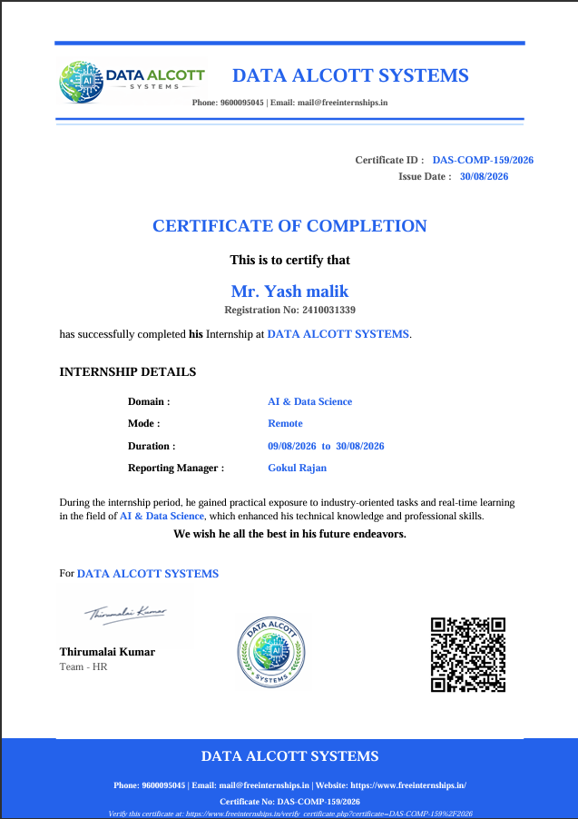

Table of Contents
Candidate's Declaration 1
Acknowledgement 1
Internship Completion Certificate 1
Table of Contents 1
4. Project Description 1
4.1 Internship Overview 1
4.2 Organization Profile 1
4.3 AI Registration Assistant Chatbot 1
4.3.1 Introduction 1
4.3.2 Problem Statement 1
4.3.3 Objectives 1
4.3.4 Scope 1
4.3.5 Key Features 1
4.3.6 Technologies and Tools Used 1
4.3.7 System Architecture 1
4.3.8 Workflow / Methodology 1
4.3.9 Implementation 1
4.3.10 Testing and Validation 1
4.3.11 Expected Outcomes / Results 1
4.4 AI Career Guidance Assistant 1
4.4.1 Introduction 1
4.4.2 Problem Statement 1
4.4.3 Objectives 1
4.4.4 Scope 1
4.4.5 Key Features 1
4.4.6 Technologies and Tools Used 1
4.4.7 System Architecture 1
4.4.8 Workflow / Methodology 1
4.4.9 Implementation 1
4.4.10 Testing and Validation 1
4.4.11 Expected Outcomes / Results 1
4.5 AI Resume Reviewer & ATS Optimizer 1
4.5.1 Introduction 1
4.5.2 Problem Statement 1
4.5.3 Objectives 1
4.5.4 Scope 1
4.5.5 Key Features 1
4.5.6 Technologies and Tools Used 1
4.5.7 System Architecture 1
4.5.8 Workflow / Methodology 1
4.5.9 Implementation 1
4.5.10 Testing and Validation 1
4.5.11 Expected Outcomes / Results 1
4.6 AI Internship Recommendation Engine 1
4.6.1 Introduction 1
4.6.2 Problem Statement 1
4.6.3 Objectives 1
4.6.4 Scope 1
4.6.5 Key Features 1
4.6.6 Technologies and Tools Used 1
4.6.7 System Architecture 1
4.6.8 Workflow / Methodology 1
4.6.9 Implementation 1
4.6.10 Testing and Validation 1
4.6.11 Expected Outcomes / Results 1
4.7 AI Project Topic Recommender 1
4.7.1 Introduction 1
4.7.2 Problem Statement 1
4.7.3 Objectives 1
4.7.4 Scope 1
4.7.5 Key Features 1
4.7.6 Technologies and Tools Used 1
4.7.7 System Architecture 1
4.7.8 Workflow / Methodology 1
4.7.9 Implementation 1
4.7.10 Testing and Validation 1
4.7.11 Expected Outcomes / Results 1
4.8 Overall Internship Learning and Experience 1
4.9 Certificates and Communication Proof 1
5. Bibliography / References 1
Appendix: Information Still Required 1

4. Project Description

4.1 Internship Overview
This report documents the internship undertaken by Yash Malik (Roll No. 2410031339, Student Code DAS005423), a Bachelor of Technology (Computer Science and Engineering) student at IILM University, Greater Noida, Uttar Pradesh, at Data Alcott Systems in the domain of AI & Data Science / Software Development.
The internship was carried out remotely and, as per the Certificate of Completion issued by Data Alcott Systems (Certificate No. DAS-COMP-159/2026), spanned the period from 9 August 2026 to 30 August 2026, under the reporting supervision of Mr. Gokul Rajan.
During the internship, five distinct projects were undertaken: the AI Registration Assistant Chatbot, the AI Career Guidance Assistant, the AI Resume Reviewer & ATS Optimizer, the AI Internship Recommendation Engine, and the AI Project Topic Recommender. Each of these is documented in detail in the following sections, covering its purpose, objectives, features, architecture, workflow, implementation, testing, and outcomes, based on a review of the corresponding project source code and documentation.
Where a specific detail — such as a formal test log, a system architecture diagram, an interface screenshot, or an internal task assignment — has not been independently confirmed or supplied, it has been marked as [DETAIL REQUIRED] rather than assumed, in keeping with the principle that this report should represent only verified, accurate information about the internship.

4.2 Organization Profile
Data Alcott Systems is a software development company that, according to its publicly available profile, was founded in 2015 and has grown into an organisation with a team of over 150 professionals, including software engineers, data scientists, UX/UI designers, and cybersecurity specialists. The company's stated areas of work include custom software development, mobile application development, cloud solutions, data analytics, cybersecurity, and IT consulting.
Alongside its core software development business, Data Alcott Systems runs a structured internship initiative — branded as "Free Internship Online" and hosted at freeinternships.in — through which students can undertake free, fully remote internships across domains such as AI & Data Science. The stated aim of this initiative is to give students exposure to industry-style project work rather than passive video-based learning, with submissions reviewed by a mentor and completion recognised through a verifiable certificate, such as the one issued for this internship (Certificate No. DAS-COMP-159/2026).

4.3 AI Registration Assistant Chatbot

4.3.1 Introduction
The AI Registration Assistant Chatbot was one of the core modules undertaken during the internship. It is a conversational agent, built in Python using NLTK and scikit-learn, that collects, validates, and stores a student's registration details through a natural back-and-forth dialogue rather than a static form. The project was developed incrementally across several stages — intent recognition, entity extraction, dialog management, data persistence, and a final combined build with sentiment awareness — reflected directly in the project's file structure (day2_intent.py through day6_final.py).

4.3.2 Problem Statement
Manual or purely form-based registration processes are prone to incomplete entries, inconsistent formatting, and a lack of real-time guidance for the user. A conversational interface that can understand what a user is asking for, guide them step-by-step, and validate each piece of information as it is entered reduces these issues at the point of data capture rather than after the fact.

4.3.3 Objectives
- To classify user intent (greeting, registration request, goodbye, or general query) from free-text input using a machine-learning classifier.
- To extract and validate key entities — full name and email address — using rule-based regular expressions.
- To manage the multi-turn conversation using an explicit dialog state machine.
- To persist completed registrations to a structured JSON store with a unique identifier for each record.
- To detect the general sentiment of user messages as a supporting signal during the conversation.

4.3.4 Scope
The scope of this module was limited to the conversational registration workflow itself — recognising intent, collecting and validating a defined set of fields, and storing the completed record — for an internship-registration use case.

4.3.5 Key Features
- Intent Recognition: a TF-IDF + Logistic Regression classifier trained on labelled example patterns (intents.json) to identify greetings, registration requests, and exit commands.
- Entity Extraction & Validation: regular-expression-based validation of full name (letters only) and email address format.
- Dialog Management: an explicit finite-state conversation flow (START → COLLECT_NAME → COLLECT_EMAIL → further fields → completion) that keeps track of what has been collected so far.
- JSON-based Storage: each completed registration is assigned a unique Registration ID and appended to a persistent registrations.json file.
- Sentiment Analysis: a lightweight keyword-based classifier (POSITIVE / NEGATIVE / NEUTRAL) used to adapt the tone of certain responses.

4.3.6 Technologies and Tools Used
Python 3 was used as the core language, with NLTK for tokenisation and lemmatisation, and scikit-learn's TfidfVectorizer and LogisticRegression for intent classification. Entity validation relies on Python's built-in re (regular expression) module, and registration records are persisted as JSON using Python's standard json module — no external database was used.

4.3.7 System Architecture
At a conceptual level, the assistant consists of: (i) a training layer that vectorises example patterns from intents.json using TF-IDF and fits a Logistic Regression model to classify intent tags; (ii) a FinalRegistrationBot class that holds conversation state and routes each user message either to the intent classifier (when in the START state) or to the relevant field-validation step (when collecting a specific piece of data); and (iii) a persistence layer that reads and appends to registrations.json.
Figure: System Architecture — AI Registration Assistant Chatbot
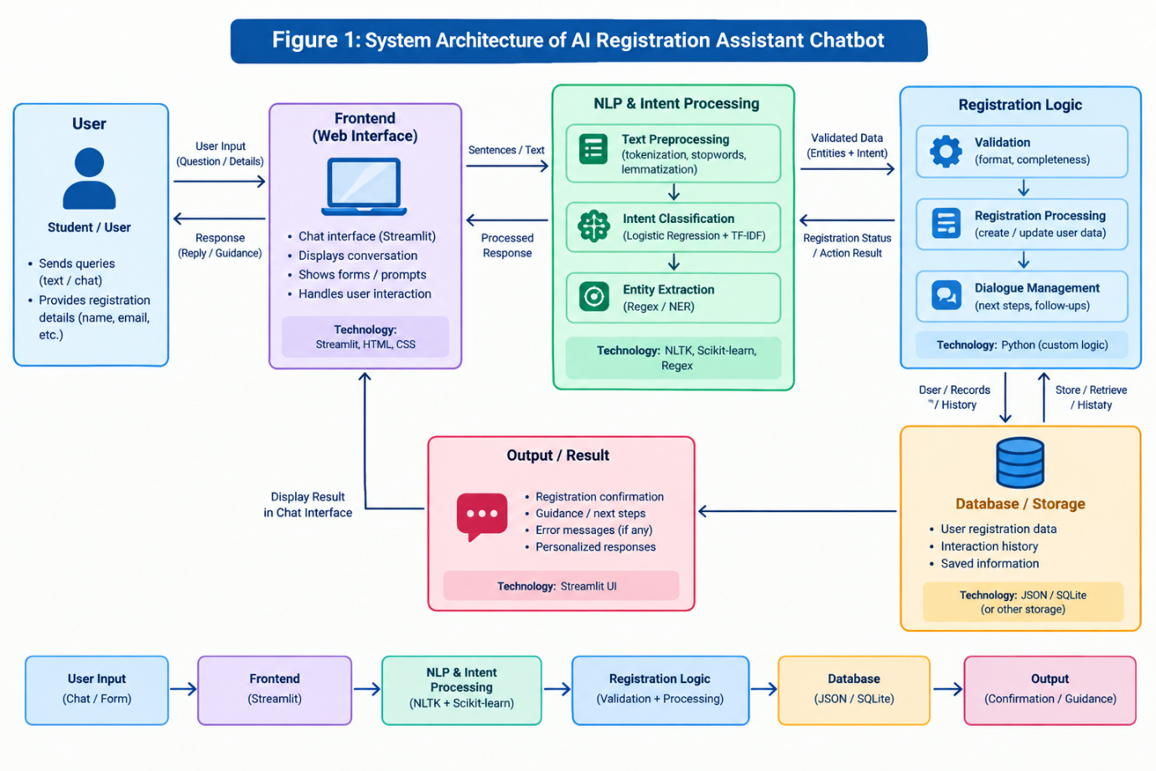

4.3.8 Workflow / Methodology
- The student sends a message; the bot pre-processes it (lowercasing, tokenisation, lemmatisation).
- While in the START state, the message is vectorised and classified by the trained Logistic Regression model into an intent such as 'greeting', 'register', or 'goodbye'.
- On a 'register' intent, the bot transitions through states to collect the student's name and email, validating each with the corresponding regular expression before advancing.
- Sentiment analysis runs alongside intent classification and can adjust the tone of certain responses (e.g., acknowledging a positive greeting).
- Once all required fields are validated, the completed record is assigned a unique Registration ID and appended to registrations.json.

4.3.9 Implementation
The classifier is trained at start-up directly from intents.json: each example pattern is pre-processed and vectorised with TfidfVectorizer, and a LogisticRegression model is fit on the resulting vectors against their intent labels. The FinalRegistrationBot class implements process_input(), which branches on self.state — in COLLECT_NAME, input is validated against ^[A-Za-z\s.]+$ before being accepted; in COLLECT_EMAIL, a standard email-format regular expression is applied. On successful completion, save_to_json() loads any existing registrations.json content, appends the new record, and rewrites the file.

4.3.10 Testing and Validation
Testing was carried out manually by exercising the conversation flow with a mix of valid and invalid inputs at each stage — for example, submitting a name containing digits or an incorrectly formatted email address — to confirm that the validation rules correctly rejected them and that the bot's prompts guided the user to correct the input. Completed registrations were verified by inspecting registrations.json to confirm that each entry received a unique Registration ID and that no data was overwritten. [DETAIL REQUIRED: a documented set of specific test cases and their pass/fail outcomes, if a formal test log was maintained.]

4.3.11 Expected Outcomes / Results
- A working, conversational registration flow capable of classifying intent, guiding the user step-by-step, and validating input in real time.
- A structured, append-only JSON store of registration records, each identifiable by a unique Registration ID.
- Practical, hands-on experience of combining a trained NLP classifier with a rule-based dialog manager in a single application.

4.4 AI Career Guidance Assistant

4.4.1 Introduction
The AI Career Guidance Assistant combines a rule-based conversational chatbot with a lightweight recommendation engine to help students explore career paths that align with their skills and interests. The project is built in Python, using NLTK for text processing and Streamlit for the user-facing interface.

4.4.2 Problem Statement
Students often find it difficult to choose a career path given the sheer number of available options and the differing skill requirements of each. Without an accessible way to relate their own skills and interests to specific careers, they may rely on guesswork or generic advice rather than a structured comparison.

4.4.3 Objectives
- To apply basic NLP techniques (tokenisation, lemmatisation, pattern-based intent classification) to understand career-related queries.
- To build a recommendation mechanism that matches a student's stated skills and interest area against a set of defined career profiles.
- To surface useful context for each recommended career — required skills, salary range, and market demand — alongside the match itself.
- To provide this guidance through both a conversational chatbot and a structured recommendation view.

4.4.4 Scope
The scope of this project was limited to career exploration and recommendation based on a fixed, in-code dataset of career profiles (CAREER_DATA); it does not extend to live labour-market data or job-application functionality.

4.4.5 Key Features
- AI Career Chatbot: recognises intents such as greetings, career-path queries, skill queries, salary questions, and general guidance requests, and responds from a curated set of templated replies.
- Career Recommendation Engine: scores each career in the dataset by counting how many of the student's stated skills match that career's required-skill list, and adds a bonus if the student's stated interest area matches the career's associated interest tags.
- Career Information Base: covers eight roles — Data Analyst, Data Scientist, AI/ML Engineer, Software Engineer, Full Stack Developer, Cyber Security Engineer, DevOps Engineer, and Product Manager — each with a description, required skills, salary range, and demand level.
- NLP Processing: text normalisation, tokenisation, and lemmatisation using NLTK ahead of pattern matching.

4.4.6 Technologies and Tools Used
Python was used as the core language, with NLTK for text normalisation and lemmatisation, scikit-learn available for potential ML-based extensions, and Streamlit for the interactive web interface.

4.4.7 System Architecture
The system has two parallel components that share the same underlying career dataset: a pattern-matching chatbot (chatbot.py) that classifies free-text queries into intents and returns a templated response, and a scoring-based recommender (recommender.py) that compares a student's declared skills and interest against every entry in career_data.py and returns a ranked list of matches. Both are exposed through a single Streamlit application (app.py).
Figure: System Architecture — AI Career Guidance Assistant
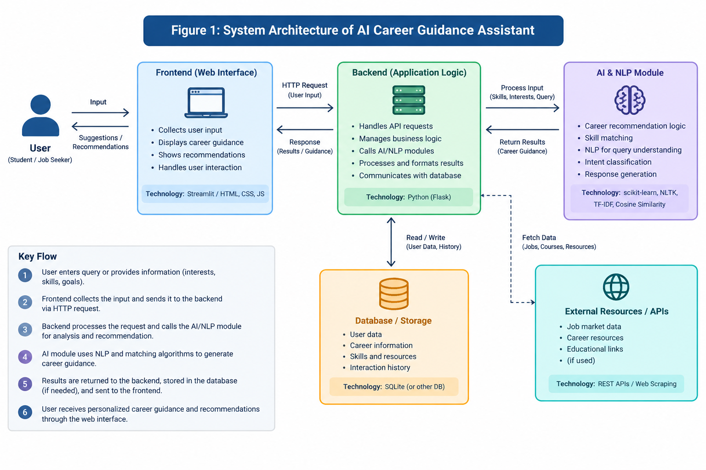

4.4.8 Workflow / Methodology
- The student either types a free-text question to the chatbot or submits a structured profile (skills + interest area) to the recommender.
- For chatbot queries, the input is tokenised and lemmatised, then matched against a set of known intent patterns to select an appropriate templated response.
- For recommendations, recommend_careers() iterates over every career in CAREER_DATA, calculates a skill-match percentage against that career's required skills, and adds a fixed bonus if the student's interest matches the career's tagged interests, capping the final score at 100.
- Recommended careers are returned sorted by score, along with matched skills, salary range, and demand level for each.

4.4.9 Implementation
recommend_careers(user_skills, user_interest) lower-cases the input skills and interest, then for each career computes skill_score = (matched_skills / total_required_skills) * 100 and adds 20 points if the student's interest tag matches the career's interest list, capping the combined final_score at 100. The chatbot side uses a dictionary of INTENTS, each mapping a list of example patterns to a list of candidate responses, with a WordNetLemmatizer normalising both the stored patterns and the incoming query before comparison.

4.4.10 Testing and Validation
The chatbot and recommender were tested manually with representative skill/interest combinations (for example, a profile listing Python and machine-learning skills with an 'AI' interest, which correctly surfaced the AI/ML Engineer career as a top match) and with a range of chatbot queries covering each supported intent category, to confirm relevant responses were returned. [DETAIL REQUIRED: a documented set of test profiles/queries and their outcomes, if formally logged.]

4.4.11 Expected Outcomes / Results
- A working Streamlit application offering both a conversational chatbot and a structured, score-based career recommendation view.
- A transparent, explainable scoring method (skill overlap + interest bonus) rather than an opaque black-box recommendation.
- A reusable career-information base that could be extended with additional roles or data points in the future.

4.5 AI Resume Reviewer & ATS Optimizer

4.5.1 Introduction
The AI Resume Reviewer & ATS Optimizer (internally tracked as Task AI-SS-004, within the 'Student Support & Internship Management NLP' domain) is an end-to-end resume analysis engine built in Python. It ingests a resume in PDF, DOCX, or plain-text format and returns a structured, transparent evaluation covering skills, experience, education, and ATS (Applicant Tracking System) compatibility, with an optional comparison against a target job description.

4.5.2 Problem Statement
Many students and early-career job seekers are unsure whether their resume effectively communicates their strengths, and do not have easy access to an experienced reviewer who can give specific, timely feedback. Common issues include missing sections, inconsistent formatting, weak or passive language, and a lack of quantified achievements — all of which can also reduce a resume's compatibility with automated ATS screening.

4.5.3 Objectives
- To parse resumes from multiple common file formats into clean, analysable text.
- To automatically segment a resume into its constituent sections (contact details, summary, experience, education, skills, projects, certifications).
- To extract and categorise technical and soft skills across multiple domains.
- To analyse experience for tenure, seniority, strong action verbs, and quantified impact.
- To audit ATS compatibility (contact details, standard section headers, formatting hygiene).
- To compute a transparent, weighted score out of 100 and generate specific, actionable feedback.
- To optionally compare the resume against a target job description using text-similarity techniques.

4.5.4 Scope
The scope covers analysing the content and structure of an uploaded resume and producing scored, structured feedback, with an optional job-description alignment check; it does not extend to automated resume rewriting or direct submission to external ATS platforms.

4.5.5 Key Features
- Multi-format Document Parsing: extracts text from PDF (pypdf) and DOCX (python-docx) files in addition to plain text, with fallback handling.
- NLP Preprocessing & Section Segmentation: text normalisation and lemmatisation (NLTK WordNetLemmatizer) with automatic detection of standard resume sections.
- Multi-domain Skill Taxonomy Extraction: categorises detected skills across six domains — Programming, Data Science & AI, Web Development, Cloud & DevOps, Databases, and Tools & Methodologies — plus soft/interpersonal skills.
- Experience & Impact Analysis: estimates total years of experience, classifies seniority (entry/mid/senior), and detects strong action verbs and quantified achievements (percentages, revenue figures, scale indicators).
- Education & Academic Extraction: detects degree level, field of study, institution, and academic performance (GPA/CGPA/percentage).
- ATS Compatibility Audit: checks for contact details (email, phone, LinkedIn, GitHub, location), standard section headers, and formatting hygiene.
- Job Description Alignment: computes TF-IDF vectors and cosine similarity between the resume and a target job description, highlighting matched and missing keywords.
- Granular 100-point Scoring Engine: Skills (30), Experience & Impact (25), Education (15), ATS Compatibility (15), and Content Depth (15).
- Multiple interfaces: an interactive Streamlit web dashboard, a command-line tool for single or batch evaluation, and a JSON report output.

4.5.6 Technologies and Tools Used
Python 3.9+, NLTK (tokenisation, lemmatisation, stopwords), scikit-learn (TfidfVectorizer, cosine similarity), pandas and NumPy for data handling, pypdf and python-docx for document parsing, Streamlit and Plotly for the interactive dashboard and charts, and tabulate for formatted CLI output.

4.5.7 System Architecture
The system follows a modular pipeline orchestrated by a master ResumeReviewer class (app/analyzer.py): a ResumeParser extracts raw text; a TextPreprocessor cleans and segments it into sections; four analysis modules — SkillExtractor, ExperienceAnalyzer, EducationAnalyzer, and ATSChecker — run over the segmented text; an optional JobDescriptionMatcher compares the resume against a supplied job description using TF-IDF and cosine similarity; a ResumeScorer combines all of the above into a weighted 100-point score; and a FeedbackGenerator turns the scored analysis into actionable, categorised feedback, surfaced through either the Streamlit dashboard or the CLI/JSON output.
Figure: System Architecture — AI Resume Reviewer & ATS Optimizer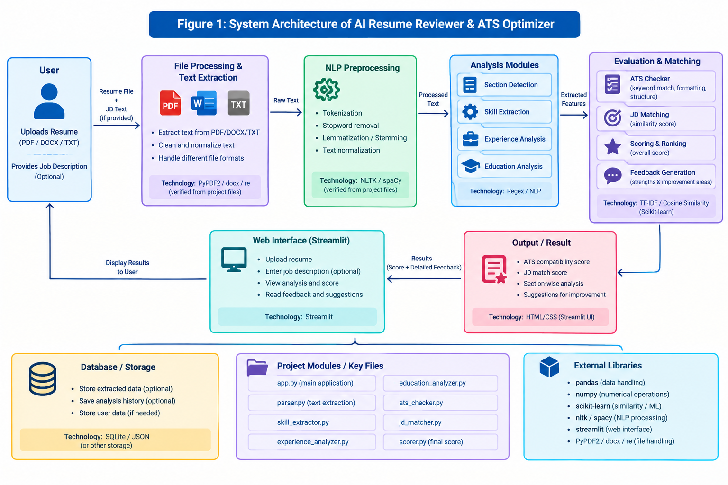

4.5.8 Workflow / Methodology
- The user uploads a resume (PDF, DOCX, or TXT) through the web dashboard or points the CLI at a file (or a folder, for batch mode).
- The ResumeParser extracts raw text, and the TextPreprocessor normalises and segments it into standard resume sections.
- The SkillExtractor, ExperienceAnalyzer, EducationAnalyzer, and ATSChecker each analyse the relevant sections in parallel.
- If a target job description is supplied, the JobDescriptionMatcher computes TF-IDF vectors for both texts and reports their cosine similarity along with matched/missing keywords.
- The ResumeScorer combines all category results into a weighted score out of 100, and the FeedbackGenerator produces specific, actionable suggestions.
- Results are displayed on the Streamlit dashboard (with score breakdowns and charts) or returned as a JSON report via the CLI.

4.5.9 Implementation
The ResumeScorer computes each category with an explicit, documented formula — for example, the Skills category (30 points) awards up to 20 points for technical-skill count (min(technical_count * 2.5, 20)), up to 5 points for soft-skill count (min(soft_count * 1.5, 5)), and up to 5 points for domain diversity, with the total capped at 30. Similar transparent formulas are used for the Experience, Education, ATS, and Content Depth categories, so that every point awarded can be traced back to a specific, inspectable rule rather than a black-box model.

4.5.10 Testing and Validation
An automated unit and integration test suite (tests/test_reviewer.py, run via python -m unittest) exercises the parsing, extraction, and scoring components against four representative sample resumes bundled with the project — a senior software engineer, an entry-level data scientist, a mid-level product manager, and a deliberately weak sample resume — confirming that scores and detected skills/sections behave as expected across a spread of resume qualities.

4.5.11 Expected Outcomes / Results
- A working end-to-end resume analysis engine producing a transparent, weighted score (e.g., 88.5/100 for the bundled senior-engineer sample) with a full category breakdown.
- Automatic detection of technical/soft skills, estimated experience tenure and seniority, and quantified achievements from unstructured resume text.
- An ATS compatibility score and specific, actionable feedback, plus an optional job-description match score with keyword-level detail.
- Three usable interfaces — an interactive Streamlit dashboard, a single-file CLI mode, and a batch CLI mode producing a JSON report — backed by an automated test suite.

4.6 AI Internship Recommendation Engine

4.6.1 Introduction
The AI Internship Recommendation Engine (Task AI-SS-002, domain 'Student Support & Internship Management') recommends suitable internships to students by combining Collaborative Filtering, Content-Based Filtering, and a weighted Hybrid approach, built in Python using pandas, NumPy, and scikit-learn, with a Streamlit front end.

4.6.2 Problem Statement
Students frequently struggle to find internships that genuinely match their skills, domain, and experience level, particularly when browsing a large and heterogeneous list of postings without any personalisation. A system that reasons over both a student's own profile and the collective preferences of similar students can surface more relevant options than keyword search alone.

4.6.3 Objectives
- To build a student-internship rating matrix from historical rating data and use it to recommend internships liked by similar students (Collaborative Filtering).
- To match a student's skills and domain directly against internship requirements using text-similarity techniques (Content-Based Filtering).
- To combine both signals into a single Hybrid recommendation with a defined weighting.
- To present a ranked, explainable list of recommended internships through a simple web interface.

4.6.4 Scope
The scope covers recommending internships from a provided CSV-based dataset (students, internships, and ratings) using the three techniques above; it does not integrate with a live, externally hosted internship listing service.

4.6.5 Key Features
- Collaborative Filtering: builds a student-internship rating matrix and uses cosine similarity between rating vectors to identify students with similar preferences, then recommends internships those similar students rated highly.
- Content-Based Filtering: uses TF-IDF vectorisation and cosine similarity to compare a student's skills/domain profile directly against each internship's required skills and domain.
- Hybrid Recommendation: combines the two scores using a fixed 60% Collaborative / 40% Content-Based weighting to produce a final ranked list.
- CSV-based Dataset: student profiles, internship postings, and historical ratings are all stored as CSV files, with no external database required.
- Streamlit Interface: allows a student profile to be selected and the resulting recommendations to be viewed interactively.

4.6.6 Technologies and Tools Used
Python, pandas (data loading and manipulation), NumPy (numerical operations), scikit-learn (TfidfVectorizer and cosine_similarity), and Streamlit for the web interface.

4.6.7 System Architecture
An InternshipRecommender class loads students.csv, internships.csv, and ratings.csv at start-up; it builds a student-internship rating matrix (via a pandas pivot table) for Collaborative Filtering, and separately vectorises skill/domain text for Content-Based Filtering. A hybrid step combines the two sets of scores with fixed weights before the ranked results are rendered through app.py in Streamlit.
Figure: System Architecture — AI Internship Recommendation Engine
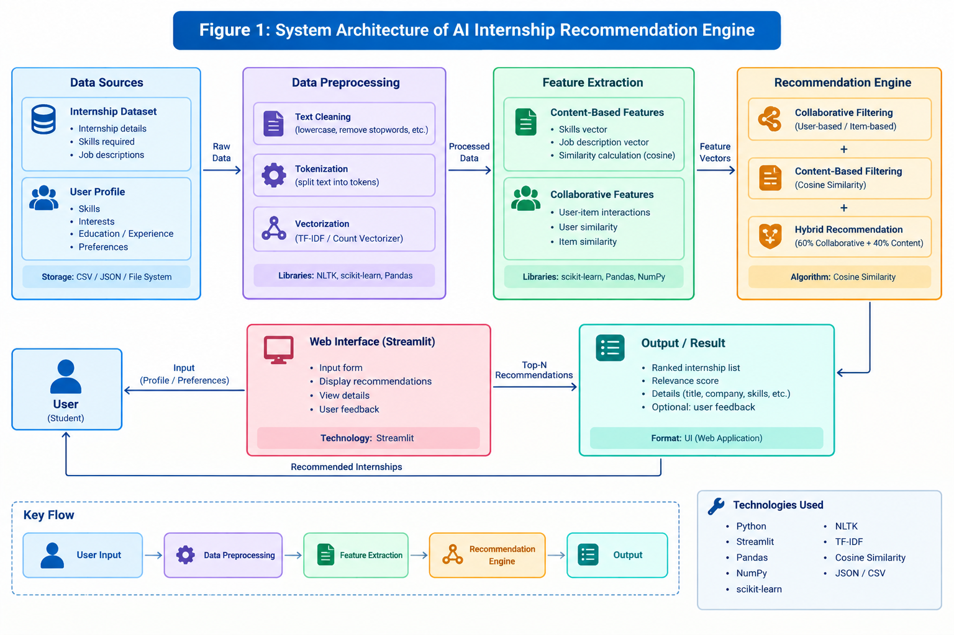

4.6.8 Workflow / Methodology
- A student profile is selected in the Streamlit interface.
- Collaborative Filtering computes the cosine similarity between the selected student's rating vector and every other student's rating vector, then aggregates ratings from the most similar students for internships the selected student has not yet rated.
- Content-Based Filtering computes the cosine similarity between the student's skills/domain text and each internship's required-skills/domain text using TF-IDF vectors.
- The Hybrid step combines the two scores as (0.6 × Collaborative score) + (0.4 × Content-Based score) for each candidate internship.
- Internships are ranked by their combined hybrid score and presented to the student with a match score.

4.6.9 Implementation
create_user_item_matrix() pivots the ratings data into a student × internship matrix (missing ratings filled with 0). collaborative_filtering(student_id, top_n) computes cosine_similarity between the target student's row and every other row, sorts students by similarity, and aggregates the ratings that similar students gave to internships the target student has not yet rated. The content-based component separately vectorises the 'skills' and 'required_skills' text fields (split on the '|' delimiter used in the CSVs) with TfidfVectorizer before computing similarity.

4.6.10 Testing and Validation
The recommender was tested manually against the bundled sample dataset (students.csv, internships.csv, ratings.csv) by selecting different student profiles and confirming that the returned recommendations and match scores were consistent with the students' stated skills, domain, and prior ratings — for example, a student with strong AI-related ratings and skills correctly received Machine Learning/Data Scientist internship recommendations with the highest match scores. [DETAIL REQUIRED: a documented, repeatable test scenario set, if formally logged.]

4.6.11 Expected Outcomes / Results
- A working Streamlit application that returns ranked internship recommendations (e.g., 'Machine Learning Intern — Match Score 0.82') for a selected student profile.
- A demonstrated combination of Collaborative and Content-Based Filtering into a single, weighted Hybrid recommender.
- A fully CSV-driven system requiring no external database, making it straightforward to inspect, extend, or re-run with new sample data.

4.7 AI Project Topic Recommender

4.7.1 Introduction
The AI Project Topic Recommender helps students identify suitable academic project topics based on their stated interests, skills, academic background, and experience level. It is built in Python and served through a Flask web interface, using TF-IDF vectorisation and cosine similarity for Content-Based Filtering.

4.7.2 Problem Statement
Choosing an appropriate project topic is often difficult for students, particularly when they are unsure how to connect their existing skills and interests to an academically suitable and sufficiently scoped project. Without structured guidance, students may pick topics that do not build on their strengths or that are mismatched in difficulty.

4.7.3 Objectives
- To collect a student's interests, skills, and other profile information relevant to project selection.
- To represent both student profiles and available project topics as text and compare them using TF-IDF and cosine similarity.
- To generate a ranked, Top-N list of recommended project topics for a given student.
- To allow recommendations to be filtered by difficulty level and domain.

4.7.4 Scope
The scope covers recommending project topics from a fixed dataset (projects.csv) based on a student's profile; it does not extend to evaluating the academic feasibility or formal approval of a recommended topic.

4.7.5 Key Features
- Text Preprocessing: lower-casing, removal of special characters, and whitespace normalisation applied to both the project dataset and incoming student queries.
- Combined Text Representation: each project's title, domain, tech stack, and difficulty level are concatenated into a single text field for vectorisation.
- TF-IDF Vectorisation & Cosine Similarity: the project dataset is vectorised once at start-up (with English stop-words removed); a student's query is vectorised the same way and compared against every project.
- Top-N Recommendation with Filtering: results can be filtered by difficulty and/or domain before the top matches are returned.
- Flask Web Interface: a simple form-based front end (templates/index.html, static/style.css) for entering a profile and viewing recommended topics.

4.7.6 Technologies and Tools Used
Python, pandas and NumPy for data handling, NLTK for supporting text-processing utilities, scikit-learn (TfidfVectorizer, cosine_similarity) for the recommendation logic, and Flask for the web application.

4.7.7 System Architecture
A ProjectTopicRecommender class loads projects.csv at start-up, builds a combined_text field per project (title + domain + tech stack + difficulty), cleans it via preprocess_text(), and fits a single TfidfVectorizer (with English stop-words removed) over all projects to produce a matrix of topic vectors. A Flask app (app.py) accepts a student's profile through a simple HTML form, passes it to recommend_projects(), and renders the ranked results back through index.html.
Figure: System Architecture — AI Project Topic Recommender
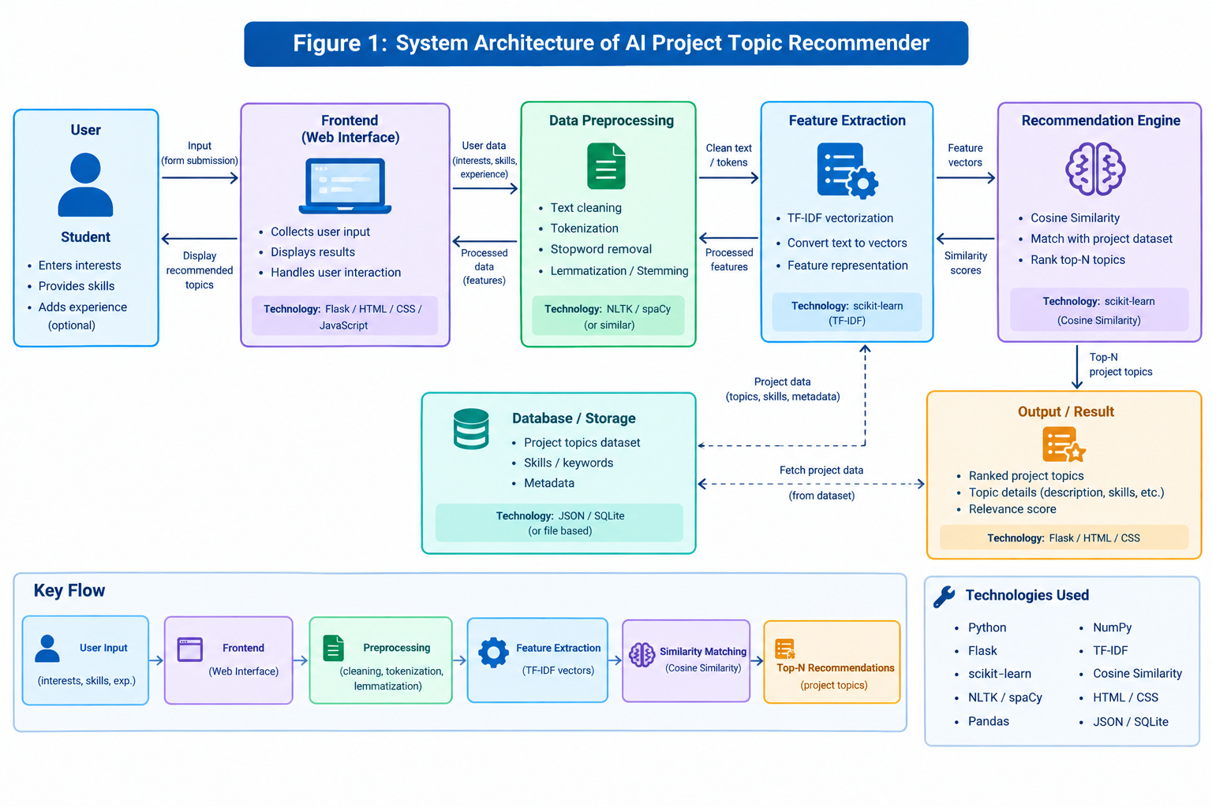

4.7.8 Workflow / Methodology
- The student submits their interests, skills, and (optionally) difficulty/domain preferences through the Flask form.
- The submitted profile text is cleaned using the same preprocess_text() routine used on the project dataset.
- The cleaned profile is transformed into a vector using the already-fitted TfidfVectorizer, and its cosine similarity against every project's topic vector is computed.
- Projects are ranked by similarity score, optionally filtered by difficulty and/or domain, and the Top-N results are returned to the student.

4.7.9 Implementation
preprocess_text() lower-cases input, strips non-alphabetic characters using a regular expression, and collapses repeated whitespace. At initialisation, ProjectTopicRecommender builds projects['combined_text'] by concatenating the title, domain, tech_stack, and difficulty columns from projects.csv, cleans it, and fits a single TfidfVectorizer(stop_words='english') over the resulting corpus to produce self.topic_vectors, which is later compared against a similarly vectorised student query in recommend_projects().

4.7.10 Testing and Validation
The recommender was tested manually using the bundled students.csv sample profiles, confirming that project recommendations returned for each sample profile were topically relevant to the stated interests and skills, and that difficulty/domain filters correctly narrowed the result set. [DETAIL REQUIRED: a documented set of specific test profiles and expected vs. actual recommendations, if formally logged.]

4.7.11 Expected Outcomes / Results
- A working Flask application that returns a ranked, Top-N list of project topic recommendations for a submitted student profile.
- Demonstrated use of TF-IDF vectorisation and cosine similarity for content-based topic matching.
- A filterable recommendation flow (by difficulty and domain) built on a simple, inspectable CSV dataset.

4.8 Overall Internship Learning and Experience
Across the five projects undertaken during this internship, a common thread emerges: each project applies natural language processing and/or similarity-based recommendation techniques to a different point in a student's journey — registering for the programme, exploring career direction, presenting oneself through a resume, finding a suitable internship, and choosing an academic project topic. Working across all five gave exposure to a fairly complete slice of how a small suite of related, practically-oriented NLP and recommendation tools can be conceived, structured, and built using a consistent Python-based toolchain (NLTK, scikit-learn, pandas/NumPy) with different front ends (CLI, Streamlit, Flask).
The internship reinforced the importance of structuring a project properly before writing code — defining the problem, the objectives, and the scope clearly, so that the resulting feature set stays focused rather than growing arbitrarily. It also reinforced the practical differences between rule-based approaches (regex validation, pattern-matched intents, fixed-weight hybrid scoring) and similarity/ML-based approaches (TF-IDF and cosine similarity, Logistic Regression classification), and when each is an appropriate, explainable choice for a given task.
Overall Internship Learning and Experience
During the internship, I gained practical experience in developing AI-based applications using Python, NLP, Machine Learning, and web technologies. I worked on projects involving career guidance, internship recommendation, registration assistance, resume analysis, and project topic recommendation.
I developed skills in NLP, TF-IDF, cosine similarity, recommendation systems, data processing, chatbot development, testing, debugging, and Streamlit/Flask application development. I also learned how to organize project modules, process user input, implement AI-based logic, and connect backend processing with user interfaces.
The main challenges involved understanding existing code, managing dependencies, debugging errors, and integrating different modules. These challenges improved my problem-solving and practical development skills.
Overall, the internship helped me connect theoretical concepts with practical AI applications and increased my confidence in developing and testing real-world software projects.

4.9 Certificates and Communication Proof
This section is intended to hold the Certificate of Completion issued by Data Alcott Systems, along with any additional communication proof — such as offer letters, task-assignment emails, or evaluation feedback — exchanged during the internship.
Figure: Certificate of Completion — Data Alcott Systems
The verified details of the certificate are as follows: issued to Mr. Yash Malik (Student Code DAS005423); domain — AI & Data Science; mode — Remote; duration — 9 August 2026 to 30 August 2026; reporting manager — Gokul Rajan; certificate number — DAS-COMP-159/2026; issue date — 30 August 2026.

5. Bibliography / References
The following sources were referred to while preparing this report:
1. Data Alcott Systems, official website. Available: https://www.dataalcott.com/
2. Data Alcott Systems, "Free Internship Online — About Us." Available: https://www.freeinternships.in/Aboutus.php
3. Data Alcott Systems, Certificate of Completion verification portal. Available: https://www.freeinternships.in/verify_certificate.php
4. IILM University, Greater Noida, Uttar Pradesh, official website. [DETAIL REQUIRED: exact URL/department page if to be cited.]
5. NLTK Project, official documentation. Available: https://www.nltk.org/
6. scikit-learn developers, official documentation. Available: https://scikit-learn.org/
7. Streamlit Inc., official documentation. Available: https://docs.streamlit.io/
8. Pallets Projects, Flask documentation. Available: https://flask.palletsprojects.com/
9. pandas development team, official documentation. Available: https://pandas.pydata.org/docs/
URL of Github:
1. https://github.com/yashmalik07/AI-Career-Guidance-Assistant
2. https://github.com/yashmalik07/-AI-Resume-Reviewer
3. https://github.com/yashmalik07/Project-Topic-Recommender
4. https://github.com/yashmalik07/AI-Internship-Recommendation-Engine-Project
5. https://github.com/yashmalik07/AI-Registration-Assistant-Project

Appendix: Information Still Required
The following details could not be independently confirmed at the time of writing and have been marked with placeholders throughout this report. Once supplied, they should be inserted in the corresponding sections so that a final, fully accurate version of this report can be produced:
- Exact designation/title of the Reporting Manager, Mr. Gokul Rajan.
- Name of the internship coordinator/faculty guide at IILM University (for the Acknowledgement section), if applicable.
- GitHub repository URLs for each of the five projects.
- Formal test logs / specific test cases and results actually executed for each project, if maintained beyond the manual verification described in this report.
- Screenshots of each project's interface, to replace the placeholders in this report.
- A system architecture diagram for each project, to replace the placeholder descriptions in this report.
- Personal reflections on challenges faced, skills gained, and feedback received during the internship (Section 4.8).
- Any additional communication proof (offer letter, task emails, evaluation feedback) to accompany the certificate in Section 4.9.
- Date of signing for the Candidate's Declaration.

