

NAME: YASH MATHUR
Course : B.TECH CSE(UX/UI)
Roll No: 2401360020
CourseName : DataStructure
Faculty : Dr.VandnaBatra
LAB FILE

INDEX
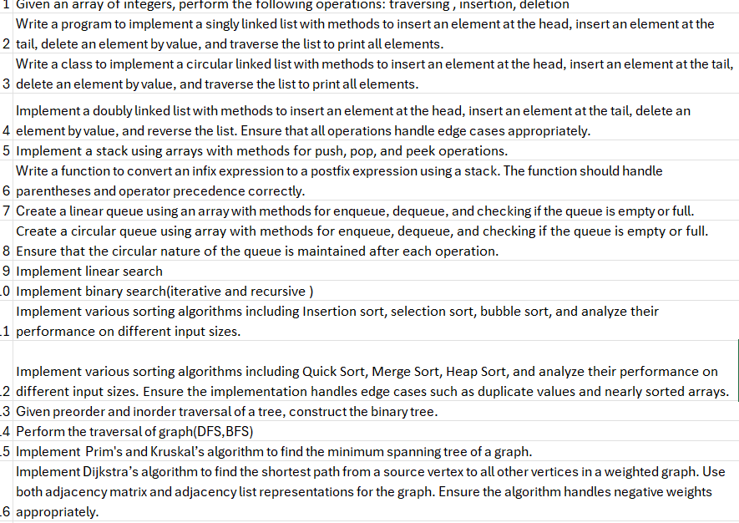

Question 1. Given an array of integers, perform the following operations:
● Traversing
● Insertion
● Deletion
Answer :
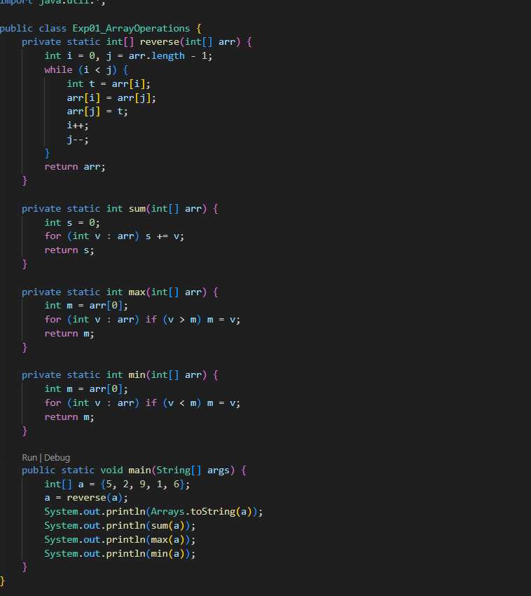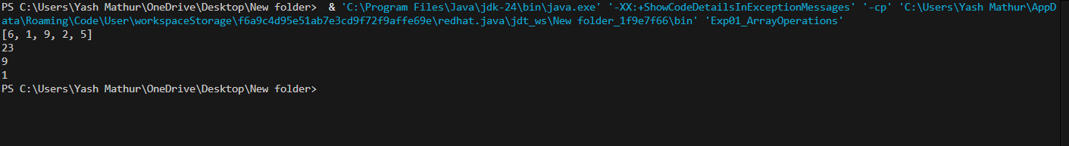

Question 2 : Write a program to implement a singly linked list with methods to
insert an element at the head, insert an element at the tail, delete an element
by value, and traverse the list to print all elements.
Answer :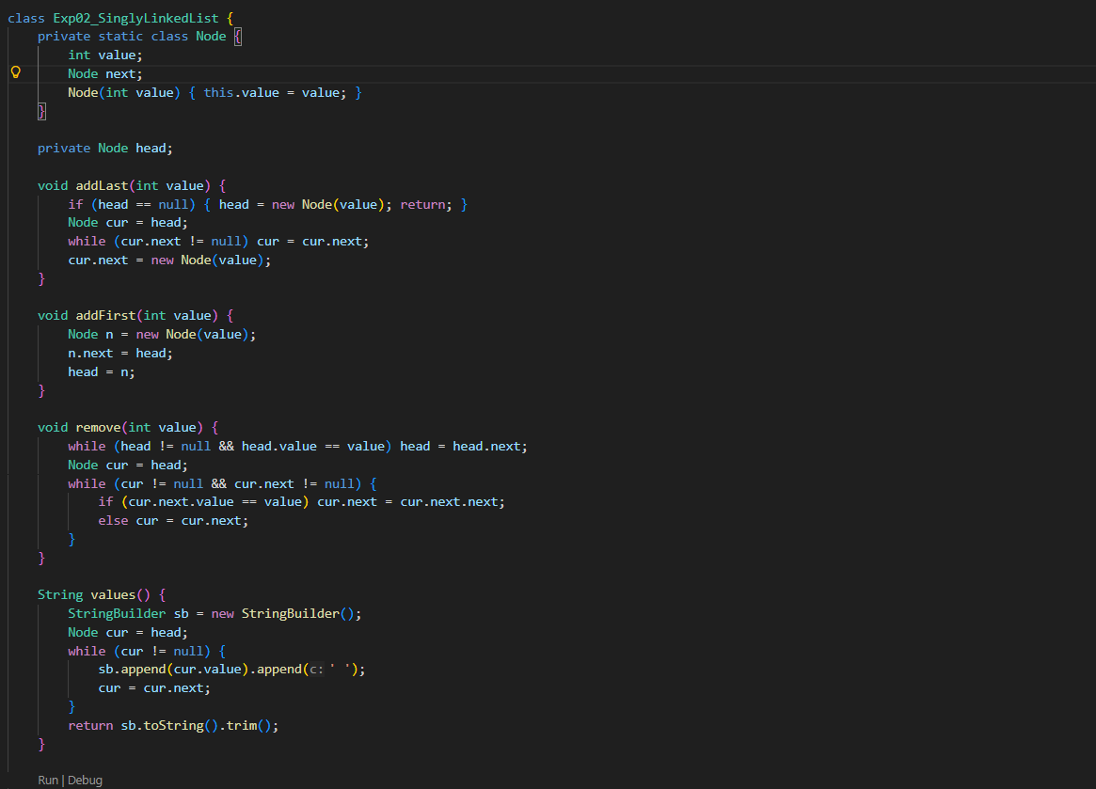
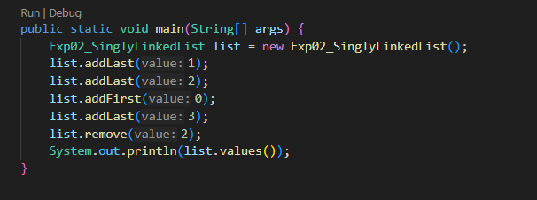

Question 3 : Write a class to implement a circular linked list with methods to
insert an element at the head, insert an element at the tail, delete an element
by value, and traverse the list to print all elements.
Answer 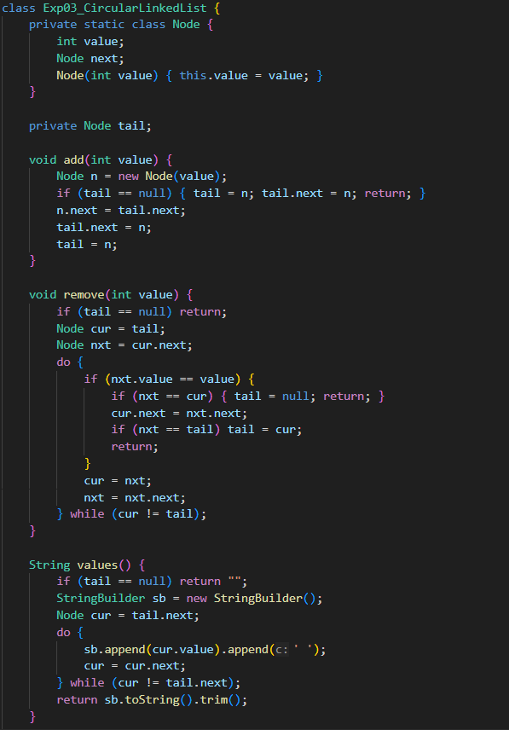
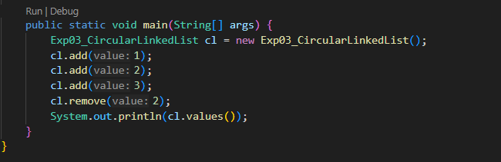

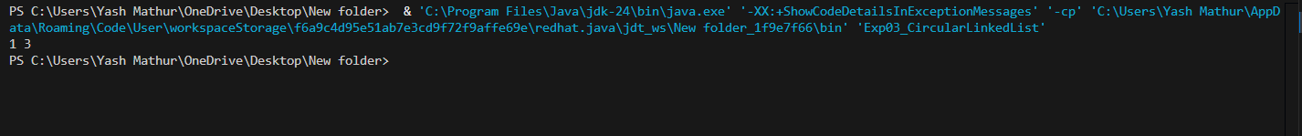

Question 4: Implement a doubly linked list with methods to insert an element
at the head, insert an element at the tail, delete an element by value, and
reverse the list. Ensure that all operations handle edge cases appropriately.
Answer :
Code :
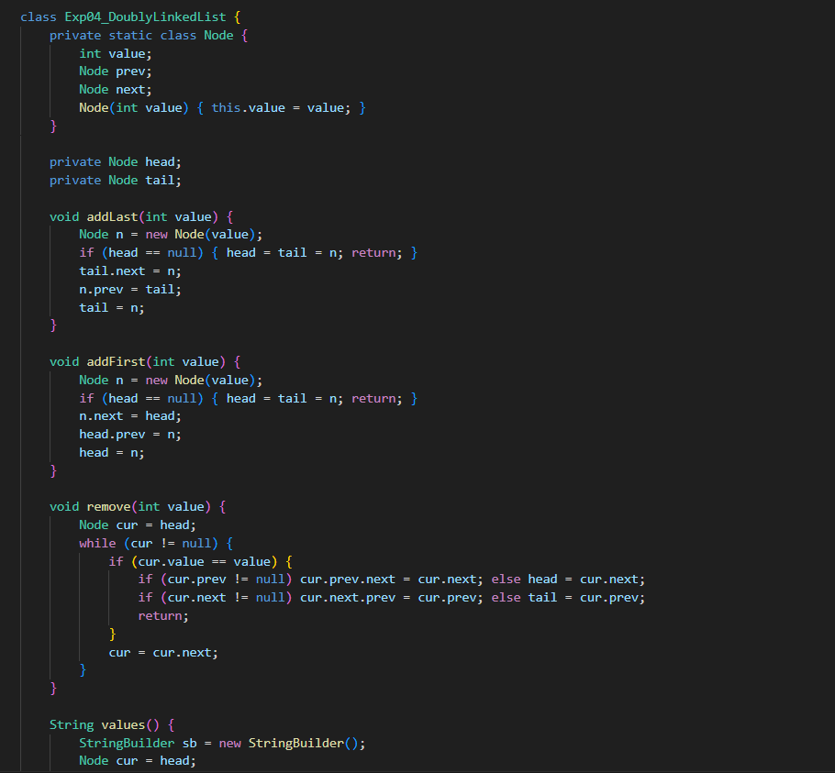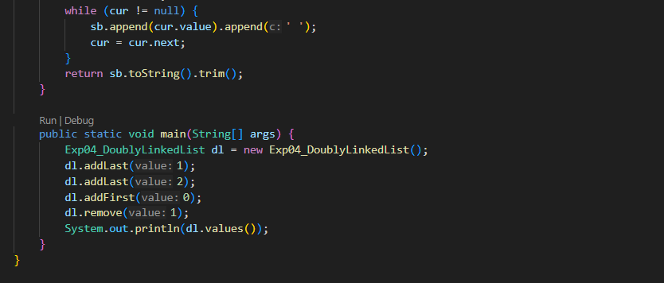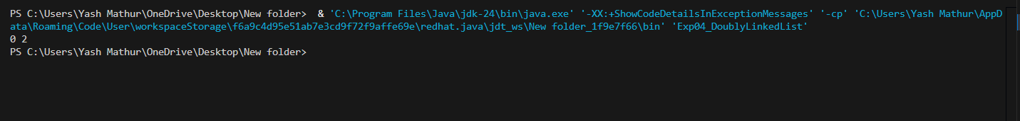

Question 5 : Implement a stack using arrays with methods for push, pop, and
peek operations.
Code :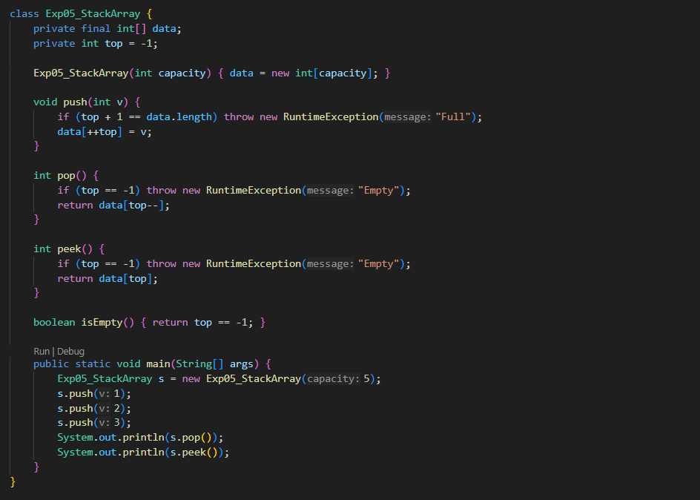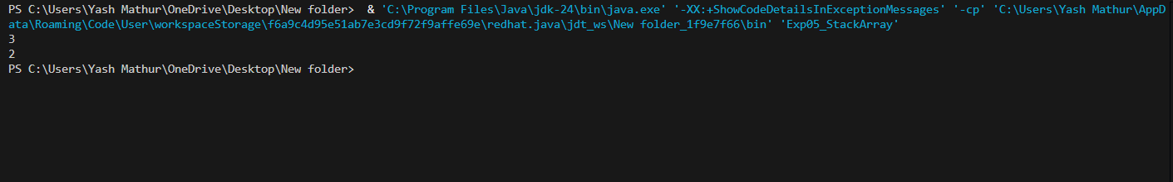
Question 6 : Write a function to convert an infix expression to a postfix
expression using a stack. The function should handle parentheses and
operator precedence correctly.
Answer :

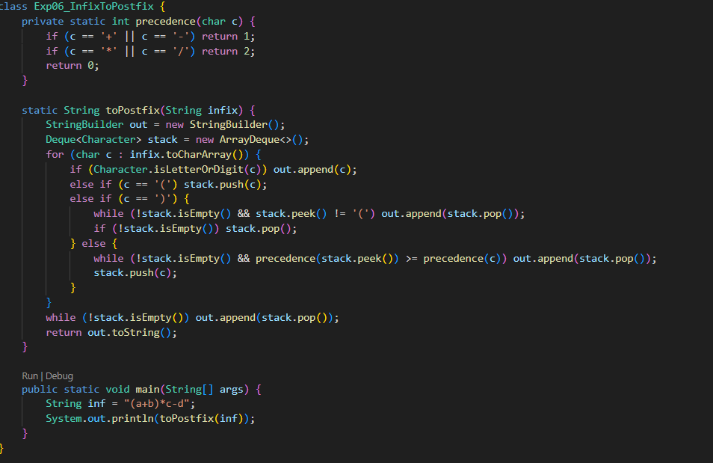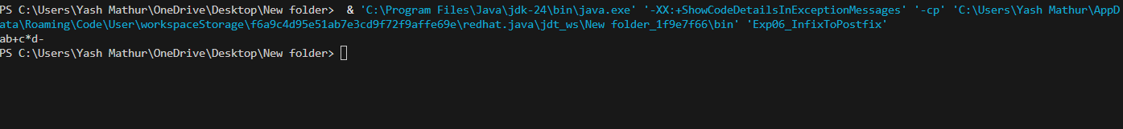

Question 7 :Create a linear queue using an array with methods for enqueue,
dequeue, and checking if the queue is empty or full.
Answer :

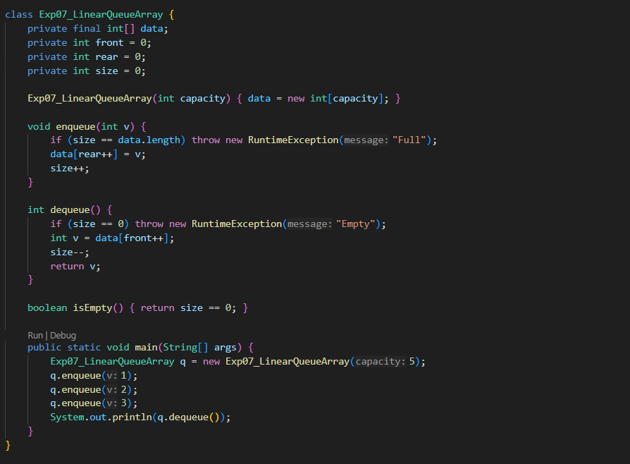
QUESTION 8 : Create a circular queue using array with methods for enqueue,
dequeue, and checking if the queue is empty or full. Ensure that the circular
nature of the queue is maintained after each operation.
Answer :

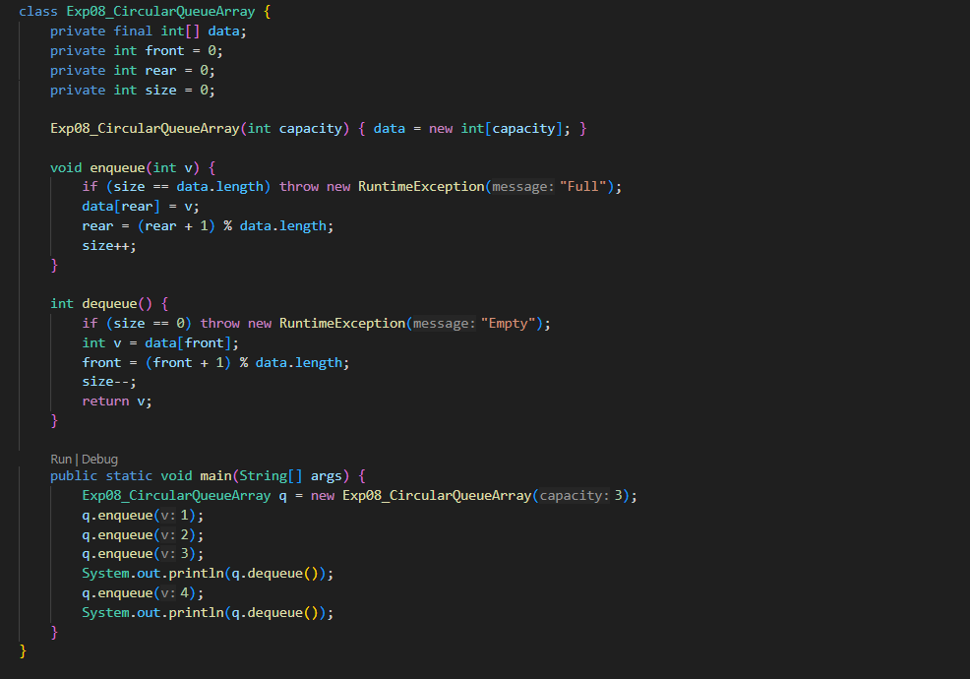
QUESTION 9 : Implement linear search
ANSWER :
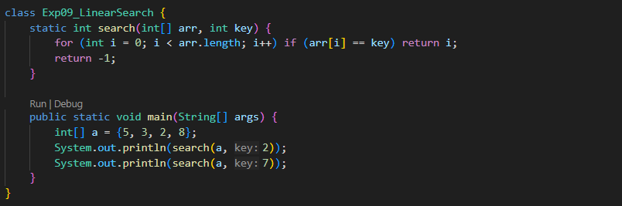
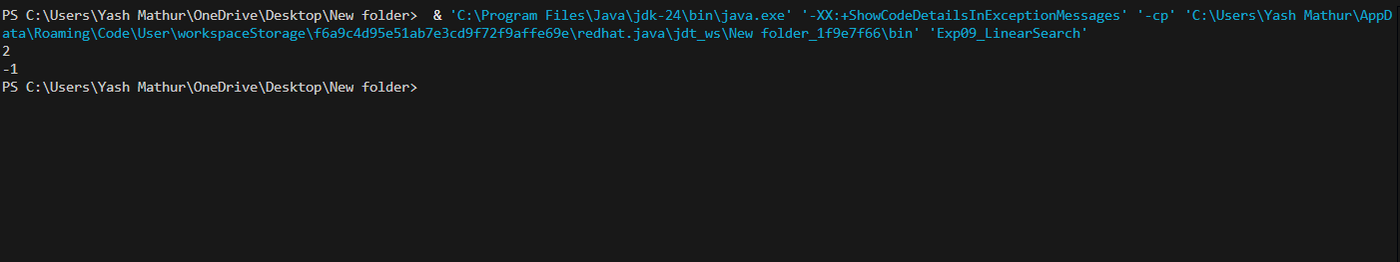
Question 10 : Implement binary search(iterative and recursive )
Answer :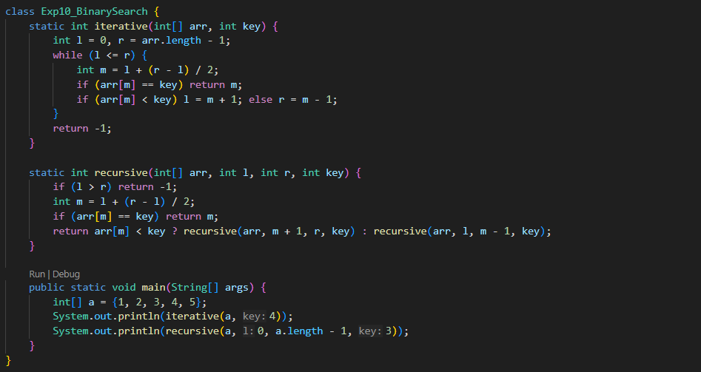
Question 11: Implement various sorting algorithms including Insertion sort,
selection sort, bubble sort, and analyze their performance on different input
sizes.
Answer :

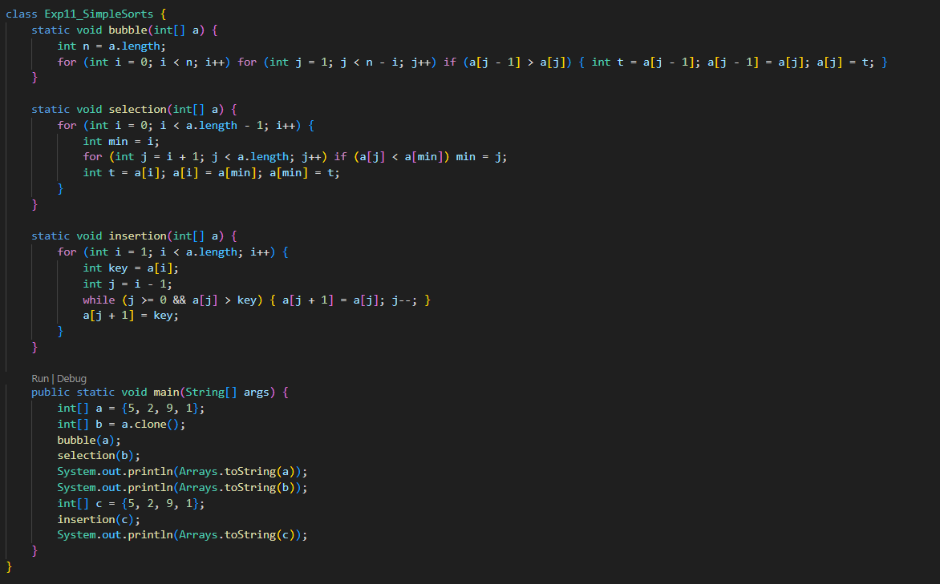
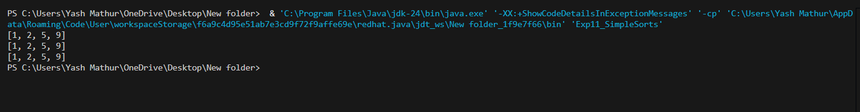
QUESTION 12 : Implement various sorting algorithms including Quick Sort,
Merge Sort, Heap Sort, and analyze their performance on different input sizes.
Ensure the implementation handles edge cases such as duplicate values and
nearly sorted arrays.
Answer :

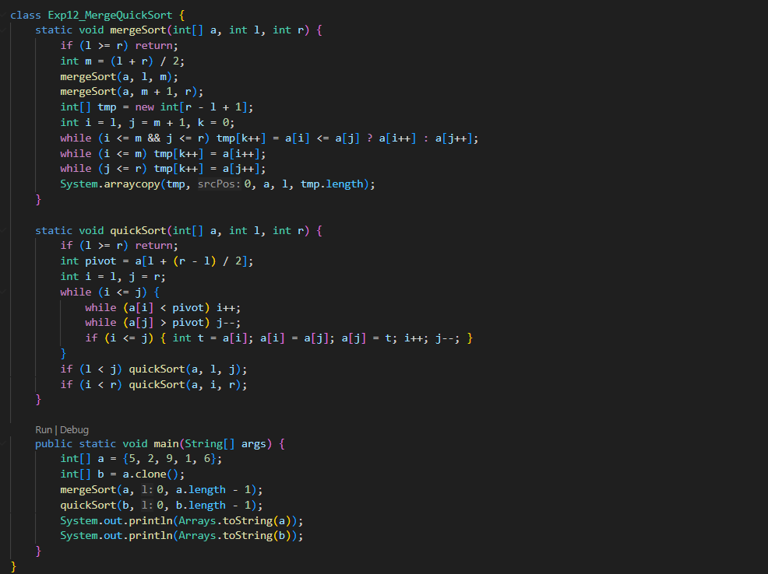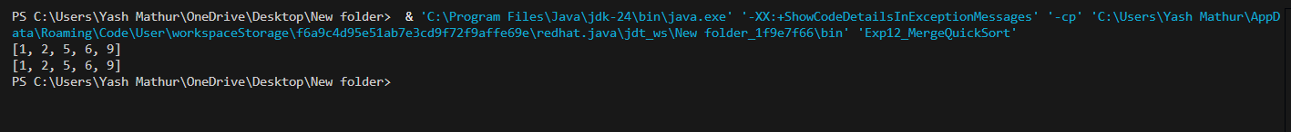
QUESTION 13 : Given preorder and inorder traversal of a tree, construct the
binary tree.
Answer :

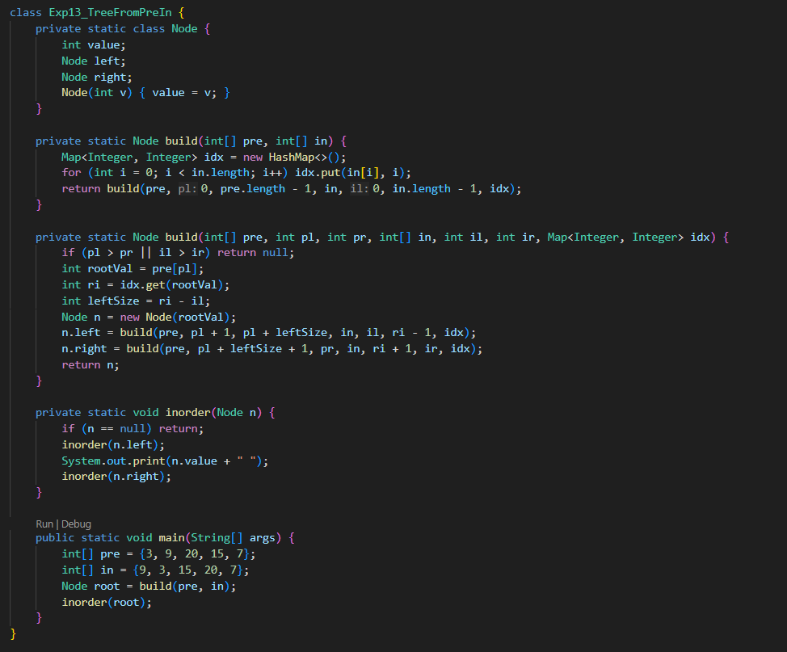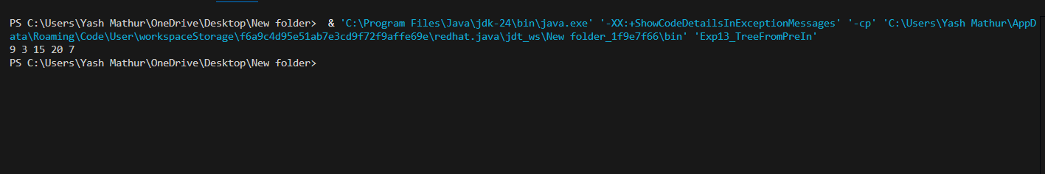
Question 14 : Perform the traversal of graph(DFS,BFS)
Answer :

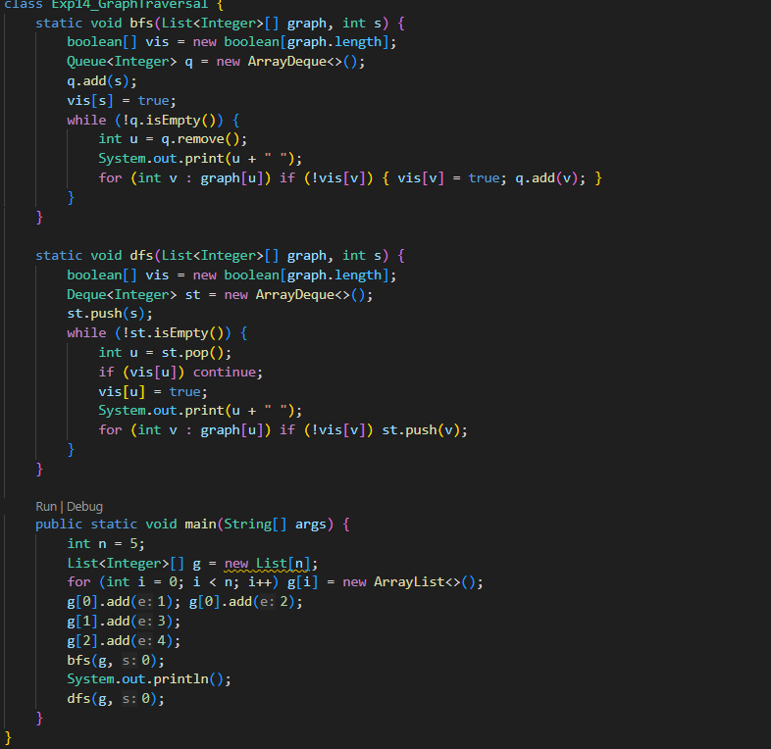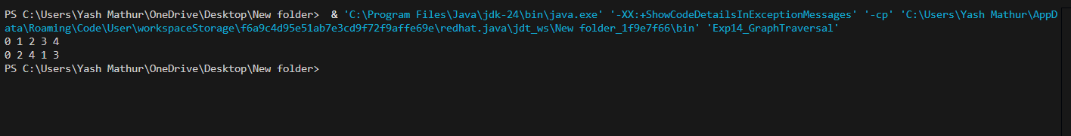
Question 15 : Implement Prim's and Kruskal’s algorithm to find the minimum
spanning tree of a graph.
Answer :
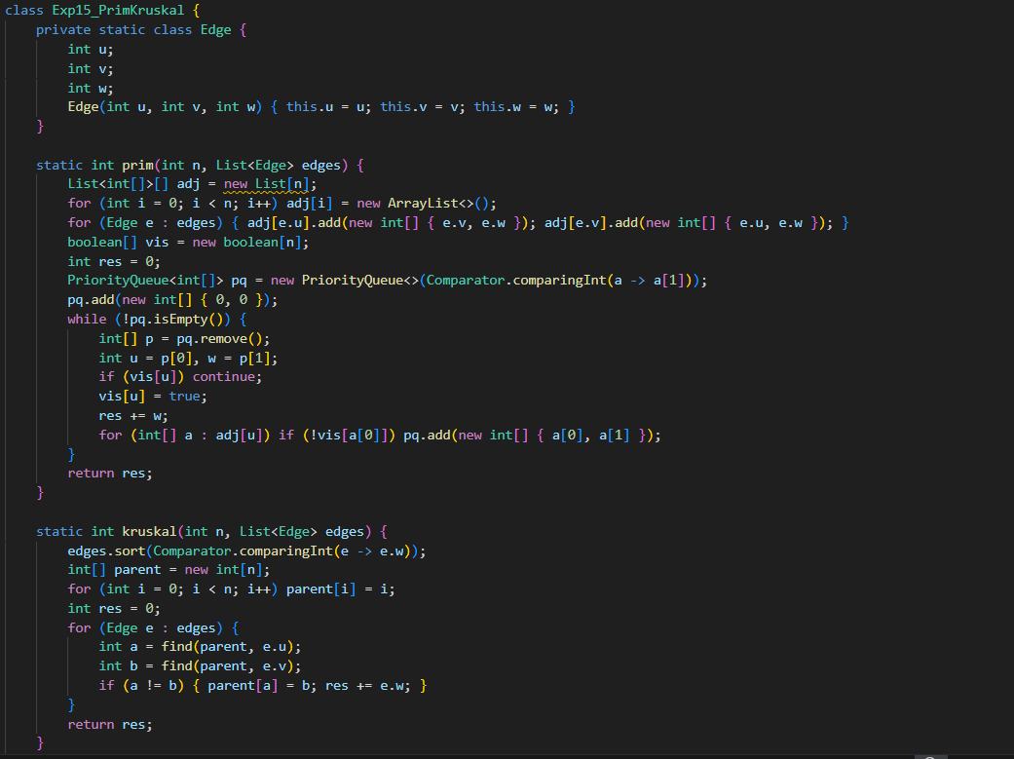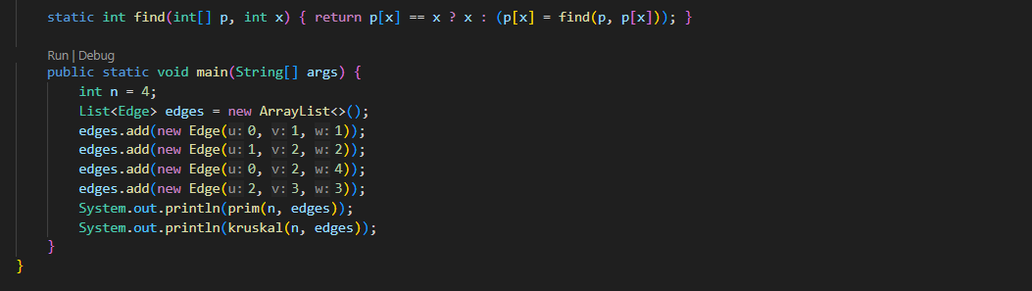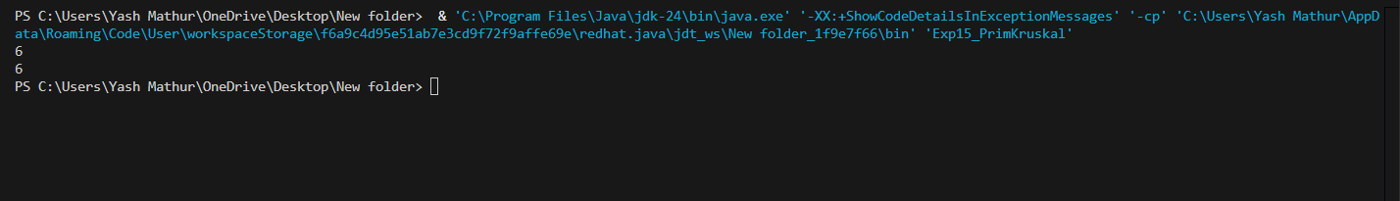
QUESTION 16 : Implement Dijkstra’s algorithm to find the shortest path from a
source vertex to all other vertices in a weighted graph. Use both adjacency
matrix and adjacency list representations for the graph. Ensure the algorithm
handles negative weights appropriately.
Answer :