

USER MANUAL
Student Fees Auto Bulk Entry

InTelli Solutions
Karnal, Haryana, INDIA-132001
Telefone-+919813501438, +919991428000
E-mail-intallysolutions@gmail.com
Web-Site: - http://www.intallysolutions.com

© 2011 InTelli Solutions. All rights reserved.

Tally, Tally 9, Tally9, Tally.ERP, Tally.ERP 9, Shoper, Shoper 9, Shoper POS, Shoper HO, Shoper 9 POS, Shoper 9 HO, TallyDeveloper, Tally Developer, Tally. Developer 9, Tally.NET, Tally Development Environment, Tally Extender, Tally Integrator, Tally Integrated Network, Tally Service Partner, TallyAcademy & Power of Simplicity are either registered trademarks or trademarks of Tally Solutions Pvt. Ltd. in India and/or other countries. All other trademarks are properties of their respective owners.
Version: InTelli Solutions/ Student Fees Auto Bulk Entry/1.4/ October 2019

<< Student Fees Auto Bulk Entry/1.4>>
Introduction
This add-on provide the educational institutions an option to post fees due entry to the whole class of students by selecting date, class names and configure the due fees heads.
They need to define the fee heads and fee amounts at the class group and then they can post fee due entries to the ledgers of all students in just one click. Entries which need to be passed to the whole group of particular class can be passed by this add-on.

Benefits
- Easy maintain of students and classes in institute.
- Easy maintaining of dues for students.
What’s New?
New in Release 1.4: -
- Compatible with Tally.ERP 9 Release 6.5.4.

Important!
Take back up of your company data before activating the Add-on.

Once you try / purchase an Add-on, follow the steps below to configure the Add-on and use it.
Setup Guide
- Update your license by going to Gateway of Tally → F12: Configuration → Licensing → Update License
(In case you are using multi-site account, you will need to configure Tally.ERP 9 to activate the Add-on for a particular site. Click here for the steps.)
- Shut down and Restart Tally.ERP 9 and open your company.
- Get Add-on help and open user manual.
For Tally.ERP Series A versions lower than Release 5.0
Go to H: Help → Add-on Help to open the user manual.
For Tally.ERP Series A release 5.0 and above
Press Ctrl + Alt + H to get Add-on help.

- Activate the Add-on.
For Tally.ERP 9 Series A version lower than Release 3.2
Go to Gateway of Tally > F11: Features > Accounting Features
Set “Yes” to the options “Enable Students Fee Auto Bulk Entry”

For Tally.ERP 9 Series A Release 3.2 and above
Go to Gateway of Tally > F11: Features > Add-on Features
Set “Yes” to the options “Enable Students Fee Auto Bulk Entry”

- Create class groups and define fee structure for them as follows: -
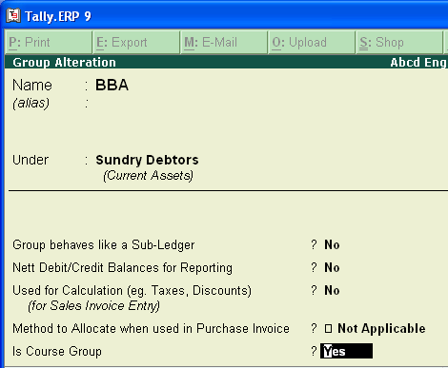
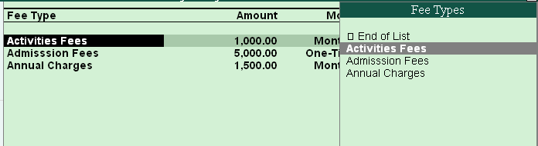
- select the fees heads from the popup which are created as below (use the parent groups as shown): -
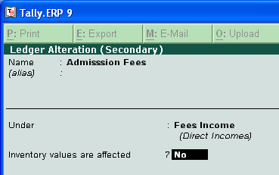
- Complete the fee structure: -
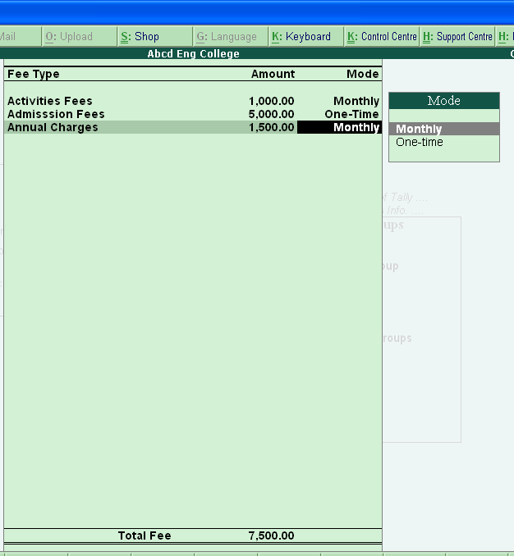
- Now create student ledgers under the class groups as below: -
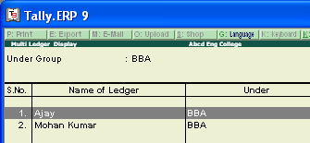
- Now go to Gateway of tally→ Student Fees Entry: -
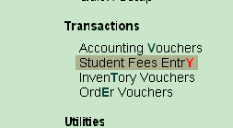
- Configure the screen as below : -
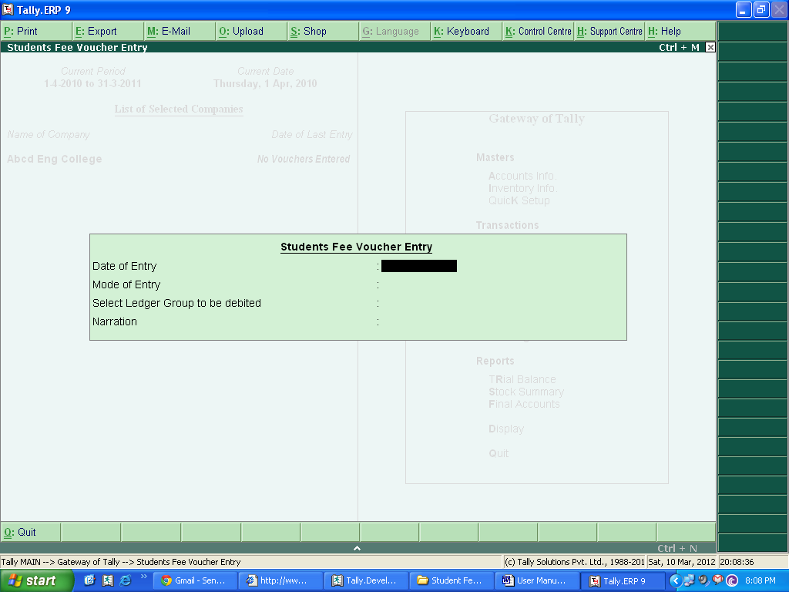
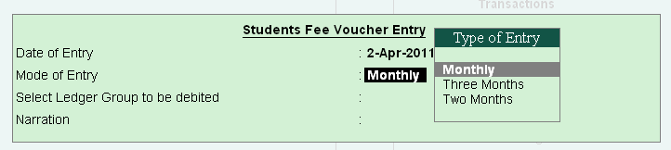
- Enter the date of entry, and select type of entry as shown above, amount will be multiplied accordingly.
- Select the class group: -
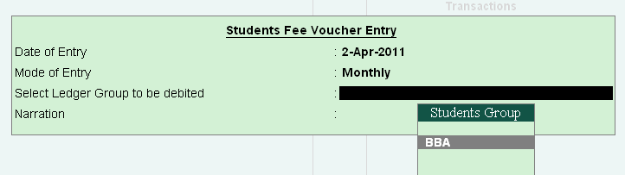
- select the fee heads defined at the class group and complete the fees entry configuration: -
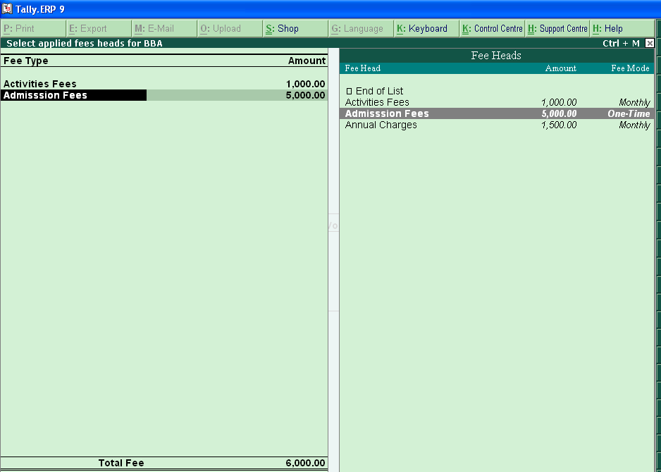
- Enter narration and accept the screen: -
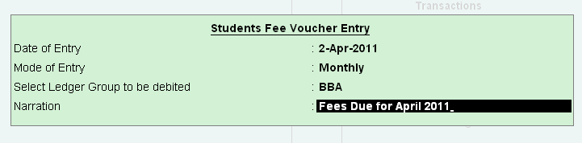

- Fees due entries are auto passed for all student ledgers in the selected class group, by the configuration above: -
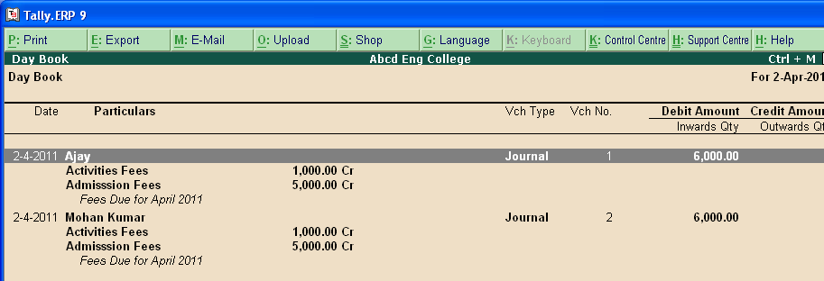
FAQs
Which version/releases of Tally.ERP 9 does the add-on support?
This add-on will work only from Tally.ERP 9 Series A, release 3.0 to Tally.ERP 9 Series A, 6.5.4.

How will I get support for this add-on?
For any functional support requirements please do write to us on intallysolutions@gmail.com or call us at +91-9813501438, +91-9991428000. Alternatively, you can send a support query from Support Centre (Ctrl + H).

If I need some enhancement / changes to be incorporated for the add-on, whom should I contact?
Please to write to us on intallysolutions@gmail.com with your additional requirements and we will revert to you in 24 business hours.

Will new features added be available to us?
We offer one year availability of all support and new features free of cost. After one year, nominal subscription cost will be applicable to you to continue to get free support and updates.

What will happen after one year?
20% of the then MRP will be charged for one year of email support and versions (minor & major).

I am using a multisite. Can I use the same Add-on for all the sites?
No, one Add-on will work only for 1 site. You need to purchase again if you want to use the same Add-on for more sites.

How do I configure the add-ons?
If you are a Tally.ERP 9 Multi site user, add the Add-on to the required site as follows:
  - Press Ctrl + K or Click on Control Centre and log into your account
  - Go to Licensing & Configuration → TDL Management → F8: TDL Config List → Select the site’s default TDL
  - Under ‘Specify Account TDLs for loading’, select the Add-on Name and accept the screen.
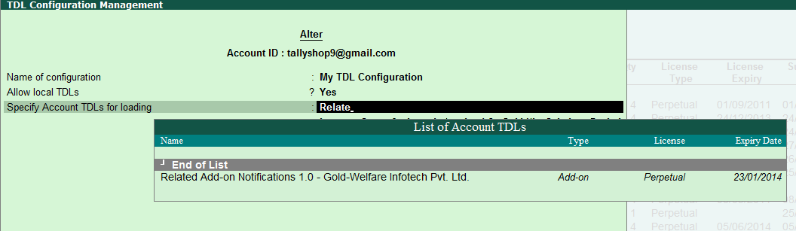
  - Update your license by going to Gateway of Tally → F12: Configuration → Licensing → Update License
Note: To know or change the site’s default TDL configuration, go to Licensing & Configuration → License Management → F6: Show Config and look at the TDL Configuration column.)

If you face problems in configuring the add-on, click on this link to know more.
http://www.tallysolutions.com/website/html/solutions/how-to-configure.php

I have upgraded to a new Tally.ERP 9 Release. What will happen?
Normally, the add-on will work fine without any glitches. If you face problems with the Add-on, you can contact us for support.

Product and Features Page shows errors with the Add-on. What do I do?
Check first if the error is because of the Add-on or because of clashes between 2 TDLs (An add-on is also a TDL). In case of clashes, disable one or more TDLs and check which TDL has error. If the Add-on has a problem, you can report it to us.

My Tally went into educational mode after installing the add-on. What do I do?
Go into Control Centre → Licensing & Configuration → TDL Management → F8: TDL Config List → Select the site’s TDL configuration which has the Add-on and remove the Add-on from the list. Update the license.

How do I find out if a new release of the Add-on is available?
Go to Control Centre → Licensing & Configuration → TDL Management and check under version available Column.

How do I update to the latest release?
Go to Control Centre → Licensing & Configuration → TDL Management and check under version available Column. If the version number shown under ‘Version Available’ column is higher than the version number shown in Name of the Add-on, select the Add-on and press F4 or click on F4: Download to download the new version. Update the license and restart Tally after download.

How do I cross upgrade the Add-on from Silver to Gold Edition?
Go to Control Centre → Licensing & Configuration → TDL Management, select the Add-on and press F6 or click on F6: Change Edition. Update the license and restart Tally after download.

My Subscription for the Add-on has expired. How do I renew my subscription?
Go to Control Centre → Licensing & Configuration → TDL Management and check under Subscription Expiry column. If the subscription is about to expire or expired, select the Add-on, Press F5 or click on F5: Renew and fill in the required details to renew your subscription. Update the license and restart Tally after download.

Will this add-on work in remote session?
Yes, this add-on will work remotely.

