1. Evidence Summary
This document compiles the NCBI BLAST result screenshots supplied for the nine sample-level assemblies and links each screenshot to its source sample, informative assembled contig, top database match and cautious taxonomic interpretation. MC1-1 is represented by two informative contigs, so ten BLAST screenshots are retained for nine samples.
Sample | Working identification | Identity | Coverage | Confidence | Evidence
B1 | Gryllus bimaculatus | 99.78% | 91% | High | Screenshot retained
B2 | Gryllus bimaculatus | 99.78% | 89% | High | Screenshot retained
C9-2 | Rhaphidophoridae sp. | 99.83% | 100% | High match; species unresolved | Screenshot retained
Cricket-Unknown | closest: Teleogryllus mitratus | 88.47% | 97% | Low at species level | Screenshot retained
GH1 | Spathosternum prasiniferum prasiniferum | 98.96% | 99% | High | Screenshot retained
GH2 | Spathosternum prasiniferum prasiniferum | 99.04% | 100% | High | Screenshot retained
MC1-1 | Gryllotalpa sp.; closest G. orientalis | 95.39% best contig | 94% | Moderate genus/relationship | Screenshot retained
MKM10 | cricket/Orthoptera; closest V. hemelytrus | 82.62% | 99% | Low at species level | Screenshot retained
T2 | Teleogryllus mitratus | 99.67% | 94% | High | Screenshot retained

Interpretation principle: High percent identity and broad query coverage support strong similarity to the reference sequence, but BLAST rank alone is not treated as definitive species delimitation when identity is substantially lower or when the reference itself lacks a species name. These screenshots are evidence records, not replacements for voucher-based taxonomy or phylogenetic analysis.

2. B1
Source sample/file | TSN20260519-0852-00054_B1_20260521-BAN6_B10_B10_i78
Assembled contig | k141_0 flag=1 multi=1291.0000 len=1012
Query ID | Query_3147265
Query length | 1,012 bp
Top BLAST match | Gryllus bimaculatus genome assembly, organelle: mitochondrion
Query coverage | 91%
Percent identity | 99.78%
E-value | 0.0
Accession | OZ281583.1

Interpretation. Strong species-level mitochondrial support for Gryllus bimaculatus.
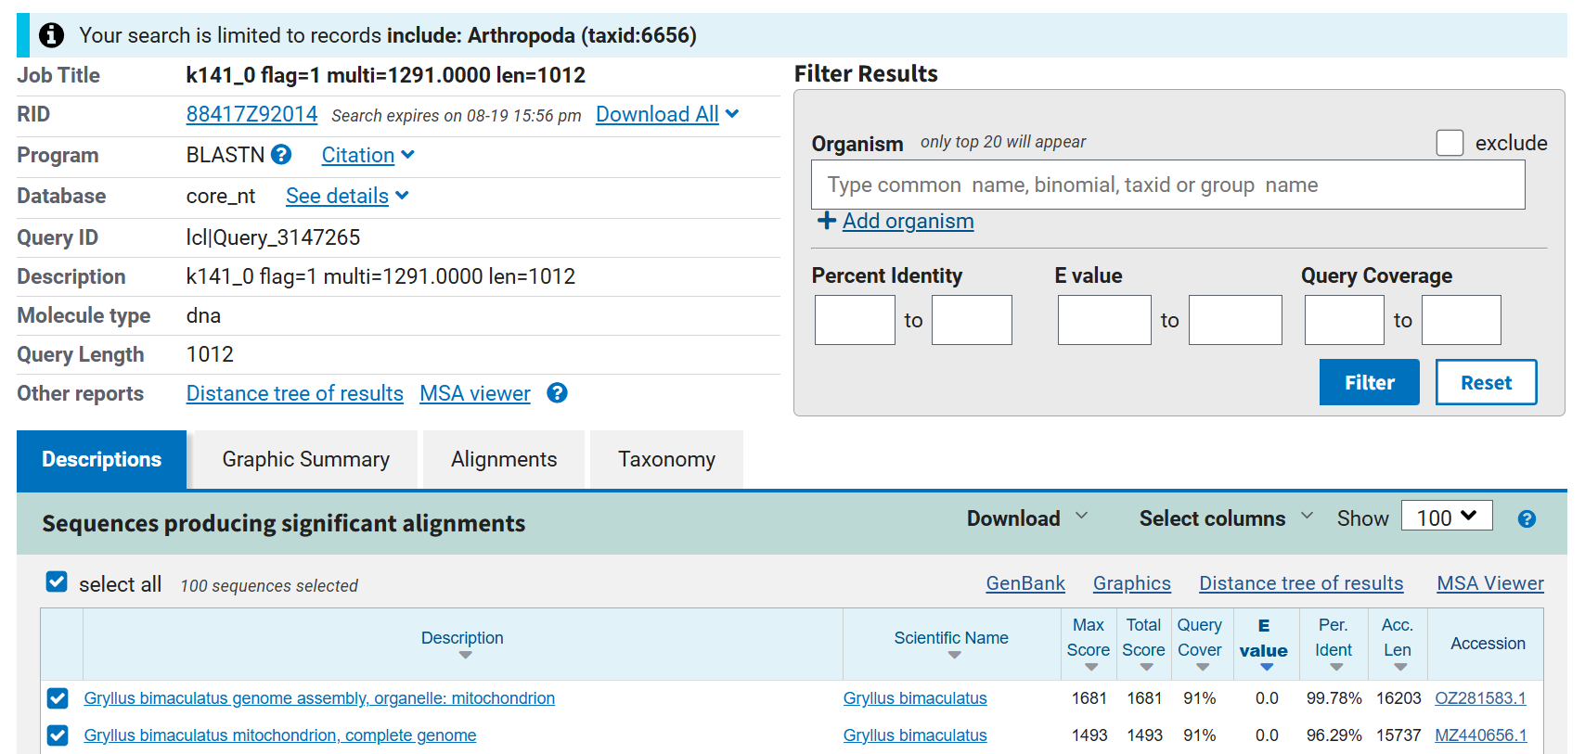
Figure 1. NCBI BLAST result screenshot for B1.

3. B2
Source sample/file | TSN20260519-0852-00054_B2_20260521-BAN6_C10_C10_i78
Assembled contig | k141_0 flag=1 multi=1119.0000 len=1031
Query ID | Query_3299005
Query length | 1,031 bp
Top BLAST match | Gryllus bimaculatus genome assembly, organelle: mitochondrion
Query coverage | 89%
Percent identity | 99.78%
E-value | 0.0
Accession | OZ281583.1

Interpretation. Strong species-level mitochondrial support for Gryllus bimaculatus; independent agreement with B1.
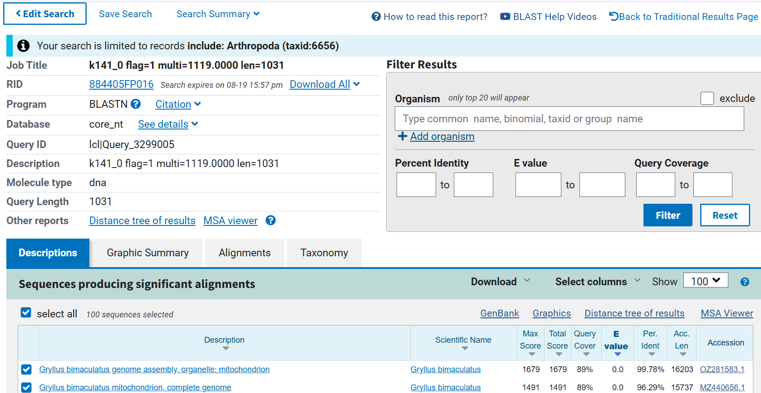
Figure 2. NCBI BLAST result screenshot for B2.

4. C9-2
Source sample/file | TSN20260519-0852-00054_C9-2_20260521-BAN6_A11_A11_i78
Assembled contig | k141_6 flag=3 multi=829.0000 len=1095
Query ID | Query_3461111
Query length | 1,095 bp
Top BLAST match | Rhaphidophoridae sp. mitochondrion, complete genome
Query coverage | 100%
Percent identity | 99.83%
E-value | 0.0
Accession | OR865114.1

Interpretation. Extremely strong mitochondrial match to the available Rhaphidophoridae sp. reference; species remains unresolved because the reference itself is not identified to species.
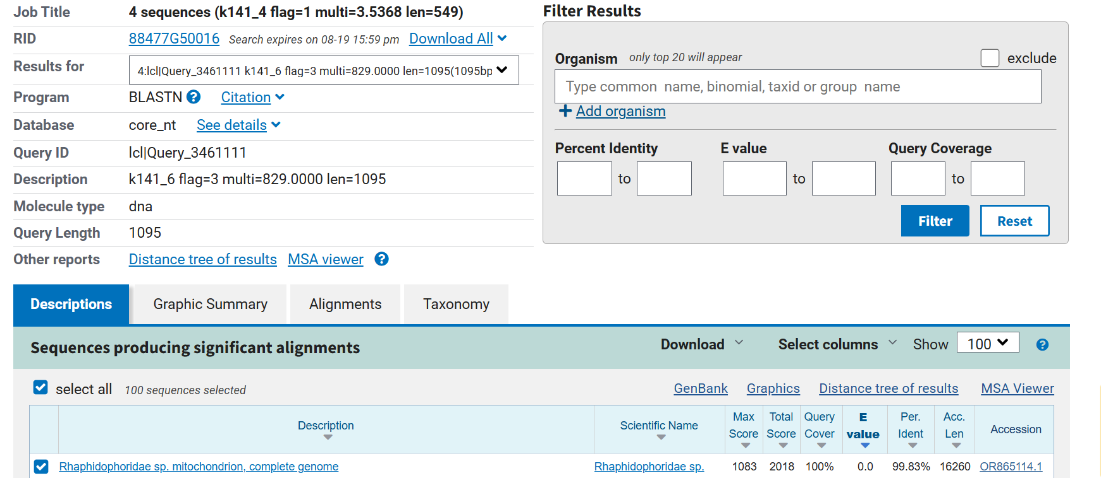
Figure 3. NCBI BLAST result screenshot for C9-2.

5. Cricket-Unknown
Source sample/file | TSN20260519-0852-00054_Cricket-Unknown_20260521-BAN6_E10_E10_i78
Assembled contig | k141_0 flag=1 multi=787.0000 len=898
Query ID | Query_1365825
Query length | 898 bp
Top BLAST match | Teleogryllus mitratus mitochondrion, complete genome
Query coverage | 97%
Percent identity | 88.47%
E-value | 0.0
Accession | PX591113.1

Interpretation. Closest database match is Teleogryllus mitratus, but 88.47% identity is too low for a confident species assignment. The sample is best retained as an unresolved cricket related to Teleogryllus pending marker sequencing/phylogenetic confirmation.
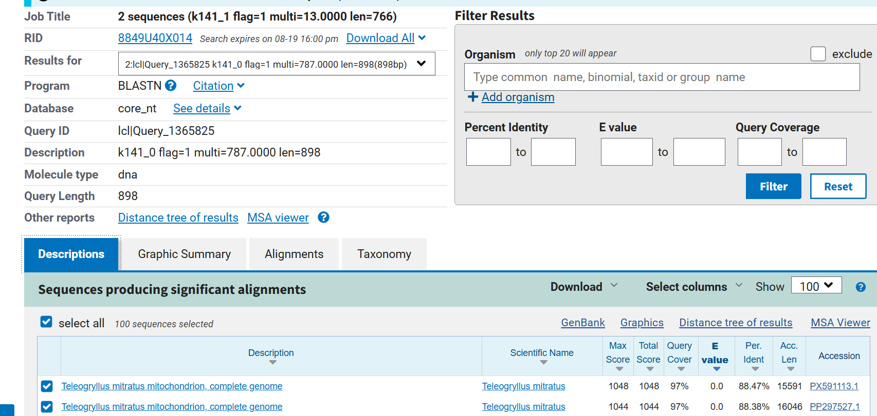
Figure 4. NCBI BLAST result screenshot for Cricket-Unknown.

6. GH1
Source sample/file | TSN20260519-0852-00054_GH1_20260521-BAN6_F10_F10_i78
Assembled contig | k141_0 flag=1 multi=578.0000 len=1034
Query ID | Query_3379179
Query length | 1,034 bp
Top BLAST match | Spathosternum prasiniferum prasiniferum mitochondrion, complete genome
Query coverage | 99%
Percent identity | 98.96%
E-value | 0.0
Accession | NC_046532.1

Interpretation. Strong species-level mitochondrial support for Spathosternum prasiniferum prasiniferum.
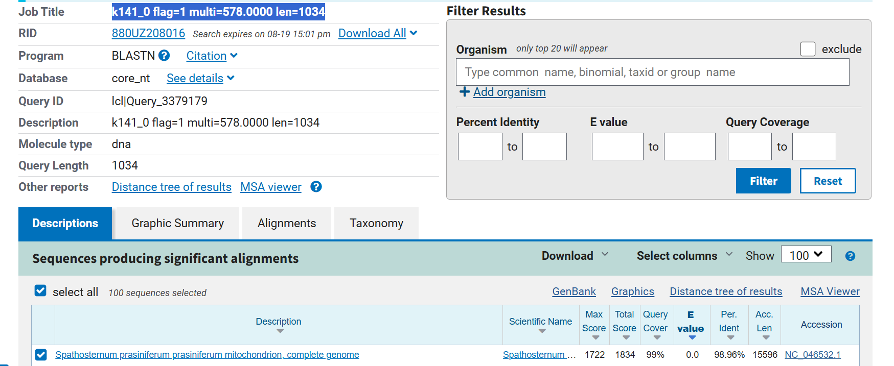
Figure 5. NCBI BLAST result screenshot for GH1.

7. GH2
Source sample/file | TSN20260519-0852-00054_GH2_20260521-BAN6_G10_G10_i78
Assembled contig | k141_0 flag=1 multi=884.0000 len=1027
Query ID | Query_7215125
Query length | 1,027 bp
Top BLAST match | Spathosternum prasiniferum prasiniferum mitochondrion, complete genome
Query coverage | 100%
Percent identity | 99.04%
E-value | 0.0
Accession | NC_046532.1

Interpretation. Strong species-level mitochondrial support for Spathosternum prasiniferum prasiniferum; independent agreement with GH1.
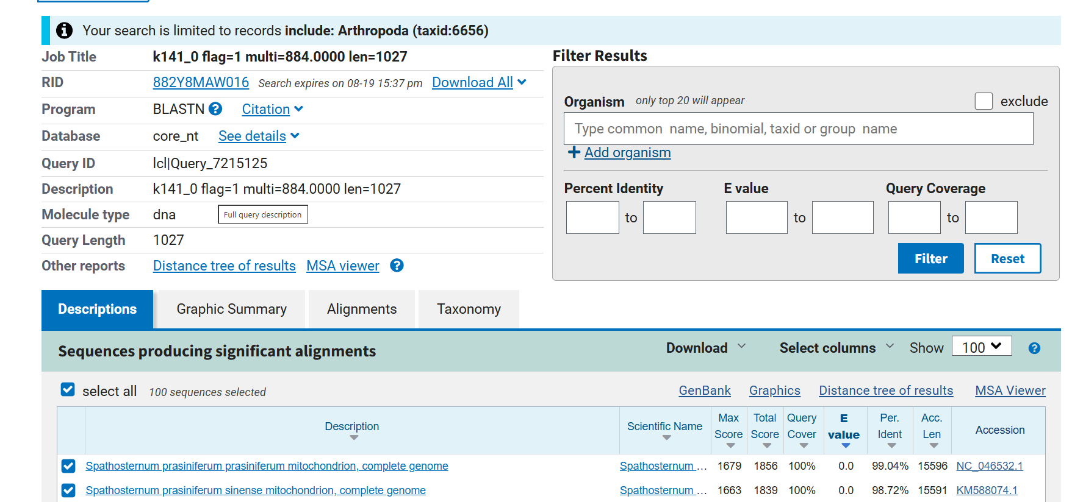
Figure 6. NCBI BLAST result screenshot for GH2.

8. MC1-1
Source sample/file | TSN20260519-0852-00054_MC1-1_20260521-BAN6_H10_H10_i78
Assembled contig | k141_1 flag=1 multi=4.8406 len=718
Query ID | Query_1524093
Query length | 718 bp
Top BLAST match | Gryllotalpa orientalis mitochondrion, complete genome
Query coverage | 100%
Percent identity | 92.62%
E-value | 0.0
Accession | ON210982.1

Interpretation. First of two independent informative contigs. It supports affinity to Gryllotalpa, with G. orientalis as the closest reference, but identity alone is not sufficient for definitive species assignment.
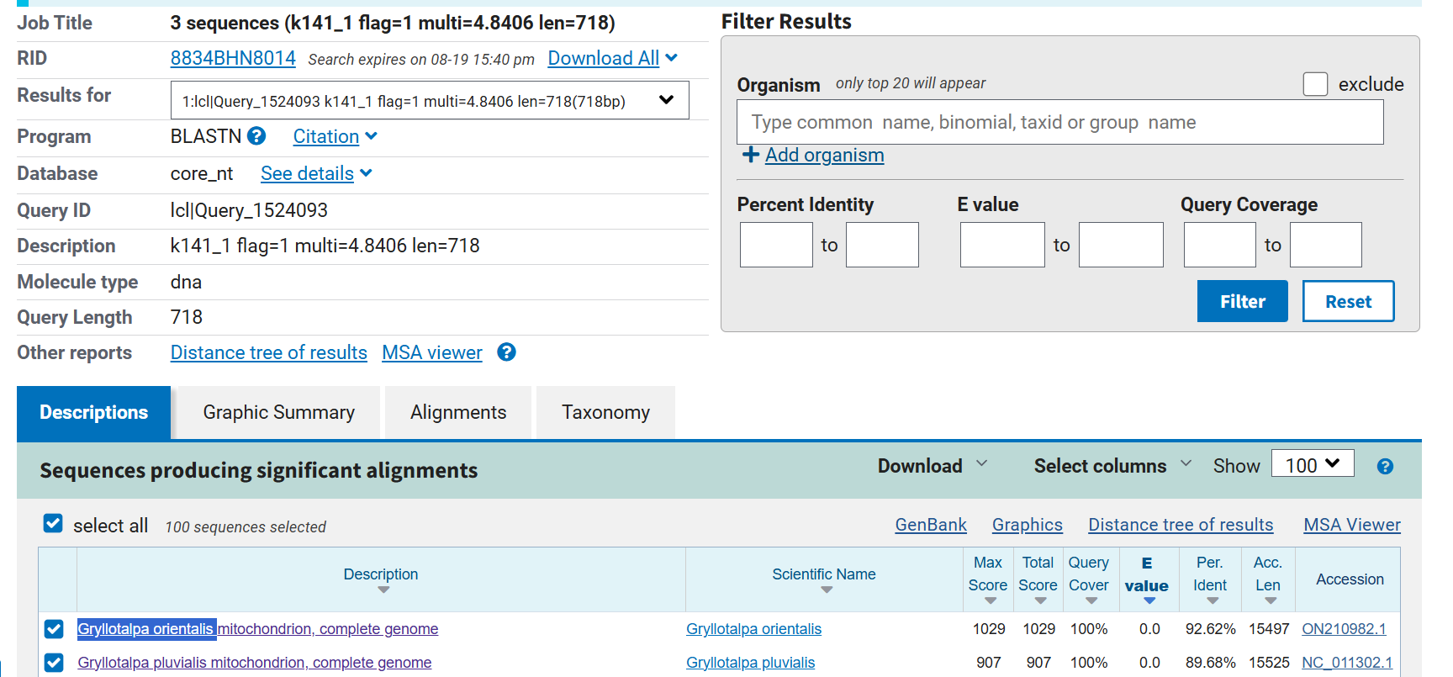
Figure 7. NCBI BLAST result screenshot for MC1-1.

9. MC1-1 (second contig)
Source sample/file | TSN20260519-0852-00054_MC1-1_20260521-BAN6_H10_H10_i78
Assembled contig | k141_2 flag=1 multi=888.0000 len=942
Query ID | Query_1524095
Query length | 942 bp
Top BLAST match | Gryllotalpa orientalis mitochondrion, complete genome
Query coverage | 94%
Percent identity | 95.39%
E-value | 0.0
Accession | ON210982.1

Interpretation. Second independent contig strengthens assignment to Gryllotalpa; G. orientalis is the closest available match, but species-level identification should remain cautious.
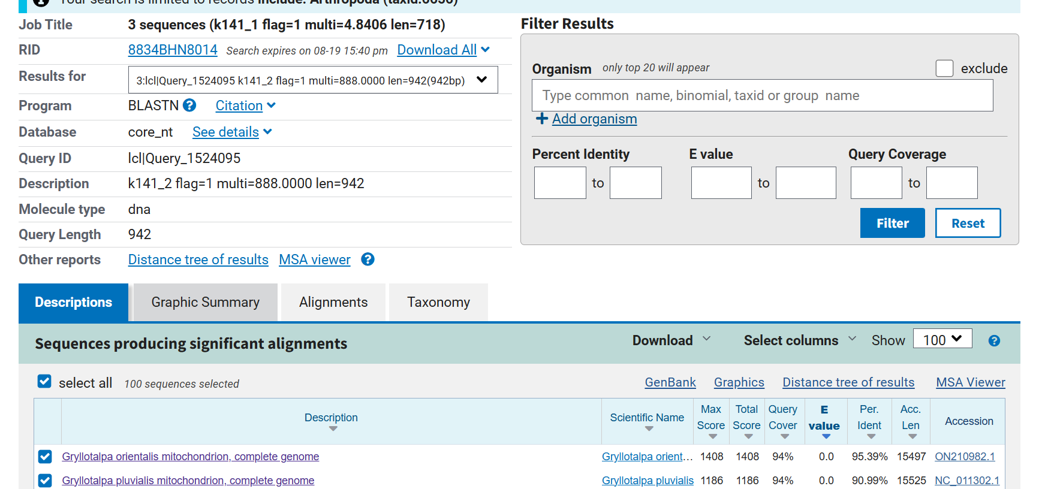
Figure 8. NCBI BLAST result screenshot for MC1-1 (second contig).

10. MKM10
Source sample/file | TSN20260519-0852-00054_MKM10_20260521-BAN6_A10_A10_i78
Assembled contig | k141_4 flag=1 multi=12.6927 len=922
Query ID | Query_1991114
Query length | 922 bp
Top BLAST match | Velarifictorus hemelytrus mitochondrion, complete genome
Query coverage | 99%
Percent identity | 82.62%
E-value | 0.0
Accession | NC_030762.1

Interpretation. Distant mitochondrial match to a cricket reference. The result supports Orthopteran/cricket affinity but is not adequate for species-level identification; additional locus-based sequencing and phylogenetic analysis are warranted.
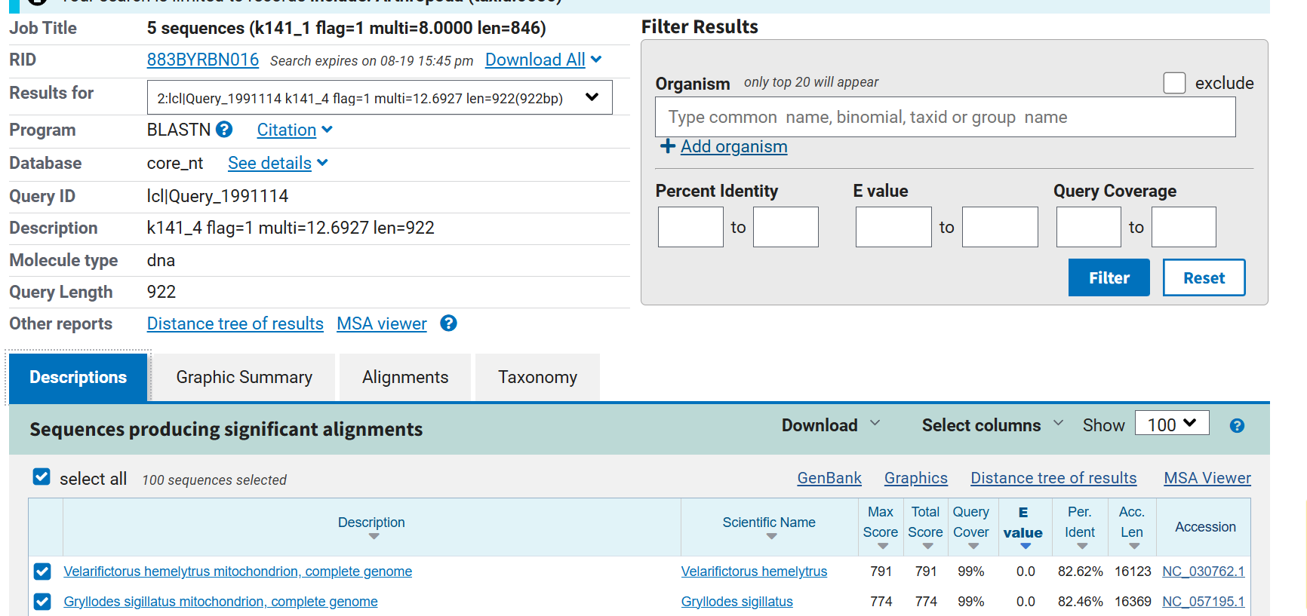
Figure 9. NCBI BLAST result screenshot for MKM10.

11. T2
Source sample/file | TSN20260519-0852-00054_T2_20260521-BAN6_D10_D10_i78
Assembled contig | k141_1 flag=1 multi=960.0000 len=973
Query ID | Query_416094
Query length | 973 bp
Top BLAST match | Teleogryllus mitratus mitochondrion, complete genome
Query coverage | 94%
Percent identity | 99.67%
E-value | 0.0
Accession | PP297527.1

Interpretation. Very strong species-level mitochondrial support for Teleogryllus mitratus.
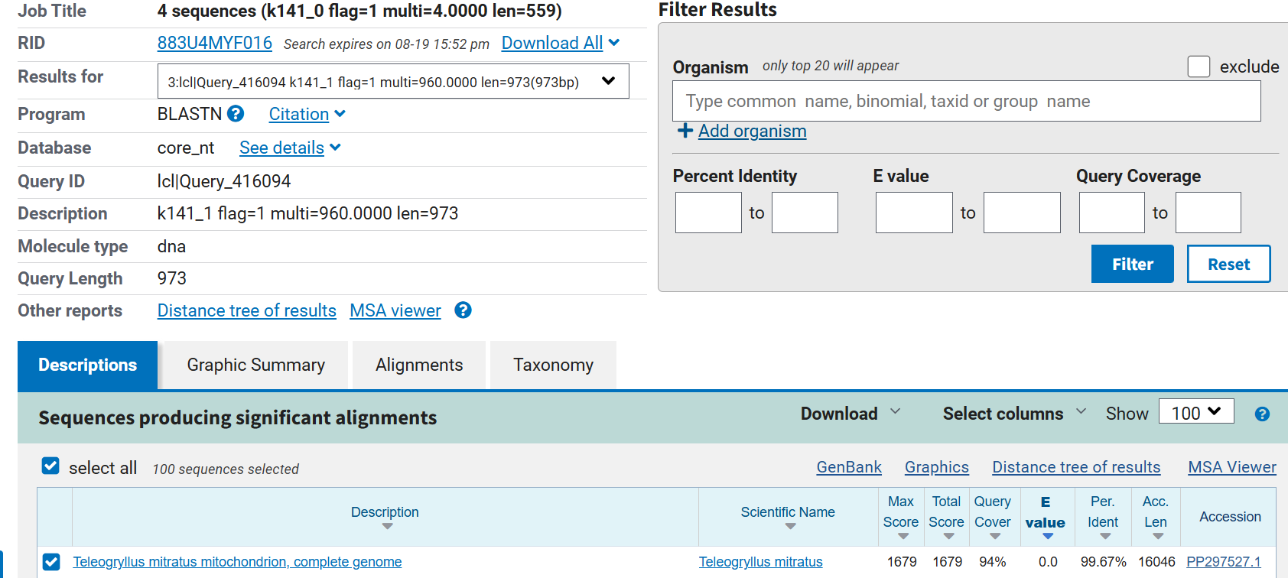
Figure 10. NCBI BLAST result screenshot for T2.

12. Provenance and Archive Notes
The screenshots in this compilation are reproduced without altering the scientific values displayed in the NCBI result interface. Original cryptic screenshot filenames are preserved elsewhere in the project ZIP archive, and logically renamed copies are also supplied for easier navigation.
The BLAST result records shown here were supplied incrementally during the project discussion. The archive therefore represents the evidence actually provided, not a newly executed BLAST analysis. The working interpretations are intentionally conservative where sequence identity is lower or taxonomic reference labels are incomplete.

