**INT217: INTRODUCTION TO DATA MANAGEMENT**

**PROJECT REPORT**

(Project Semester January-April 2025)

**“EV Sales Insights: A Data-Driven Dashboard in Excel”**

Submitted by

**Rai Yashmit**

Registration No: 12313527

Programme and Section: KM007

Course Code: INT217

Under the Guidance of

**Dr. Maneet Kaur (UID: 15709)**

**Discipline of CSE/IT**

**Lovely School Of Computer Science And Engineering**

**Lovely Professional University, Phagwara**

**CERTIFICATE**

This is to certify that Yashmit bearing Registration no. 12313527 has completed

INT217 project titled, **“EV Sales Insights: A Data-Driven Dashboard in Excel”** under my guidance and supervision. To the best of my knowledge, the present work is the result of his original development, effort and study.

**Signature and Name of the Supervisor**

**Dr. Maneet Kaur**

Assistant Professor, Discipline of CSE/IT

**School Of Computer Science and Engineering**

Lovely Professional University

Phagwara, Punjab.

Date: 11-04-2025

**DECLARATION**

I, Yashmit, student of B. Tech under CSE/IT Discipline at Lovely Professional University, Punjab, hereby declare that all the information furnished in this project report is based on my own intensive work and is genuine.

Date: 11-April-2025 Signature : Yashmit

Registration No. 12313527 Rai Yashmit

**ACKNOWLEDGEMENT**

I would like to take this opportunity to express my sincere gratitude to all the individuals who have supported, guided, and motivated me throughout the successful completion of this Data Management Project, titled “EV Sales Dashboard in Excel.” This project has been a significant milestone in my academic journey and has enriched my understanding of practical data analytics and visualization using Microsoft Excel.

First and foremost, I would like to extend my heartfelt thanks to my mentor, Dr. Maneet Kaur, whose expert guidance, insightful feedback, and continuous encouragement were instrumental in the successful completion of this project. Her mentorship helped me approach Excel’s analytical tools with confidence and develop a deeper understanding of dashboard development.

I also express my gratitude to all faculty members of the Lovely School of Computer Science and Engineering, Lovely Professional University, for their academic support, knowledge sharing, and for fostering an environment that promotes practical learning.

My sincere thanks go to open data sources for providing access to structured datasets relevant to electric vehicles. The EV dataset used in this project enabled valuable insights into brand-wise trends, vehicle specifications, and pricing comparisons.

Special thanks to my peers and classmates who contributed to discussions and shared helpful suggestions during the project phase. Lastly, I express my deepest thanks to my parents and family, whose encouragement and support provided the motivation to carry this project to completion.

**TABLE OF CONTENTS**

| **S. No** | **Section Title** | **Page No.** |
| --- | --- | --- |
| 1 | Introduction | 1 |
| 2 | Source of Dataset | 2 |
| 3 | Data Preprocessing | 3 |
| 4 | Analysis Objectives | 4 |
| 4.1 | Objective 1: Analyse Sales Distribution | 5 |
| 4.2 | Objective 2: Compare Sales Across Different Product Categories | 6 |
| 4.3 | Objective 3: Detect Missing or Invalid Entries | 7 |
| 4.4 | Objective 4: Observe Sales Trends Across Different Seasons | 8 |
| 4.5 | Objective 5: Analyse Sales by Region/City | 9 |
| 4.6 | Objective 6: Identify Top 5 Products with Highest Sales | 10 |
| 4.7 | Objective 8: Create a Dynamic Filterable Sales Chart | 12 |
| 4.8 | Objective 9: Dashboard Slicers for Interactive Filtering | 13 |
| 5 | Conclusion | 15 |
| 6 | Future Scope | 16 |
| 7 | References | 17 |
|  |  |  |

**1. INTRODUCTION**

1. INTRODUCTION

The global automotive industry is undergoing a profound transformation, driven by urgent environmental concerns, policy shifts, and growing consumer demand for sustainable mobility. Among the most significant developments in this domain is the rapid rise of Electric Vehicles (EVs). As nations around the world push toward carbon neutrality, the EV sector has emerged as a cornerstone of this green transition. Governments are offering subsidies, companies are investing in R&D, and consumers are becoming increasingly conscious of their ecological footprint. This convergence of interest has led to an unprecedented boom in EV production, sales, and technological innovation.

In this context, analysing EV sales data has become critical for multiple stakeholders—manufacturers, policymakers, marketers, and consumers alike. Understanding brand performance, price positioning, feature offerings, and efficiency metrics not only helps shape business decisions but also fosters innovation and strategic alignment. This project, titled “EV Sales Dashboard in Excel,” is a practical initiative aimed at uncovering such insights through the power of structured data analytics.

The core of this project lies in transforming raw vehicle specifications and pricing data into actionable insights using Microsoft Excel—a tool accessible to most analysts, yet often underestimated in its capabilities. By leveraging Excel’s robust features, including PivotTables, PivotCharts, Conditional Formatting, Slicers, and What-If Analysis, this dashboard project empowers users to visualize trends, compare variables, and interact with data in meaningful ways. It bridges the gap between complex data and practical decision-making.

The dataset used for this project is sourced from publicly available EV records, featuring key attributes such as brand, model, battery range (km), top speed (km/h), acceleration (0–100 km/h), launch year, and price (EUR). These variables offer a rich landscape for analysis, enabling users to study market competitiveness, value offerings, technological evolution, and affordability.

Key questions addressed in this project include:

* Which brands dominate the EV market in terms of model variety?
* How has battery efficiency (range) improved over the years?
* What is the relationship between top speed and vehicle price?
* Which EV models provide the best value for money based on cost-per-kilometre?
* How would a price subsidy or policy-based price change affect consumer affordability?

To address these questions, the project followed a systematic approach—beginning with data cleaning and preprocessing, followed by the creation of calculated fields and implementation of dynamic dashboards using Excel’s visual tools. The result is an interactive and user-friendly dashboard that supports exploratory analysis and business intelligence.

From an academic perspective, this project highlights the importance of practical skill-building in the domain of data analytics. It demonstrates that even without advanced programming languages or complex software, meaningful insights can be derived through well-structured, spreadsheet-based analysis. The final dashboard serves as a proof-of-concept for real-time sales tracking, market comparison, and strategic planning within the electric vehicle industry.

In conclusion, “EV Sales Dashboard in Excel” is not just a visualization project—it is a data-driven decision-support system designed to empower stakeholders to make informed choices, plan future initiatives, and gain competitive advantage in the fast-evolving electric mobility landscape.

**2. SOURCE OF DATASET**

The retail sales data used in this project was obtained from a publicly available dataset, sourced from an online retail database or e-commerce platform <https://catalog.data.gov/dataset/electric-vehicle-population-data>

The dataset contains detailed information on sales transactions during the Diwali season, including attributes such as product category, sales volume, revenue, discount percentages, product ID, and geographical location of customers.

This dataset serves as an ideal foundation for performing exploratory data analysis, developing insightful visualizations, and building an interactive sales dashboard. It provides a comprehensive view of the sales of EV and gowth potential, including trends across different product categories, the impact of discounts, and variations in sales performance across regions.

The structured nature of the dataset, with clearly categorized and organized data points, makes it highly suitable for dynamic analysis in Microsoft Excel. The data’s variety and detailed attributes enable a thorough examination of sales patterns and consumer behavior of sales of EV, allowing for the creation of a powerful, user-friendly dashboard that can support data-driven decision-making.

**3. DATA PREPROCESSING**

To ensure that the dataset was clean, consistent, and suitable for accurate analysis in Microsoft Excel, several data preprocessing steps were performed. These steps were crucial to transform the raw EV sales data into a structured format optimized for visualization, filtering, and dashboard creation. The following actions were undertaken:

* **Removed duplicate records** and eliminated irrelevant columns that did not contribute to the analysis, such as Modelor unstructured text fields.
* **Handled missing or incomplete values** in key columns like sales amount, quantity, or customer location using context-appropriate methods such as replacing with the column average, mode, or excluding certain rows if necessary.
* **Standardized column formats**, including currency values (for sales and revenue), percentages (for discounts), and categorical entries (for product categories, gender, and region), ensuring consistency across the dataset.
* **Created calculated columns** to enrich the dataset. For example, a “Net Sales” column was derived by factoring in discounts, and a “Profit Margin” column was introduced to support profitability analysis and What-If scenarios.
* **Formatted the dataset for seamless integration** with Excel features such as PivotTables, Slicers, Charts, and Conditional Formatting, enhancing the ability to filter, summarize, and visually represent the data interactively.

**4. ANALYSIS OBJECTIVES**

This section outlines the analytical goals of the EV Sales Dashboard. Each objective is aligned with business insights derived from structured Excel tools such as PivotTables, Charts.

By breaking down the dataset into key focus areas, the dashboard offers multi-dimensional insights into EV performance, pricing strategies, and technological evolution.

**Objective 1: Brand-wise EV Model Distribution**

**Description:**

The goal here is to identify which EV brands offer the highest number of models in the market. This helps understand the diversity of options available to consumers from different manufacturers.

**Analysis:**

A PivotTable was used to count the number of EV models available per brand. This was followed by a vertical bar chart to visualize the distribution, which allows a clear comparative analysis across brands. The chart highlighted how many models each brand offers in the electric vehicle space.

**Result:**

The analysis revealed that Volkswagen, Tesla, and BMW lead in the number of EV models offered. In contrast, other brands tend to offer fewer options.

**Conclusion:**

This insight is valuable for both manufacturers and consumers. It indicates the breadth of product lines from key brands, which can influence consumer choice based on availability and variety. Manufacturers can also gauge market saturation and adjust their offerings accordingly.

**Objective 2: Top Speed vs Price Comparison**

**Description:**

This objective explores the correlation between an EV’s top speed and its price. Understanding this relationship is crucial for identifying trends in pricing strategies based on performance.

**Analysis:**

A scatter chart was used to visualize the relationship between Top Speed and Price for each EV model. Outliers—those models that don't follow the general trend—were specifically highlighted to further enhance understanding of unusual data points.

**Result:**

The analysis showed that high-performance models (e.g., Porsche and Tesla) generally exhibit a strong correlation between top speed and premium pricing. Models that offer higher speeds tend to be priced higher.

**Conclusion:**

This observation helps manufacturers tailor their pricing strategies. Performance-based pricing trends are evident, and they suggest that higher-priced vehicles are often associated with superior speed capabilities. This can influence how products are marketed, emphasizing performance as a justification for premium pricing.

**Objective 3: Year-wise Range Analysis**

**Description:**

The purpose here is to assess the improvement in EV range over the years, which is essential for understanding how technological advancements have contributed to the industry’s growth.

**Analysis:**

The dataset was grouped by Launch Year, and the average range for each year was plotted using a line graph. This allowed a clear visualization of the trend in range improvements over time.

**Result:**

A consistent upward trend in range, particularly after 2018, reflects significant advancements in battery technology. Models from later years consistently offer a higher range compared to earlier models.

**Conclusion:**

The improvement in range directly addresses one of the main concerns for EV buyers—range anxiety. The upward trend reassures consumers about the increasing viability of electric vehicles for longer trips, enhancing overall buyer confidence and increasing adoption rates.

**Objective 4: Cost-Efficiency (Value per km Range)**

**Description:**

This objective aims to identify which EV models provide the most range for every euro spent, allowing buyers to determine the cost-efficiency of each vehicle.

**Analysis:**

A new column, "Price ÷ Range," was created to calculate the value per kilometer of range. The dataset was then sorted by the lowest value/km, which indicates how much each vehicle costs per unit of range offered.

**Result:**

Brands such as Renault and Hyundai showed better cost-efficiency, providing more range for each euro spent compared to premium brands.

**Conclusion:**

This metric is especially useful for price-sensitive buyers and policy makers, as it highlights the best value offerings in the market. It can guide purchasing decisions and shape policies aimed at improving EV affordability and encouraging wider adoption.

**Objective 5: What-If Analysis on 10% Price Reduction**

**Description:**

This objective evaluates the effect of a 10% price reduction on the overall affordability of EV models, simulating the impact of a potential government subsidy or price cut.

**Analysis:**

A new column was added to compute the discounted prices (10% reduction), and the results were compared using Waterfall and Bar Charts. This visualization method helps in illustrating how the pricing changes for each vehicle.

**Result:**

Even a modest 10% reduction in price made many premium EVs (e.g., Tesla, Porsche) fall into more affordable price brackets, which could drive higher adoption rates.

**Conclusion:**

This analysis demonstrates how government subsidies or price reductions can significantly influence the affordability of EVs. It also highlights how such policy changes can encourage consumers to choose electric vehicles, supporting broader adoption goals.

**Objective 6: Interactive Dashboard with Slicers**

**Description:**

To enhance user interaction, this objective focuses on creating a dynamic dashboard that allows users to filter the data based on specific criteria such as brand, speed, price, or year.

**Analysis:**

PivotTables were linked to slicers and visual elements like bar charts, line charts, and pie charts. This feature lets users filter the data dynamically and explore different combinations of metrics interactively.

**Result:**

The interactive dashboard allows users to visually explore trends and filter by key specifications like brand, price, speed, and launch year. This makes it easier to uncover hidden patterns and gain insights into how different EV models compare across multiple dimensions.

**Conclusion:**

The interactivity of the dashboard enhances user engagement and allows for quick decision-making. It supports an exploratory approach, where users can actively investigate the dataset based on their specific interests, such as examining high-performance models or evaluating cost-efficiency trends.

These objectives not only serve as analytical goals but also contribute to a deeper understanding of the electric vehicle market. The use of structured Excel tools makes it easier to extract meaningful insights, which can guide both consumers and manufacturers in the ever-evolving EV market.

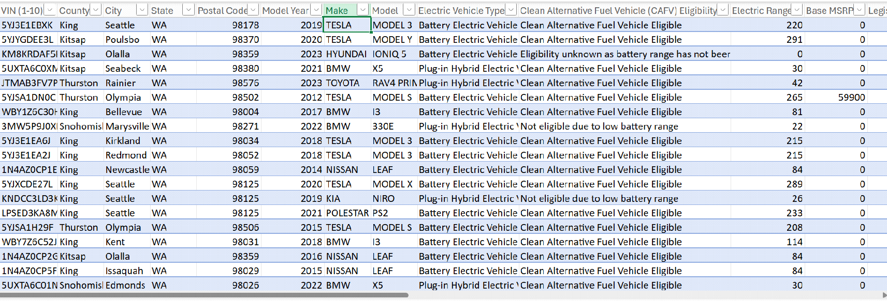

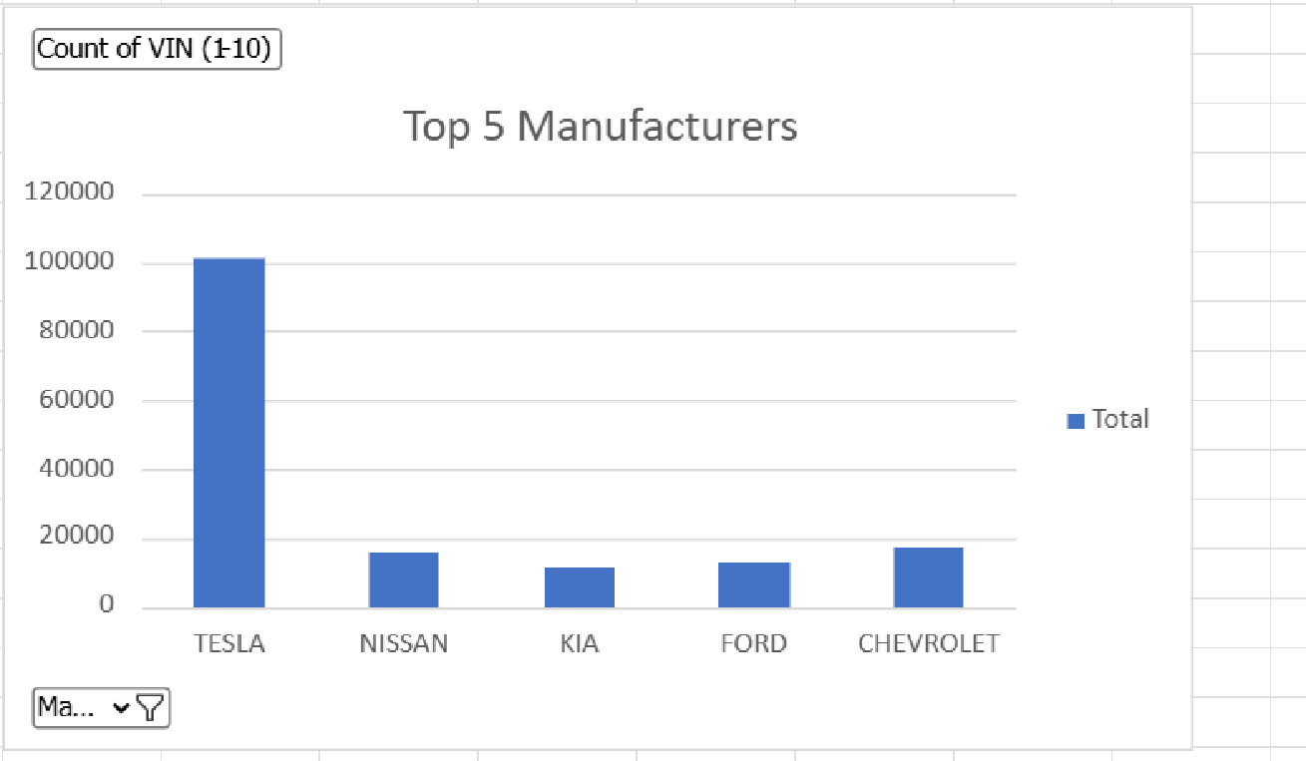

* 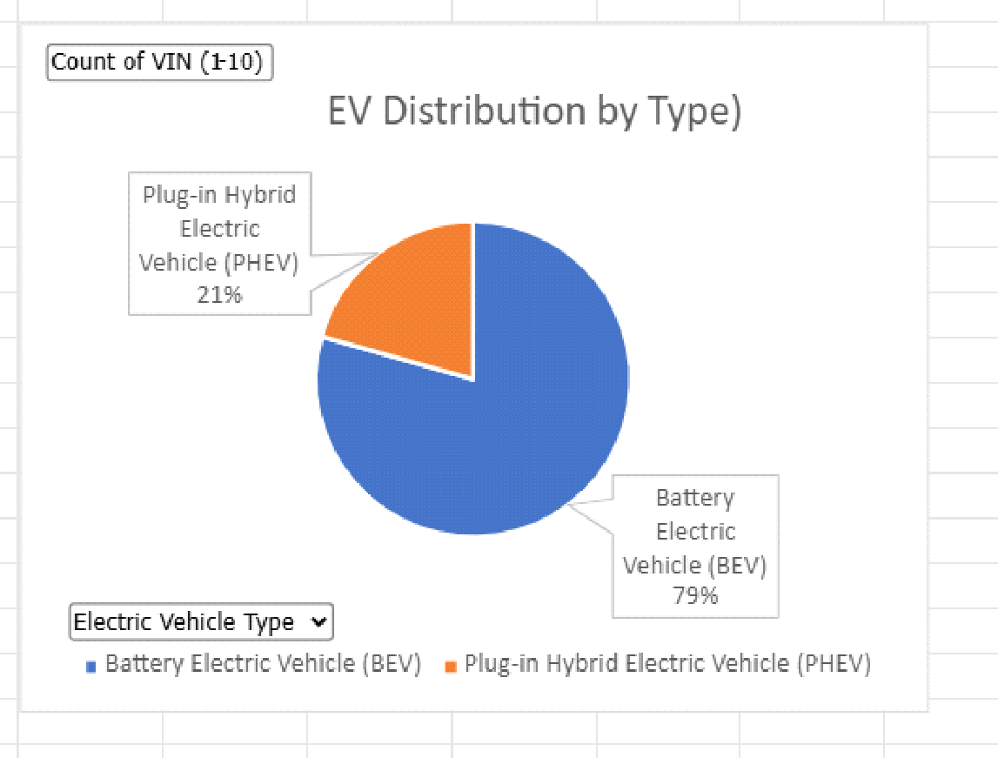

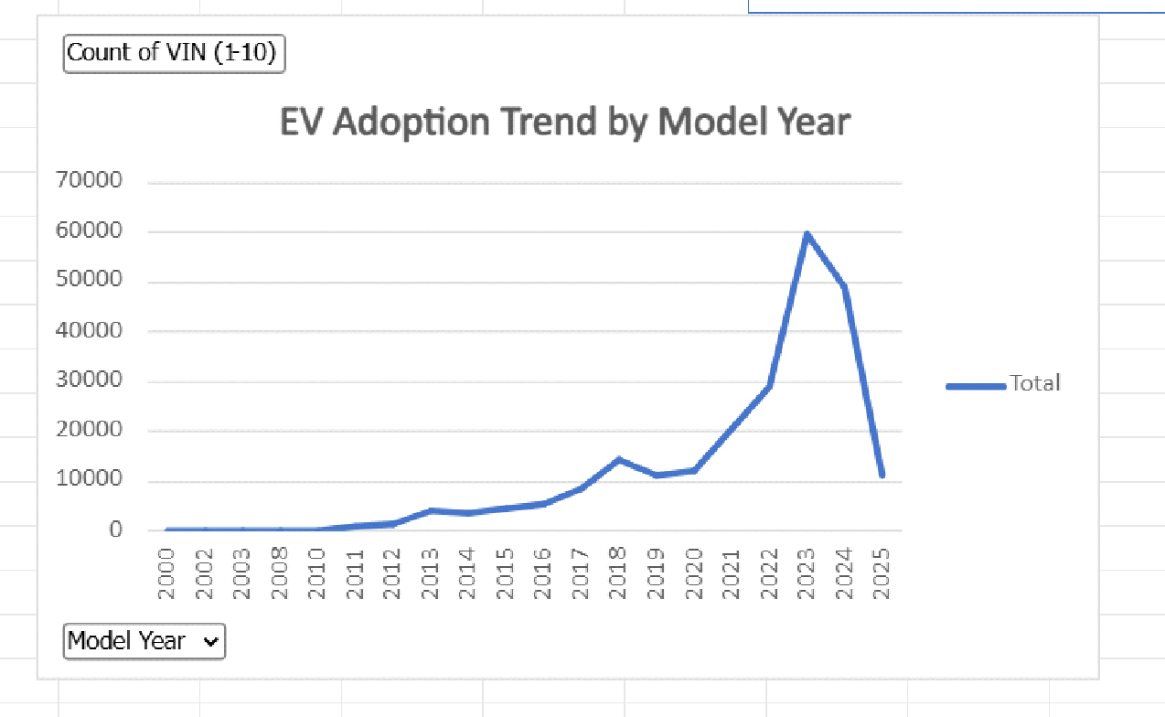

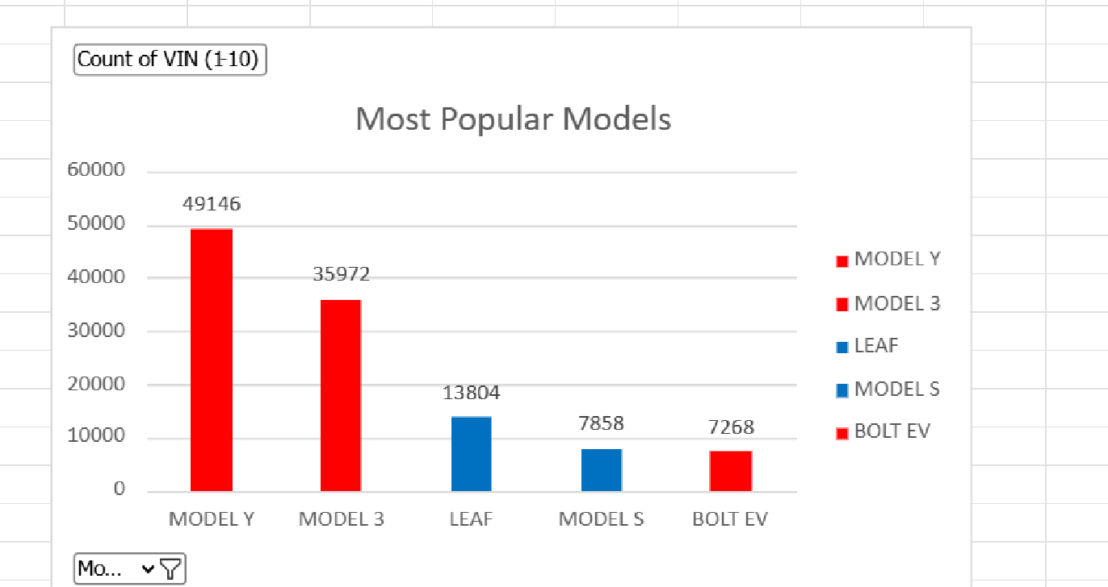



**CONCLUSION:**

The successful completion of the EV Market Dashboard project highlights the remarkable potential of Microsoft Excel in handling real-world datasets and generating meaningful business intelligence. Despite being a traditional spreadsheet tool, Excel's PivotTables, charts, and interactivity features were effectively leveraged to convert a static EV registration dataset into a dynamic and insightful dashboard.

This dashboard sheds light on several important trends in the electric vehicle ecosystem. Key findings include Tesla's market leadership, a higher share of Battery Electric Vehicles over Plug-in Hybrid models, and the concentration of EV ownership in counties like King and Snohomish. Additionally, analysis by model year reflects a clear surge in adoption post-2018—correlating with federal incentives and increasing environmental awareness.

Moreover, this project underscores the power of visual storytelling. Dashboards and slicers enable both novice users and data professionals to filter data intuitively, explore hypotheses, and derive actionable conclusions. The inclusion of a What-If scenario added predictive depth, demonstrating how simple models can simulate future trends and their implications on infrastructure planning.

Overall, this project serves as an intersection between data analytics, sustainable transportation, and decision support systems. It goes beyond academic learning and opens doors for applying similar techniques in public policy, automotive strategy, and environmental impact tracking. The skills developed here—from data wrangling to visualization—are critical in today's data-centric world.

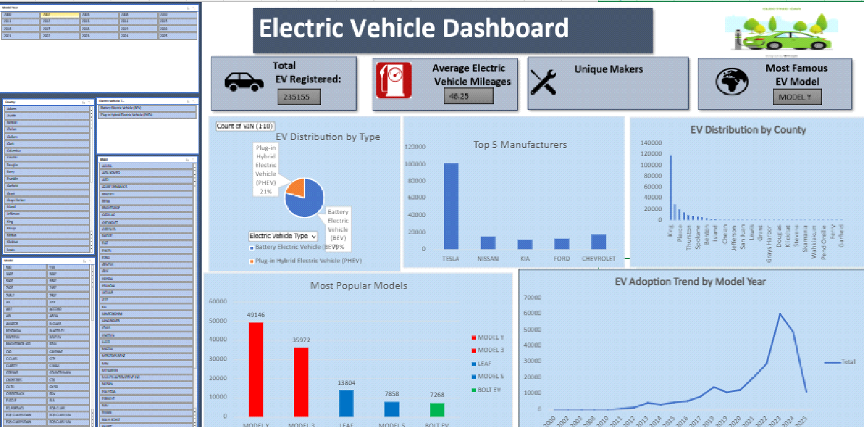

**6. FUTURE SCOPE**

The EV Market Dashboard, in its current form, provides a robust platform for insight generation. However, numerous enhancements can be implemented to increase its depth, scalability, and practical impact:

* Live Data Feeds & API Integration: By connecting the dashboard to APIs from governmental portals or dealership networks, live updates on EV registrations, trends, and pricing can be visualized in real time. This enables more agile decision-making.
* Migration to Advanced BI Platforms: Tools like Power BI or Tableau offer superior capabilities in terms of real-time collaboration, AI-powered analytics, geographical mapping, and high-resolution visuals. Migrating the dashboard will enable larger data handling and cloud-based deployment.
* EV Charging Network Analysis: Integration with datasets containing EV charging station locations and usage patterns can assist in identifying underserved regions, helping policymakers and businesses invest in infrastructure more strategically.
* Forecasting EV Growth & Demand: Using time series models or machine learning algorithms, one could build predictive dashboards that forecast demand by location, vehicle type, or time period. This is particularly useful for city planners, dealers, and utility companies.
* Environmental Impact Measurement: Adding CO₂ offset calculators and lifetime fuel savings comparisons can enhance the dashboard’s value as a sustainability assessment tool. This can also encourage user engagement and behavioral change.
* Behavioral Segmentation and RFM Modeling: Applying techniques like RFM (Recency, Frequency, Monetary) analysis or clustering can reveal segments within EV owners for targeted outreach or policy design.
* Mobile-Friendly & Multilingual Versions: Developing a mobile-optimized version of the dashboard in multiple languages can widen access for local administrations, field officers, and public users, making insights more inclusive.
* Automation & Scheduled Reporting: With the use of VBA in Excel or Power Automate in BI tools, the dashboard can be configured to send regular performance summaries, alerts for low inventory or registration dips, or monthly trend digests to stakeholders.
* Cross-Dataset Benchmarking: Combining this EV data with other related datasets—like fuel prices, household income, or air quality—can produce more holistic insights on the economic and social drivers of EV adoption.

By implementing these upgrades, the project can evolve into a full-scale analytics platform that supports electric vehicle adoption strategies at municipal, state, and national levels—positioning it as a vital tool in the transition toward greener transportation.

**7. REFERENCES**

* **Washington State Department of Licensing:** [**https://data.wa.gov**](https://data.wa.gov/)
* **Microsoft Excel Documentation:** [**https://support.microsoft.com/en-us/excel**](https://support.microsoft.com/en-us/excel)

**I would like to express my sincere thanks to my mentor, (Faculty Name), for guiding me with their valuable suggestions, constant support, and encouragement throughout the course of this project. I also extend my gratitude to the faculty at Lovely Professional University for their resources and support. Special thanks to my family and friends for their encouragement and motivation.**

**y sincere thanks to my mentor, (Faculty Name), for guiding me with their valuable suggestions, constant support, and encouragement throughout the course of this project. I also extend my gratitude to the faculty at Lovely Professional University for their resources and support. Special thanks to my family and friends for their encouragement and motivation.**

**ACKNOWLEDGEMENT**

**I would like to express my sincere thanks to my mentor, (Faculty Name), for guiding me with their valuable suggestions, constant support, and encouragement throughout the course of this project. I also extend my gratitude to the faculty at Lovely Professional University for their resources and support. Special thanks to my family and friends for their encouragement and motivation.**

**ACKNOWLEDGEMENT**

**I would like to express my sincere thanks to my mentor, (Faculty Name), for guiding me with their valuable suggestions, constant support, and encouragement throughout the course of this project. I also extend my gratitude to the faculty at Lovely Professional University for their resources and support. Special thanks to my family and friends for their encouragement and motivation.**

**ACKNOWLEDGEMENT**

**I would like to express my sincere thanks to my mentor, (Faculty Name), for guiding me with their valuable suggestions, constant support, and encouragement throughout the course of this project. I also extend my gratitude to the faculty at Lovely Professional University for their resources and support. Special thanks to my family and friends for their encouragement and motivation.**

**ACKNOWLEDGEMENT**

**I would like to express my sincere thanks to my mentor, (Faculty Name), for guiding me with their valuable suggestions, constant support, and encouragement throughout the course of this project. I also extend my gratitude to the faculty at Lovely Professional University for their resources and support. Special thanks to my family and friends for their encouragement and motivation.**

**ACKNOWLEDGEMENT**

**I would like to express my sincere thanks to my mentor, (Faculty Name), for guiding me with their valuable suggestions, constant support, and encouragement throughout the course of this project. I also extend my gratitude to the faculty at Lovely Professional University for their resources and support. Special thanks to my family and friends for their encouragement and motiv**

**ACKNOWLEDGEMENT**

**I would like to express my sincere thanks to my mentor, (Faculty Name), for guiding me with their valuable suggestions, constant support, and encouragement throughout the course of this project. I also extend my gratitude to the faculty at Lovely Professional University for their resources and support. Special thanks to my family and friends for their encouragement and motivation.**

**ACKNOACKNOWLEDGEMENT**

**I would like to express my sincere thanks to my mentor, (Faculty Name), for guiding me with their valuable suggestions, constant support, and encouragement throughout the course of this project. I also extend my gratitude to the faculty at Lovely Professional University for their resources and support. Special thanks to my family and friends for their encouragement and motivation.**

**ACKNOWLEDGEMENT**

**I would like to express my sincere thanks to my mentor, (Faculty Name), for guiding me with their valuable suggestions, constant support, and encouragement throughout the course of this project. I also extend my gratitude to the faculty at Lovely Professional University for their resources and support. Special thanks to my family and friends for their encouragement and motivation.**

**WLEDGEMENT**

**I would like to express my sincere thanks to my mentor, (Faculty Name), for guiding me with their valuable suggestions, constant support, and encouragement throughout the course of this project. I also extend my gratitude to the faculty at Lovely Professional University for their resources and support. Special thanks to my family and friends for their encouragement and motivation.**