GenAI Assignment
Name: Yashmitha Shailesh
SRN: PES2UG23CS715
Section: K
EmailID: yashmithashailesh@gmail.com
Mobile number: 8618764905
Github link: https://github.com/yashmithaa/Genai

Assignment 1
Experiment 1: Text Generation
Task: Try to generate text using the prompt: "Once upon a time"
Observations:
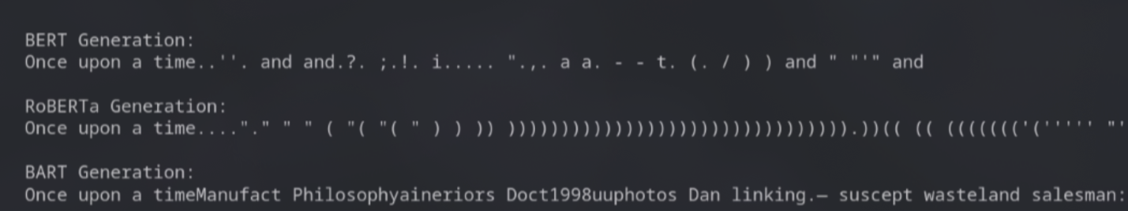
Experiment 2: Masked Language Modeling (Missing Word)
Task: Predict the missing word in: "The goal of Generative AI is to [MASK] new content."
Observations:
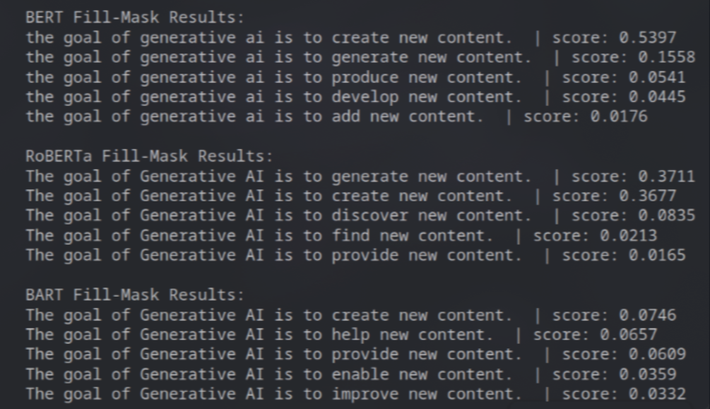
Experiment 3: Question Answering
Task: Answer the question "What are the risks?" based on the context: "Generative AI poses significant risks such as hallucinations, bias, and deepfakes."
Observations:
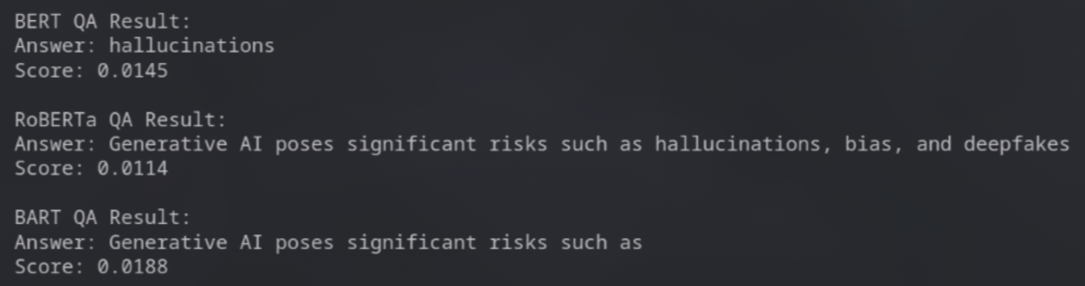
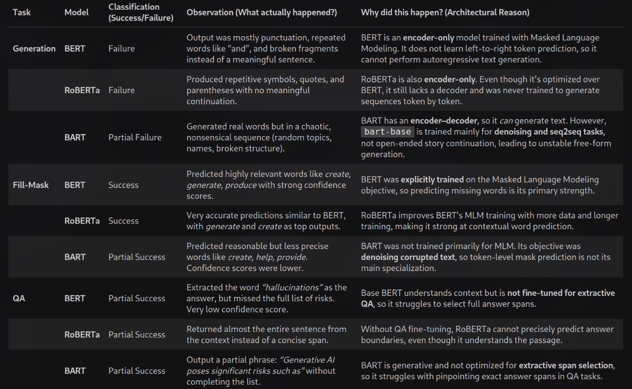
Key concepts understood
- Transformer families and capabilities:
  - Encoder-only (BERT, RoBERTa): strong at masked token prediction, poor for autoregressive generation.
  - Encoder–decoder (BART): suited for seq2seq/denoising tasks and can generate, but not necessarily optimal for open-ended autoregressive continuation without proper fine-tuning.
  - Hugging Face pipelines: quick way to run tasks (text-generation, fill-mask, question-answering) with minimal boilerplate.
- Task-model alignment: models must match task objectives (e.g., MLM models for fill-mask; decoder/generative models for text generation).
- Evaluation: qualitative checks (success/failure), inspect outputs and confidence scores, and reason about architectural causes for failures.
The solution implemented
- bert-base-uncased, roberta-base, facebook/bart-base used to compare behaviors across tasks.
- Pipelines initialized

  - Text generation pipelines for each model (attempted autoregressive generation).
  - Fill-mask pipelines for MLM-style prediction.
  - Question-answering pipelines for extractive QA.
- Experiments performed
  - Text generation: same prompt ("Once upon a time") used to observe each model’s ability to continue text; used sampling, temperature, top-p and penalties.
  - Fill-mask: masked sentences formatted per model conventions and top predictions inspected.
  - QA: simple context+question to test extractive span selection; answer and score displayed.
- Observations / outcomes (brief)
  - BERT / RoBERTa: fail at open-ended generation; successful at fill-mask.
  - BART: partial generation ability but unstable for free-form continuation; moderate fill-mask performance.
  - QA with base checkpoints: partial/low-quality extractive answers because base models were not fine-tuned for QA.

Assignment 2
Medical symptom checker
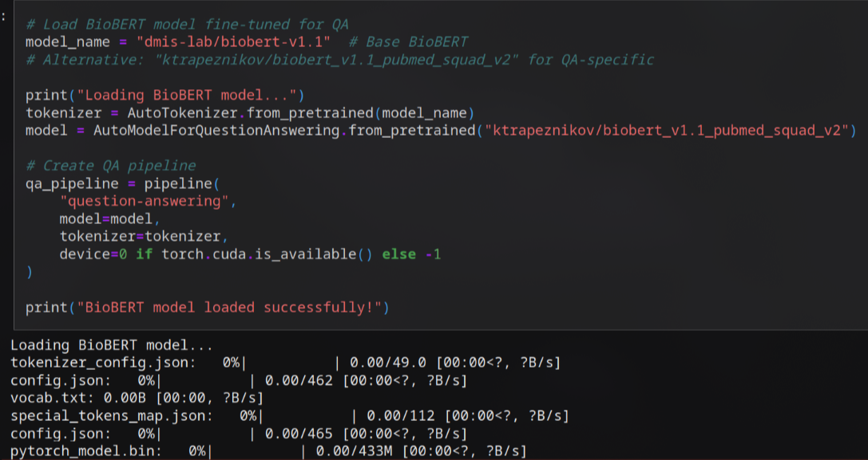
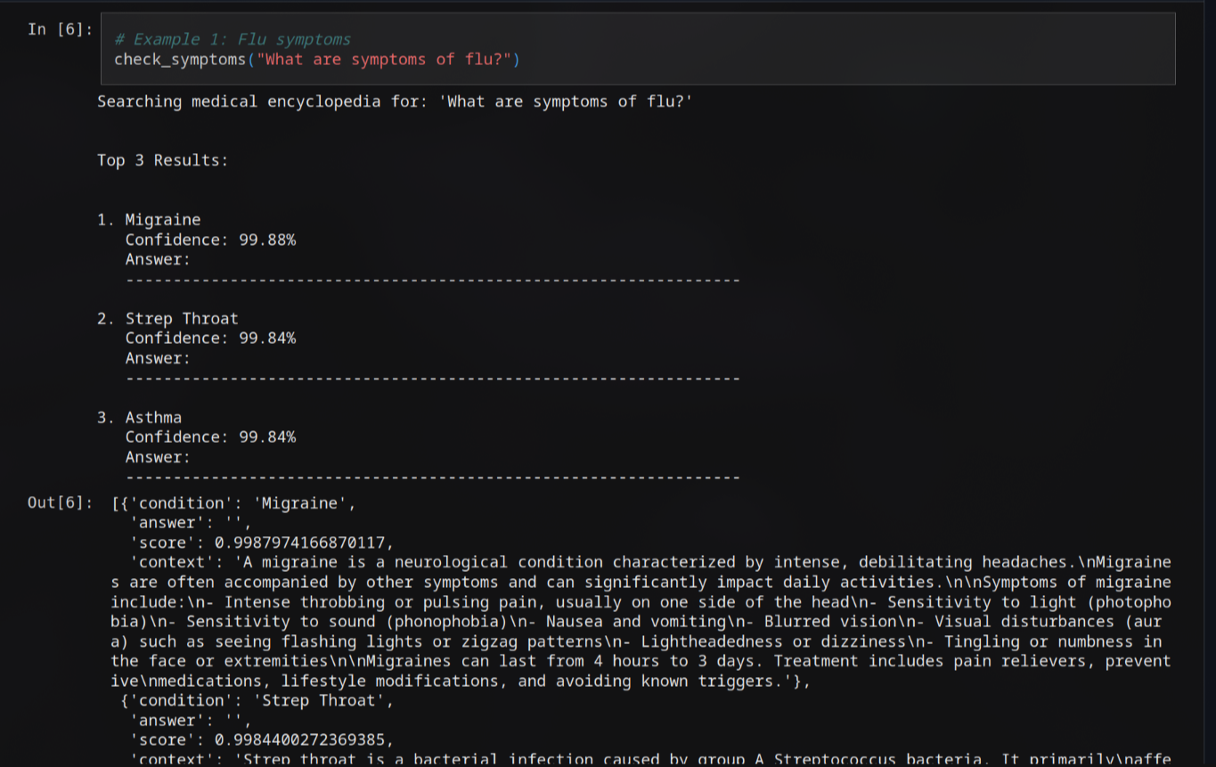
Key concepts understood
- Pretrained domain models: BioBERT (biomedical pretraining) used to improve medical-text understanding.
- Extractive QA behavior: model returns answer span, score (confidence), and handles impossible/no-answer cases.
- Result filtering and ranking: apply minimum score threshold and sort by confidence to produce top-K candidates.
- Safety & limitations: model outputs are probabilistic and not medical advice; include a disclaimer and encourage professional consultation.
The solution implemented
- Tokenizer loaded from a base BioBERT checkpoint.
  - QA model loaded from a BioBERT checkpoint fine-tuned for SQuAD-style QA ("ktrapeznikov/biobert_v1.1_pubmed_squad_v2").
  - Creates a QA pipeline with device selected automatically.
- Medical knowledge source
  - Builds MEDICAL_ENCYCLOPEDIA: mapping of condition name → description/context.
- Symptom-checking workflow (check_symptoms)
  - Accepts a natural-language question, top_k, and min_score.
  - Iterates all conditions, runs the QA pipeline using each condition's context.
  - Keeps answers above min_score and records condition, answer, score, and context.
  - Sorts results by confidence and prints the top-K formatted results.
  - Returns the top-K results programmatically.
  - Detail extraction (get_condition_details)

