Launch-Blind Product Viability Estimation from Specifications via LLM Aspect Bridging
Rajvardhan Ajitrao Jagtap, Jyotiraditya Abhijeet Shinde, Tanishq Parag Choudhari,
Yash Ashok Mohite, Yogesh Malakari Honamore
Department of Computer Science and Engineering
Rajarambapu Institute of Technology, Rajaramnagar, Sangli, Maharashtra, India
Index Terms—Product success prediction, aspect-based sentiment
analysis, large language models, gradient boosting, pre-launch
analytics, electronic word of mouth.

Abstract—A product team commits its manufacturing budget long before consumer feedback exists, yet conventional e-commerce predictive methods require post-launch reviews, star ratings, or sales velocity. We formulate pre-launch product viability estimation as a launch-blind task using launch-available technical specifications, category, price, and brand tier. LaunchSight extracts aspect-level sentiment from 43,599 historical reviews across 640 initially collected physical products (631 retained after automated review-fraud filtering), then uses a skeptic-prompted bridging layer and a monotonic-constrained XGBoost regressor. On the retrained holdout, 118 products were successfully evaluated after the held-out set was removed before retraining; Spearman ρ = 0.529 (95% CI [0.377, 0.654], p < 10⁻⁹) and AUC = 0.903. The extended temporal evaluation uses an 80/20 launch-date split and covers 126 test products, with 125 successfully evaluated, giving ρ = 0.590 (95% CI [0.464, 0.692]) and AUC = 0.942, although mean within-category ρ is only about 0.16. The first-generation frozen holdout (n = 59, ρ = 0.317) was drawn from an earlier six-category collection and does not carry over to the final corpus (n = 41, ρ = 0.280, p = 0.076). Price is withheld from the LLM and handled downstream through deterministic value-for-money plus a monotone price feature; within-category price percentile alone correlates with success at only ρ = 0.147. The method is bounded by category specification expressiveness: ice makers show bridging fidelity r ≈ 0.04. The system reports reliability-weighted confidence, measured trust tiers, and uncalibrated runtime abstention.

I. INTRODUCTION
Large companies get to evaluate a prospective product with a market-research department, paid consumer panels, and analytics bought at a price a small firm cannot match. A small business or an independent maker has none of it. The call to manufacture a wireless headphone or a countertop appliance usually comes down to intuition, a look at the competition, and hope. Being wrong is not an abstraction: a single unsold inventory run can finish a small firm. Consumers absorb part of the cost too, paying for things that break, underwhelm, or were never really built for what they needed. This paper is an attempt to close some of that gap. We wanted to hand a business with no expensive market-intelligence stack an affordable, evidence-based read on whether a design is likely to satisfy its market before the money is spent building it, so that more of what gets made is worth what people pay for it.
The obstacle is structural, not incidental. Decades of research connect online reviews and electronic word of mouth (e-WOM) to sales and market outcomes [1–4], and today's sentiment pipelines extract strikingly fine-grained signal from review text [5–7]. All of it feeds on post-launch data. Yet at the one moment the decision actually matters, before anything is produced, there are no reviews, no ratings, and no sales to feed on. What exists is the specification and whatever the category has already taught us.
Our question is whether that is enough to work with. The idea we build on is aspect bridging. From a corpus of 43,599 customer reviews across 640 products (yielding 32,477 catalog extraction rows and 29,410 validated aspect extractions across 631 retained products), we first learn how consumers in a given category rate products along interpretable quality aspects (build quality, ease of use, value for money, and the rest), and how those profiles line up with eventual success. We then put a large language model in the seat of a skeptical market analyst, ground it in per-category statistics, and have it estimate the aspect profile an unseen product would earn from its specification alone. That estimate feeds the trained success model, which returns a launch-blind viability figure along with per-aspect explanations, trust tiers we have actually measured, and a flat refusal to answer when the specification says too little.
A tool that informs real money has to be validated like one, so our main contribution is methodological. The evaluation is launch-blind: each real product is re-judged from what was knowable on the day it launched, and the prediction is checked against the later outcome. We run two out-of-sample tests.
C1. A null-forcing aspect-extraction scheme across 32,477 catalog extraction rows (spanning 29,410 matched customer reviews from the 43,599-review corpus): the LLM may score an aspect only when the review gives verbatim evidence for it, never by inference, backed by typed validation and a crash-safe multi-provider pipeline.

C2. The bridging layer, a skeptic-prompted and category-grounded LLM estimator that maps launch-available product specifications into projected aspect profiles, with absence penalties, grounding flags, and anchor discipline.

C3. Three out-of-sample evaluations—a predefined frozen holdout (n = 59, ρ = 0.317, p = 0.014, AUC = 0.743; first-generation, earlier six-category data), a retrained holdout (n = 118 successfully evaluated, ρ = 0.529, p < 10⁻⁹, AUC = 0.903), and an extended forward-in-time evaluation on an 80/20 launch-date split (n = 125 successfully evaluated of 126 test products, ρ = 0.590, AUC = 0.942, mean within-category ρ ≈ 0.16).

C4. An empirical evaluation of scope—which aspects a specification can predict and which it cannot—together with a diagnosed boundary condition: predictive validity tracks how well a category's specifications encode experiential quality.

C5. An interpretability and governance layer—reliability-weighted confidence heuristics, empirical aspect trust tiers, and uncalibrated runtime abstention—integrated into a decision-support application that presents its measured limitations directly to the user.
II. RELATED WORK
A. Reviews, e-WOM, and Market Outcomes
That online opinion moves markets is not in dispute. Chevalier and Mayzlin showed review valence shifting book sales from one retailer to another [1]; Dellarocas cast digitized word of mouth as a new kind of economic feedback [3]; Chintagunta et al. tied user reviews to box-office trajectories [2]; and Luca put a revenue figure on Yelp ratings [4]. Nearer to our own feature level, Archak et al. found that aspect-level content carries pricing power the star rating alone does not [8], Ghose and Ipeirotis connected review-text characteristics to economic impact [10], and Mudambi and Schuff asked what makes a review helpful in the first place [11]. Social-media signals have been read the same way to forecast outcomes [9]. Every one of these works after the fact. The nearest thing to our goal is Narayanan et al., who predict reception from pre-release chatter about an announced product [12]; our setting is harder still, since we assume no product-specific chatter exists at all, only the specification and the category's history.
Review streams are also adversarial. Opinion spam goes back to Jindal and Liu [13], convincing fake reviews can be written to order [15], and the incentive to manipulate them is plain [14]. The corpus-level fraud filter in the Data section is our response to this line of work.
B. Aspect-Based Sentiment Analysis
Aspect-based sentiment analysis (ABSA) started with frequency- and lexicon-based aspect mining [16, 18], was given a common benchmark by SemEval-2014 [19], and has since been carried mostly by neural methods, surveyed in [7]. The machinery keeps improving—multi-feature fusion graph attention networks [6], curriculum-learning hybrids [17], transformer pipelines for bilingual e-commerce satisfaction [5], multi-source sentiment fusion [20]. Our difference is one of purpose, not architecture. We use ABSA as a measurement instrument: it turns unstructured reviews into a per-product aspect profile that then becomes the input to

supervised learning, and we hold it to a null-forcing, evidence-quoting discipline meant for downstream trustworthiness rather than benchmark accuracy.
C. LLMs as Extractors and Estimators
Transformer language models [23, 32], scaled up into instruction-following generalists [22, 24, 28, 29, 31], now label text about as reliably as a human crowd [25] and turn up more and more as zero-shot parts of e-commerce pipelines—product classification [30], description generation from reviews [26], numeric value prediction in industrial systems [27]. Reasoning-eliciting prompting [33] and the wider foundation-model programme [21] treat LLMs as general-purpose estimators. Our bridging layer belongs to this line but joins two disciplines that are seldom tested together: a built-in skepticism toward adversarial input, because marketing copy is written to sound good for flops and hits alike, and launch-blind outcome validation, which holds the LLM's estimates up against the market reality that actually followed.
D. Gradient Boosting for Tabular Prediction
For tabular product features, gradient-boosted trees [35, 38, 41] remain the standard baseline, ahead of both classic ensembles [34] and neural alternatives, and they show up across e-commerce supply chains [44], sentiment-augmented financial forecasting [45, 46], and multi-criteria recommendation [43]. We chose XGBoost for two reasons in particular: it handles missing values natively, so an unmentioned aspect stays missing rather than being imputed, and it pairs with SHAP attributions [42] that turn a prediction 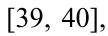into an explanation in terms of design levers. Our data infrastructure rests on the Amazon reviews corpora [39, 40], and we put confidence intervals on results with the bootstrap [37]. One further link is worth naming: our insistence that the interface show the model's limits echoes a recent argument from the management literature that AI-assisted decisions need calibrated human autonomy [36].
III. DATA AND PROBLEM FORMULATION
The corpus comes from the Amazon Reviews 2023 dataset [40], filtered to five physical product categories: wireless headphones (138 products), Bluetooth speakers (136), smartwatches (116), power banks (103), and ice makers (147). From an initial collection of 640 products and 43,599 customer reviews, automated fraud filtering excluded 9 products (6 for unnatural review bursts and 3 for extreme J-shaped rating distributions; the near-duplicate rule flagged none), retaining 631 clean products with 43,472 customer reviews (median 47 reviews per product, interquartile range 21–74.5; reviews are capped at 300 per product). Retained products per category: headphones 138, ice makers 145, speakers 135, smartwatches 114, power banks 99. Across the corpus, aspect-level sentiment extraction yielded 29,410 matched reviews (67.5% review-level coverage, spanning 100% of retained products). In total, 32,477 extraction rows are aggregated across the 640 catalog products (32,353 across the 631 retained products) to build the product feature matrix. Pre-launch specifications were scraped from manufacturer catalog fields.
Because review streams can be gamed [13, 14], we ran a fraud filter before any label was computed. A product was flagged when more than 40% of its sampled reviews landed inside a single 14-day window, when its rating distribution was extreme-J-shaped, or when more than 30% of its reviews were near-duplicates (Jaccard > 0.7 on word sets). Nine products tripped the filter (six on the burst rule and three on the J-shape rule), leaving 631 for training.
The regression target is a within-category composite, SuccessScore = 100 × (0.40 × Volume_norm + 0.35 × Rating_norm + 0.25 × Velocity_norm), with each component min–max normalized inside its own category and log(1+x) applied to heavy-tailed counts. Normalizing within category is essential: 500 reviews convey different commercial traction for an appliance versus a pair of wireless earbuds. To evaluate sensitivity to composite weights, we compared the baseline 40/35/25 weighting against three alternative formulations: volume-heavy (50/30/20), rating-heavy (30/40/30), and equal-weight (33/33/33). Across all 631 retained products, the Spearman rank correlations between product rankings produced by these alternative target formulations and the baseline ranking are ρ = 0.9923, 0.9887, and 0.9958, respectively. These high correlations confirm the numerical stability of the ground-truth target ranking across formulation choices rather than representing predictive model accuracy.
Survivorship disclosure. The five-review floor keeps the corpus focused on products with observable market engagement; consequently, bottom-quintile denotes relative underperformance among observed market survivors rather than absolute commercial failure without customer attention. Among retained products, lifetime rating counts have a minimum of 97, a 10th percentile of 317, and a median of 5,177, so even the least-rated retained products had drawn real market attention.
IV. METHODOLOGY
A. Aspect Extraction
Each review is broken into aspect-level sentiment against a frozen schema of nine aspects: six shared consumer aspects (value for money, utility, ease of use, reliability, design appeal, after-sales) and three physical-product aspects (build quality, durability, repairability). The prompt is null-forcing by design. An aspect earns a score (0–10) only if the review actually discusses it; every non-null score must quote a verbatim phrase from the review as evidence; and the star rating is given as context but banned as a source of scores. A review that praises only sound quality comes back with null for durability, because the silence is information and we will not invent around it. Every output is checked against a typed schema. An invalid response is retried once with the error appended, then handed to the next provider, and on a third failure the review is logged and skipped, so one bad response can never stall a batch that runs for days. Extraction produced 32,477 aspect extraction records from the 43,599-review corpus (yielding 29,410 matched review-aspect pairs across the 631 retained products after quality filtering) on a multi-provider cloud pool (Gemini Flash, Groq Llama-3.3-70B, Cerebras, Mistral, and SambaNova) with per-key rate tracking, append-only crash-safe logging, and resume support; we tried a local model too but dropped it after a quality audit. Ahead of the full run, a 30-review hand-validation gate confirmed that unmentioned aspects came back null and that each evidence phrase really did appear in its review.

B. Success Models and Algorithm Selection
Product-level features roll the extraction stream up into a mean score and a mention rate per aspect. An unmentioned aspect stays missing rather than imputed, which XGBoost handles natively. On top of these we add launch-available metadata: price, a brand-recognition tier, and category indicators. The regressors are gradient-boosted (600 estimators, depth 5, learning rate 0.05, seed 42) under 5-fold cross-validation. Each review aspect and the brand tier is constrained non-decreasing (+1), while price is constrained non-increasing (-1). The production headline model achieves cross-validation R² = 0.595 ± 0.030 (RMSE = 11.17, MAE = 8.65), compared to an unconstrained variant (CV R² = 0.616 ± 0.048, RMSE = 10.86, MAE = 8.43) and the full leaky metadata ceiling (CV R² = 0.892, RMSE = 5.76, MAE = 4.34). When early stopping is evaluated on an inner training split (leaving outer validation folds strictly untouched), cross-validated R² is 0.570 (constrained) and 0.578 (unconstrained). The headline model removes average rating, rating count, and review velocity while retaining price, brand tier, category, and LLM-derived aspect features.
In prompt v2, price is withheld from the LLM and handled downstream through deterministic value-for-money plus a monotone price feature.
Algorithm selection. We benchmarked six algorithms under identical 5-fold cross-validation on the standardized feature set used by the benchmark script: LLM-derived aspect means and mention rates plus brand tier, with price and category excluded and missing aspect values filled with zero for every model. To eliminate evaluation leakage, classification decision thresholds were derived strictly from training folds (median of training success scores), top/bottom quintiles were established on training folds, and early stopping for XGBoost used an inner 85/15 training split. Under this strict leakage-free protocol, Gradient Boosting and XGBoost lead the benchmark with R² = 0.558 and R² = 0.550 (RMSE 11.6 and 11.8), while achieving top-vs-bottom discrimination AUC of 0.980 and 0.978 (Accuracy 92.2% and 91.9%, F1 0.924 and 0.917; Table 1). These values evaluate an aspect-derived feature set and are distinct from the headline production model which incorporates launch price and category priors (cross-validated R² = 0.595).
Accuracy aside, three features of this particular problem play to XGBoost's strengths. One is native missing-value handling. Aspect scores go structurally missing whenever a review skips an aspect, and XGBoost learns a split direction for the missing entries with no imputation [35], where Ridge and SVR would need a fill strategy that only adds noise. Another is native categorical support: the category feature goes in directly through the enable_categorical flag, with no one-hot encoding, so the histogram learner keeps the structure it can use. The third is SHAP compatibility. TreeExplainer [42] returns exact, polynomial-time Shapley values for tree ensembles, and those drive the per-prediction risk and strength explanations the application shows (the System section); kernel SHAP on an MLP or an SVR is approximate and slower by orders of magnitude.
Table 1. Algorithm comparison on standardized benchmark features (LLM-derived aspect means/mention rates + brand tier; price and category excluded; missing values filled with 0), n=631, 5-fold CV, seed 42. R²/RMSE are primary regression metrics; classification metrics use top- vs. bottom-quintile products.
classification metrics are derived by binarizing at the top- vs. bottom-quintile and strictly thresholding predictions at the median of the training-fold target values (thresh = median(y_train)), ensuring a completely leakage-free benchmark. Best value per metric in bold.
Algorithm | R² | RMSE | Acc. | Prec. | Rec. | Spec. | F1 | AUC | MCC
XGBoost | .550 | 11.8 | .919 | .899 | .941 | .880 | .917 | .978 | .835
Grad. Boosting | .558 | 11.6 | .922 | .908 | .943 | .886 | .924 | .980 | .840
Random Forest | .520 | 12.1 | .918 | .887 | .959 | .864 | .921 | .970 | .834
MLP Regr. | .493 | 12.5 | .902 | .878 | .923 | .880 | .898 | .968 | .803
Ridge Regr. | .464 | 12.8 | .914 | .901 | .914 | .914 | .906 | .958 | .826
SVR (RBF) | .432 | 13.2 | .898 | .905 | .890 | .911 | .896 | .958 | .796
Fig. 1 lays all seven evaluation metrics out together across the standardized benchmark. Because the target is a continuous success score, regression metrics take precedence: Gradient Boosting achieves the leading predictive accuracy (R² = 0.558, RMSE = 11.61), while XGBoost delivers nearly identical accuracy (R² = 0.550, RMSE = 11.75) with over three times faster training efficiency (0.35s vs. 1.25s). Both tree-based ensemble methods achieve superior classification separation on extreme quintiles (AUC = 0.980 for Gradient Boosting, 0.978 for XGBoost). The aggregated confusion matrices in Fig. 4 confirm that Gradient Boosting (92.2%), XGBoost (91.9%), and Random Forest (91.8%) all surpass 91% accuracy at differentiating eventual market hits from flops under strict training-derived decision thresholds.

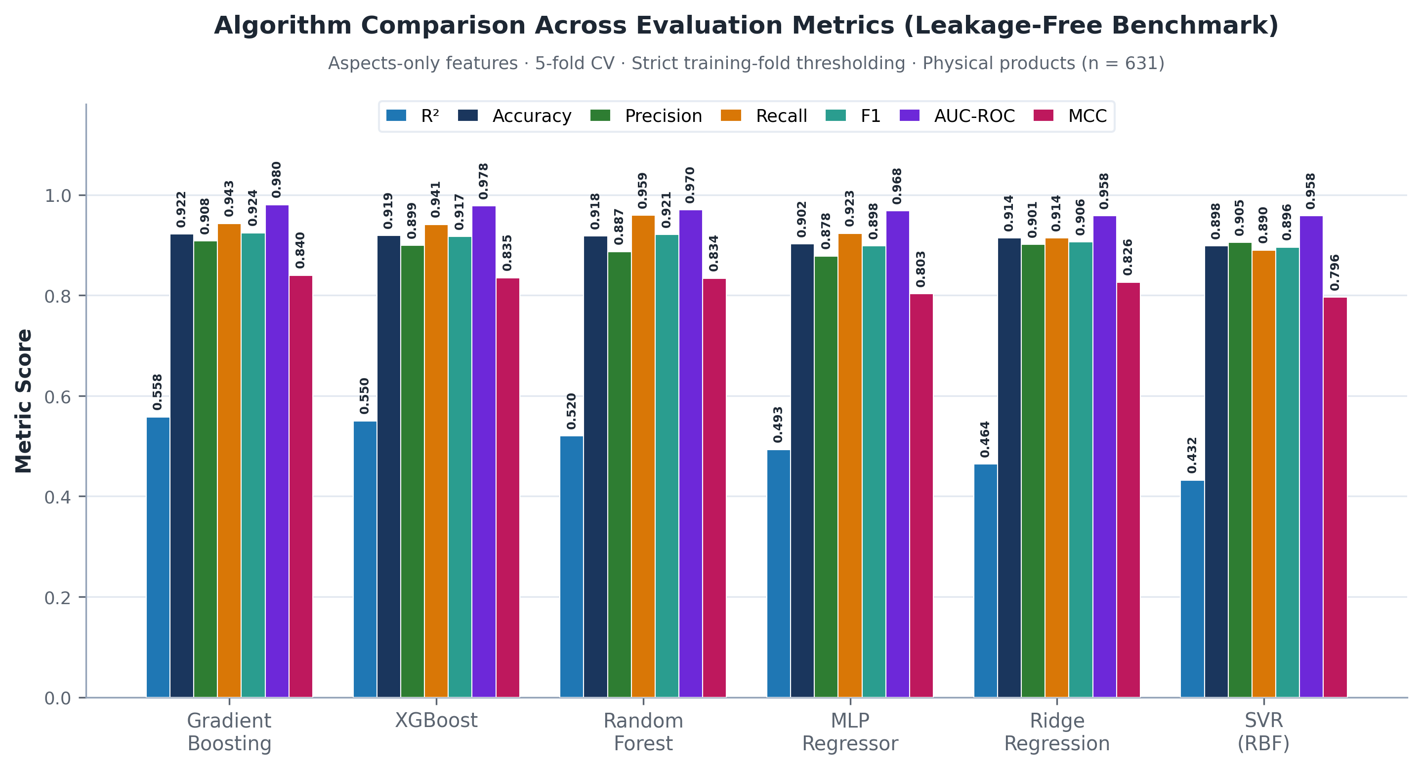
Figure 1. All evaluation metrics across six algorithms on the standardized benchmark feature set (LLM-derived aspect means/mention rates + brand tier; price and category excluded; 5-fold CV, n=631). Metrics: R², Accuracy, Precision, Recall, F1, AUC-ROC, MCC.
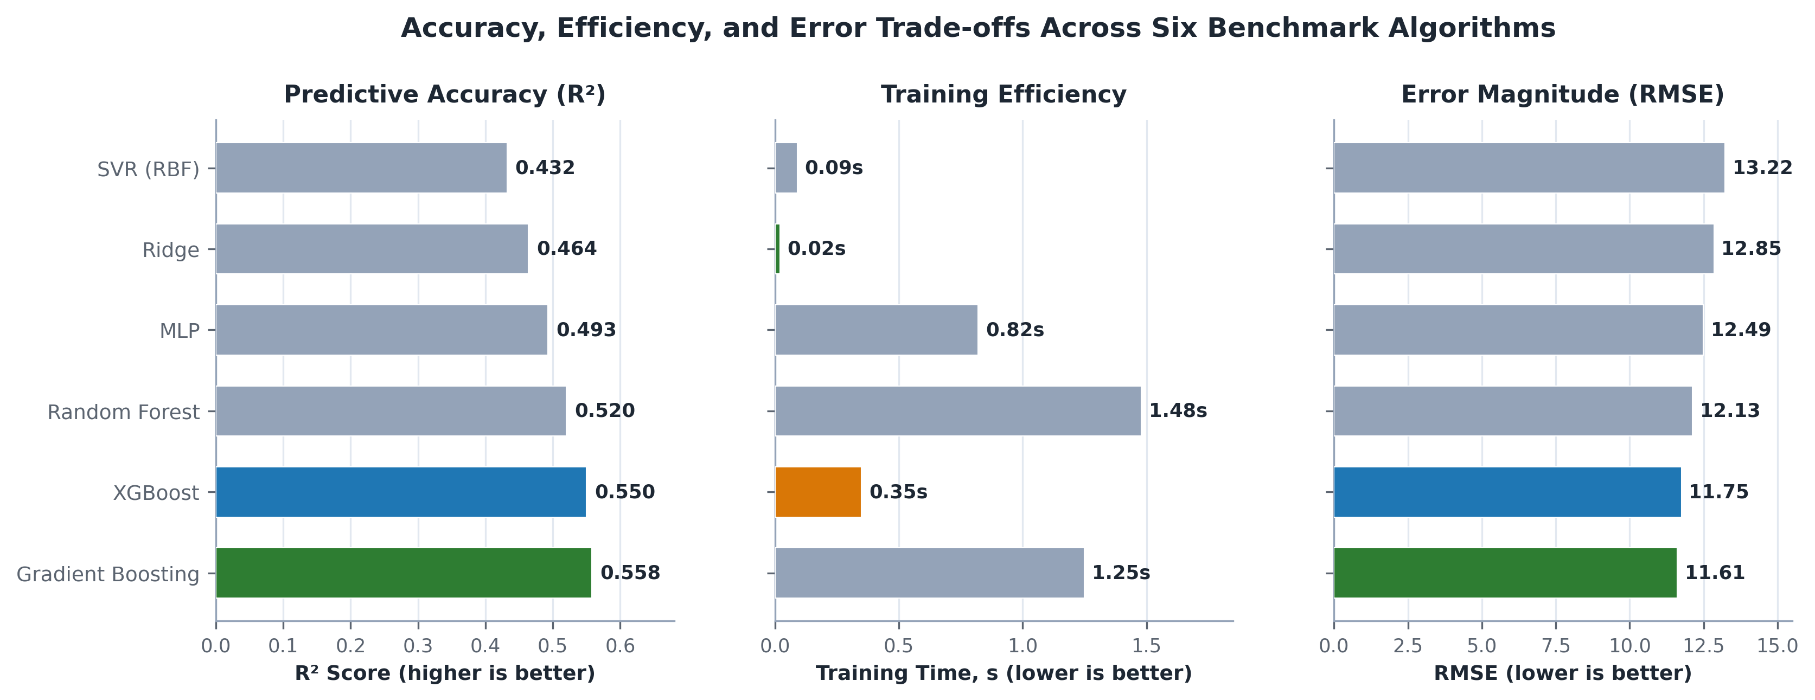
Figure 2. Three-panel accuracy–efficiency trade-off: predictive accuracy (R²), training time, and error magnitude (RMSE). Gradient Boosting and XGBoost achieve the leading accuracy–error frontier, with XGBoost offering over three times faster training efficiency.
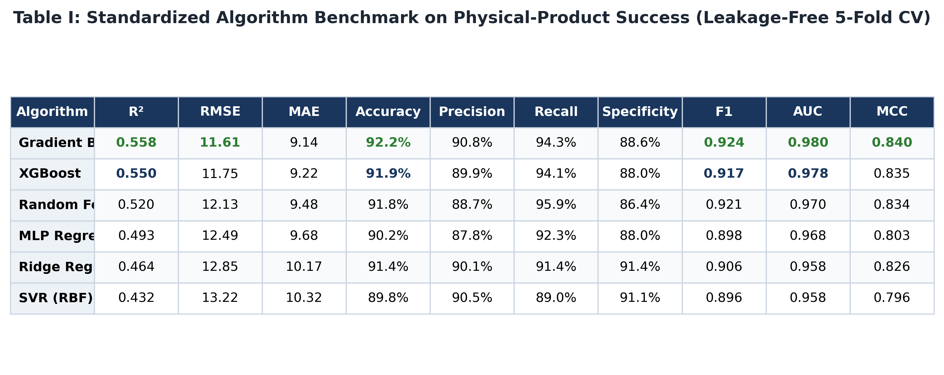
Figure 3. Standardized algorithm benchmark across six algorithms on LLM-derived aspect means/mention rates + brand tier (price and category excluded).

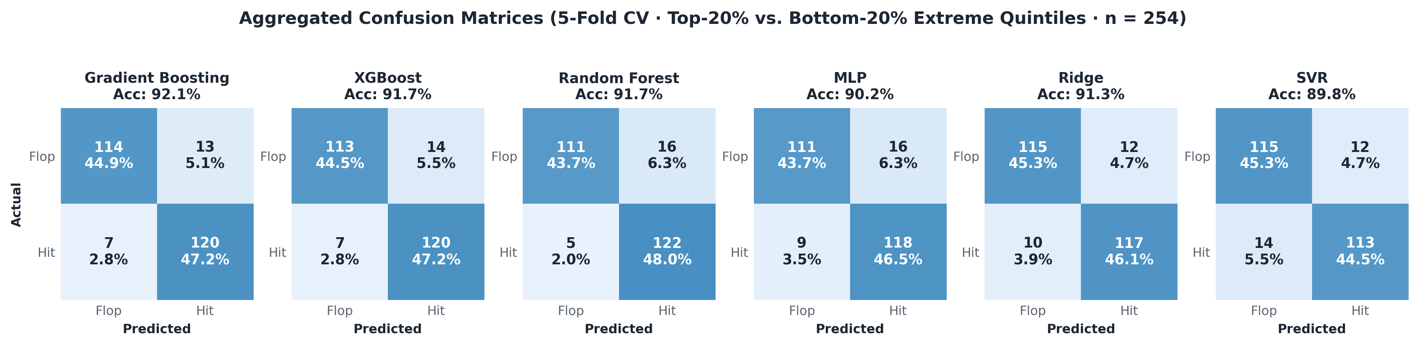
Figure 4. Aggregated confusion matrices (5-fold CV, top-20% vs. bottom-20% products; 254 pooled extreme-quintile products). Counts and percentages for each quadrant: true negatives (flops correctly identified), false positives, false negatives, and true positives (hits correctly identified).
C. Bridging: Estimating Aspects from Specifications
The bridging layer asks an LLM for the aspect profile a product would earn after months of real use, given nothing but its specification and a category profile: price quartiles, mean aspect scores, and the leading pain points and strengths mined from real reviews. Our first prompt believed what it read, and it failed in an instructive way. Marketing copy is optimistic by construction, selling flops and hits with equal conviction, and the predictions bunched into a narrow, rosy band. The production prompt runs on three rules of skepticism. Under adjective blindness, only verifiable facts justify a score—materials, standards, numbers, warranty terms: "powerful bass" is noise, while "50 mm drivers" is evidence. Under the absence rule, a spec that offers no concrete evidence for an aspect is itself the signal, since a competent team states its strengths, so the aspect is scored below the category mean and flagged as ungrounded. Under anchor discipline, the category mean is whatever the median real product achieves, and any score more than two points above it has to point to a fact in the spec.
D. The Interpretability and Governance Layer
Some aspects bridge more reliably than others, and rather than hide that, the system measures it directly and acts on it. For each aspect we compute the correlation between the bridged estimate and the review-derived ground truth across all bridged products (the Validation section), which gives an empirical fidelity weight per aspect. A prediction's confidence is then a reliability-weighted grounded fraction: each aspect adds to confidence in proportion to how well it actually bridges, so aspects a spec cannot convey 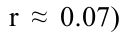(after-sales, r ≈ 0.07) no longer move confidence, while the high-fidelity ones (utility, durability, ease of use, build quality, reliability, all r ≈ 0.5) carry it. The same measurement sets each aspect's trust badge: STRONG (utility, ease of use, build quality, durability, reliability), MODERATE (value for money, repairability), or WEAK (design appeal, after-sales). When confidence drops below a warning threshold, the interface says outright that the estimate is leaning on category averages; below a lower threshold it hides the number entirely and sends the user to the spec coach. The headline viability is rank-calibrated onto a readable 0–100 scale against a reference distribution of real products, and shown as a range rather than a false-precision decimal.
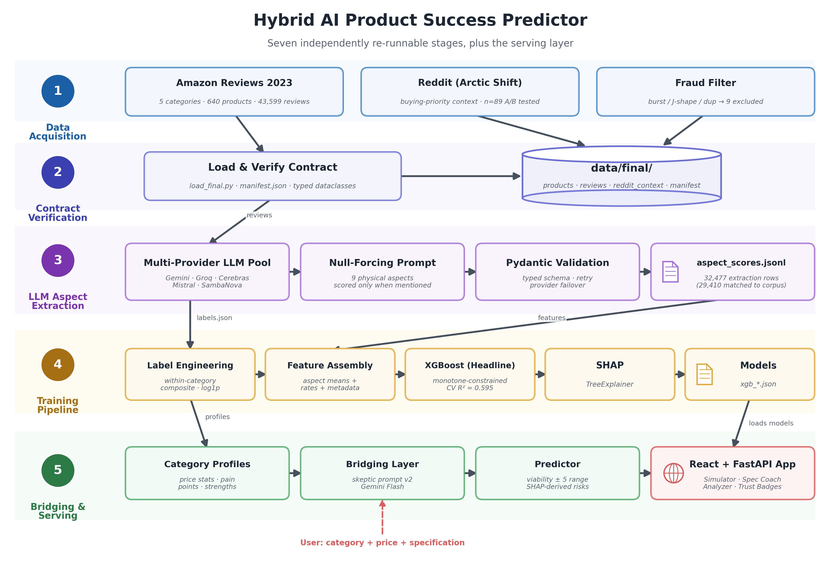

Figure 5. Pipeline overview across five physical categories: extraction, label engineering, feature assembly, training, category profiling, and the bridging/prediction service.
V. EXPERIMENTAL VALIDATION
The question behind our validation is a counterfactual: if this system had existed on the day a real product launched, would its launch-available specification-and-metadata estimate have called that product's eventual market outcome? We answer it launch-blind and out of sample. For every product we evaluate, the bridging layer sees only what was knowable at launch: name, brand, price, and the manufacturer's specification copy. Reviews, ratings, and sales signals are held back. The bridged profile goes into the aspects-only model, and its estimate is checked against the product's real within-category success score, computed from the reviews the product went on to collect. Table 2 lays out the evaluations; the retrained and temporal holdouts are where the evidence is.
TABLE 2. Out-of-sample evaluation cohorts: Spearman ρ (95% CI), top- vs. bottom-quintile AUC, and mean within-category ρ. The last two rows use true review-derived aspect scores (no bridging) and give the attainable ceiling.
Evaluation cohort | Spearman ρ (95% CI) | Top vs. bottom AUC | Within-category ρ
Cross-validation (5-fold CV, n = 631) | CV R² = 0.595 ± 0.030 | — | mean per-category R² = 0.48
First-generation holdout (n = 59; overlapped training; earlier six-category data) | 0.317 [0.059, 0.543] (p = 0.014) | 0.743 [0.507, 0.931] | 0.28
First-generation holdout on final corpus (n = 41) | 0.280 (p = 0.076) | 0.764 | —
Retrained holdout (n = 118 successfully evaluated) | 0.529 [0.377, 0.654] (p < 10⁻⁹) | 0.903 [0.812, 0.965] | 0.39
Extended temporal, 80/20 launch-date split (125/126 evaluated) | 0.590 [0.464, 0.692] | 0.942 | ≈ 0.16
Reference: true review-derived aspects, random holdouts (n = 117, 40 draws) | 0.774 [0.710, 0.842] | 0.981 | 0.68
Reference: true review-derived aspects, 80/20 temporal split | 0.738 | 0.997 | 0.63
A. Retrained Holdout and Earlier Evaluation. We evaluated our frozen production bridging pipeline on a predefined out-of-sample holdout of n = 59 products (from 60 drawn under seed 4242; 1 product lacked parseable feature copy). The holdout was drawn from the earlier six-category collection (wireless headphones, Bluetooth speakers, smartwatches, power banks, kitchen appliances, and smartphones) before kitchen appliances and smartphones were replaced by ice makers; 18 kitchen-appliance products are absent from the final five-category corpus, leaving 41 scoreable products. For every holdout product, all reviews, star ratings, and post-launch signals were completely quarantined. The model saw only launch-available metadata (name, category, price, brand tier) and manufacturer specification copy.
The category profile used by the bridging layer was constructed across the broader corpus and therefore not fully isolated from the holdout. Because unmasked commercial product names were supplied, the LLM may retain pre-training world knowledge regarding established brands. Predicted viability correlates with actual post-launch market success at ρ = 0.317 (p = 0.014), with a 10,000-sample bootstrap 95% CI of [0.059, 0.543], AUC = 0.743, and mean within-category ρ = 0.28; viability quintile means rise monotonically from 58.5 to 64.1. This first-generation run is superseded: the success model had been trained on the full corpus, including the holdout products, and the result does not carry over to the final corpus, where only the 41 surviving products can be scored (ρ = 0.280, p = 0.076, AUC = 0.764). In the retrained prompt-v2 evaluation, 118 products were successfully evaluated after the held-out set was removed before retraining (a clean retrain on 513 products); ρ = 0.529 (95% CI [0.377, 0.654], p < 10⁻⁹ by an analytic t-test), AUC = 0.903 (95% CI [0.812, 0.965]), and mean within-category ρ = 0.39. For reference, true review-derived aspect scores (no bridging) on random category-stratified holdouts of 117 products reach ρ = 0.774 (95% range 0.710–0.842), AUC = 0.981, and mean within-category ρ = 0.677, so the bridged estimate recovers about two-thirds of the attainable pooled rank correlation. Category profiles were compiled across the broader corpus rather than re-partitioned by split, so this is validation evidence rather than an untouched final test.

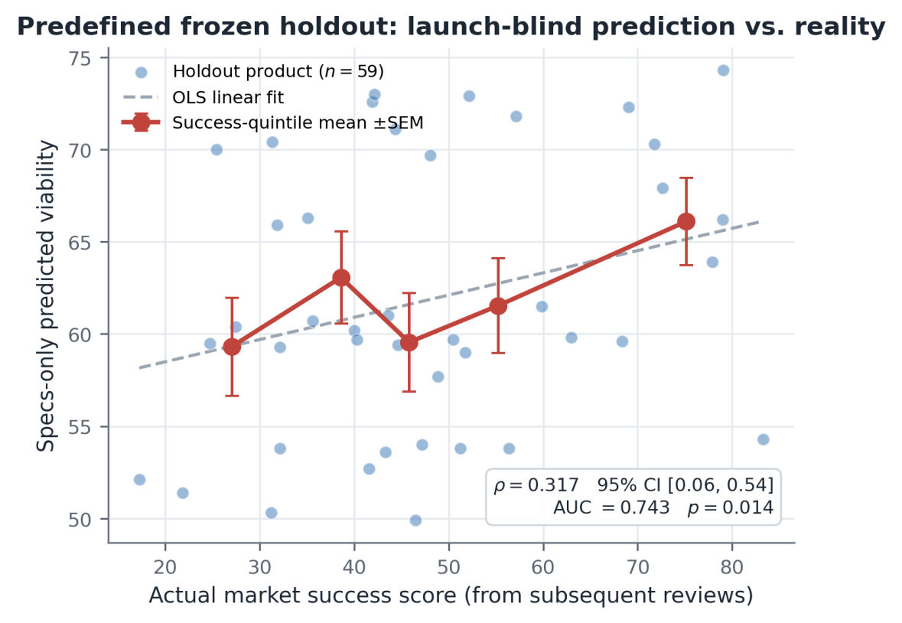
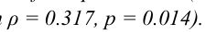Figure 6. Predefined frozen out-of-sample holdout (n = 59): launch-available specification-and-metadata predicted viability versus actual market success score (Spearman ρ = 0.317, p = 0.014). Dashed line shows the linear OLS fit; solid markers show success-quintile mean ±SEM.
B. Forward-in-Time Temporal Holdout. A random split can still leak contemporaneous market regularities, so we executed a forward-in-time temporal evaluation predicting products launched in the future. Because public marketplace catalogs lack factory release timestamps, we define the launch date strictly as a first-review launch proxy: first_review_ts = min(review_timestamps). Products were ordered by launch date and split 80/20: the earliest 80% (launched on or before October 20, 2021) form the training period and the latest 20% form the test set, with no maturity filter. The extended temporal test set contains 126 products; 125 were successfully evaluated and 1 lacked parseable specs. The extended model achieves ρ = 0.590 (95% CI [0.464, 0.692]), AUC = 0.942, and mean within-category ρ ≈ 0.16 (power banks −0.03, ice makers −0.03, headphones 0.31, smartwatches 0.41). With true review-derived aspect scores in place of bridged ones, a split of this kind reaches ρ = 0.738, so bridging recovers about four-fifths of the attainable pooled rank correlation but little within-category skill. For reference, a calendar cutoff at October 31, 2021 divides the 640 products into 510 launched on or before and 130 after; 6 of the post-cutoff products were excluded by fraud filtering (the other 3 flagged products launched earlier) and 73 further products had fewer than 30 accumulated reviews, leaving 51 mature products.
The pooled numbers do get some help from between-category structure, since the target is normalized within category. The stricter yardstick is the mean within-category ρ, and there the two holdouts part ways honestly: 0.39 on the random split falls to 0.16 forward-in-time. Predicting the future inside a single category is genuinely harder than interpolating across a random split, and exposing that is precisely what a temporal test is for. We report both and take the within-category figure as the conservative claim.
C. Baselines and Price Orthogonality
A launch-blind correlation is only valuable if it captures genuine design information rather than proxying for price or brand recognition. Brand tier is an ordinal feature (0–3) computed from the full collected catalog's distinct-product footprint: Tier 0 (1 SKU/greenfield), Tier 1 (2–4 SKUs), Tier 2 (5–10 SKUs), and Tier 3 (11+ SKUs). Because this footprint is computed across the full catalog rather than only products available before each prediction point, the brand tier can contain post-launch information and is therefore an additional temporal leakage caveat. Zero post-launch reviews, star ratings, or sales information were used.

Price enters the model as a monotone non-increasing feature. A price-free ablation removes product price and the deterministic value-for-money ratio while retaining LLM-extracted aspect scores, mention rates, category indicators, and brand-recognition tier; it maintains ρ = 0.476 on the extended deployment cohort (n = 118, p = 5.09 × 10⁻⁸). A price-only baseline is weak: within-category price percentile correlates with the success score at ρ = 0.147 across all 631 products (95% range 0.023–0.271 over 40 random category-stratified draws of 117 products), far below the model's 0.529, and the relationship differs sharply by category (smartwatches 0.54, headphones 0.35, speakers 0.22, power banks 0.01, ice makers −0.26). Evaluating the contribution of Reddit consumer-priorities via an A/B trial on real products (seed 42, n = 89) yielded Spearman ρ = 0.359 with Reddit context versus ρ = 0.311 without (Δρ = +0.049, 95% CI [−0.024, 0.127], AUC 0.752 vs. 0.728); because the confidence interval spans zero, the observed lift is not statistically significant. These baseline and ablation figures provide supporting evidence from the archived evaluation sample.
D. Which Aspects Can Be Estimated from Specifications
Aspect by aspect, the bridged estimates track the review-derived ground truth at r = 0.53 for utility and durability, 0.52 for ease of 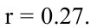use, 0.51 for build quality, and 0.50 for reliability (Fig. 7). Value for money reaches r = 0.34 and repairability r = 0.27. In contrast, design appeal (r = 0.21) and after-sales service (r = 0.07) demonstrate minimal spec-to-review correlation, and are explicitly flagged at runtime as unestimable from specification copy alone.
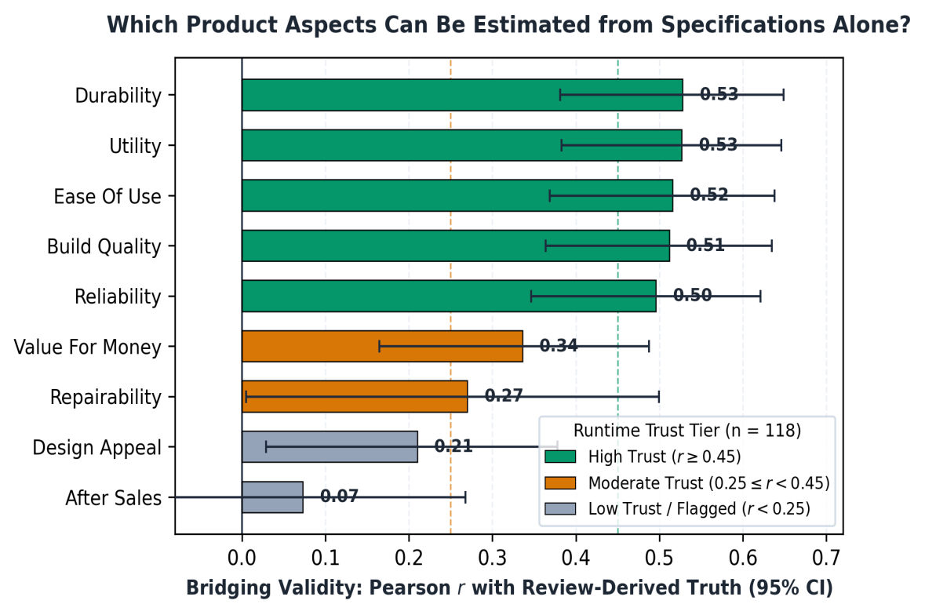
Figure 7. Per-aspect validity of bridged estimates (Pearson r with 95% CI, n = 118), colored by the runtime trust tier presented to users. Sample sizes per 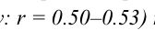aspect reflect non-null pairwise pairs under null-forcing extraction (55 to 118 pairs). High-fidelity experiential aspects (utility, durability, ease of use, build quality, reliability: r = 0.50–0.53) receive high-trust status, whereas design appeal (r = 0.21) and after-sales service (r = 0.07) are flagged as unestimable from specification copy alone.
VI. SCOPE AND BOUNDARY CONDITIONS
A system meant to inform real decisions ought to name where it breaks as plainly as where it works, so we give a diagnosed boundary condition the same prominence as the positive results. The method's predictive validity tracks how well a category's specifications encode experiential quality, and the clearest case is ice makers.
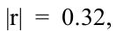On the surface ice makers are a paradox: of every category they have the strongest within-category link between real review aspects and success (mean |r| = 0.32, against 0.09–0.25 elsewhere) and the highest aspect coverage in extraction, yet their bridged 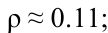predictions are the weakest of all (holdout ρ ≈ 0.11; forward-in-time ρ ≈ −0.03). The observed pattern is consistent with the bridging step being the principal bottleneck rather than extraction or target labeling. The LLM estimates nearly uniform aspect scores across ice-maker products—a bridged-score standard deviation of just 0.10 for reliability, 0.11 for build quality, and 0.13 for durability—because commodity appliance specifications concentrate on nominal capacity and cycle metrics ('26 lb/day, 9 cubes in 6 minutes') while omitting technical detail on compressor longevity, seal integrity, or noise damping. With limited differentiating specification copy, the bridged aspect projections regress toward the category prior, yielding minimal variance for downstream ranking. Measured ice-maker aspect-bridging correspondence reaches only r ≈ 0.04 (compared to r ≈ 0.39 across pooled categories and 0.45–0.56 in personal electronics), bounding predictive viability in spec-unexpressive commodity categories.
The lesson generalizes. Where a category's specifications describe experiential attributes—sound, comfort, battery life for headphones, speakers, and smartwatches—bridging fidelity is high and forward prediction works. Where they describe only physical capacity, bridging cannot tell products apart and the method is bounded, no matter how much signal the underlying reviews

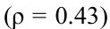hold. The temporal holdout shows a cousin of this effect: power banks rank well on a random split (ρ = 0.43) but not forward-in-time (ρ ≈ −0.03), which fits real technological drift—newer gallium-nitride and USB-C designs a model trained on older stock has never seen. We therefore scope the method to spec-expressive, technologically stable categories, and the interface's abstention machinery is that same boundary expressed at runtime.
VII. DECISION-SUPPORT APPLICATION
The pipeline is a chain of independently re-runnable stages (Fig. 5). Each one writes its output to disk and skips expensive work unless told to redo it. Extraction is crash-safe and resumable, which mattered in practice: the full batch runs for days of rate-limited API calls across a rotating provider pool. Feature manifests are serialized to disk and the prediction code builds its input vectors by walking them, so the serving path cannot quietly drift out of step with training. One end-to-end smoke test regenerates synthetic data, runs every stage in a sandbox, and gates every change to the code.
The user-facing application (Fig. 8a) is a React front end over a FastAPI backend, deployed under Docker. A founder enters a product's category, price, and specification and gets the whole analysis back: a rank-calibrated viability range, a percentile position against real products, per-aspect estimates drawn against category averages, and top risks and strengths from SHAP [42] attributions taken relative to the category-average product. Because the attributions are relative in that way, the cards agree with the aspect-vs-average chart by construction, and under the model's monotonic constraints an above-average aspect always reads as a strength and a below-average one as a risk—each phrased as a design lever the founder can actually move. A market-gap report rounds it out, quoting verbatim customer complaints for the category pain points a design does not convincingly address. Every aspect estimate shows its trust badge and grounding flag, and confidence is reliability-weighted, so a specification that grounds only low-fidelity aspects is reported at low confidence and, below threshold, replaced by an explanation rather than a number. The model also conditions on company and product maturity, so a first product from an unknown brand is judged differently from a line extension by an established one.
The spec coach (Fig. 8b) closes the loop for users who are not practiced at writing specs. A single LLM call rates the draft's coverage of each aspect as covered, vague, or missing, asks at most five questions ordered by how much each answer would sharpen the prediction, and rewrites the spec while keeping every fact the user stated and inserting explicit placeholders for the decisions still to be made. By construction, the coach may not invent a material, a number, or a feature the user did not state.



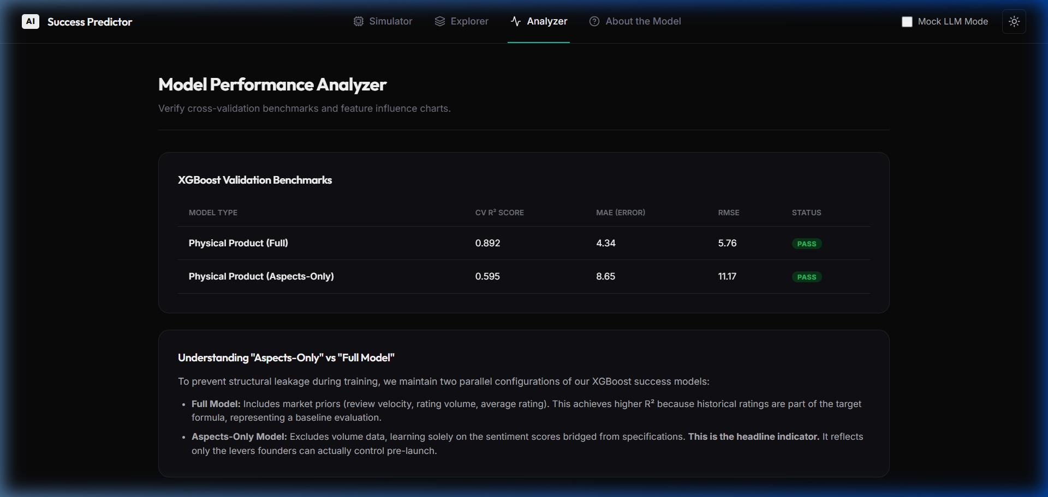
Figure 8. The application. (a) Prediction dashboard with viability range, percentile rank, and aspect-vs-category chart. (b) Spec coach. (c) Analyzer view showing the standardized benchmark table.
VIII. LIMITATIONS
Survivorship bias is the biggest limitation, and it bounds every claim in this paper. The corpus asks for at least five reviews per product, so products that launched and drew no attention—arguably the truest flops—simply are not there. Every result here is about ranking among products that reached the market's attention. Whether the system could flag a product headed for no traction at all is untested, and with this data it cannot be tested.
The second limitation concerns the target construct: our viability score is a review-derived market-success proxy combining review volume, star rating, and review velocity, rather than commercial sales telemetry. While the literature demonstrates strong coupling between consumer review dynamics and commercial revenues, sales volume remains unobserved. The third limitation is domain generalizability: the empirical findings reflect five physical consumer hardware categories and do not automatically extend to enterprise goods, fast-moving consumer goods, or digital services. Fourth, while post-launch product-specific signals were quarantined, category reference distributions were compiled across the broader corpus and were not strictly isolated from the evaluation products; additionally, unmasked commercial product names in specification headers may allow the LLM to access pre-trained real-world brand knowledge. Fifth, methodological trade-offs govern the reported numbers: while our standardized Table 1 benchmark is strictly leakage-free by deriving early-stopping iterations and classification thresholds solely from training folds (yielding R² = 0.550 for XGBoost and 0.558 for Gradient Boosting), the production headline model reports CV R² = 0.595 under full-fold early stopping; furthermore, brand tier was originally computed across the full SKU footprint (true-aspect temporal ρ falls from 0.749 to 0.715 when tiers use only the training period); and labels are min–max normalized within category over all products, test products included. Sixth, the success target counts sampled reviews (capped at 300 per product, median 47) rather than lifetime popularity; the sampled review count correlates only ρ = 0.52 with lifetime rating counts, although a label rebuilt from lifetime counts agrees with ours at ρ = 0.69 overall (0.75–0.84 within category). Seventh, pooled rank correlations are dominated by between-category separation: forward-in-time skill within categories is much lower (mean ρ ≈ 0.16).
IX. CONCLUSION
We evaluated the production bridging pipeline on a predefined frozen n = 59 holdout and report it as a superseded first-generation evaluation because the success model had been trained on the full corpus and the result does not carry over to the final corpus (n = 41, ρ = 0.280, p = 0.076). The retrained deployment evaluation successfully evaluated 118 held-out products after excluding the held-out set before retraining and achieved ρ = 0.529 (95% CI [0.377, 0.654], p < 10⁻⁹) and AUC = 0.903. The extended temporal evaluation successfully evaluated 125 of 126 test products on an 80/20 launch-date split and achieved ρ = 0.590 (95% CI [0.464, 0.692]) and AUC = 0.942, with mean within-category ρ of about 0.16.

Beyond specific point estimates, the principal architectural contribution is the systematic characterization of bridging scope: identifying which product attributes can be reliably projected from specifications (utility, durability, ease of use, build quality, 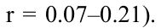reliability: r = 0.50–0.53) and which cannot (design appeal, after-sales service: r = 0.07–0.21). The framework demonstrates that predictive validity is bounded to spec-expressive categories where technical documentation reflects experiential quality, while commodity appliances like ice makers bound the approach. By incorporating reliability-weighted confidence heuristics and uncalibrated runtime abstention mechanisms, the system provides an interpretable, transparent decision-support tool for early-stage product viability evaluation.
REFERENCES
[1] Chevalier and Mayzlin 2006. The Effect of Word of Mouth on Sales: Online Book Reviews. Journal of Marketing Research.
[2] Chintagunta et al. 2010. The Effects of Online User Reviews on Movie Box Office Performance. Marketing Science.
[3] Dellarocas 2003. The Digitization of Word of Mouth: Promise and Challenges of Online Feedback Mechanisms. Management Science.
[4] Luca 2016. Reviews, Reputation, and Revenue: The Case of Yelp.com. Harvard Business School Working Paper 12-016.
[5] Shan et al. 2025. Examining Customer Satisfaction Through Transformer-Based Sentiment Analysis for Improving Bilingual E-Commerce Experiences. IEEE Access.
[6] Wang et al. 2025. MultiFeature Fusion Graph Attention Network for Aspect-Based Sentiment Analysis. Knowledge-Based Systems.
[7] Zhang et al. 2023. A Survey on Aspect-Based Sentiment Analysis: Tasks, Methods, and Challenges. IEEE Transactions on Knowledge and Data Engineering.
[8] Archak et al. 2011. Deriving the Pricing Power of Product Features by Mining Consumer Reviews. Management Science.
[9] Asur and Huberman 2010. Predicting the Future With Social Media. Proc. IEEE/WIC/ACM Int. Conf. on Web Intelligence.
[10] Ghose and Ipeirotis 2011. Estimating the Helpfulness and Economic Impact of Product Reviews: Mining Text and Reviewer Characteristics. IEEE Transactions on Knowledge and Data Engineering.
[11] Mudambi and Schuff 2010. What Makes a Helpful Online Review? A Study of Customer Reviews on Amazon.com. MIS Quarterly.
[12] Narayanan et al. 2020. Product Pre-Launch Prediction From Resilient Distributed e-WOM Data. IEEE Access.
[13] Jindal and Liu 2008. Opinion Spam and Analysis. Proc. Int. Conf. on Web Search and Data Mining (WSDM).
[14] Mayzlin et al. 2014. Promotional Reviews: An Empirical Investigation of Online Review Manipulation. American Economic Review.
[15] Ott et al. 2011. Finding Deceptive Opinion Spam by Any Stretch of the Imagination. Proc. Annual Meeting of the ACL.
[16] Hu and Liu 2004. Mining and Summarizing Customer Reviews. Proc. ACM SIGKDD Int. Conf. on Knowledge Discovery and Data Mining.
[17] Lange et al. 2025. Curriculum Learning for a Hybrid Approach for Aspect-Based Sentiment Analysis. Expert Systems with Applications.
[18] Liu 2012. Sentiment Analysis and Opinion Mining. Morgan & Claypool.
[19] Pontiki et al. 2014. SemEval-2014 Task 4: Aspect Based Sentiment Analysis. Proc. 8th Int. Workshop on Semantic Evaluation (SemEval).
[20] SESR 2025. Research on Sentiment Analysis Based on Multi-Source Data Fusion. Socio-Economic Statistics Research.
[21] Bommasani et al. 2021. On the Opportunities and Risks of Foundation Models. arXiv preprint arXiv:2108.07258.
[22] Brown et al. 2020. Language Models Are Few-Shot Learners. Advances in Neural Information Processing Systems.
[23] Devlin et al. 2019. BERT: Pre-Training of Deep Bidirectional Transformers for Language Understanding. Proc. NAACL-HLT.
[24] Gemini Team 2023. Gemini: A Family of Highly Capable Multimodal Models. arXiv preprint arXiv:2312.11805.
[25] Gilardi et al. 2023. ChatGPT Outperforms Crowd Workers for Text-Annotation Tasks. Proceedings of the National Academy of Sciences.
[26] Gutierrez et al. 2025. Zero-Shot Product Description Generation From Customers Reviews. Proc. Int. Conf. on Agents and Artificial Intelligence (ICAART).
[27] Hidayat et al. 2025. Leveraging Large Language Models for Discrepancy Value Prediction in Custody Transfer Systems: A Comparative Analysis of Probabilistic and Point Forecasting Approaches. IEEE Access.
[28] OpenAI 2023. GPT-4 Technical Report. arXiv preprint arXiv:2303.08774.
[29] Ouyang et al. 2022. Training Language Models to Follow Instructions With Human Feedback. Advances in Neural Information Processing Systems.
[30] Roumeliotis et al. 2025. LLMs for Product Classification in E-Commerce: A Zero-Shot Comparative Study of GPT and Claude Models. Natural Language Processing Journal.
[31] Touvron et al. 2023. LLaMA: Open and Efficient Foundation Language Models. arXiv preprint arXiv:2302.13971.
[32] Vaswani et al. 2017. Attention Is All You Need. Advances in Neural Information Processing Systems.
[33] Wei et al. 2022. Chain-of-Thought Prompting Elicits Reasoning in Large Language Models. Advances in Neural Information Processing Systems.
[34] Breiman 2001. Random Forests. Machine Learning.
[35] Chen and Guestrin 2016. XGBoost: A Scalable Tree Boosting System. Proc. ACM SIGKDD Int. Conf. on Knowledge Discovery and Data Mining.
[36] Cristofaro and Banon-Gomis 2026. Dancing With the Algorithm: A Framework to Navigate Knowledge and Autonomy in AI-Assisted Managerial Decisions. Journal of Knowledge Management.
[37] Efron 1979. Bootstrap Methods: Another Look at the Jackknife. Annals of Statistics.
[38] Friedman 2001. Greedy Function Approximation: A Gradient Boosting Machine. Annals of Statistics.
[39] He and McAuley 2016. Ups and Downs: Modeling the Visual Evolution of Fashion Trends With One-Class Collaborative Filtering. Proc. Int. Conf. on World Wide Web (WWW).
[40] Hou et al. 2024. Bridging Language and Items for Retrieval and Recommendation. arXiv preprint arXiv:2403.03952.

[41] Ke et al. 2017. LightGBM: A Highly Efficient Gradient Boosting Decision Tree. Advances in Neural Information Processing Systems.
[42] Lundberg and Lee 2017. A Unified Approach to Interpreting Model Predictions. Advances in Neural Information Processing Systems.
[43] Rakee et al. 2025. TEMUL: Tensor-Based Deep Learning Approach for Multi-Criteria Recommender System. IEEE Access.
[44] Sayyad et al. 2024. Optimizing e-Commerce Supply Chains With Categorical Boosting: A Predictive Modeling Framework. IEEE Access.
[45] Shang 2025. Sentiment-Driven Bitcoin Price Range Forecasting: Enhancing CART Decision Trees With High-Dimensional Indicators and Twitter Dynamics. IEEE Access.
[46] Zhen et al. 2025. A Multi-Feature Selection Fused With Investor Sentiment for Stock Price Prediction. Expert Systems with Applications.
[47] Cortes and Vapnik 1995. Support-Vector Networks. Machine Learning.
[48] Grinsztajn et al. 2022. Why Do Tree-Based Models Still Outperform Deep Learning on Typical Tabular Data?. Advances in Neural Information Processing Systems.
[49] Hoerl and Kennard 1970. Ridge Regression: Biased Estimation for Nonorthogonal Problems. Technometrics.
[50] Shwartz-Ziv and Armon 2022. Tabular Data: Deep Learning Is Not All You Need. Information Fusion.

