CS585

Natural Language Processing

HW4 – Native Language Identification using pre-trained BERT (Bi-directional Encoder Representations from Transformers)

Yash Patel

A20451170

[Ypatel31@hawk.iit.edu](mailto:Ypatel31@hawk.iit.edu)

Prof. Derrick Higgins (Instructor)

* **Instructions for running code**
  1. **Requirements:**
     1. Python 3.6.0
     2. Jupyter notebook
     3. Libraries:
        + numpy
        + pandas
        + scikit-learn
        + matplotlib
        + seaborn
        + tensorflow==1.14.0
        + protobuf==3.6.0
  2. **Directory Structure**
     1. Project directory
        + BERT_BASE_DIR (cloned reps)
        + BERT_DATA_DIR (pre-trained BERT model)
        + bert_input_data
          - eval.txt
          - test.txt
          - train.txt
        + bert_output_data
          - eval.josnlines
          - test.jsonlines
          - train.jsonlines
        + data
          - lang_id_eval.csv
          - lang_id_test.csv
          - lang_id_train.csv
        + model-training-with-BERT-vectors.ipynb
        + re-format.sh
        + run_bert_fv.sh
  3. **Steps**
     1. Clone the BERT repo from git-hub and rename it with BERT_BASE_DIR.
     2. Download pre-trained BERT model and rename it with BERT_BASE_DIR.
     3. Download handout material which has data of native language and text of speaker. Run re-format.sh (shell script) file.

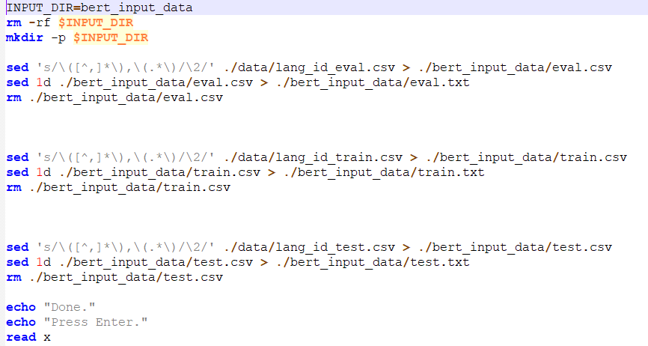

This script first removes bert_input_data directory if one is created and then create new one. Then it reformates all the data files and save them in text files in newly create bert_input_data directory in such a way that they have only text of speakers. they don’t include native languages and titles.

* + 1. Then install tensorflow with 1.14 version and protobuf with 3.6.0 version to run the run_bert_fv.sh (shell script) which runs a extract_features.py python file to generate vectors. After installing run run_bert_fv.sh file. This will generate 7.5 GB of vector data from text of speakers. For input it will take re-formatted text files from bert_input_data directory and it generates vectors (.jsonlines) in bert_output_data directory.
    2. Then run model-training-with-BERT-vectors.ipynb in jupyter notebook to train ,test and evaluate your model.
* **Summary of evaluation finding**
  1. Load native language for training and testing from csv files in data directory as targets. Load BERT generated vectors (.jsonlines) for training and testing from bert_output_data directory as features.
  2. Train your own model with this training vectors as features and training native language as targets. Here, I used Logistic Regression model, Decision Tree model and Support Vector Machine model.
  3. Then we found four performance measurements,
     + Accuracy
       - Logistic Regression:
         * Training accuracy: 0.7348333333333333
         * Testing accuracy: 0.466
       - Decision Tree:
         * Training accuracy: 1.0
         * Testing accuracy: 0.1755
       - Support Vector Machine:
         * Training accuracy: 0.7658333333333334
         * Testing accuracy: 0.426
     + Confusion Matrix
       - Logistic Regression:

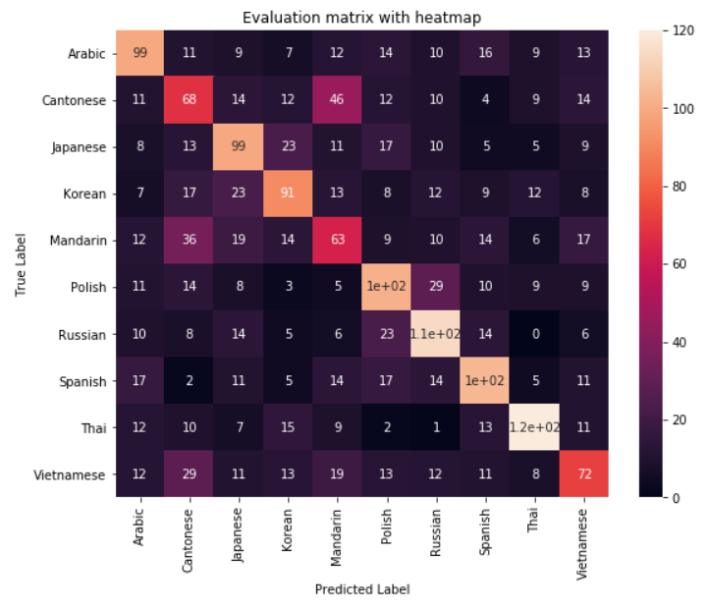

* + - * Decision Tree:

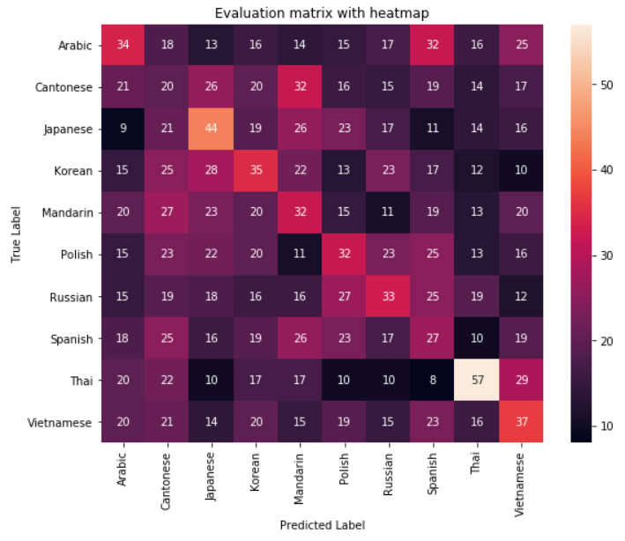

* + - * Support Vector Machine:

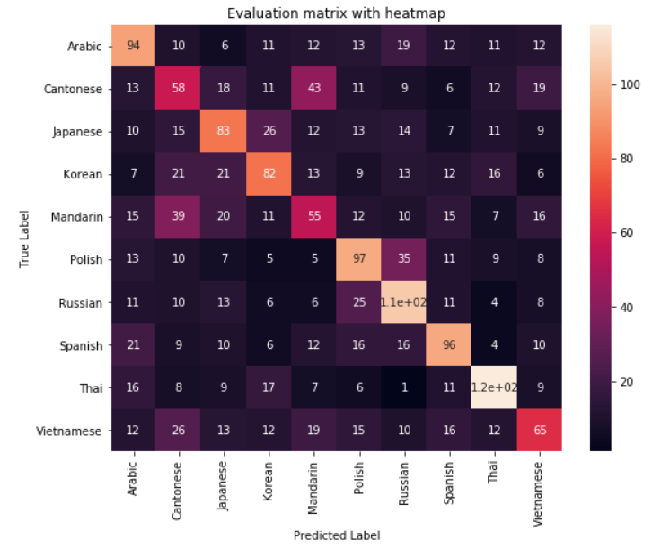

* + - Misclassification for each class
      * Logistic Regression

language misclassification precision recall f1 score support

0 Arabic 10.05 0.497487 0.495 0.496241 200

1 Cantonese 13.60 0.326923 0.340 0.333333 200

2 Japanese 10.85 0.460465 0.495 0.477108 200

3 Korean 10.30 0.484043 0.455 0.469072 200

4 Mandarin 13.60 0.318182 0.315 0.316583 200

5 Polish 10.65 0.470046 0.510 0.489209 200

6 Russian 9.70 0.513514 0.570 0.540284 200

7 Spanish 9.60 0.520000 0.520 0.520000 200

8 Thai 7.15 0.655738 0.600 0.626632 200

9 Vietnamese 11.30 0.423529 0.360 0.389189 200

* + - * Decision Tree

language misclassification precision recall f1 score support

0 Arabic 15.95 0.181818 0.170 0.175711 200

1 Cantonese 19.05 0.090498 0.100 0.095012 200

2 Japanese 16.30 0.205607 0.220 0.212560 200

3 Korean 16.60 0.173267 0.175 0.174129 200

4 Mandarin 17.35 0.151659 0.160 0.155718 200

5 Polish 16.45 0.165803 0.160 0.162850 200

6 Russian 15.75 0.182320 0.165 0.173228 200

7 Spanish 17.60 0.131068 0.135 0.133005 200

8 Thai 13.50 0.309783 0.285 0.296875 200

9 Vietnamese 16.35 0.184080 0.185 0.184539 200

* + - * Support Vector Machine

language misclassification precision recall f1 score support

0 Arabic 11.20 0.443396 0.470 0.456311 200

1 Cantonese 14.50 0.281553 0.290 0.285714 200

2 Japanese 11.70 0.415000 0.415 0.415000 200

3 Korean 11.15 0.438503 0.410 0.423773 200

4 Mandarin 13.70 0.298913 0.275 0.286458 200

5 Polish 11.15 0.447005 0.485 0.465228 200

6 Russian 11.05 0.454936 0.530 0.489607 200

7 Spanish 10.25 0.487310 0.480 0.483627 200

8 Thai 8.50 0.574257 0.580 0.577114 200

9 Vietnamese 11.60 0.401235 0.325 0.359116 200

* + - Misclassification for each pair of classes
      * Logistic Regression:

True Label Predicted Label Misclassification

0 Arabic Cantonese 11

1 Arabic Japanese 8

2 Arabic Korean 7

3 Arabic Mandarin 12

4 Arabic Polish 11

5 Arabic Russian 10

6 Arabic Spanish 17

7 Arabic Thai 12

8 Arabic Vietnamese 12

9 Cantonese Arabic 11

10 Cantonese Japanese 13

11 Cantonese Korean 17

12 Cantonese Mandarin 36

13 Cantonese Polish 14

14 Cantonese Russian 8

15 Cantonese Spanish 2

16 Cantonese Thai 10

17 Cantonese Vietnamese 29

18 Japanese Arabic 9

19 Japanese Cantonese 14

20 Japanese Korean 23

21 Japanese Mandarin 19

22 Japanese Polish 8

23 Japanese Russian 14

24 Japanese Spanish 11

25 Japanese Thai 7

26 Japanese Vietnamese 11

27 Korean Arabic 7

28 Korean Cantonese 12

29 Korean Japanese 23

30 Korean Mandarin 14

31 Korean Polish 3

32 Korean Russian 5

33 Korean Spanish 5

34 Korean Thai 15

35 Korean Vietnamese 13

36 Mandarin Arabic 12

37 Mandarin Cantonese 46

38 Mandarin Japanese 11

39 Mandarin Korean 13

40 Mandarin Polish 5

41 Mandarin Russian 6

42 Mandarin Spanish 14

43 Mandarin Thai 9

44 Mandarin Vietnamese 19

45 Polish Arabic 14

46 Polish Cantonese 12

47 Polish Japanese 17

48 Polish Korean 8

49 Polish Mandarin 9

50 Polish Russian 23

51 Polish Spanish 17

52 Polish Thai 2

53 Polish Vietnamese 13

54 Russian Arabic 10

55 Russian Cantonese 10

56 Russian Japanese 10

57 Russian Korean 12

58 Russian Mandarin 10

59 Russian Polish 29

60 Russian Spanish 14

61 Russian Thai 1

62 Russian Vietnamese 12

63 Spanish Arabic 16

64 Spanish Cantonese 4

65 Spanish Japanese 5

66 Spanish Korean 9

67 Spanish Mandarin 14

68 Spanish Polish 10

69 Spanish Russian 14

70 Spanish Thai 13

71 Spanish Vietnamese 11

72 Thai Arabic 9

73 Thai Cantonese 9

74 Thai Japanese 5

75 Thai Korean 12

76 Thai Mandarin 6

77 Thai Polish 9

78 Thai Russian 0

79 Thai Spanish 5

80 Thai Vietnamese 8

81 Vietnamese Arabic 13

82 Vietnamese Cantonese 14

83 Vietnamese Japanese 9

84 Vietnamese Korean 8

85 Vietnamese Mandarin 17

86 Vietnamese Polish 9

87 Vietnamese Russian 6

88 Vietnamese Spanish 11

89 Vietnamese Thai 11

* + - * Decision Tree:

True Label Predicted Label Misclassification

0 Arabic Cantonese 21

1 Arabic Japanese 9

2 Arabic Korean 15

3 Arabic Mandarin 20

4 Arabic Polish 15

5 Arabic Russian 15

6 Arabic Spanish 18

7 Arabic Thai 20

8 Arabic Vietnamese 20

9 Cantonese Arabic 18

10 Cantonese Japanese 21

11 Cantonese Korean 25

12 Cantonese Mandarin 27

13 Cantonese Polish 23

14 Cantonese Russian 19

15 Cantonese Spanish 25

16 Cantonese Thai 22

17 Cantonese Vietnamese 21

18 Japanese Arabic 13

19 Japanese Cantonese 26

20 Japanese Korean 28

21 Japanese Mandarin 23

22 Japanese Polish 22

23 Japanese Russian 18

24 Japanese Spanish 16

25 Japanese Thai 10

26 Japanese Vietnamese 14

27 Korean Arabic 16

28 Korean Cantonese 20

29 Korean Japanese 19

30 Korean Mandarin 20

31 Korean Polish 20

32 Korean Russian 16

33 Korean Spanish 19

34 Korean Thai 17

35 Korean Vietnamese 20

36 Mandarin Arabic 14

37 Mandarin Cantonese 32

38 Mandarin Japanese 26

39 Mandarin Korean 22

40 Mandarin Polish 11

41 Mandarin Russian 16

42 Mandarin Spanish 26

43 Mandarin Thai 17

44 Mandarin Vietnamese 15

45 Polish Arabic 15

46 Polish Cantonese 16

47 Polish Japanese 23

48 Polish Korean 13

49 Polish Mandarin 15

50 Polish Russian 27

51 Polish Spanish 23

52 Polish Thai 10

53 Polish Vietnamese 19

54 Russian Arabic 17

55 Russian Cantonese 15

56 Russian Japanese 17

57 Russian Korean 23

58 Russian Mandarin 11

59 Russian Polish 23

60 Russian Spanish 17

61 Russian Thai 10

62 Russian Vietnamese 15

63 Spanish Arabic 32

64 Spanish Cantonese 19

65 Spanish Japanese 11

66 Spanish Korean 17

67 Spanish Mandarin 19

68 Spanish Polish 25

69 Spanish Russian 25

70 Spanish Thai 8

71 Spanish Vietnamese 23

72 Thai Arabic 16

73 Thai Cantonese 14

74 Thai Japanese 14

75 Thai Korean 12

76 Thai Mandarin 13

77 Thai Polish 13

78 Thai Russian 19

79 Thai Spanish 10

80 Thai Vietnamese 16

81 Vietnamese Arabic 25

82 Vietnamese Cantonese 17

83 Vietnamese Japanese 16

84 Vietnamese Korean 10

85 Vietnamese Mandarin 20

86 Vietnamese Polish 16

87 Vietnamese Russian 12

88 Vietnamese Spanish 19

89 Vietnamese Thai 29

* + - * Support Vector Machine:

True Label Predicted Label Misclassification

0 Arabic Cantonese 13

1 Arabic Japanese 10

2 Arabic Korean 7

3 Arabic Mandarin 15

4 Arabic Polish 13

5 Arabic Russian 11

6 Arabic Spanish 21

7 Arabic Thai 16

8 Arabic Vietnamese 12

9 Cantonese Arabic 10

10 Cantonese Japanese 15

11 Cantonese Korean 21

12 Cantonese Mandarin 39

13 Cantonese Polish 10

14 Cantonese Russian 10

15 Cantonese Spanish 9

16 Cantonese Thai 8

17 Cantonese Vietnamese 26

18 Japanese Arabic 6

19 Japanese Cantonese 18

20 Japanese Korean 21

21 Japanese Mandarin 20

22 Japanese Polish 7

23 Japanese Russian 13

24 Japanese Spanish 10

25 Japanese Thai 9

26 Japanese Vietnamese 13

27 Korean Arabic 11

28 Korean Cantonese 11

29 Korean Japanese 26

30 Korean Mandarin 11

31 Korean Polish 5

32 Korean Russian 6

33 Korean Spanish 6

34 Korean Thai 17

35 Korean Vietnamese 12

36 Mandarin Arabic 12

37 Mandarin Cantonese 43

38 Mandarin Japanese 12

39 Mandarin Korean 13

40 Mandarin Polish 5

41 Mandarin Russian 6

42 Mandarin Spanish 12

43 Mandarin Thai 7

44 Mandarin Vietnamese 19

45 Polish Arabic 13

46 Polish Cantonese 11

47 Polish Japanese 13

48 Polish Korean 9

49 Polish Mandarin 12

50 Polish Russian 25

51 Polish Spanish 16

52 Polish Thai 6

53 Polish Vietnamese 15

54 Russian Arabic 19

55 Russian Cantonese 9

56 Russian Japanese 14

57 Russian Korean 13

58 Russian Mandarin 10

59 Russian Polish 35

60 Russian Spanish 16

61 Russian Thai 1

62 Russian Vietnamese 10

63 Spanish Arabic 12

64 Spanish Cantonese 6

65 Spanish Japanese 7

66 Spanish Korean 12

67 Spanish Mandarin 15

68 Spanish Polish 11

69 Spanish Russian 11

70 Spanish Thai 11

71 Spanish Vietnamese 16

72 Thai Arabic 11

73 Thai Cantonese 12

74 Thai Japanese 11

75 Thai Korean 16

76 Thai Mandarin 7

77 Thai Polish 9

78 Thai Russian 4

79 Thai Spanish 4

80 Thai Vietnamese 12

81 Vietnamese Arabic 12

82 Vietnamese Cantonese 19

83 Vietnamese Japanese 9

84 Vietnamese Korean 6

85 Vietnamese Mandarin 16

86 Vietnamese Polish 8

87 Vietnamese Russian 8

88 Vietnamese Spanish 10

89 Vietnamese Thai 9

* + - Summary: For text classification we can use decision tree, support vector machine, logistic regression, neural network etc. In test data there are 2000 data instance and 200 per language class. According to me this logistic regression model might optimum to find native language of the speaker as per the accuracy and misclassification rate. Accuracy on test data using logistic regression is around 46%. Misclassification for each language class is around 10% (+3%). Accuracy on test data using decision tree is around 17%. Misclassification for each language class is around 15% (+3%). Accuracy on test data using support vector machine is around 42%. Misclassification for each language class is around 11% (+3%). So, true label probability for each class is 0.1. but when you test on logistic regression model, it decreases to 0.05 (approx.) which is 50% of true label probability. On decision tree, it decreases to 0.02 (approx.) which is 20% of true label probability. On support vector machine, it decreases to 0.04 (approx.) which is 40% of true label probability. Here, decision tree has low accuracy. Reason for that might be it defines its depth by its own or large number of features or it predicts for very similar data but here text might change person to person or overfitting or complex rules. Here, support vector machine also has low accuracy. Reason for that might be it’s difficult for it to know the pattern it relies on.
  1. **Further improvements:** We can train others models and evaluate it. Like, we can train neural network with different numbers of hidden layer, neurons per layers, activation functions, etc. Any difference in hidden layer or neurons per layers or activation functions can give different accuracy. And we can choose best of them. We can define decision tree’s depth. It can give us different accuracy as we use different type of encoding like one-hot, binary, categorical, numeric and we can use on of the best encoding method as per the accuracy.
* **Notes on challenges**
  1. How to define depth of the decision tree based on the features type (categorical or nominal).
  2. How to reduce dimensions of feature vector if possible, in this case.
  3. How to know that which kind of model understand which kind of patterns to learn data.
  4. How to decide the range of hidden layers, neurons and activation function for neural network architecture based on features and targeted classes dimensions, classification and regression process.