**Name: Yash Mahendrakumar Wani**

**Net ID: yxw230008**

**Web Programming Language**

**Project - Task 1**

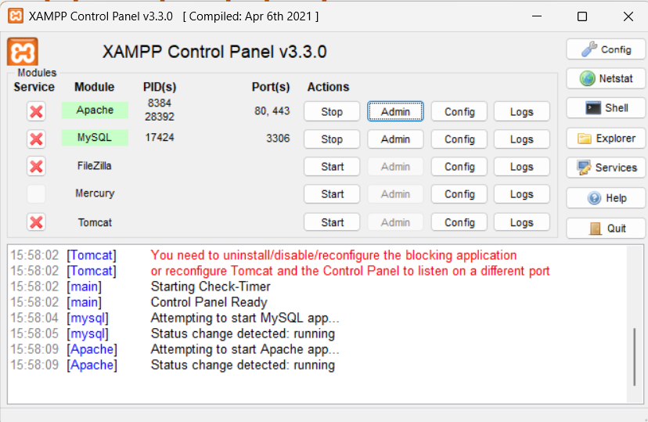

1.2.1 Starting Apache and MySQL in XAMPP

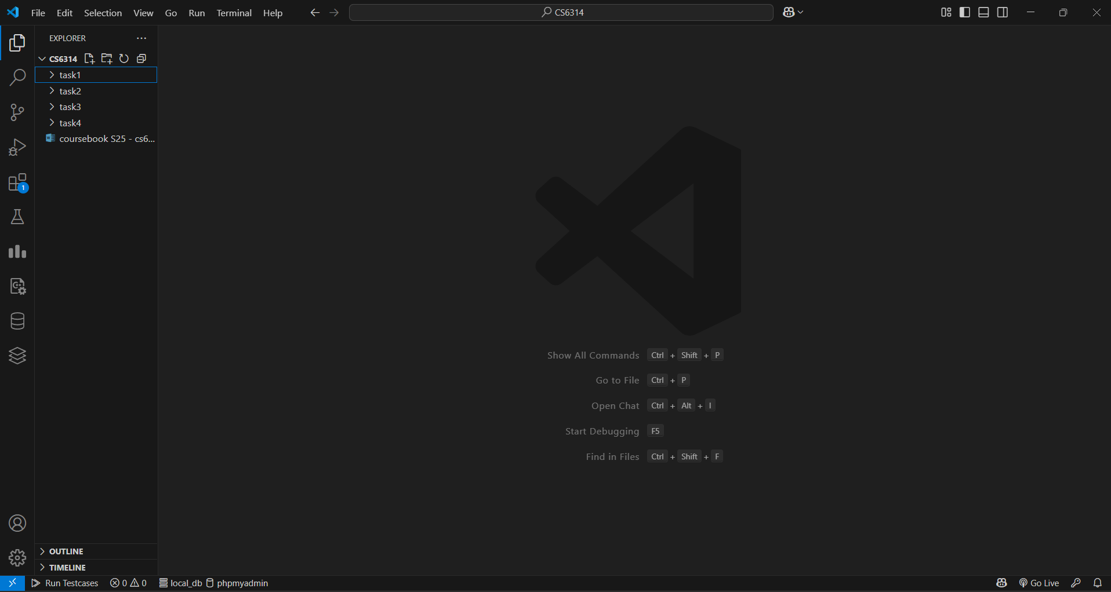

1.2.2 Selecting Visual Studio Code as editor

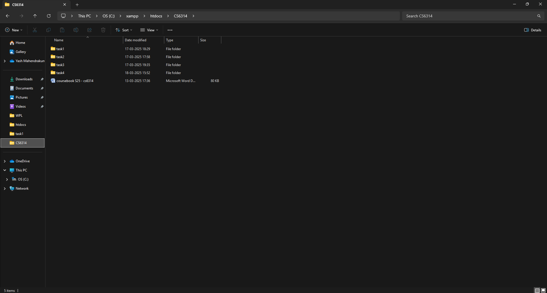

1.2.3 Creating CS6314 folder and subfolders

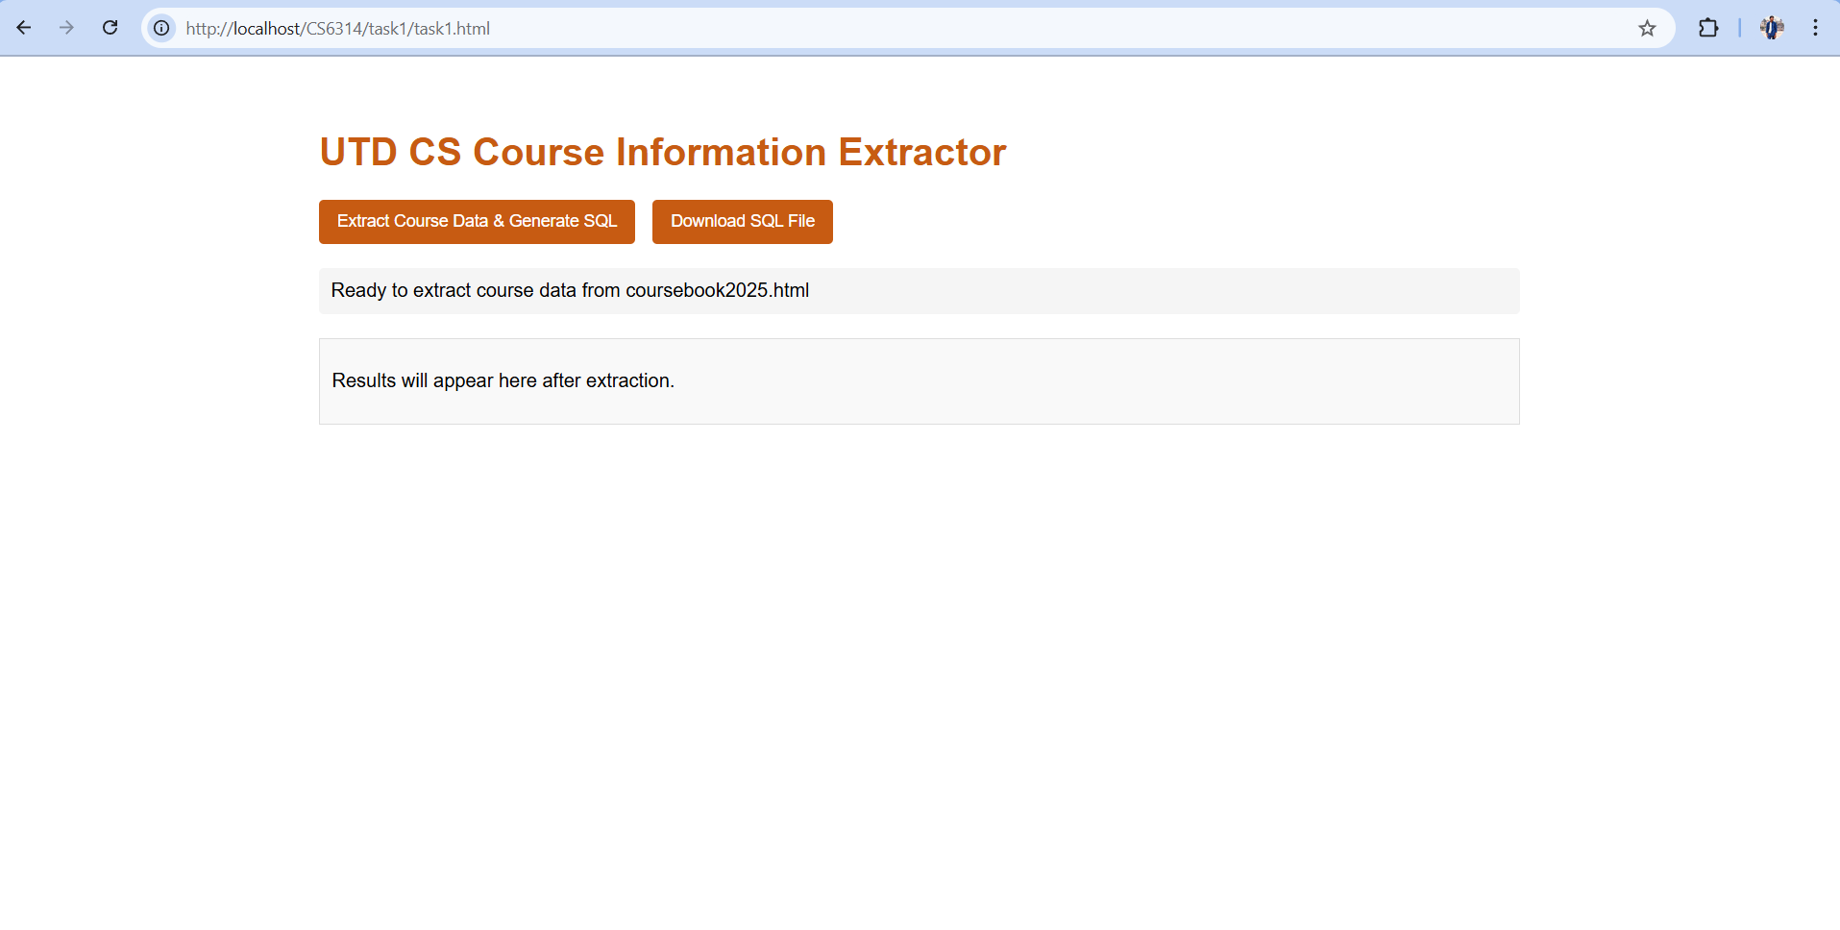

1.2.4 Display if task1.html

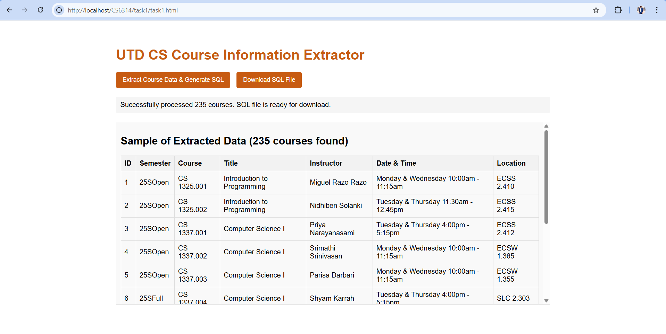

1.2.5 After clicking Extract Course Data & Generate SQL it will run the process and display sample data

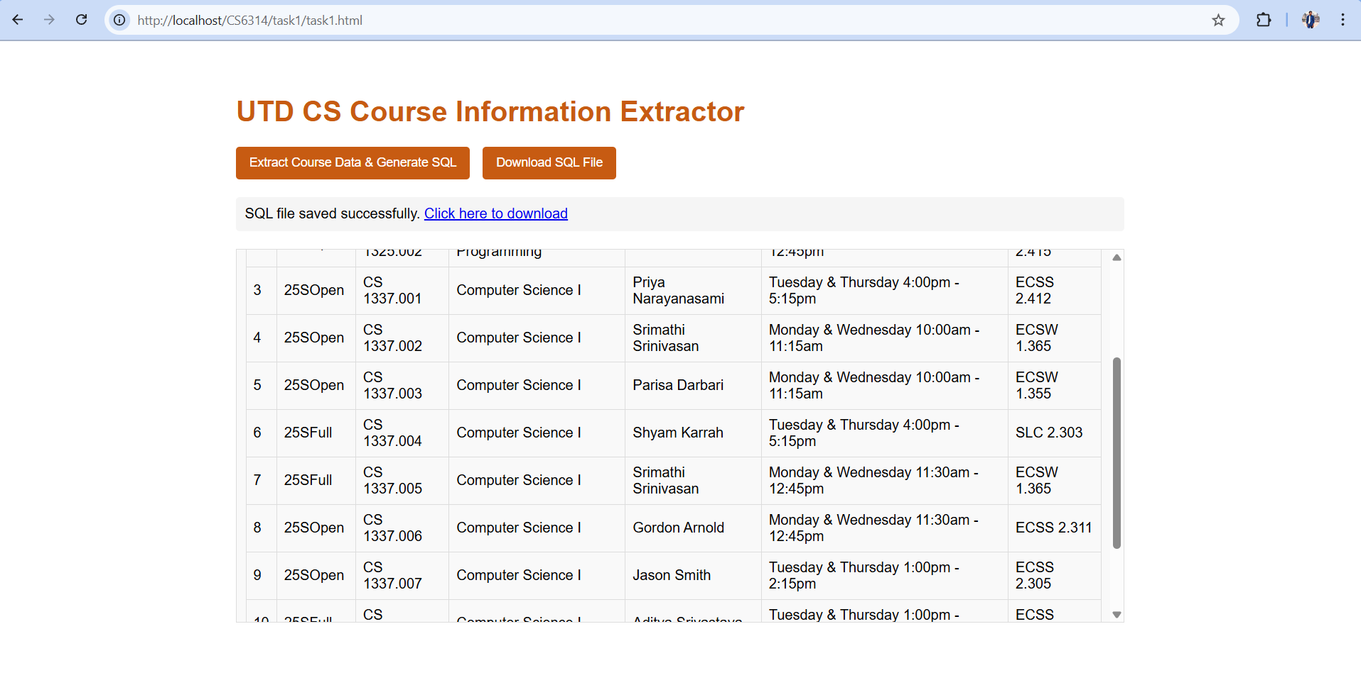

1.2.6 After clicking Download SQL File it will download the file in the same directory as the html code.

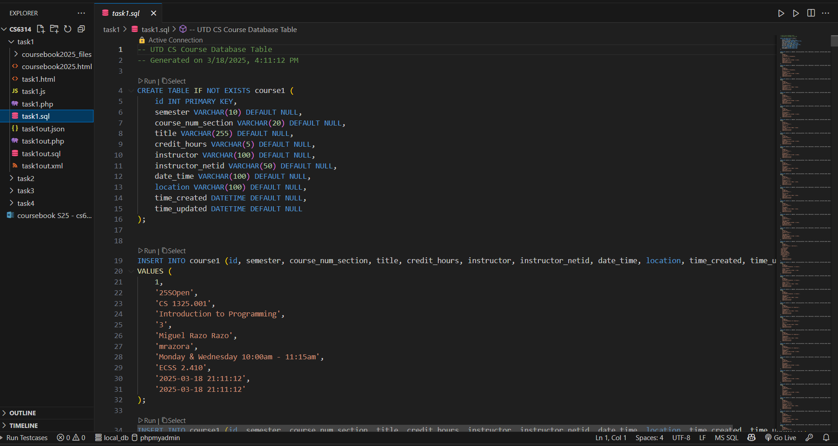

1.2.7 We can see task1.sql in the directory

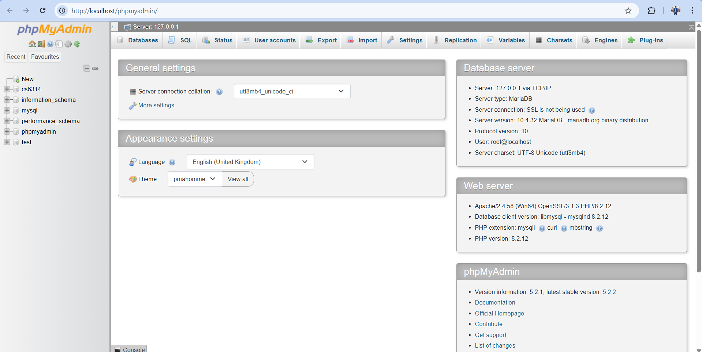

1.2.8 phpMyAdmin page

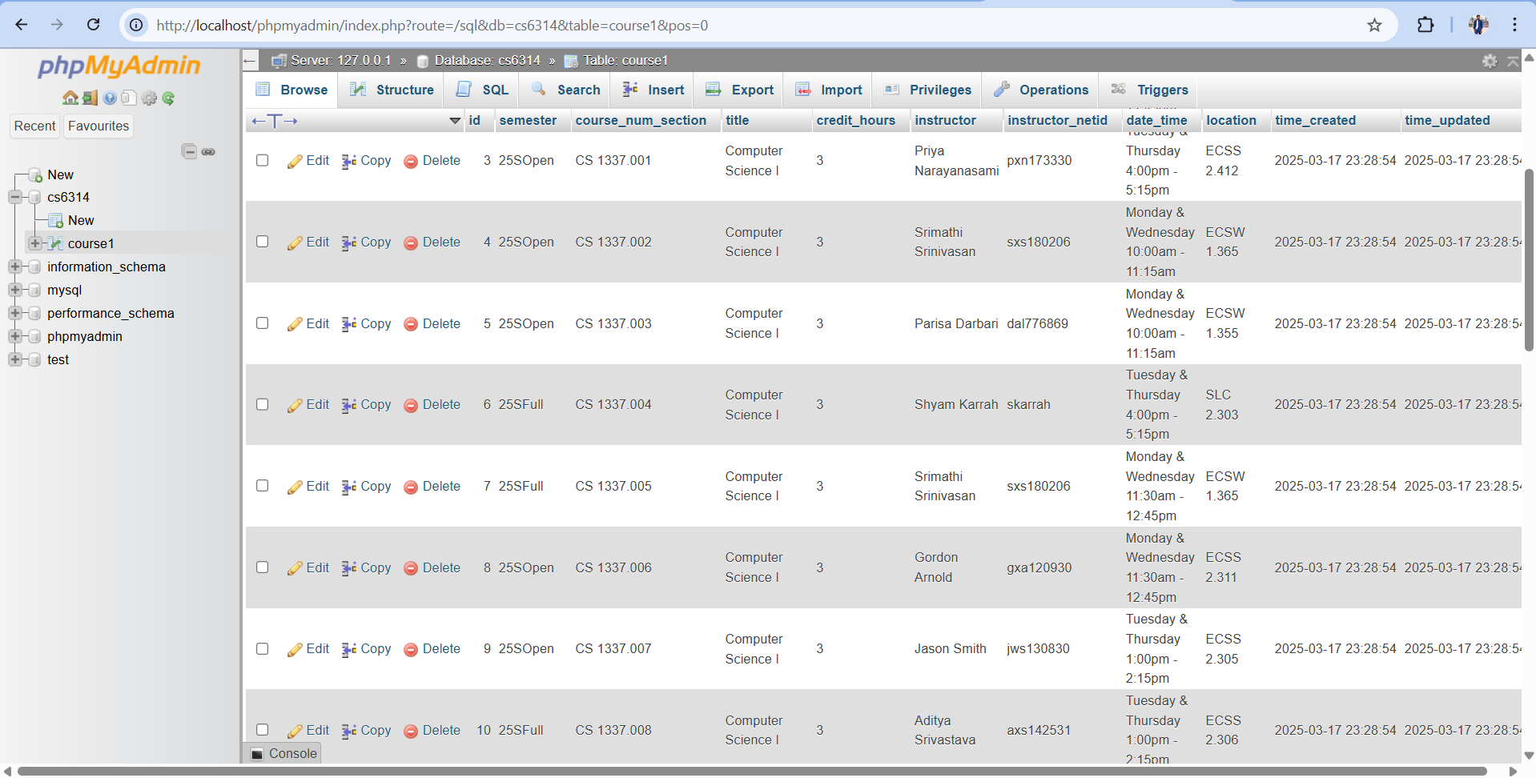

1.2.9 Create CS6314 and importing task1.sql

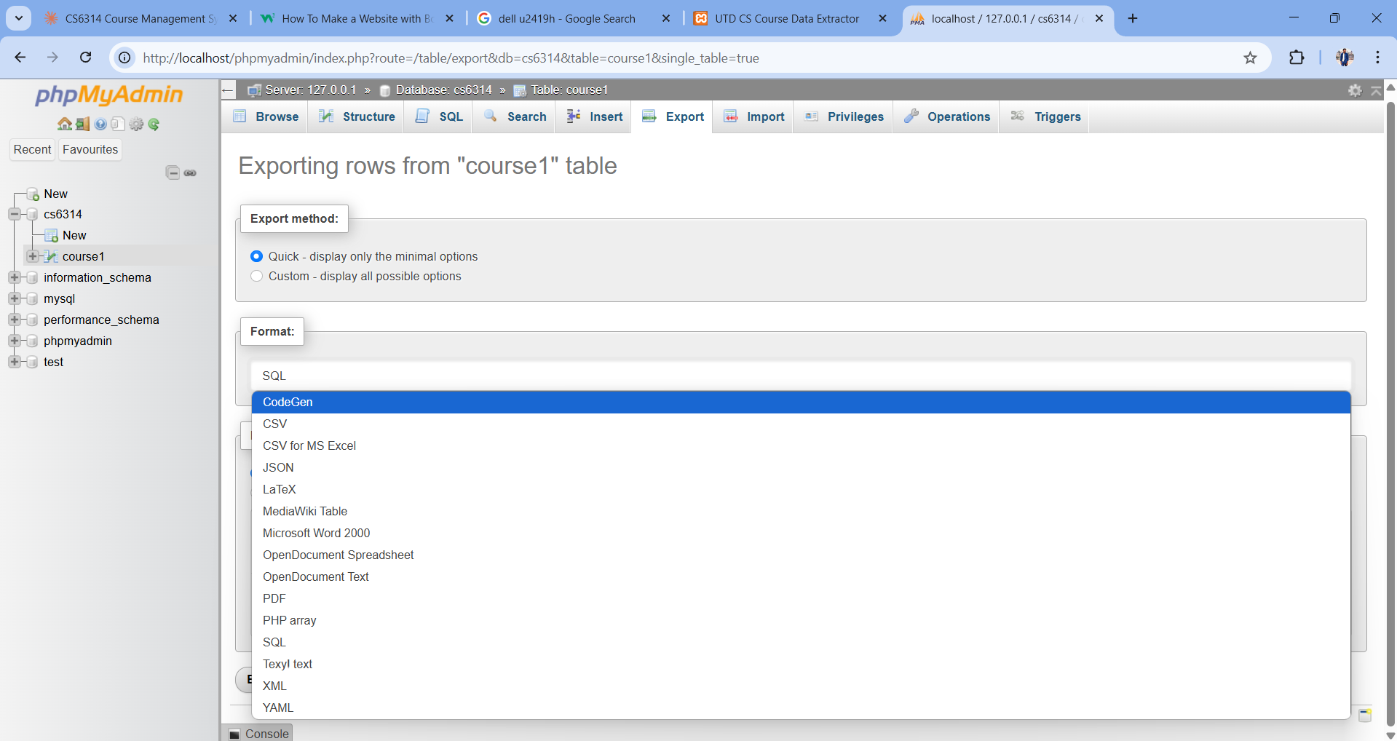

1.2.10 Exporting course1to xml, php, json, and sql format

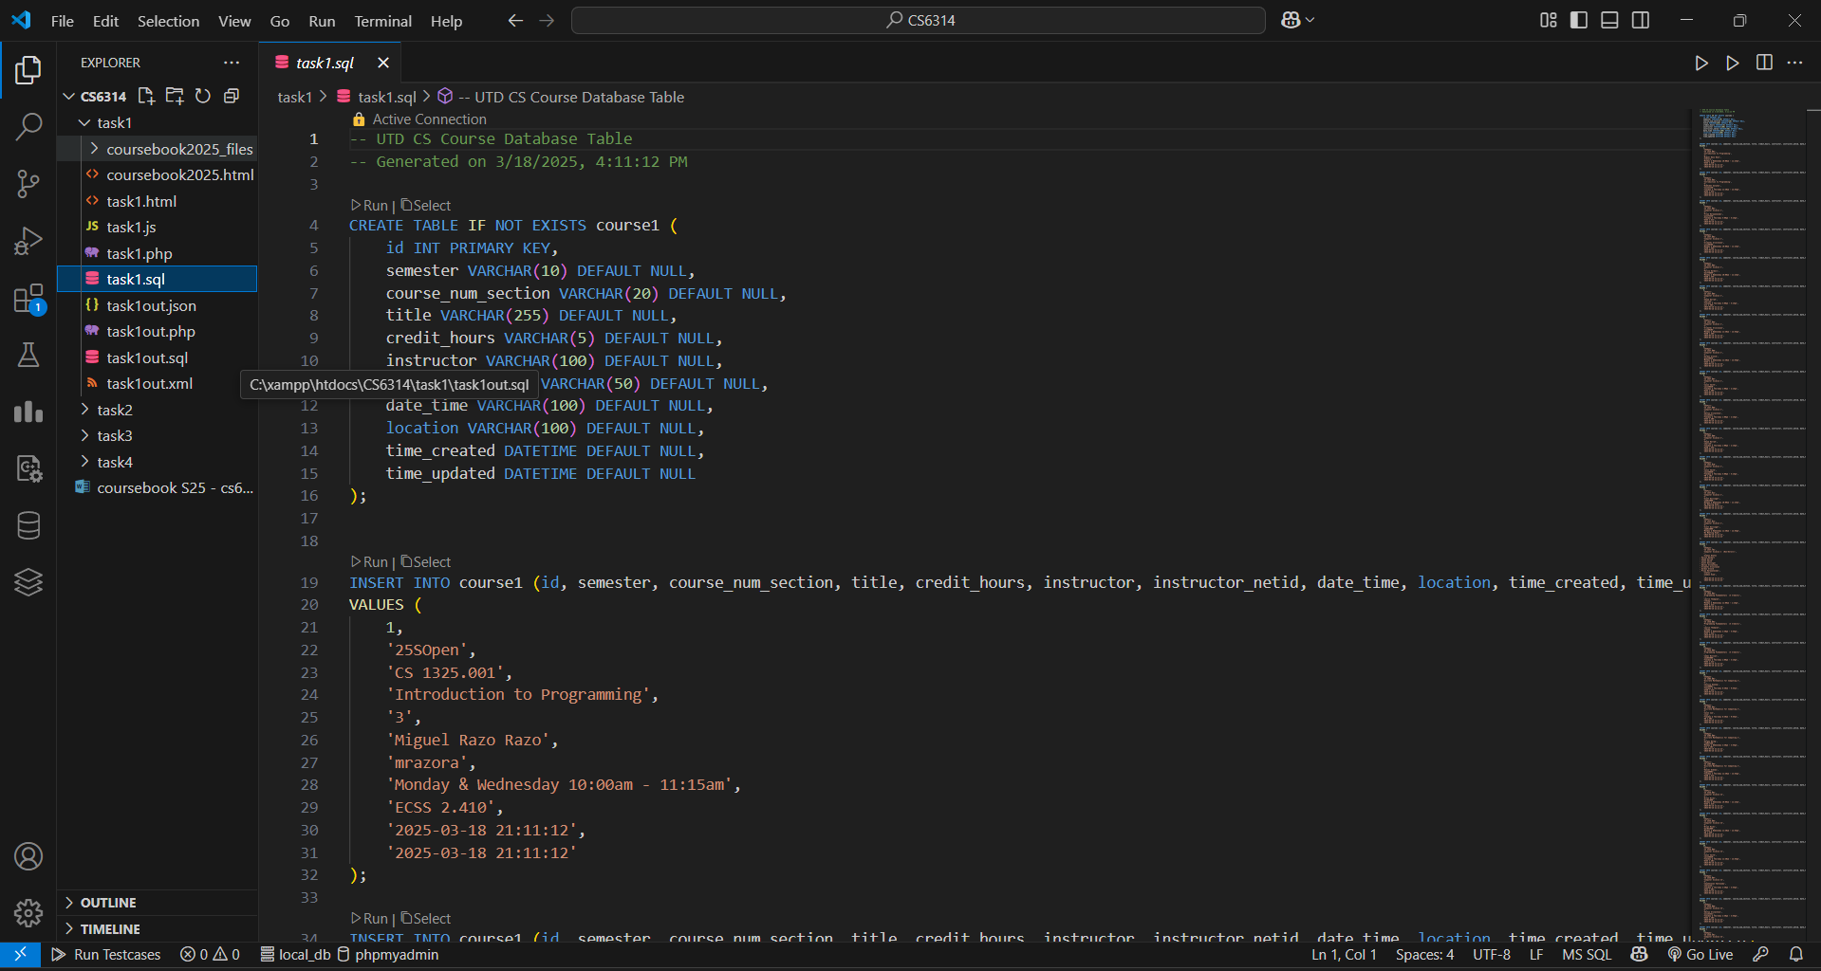

1.2.11 You can see json, php, sql and xml file