**Name: Yash Mahendrakumar Wani**

**Net ID: yxw230008**

**Web Programming Language**

**Project - Task 3**



3.3.1 Created Header Section



3.3.2 Created Navigation

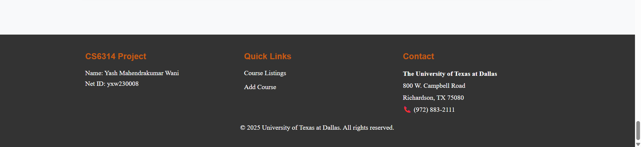

3.3.3 Created Footer

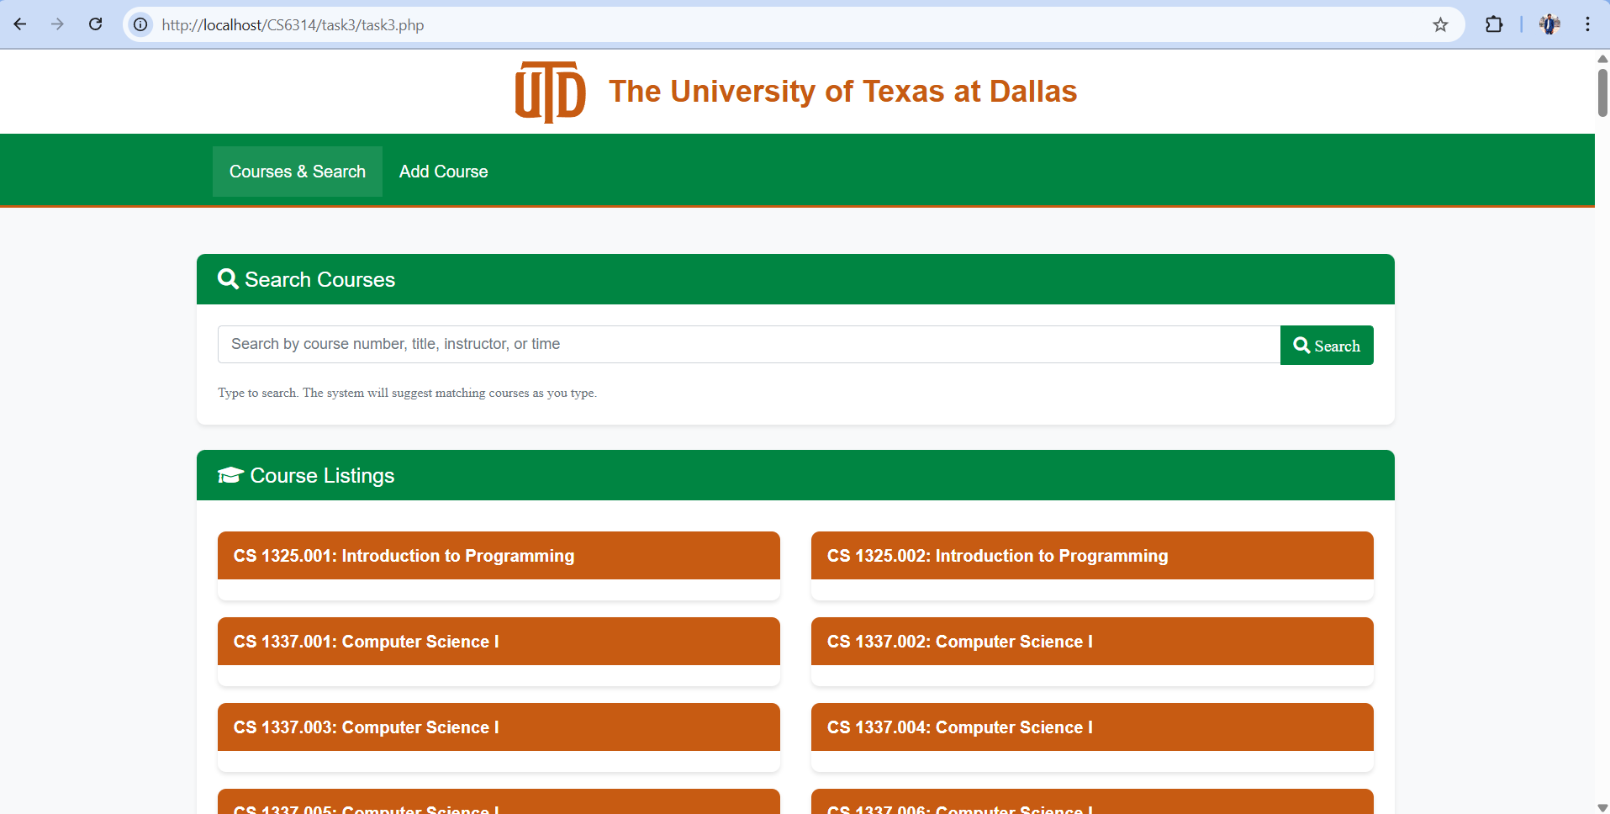

3.3.4 The complete Page View

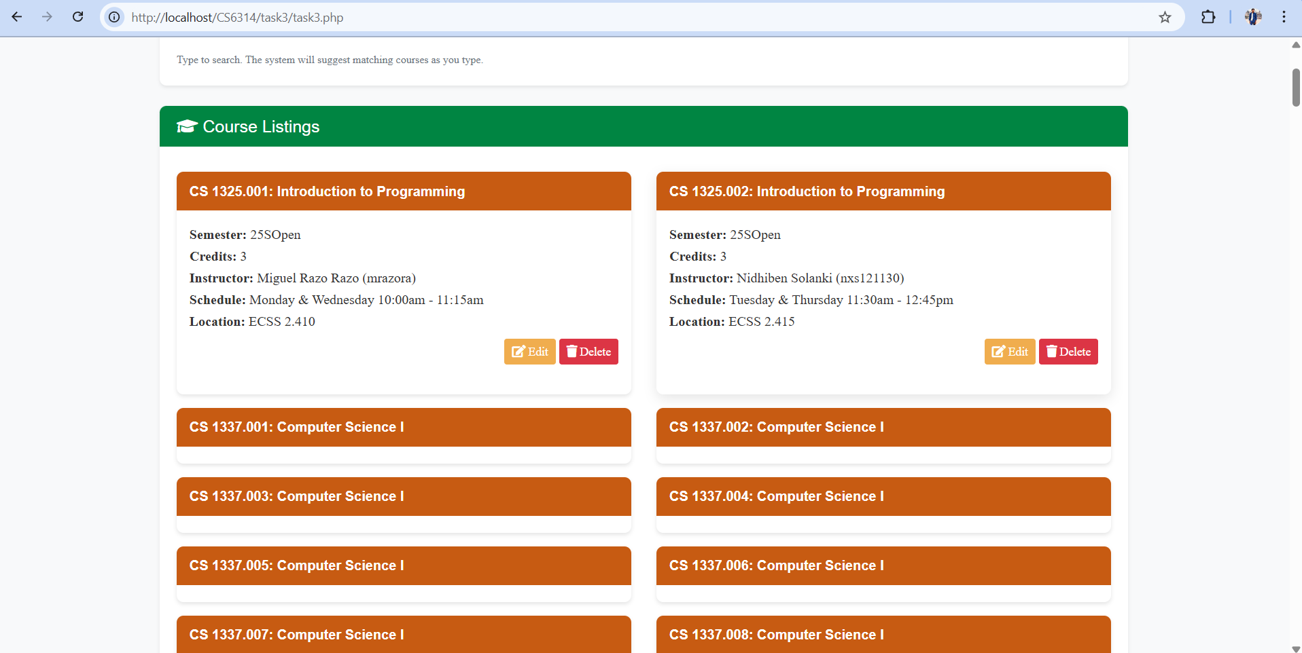

3.3.5 When we click on the course title the description of the course maximizes and clicking again will minimize

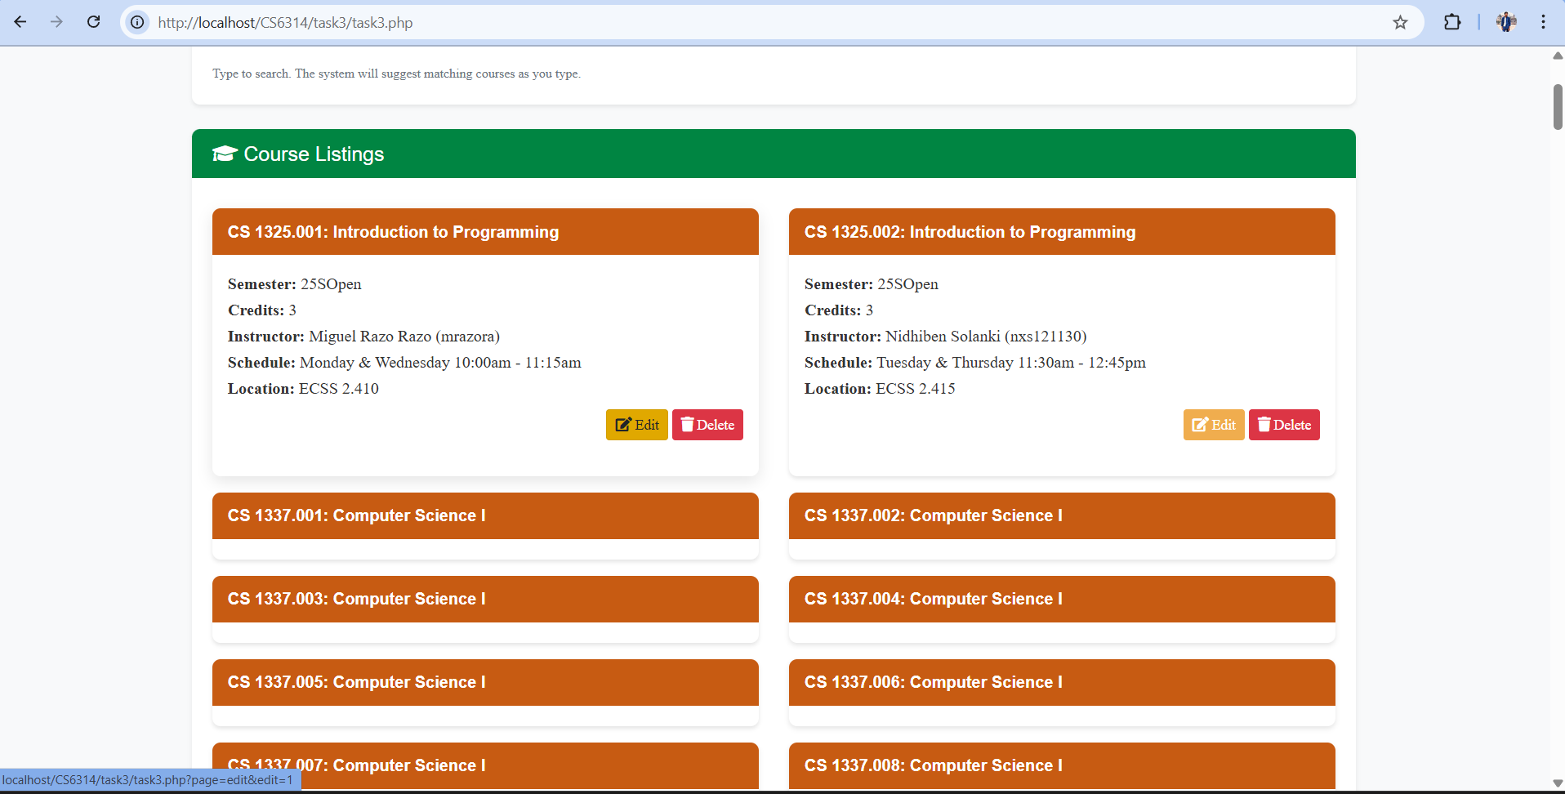

3.3.6 We have edit and delete options there itself.

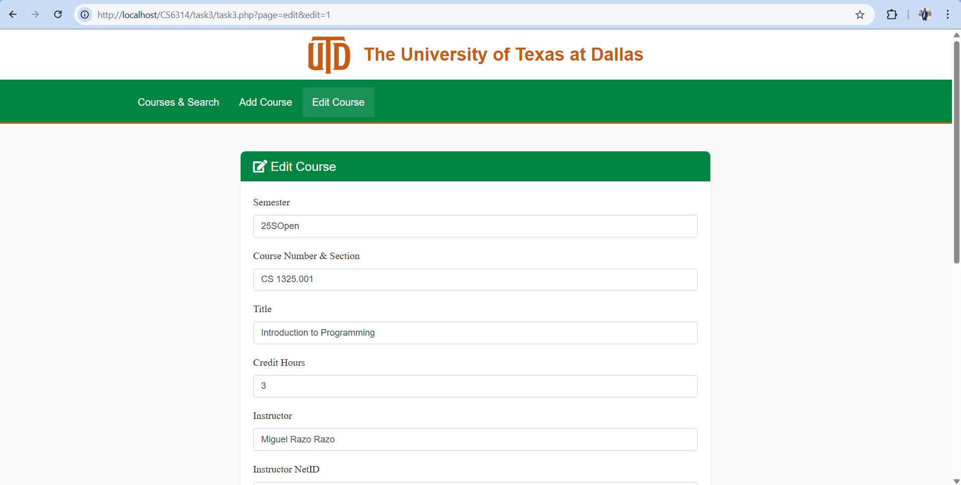

3.3.7 Once we click Edit a new navigation tab is made to make the changes.

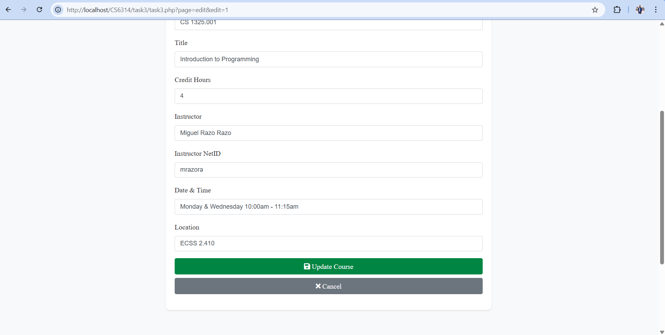

3.3.8 we will change the credit hours to 4 and press ‘Update Course’

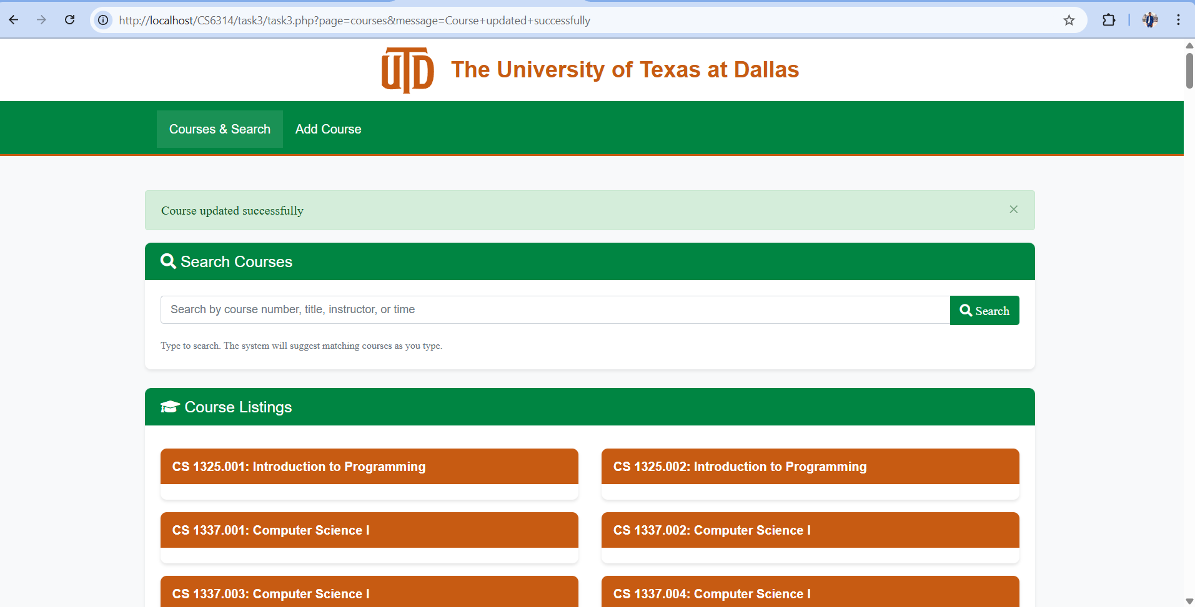

3.3.9 Once we update the course, we will see the notification for time being

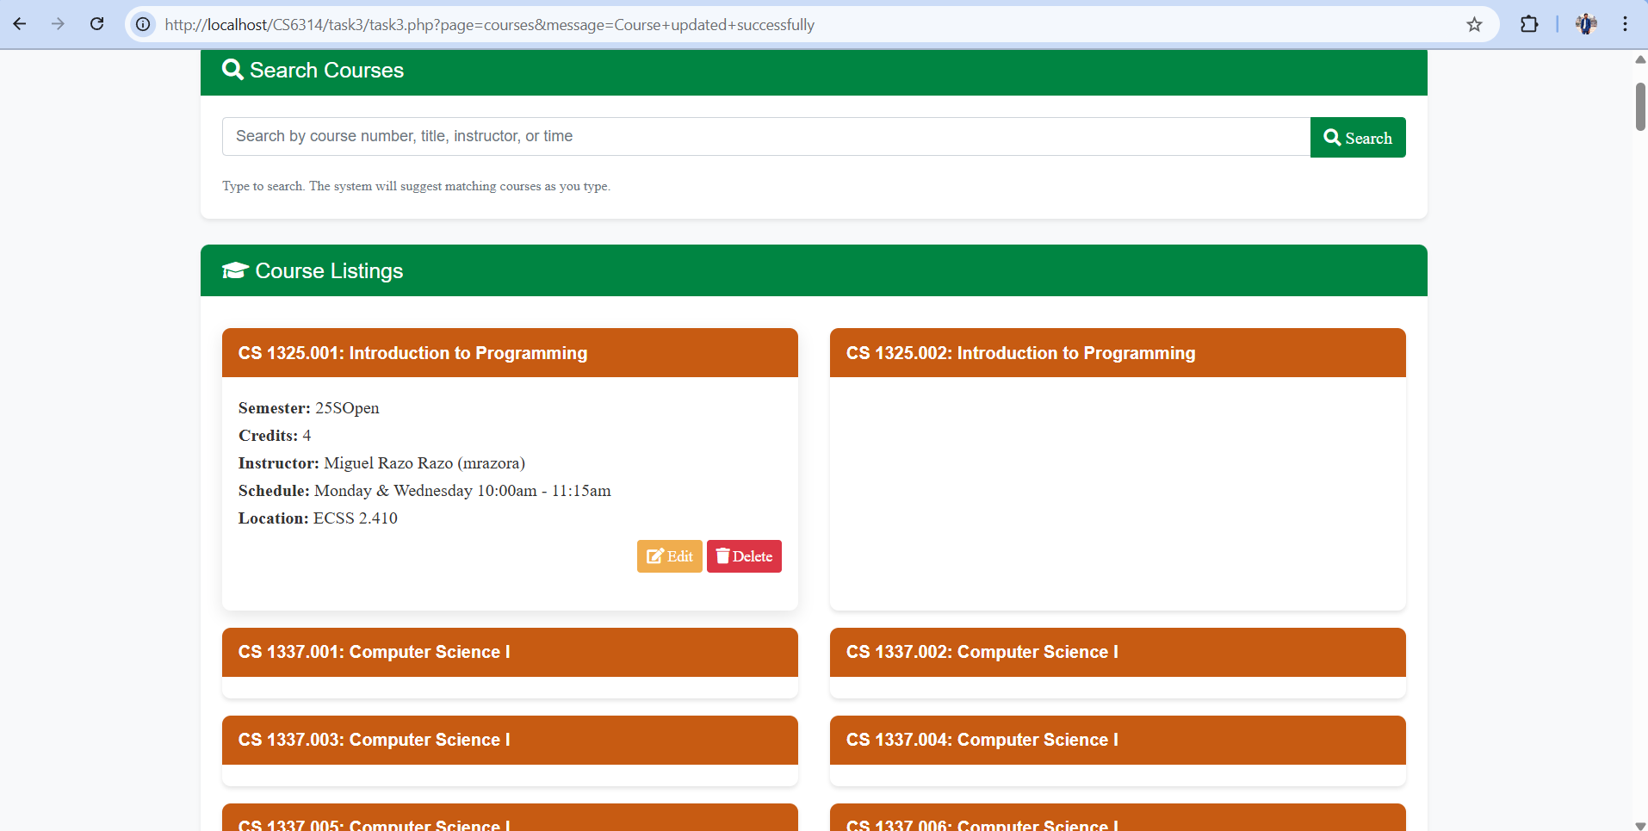

3.3.10 You can see the change in the credits

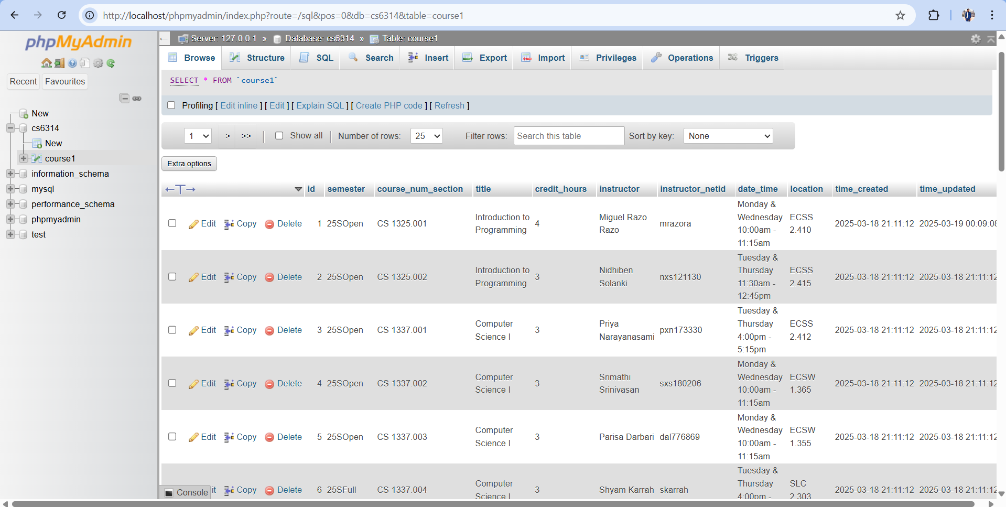

3.3.11 Changes can be noticed in database

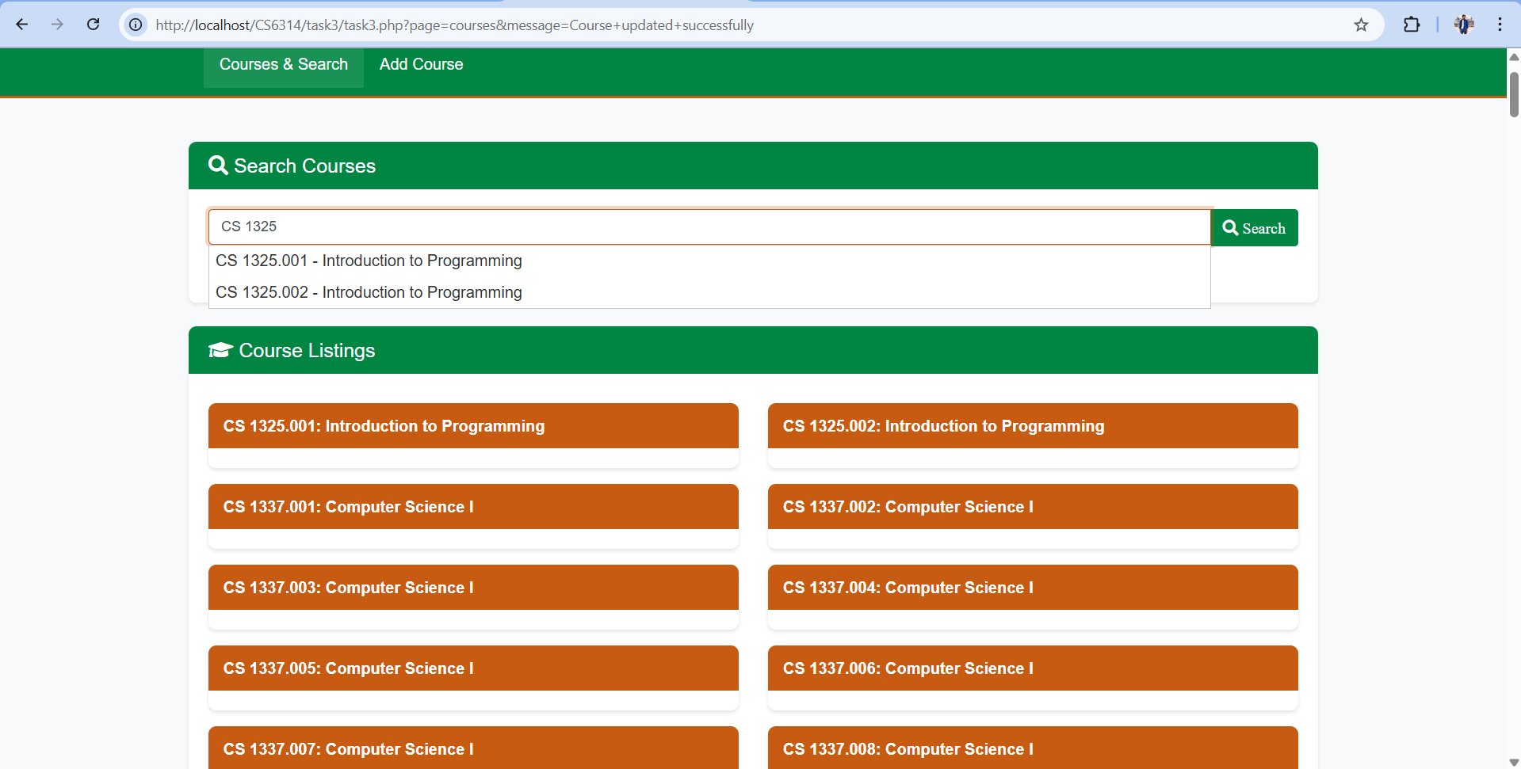

3.3.12 For the search section we can see the suggestion.

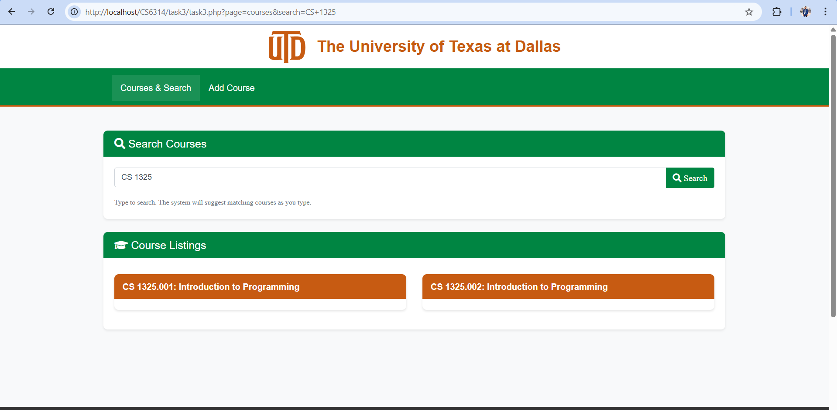

3.3.13 After clicking search only valid options will be displayed.

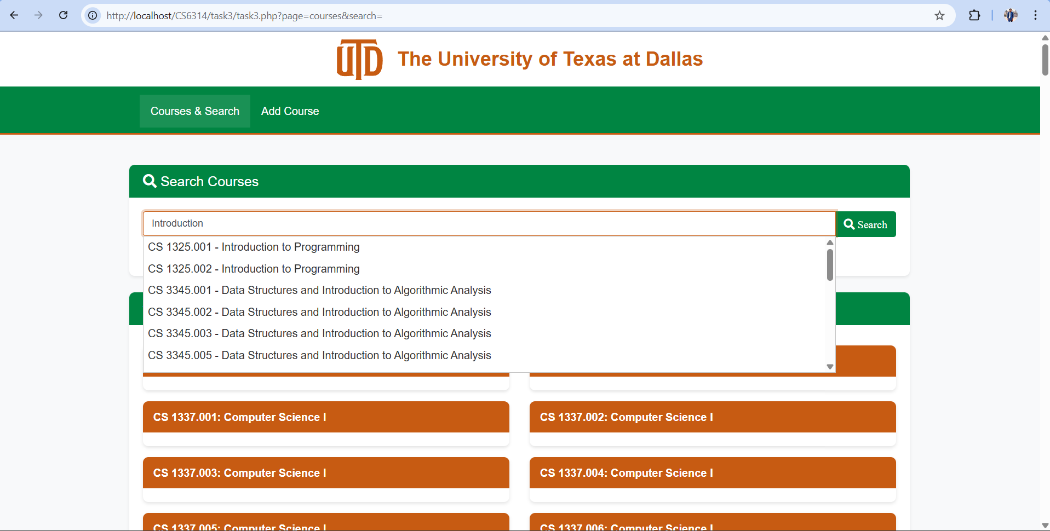

3.3.14 We can search by Title as well.

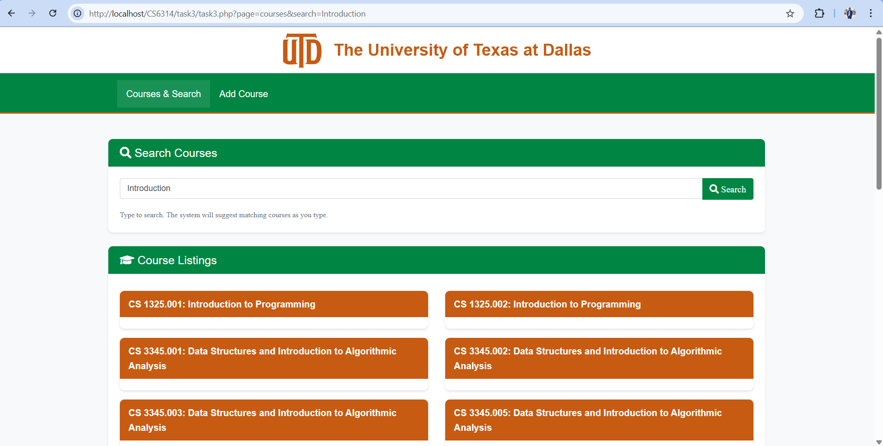

3.3.15 All courses will be displayed which has ‘Introduction’ word in title

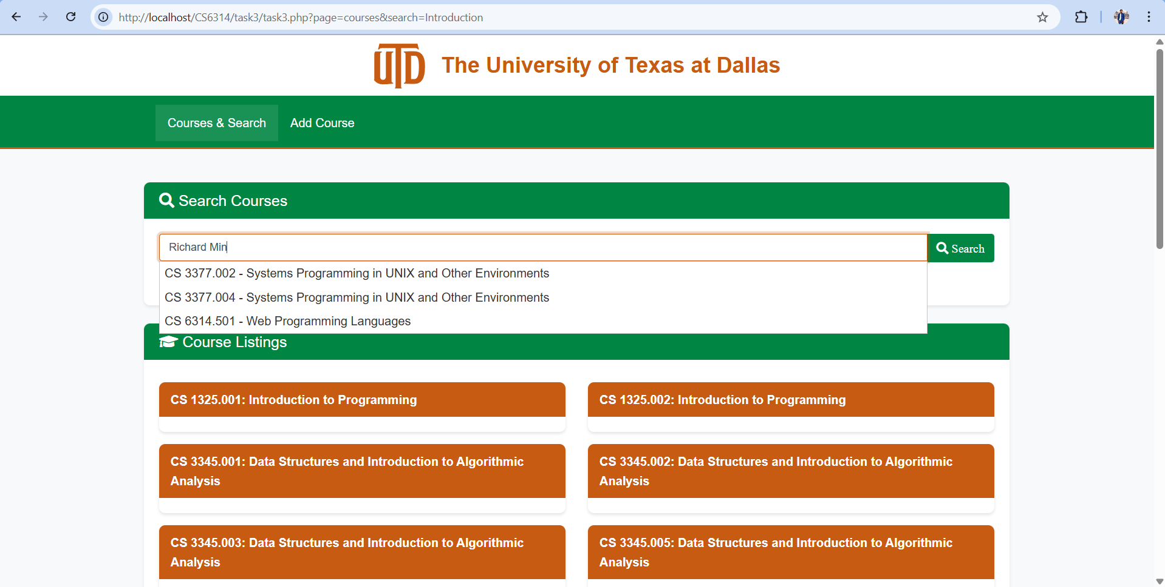

3.3.16 We can search by the name of the professor

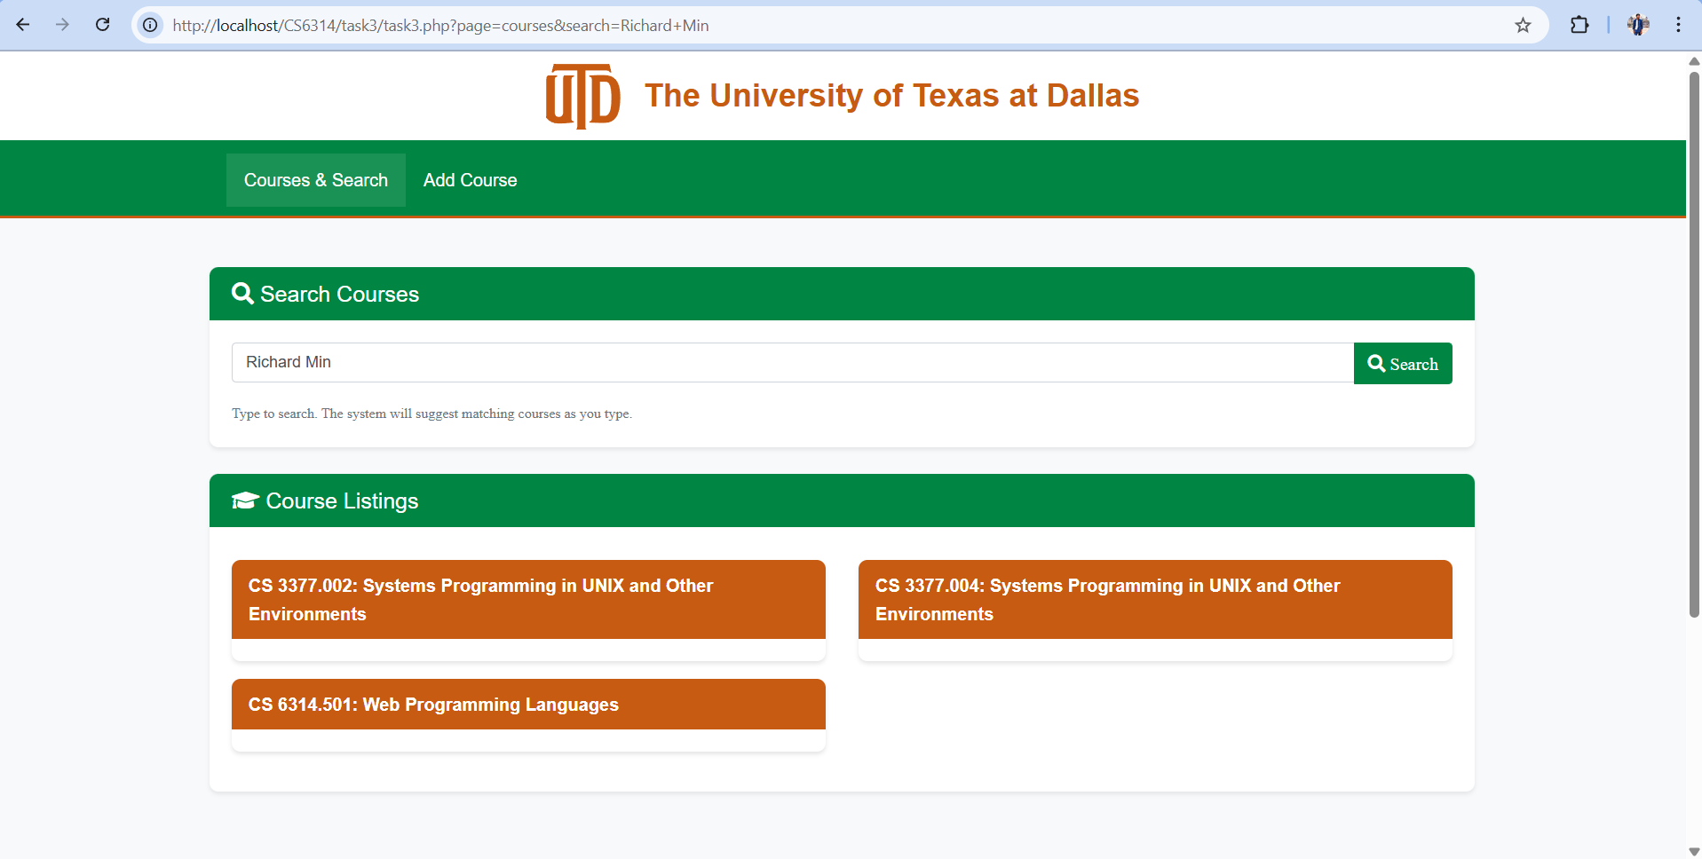

3.3.17 All the courses taken by the professor will be displayed

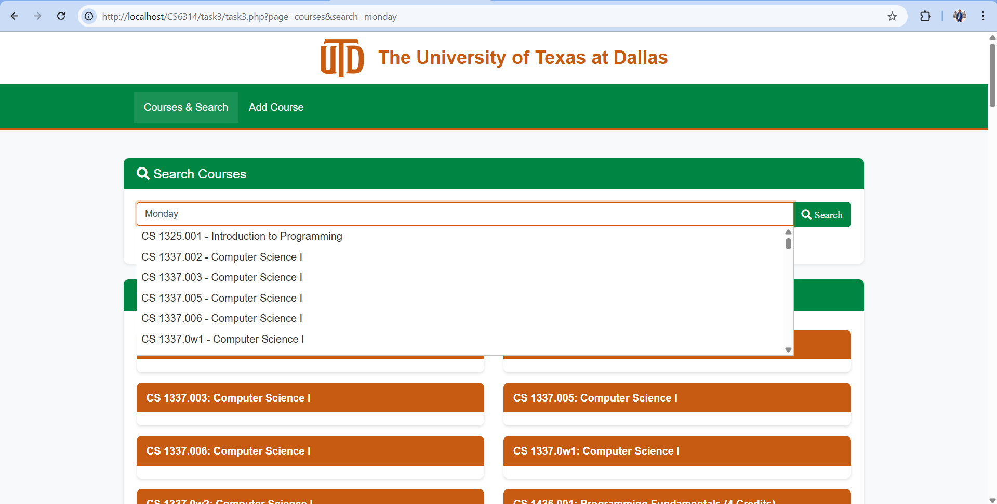

3.3.18 We can search for the courses by Days as well

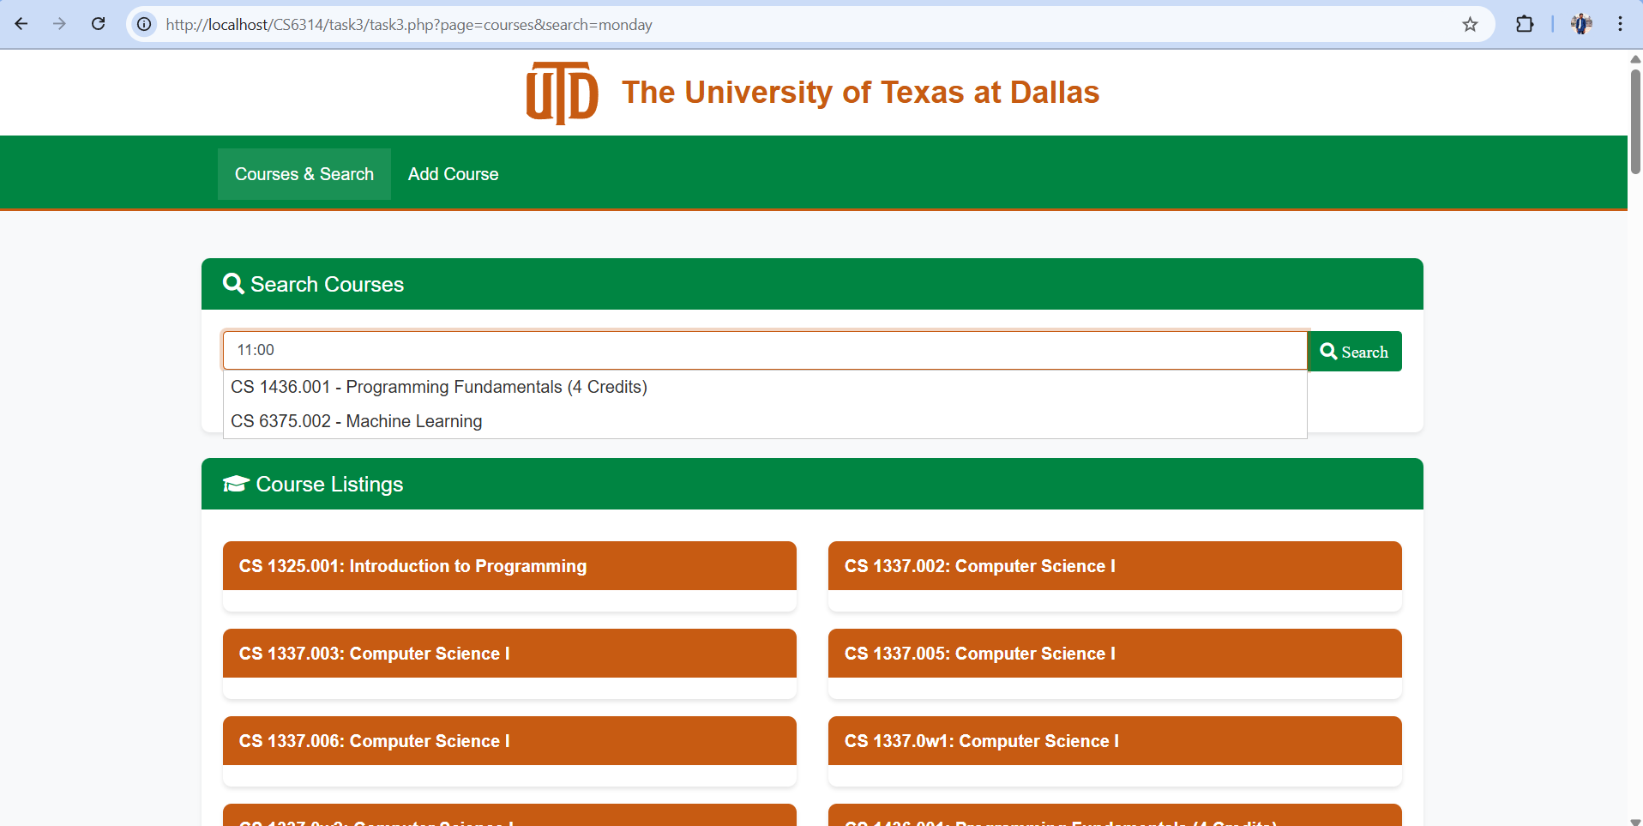

3.3.19 We can search for the courses on time as well

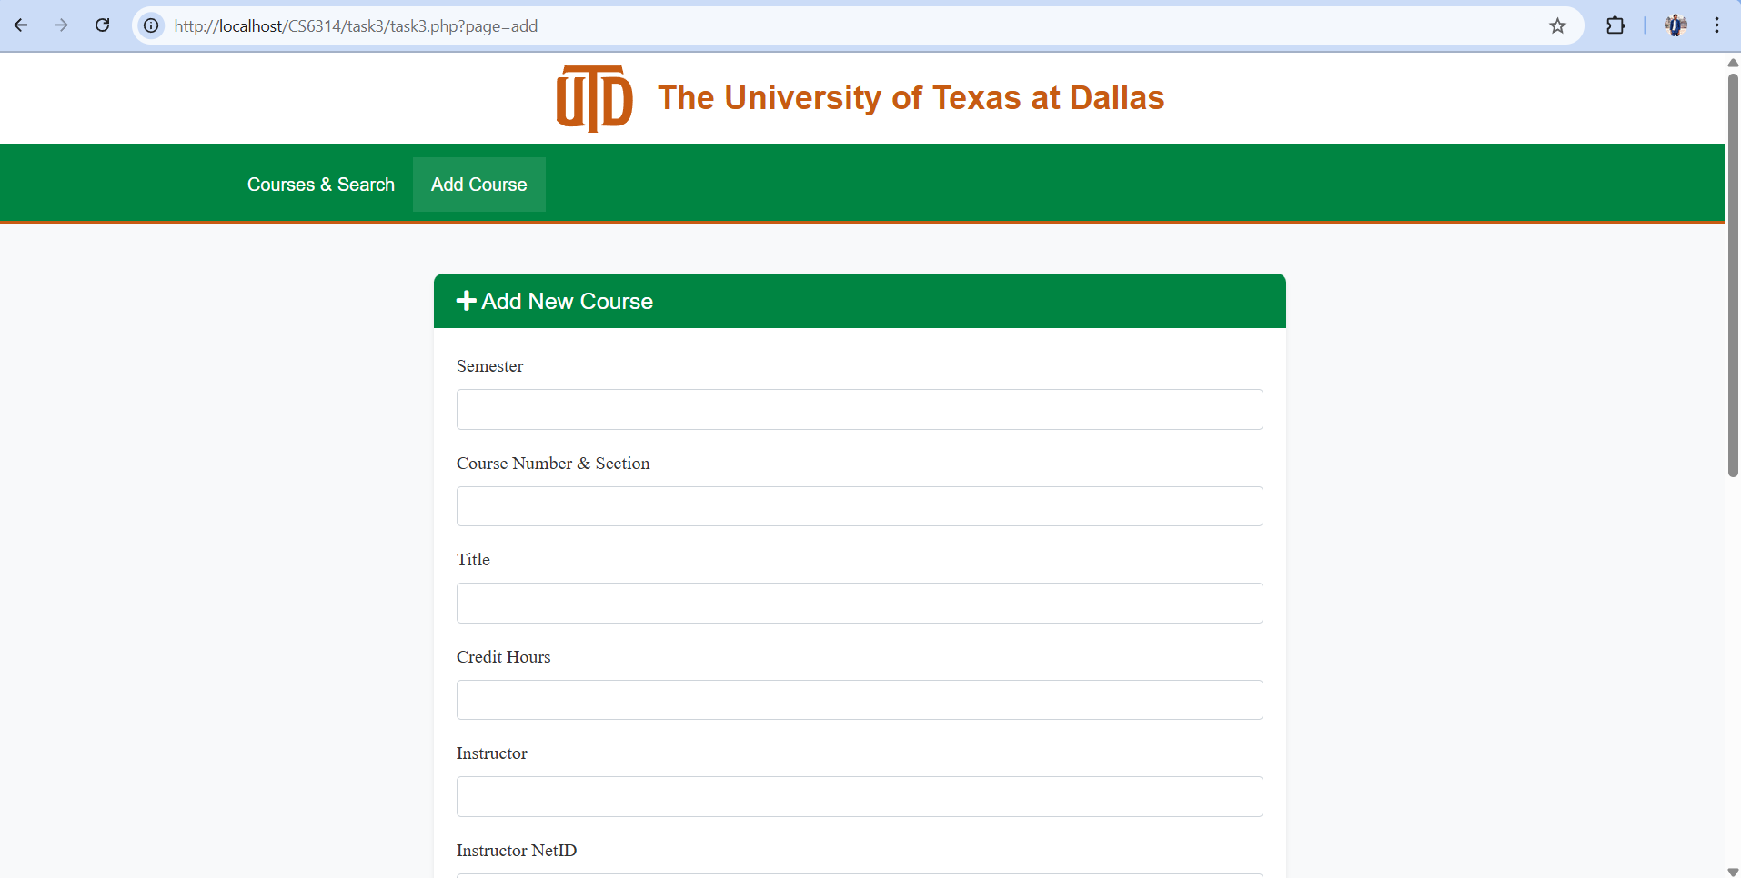

3.3.20 We can add the course by navigating to ‘Add Course’ section

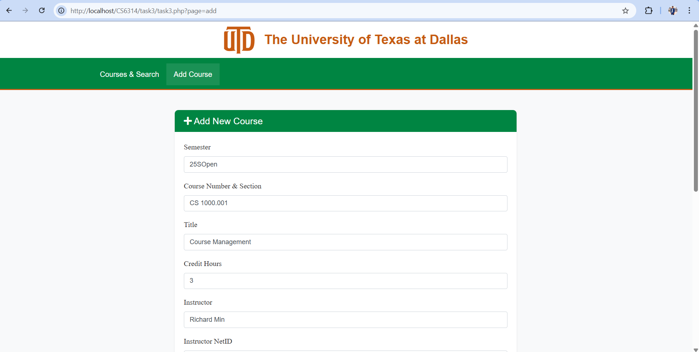

3.3.21 Added the details in the section

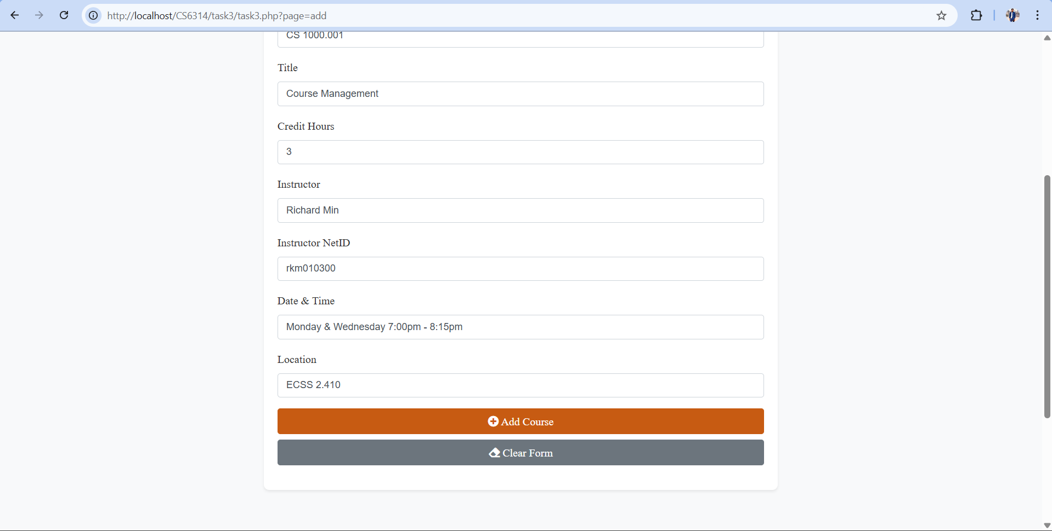

3.3.22 Press ‘Add Course’ to save the course

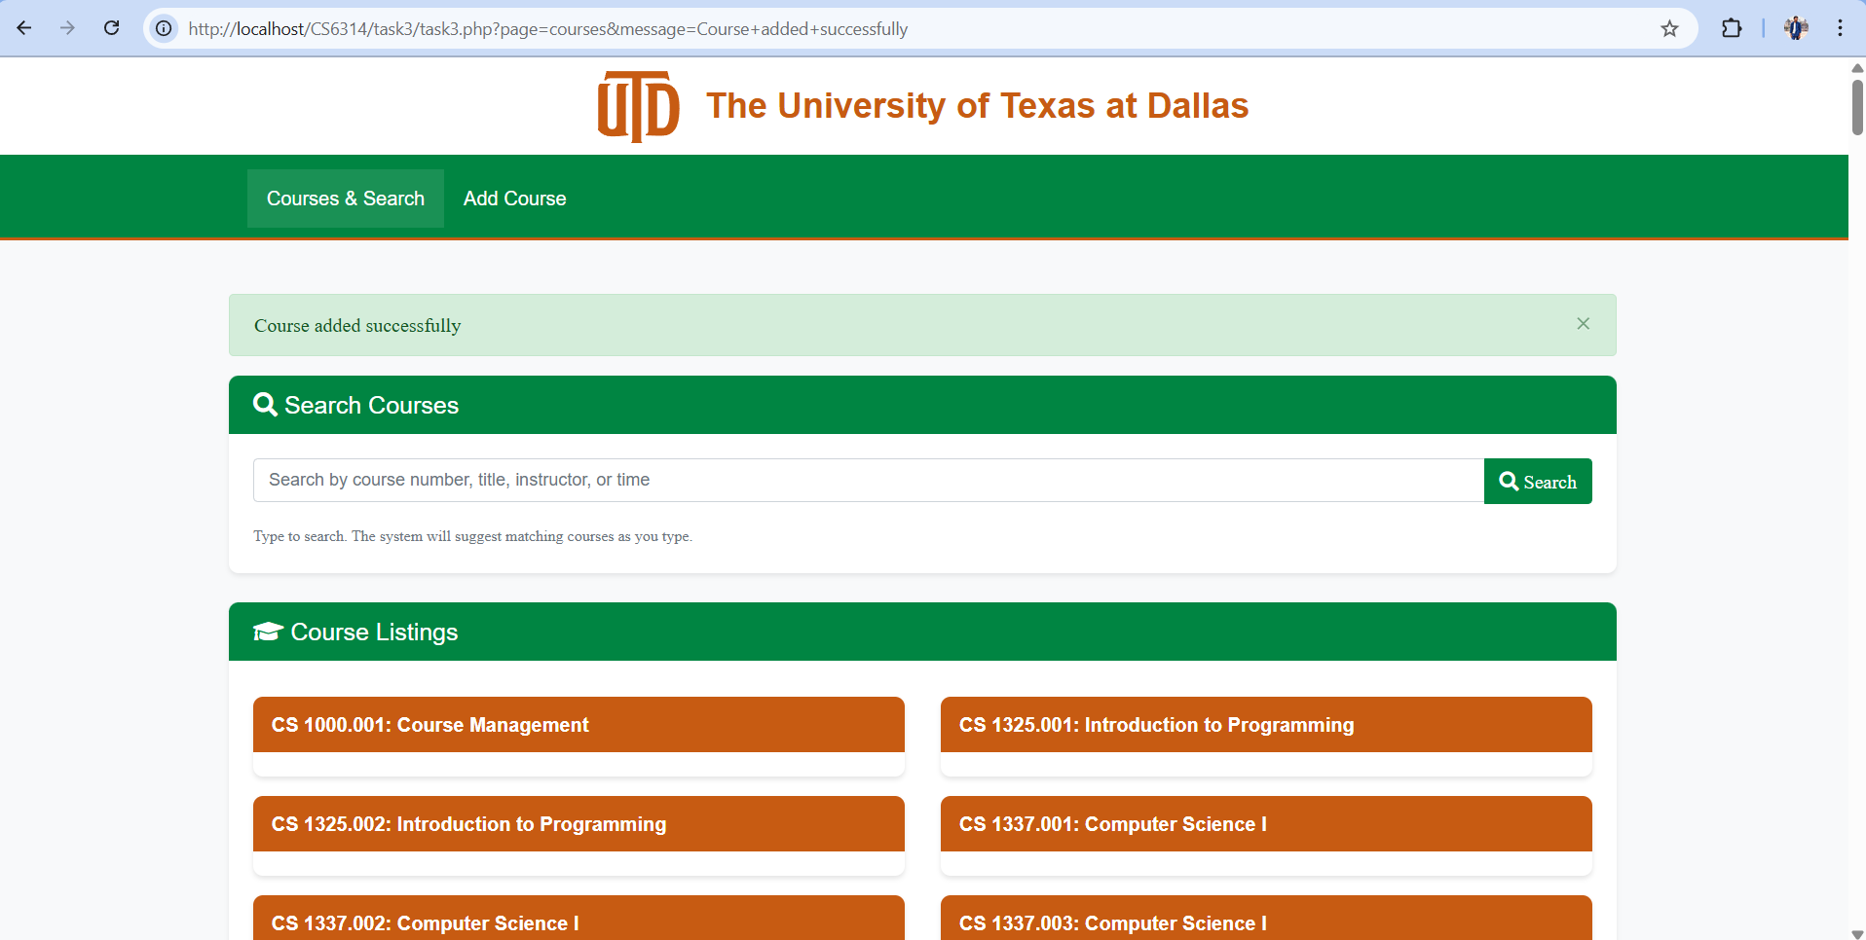

3.3.23 We will get notification for while and we can see the course in listings

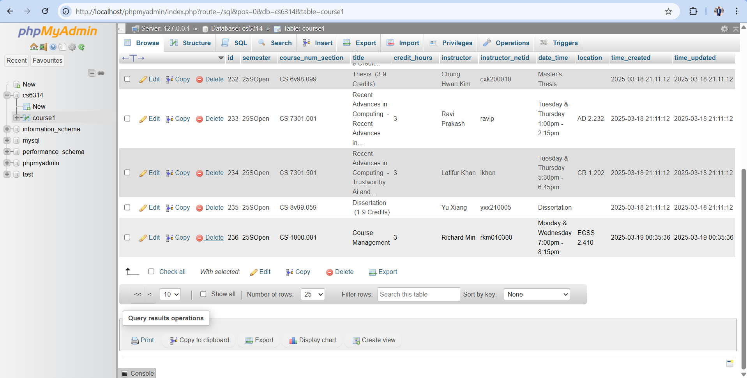

3.3.24 Database is updated

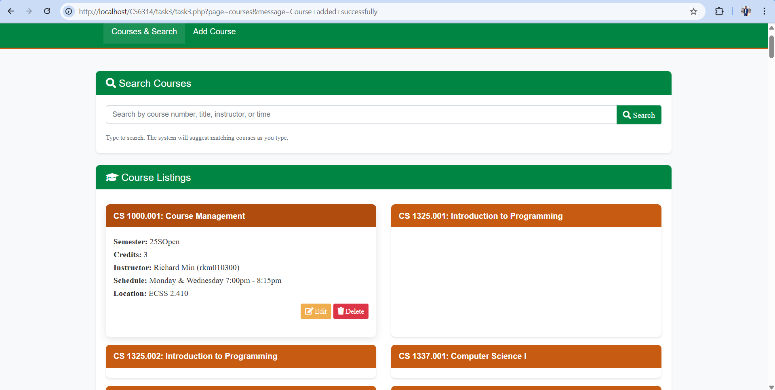

3.3.25 Now we will delete the course

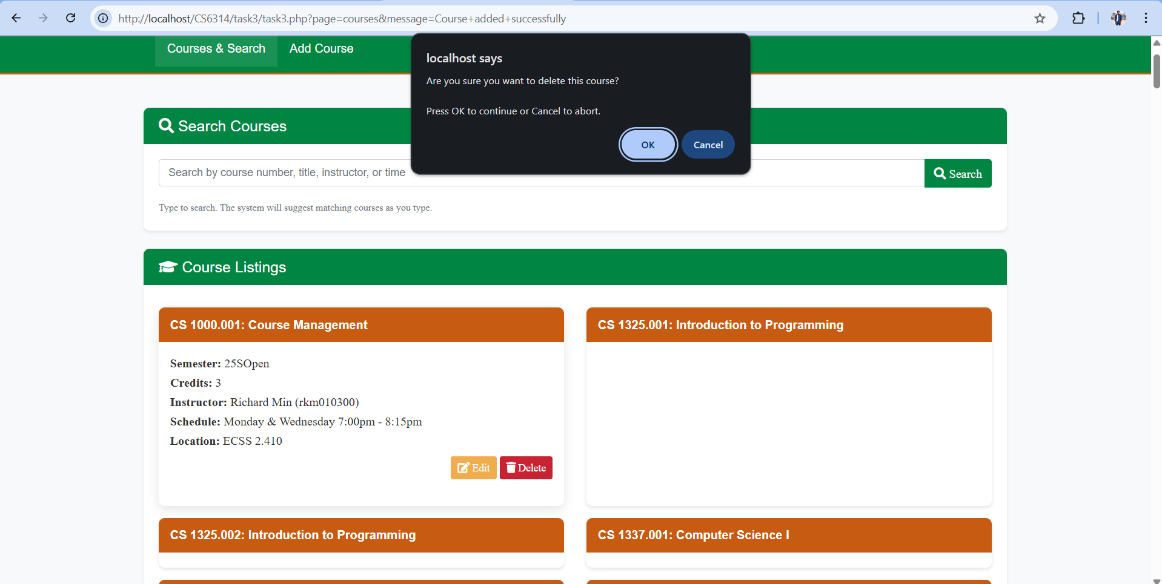

3.3.26 Warning before deleting the course

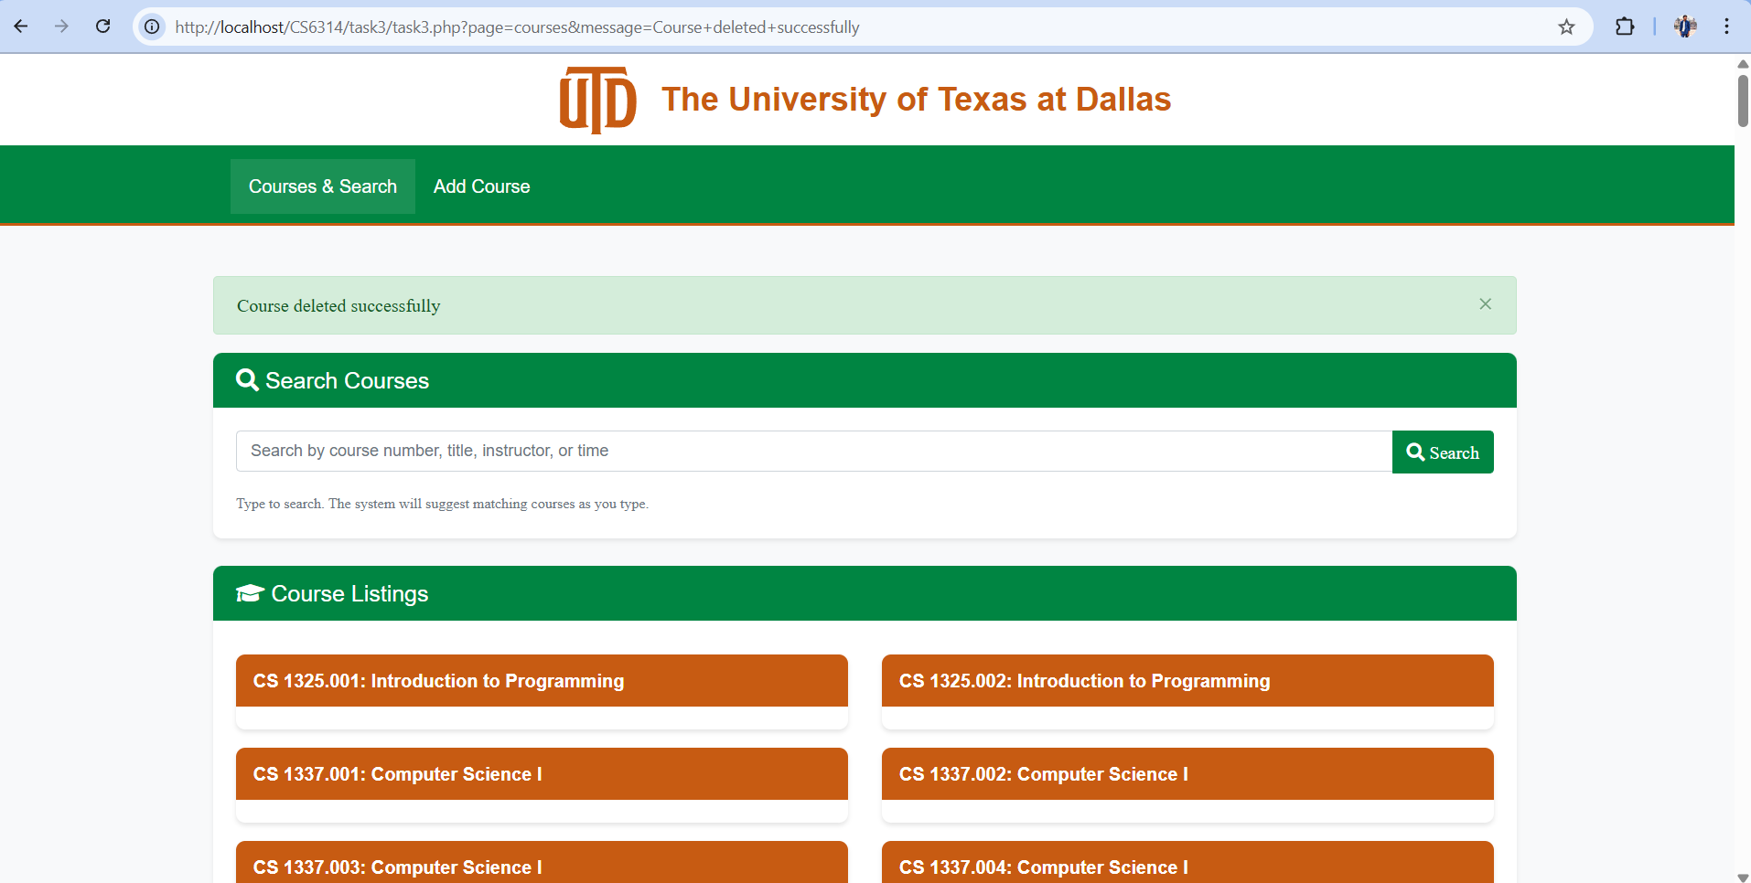

3.3.27 After clicking ‘Ok’ the course will be deleted

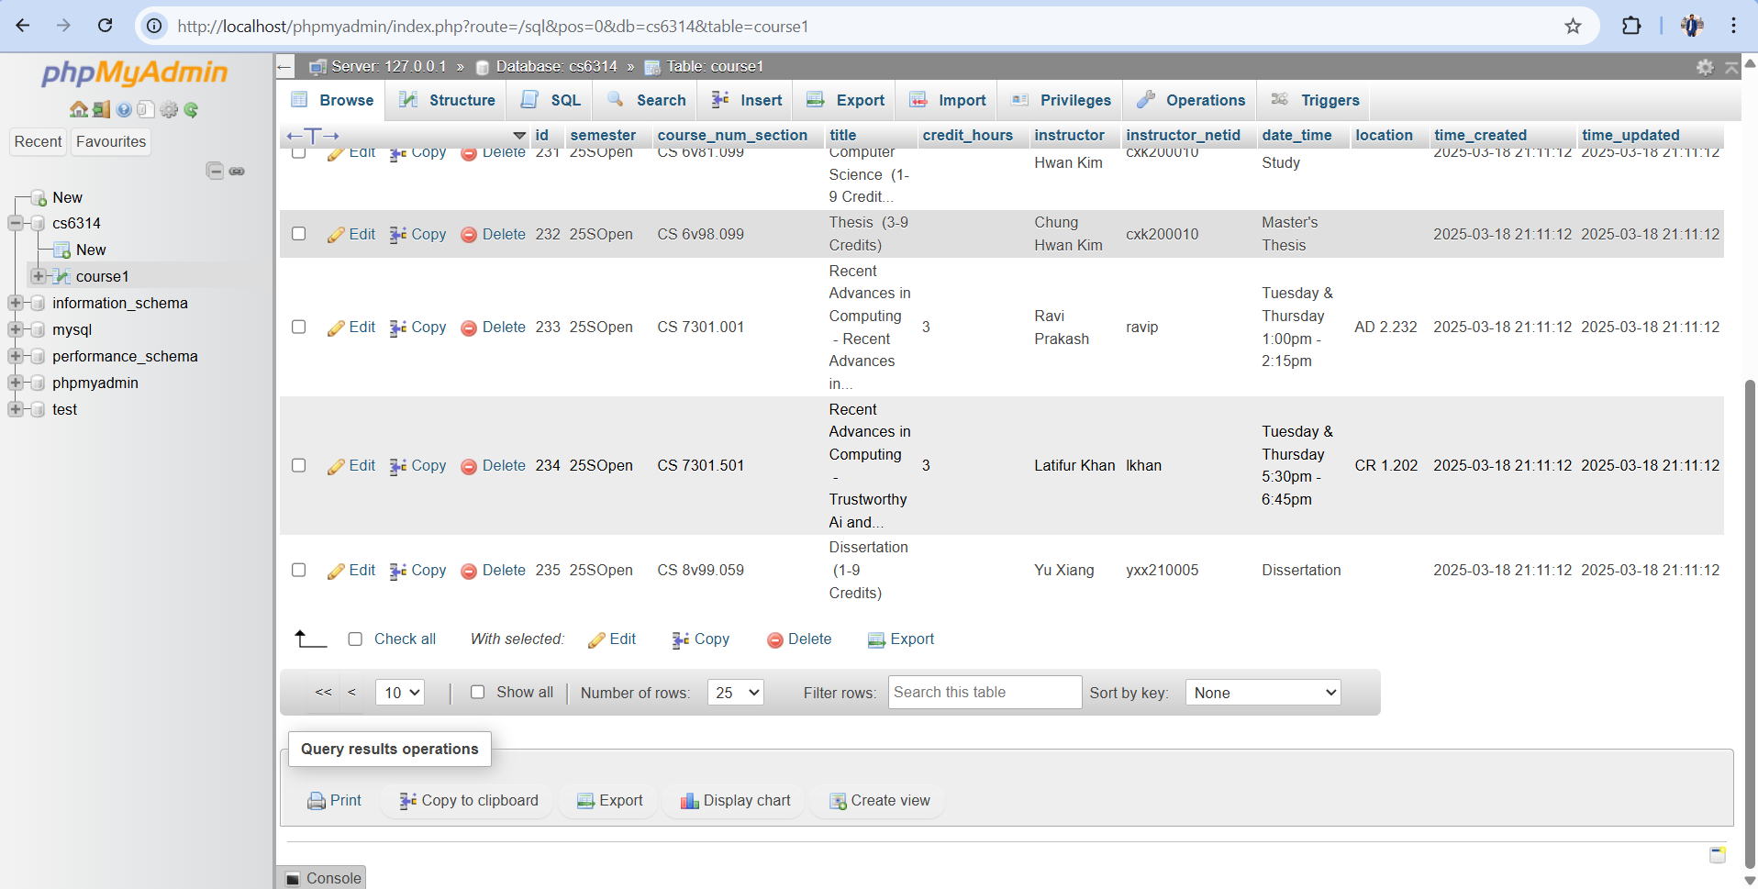

3.3.28 The course has been deleted from the database.