**TABLE OF CONTENTS**

**Chapter Page No**

**1 Introduction 7**

**1.1 Motivation 7**

**1.2 Objectives 7**

**2. Literature Survey 8**

**3. System Analysis and Design 8**

**4. System Requirements 14**

**4.1 Hardware Requirements 14**

**4.2 Software Requirements 15**

**5. Results 16**

**6. Applications 17**

**7. Conclusion 17**

**Future Enhancement 17**

**References 18**

**LIST OF FIGURES**

**Figure No. Figure Caption page. No.**

1. **Pulse Diagram 9**
2. **VISUALISATION OF OUR DESIGN. 9**
3. **LED and Arduino UNO 14**
4. **Sender Terminal 15**
5. **Receiver Terminal 16**
6. **Proof of Concept 16**

**ABSTRACT**

In present scenario, Radio waves are being used in communication systems. These Radio channels are getting crowded and causes interference leading to reduced bandwidth and increased latency. Visible Light Spectrum has higher bandwidth well defined channels which can be used to transmit data with higher bandwidth and efficiency.

Li-Fi is a technology for wireless communication between devices using light to transmit data. In its present state LED lamps can be used for the transmission of visible light sending data through a LED light bulb that varies in intensity faster than human eye can follow.

Like Wi-Fi, Li-Fi is wireless and uses similar 802.11 protocols, but it uses ultraviolet, infrared and visible light communication (instead of radio frequency waves), which has much bigger bandwidth. Li-Fi is ideal for high density wireless data coverage in confined area and for relieving radio interference issues.

Li-Fi comprises a wide range of frequencies and wavelengths, from the infrared through visible and down to the ultraviolet spectrum.

**INTRODUCTION**

The LED light in a room is used not just to light up the room but also provide wireless communication. Using Arduino data is modulated and sent across using a common LED bulb to another Arduino where it can process the data and display it on a computer screen. This shows a proof of concept of LiFi.

* 1. **MOTIVATION**

With a significant increase in data consumption, especially in the wireless medium, there is a clear need to provide an alternative to the current radio-based communications. Radio channels are not enough to meet the future demands if current trends in internet usage are to be considered.

Visible light as a medium is such a candidate due to higher bandwidth, its harmless nature and localised, hence secure coverage it is a good demonstration of what is to come in fast evolving world of technology.

* 1. **OBJECTIVES**
* The main objective of the project is to demonstrate a proof of concept of Li-Fi (Light Based Communication).
* Communication is visible
* No radio waves
* Reuses already existing components
* Low-complexity
* Use existing wireless protocols and build upon them.
* Use of inexpensive components.

1. **LITERATURE SURVEY**

We reviewed many things on the internet to know more and more things about LI-FI. We saw a ted talk based on this technology where he streams a high definition video on a screen using li-fi. we came to know that some researchers at oxford have reached the speeds of 224 Gbps. you would be interested to know that there is an office in Paris where the internet is provided by li-fi. We also came to know that prof harald hass from the university of Edinberg started working on li-fi from 2006 when he wrote a paper on it.

We came to know many advantages of wi-fi over li-fi. such as data security in li-fi as the data which is present in the light cannot pass through the walls of a room, it can send data faster than li-fi as its frequency range is greater than 1000times that of radio-waves, as radio-waves are harmful at petrol pump and some hospitals, li-fi can be used as it is not harmful as it is only visible light.

Then we came to know that this is an underrated technology and this is the future, due to lack in technology we are not able to make li-fi work at its potential. so, we chose this as our mini project.

In this project we are going to show the basic technology on which this li-fi technology works on. And We are going to send data bit by bit using simple LED’s and send data serially.

3. **SYSTEM ANALYSIS AND DESIGN**

* Arduino Uno microcontroller for encoding and decoding.
* Use of an Led as a receiver as well as a transmitter.
* Led is pulse width modulated to represent a ‘0’ and ‘1’.
* Using amplitude modulation using light for a proof of concept.
* Two LEDs are used one for data and one for clock.
* The clock runs at 10Hz.
* At the input terminal the text to be sent is entered.
* At the input side each character is converted to ASCII value.
* This ASCII value is read serially for every ‘1’ the LED is set HIGH and for every ‘0’ it is set LOW.
* At the receiver side the data led is read for every clock pulse.
* After 8 clock pulses the bits are recorded and converted to characters according to its ASCII value.
* The text is displayed on output terminal.

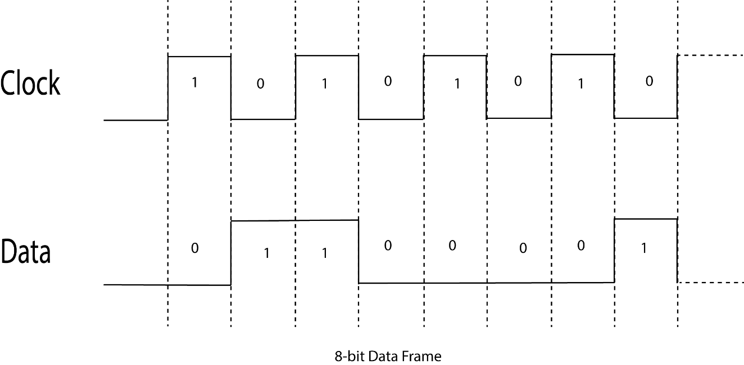

**FIG: Pulse Diagram**

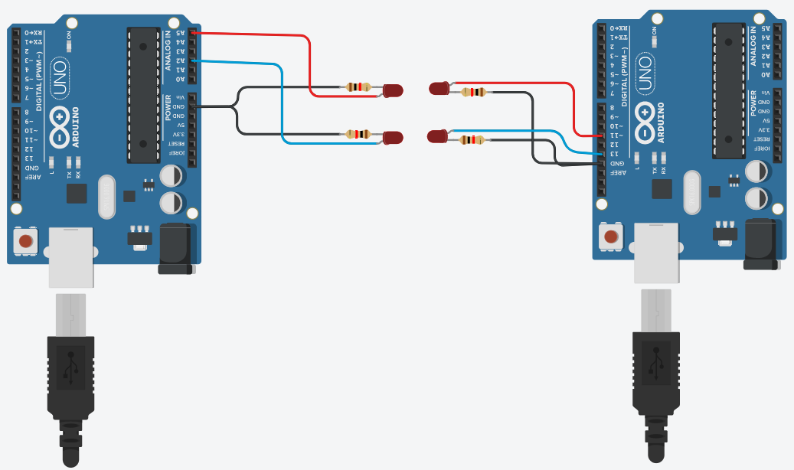

**Fig: VISUALISATION OF OUR DESIGN**

**4. SYSTEM REQUIREMENTS**

4.1 HARDWARE REQUIREMENTS

* **2 Arduino Uno’s** **-** A microcontroller board based on the ATmega328P.It has 14 digital input/output pins (of which 6 can be used as PWM outputs), 6 analogue inputs, a 16 MHz quartz crystal, a USB connection, a power jack, an ICSP header and a reset button.
* **LED 10mm.**
* **Resistors.**
* **USB cable TYPE A TO B.**

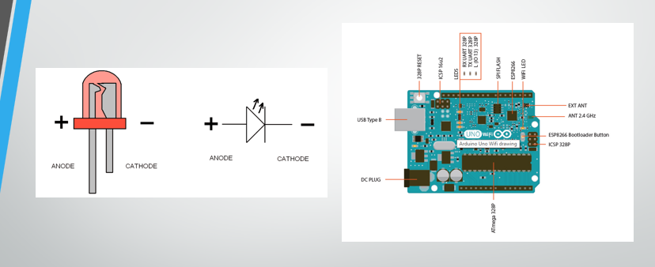

4.2 SOFTWARE REQUIREMENTS

* **Windows**
* **Arduino IDE**

**5. RESULTS**

* Can transfer text data over light from one Arduino to another.
* One character at a time is sent.
* Data can be transferred up to a max distance of 2cm.
* Data is transferred at a rate of 10b/s.

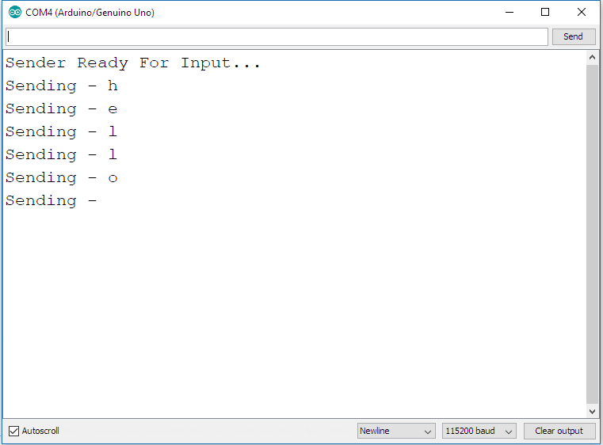

**FIG Sender Terminal**

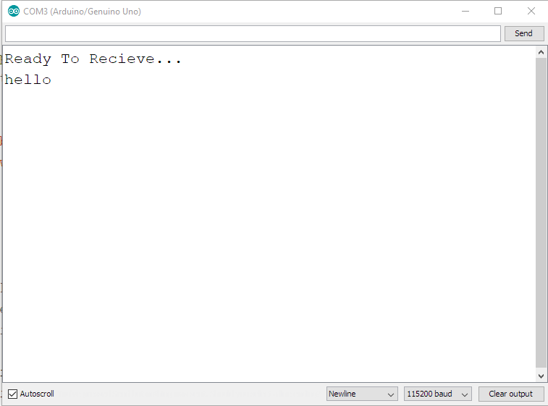

**FIG: Receiver Terminal**

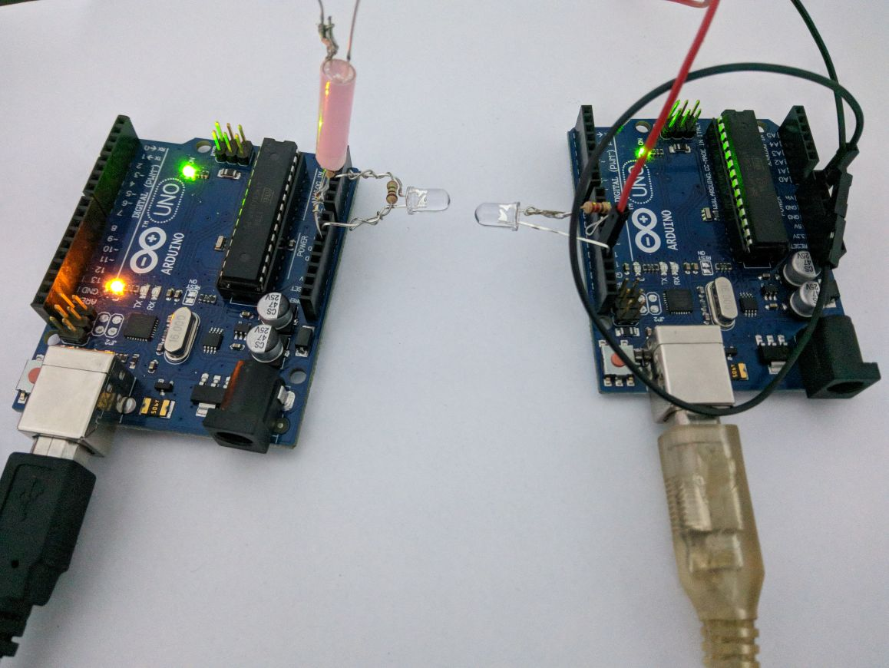

**FIG: Proof Of Concept**

**6.APPLICATIONS**

* Standard indoor lighting can be converted to provide light and high bandwidth data stream.
* Aviation & Healthcare: Li-Fi emits no electromagnetic interference and so does not interfere with operation of sensitive instruments.
* High Density Connectivity: Since Li-Fi has theoretically large bandwidth, it can be used to provide connectivity in high density use cases like a sports stadium.
* Secure Network Connectivity: As the light cannot penetrate through walls, the signal cannot be hacked from a remote location.
* Smart Lighting: Any private or public lighting including street lamps can be used to provide data communications.
* Indoor Connectivity: Laptops, smart phones, tablets and other mobile devices can interconnect directly using Li-Fi. Short range links give very high data rates and also provides security.

**7. CONCLUSION**

Lights will no longer be used only to illuminate indoors but also provide data communications. Undoubtedly Wi-Fi is widely used by all of us but factors like increasing congestion, interference with sensitive equipment and saturation of the bandwidth clearly indicate the shortcomings of the current technology. Li-Fi, on the other hand, digitizes the world by manipulating light in order to transmit information using low-energy technology. Besides, features like high-speed data transfer and privacy further favour the use of Li-Fi over Wi-Fi.

Although it will be impossible to replace Wi-Fi with Li-Fi because of the existing infrastructure but it is very useful in highly specific applications where Wi-Fi may interfere with other equipment, for example in hospitals and planes.

**FUTURE ENHANCEMENT**

* Duplex communication can be implemented.
* Active detection of threshold.
* Manchester encoding for higher bandwidth and performance.
* Use of assemble level programming for greater performance.
* Common lighting can be used to provide high speed internet.
* Li-Fi communication can be built upon existing 802.11 protocols.

**REFERENCES**

* <https://github.com/jpiat/arduino>
* <https://www.arduino.cc/reference/en/>
* <https://www.lifi.eng.ed.ac.uk/lifi-news/2017-04-01-1855/comprehensive-summary-modulation-techniques-lifi>
* <https://purelifi.com/technology/>
* <https://www.youtube.com/watch?v=25_dIc_4JG0&index=27&list=LLqAjEfvC5CMPlDI7PX0mVbw&t=0s>
* <https://www.youtube.com/watch?v=wqH9KX9o0vg>