Pizza Sales Analysis
SQL Exploratory Data Analysis Report

Database: MySQL | Period: 1 January to 31 December 2015
Tables: orders, order_details, pizzas, pizza_types

Contents
1. Executive Summary
2. Business Problem and Objectives
3. Dataset Description
4. Data Preparation and Quality Checks
5. Analysis and Findings (Q1 to Q10)
6. Additional Insights
7. Key Takeaways
8. Recommendations
9. Limitations and Next Steps
10. Tools and Skills

1. Executive Summary
This report analyses one year of sales from a pizza restaurant using SQL. The goal is to understand what sells, when it sells and what earns the most, then turn those findings into practical recommendations.
Metric | Value
Total orders | 21,350
Total pizzas sold | 49,574
Total revenue | $817,860.05
Average order value | $38.31
Average pizzas per day | 138.47
Pizzas per order | 2.32

Headline findings:
- Large (L) is the most ordered size, at 38.2% of all pizzas.
- Classic is the biggest category by volume (30.0%), but the top 3 pizzas by revenue are all Chicken pizzas.
- Orders peak at lunch (12 to 2 pm) and dinner (5 to 7 pm).
- Friday is the strongest day and Sunday the weakest.

2. Business Problem and Objectives
The restaurant wants data-backed answers to help with staffing, menu design and promotions. The analysis targets ten questions:
- How many orders were placed and how much revenue was earned?
- Which pizza is the most expensive, and which sizes, pizzas and categories sell most?
- When during the day do customers order?
- How many pizzas are sold per day, and which pizzas earn the most revenue?

3. Dataset Description
The data is stored in four related tables.
Table | Rows | Description
orders | 21,350 | One row per order: order_id, date, time
order_details | 48,620 | One row per pizza line: order_details_id, order_id, pizza_id, quantity
pizzas | 96 | One row per pizza and size: pizza_id, pizza_type_id, size, price
pizza_types | 32 | Pizza name, category and ingredients

Table relationships
pizza_types links to pizzas on pizza_type_id. pizzas links to order_details on pizza_id. order_details links to orders on order_id. Almost every analysis therefore joins two to four tables.

4. Data Preparation and Quality Checks
Before analysis, the tables were validated and the schema was corrected.
Check | Result
Order lines with a pizza_id not found in pizzas | 0
Orders with NULL date or time | 0
Date range | 2015-01-01 to 2015-12-31 (358 trading days)
Price range | $9.75 to $35.95 (average $16.44)

Schema corrections made to the original script:
- pizzas.price changed from INT to DECIMAL(6,2). With INT, prices such as $12.75 are rounded, which distorts revenue.
- pizza_types.ingredients widened from VARCHAR(100) to VARCHAR(255), because long ingredient lists can be truncated.
- Primary keys added to each table.
- Order dates arrive as m/d/yyyy and must be converted with STR_TO_DATE(@d, '%m/%d/%Y') on import.

5. Analysis and Findings

Q1. Total number of orders placed
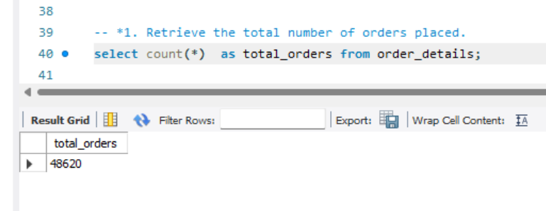

Result: 21,350 orders. These contain 48,620 order lines and 49,574 pizzas. Counting rows in order_details would give 48,620, which is order lines, not orders.

Q2. Total revenue
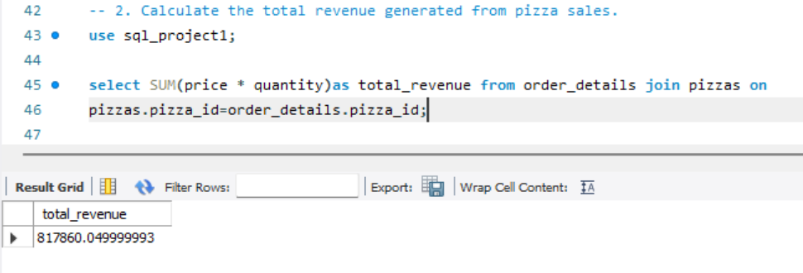

Result: $817,860.05. Average order value is $38.31.

Q3. Highest-priced pizza
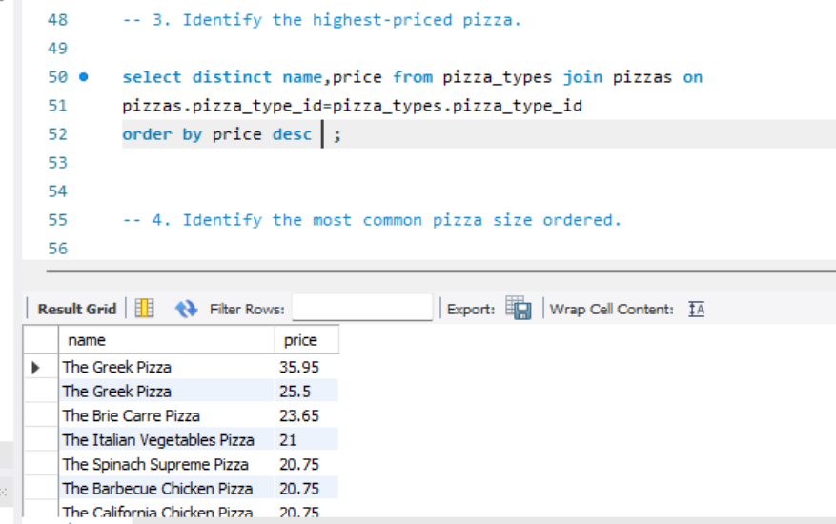

Result: The Greek Pizza in XXL at $35.95. The next highest are The Greek Pizza XL ($25.50) and The Brie Carre Pizza S ($23.65).

Q4. Most common pizza size ordered
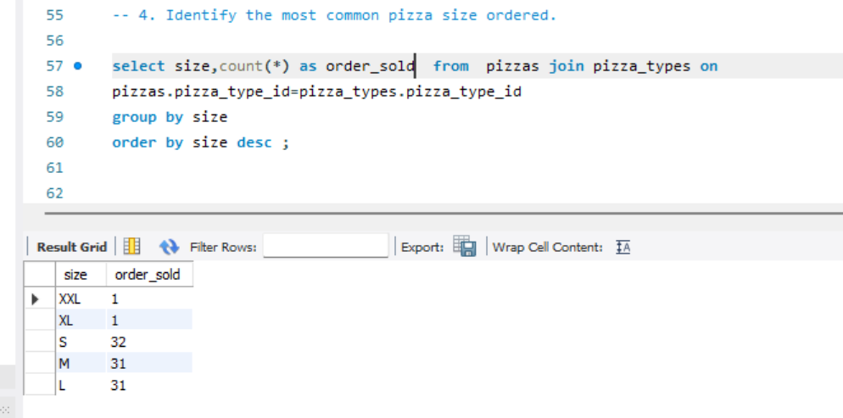
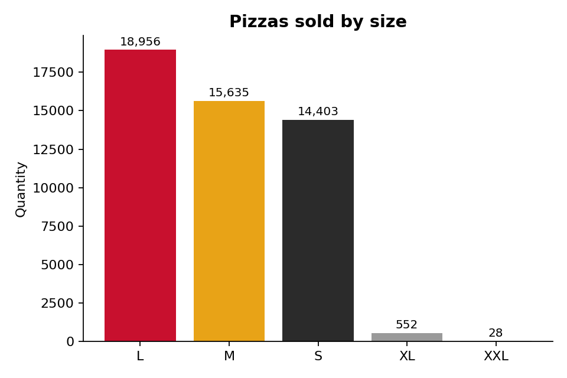
Insight: L, M and S make up 99% of sales. XL and XXL are rarely ordered and could be reviewed.

Q5. Top 5 most ordered pizza types

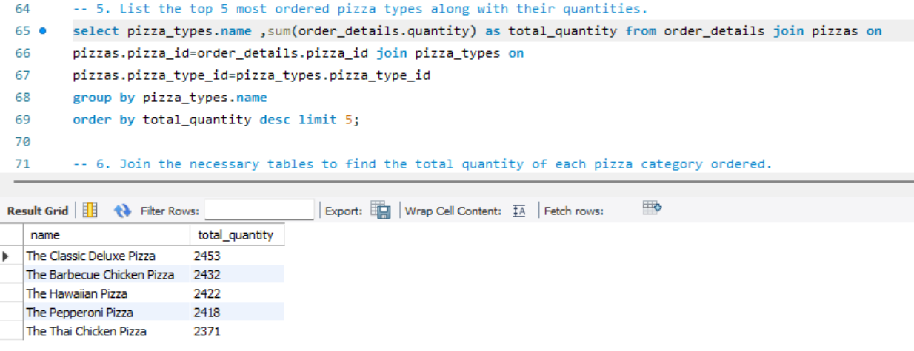
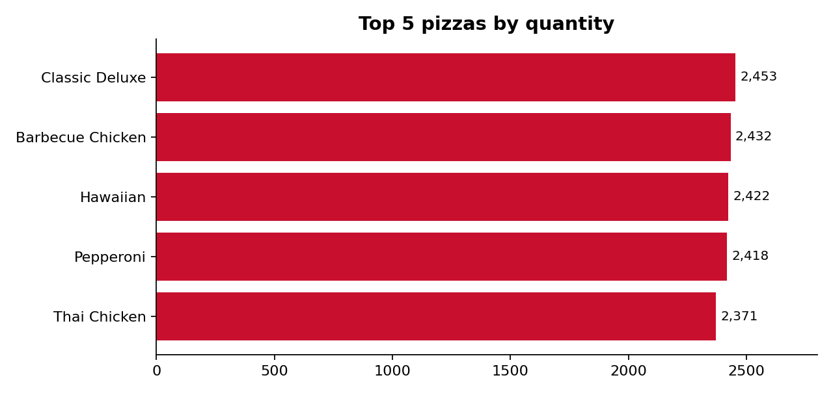
Insight: only 82 pizzas separate first from fifth, so no single pizza dominates.

Q6. Total quantity ordered per category

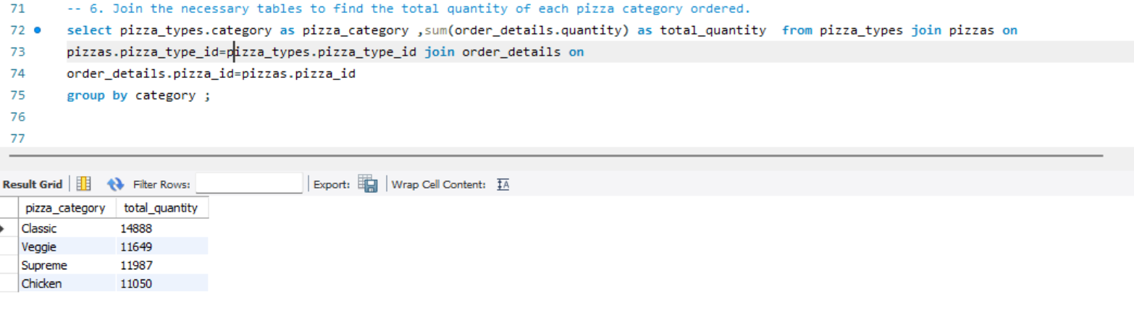

Q7. Distribution of orders by hour of day

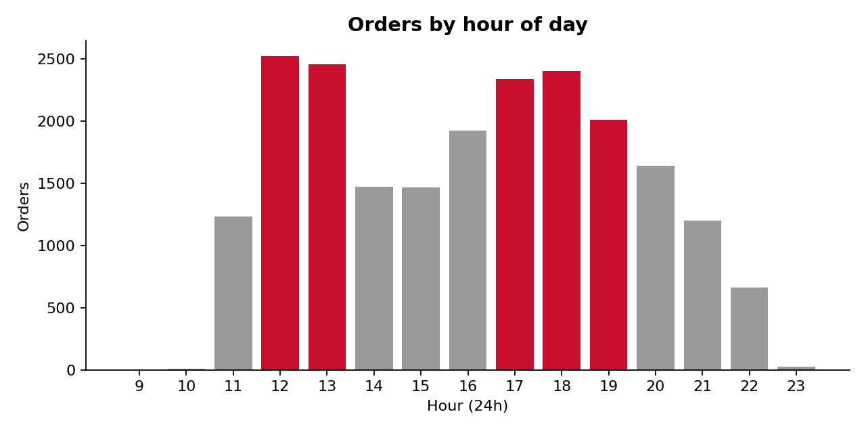
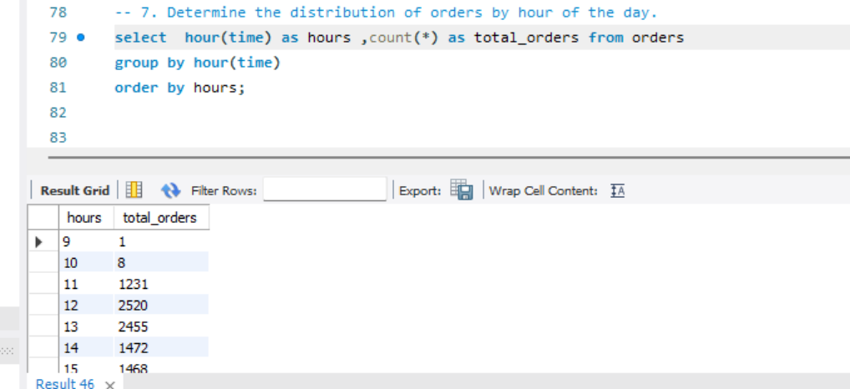

Insight: two clear peaks. Lunch (12:00 to 13:59) has 4,975 orders and dinner (17:00 to 18:59) has 4,735. Activity is minimal before 11 am and after 10 pm.

Q8. Category-wise distribution of pizza types
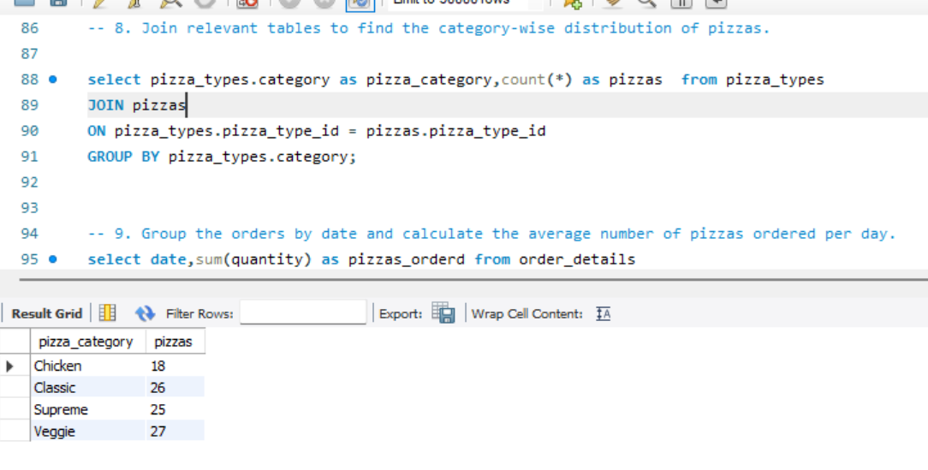
Insight: Chicken has the fewest menu items yet earns the most revenue per item

Q9. Average number of pizzas ordered per day
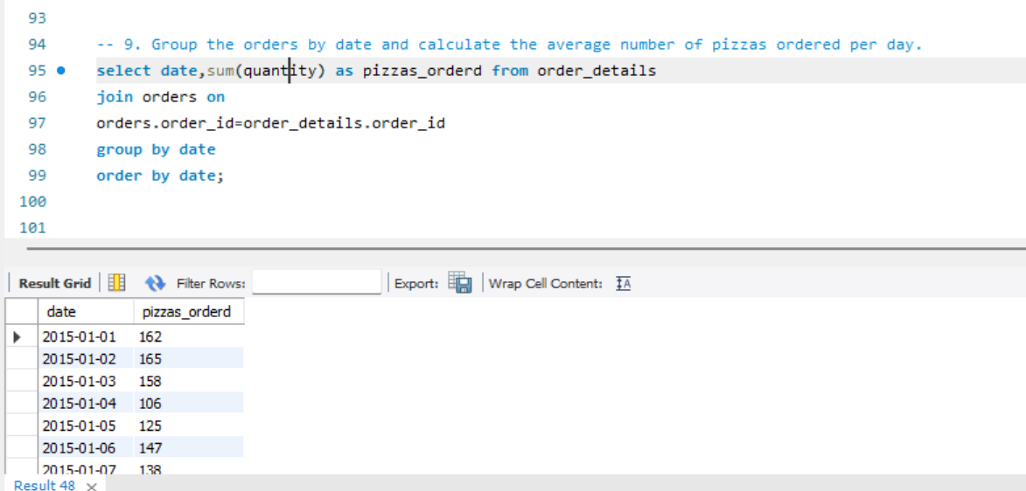
Result: The busiest day was 31 december 2015 (178 pizzas) and the quietest was 22 november 2015 (84 pizzas).

Q10. Top 3 pizza types by revenue
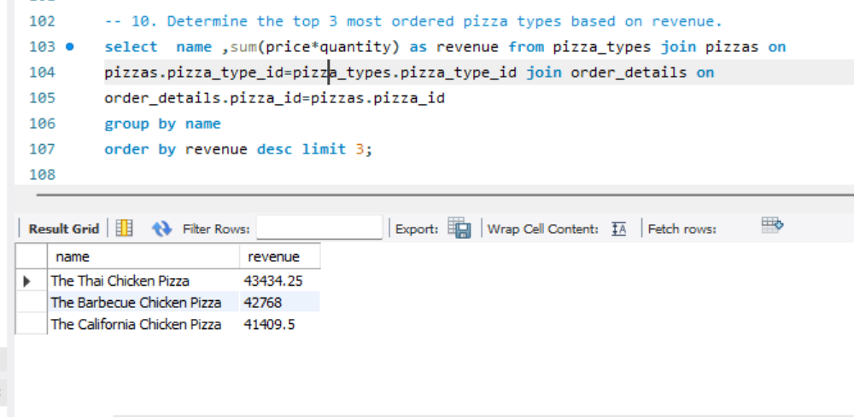
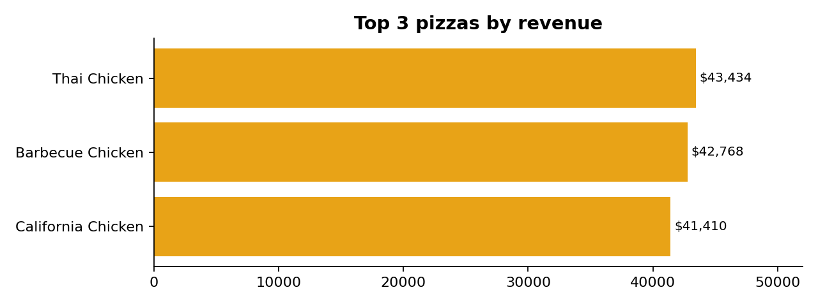
Insight: all three top earners are Chicken pizzas.

6. Additional Insights
Insight | Result
Busiest weekday | Friday, 8,242 pizzas (Sunday lowest at 6,035)
Best month | July, $72,558 (October lowest at $64,028)
Least-sold pizza | The Brie Carre Pizza, 490 sold
Revenue by category | Classic $220,053; Supreme $208,197; Chicken $195,920; Veggie $193,690
Revenue per pizza type | Chicken $32.7K; Classic $27.5K; Supreme $23.1K; Veggie $21.5K
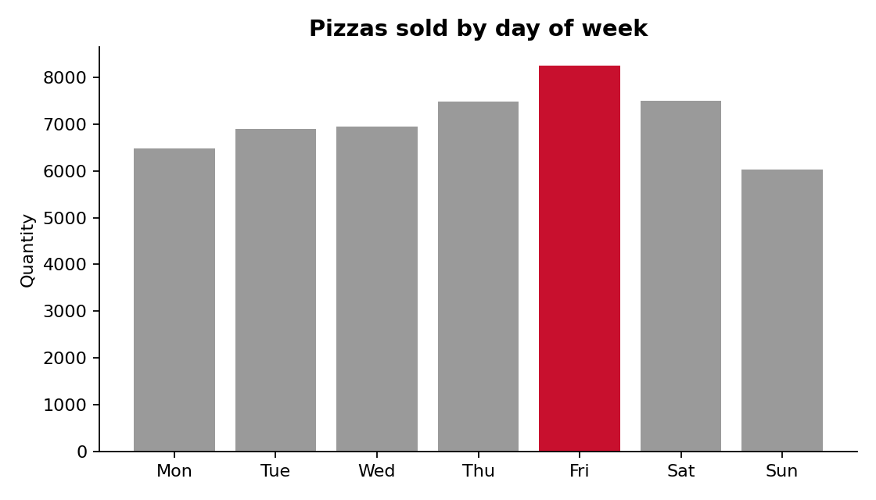
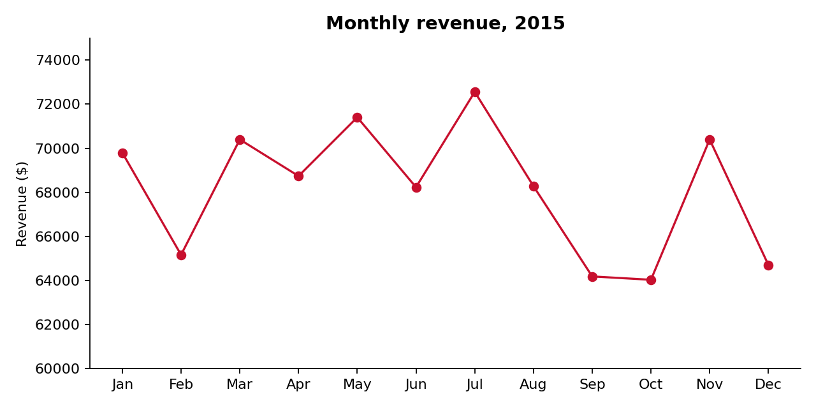

7. Key Takeaways
- The business earned $817.9K from 21,350 orders in 2015.
- Volume and revenue tell different stories: Classic leads volume, Chicken leads revenue per menu item.
- Demand is concentrated in two daily windows and is strongest on Fridays.
- Extra-large sizes and the Brie Carre pizza contribute very little.

8. Recommendations
- Schedule extra staff for 12 to 2 pm and 5 to 7 pm, especially on Fridays.
- Promote Chicken pizzas and bundle them with large sizes.
- Review the XL and XXL sizes (580 sold combined) and the Brie Carre pizza (490 sold).
- Introduce off-peak offers for mid-afternoon, late evening and Sundays.
- Track revenue per menu item, not just volume, when planning the menu.

9. Limitations and Next Steps
- Only one year of data is available, so year-on-year trends and seasonality cannot be confirmed.
- No customer identifiers exist, so repeat-customer analysis is not possible.
- Next steps: window functions for running totals, ranking pizzas within categories, and a dashboard in Power BI or Tableau.

